Marci M. McBride

CSE 122

HW 1

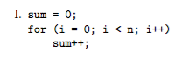

|  |  |  |
| --- | --- | --- |
| Line | Cost | N |
| C1 | 1 | 1 |
| C2 | 2 | N+1 |
| C3 | 1 | n |

T(n)= C1(1) + C2(N+1) + C3(n)

= n(C2+C3)+ C2 + C1

T(n) = 3n+3 = 3(n+1)

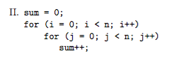

|  |  |  |
| --- | --- | --- |
| Line | Cost | N |
| C1 | 1 | 1 |
| C2 | 2 | N+1 |
| C3 | 2 | N(n+1) |
| C4 | 1 | N2 |

T(n)= C1(1) + C2(N+1) + C3(n(n+1))+C4(N2)

T(n) = 1 + 2n + 2 + 2(n2+n) + n2

=3n2 + 4n + 3

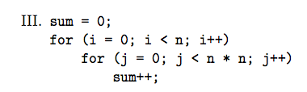

|  |  |  |
| --- | --- | --- |
| Line | Cost | N |
| C1 | 1 | 1 |
| C2 | 2 | N+1 |
| C3 | 2 | N(n2+1) |
| C4 | 1 | N3 |

T(n)= C1(1) + C2(N+1) + C3(n(n2+1))+C4(N3)

T(n) = 1 + 2n + 2 + 2(n3+n) + n3

=3n3 + 4n + 3

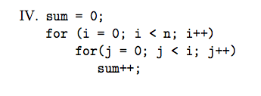

|  |  |  |
| --- | --- | --- |
| Line | Cost | N |
| C1 | 1 | 1 |
| C2 | 2 | N+1 |
| C3 | 2 |  |
| C4 | 1 |  |

T(n)= C1(1) + C2(N+1) + C3(n(n2+1))+C4(N3)

T(n) = 1 + 2n + 2 + 2(n3+n) + n3

=3n3 + 4n + 3