Marci M. McBride

CSE 122

HW3

Part 1

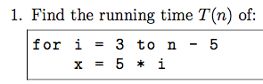

|  |  |
| --- | --- |
| Cost | # |
| C1 | n-6 |
| C2 | n-7 |

T(n) = C1(n-6)+C2(n-7)

T(n) = n(C1+C2)-6C1-7C2

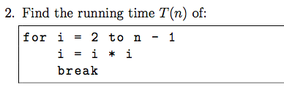

|  |  |
| --- | --- |
| Cost | # |
| C1 | 1 |
| C2 | 1 |
| C3 | 1 |

T(n) = C1+C2+C3

T(n) = 1

**However since there is a break statement technically T(n) = c.**

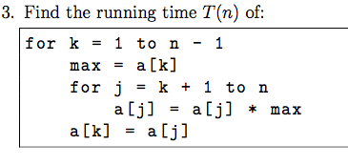

|  |  |
| --- | --- |
| Cost | # |
| C1 | n |
| C2 | n-1 |
| C3 | [(n(n+1)/2]-1 |
| C4 | n(n-1)/2 |
| C5 | n-1 |

T(n) = C1(n)+C2(n-1)+ C3([(n(n+1)/2]-1)+C4(n(n-1)/2) + C5(n-1)

T(n) = C1n + C2n –C2 + C3((n2+n)/2) – C3 + C4(n2-n)/2 + C5n –C5

T(n) = n(C1+C2+C5) + (C3+C4) ((n2+n)/2)– C2 – C5 –C3

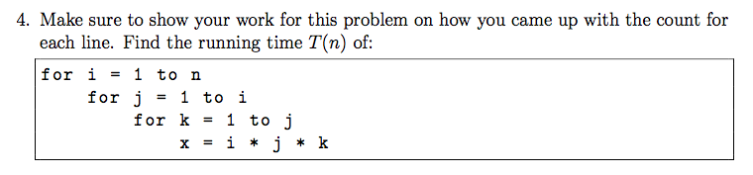

|  |  |
| --- | --- |
| line | # |
| C1 | n+1 |
| C2 | (n2+3n)/2 |
| C3 | (¾) (n (1+n))+(1/12)( n (1+n) (1+2 n)) |
| C4 | (1/12)( n (1+n) (1+2 n)) +(1/4) (n (1+n)) |

Hmmm show our work… ill give it a try

|  |  |
| --- | --- |
| C1  ((n-1)+1)+1  ((n)+1) | C2  Sum of i=1 to n  Of i+1  = N(n+1)/2 +n  =(n2+3n)/2 |
| C3  Sum from I =1 to n of the sum of j=1 to I of j +1  =i(i+1)/2 +i  =(i2+3i)/2 | C4  Sum from I =1 to n of the sum of j=1 to I of j  =i(i+1)/2  =(i2+i)/2 |

T(n) = C1(n+1) + C2((n2+3n)/2) + C3((¾) (n (1+n))+(1/12)( n (1+n) (1+2 n)) + C4(1/12)( n (1+n) (1+2 n)) +(1/4) (n (1+n))

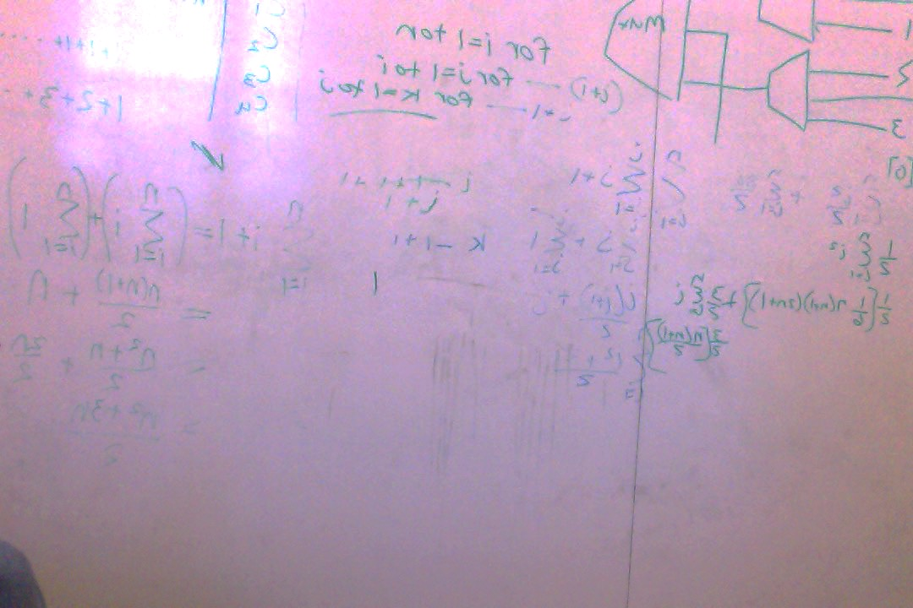

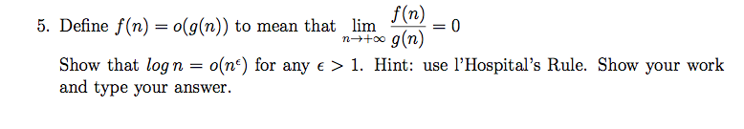

Macintosh HD:Users:marci_puravida:Desktop:Screen Shot 2015-09-27 at 1.37.21 PM.pngMacintosh HD:Users:marci_puravida:Desktop:Screen Shot 2015-09-27 at 1.37.21 PM.png (log n)/ (nε) =Macintosh HD:Users:marci_puravida:Desktop:Screen Shot 2015-09-28 at 6.50.37 PM.png (1/n) / ε nε -1 =Macintosh HD:Users:marci_puravida:Desktop:Screen Shot 2015-09-28 at 6.50.37 PM.png1/(n(εnε-1)

=Macintosh HD:Users:marci_puravida:Desktop:Screen Shot 2015-09-28 at 6.50.37 PM.png1/nε =0

since ε>1