Sector trends supplementary data

William F. Lamb

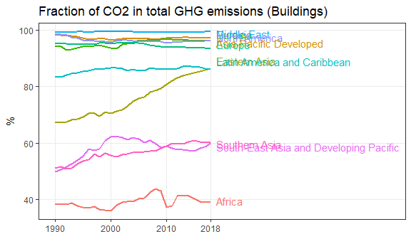 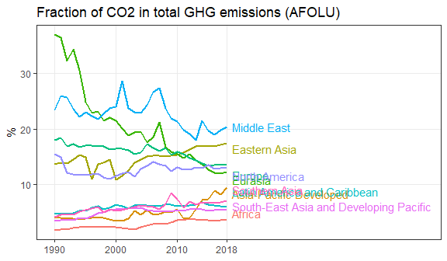

## Joining, by = c("ISO", "year")

## Joining, by = c("ISO", "year", "country", "region_ar6_10")

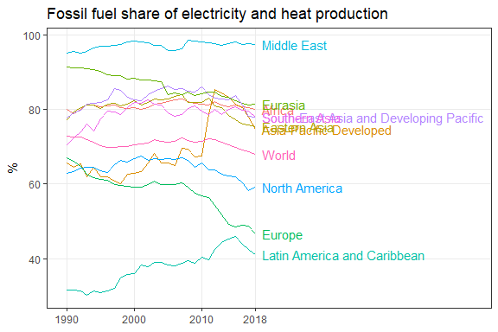

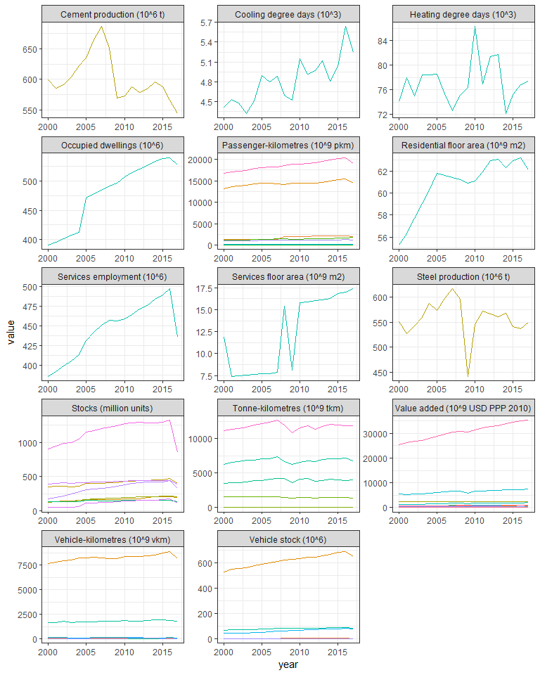

##   
## Attaching package: 'maps'

## The following object is masked from 'package:purrr':  
##   
## map

