Emissions trends and drivers: sectoral trends

William F. Lamb

Table of Contents

Energy 2

Industry 3

Transport 4

Buildings 5

AFOLU 6

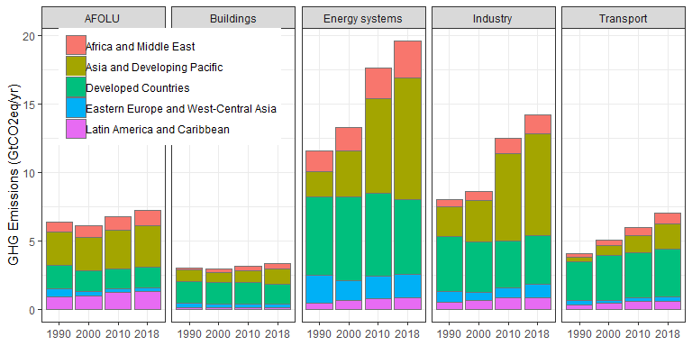

# Energy

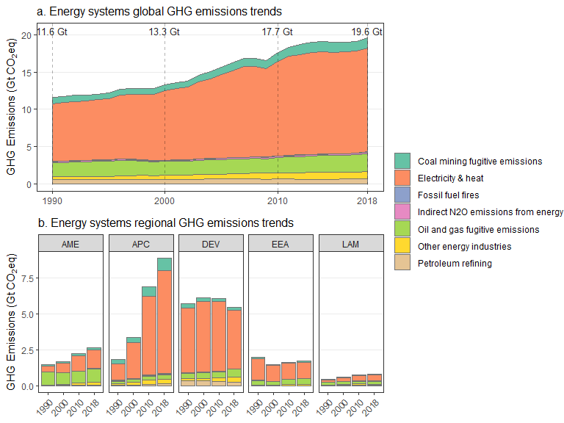

# Industry

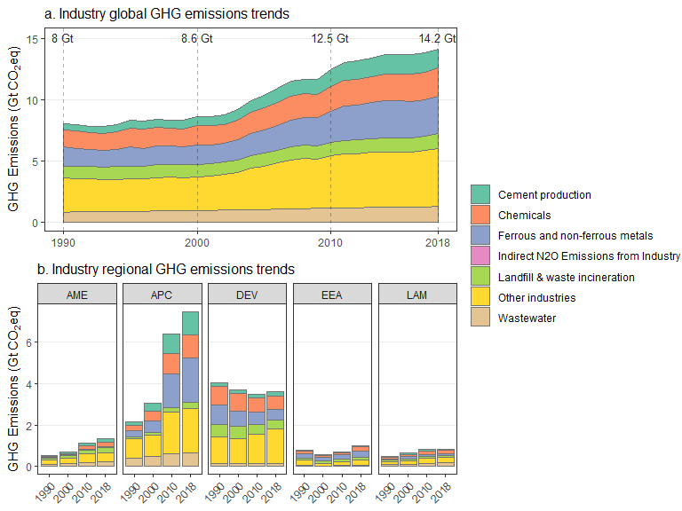

# Transport

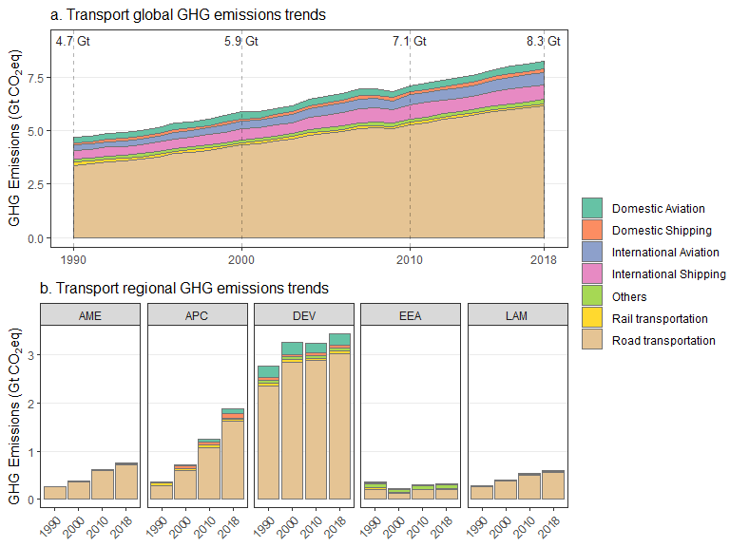

# Buildings

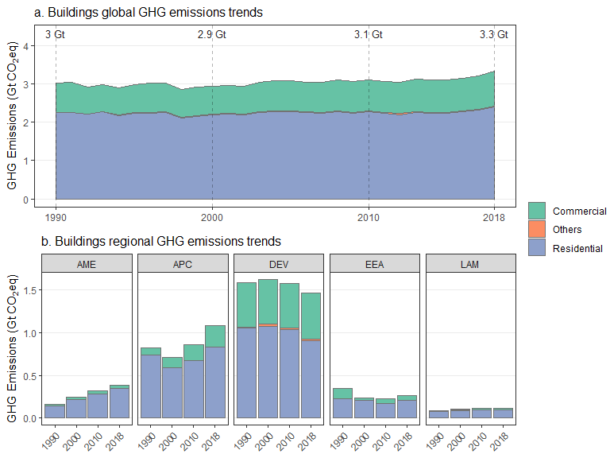

# AFOLU

