Covid emissions

William F. Lamb

## Setup

## Table of emissions changes in 2020

## Note: Using an external vector in selections is ambiguous.  
## i Use `all_of(group)` instead of `group` to silence this message.  
## i See <https://tidyselect.r-lib.org/reference/faq-external-vector.html>.  
## This message is displayed once per session.

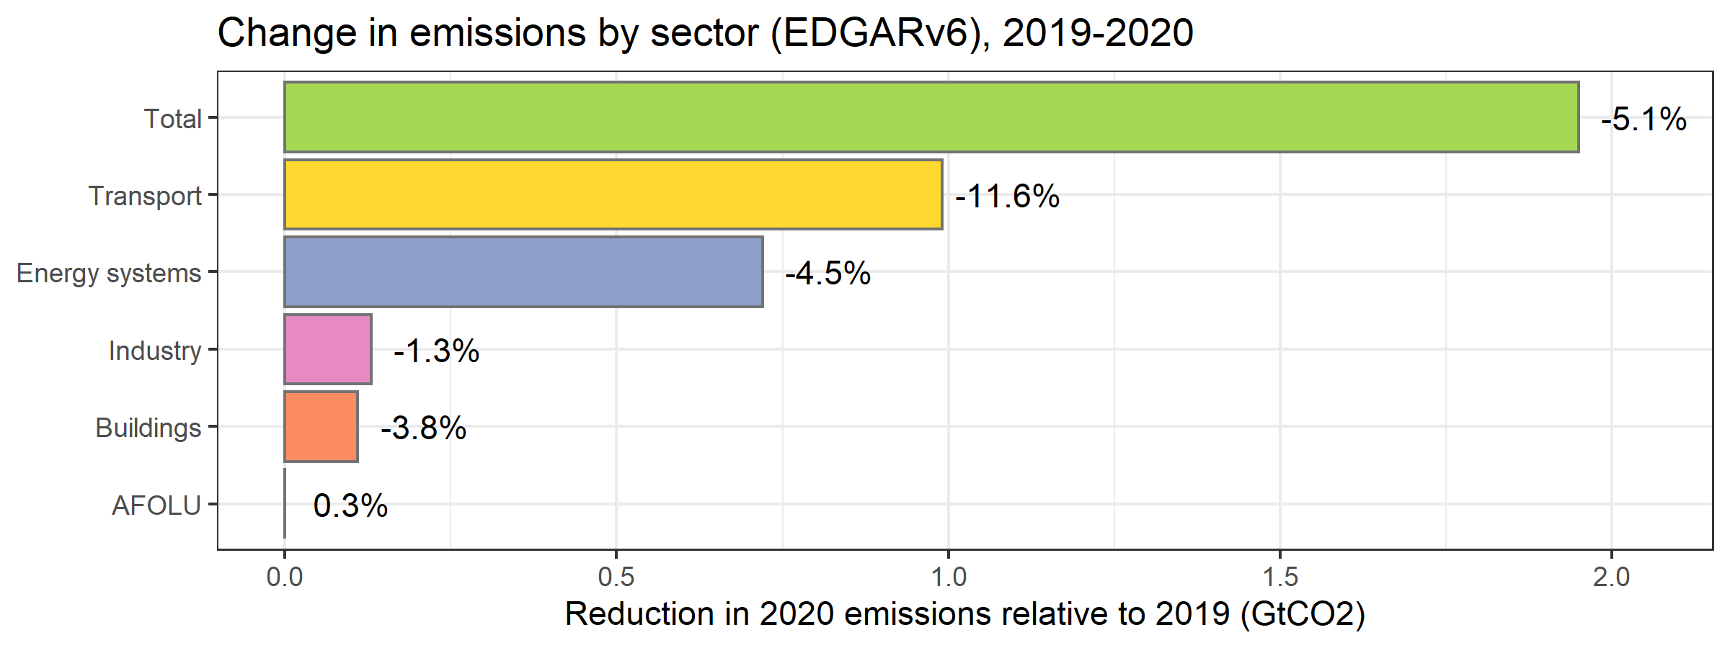

## `summarise()` has grouped output by 'chapter_title'. You can override using the `.groups` argument.  
## `summarise()` has grouped output by 'chapter_title'. You can override using the `.groups` argument.  
## `summarise()` has grouped output by 'chapter_title'. You can override using the `.groups` argument.

## Scale for 'fill' is already present. Adding another scale for 'fill', which  
## will replace the existing scale.

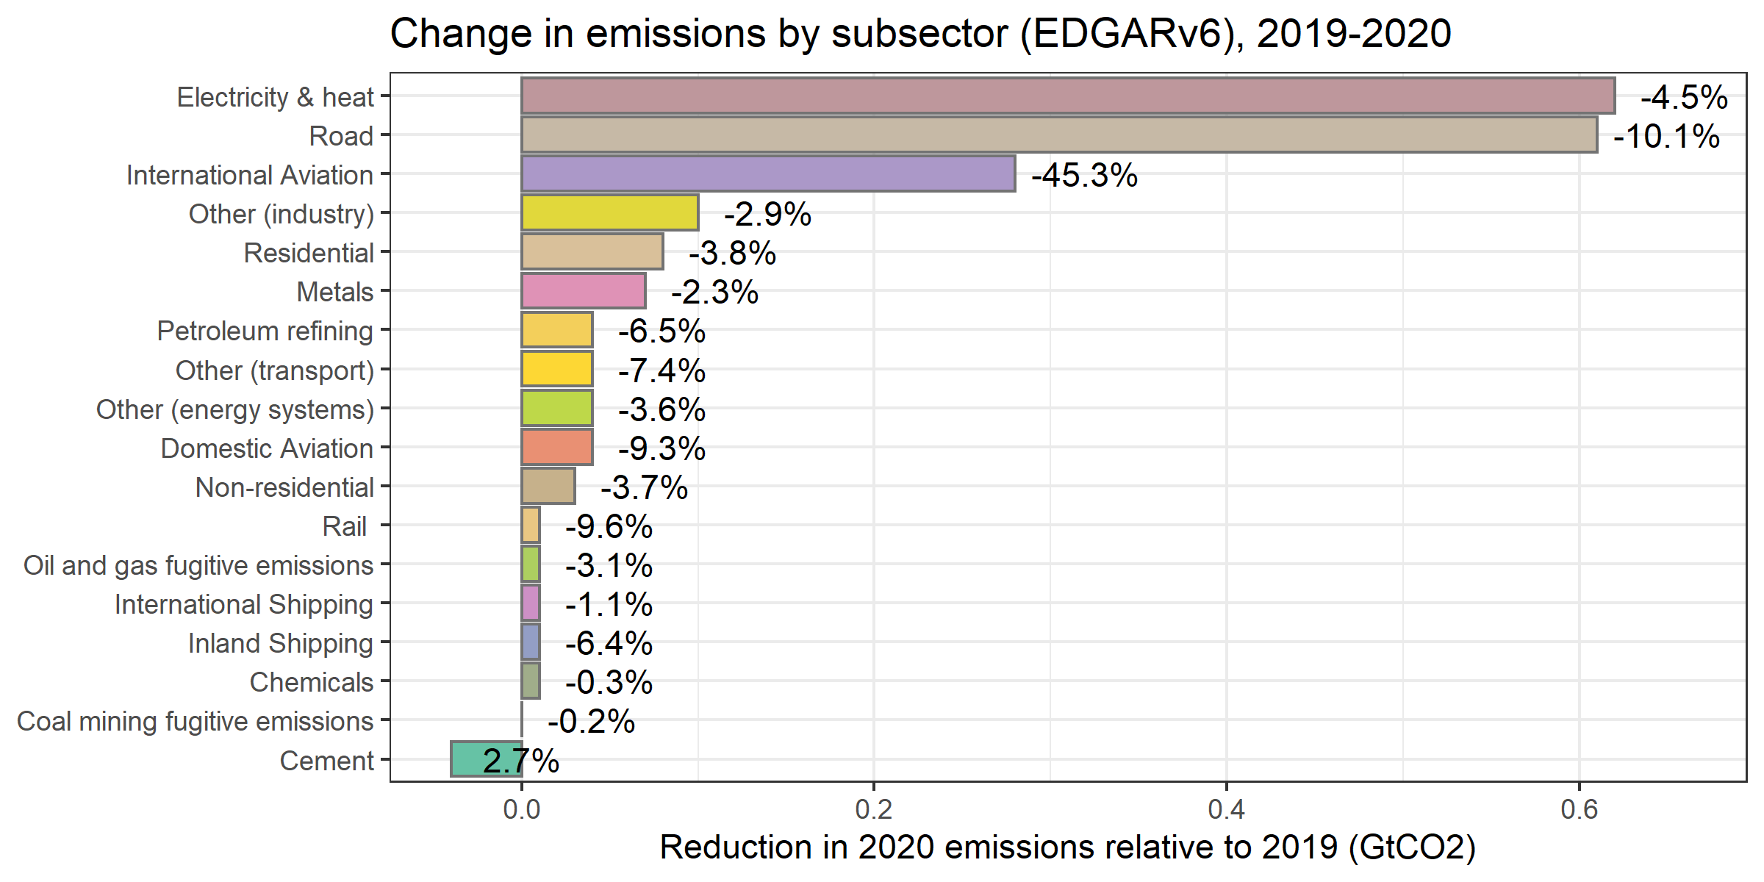

## `summarise()` has grouped output by 'region_ar6_6', 'region_ar6_10'. You can override using the `.groups` argument.  
## `summarise()` has grouped output by 'region_ar6_6', 'region_ar6_10'. You can override using the `.groups` argument.  
## `summarise()` has grouped output by 'region_ar6_6', 'region_ar6_10'. You can override using the `.groups` argument.

## Scale for 'fill' is already present. Adding another scale for 'fill', which  
## will replace the existing scale.

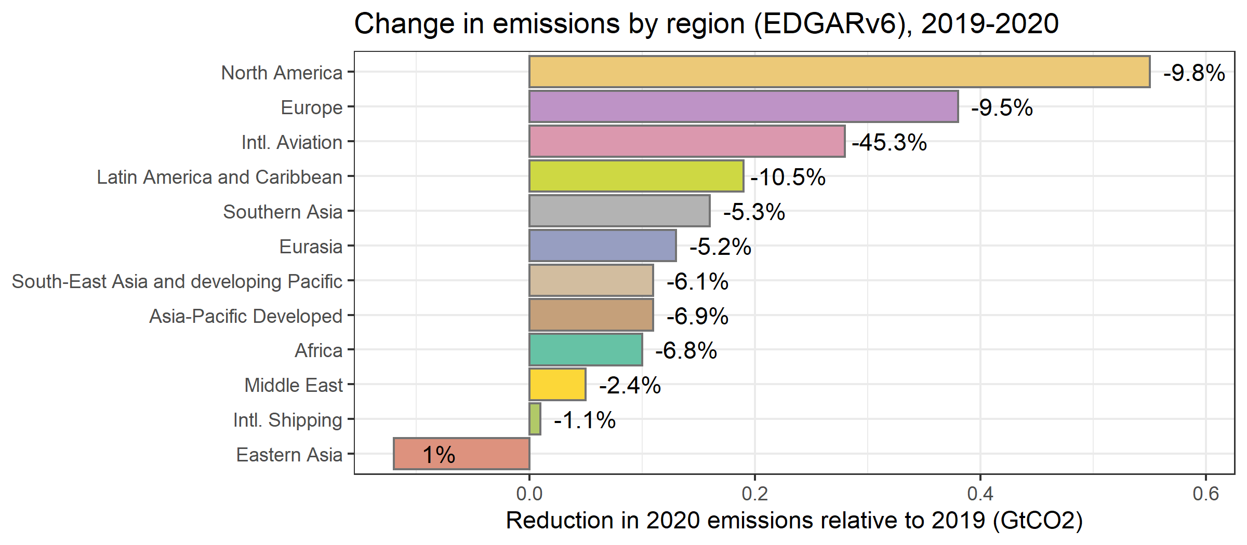

## Annual emissions 1970-2020

## Joining, by = "year"

## `summarise()` has grouped output by 'label', 'rate'. You can override using the `.groups` argument.

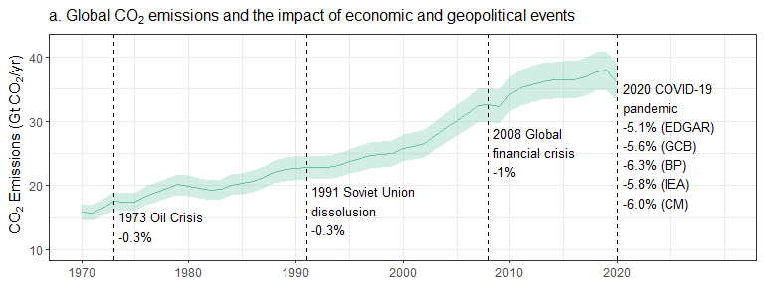 ## Daily emissions 2020 ### Carbon Monitor

## `summarise()` has grouped output by 'date'. You can override using the `.groups` argument.

## `summarise()` has grouped output by 'sector', 'date'. You can override using the `.groups` argument.

### Global Carbon Project

### Sector comparison plot

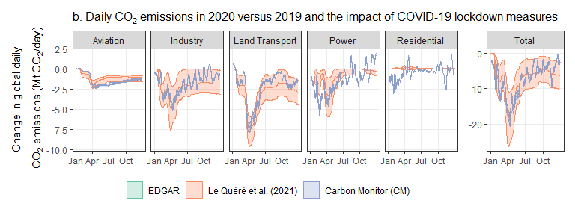

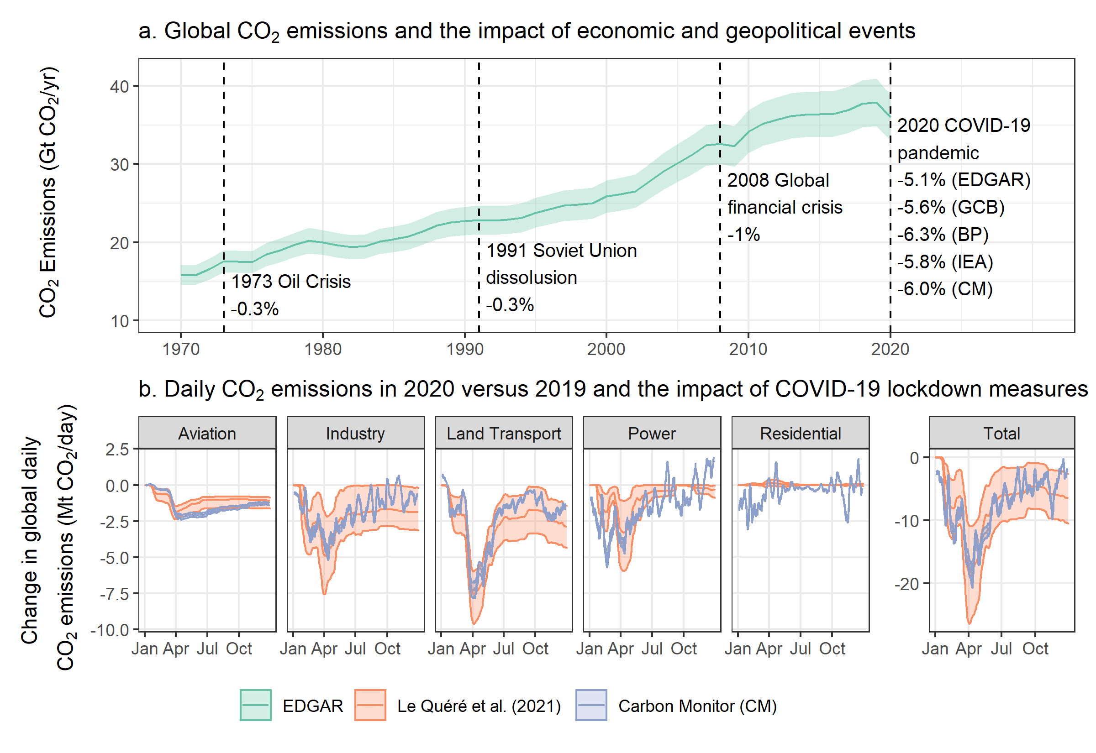

### Total sector reductions

## `summarise()` has grouped output by 'sector'. You can override using the `.groups` argument.

## `summarise()` has grouped output by 'year'. You can override using the `.groups` argument.

## Joining, by = "sector"