data_checking

William F. Lamb

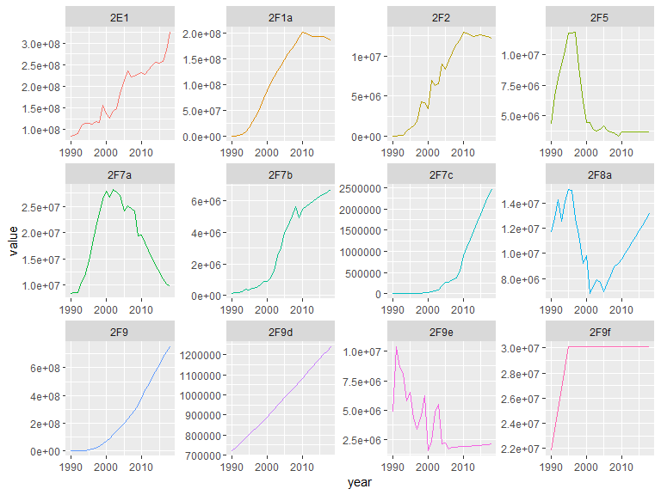

## differences by gas

## Joining, by = c("year", "key")

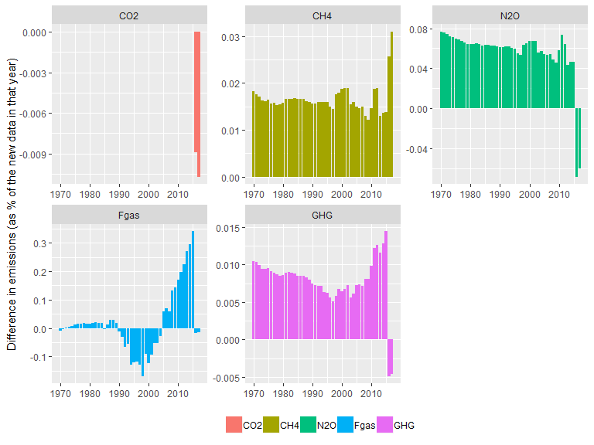

## differences by chapter

## Joining, by = c("year", "chapter", "key")

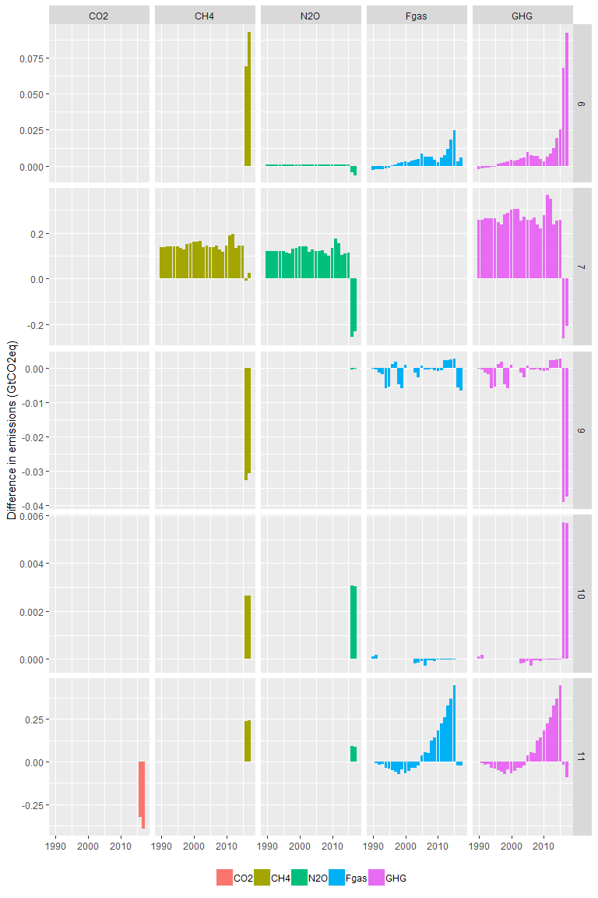

## differences by individual sector

## Joining, by = c("year", "sector_code", "description", "key")

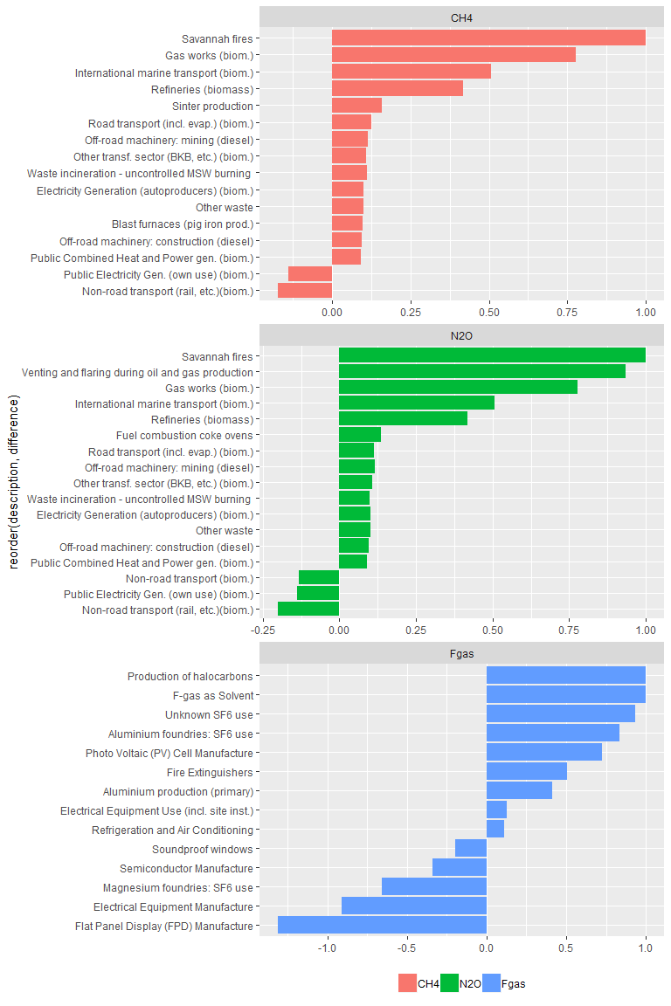

## new data - sector trends

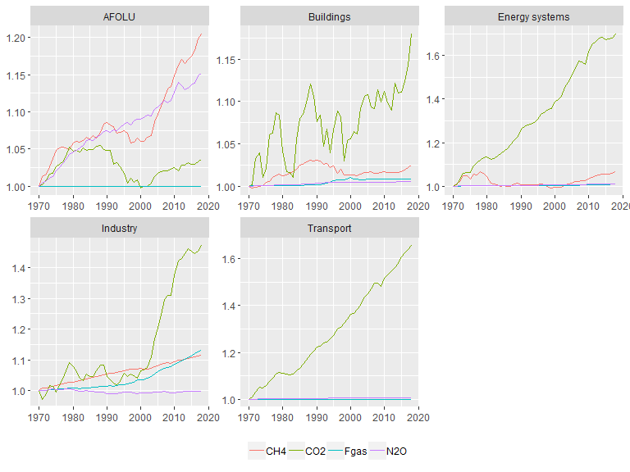

## new data - region trends

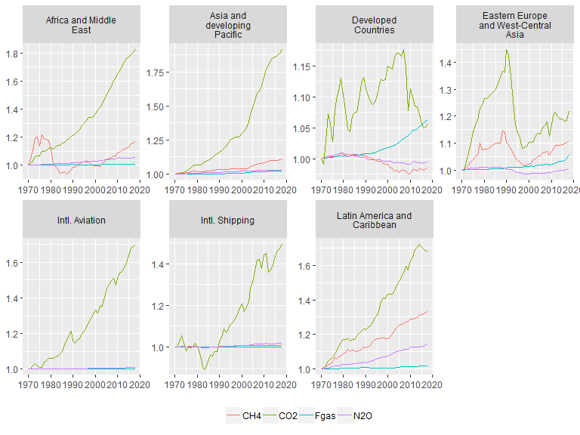

## new data - high emitting country trends

