Decarbonising countries

William F. Lamb

08 Dezember, 2020

Table of Contents

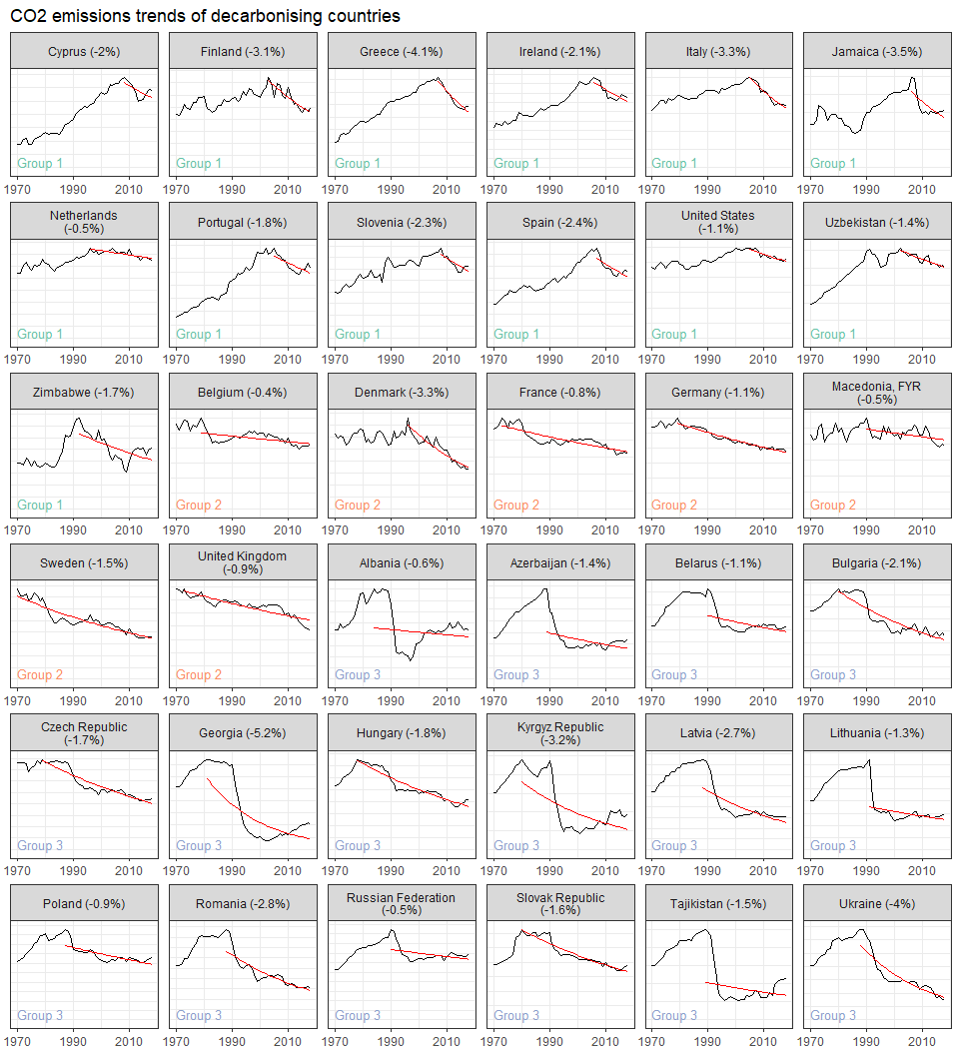

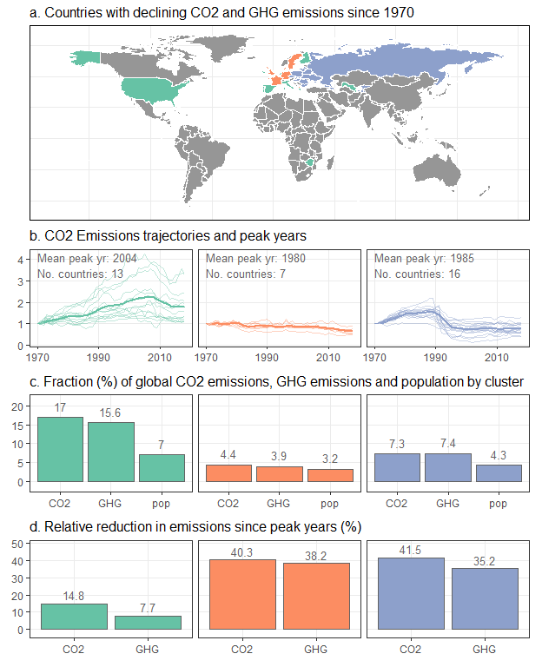

## Scale for 'fill' is already present. Adding another scale for 'fill',  
## which will replace the existing scale.

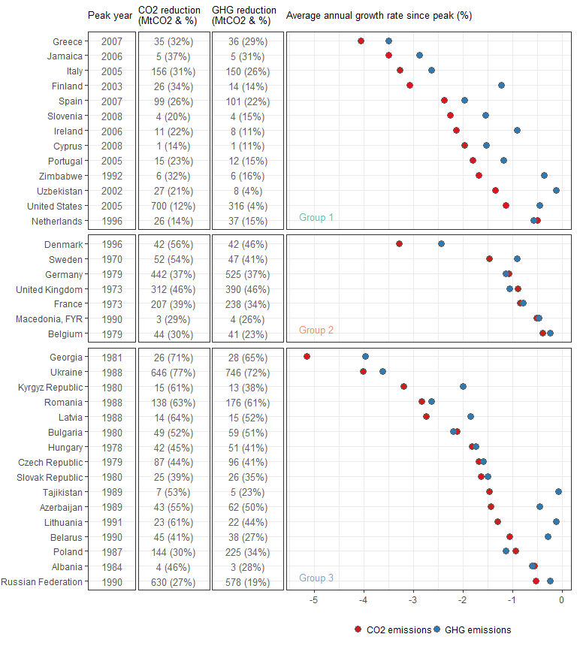

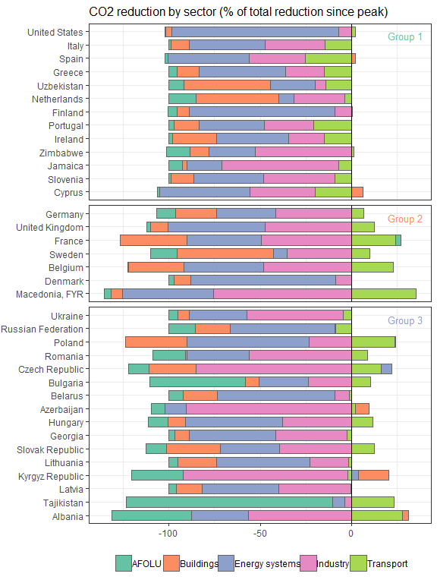

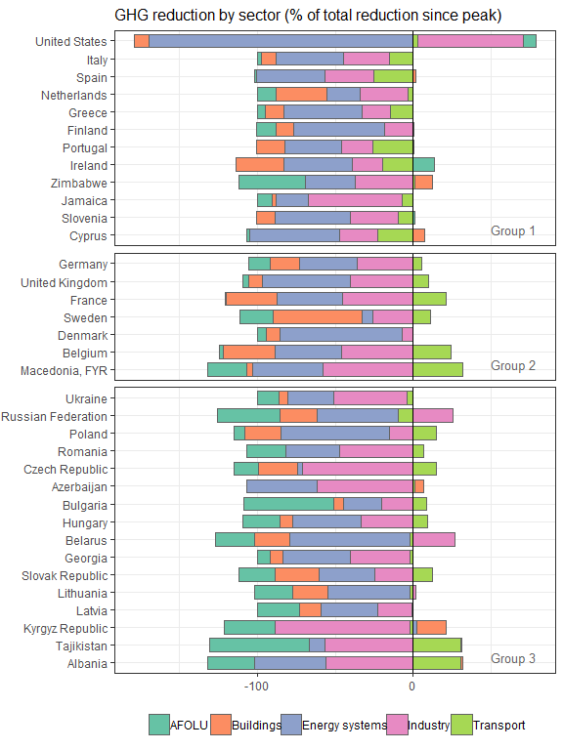

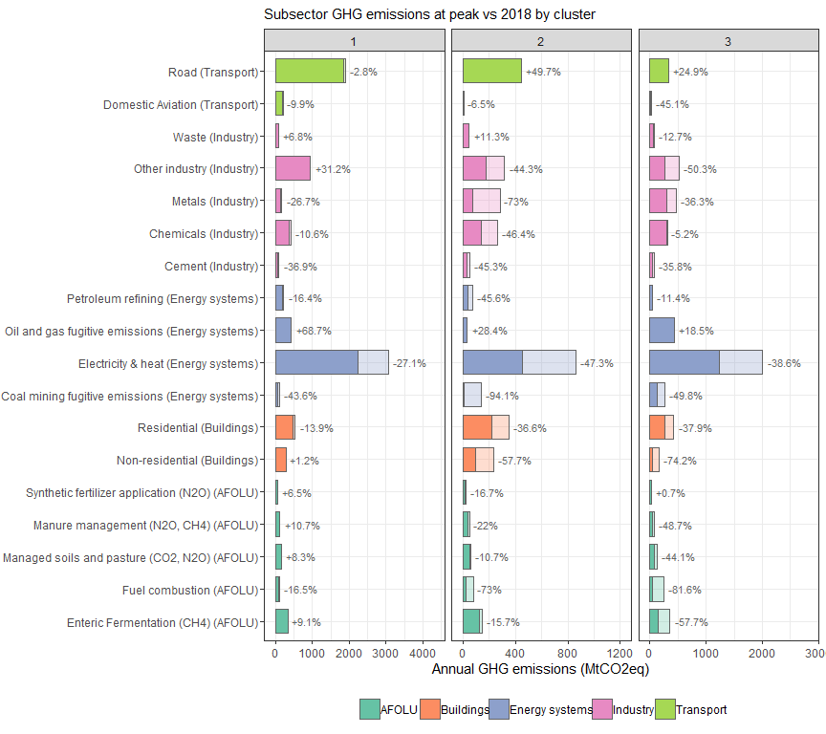

## Scale for 'colour' is already present. Adding another scale for  
## 'colour', which will replace the existing scale.  
## Scale for 'colour' is already present. Adding another scale for  
## 'colour', which will replace the existing scale.

## Scale for 'fill' is already present. Adding another scale for 'fill',  
## which will replace the existing scale.  
## Scale for 'fill' is already present. Adding another scale for 'fill',  
## which will replace the existing scale.

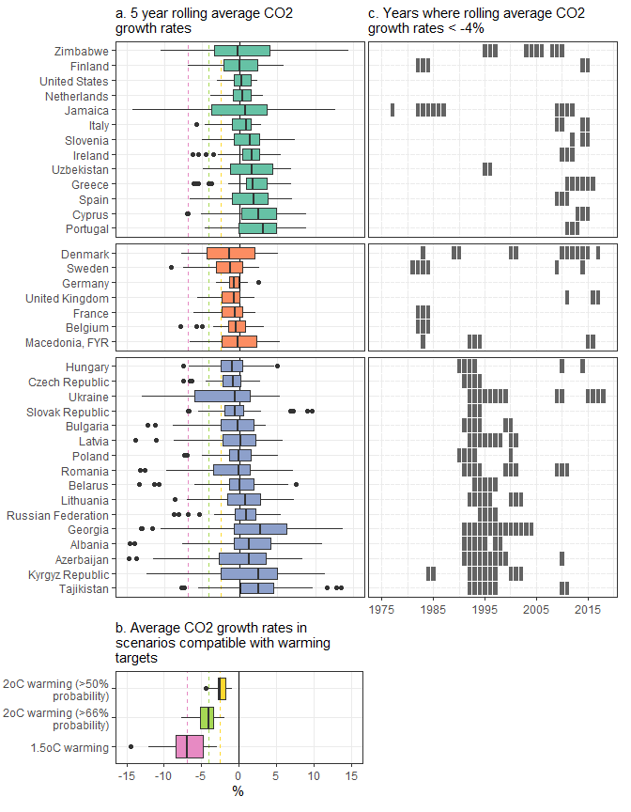

## Note: zip::zip() is deprecated, please use zip::zipr() instead