Emissions trends and drivers: overview

William F. Lamb

### Waterfall plots for different GWPs

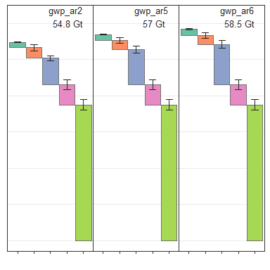

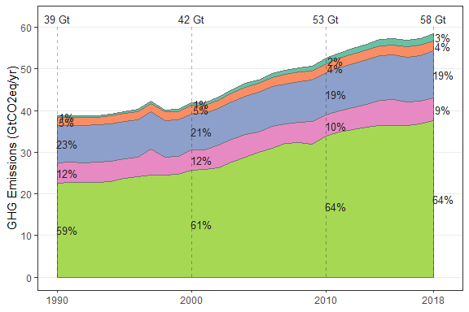

## Scale for 'fill' is already present. Adding another scale for 'fill',  
## which will replace the existing scale.

## Scale for 'colour' is already present. Adding another scale for  
## 'colour', which will replace the existing scale.

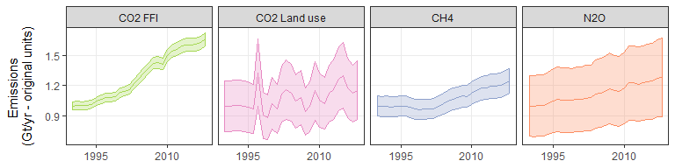

### Figure 1: GHG emissions by gas

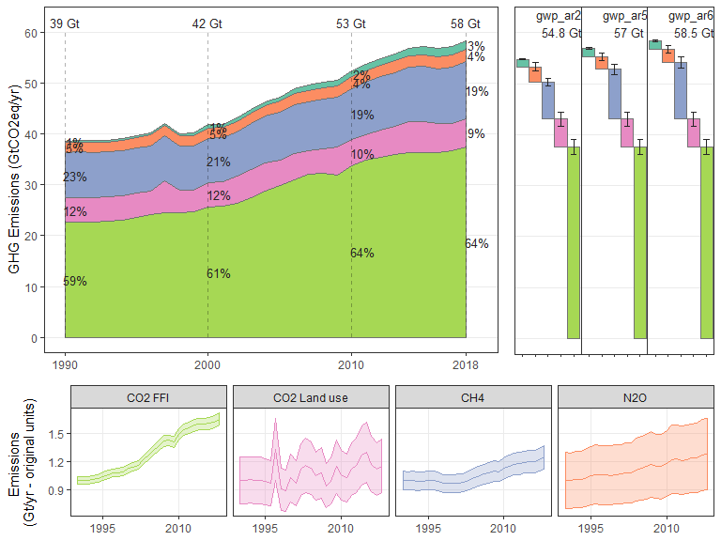

### Figure 2: Long term CO2 emissions sources and sinks

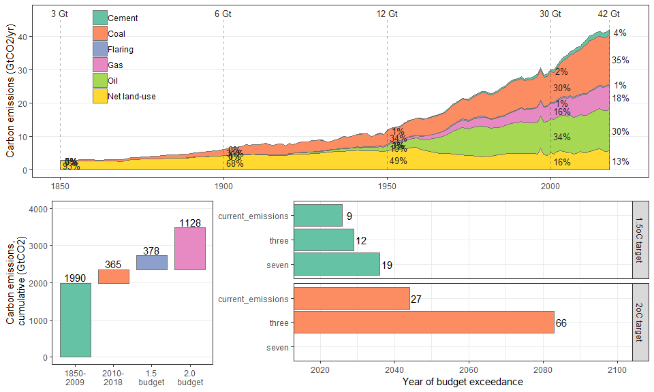

### Figure 5: Total GHGs, split by region

## Joining, by = "ISO"

## $`1`

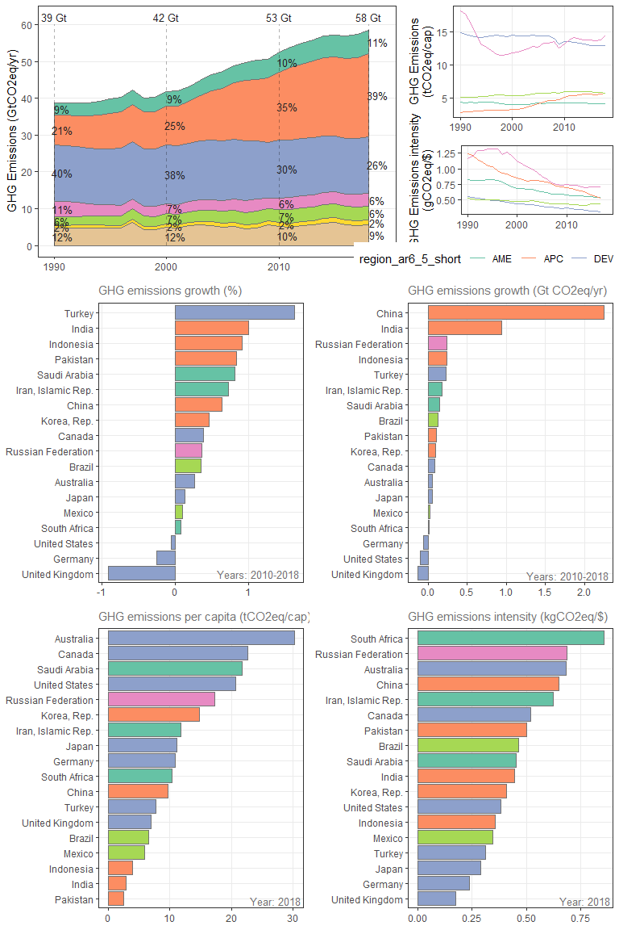

##   
## $`2`

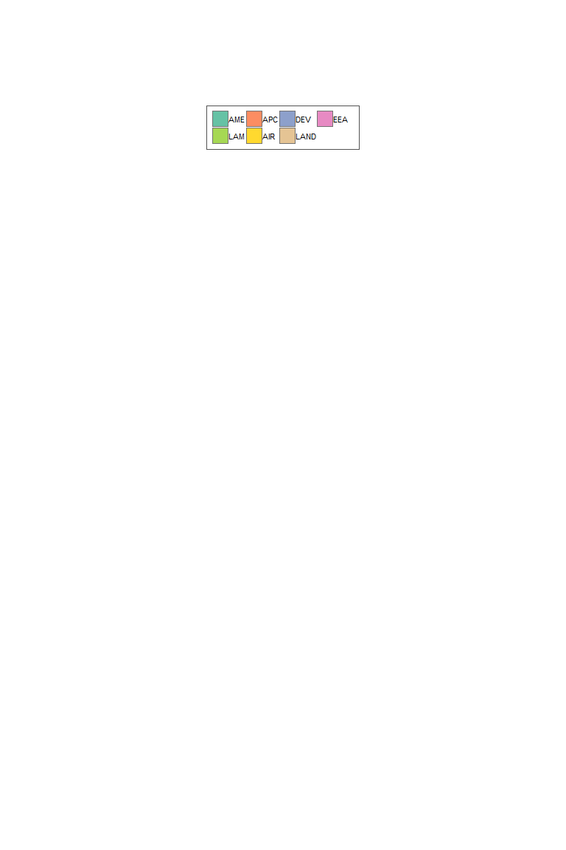

##   
## attr(,"class")  
## [1] "list" "ggarrange"

