sdgs

William F. Lamb

19 3 2020

## Warning: funs() is soft deprecated as of dplyr 0.8.0  
## please use list() instead  
##   
## # Before:  
## funs(name = f(.)  
##   
## # After:   
## list(name = ~f(.))  
## This warning is displayed once per session.

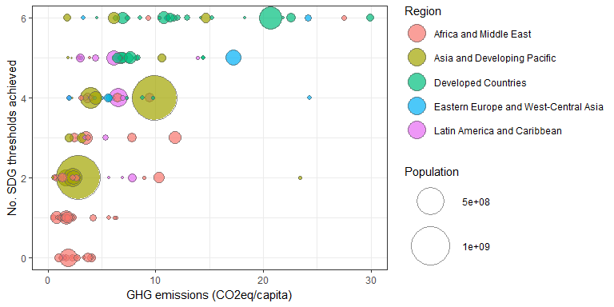

## Joining, by = c("ISO", "year")

