Long term CO2 emissions trends, sources and sinks

William F. Lamb

30 10 2020

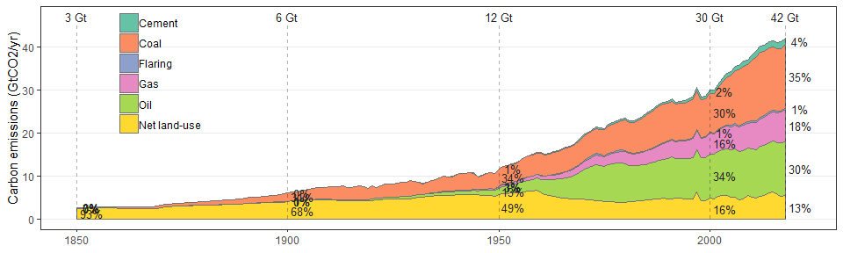

## Scale for 'fill' is already present. Adding another scale for 'fill',  
## which will replace the existing scale.

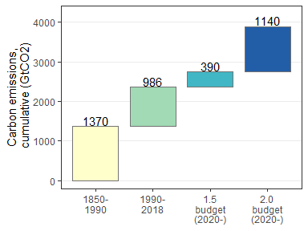

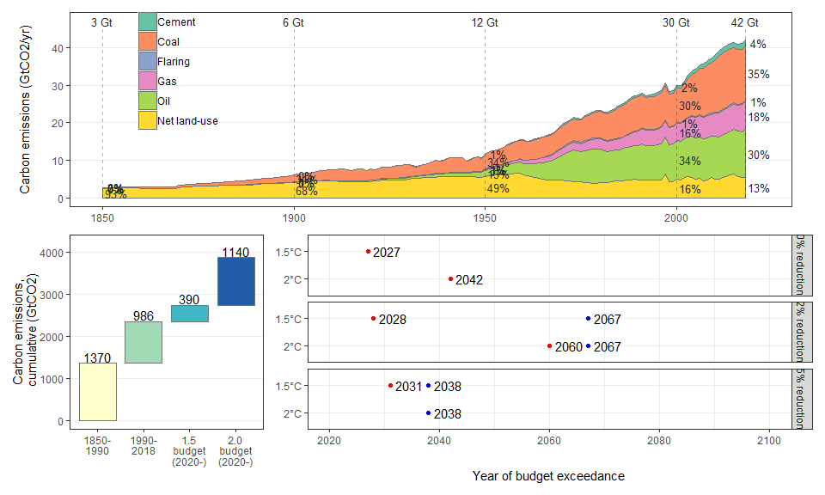

## Note: zip::zip() is deprecated, please use zip::zipr() instead