emissions_by_country

William F. Lamb

17 11 2020

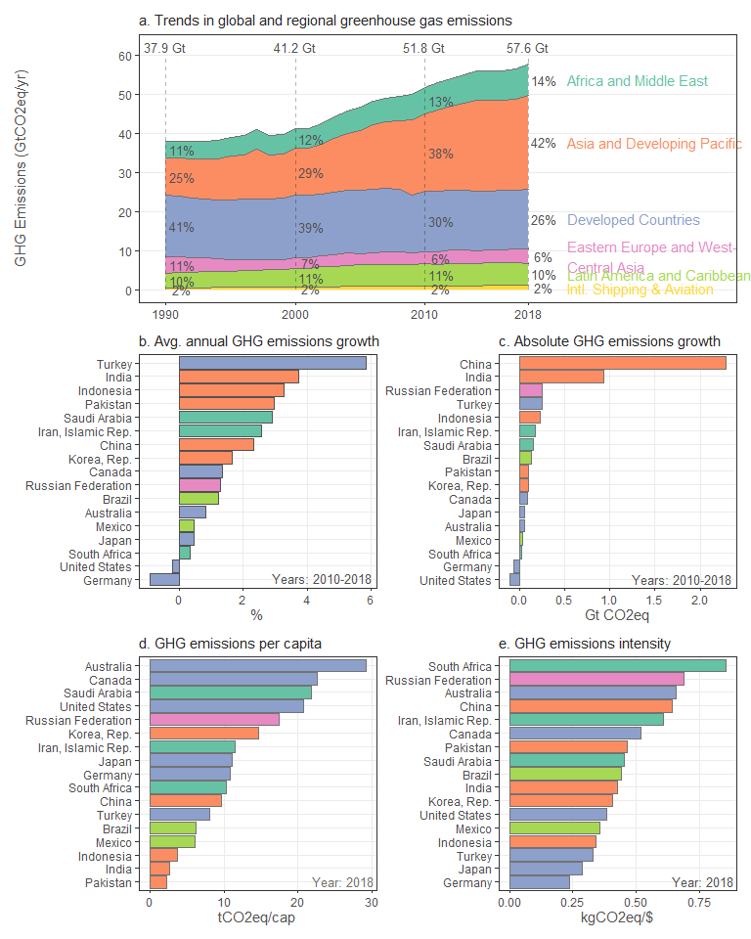

## Joining, by = "region_ar6_dev"

## Joining, by = "region_ar6_5"