Emissions trends and drivers: overview

William F. Lamb

### Figure 1: GHG emissions by gas

## Joining, by = "gas"  
## Joining, by = "gas"

## $`1`

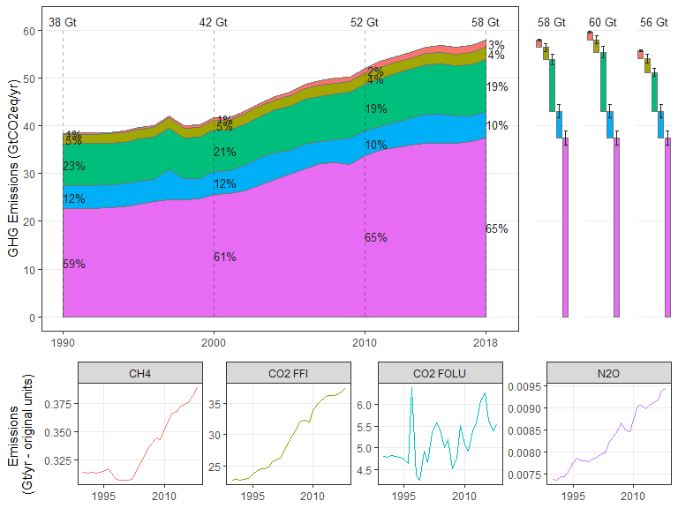

##   
## $`2`

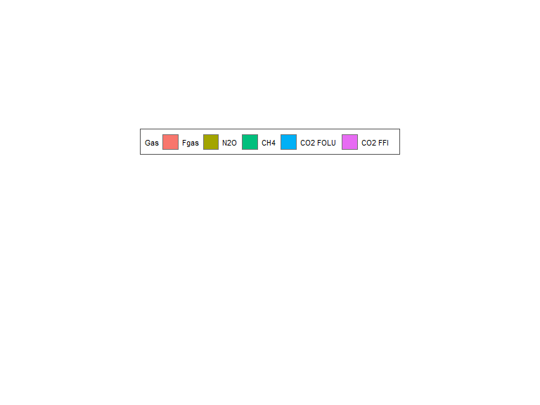

##   
## attr(,"class")  
## [1] "list" "ggarrange"

### Figure 2: Long term CO2 emissions sources and sinks

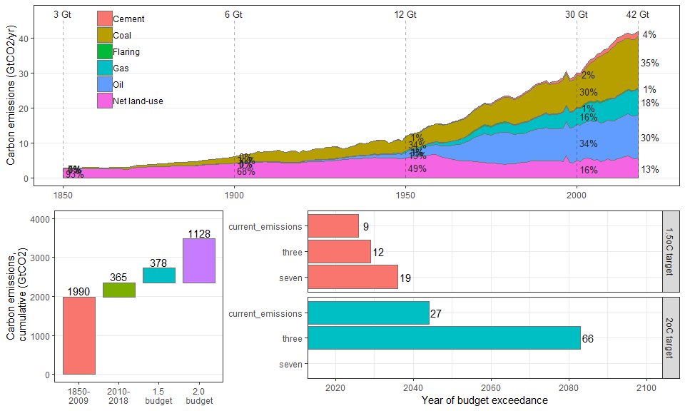

### Figure 5: Total GHGs, split by region

## Joining, by = "ISO"

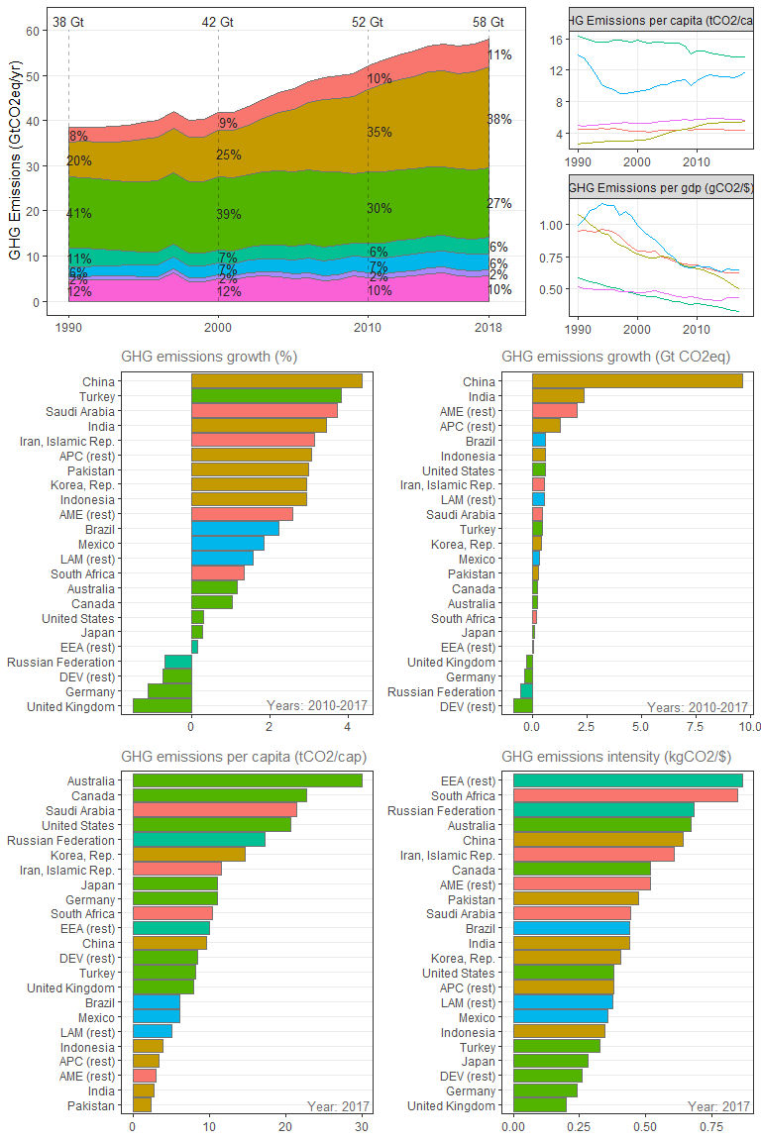

### Figure 9: Total GHGs, split by sector

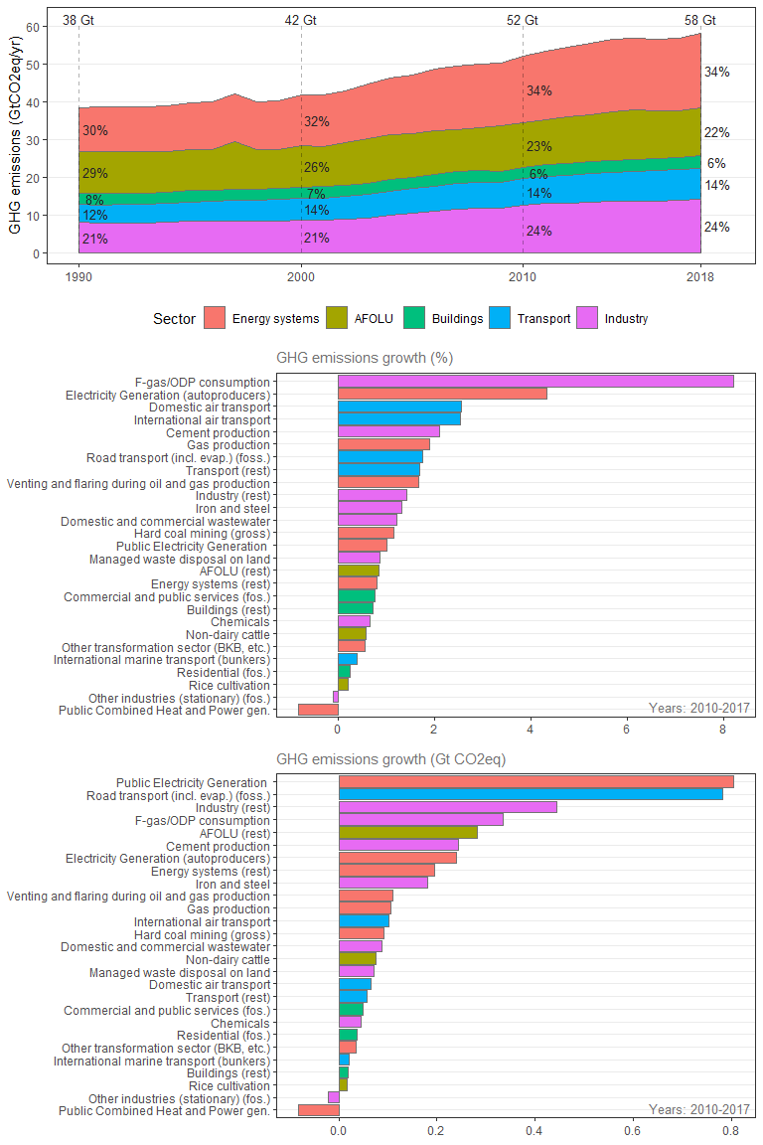

### Figure PROPOSAL: Individual gases, split by region

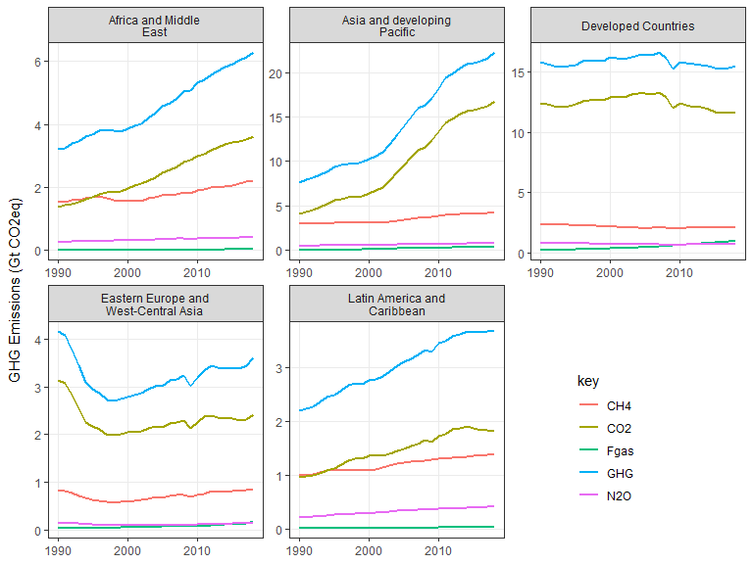

### Figure PROPOSAL: GHGs by sector, split by region

