Kaya decomposition of sectoral CO2 emissions

William F. Lamb

7 6 2020

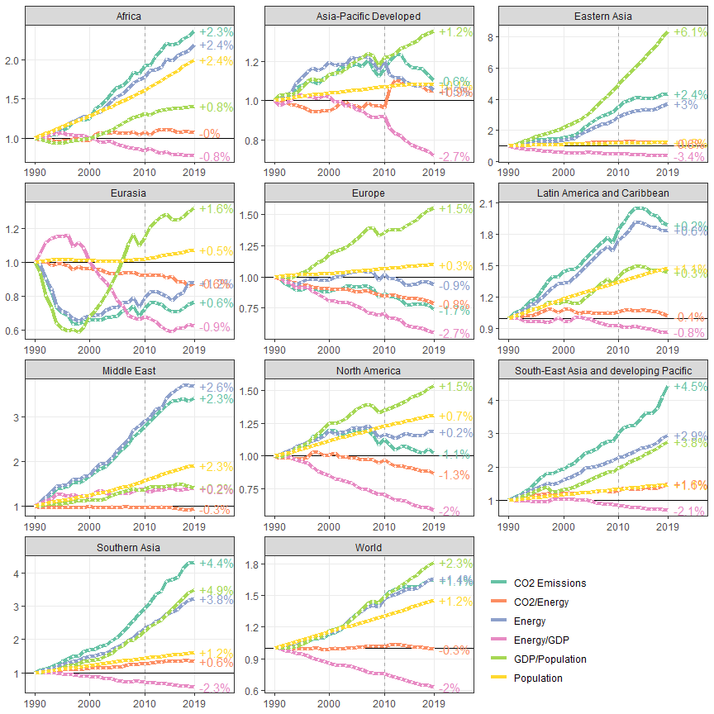 # Energy systems

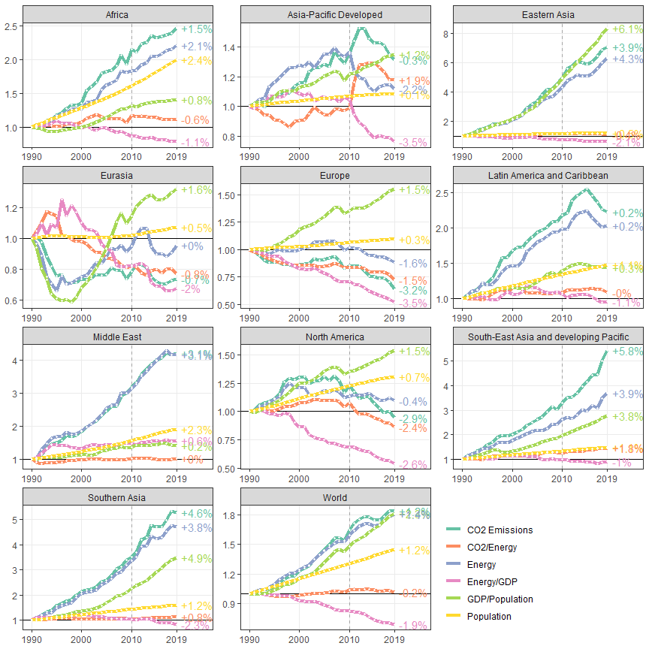

# Buildings

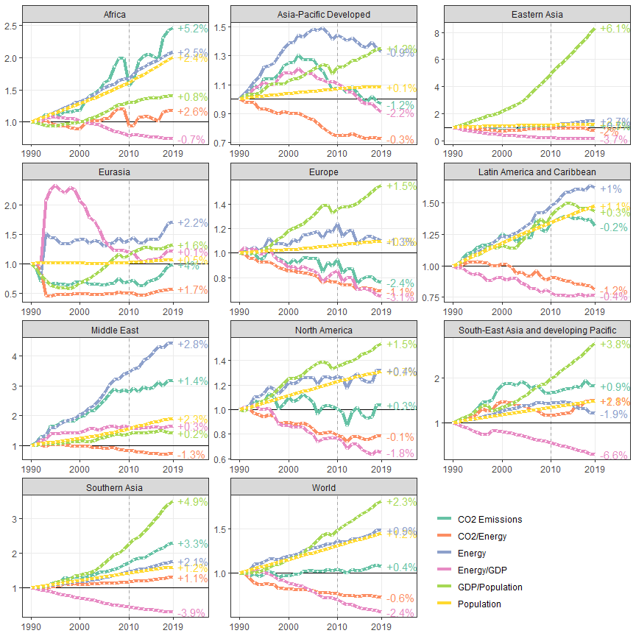

# Transport

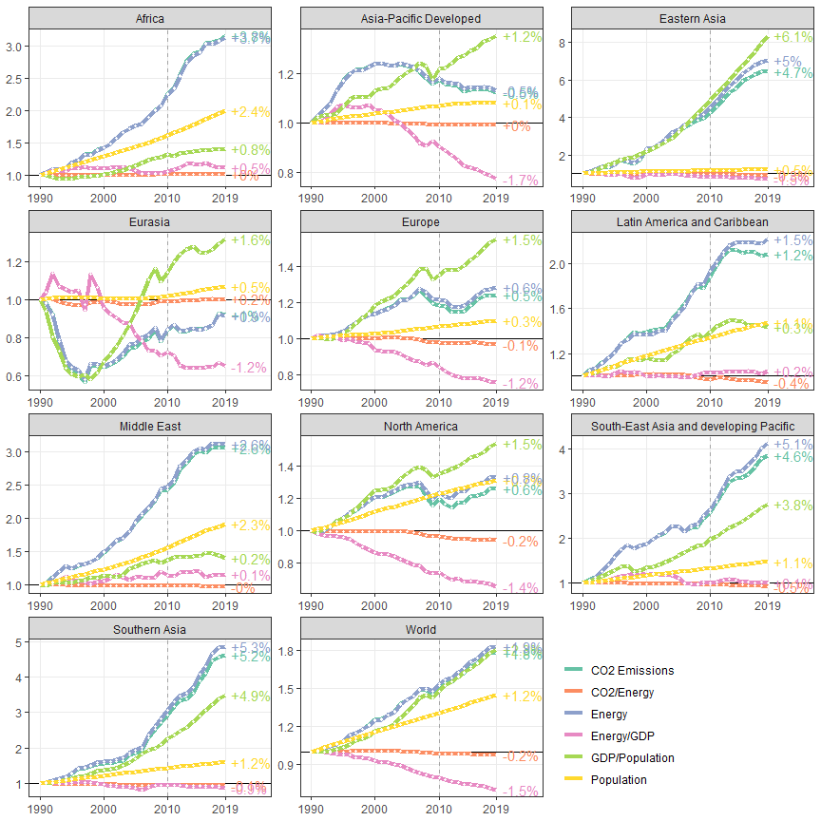

# Industry

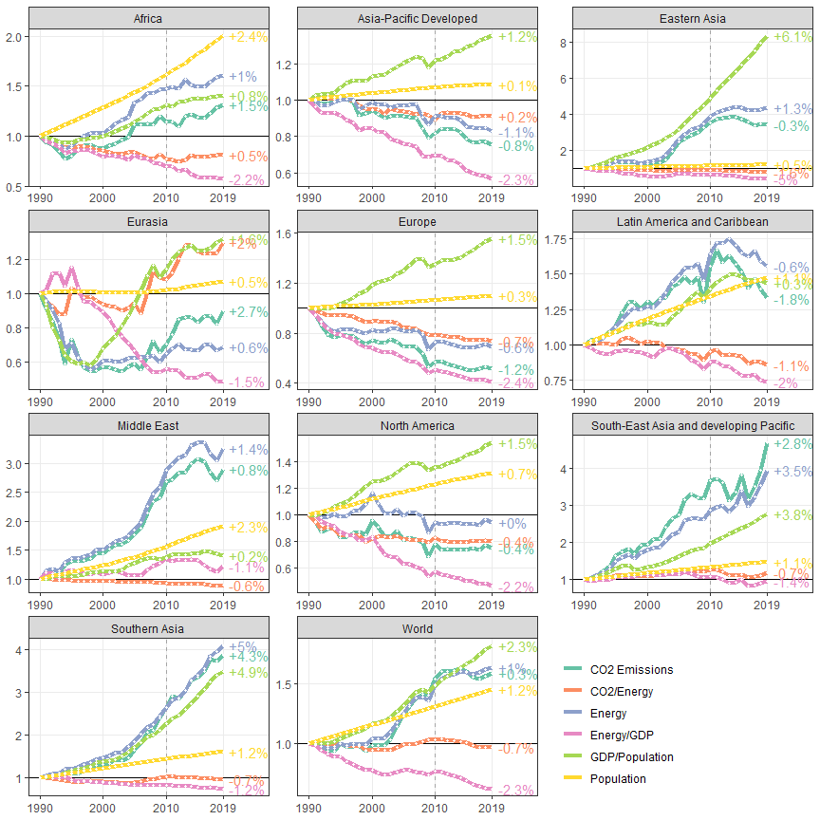

# AFOLU (Hong et al. decomposition)

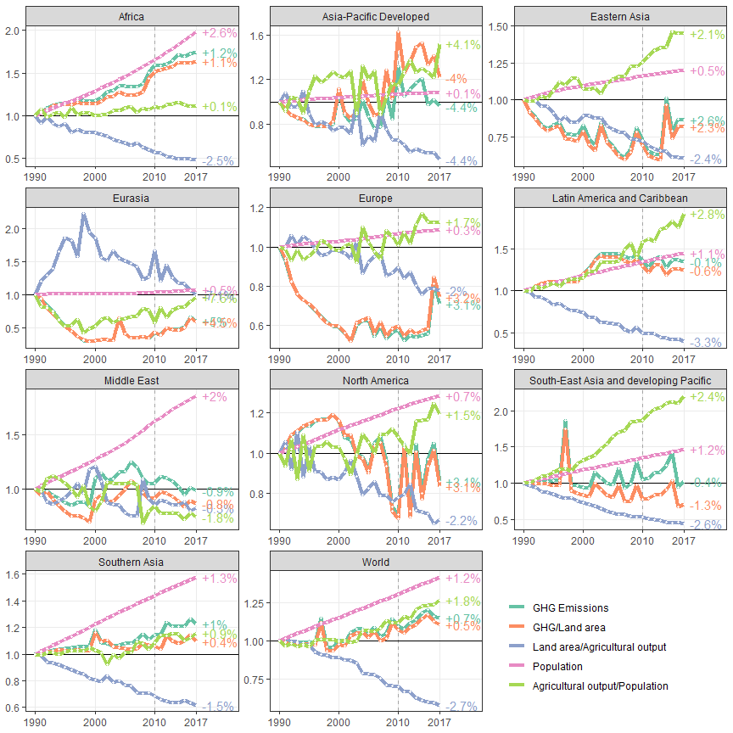

openxlsx::saveWorkbook(wb,paste0("../../Results/Plot data/ipcc_ar6_figure_sector_kaya.xlsx"),overwrite=T)