Kaya decomposition of sectoral CO2 emissions

William F. Lamb

7 6 2020

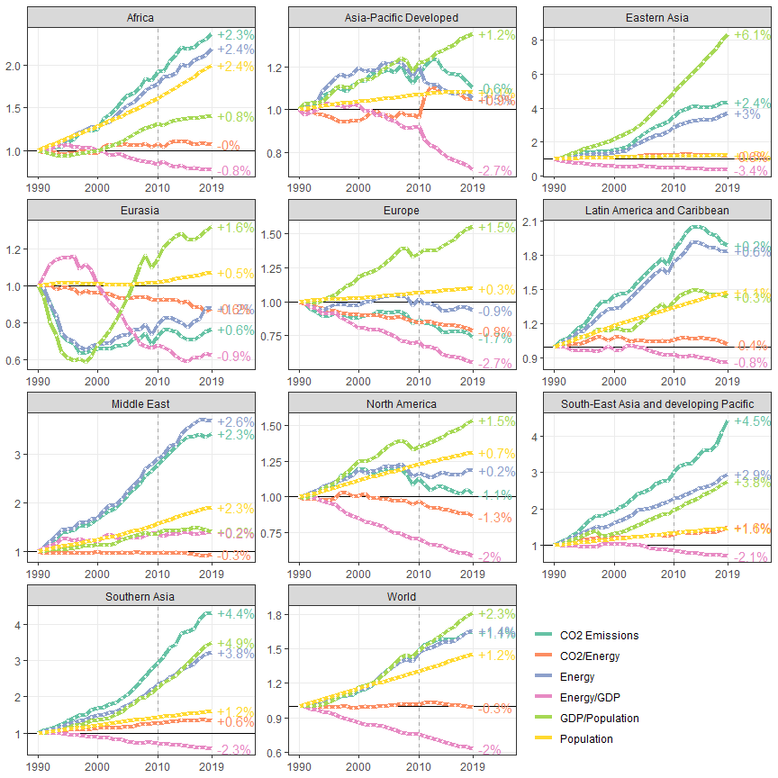

# Energy systems

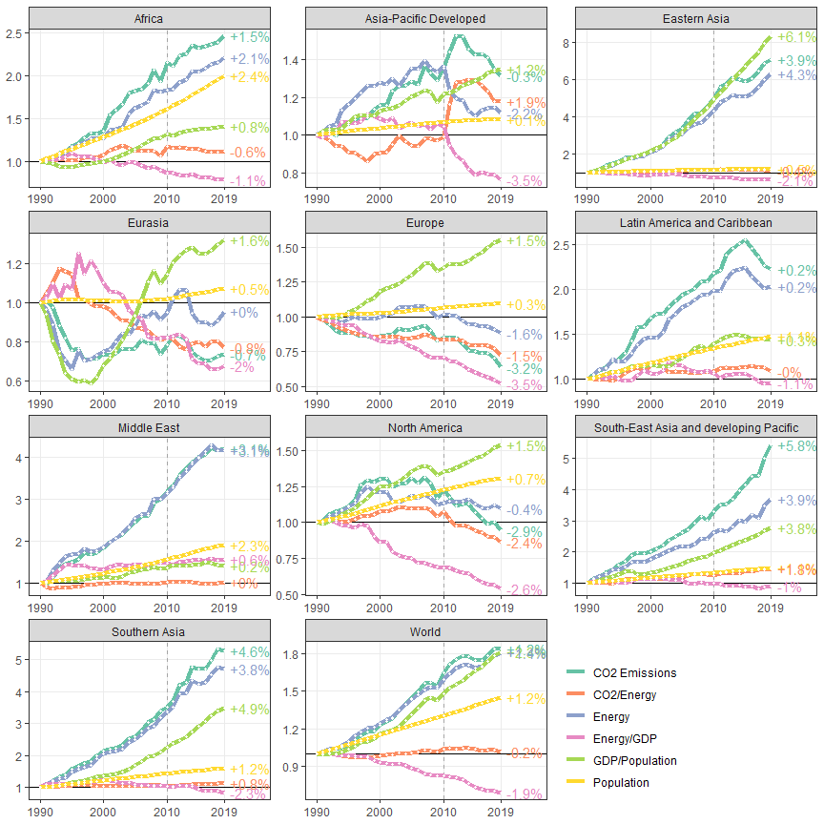

# Buildings

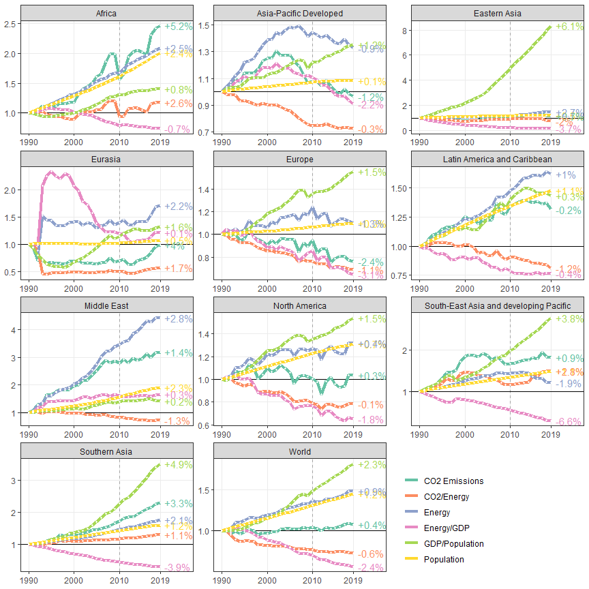

# Transport

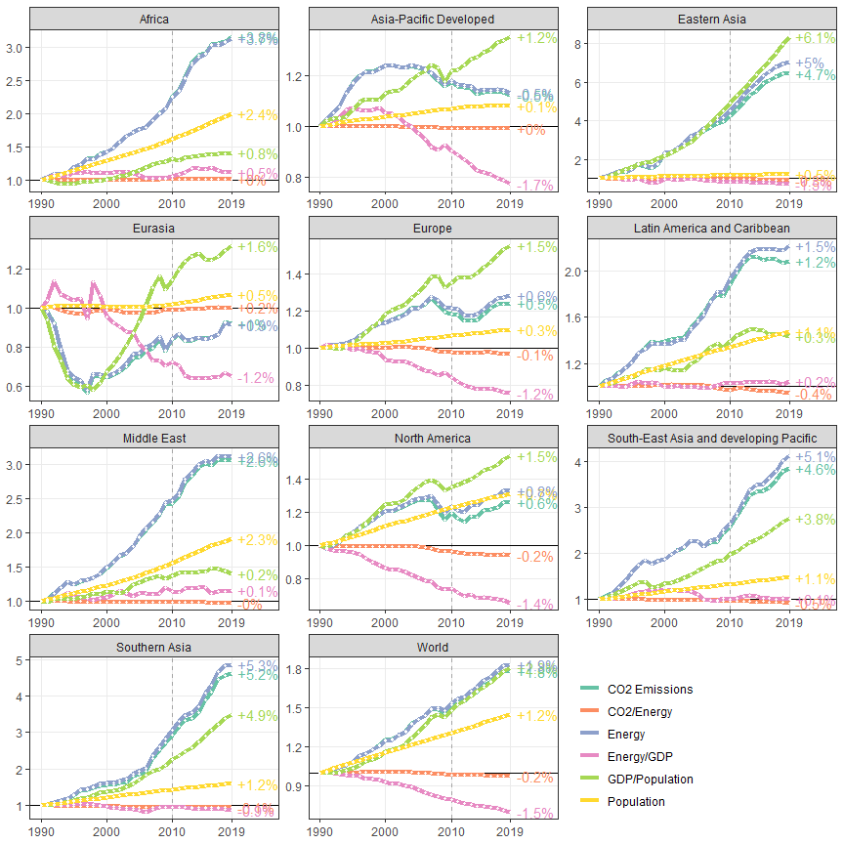

# Industry

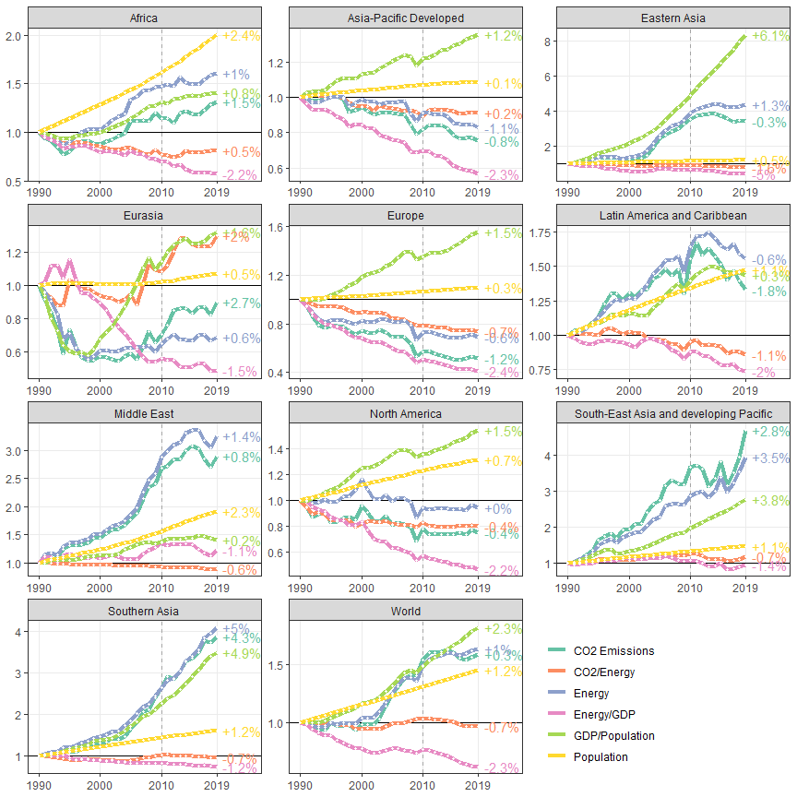

# AFOLU (Hong et al. decomposition)

## `summarise()` has grouped output by 'year'. You can override using the `.groups` argument.  
## `summarise()` has grouped output by 'year'. You can override using the `.groups` argument.

## `summarise()` has grouped output by 'ISO', 'year'. You can override using the `.groups` argument.

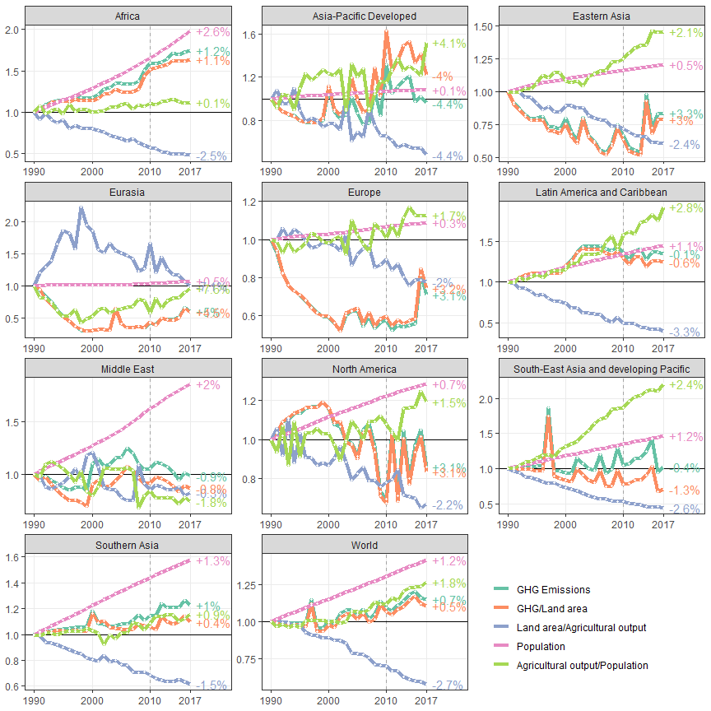

openxlsx::saveWorkbook(wb,paste0("../../Results/Data/ipcc_ar6_figure_data_kaya.xlsx"),overwrite=T)  
  
openxlsx::addWorksheet(wb2,"afolu_data")  
openxlsx::writeData(wb2, sheet = "afolu_data",all_data, colNames = T, rowNames = F)  
#openxlsx::saveWorkbook(wb2,"../../Results/Data/kaya_data.xlsx",overwrite=T)