Kaya buildings

William F. Lamb

2 12 2020

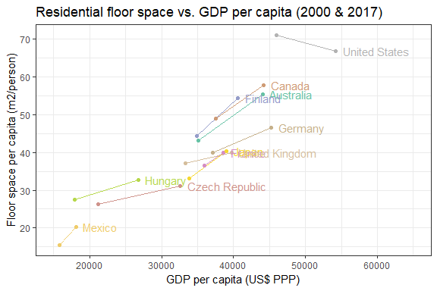

## Residential

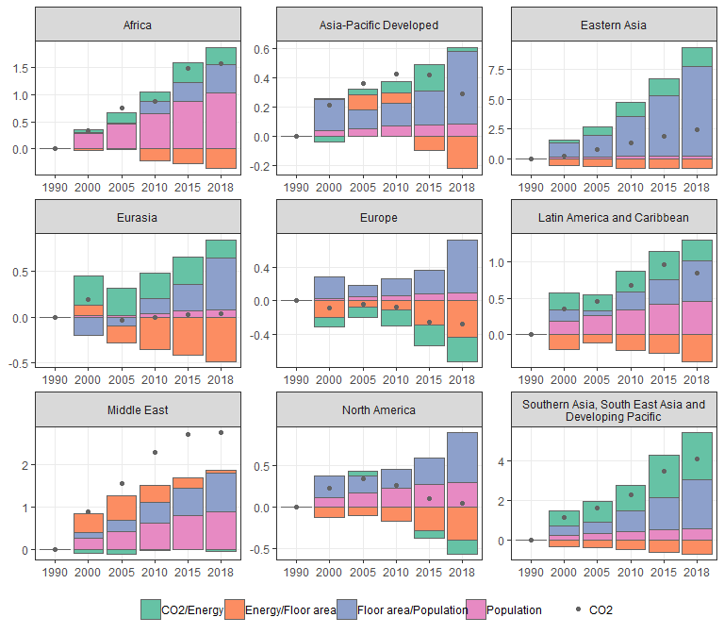

## Non-residential

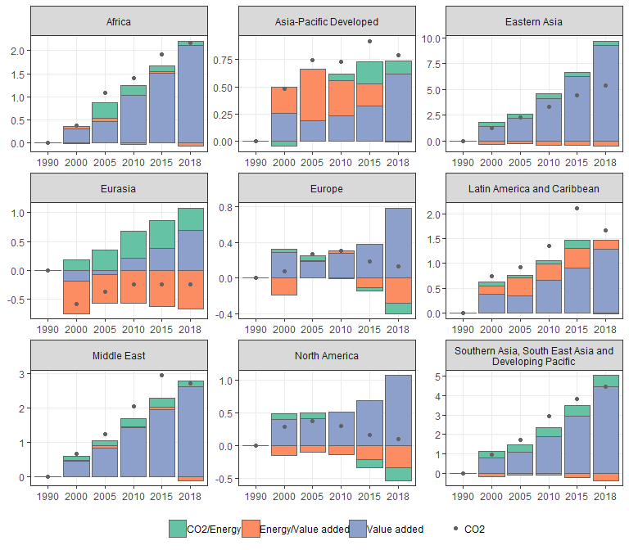

# scenarios

# Residential

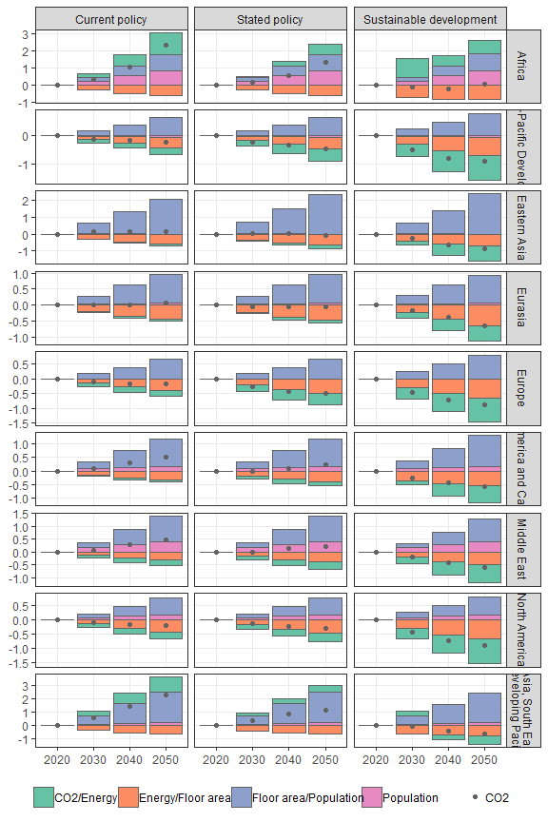

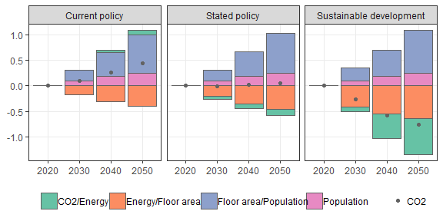

# Non-residential

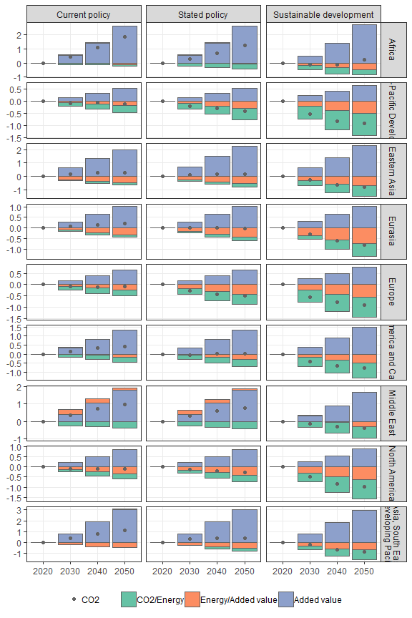

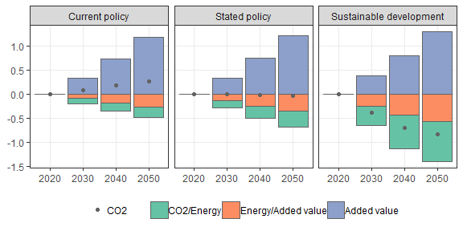

openxlsx::saveWorkbook(wb,"../../Results/Data/building_kaya.xlsx",overwrite=T)

## Note: zip::zip() is deprecated, please use zip::zipr() instead