GHG emissions trends by region

William F. Lamb

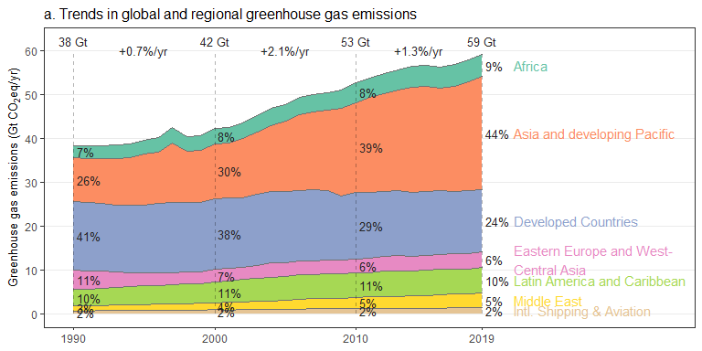

## No summary function supplied, defaulting to `mean_se()`  
## No summary function supplied, defaulting to `mean_se()`

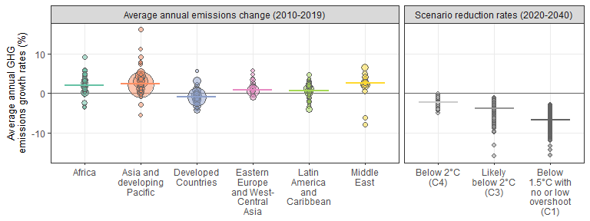

## No summary function supplied, defaulting to `mean_se()`  
## No summary function supplied, defaulting to `mean_se()`

