GHG emissions trends by sector

William F. Lamb

Table of Contents

# Setup

## Growth rate calculation

# Data

## Gather trend data

## Gather region data

# All 5 sectors by 10 regions

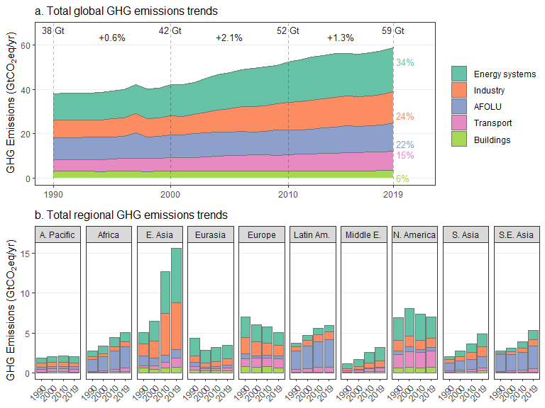

# Energy

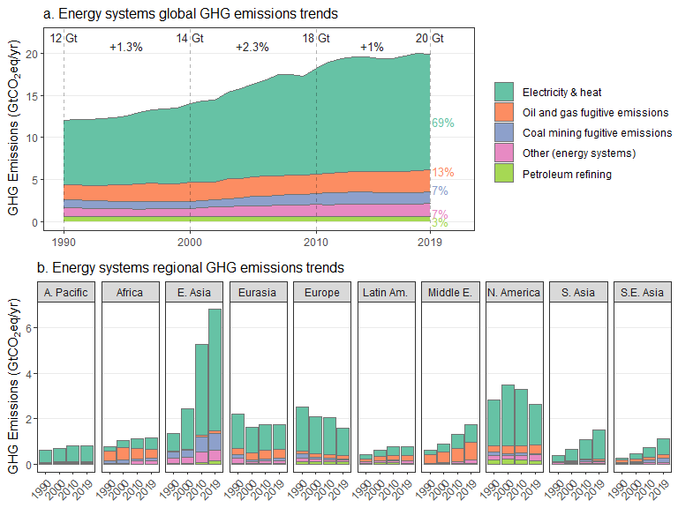

# Industry

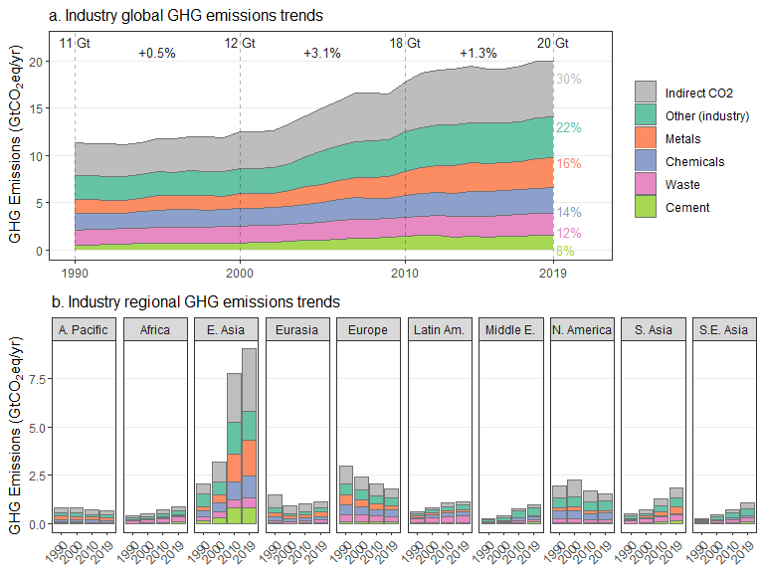

# Transport

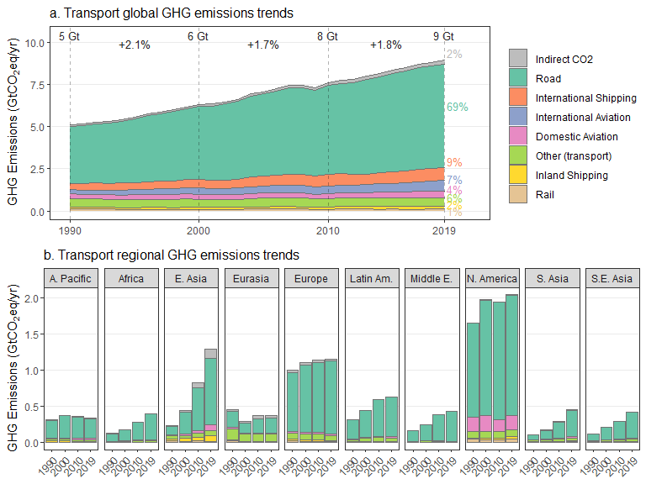

# Buildings

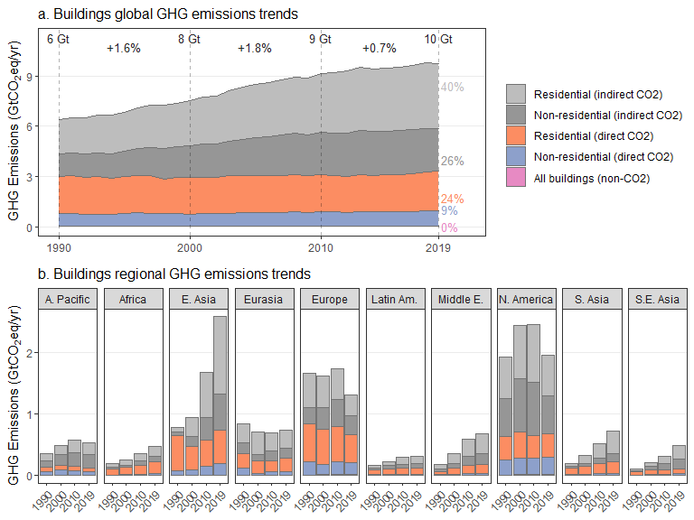

# Buildings (Scope 3) ->indirect CO2 only until 2018, compilation with end-year 2019 therefore failed

# AFOLU

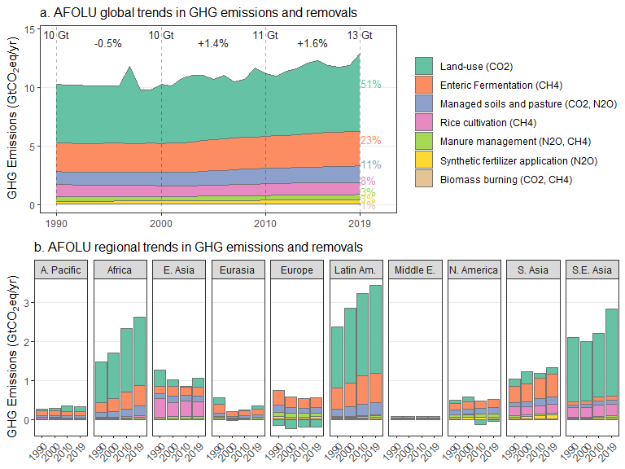

# Top emitting sectors + indirect emissions

