SDGs and emissions

William F. Lamb

## Warning: funs() is soft deprecated as of dplyr 0.8.0  
## please use list() instead  
##   
## # Before:  
## funs(name = f(.)  
##   
## # After:   
## list(name = ~f(.))  
## This warning is displayed once per session.

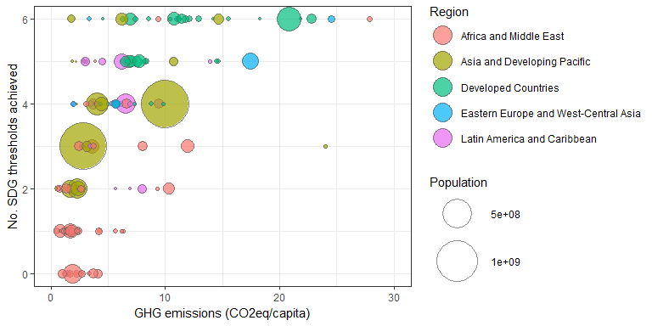

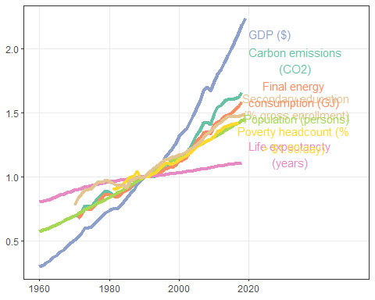

## Joining, by = "alpha.3"

