sector_summary

William F. Lamb

14 6 2021

# Setup

# Data preparation

## Total sector & subsector trend

## % of sector emissions in each region

## Per capita sector emissions by region

## Kaya analysis

## Kaya analysis AFOLU

# Figures

## Trend figure

## Fraction figure

## Per capita figure

## Kaya figure

# Results

## AFOLU

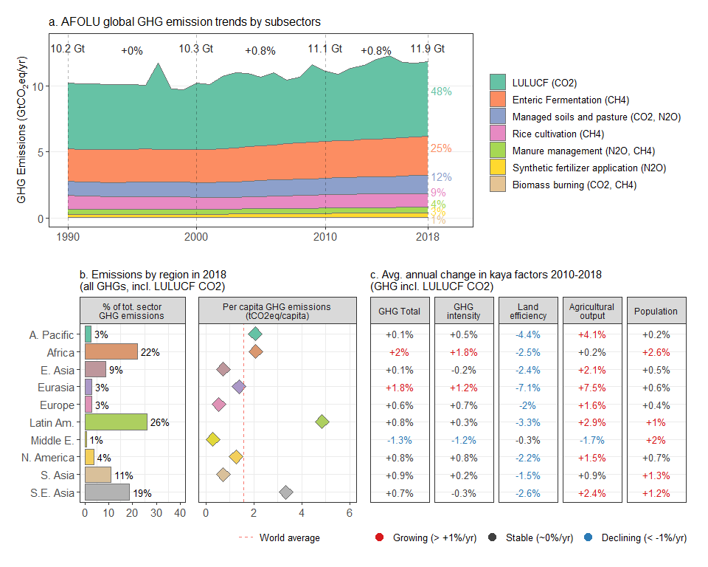

## Energy systems

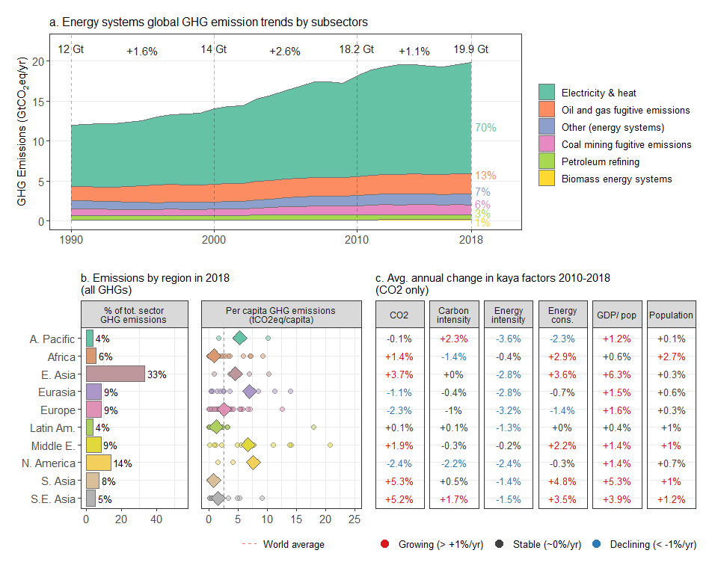

## Industry

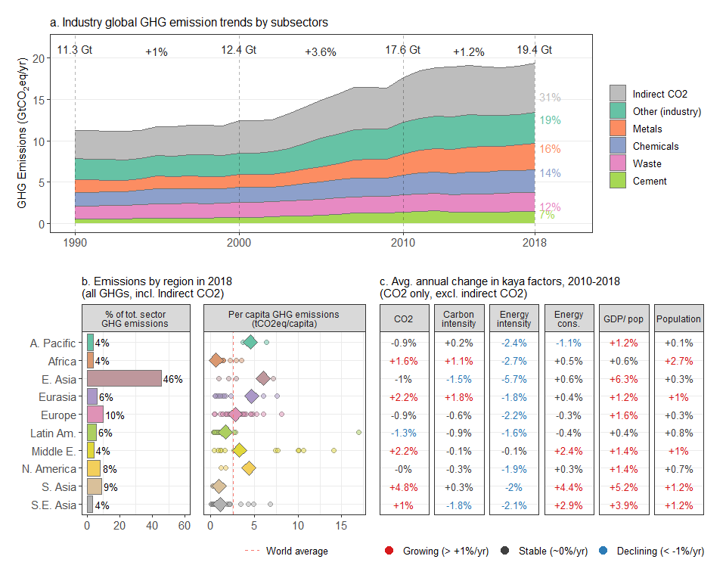

## Buildings

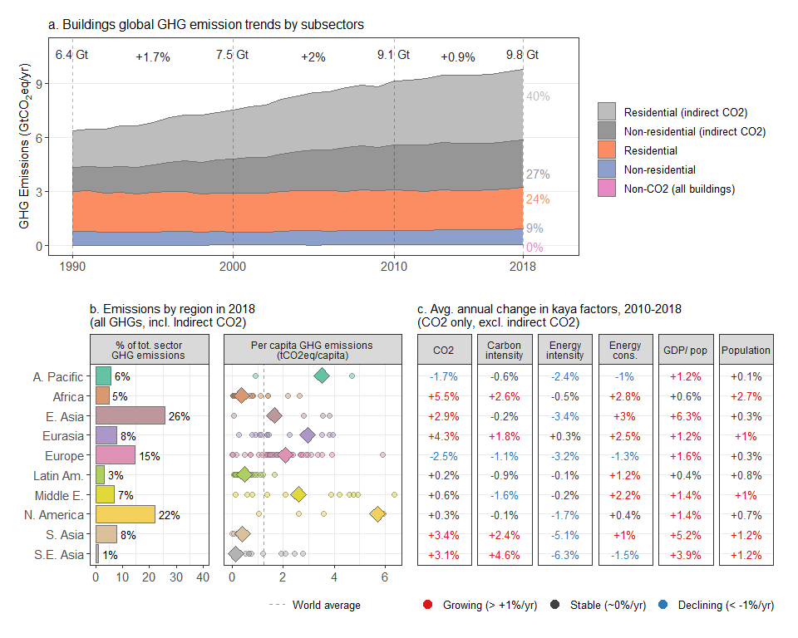

## Transport

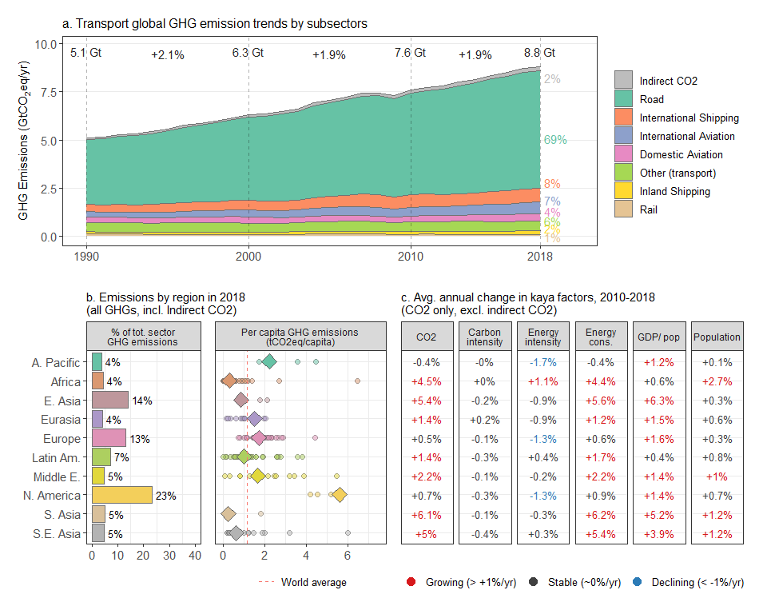

## Total

