Emissions trends and drivers: sectoral trends

William F. Lamb

Table of Contents

Energy 2

Industry 3

Transport 4

Buildings 5

AFOLU 6

# Energy

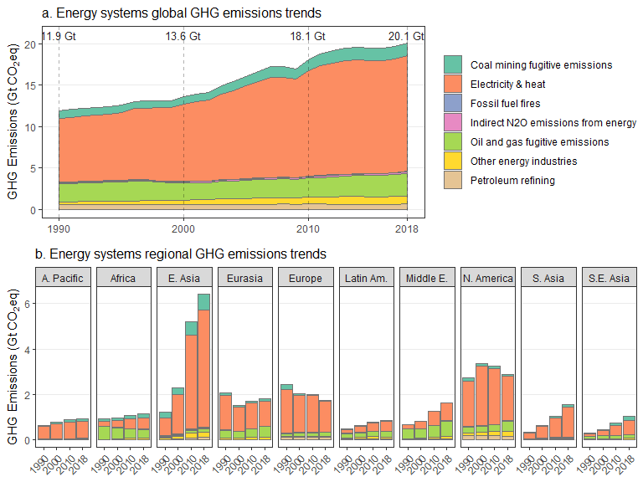

# Industry

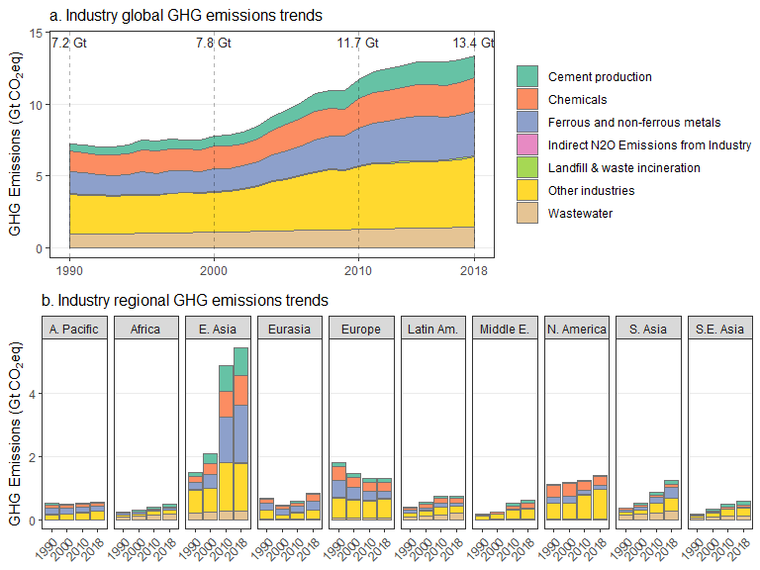

## Note: zip::zip() is deprecated, please use zip::zipr() instead

# Transport

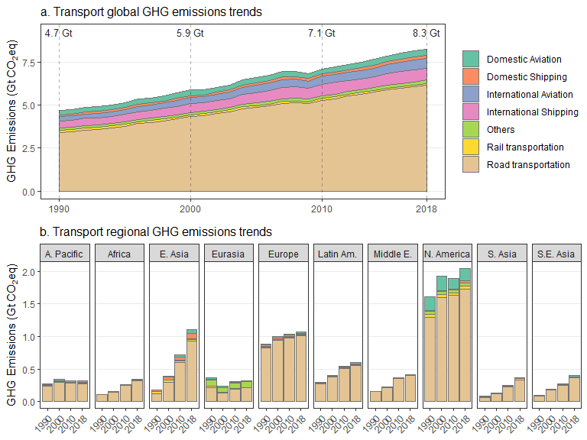

# Buildings

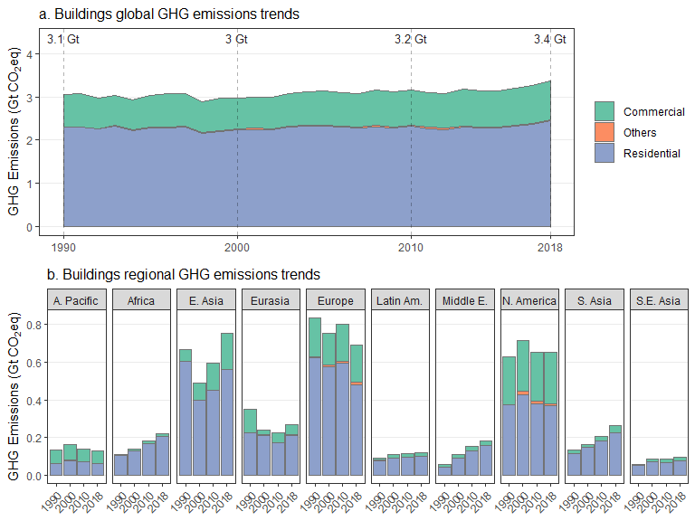

# AFOLU

