Emissions trends and drivers: sectoral trends

William F. Lamb

Table of Contents

Summary 1

1. All sectors 3

Transport 3

Buildings 5

7. List of category codes 6

# Summary

This document provides an overview and breakdown of emissions trends by IPCC chapter. We have compiled a consistent allocation of emissions categories to sectors using the EDGAR emissions database. We propose to use this allocation and the following figures across the main sectoral chapters of AR6.

The following supporting information is available online:

* our code in R
* the sector categorisations
* the figure files
* the data files for each figure
* this document and any updates

Please find these at: <https://github.com/mcc-apsis/AR6-Emissions-trends-and-drivers>

Latest update: 02 Juni, 2020, 08:10

**Author information**

William F. Lamb - Mercator Research Institute on Global Commons and Climate Change (MCC); School of Earth and Environment, University of Leeds; Contributing Author in Chapter 2 of the Working Group III Report (Emissions Trends and Drivers); [lamb@mcc-berlin.net](mailto:lamb@mcc-berlin.net)

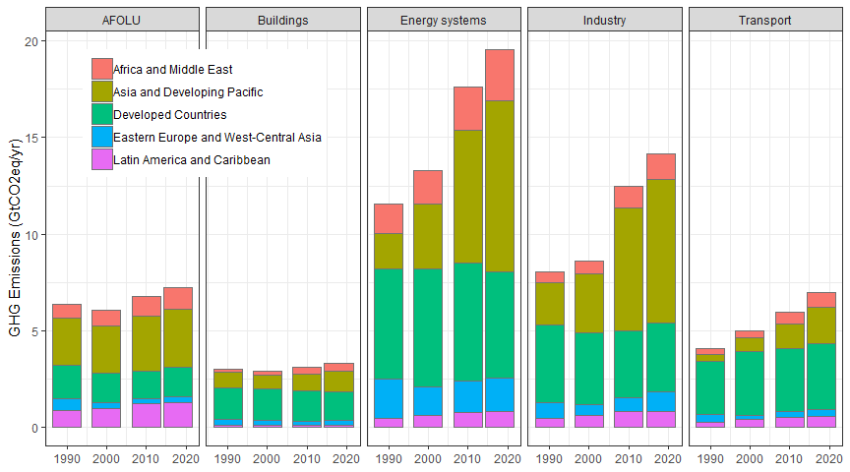

# 1. All sectors

# Transport

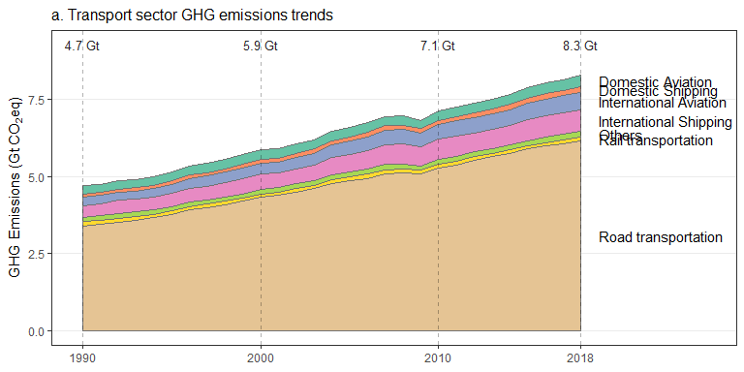

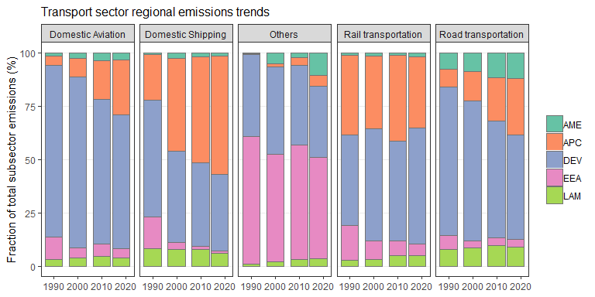 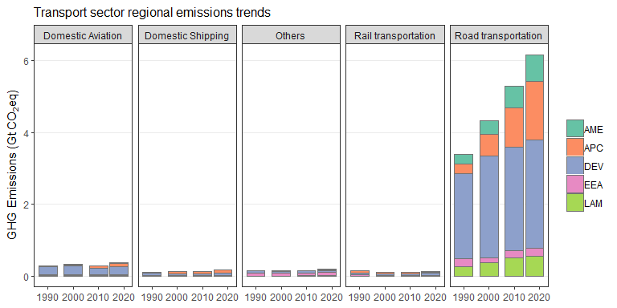 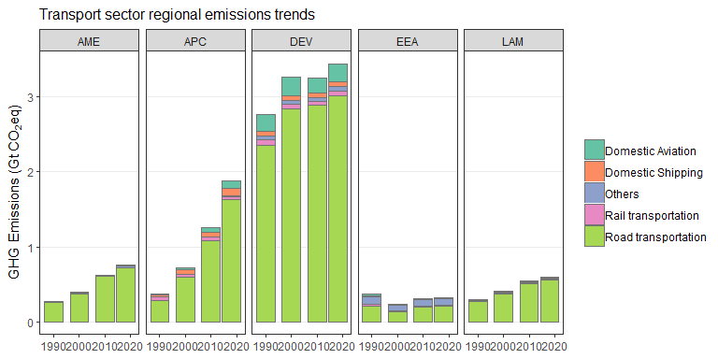

# Buildings

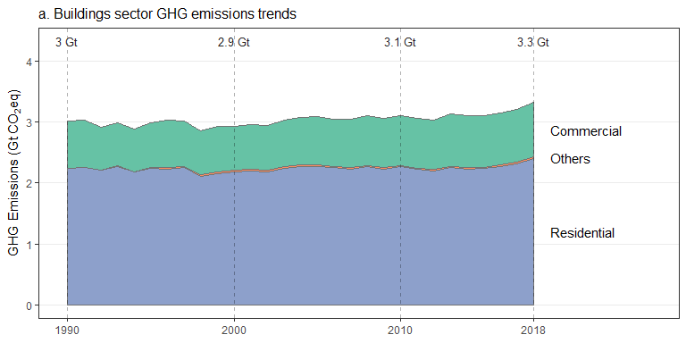 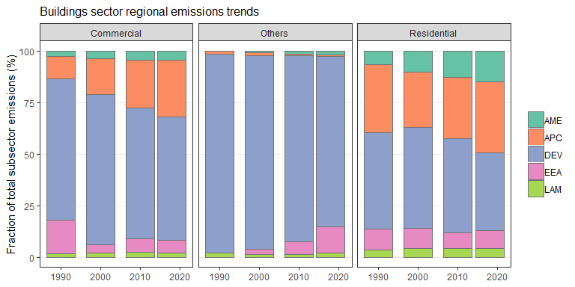 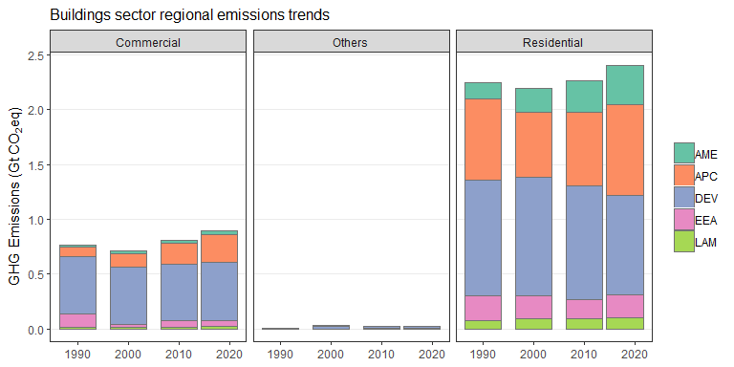 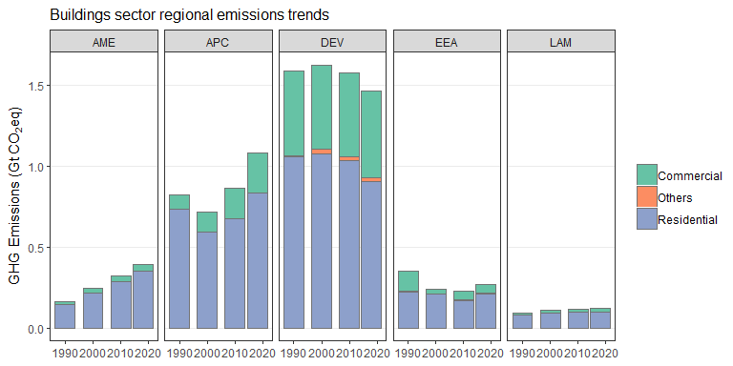

# 7. List of category codes