Emissions trends and drivers: overview
William F. Lamb

Figure 1: GHG emissions by gas
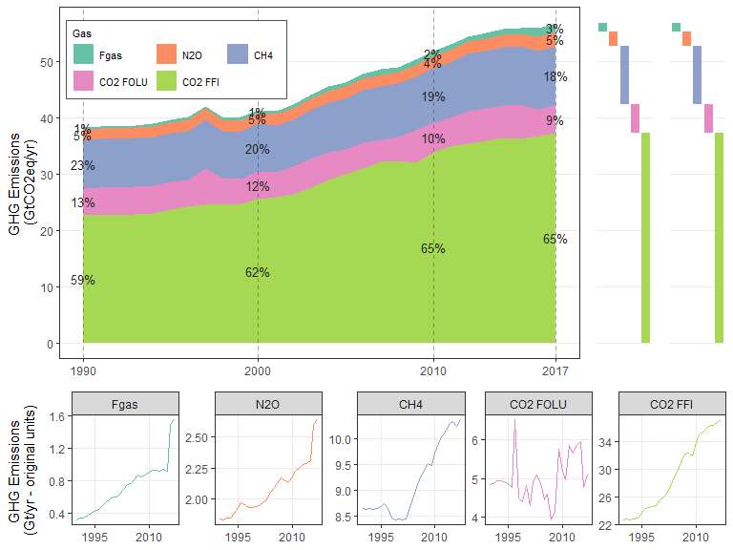

Figure 2: Long term CO2 emissions sources and sinks
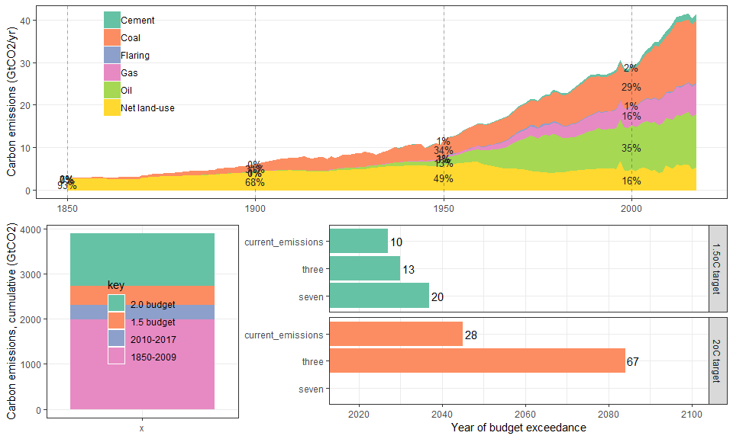

Figure 5: Total GHGs, split by region
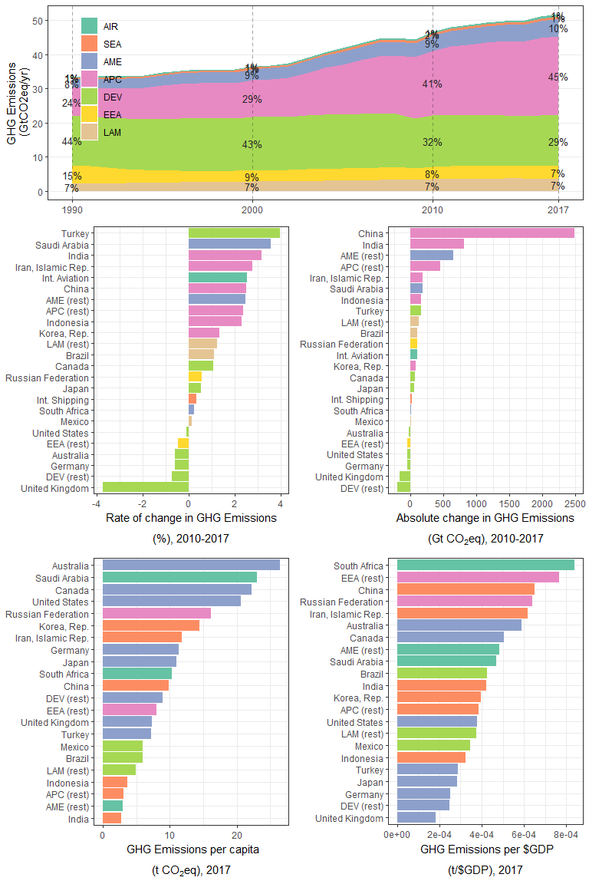

Figure 9: Total GHGs, split by sector
