social outcomes of climate policies

William F. Lamb

Current version and code:<https://github.com/mcc-apsis/Social-outcomes-of-climate-policies/tree/master/Results>

Latest update: 08 Januar, 2020, 15:48

## Literature and methods

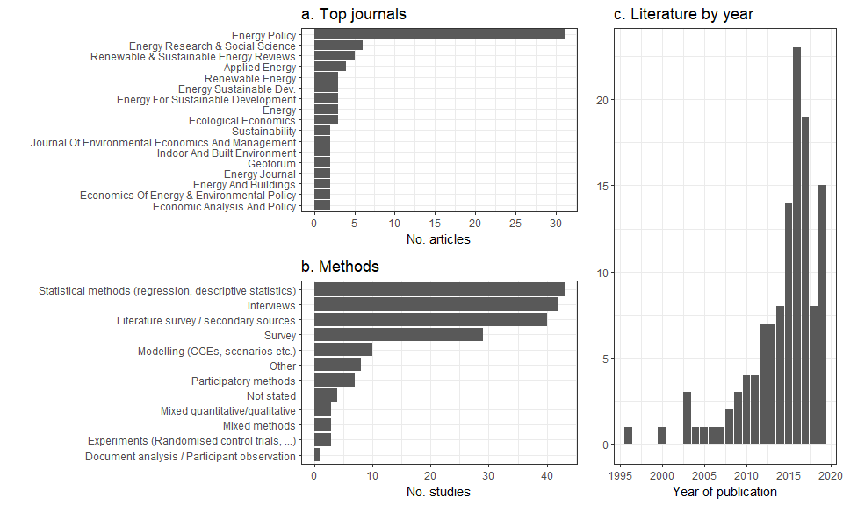

## Policies and geographic coverage

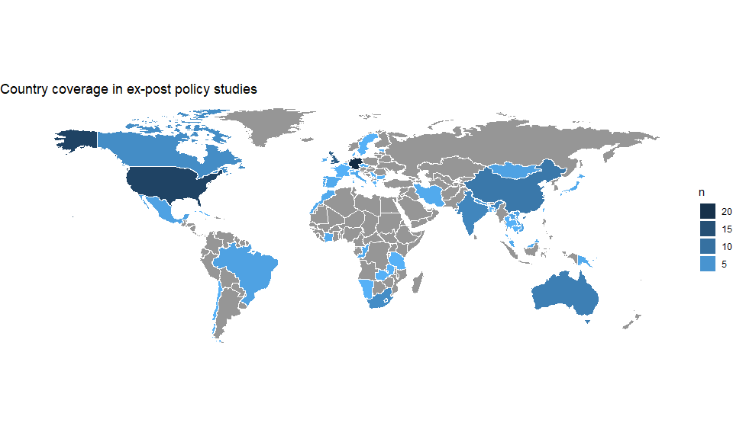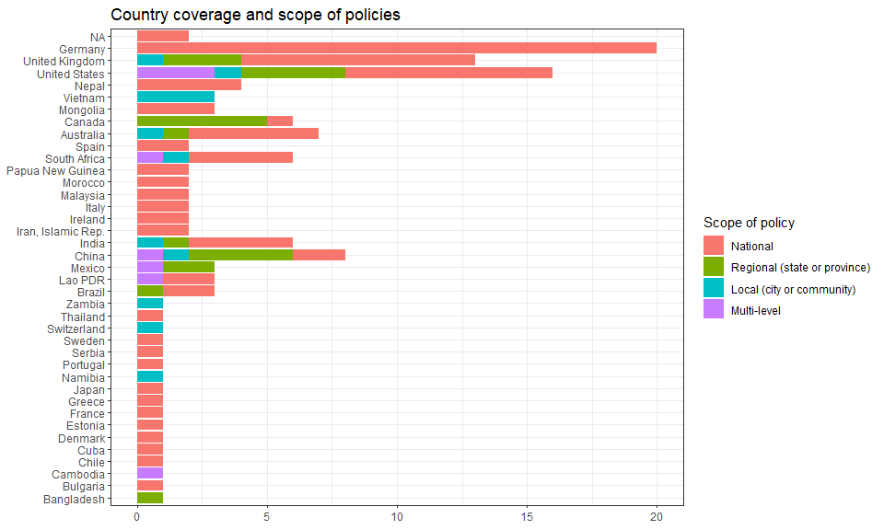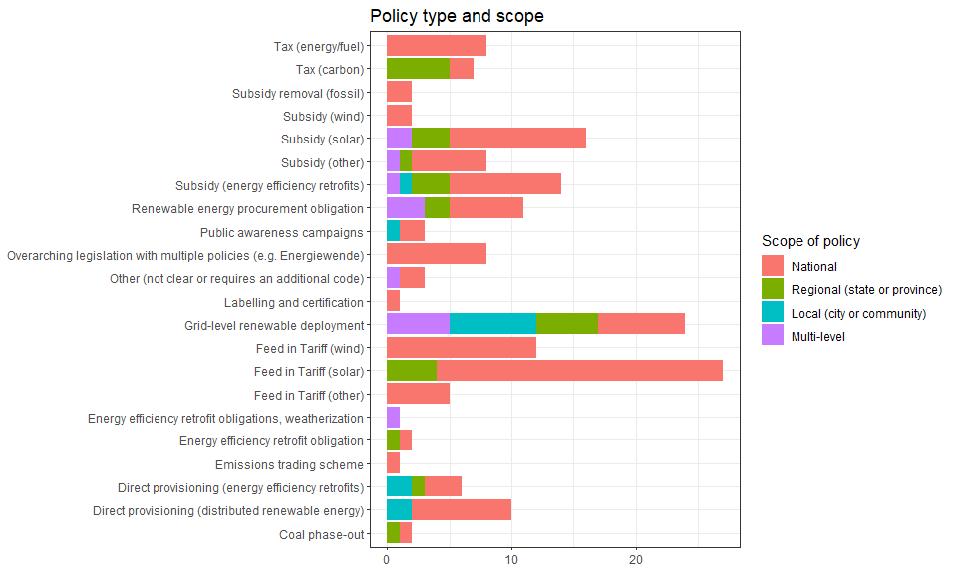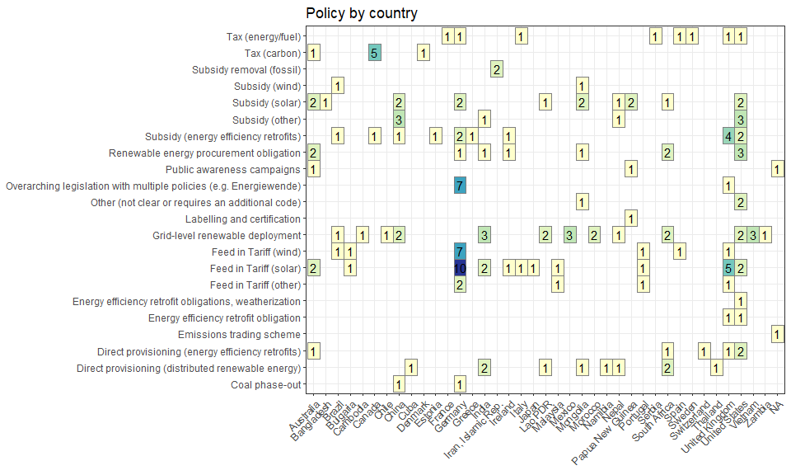 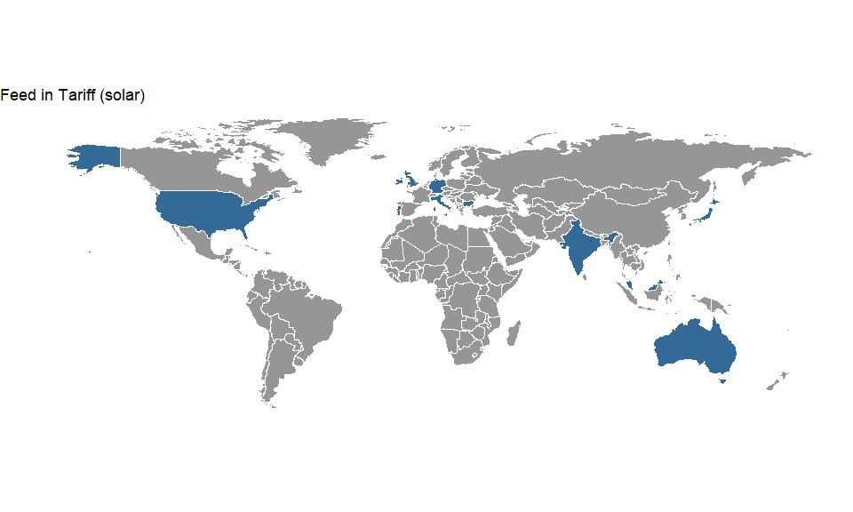

| link | country | policy_name | social_outcome_type | social_outcome | social_outcome_population | social_outcome_population_detail |
| --- | --- | --- | --- | --- | --- | --- |
| http://dx.doi.org/10.1016/j.erss.2018.09.008 | Australia | Feed in Tariff | Equality (geographic) | Negative | A part of the society or locality | Australian capital cities |
| http://dx.doi.org/10.1016/j.renene.2015.09.061 | Australia | Mandatory Renewable Energy Target (MRET) and state-level FiTs | Equality (income) | Negative | Everyone in the society or locality | households |
| http://dx.doi.org/10.1063/1.5097424 | Australia |  | Equality (income) | Negative | Everyone in the society or locality | solar PV adopters and non-adopters |
| http://dx.doi.org/10.1016/j.erss.2018.09.008 | Australia | Feed in Tariff | Equality (income) | Negative | A part of the society or locality | Australian capital cities |
| http://dx.doi.org/10.1016/j.erss.2018.02.020 | Bulgaria | "Bulgaria's first renewables law" (?) | Procedural justice | Negative | Everyone in the society or locality | Bulgaria in general |
| http://dx.doi.org/10.1016/j.erss.2018.02.020 | Bulgaria | "Bulgaria's first renewables law" (?) | Equality (income) | Negative | Everyone in the society or locality | Households, taxpayers in Bulgaria, esp. low income |
| http://dx.doi.org/10.1016/j.erss.2018.02.020 | Bulgaria | "Bulgaria's first renewables law" (?) | Affordability (electricity/fuel) | Negative | Everyone in the society or locality | Households, taxpayers in Bulgaria, esp. low income |
| http://dx.doi.org/10.1016/j.erss.2018.02.020 | Bulgaria | "Bulgaria's first renewables law" (?) | Equality (geographic) | Negative | A part of the society or locality | Rural households relying on wood and oil generators |
| http://dx.doi.org/10.1016/j.apenergy.2016.06.073 | Germany | Renewable Energy Act, EEG | Employment | Mixed (positive and negative) | Everyone in the society or locality | net 0 jobs |
| http://dx.doi.org/10.5547/01956574.38.SI1.cboh | Germany | technology-specific feed-in tariffs (FITs) | Equality (income) | Negative | Everyone in the society or locality | electricity consuming households |
| http://dx.doi.org/10.1016/j.eap.2015.09.003 | Germany | feed-in tariff (FIT) for PV on houses | Equality (income) | Negative | Everyone targetted by the policy | households |
| http://dx.doi.org/10.1007/s00181-013-0728-z | Germany | technology-specific feed-in tariffs (FITs) | Equality (income) | Negative | Everyone in the society or locality | households |
| http://dx.doi.org/10.1016/j.enpol.2010.03.029 | Germany | technology-specific feed-in tariffs (FITs) | Affordability (electricity/fuel) | Negative | Everyone in the society or locality | electricity consumers |
| http://dx.doi.org/10.1016/j.eap.2015.01.004 | Germany | EEG levy | Affordability (electricity/fuel) | Negative | A part of the society or locality | population beyond poverty line had to pay a larger share of their income for electricity |
| http://dx.doi.org/10.1016/j.eneco.2014.04.020 | Germany |  | Equality (income) | Negative | Everyone in the society or locality |  |
| http://dx.doi.org/10.1016/j.enpol.2008.07.026 | Germany | EEG | Employment | Negative | Everyone in the society or locality | direct and indirect employment effects |
| http://dx.doi.org/10.1016/j.enpol.2019.05.043 | Germany | Energiewende | Equality (income) | Negative | Everyone in the society or locality | we focus on the impact of the German  feed-in tariff for promoting renewable energies on household disposable  incomes. |
| http://dx.doi.org/10.3390/su71215834 | Germany | EEG | Affordability (electricity/fuel) | Mixed (positive and negative) | Everyone in the society or locality | electricity users |
| http://dx.doi.org/10.1016/j.enpol.2010.03.029 | Germany | technology-specific feed-in tariffs (FITs) | Employment | Mixed (positive and negative) | Everyone in the society or locality | employees |
| http://dx.doi.org/10.1016/j.eap.2015.01.004 | Germany | EEG levy | Equality (income) | Negative | A part of the society or locality | population below poverty line contributes a larger and growwing share of their income to renewable energy promotion than high income groups. |
| http://dx.doi.org/10.1016/j.enpol.2008.07.026 | Germany | EEG | Affordability (electricity/fuel) | Negative | A part of the society or locality | anyone not exempt from the EEG contribution |
| http://dx.doi.org/10.1016/j.enpol.2019.05.043 | Germany | Energiewende | Equality (geographic) | Negative | Everyone in the society or locality | we focus on the impact of the German  feed-in tariff for promoting renewable energies on household disposable  incomes. |
| http://dx.doi.org/10.3390/su71215834 | Germany | EEG | Equality (income) | Mixed (positive and negative) | Everyone in the society or locality |  |
| http://dx.doi.org/10.1016/j.geoforum.2016.09.004 | India | Gujarat Solar Power Policy | Equality (income) | Negative | A part of the society or locality | Charanka village, especially illiterate, marginalised (i.e. low caste) groups (e.g. landless Rabaris) |
| http://dx.doi.org/10.1016/j.enpol.2015.08.019 | India | ‘Jawaharlal Nehru National Solar Mission’ | Procedural justice | Negative | A part of the society or locality | Charanka village community, esp. lower caste and illiterate |
| http://dx.doi.org/10.1016/j.geoforum.2016.09.004 | India | Gujarat Solar Power Policy | Procedural justice | Negative | A part of the society or locality | Charanka village, especially illiterate, marginalised (i.e. low caste) groups (e.g. landless Rabaris) |
| http://dx.doi.org/10.1016/j.erss.2015.02.006 | Ireland | Public Service Obligation (PSO) levies | Affordability (electricity/fuel) | Mixed (positive and negative) | Everyone in the society or locality |  |
| http://dx.doi.org/10.1016/j.enpol.2015.10.013 | Italy | A3 Surcharge | Equality (income) | Negative | Everyone in the society or locality | All households |
| http://dx.doi.org/10.1007/s11625-018-0613-y | Japan | Feed-in Tariff | Equality (income) | Positive | A part of the society or locality | Sites of mega-solar projects |
| http://dx.doi.org/10.1016/j.enpol.2013.12.044 | Malaysia | Feed in Tariff | Employment | Positive | Everyone in the society or locality | 10,852 jobs |
| http://dx.doi.org/10.1016/j.apenergy.2016.04.044 | Portugal |  | Employment | Positive | Everyone in the society or locality |  |
| http://dx.doi.org/10.1016/j.apenergy.2016.04.044 | Portugal |  | Affordability (electricity/fuel) | Negative | Everyone in the society or locality |  |
| http://dx.doi.org/10.1016/j.enpol.2017.03.043 | United Kingdom | Feed in Tariff | Equality (income) | Negative | Everyone in the society or locality | All households |
| http://dx.doi.org/10.1016/j.enpol.2011.11.045 | United Kingdom | Feed in tariff | Affordability (electricity/fuel) | Positive | Some of those targetted by the policy | 2 local cases |
| http://dx.doi.org/10.1016/j.ecolecon.2016.02.012 | United Kingdom | British Feed-in Tariff | Equality (income) | Negative | Everyone in the society or locality | electricity consumers |
| http://dx.doi.org/10.1016/j.rser.2017.04.029 | United Kingdom | feed-in-tarif for small-scale PV systems | Equality (income) | Negative | Everyone in the society or locality | electricity consumers |
|  | United Kingdom | Feed-in Tariff mechanism | Equality (income) | Mixed (positive and negative) | Everyone in the society or locality |  |
| http://dx.doi.org/10.1016/j.renene.2015.07.061 | United States | Hawaii PV tax credit | Equality (income) | Negative | Everyone in the society or locality | All households |
| http://dx.doi.org/10.1016/j.ecolecon.2016.02.012 | United States | California Solar Energy Initiative (CSI) | Equality (income) | Mixed (positive and negative) |  |  |

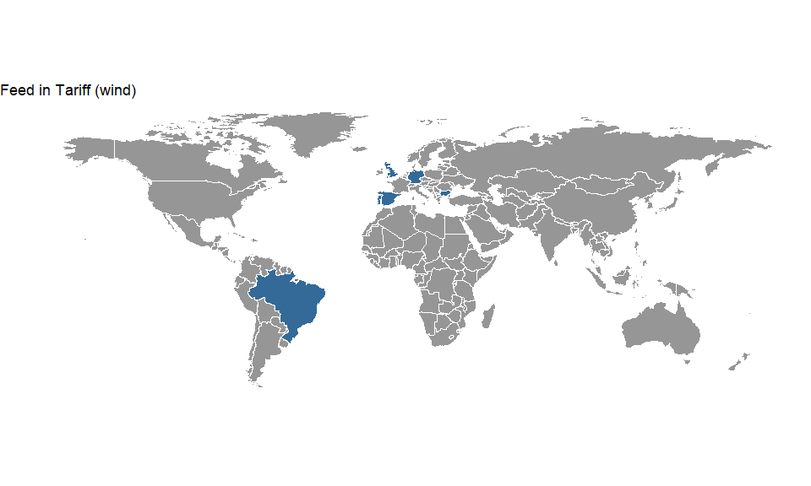

| link | country | policy_name | social_outcome_type | social_outcome | social_outcome_population | social_outcome_population_detail |
| --- | --- | --- | --- | --- | --- | --- |
| http://dx.doi.org/10.1016/j.rser.2016.08.047 | Brazil | Auctions, reduced import duties, streamlined licensing and subsidized loans | Access (other services) | Negative | A part of the society or locality | traditional communities |
| http://dx.doi.org/10.1016/j.rser.2016.08.047 | Brazil | Auctions, reduced import duties, streamlined licensing and subsidized loans | Subjective well-being | Negative | A part of the society or locality | traditional communities |
| http://dx.doi.org/10.1016/j.rser.2016.08.047 | Brazil | Auctions, reduced import duties, streamlined licensing and subsidized loans | Community cohesion/conflict | Mixed (positive and negative) | A part of the society or locality | traditional communities |
| http://dx.doi.org/10.1016/j.erss.2018.02.020 | Bulgaria | "Bulgaria's first renewables law" (?) | Procedural justice | Negative | Everyone in the society or locality | Bulgaria in general |
| http://dx.doi.org/10.1016/j.erss.2018.02.020 | Bulgaria | "Bulgaria's first renewables law" (?) | Equality (income) | Negative | Everyone in the society or locality | Households, taxpayers in Bulgaria, esp. low income |
| http://dx.doi.org/10.1016/j.erss.2018.02.020 | Bulgaria | "Bulgaria's first renewables law" (?) | Affordability (electricity/fuel) | Negative | Everyone in the society or locality | Households, taxpayers in Bulgaria, esp. low income |
| http://dx.doi.org/10.1016/j.erss.2018.02.020 | Bulgaria | "Bulgaria's first renewables law" (?) | Equality (geographic) | Negative | A part of the society or locality | Rural households relying on wood and oil generators |
| http://dx.doi.org/10.5547/2160-5890.2.1.3 | Germany | technology-specific feed-in tariffs (FITs) | Equality (income) | Negative | Everyone in the society or locality | households |
| http://dx.doi.org/10.5547/01956574.38.SI1.cboh | Germany | technology-specific feed-in tariffs (FITs) | Equality (income) | Negative | Everyone in the society or locality | electricity consuming households |
| http://dx.doi.org/10.1016/j.enpol.2010.03.029 | Germany | technology-specific feed-in tariffs (FITs) | Affordability (electricity/fuel) | Negative | Everyone in the society or locality | electricity consumers |
| http://dx.doi.org/10.1016/j.eap.2015.01.004 | Germany | EEG levy | Affordability (electricity/fuel) | Negative | A part of the society or locality | population beyond poverty line had to pay a larger share of their income for electricity |
| http://dx.doi.org/10.1016/j.eneco.2014.04.020 | Germany |  | Equality (income) | Negative | Everyone in the society or locality |  |
| http://dx.doi.org/10.1016/j.enpol.2019.05.043 | Germany | Energiewende | Equality (income) | Negative | Everyone in the society or locality | we focus on the impact of the German  feed-in tariff for promoting renewable energies on household disposable  incomes. |
| http://dx.doi.org/10.3390/su71215834 | Germany | EEG | Affordability (electricity/fuel) | Mixed (positive and negative) | Everyone in the society or locality | electricity users |
| http://dx.doi.org/10.1016/j.enpol.2010.03.029 | Germany | technology-specific feed-in tariffs (FITs) | Employment | Mixed (positive and negative) | Everyone in the society or locality | employees |
| http://dx.doi.org/10.1016/j.eap.2015.01.004 | Germany | EEG levy | Equality (income) | Negative | A part of the society or locality | population below poverty line contributes a larger and growwing share of their income to renewable energy promotion than high income groups. |
| http://dx.doi.org/10.1016/j.enpol.2019.05.043 | Germany | Energiewende | Equality (geographic) | Negative | Everyone in the society or locality | we focus on the impact of the German  feed-in tariff for promoting renewable energies on household disposable  incomes. |
| http://dx.doi.org/10.3390/su71215834 | Germany | EEG | Equality (income) | Mixed (positive and negative) | Everyone in the society or locality |  |
| http://dx.doi.org/10.1016/j.apenergy.2016.04.044 | Portugal |  | Employment | Positive | Everyone in the society or locality |  |
| http://dx.doi.org/10.1016/j.apenergy.2016.04.044 | Portugal |  | Affordability (electricity/fuel) | Negative | Everyone in the society or locality |  |
| http://dx.doi.org/10.1016/j.enpol.2008.04.022 | Spain | feed-in tariff system for RES-E | Affordability (electricity/fuel) | Mixed (positive and negative) | Everyone in the society or locality | electricity consumers |
|  | United Kingdom | Feed-in Tariff mechanism | Equality (income) | Mixed (positive and negative) | Everyone in the society or locality |  |

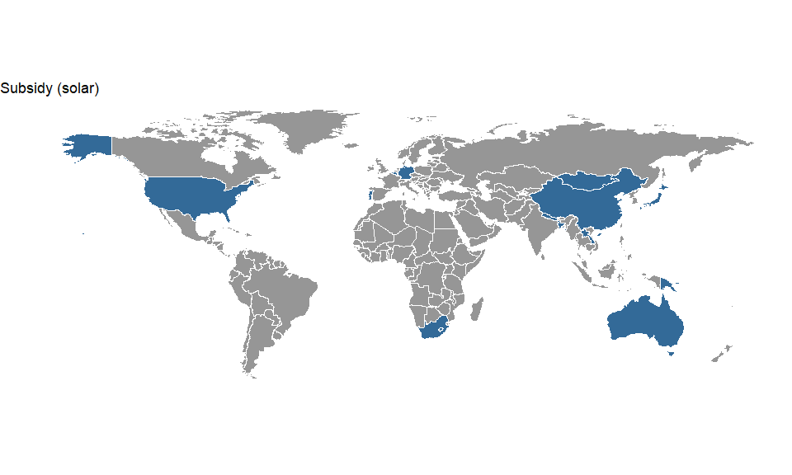

| link | country | policy_name | social_outcome_type | social_outcome | social_outcome_population | social_outcome_population_detail |
| --- | --- | --- | --- | --- | --- | --- |
| http://dx.doi.org/10.1016/j.enpol.2011.03.007 | Australia | Photovoltaic Rebate Program (PVRP), Solar Homes and Communities Plan (SHCP) | Equality (income) | Negative | Everyone in the society or locality | Solar PV adopters |
| http://dx.doi.org/10.1016/j.ecolecon.2016.02.012 | Australia | Photovoltaic Rebate Program (PVRP) | Equality (income) | Positive | Everyone in the society or locality | households |
| http://dx.doi.org/10.1016/j.enpol.2011.03.007 | Australia | Photovoltaic Rebate Program (PVRP), Solar Homes and Communities Plan (SHCP) | Equality (geographic) | Negative | Everyone in the society or locality | Solar PV adopters |
| http://dx.doi.org/10.1109/SYSTEMS.2010.5482477 | Bangladesh | Rural Electrification and Renewable Energy Development Project (REREDP). | Access (electricity) | Positive | Everyone targetted by the policy | rural electrification |
| http://dx.doi.org/10.1109/SYSTEMS.2010.5482477 | Bangladesh | Rural Electrification and Renewable Energy Development Project (REREDP). | Poverty reduction (in general, not limited to affordability/access) | Positive | Everyone targetted by the policy | some of the various benefits matter for all participants |
| http://dx.doi.org/10.1109/SYSTEMS.2010.5482477 | Bangladesh | Rural Electrification and Renewable Energy Development Project (REREDP). | Equality (gender) | Positive | Some of those targetted by the policy | some of the various benefits matter for all participants |
| http://dx.doi.org/10.1109/SYSTEMS.2010.5482477 | Bangladesh | Rural Electrification and Renewable Energy Development Project (REREDP). | Access (other services) | Positive | Some of those targetted by the policy | micro-businesses |
| http://dx.doi.org/10.1016/j.enpol.2015.10.046 | Belgium |  | Procedural justice | Negative | A part of the society or locality | homeowners |
| http://dx.doi.org/10.1016/j.enpol.2015.10.046 | Belgium |  | Equality (income) | Mixed (positive and negative) | A part of the society or locality | homeowners |
| http://dx.doi.org/10.1177/146499341201200404 | China | Renewable Energy Development Project | Access (electricity) | Not stated | Everyone targetted by the policy | 11.1MW SHS |
|  | China | Renewable Energy Development Project | Equality (income) | Positive | Everyone in the society or locality | Information extrapolated from expert interviews on the whole policy |
|  | China | Renewable Energy Development Project | Access (electricity) | Positive | Everyone targetted by the policy | Information extrapolated from expert interviews on the whole policy |
|  | China | Renewable Energy Development Project | Affordability (electricity/fuel) | Positive | Everyone targetted by the policy | Information extrapolated from expert interviews on the whole policy |
|  | Germany | 100 000 Roofs Photovoltaic Programme (HTRP) | Affordability (electricity/fuel) | Mixed (positive and negative) | Some of those targetted by the policy |  |
| http://dx.doi.org/10.5547/2160-5890.2.1.3 | Germany | technology-specific feed-in tariffs (FITs) | Equality (income) | Negative | Everyone in the society or locality | households |
|  | Germany | 100 000 Roofs Photovoltaic Programme (HTRP) | Employment |  | Populations external to the society or locality | Boost to German solar manufacturing |
| http://dx.doi.org/10.1016/j.esd.2017.11.002 | Japan | Feed-in-tariff for solar | Access (other services) | Negative | Everyone in the society or locality | Environmental (non-climate) impacts |
| http://dx.doi.org/10.1016/j.esd.2017.11.002 | Japan | Feed-in-tariff for solar | Employment | Insignificant | Everyone in the society or locality | Broad aggregate category that includes emplyoment |
| http://dx.doi.org/10.1177/146499341201200404 | Lao PDR | Off-grid Electrification Component of the Rural Electrification Project Phase I (REP I) | Access (electricity) | Not stated | Everyone targetted by the policy | 9000 SHS |
| http://dx.doi.org/10.1177/146499341201200404 | Mongolia | Herder Electrification Component of the Renewable Energy and Rural Electricity Access Project (REAP) | Access (electricity) | Not stated | Everyone targetted by the policy | 41800 SHS |
|  | Mongolia | Renewable energy and rural electrificity access project (REAP) | Access (electricity) | Positive | Everyone targetted by the policy |  |
|  | Mongolia | Renewable energy and rural electrificity access project (REAP) | Affordability (electricity/fuel) | Positive | Everyone targetted by the policy |  |
|  | Mongolia | Renewable energy and rural electrificity access project (REAP) | Subjective well-being | Positive | Some of those targetted by the policy |  |
| http://dx.doi.org/10.1016/j.esd.2018.01.001 | Nepal | Solar Home System subsidy | Equality (income) | Positive |  | Policy participants |
| http://dx.doi.org/10.1177/146499341201200404 | Papua New Guinea | The Teacher’s Solar Lighting Project (TSLP) | Access (electricity) | Not stated | Everyone targetted by the policy | 1 SHS |
| http://dx.doi.org/10.1080/08039410.2012.736405 | Papua New Guinea | Teacher's Solar Lighting Project (TSLP) | Access (other services) | Insignificant | Some of those targetted by the policy | 1 recipient |
| http://dx.doi.org/10.1016/j.enpol.2015.10.046 | Portugal |  | Procedural justice | Negative | A part of the society or locality | households |
| http://dx.doi.org/10.1016/j.enpol.2015.10.046 | Portugal |  | Equality (income) | Negative | Everyone in the society or locality | households |
| http://dx.doi.org/10.1016/j.apenergy.2015.05.120 | South Africa | Free Basic Electrification (FBE) policy, also the Electricity Basic Support Services Tariff (EBSST), known as the "poverty tariff" | Access (electricity) | Positive | A part of the society or locality |  |
| http://dx.doi.org/10.1088/1748-9326/aa815e | United States | Various, it is assessing federal and state incentives | Affordability (electricity/fuel) | Mixed (positive and negative) | A part of the society or locality |  |
|  | United States | California’s innovative Single-family Affordable Solar Homes (SASH) Program, District of Columbia’s Renewable Energy Rebate Program for low-income single family homes | Poverty reduction (in general, not limited to affordability/access) | Positive |  |  |
| http://dx.doi.org/10.1016/j.ecolecon.2016.02.012 | United States | California Solar Energy Initiative (CSI) | Equality (income) | Mixed (positive and negative) |  |  |
|  | United States | California’s innovative Single-family Affordable Solar Homes (SASH) Program, District of Columbia’s Renewable Energy Rebate Program for low-income single family homes | Affordability (electricity/fuel) | Positive | Some of those targetted by the policy | "Participating residents now benefit from no-cost electricity produced by the systems, saving each customer approximately $350 to $500 each year" |

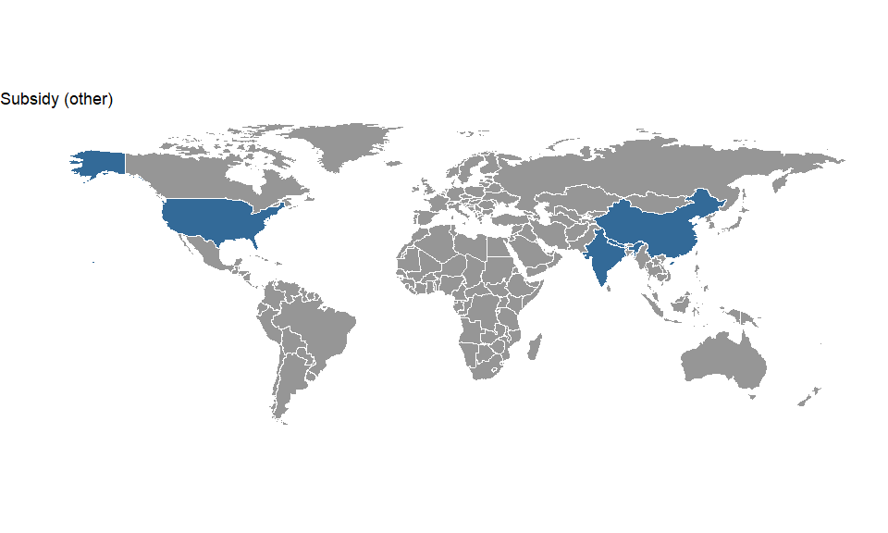

| link | country | policy_name | social_outcome_type | social_outcome | social_outcome_population | social_outcome_population_detail |
| --- | --- | --- | --- | --- | --- | --- |
| http://dx.doi.org/10.1016/j.enpol.2015.09.035 | China | Green electricity subsify | Equality (income) | Negative | Everyone in the society or locality | Distribution of subsidies across income groups. |
| http://dx.doi.org/10.1016/j.habitatint.2015.11.007 | China | Public Bicycle Sharing Programm | Equality (gender) | Negative | Some of those targetted by the policy | This research consisted of an intercept survey of 200 bicycle users, 25 at each of the eight BDSs located in downtown Suzhou with the help of a structured questionnaire (written both in English and Chinese). The eight BDSs were selected from the following land uses: two from residential, commercial, metrostation and office-areas. The arrangement was used to capture a mixed group of bicycle users from diverse backgrounds |
| http://dx.doi.org/10.1016/j.energy.2009.05.028 | China | no specific name | Affordability (electricity/fuel) | Insignificant | Some of those targetted by the policy | adopters in the studied villages as opposed to non-adopters in the same villages |
| http://dx.doi.org/10.1038/s41560-019-0386-2 | China | Beijing coal to electricity program | Affordability (electricity/fuel) | Negative | A part of the society or locality | 3 districts in Beijing |
| http://dx.doi.org/10.1016/j.habitatint.2015.11.007 | China | Public Bicycle Sharing Programm | Equality (income) | Negative | Some of those targetted by the policy | "This research consisted of an intercept survey of 200 bicycle users, 25 at each of the eight BDSs located in downtown Suzhou with the help of a structured questionnaire (written both in English and Chinese). The eight BDSs were selected from the following land uses: two from residential, commercial, metrostation and office-areas. The arrangement was used to capture a mixed group of bicycle users from diverse backgrounds" |
| http://dx.doi.org/10.1016/j.energy.2009.05.028 | China | no specific name | Poverty reduction (in general, not limited to affordability/access) | Mixed (positive and negative) | Some of those targetted by the policy | adopters in the studied villages as opposed to non-adopters in the same villages |
| http://dx.doi.org/10.1038/s41560-019-0386-2 | China | Beijing coal to electricity program | Subjective well-being | Mixed (positive and negative) | A part of the society or locality | 3 districts in Beijing |
| http://dx.doi.org/10.1016/j.energy.2009.05.028 | China | no specific name | Time/labour/drudgery | Insignificant | Some of those targetted by the policy | adopters in the studied villages as opposed to non-adopters in the same villages |
| http://dx.doi.org/10.1038/s41560-019-0386-2 | China | Beijing coal to electricity program | Equality (income) | Negative | A part of the society or locality | 3 districts in Beijing |
| http://dx.doi.org/10.1016/j.esd.2017.02.004 | India | Ministry of New and Renewable Energy (MNRE) subsidy programme | Access (other services) | Positive | A part of the society or locality | 776 villages |
| http://dx.doi.org/10.1016/j.esd.2017.02.004 | India | Ministry of New and Renewable Energy (MNRE) subsidy programme | Affordability (electricity/fuel) | Positive | Some of those targetted by the policy | 544 households across four districts of Assam |
| http://dx.doi.org/10.1016/j.esd.2017.02.004 | India | Ministry of New and Renewable Energy (MNRE) subsidy programme | Time/labour/drudgery | Positive | Some of those targetted by the policy | 544 households across four districts of Assam |
| http://dx.doi.org/10.1016/j.esd.2017.02.004 | India | Ministry of New and Renewable Energy (MNRE) subsidy programme | Access (other services) | Positive | Some of those targetted by the policy | 98 households |
| http://dx.doi.org/10.1016/j.esd.2018.01.001 | Nepal | Biogas subsidy | Equality (income) | Negative |  | Policy participants |
| http://dx.doi.org/10.1086/685597 | United States | Residential Energy Effcient Property Credit | Equality (income) | Negative | Everyone in the society or locality | Figure 5 plots the average credit amount per return by AGI category |
| http://dx.doi.org/10.1086/685597 | United States | Alternative Motor Vehicle Credit | Equality (income) | Negative | Everyone in the society or locality | Figure 5 plots the average credit amount per return by AGI category |
| http://dx.doi.org/10.1086/685597 | United States | Qualifed Plug-In Electric Drive Motor Vehicle Credit | Equality (income) | Negative | Everyone in the society or locality | Figure 5 plots the average credit amount per return by AGI category |

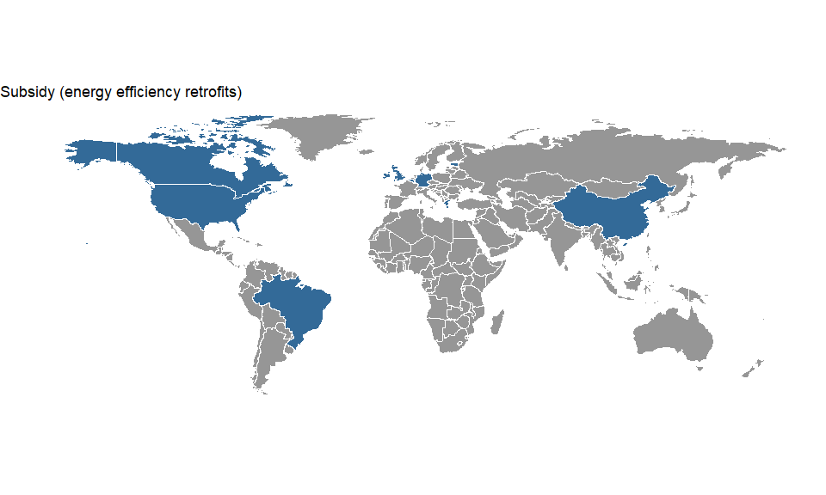

| link | country | policy_name | social_outcome_type | social_outcome | social_outcome_population | social_outcome_population_detail |
| --- | --- | --- | --- | --- | --- | --- |
| http://dx.doi.org/10.1016/j.enpol.2015.10.046 | Belgium |  | Procedural justice | Negative | A part of the society or locality | homeowners |
| http://dx.doi.org/10.1016/j.enpol.2015.10.046 | Belgium |  | Equality (income) | Mixed (positive and negative) | A part of the society or locality | homeowners |
| http://dx.doi.org/10.1109/Chilecon.2015.7400437 | Brazil | Energy Efficiency Projects | Affordability (electricity/fuel) | Positive | Everyone in the society or locality |  |
| http://dx.doi.org/10.5547/01956574.37.4.nriv | Canada | EcoEnergy Home | Equality (income) | Negative | Everyone in the society or locality | ~300,000 households |
| http://dx.doi.org/10.1016/j.enpol.2012.02.065 | China | 11th Five-Year Plan | Subjective well-being | Insignificant | Some of those targetted by the policy | Not stated |
| http://dx.doi.org/10.1016/j.enpol.2012.02.065 | China | 11th Five-Year Plan | Affordability (electricity/fuel) | Positive | Some of those targetted by the policy | Fengshuoyuan District |
| http://dx.doi.org/10.1016/j.enpol.2018.04.013 | Estonia | KredEx scheme | Equality (income) | Negative |  | 661 unique buildings |
| http://dx.doi.org/10.1016/j.enpol.2018.04.013 | Estonia | KredEx scheme | Equality (geographic) | Negative |  |  |
| http://dx.doi.org/10.1016/j.enpol.2018.08.007 | Germany | German CO2 Building Rehabilitation Programme | Affordability (electricity/fuel) | Negative | Some of those targetted by the policy | Low-income renting households |
| http://dx.doi.org/10.1016/j.enpol.2019.01.040 | Greece | Saving in-house energy savings program | Equality (income) | Positive | Everyone in the society or locality |  |
| http://dx.doi.org/10.1016/j.enbuild.2016.08.027 | Ireland | Better Energy Performance | Subjective well-being | Positive | Some of those targetted by the policy | Case-Studies Surveyed by the Paper |
| http://dx.doi.org/10.1016/j.healthplace.2005.10.004 | United Kingdom | Home is where the heat is | Affordability (electricity/fuel) | Positive | Everyone targetted by the policy | 54 households |
| http://dx.doi.org/10.1016/j.energy.2015.09.016 | United Kingdom | Warm Front Home Energy Efficiency Scheme | Affordability (electricity/fuel) | Positive |  | 2,359,500 low-income households eligibile for social benefits (later including those on benefits and in fuel poverty) |
| http://dx.doi.org/10.1186/s12889-017-4075-4 | United Kingdom | Arbed | Subjective well-being | Positive | Some of those targetted by the policy | Those who took part in the experiment |
| http://dx.doi.org/10.1016/j.enpol.2012.01.053 | United Kingdom | Warm Front Scheme | Affordability (electricity/fuel) | Positive | Some of those targetted by the policy | The study entailed thesurveyof 3489 dwellings and households participating in the Warm FrontScheme in five urban areas of England + Logistical constraints imposed by the Warm Front application process limited the set of combined property and household data to 2685 andrestrictedthenumberofproperties with a confirmed level of Warm Front intervention to1987 |
| http://dx.doi.org/10.1186/s12889-017-4075-4 | United Kingdom | Arbed | Equality (income) | Positive | Some of those targetted by the policy | Those who took part in the experiment |
| http://dx.doi.org/10.1016/j.enpol.2019.01.020 | United States | Different energy assistance programs | Affordability (other services) | Mixed (positive and negative) | Everyone in the society or locality | households |
| http://dx.doi.org/10.1016/j.enpol.2013.01.034 | United States | Multiple state-level policies | Employment | Positive | Everyone in the society or locality | Jobs in 361 metropolitan areas |

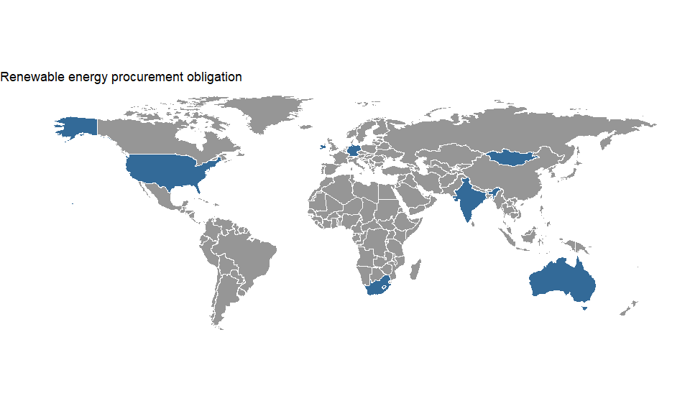

| link | country | policy_name | social_outcome_type | social_outcome | social_outcome_population | social_outcome_population_detail |
| --- | --- | --- | --- | --- | --- | --- |
| http://dx.doi.org/10.1016/j.enpol.2014.04.008 | Australia | (Mandatory) Renewable Energy Target (MRET) | Affordability (electricity/fuel) | Mixed (positive and negative) | Everyone in the society or locality | electricity consumers |
| http://dx.doi.org/10.1016/j.renene.2015.09.061 | Australia | Mandatory Renewable Energy Target (MRET) and state-level FiTs | Equality (income) | Negative | Everyone in the society or locality | households |
| http://dx.doi.org/10.1063/1.5097424 | Australia |  | Equality (income) | Negative | Everyone in the society or locality | solar PV adopters and non-adopters |
|  | Germany | 100 000 Roofs Photovoltaic Programme (HTRP) | Affordability (electricity/fuel) | Mixed (positive and negative) | Some of those targetted by the policy |  |
|  | Germany | 100 000 Roofs Photovoltaic Programme (HTRP) | Employment |  | Populations external to the society or locality | Boost to German solar manufacturing |
| http://dx.doi.org/10.1016/j.enpol.2013.02.006 | India | Village Energy Security Project | Affordability (electricity/fuel) | Positive | Some of those targetted by the policy |  |
| http://dx.doi.org/10.1016/j.enpol.2013.02.006 | India | Village Energy Security Project | Access (other services) |  | Some of those targetted by the policy | Access to cleaner cooking |
| http://dx.doi.org/10.1016/j.enpol.2013.02.006 | India | Village Energy Security Project | Employment | Positive | Some of those targetted by the policy | Access to cleaner cooking |
| http://dx.doi.org/10.1016/j.erss.2015.02.006 | Ireland | Public Service Obligation (PSO) levies | Affordability (electricity/fuel) | Mixed (positive and negative) | Everyone in the society or locality |  |
| http://dx.doi.org/10.1016/j.esd.2010.10.004 | Mongolia | Renewable Energy and Rural Electricity Access Project | Access (electricity) | Positive | Everyone targetted by the policy |  |
| http://dx.doi.org/10.1016/j.esd.2010.10.004 | Mongolia | Renewable Energy and Rural Electricity Access Project | Poverty reduction (in general, not limited to affordability/access) |  |  |  |
| http://dx.doi.org/10.1016/j.esd.2010.10.004 | Mongolia | Renewable Energy and Rural Electricity Access Project | Affordability (electricity/fuel) |  |  |  |
| http://dx.doi.org/10.1016/j.esd.2010.10.004 | Mongolia | Renewable Energy and Rural Electricity Access Project | Equality (income) |  |  |  |
| http://dx.doi.org/10.1016/j.apenergy.2016.06.073 | South Africa | The South African Renewable Energy Independent Power Producer Procurement Program (REIPPPP) | Employment | Positive | Everyone in the society or locality | 25526 jobs |
| http://dx.doi.org/10.1016/j.apenergy.2015.05.120 | South Africa | Free Basic Electrification (FBE) policy, also the Electricity Basic Support Services Tariff (EBSST), known as the "poverty tariff" | Access (electricity) | Positive | A part of the society or locality |  |
| http://dx.doi.org/10.1016/j.enpol.2013.01.034 | United States | Multiple state-level policies | Employment | Positive | Everyone in the society or locality | Jobs in 361 metropolitan areas |
| http://dx.doi.org/10.1111/1477-8947.12125 | United States | mandatory regulations on renewable energy use | Employment | Positive | Everyone in the society or locality | Private Sector Green Jobs Employment |
| http://dx.doi.org/10.1088/1748-9326/aa815e | United States | Various, it is assessing federal and state incentives | Affordability (electricity/fuel) | Mixed (positive and negative) | A part of the society or locality |  |

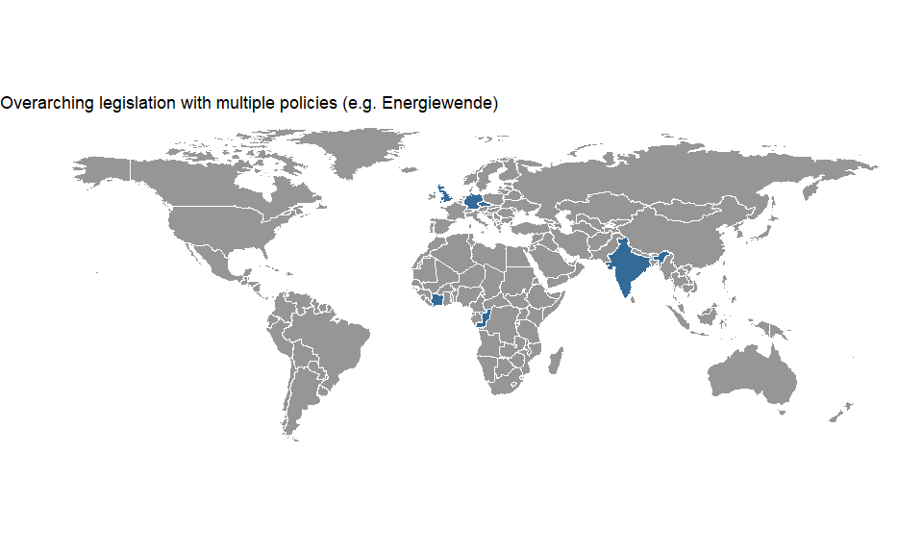

| link | country | policy_name | social_outcome_type | social_outcome | social_outcome_population | social_outcome_population_detail |
| --- | --- | --- | --- | --- | --- | --- |
| http://dx.doi.org/10.1016/j.rser.2016.11.158 | Czech Republic | national Act on support of renewable sources of energy. | Employment | Positive | A part of the society or locality | Generally the largest impact on growth of employment was identiﬁed in case of biomass and biofuels sectors (15 jobs for 1 MW of biomass energy), whilst wind energy and small hydro-power generated the fewest jobs per unit of installed capacity. More jobs per unit of output could be seen as a desirable trend for regional employment, but potentially also as a negative trend in economic eﬃciency (i.e. more labour cost per unit of output). |
| http://dx.doi.org/10.32479/ijeep.6917 | Germany | feed-in tariff and grid extension policies | Equality (income) | Negative | Everyone in the society or locality | consumers |
| http://dx.doi.org/10.1007/s11625-017-0433-5 | Germany | Energiewende | Community cohesion/conflict | Positive | A part of the society or locality | Communities in North Frisia |
| http://dx.doi.org/10.1016/j.enpol.2019.05.043 | Germany | Energiewende | Equality (income) | Negative | Everyone in the society or locality | we focus on the impact of the German  feed-in tariff for promoting renewable energies on household disposable  incomes. |
|  | Germany | Energiewende | Affordability (electricity/fuel) | Negative | Some of those targetted by the policy | low income households |
| http://dx.doi.org/10.1016/j.enpol.2016.05.024 | Germany | Energiewende | Community cohesion/conflict | Mixed (positive and negative) | A part of the society or locality | people whose jobs or villages are affected by coal mining |
| http://dx.doi.org/10.1016/j.enpol.2014.06.031 | Germany | Energiewende | Employment | Positive | A part of the society or locality | people working in the RE industry |
| http://dx.doi.org/10.3390/su71215834 | Germany | EEG | Affordability (electricity/fuel) | Mixed (positive and negative) | Everyone in the society or locality | electricity users |
| http://dx.doi.org/10.1007/s11625-017-0433-5 | Germany | Energiewende | Employment | Positive | A part of the society or locality | Communities in North Frisia |
| http://dx.doi.org/10.1016/j.enpol.2019.05.043 | Germany | Energiewende | Equality (geographic) | Negative | Everyone in the society or locality | we focus on the impact of the German  feed-in tariff for promoting renewable energies on household disposable  incomes. |
|  | Germany | Energiewende | Employment | Positive | A part of the society or locality | employees in the RE sector |
| http://dx.doi.org/10.1016/j.enpol.2016.05.024 | Germany | Energiewende | Procedural justice | Mixed (positive and negative) | A part of the society or locality | people who feel excluded by politicians or the media |
| http://dx.doi.org/10.1016/j.enpol.2014.06.031 | Germany | Energiewende | Equality (geographic) | Positive | A part of the society or locality | people working in the RE industry |
| http://dx.doi.org/10.3390/su71215834 | Germany | EEG | Equality (income) | Mixed (positive and negative) | Everyone in the society or locality |  |
| http://dx.doi.org/10.1007/s11625-017-0433-5 | Germany | Energiewende | Community cohesion/conflict | Negative | A part of the society or locality | Communities in North Frisia |
| http://dx.doi.org/10.1007/s11625-017-0433-5 | Germany | Energiewende | Procedural justice | Positive | A part of the society or locality | Communities in North Frisia |
| http://dx.doi.org/10.1080/14693062.2014.992296 | India | National Solar Mission | Employment | Positive | A part of the society or locality | Jobs in the solar industry |
| http://dx.doi.org/10.5547/2160-5890.2.1.2 | United Kingdom | Multiple energy efficiency and environmental policies, incl. the Carbon Emission Reduction Target (CERT), Community Energy Saving Programme (CESP), Warm Front Scheme (WFS), and others | Equality (income) | Negative | Everyone in the society or locality | All households |
| http://dx.doi.org/10.1016/j.energy.2018.12.199 |  |  | Poverty reduction (in general, not limited to affordability/access) | Mixed (positive and negative) | Some of those targetted by the policy | households |
| http://dx.doi.org/10.1016/j.energy.2018.12.199 |  |  | Equality (income) |  |  |  |

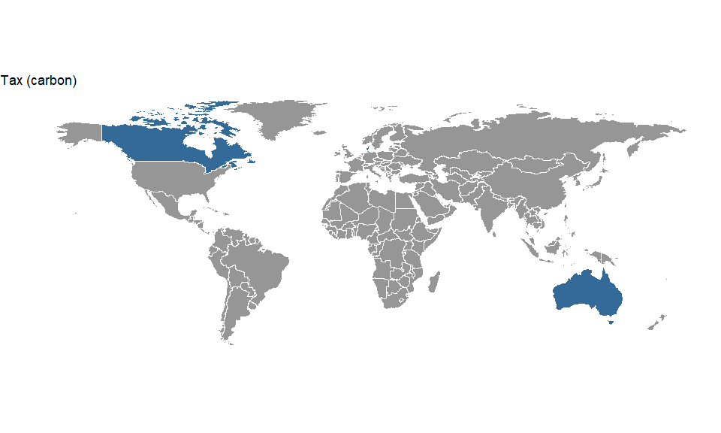

| link | country | policy_name | social_outcome_type | social_outcome | social_outcome_population | social_outcome_population_detail |
| --- | --- | --- | --- | --- | --- | --- |
| http://dx.doi.org/10.4028/www.scientific.net/AMR.869-870.840 | Australia | Australian Carbon Tax | Poverty reduction (in general, not limited to affordability/access) | Negative | Everyone in the society or locality | Low-income households |
| http://dx.doi.org/10.1016/j.reseneeco.2015.04.005 | Canada | British Colombia Carbon Tax | Equality (income) | Positive |  | All households |
| http://dx.doi.org/10.1016/j.enpol.2015.08.011 | Canada | BC carbon tax | Employment | Mixed (positive and negative) | Everyone in the society or locality |  |
| http://dx.doi.org/10.1016/j.ecolecon.2016.01.017 | Canada | British Colombia Carbon Tax | Equality (geographic) | Positive | A part of the society or locality | had the British Columbia carbon tax been introduced without any revenue recycling measures in place (i.e., if revenue had been retained by government), rural households in British Columbia would indeed have experienced the largest welfare loss due to the carbon tax. |
| http://dx.doi.org/10.1016/j.jeem.2017.03.003 | Canada | British Columbia’s revenue-neutral carbon tx | Employment | Positive | Everyone in the society or locality | overall employment effects in the state |
| http://dx.doi.org/10.1016/j.jeem.2018.03.004 | Canada | British Columbia Carbon Tax revenue-neutral | Employment | Negative | A part of the society or locality | Less-educated |
| http://dx.doi.org/10.1016/j.enpol.2015.08.011 | Canada | BC carbon tax | Equality (income) | Insignificant | Everyone in the society or locality |  |
| http://dx.doi.org/10.1016/j.jeem.2018.03.004 | Canada | British Columbia Carbon Tax revenue-neutral | Employment | Negative | Everyone in the society or locality | increases overall unemployment |
| http://dx.doi.org/10.1016/j.jeem.2018.03.004 | Canada | British Columbia Carbon Tax revenue-neutral | Employment | Negative | A part of the society or locality | increases overall unemployment |
| http://dx.doi.org/10.1016/j.ecolecon.2004.08.005 | Denmark | Danish CO2-Tax | Equality (income) | Mixed (positive and negative) | Everyone in the society or locality | Regressive effects of the tax |
| http://dx.doi.org/10.1016/j.ecolecon.2004.08.005 | Denmark | Danish CO2-Tax | Equality (geographic) | Mixed (positive and negative) | Everyone in the society or locality | Rural vs Urban population |

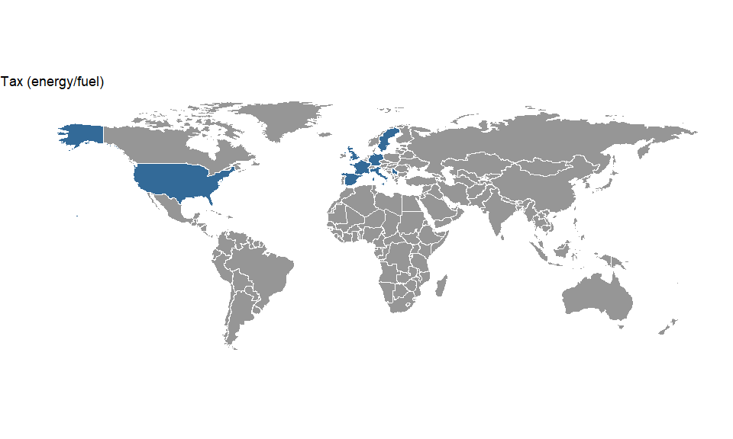

| link | country | policy_name | social_outcome_type | social_outcome | social_outcome_population | social_outcome_population_detail |
| --- | --- | --- | --- | --- | --- | --- |
| http://dx.doi.org/10.1016/j.enpol.2010.03.012 | France | Gasoline and Diesel Taxes | Equality (income) | Insignificant | Everyone in the society or locality | Suits index of lifetime income, direct and indirect effects |
| http://dx.doi.org/10.1016/j.enpol.2010.03.012 | Germany | Gasoline and Diesel Taxes | Equality (income) | Insignificant | Everyone in the society or locality | Suits index of lifetime income, direct and indirect effects |
| http://dx.doi.org/10.1016/j.enpol.2010.03.012 | Italy | Gasoline and Diesel Taxes | Equality (income) | Negative | Everyone in the society or locality | Suits index of lifetime income, direct and indirect effects |
| http://dx.doi.org/10.1016/j.enpol.2010.03.012 | Serbia | Gasoline and Diesel Taxes | Equality (income) | Insignificant | Everyone in the society or locality | Suits index of lifetime income, direct and indirect effects |
| http://dx.doi.org/10.1016/j.enpol.2010.03.012 | Spain | Gasoline and Diesel Taxes | Equality (income) | Insignificant | Everyone in the society or locality | Suits index of lifetime income, direct and indirect effects |
| http://dx.doi.org/10.1016/j.enpol.2010.03.012 | Sweden | Gasoline and Diesel Taxes | Equality (income) | Insignificant | Everyone in the society or locality | Suits index of lifetime income, direct and indirect effects |
| http://dx.doi.org/10.1016/j.enpol.2010.03.012 | United Kingdom | Gasoline and Diesel Taxes | Equality (income) | Insignificant | Everyone in the society or locality | Suits index of lifetime income, direct and indirect effects |
| http://dx.doi.org/10.1016/j.ecolecon.2017.03.025 | United States | Federal gasolene tax | Equality (income) | Negative | Everyone in the society or locality | a sample of households |
| http://dx.doi.org/10.1016/j.ecolecon.2017.03.025 | United States | Federal gasolene tax | Equality (income) | Negative | A part of the society or locality | Young people |

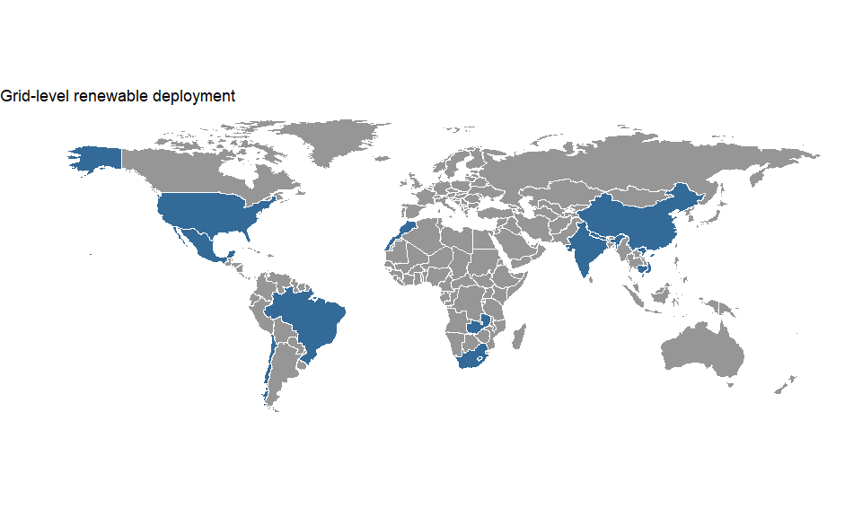

| link | country | policy_name | social_outcome_type | social_outcome | social_outcome_population | social_outcome_population_detail |
| --- | --- | --- | --- | --- | --- | --- |
| http://dx.doi.org/10.1016/j.worlddev.2015.08.015 | Brazil | planning of hydro-electric dams | Procedural justice | Negative | A part of the society or locality | people displaced by the dam |
|  | Cambodia | Lower Sesan Dam 2 | Subjective well-being | Negative | Some of those targetted by the policy | Local populations interviewed by the study |
|  | Cambodia | Lower Sesan Dam 2 | Procedural justice | Negative | Some of those targetted by the policy | Local populations interviewed by the study |
|  | Cambodia | Lower Sesan Dam 2 | Community cohesion/conflict | Negative | Some of those targetted by the policy | Local populations interviewed by the study |
|  | Cambodia | Lower Sesan Dam 2 | Equality (income) | Mixed (positive and negative) | Some of those targetted by the policy | Local Populations |
| http://dx.doi.org/10.1016/j.erss.2019.04.014 | Chile | Nonconventional Renewable Energy Law | Community cohesion/conflict | Negative | Some of those targetted by the policy | here I focus on project impacts in two case studies, Las Flores on Quimán River and HidroRiñinahue on the Riñinahue River |
| http://dx.doi.org/10.1007/s10113-017-1170-0 | China | Madushan Dam | Poverty reduction (in general, not limited to affordability/access) | Negative | A part of the society or locality | Resettled communities |
| http://dx.doi.org/10.1016/S0973-0826(08)60193-3 | China | Integrated Rural Energy Development in One Hundred Counties’’ | Access (electricity) | Positive | Everyone targetted by the policy |  |
| http://dx.doi.org/10.1016/S0973-0826(08)60193-3 | China | Integrated Rural Energy Development in One Hundred Counties’’ | Equality (income) | Positive | Some of those targetted by the policy | Peasants |
| http://dx.doi.org/10.3390/w8100437 | India | Bhilangana, Bhilangana II and Agunda–Thati hydropower dams | Procedural justice | Negative | A part of the society or locality | Local community |
| http://dx.doi.org/10.1016/j.geoforum.2016.09.004 | India | Gujarat Solar Power Policy | Equality (income) | Negative | A part of the society or locality | Charanka village, especially illiterate, marginalised (i.e. low caste) groups (e.g. landless Rabaris) |
| http://dx.doi.org/10.1016/j.enpol.2015.08.019 | India | ‘Jawaharlal Nehru National Solar Mission’ | Procedural justice | Negative | A part of the society or locality | Charanka village community, esp. lower caste and illiterate |
| http://dx.doi.org/10.3390/w8100437 | India | Bhilangana, Bhilangana II and Agunda–Thati hydropower dams | Equality (gender) | Negative | A part of the society or locality | Women in the local community |
| http://dx.doi.org/10.1016/j.geoforum.2016.09.004 | India | Gujarat Solar Power Policy | Procedural justice | Negative | A part of the society or locality | Charanka village, especially illiterate, marginalised (i.e. low caste) groups (e.g. landless Rabaris) |
| http://dx.doi.org/10.3390/w8100437 | India | Bhilangana, Bhilangana II and Agunda–Thati hydropower dams | Poverty reduction (in general, not limited to affordability/access) | Negative | A part of the society or locality | Women in the local community |
| http://dx.doi.org/10.3390/w8100437 | India | Bhilangana, Bhilangana II and Agunda–Thati hydropower dams | Time/labour/drudgery | Negative | A part of the society or locality | Local community |
|  | Lao PDR | Rural Electrification Project Phase 1 | Access (electricity) | Positive | A part of the society or locality | Those becoming electrified |
| http://dx.doi.org/10.1080/08039410.2016.1273850 | Lao PDR | Nam Theun 2 Hydropower Project | Equality (gender) | Negative | A part of the society or locality | Those within the Dam Reservoire Area |
|  | Lao PDR | Rural Electrification Project Phase 1 | Equality (gender) | Positive | Some of those targetted by the policy | Women targeted by the P2P programm |
| http://dx.doi.org/10.1080/08039410.2016.1273850 | Lao PDR | Nam Theun 2 Hydropower Project | Procedural justice | Negative | Some of those targetted by the policy | Those within the Dam Reservoire Area |
|  | Lao PDR | Rural Electrification Project Phase 1 | Access (electricity) | Positive | Everyone targetted by the policy | Women targeted by the P2P programm |
| http://dx.doi.org/10.1080/08039410.2016.1273850 | Lao PDR | Nam Theun 2 Hydropower Project | Poverty reduction (in general, not limited to affordability/access) | Negative | A part of the society or locality | Those within the Dam Reservoire Area |
|  | Lao PDR | Rural Electrification Project Phase 1 | Subjective well-being | Positive | Everyone targetted by the policy | Interviews were used and information extrapolated to all those who adopted SHS |
| http://dx.doi.org/10.2458/v24i1.20979 | Mexico | Various wind farm projects | Procedural justice | Negative | A part of the society or locality | Indigenous communities |
| http://dx.doi.org/10.1016/j.rser.2015.12.310 | Mexico | Various wind farm projects | Employment | Mixed (positive and negative) | Everyone in the society or locality | 300 jobs |
| http://dx.doi.org/10.1016/j.erss.2019.03.004 | Mexico | Open Season (OS) for Electric Energy Transmission and Transformation Reserve Capacity | Procedural justice | Negative | Some of those targetted by the policy | Our intention is to analyze the beginning of the Isthmus of Tehuantepec Wind Megaproject |
| http://dx.doi.org/10.2458/v24i1.20979 | Mexico | Various wind farm projects | Poverty reduction (in general, not limited to affordability/access) | Negative | A part of the society or locality | Indigenous communities/poor rural landowners |
| http://dx.doi.org/10.1016/j.rser.2015.12.310 | Mexico | Various wind farm projects | Poverty reduction (in general, not limited to affordability/access) | Negative | A part of the society or locality | Local communities |
| http://dx.doi.org/10.1016/j.erss.2019.03.004 | Mexico | Open Season (OS) for Electric Energy Transmission and Transformation Reserve Capacity | Community cohesion/conflict | Negative | Some of those targetted by the policy | Our intention is to analyze the beginning of the Isthmus of Tehuantepec Wind Megaproject |
| http://dx.doi.org/10.2458/v24i1.20979 | Mexico | Various wind farm projects | Community cohesion/conflict | Negative | A part of the society or locality | Indigenous communities/poor rural landowners |
| http://dx.doi.org/10.1016/j.rser.2015.12.310 | Mexico | Various wind farm projects | Community cohesion/conflict | Negative | A part of the society or locality | Local communities |
| http://dx.doi.org/10.1016/j.rser.2015.12.310 | Mexico | Various wind farm projects | Procedural justice | Negative | A part of the society or locality | Local communities |
| http://dx.doi.org/10.1016/j.apenergy.2016.06.073 | Morocco | Programme d’Electrification Rurale Globale (PERG) | Access (electricity) | Not stated | Everyone targetted by the policy | 51,559 SHS |
| http://dx.doi.org/10.1016/j.rser.2019.109259 | Morocco | Moroccan Solar Plan | Employment | Mixed (positive and negative) | A part of the society or locality | a case study of the NOORO I CSP plant in Ouarzazate, Morocco. Data collected during two empirical field studies, in combination with expert interviews and secondary data analysis, provides detailed evidence on the type and significance of livelihood impacts of the NOOR0 I CSP plant. |
| http://dx.doi.org/10.1080/02255189.2006.9669172 | Nepal | Rural Energy Development Programme (REDP) | Access (electricity) | Positive | Some of those targetted by the policy | women in 3 villages |
| http://dx.doi.org/10.1080/02255189.2006.9669172 | Nepal | Rural Energy Development Programme (REDP) | Time/labour/drudgery | Mixed (positive and negative) | Some of those targetted by the policy | women in 3 villages |
| http://dx.doi.org/10.1080/02255189.2006.9669172 | Nepal | Rural Energy Development Programme (REDP) | Procedural justice | Negative | Some of those targetted by the policy | women in 3 villages |
| http://dx.doi.org/10.1016/j.rser.2014.08.049 | South Africa | REI4P - Renewable Energy Independent Power Producers Procurement Programme | Employment | Mixed (positive and negative) | Everyone in the society or locality | the number ofjobsperMW(operationandconstruction) |
| http://dx.doi.org/10.1016/j.apenergy.2015.05.120 | South Africa | Free Basic Electrification (FBE) policy, also the Electricity Basic Support Services Tariff (EBSST), known as the "poverty tariff" | Access (electricity) | Positive | A part of the society or locality |  |
|  | United States | Langdon Wind Energy Center | Employment | Positive | Everyone in the society or locality | Local community |
| http://dx.doi.org/10.1088/1748-9326/aa815e | United States | Various, it is assessing federal and state incentives | Affordability (electricity/fuel) | Mixed (positive and negative) | A part of the society or locality |  |
| http://dx.doi.org/10.1111/lre.12072 | Vietnam | A Vuong Hydropower Dam | Access (electricity) | Positive | A part of the society or locality | Displaced/indigenous communities |
| http://dx.doi.org/10.1111/lre.12072 | Vietnam | A Vuong 210 MW hydropower dam | Poverty reduction (in general, not limited to affordability/access) | Negative | A part of the society or locality | Resettled communities |
| http://dx.doi.org/10.1007/s10113-017-1170-0 | Vietnam | Ban Chat Dam | Community cohesion/conflict | Negative | A part of the society or locality | Resettled communities |
| http://dx.doi.org/10.1111/lre.12072 | Vietnam | A Vuong Hydropower Dam | Procedural justice | Negative | A part of the society or locality | Displaced/indigenous communities |
| http://dx.doi.org/10.1111/lre.12072 | Vietnam | A Vuong 210 MW hydropower dam | Time/labour/drudgery | Negative | A part of the society or locality | Resettled communities |
| http://dx.doi.org/10.1007/s10113-017-1170-0 | Vietnam | Ban Chat Dam | Procedural justice | Negative | A part of the society or locality | Resettled communities |
| http://dx.doi.org/10.1111/lre.12072 | Vietnam | A Vuong Hydropower Dam | Time/labour/drudgery | Negative | A part of the society or locality | Displaced/indigenous communities |
| http://dx.doi.org/10.1111/lre.12072 | Vietnam | A Vuong 210 MW hydropower dam | Procedural justice | Negative | A part of the society or locality | Resettled communities |
| http://dx.doi.org/10.1007/s10113-017-1170-0 | Vietnam | Ban Chat Dam | Poverty reduction (in general, not limited to affordability/access) | Negative | A part of the society or locality | Resettled communities |
| http://dx.doi.org/10.1111/lre.12072 | Vietnam | A Vuong Hydropower Dam | Poverty reduction (in general, not limited to affordability/access) | Negative | A part of the society or locality | Displaced/indigenous communities |
| http://dx.doi.org/10.1016/j.erss.2018.11.004 | Zambia | Mpanta solar mini-grid | Access (electricity) | Mixed (positive and negative) | Everyone targetted by the policy | 247 households |
| http://dx.doi.org/10.1016/j.erss.2018.11.004 | Zambia | Mpanta solar mini-grid | Access (electricity) | Positive | Subset of participants | Community services |
| http://dx.doi.org/10.1016/j.erss.2018.11.004 | Zambia | Mpanta solar mini-grid | Equality (gender) | Mixed (positive and negative) | Subset of participants | Community services |

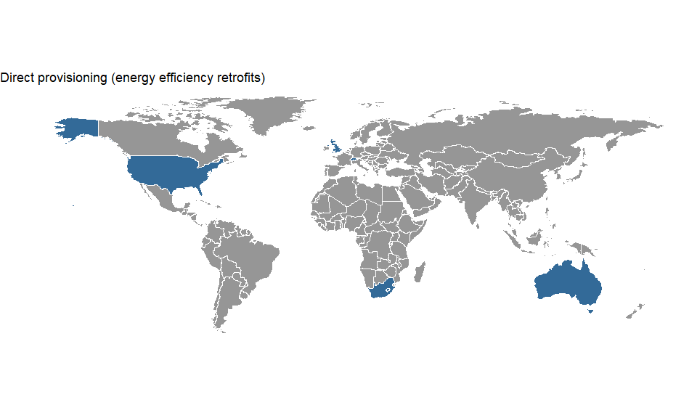

| link | country | policy_name | social_outcome_type | social_outcome | social_outcome_population | social_outcome_population_detail |
| --- | --- | --- | --- | --- | --- | --- |
| http://dx.doi.org/10.1177/1420326X15591637 | Australia | Get Bill Smart | Procedural justice | Mixed (positive and negative) | Everyone targetted by the policy | suburbs of Clarendon Vale and Rokeby, Greater Hobart, Tasmania |
|  | South Africa |  | Affordability (electricity/fuel) | Positive | Everyone targetted by the policy |  |
| http://dx.doi.org/10.1016/j.apenergy.2015.12.028 | Switzerland | Opérations éco-sociales, Communs d’immeubles. | Employment | Positive | Populations external to the society or locality | impact on switzerland as a whole not only Geneva is assessed |
| http://dx.doi.org/10.1177/1420326X17703450 | United Kingdom | Welsh Government’s strategic energy performance investment programme (Arbed phase 2) | Subjective well-being | Positive | Some of those targetted by the policy | focus group participants |
| http://dx.doi.org/10.1177/1420326X17703450 | United Kingdom | Welsh Government’s strategic energy performance investment programme (Arbed phase 2) | Affordability (electricity/fuel) | Positive | Some of those targetted by the policy | focus group participants |
| http://dx.doi.org/10.1177/1420326X17703450 | United Kingdom | Welsh Government’s strategic energy performance investment programme (Arbed phase 2) | Access (other services) | Positive | Some of those targetted by the policy | focus group participants |
| http://dx.doi.org/10.1177/1420326X17703450 | United Kingdom | Welsh Government’s strategic energy performance investment programme (Arbed phase 2) | Procedural justice | Mixed (positive and negative) | Some of those targetted by the policy | some focus group participants |
| http://dx.doi.org/10.1016/S0306-2619(03)00003-5 | United States | Weatherization Assistance Program | Affordability (electricity/fuel) | Positive | Everyone targetted by the policy | water and sewer savings, avoided shut-offs |
| http://dx.doi.org/10.1016/S0301-4215(02)00124-6 | United States | Weatherization Assistance Program | Affordability (electricity/fuel) | Positive | Some of those targetted by the policy | low income households studied (260 households in the sample) |
| http://dx.doi.org/10.1016/S0306-2619(03)00003-5 | United States | Weatherization Assistance Program | Poverty reduction (in general, not limited to affordability/access) | Positive | Everyone targetted by the policy | property value benefits, fewer evictions or involuntary moving, fewer transaction costs of learning about retrofit components individually |
| http://dx.doi.org/10.1016/S0306-2619(03)00003-5 | United States | Weatherization Assistance Program | Affordability (electricity/fuel) | Positive | Everyone in the society or locality | property value benefits, fewer evictions or involuntary moving, fewer transaction costs of learning about retrofit components individually |
| http://dx.doi.org/10.1016/S0306-2619(03)00003-5 | United States | Weatherization Assistance Program | Employment | Positive | A part of the society or locality | employment of people in the  course of weatherizing homes,wh o otherwise would have been unemployed |

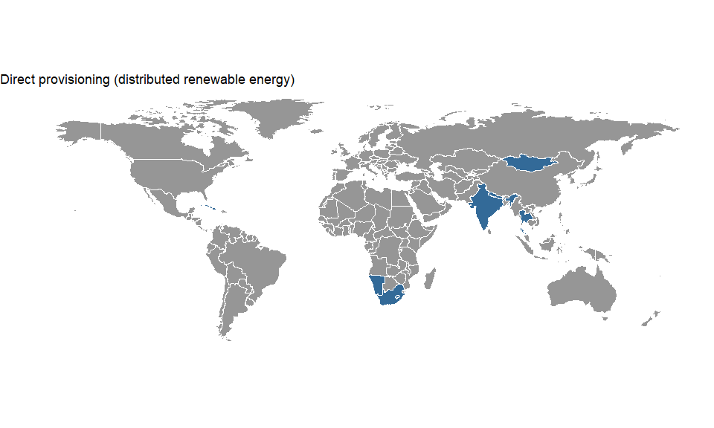

| link | country | policy_name | social_outcome_type | social_outcome | social_outcome_population | social_outcome_population_detail |
| --- | --- | --- | --- | --- | --- | --- |
| http://dx.doi.org/10.1016/j.geoforum.2009.04.001 | Cuba | Various | Poverty reduction (in general, not limited to affordability/access) | Positive | Some of those targetted by the policy | The small rural community of Manantiales was studied in order to assess the structures and processes that mediated between the adoption of energy technology and livelihoods. |
| http://dx.doi.org/10.1016/j.geoforum.2009.04.001 | Cuba | Various | Employment | Mixed (positive and negative) | Some of those targetted by the policy | The small rural community of Manantiales was studied in order to assess the structures and processes that mediated between the adoption of energy technology and livelihoods. |
| http://dx.doi.org/10.1016/j.enpol.2013.12.048 | India | National Biogas and Manure Management Programme | Affordability (electricity/fuel) | Positive | Some of those targetted by the policy | Farmers adopting technology |
| http://dx.doi.org/10.1016/j.enpol.2013.02.006 | India | Village Energy Security Project | Affordability (electricity/fuel) | Positive | Some of those targetted by the policy |  |
| http://dx.doi.org/10.1016/j.enpol.2013.02.006 | India | Village Energy Security Project | Access (other services) |  | Some of those targetted by the policy | Access to cleaner cooking |
| http://dx.doi.org/10.1016/j.enpol.2013.02.006 | India | Village Energy Security Project | Employment | Positive | Some of those targetted by the policy | Access to cleaner cooking |
|  | Lao PDR | Rural Electrification Project Phase 1 | Access (electricity) | Positive | A part of the society or locality | Those becoming electrified |
|  | Lao PDR | Rural Electrification Project Phase 1 | Equality (gender) | Positive | Some of those targetted by the policy | Women targeted by the P2P programm |
|  | Lao PDR | Rural Electrification Project Phase 1 | Access (electricity) | Positive | Everyone targetted by the policy | Women targeted by the P2P programm |
|  | Lao PDR | Rural Electrification Project Phase 1 | Subjective well-being | Positive | Everyone targetted by the policy | Interviews were used and information extrapolated to all those who adopted SHS |
| http://dx.doi.org/10.1016/j.esd.2010.10.004 | Mongolia | Renewable Energy and Rural Electricity Access Project | Access (electricity) | Positive | Everyone targetted by the policy |  |
| http://dx.doi.org/10.1016/j.esd.2010.10.004 | Mongolia | Renewable Energy and Rural Electricity Access Project | Poverty reduction (in general, not limited to affordability/access) |  |  |  |
| http://dx.doi.org/10.1016/j.esd.2010.10.004 | Mongolia | Renewable Energy and Rural Electricity Access Project | Affordability (electricity/fuel) |  |  |  |
| http://dx.doi.org/10.1016/j.esd.2010.10.004 | Mongolia | Renewable Energy and Rural Electricity Access Project | Equality (income) |  |  |  |
| http://dx.doi.org/10.1016/j.renene.2017.01.017 | Namibia | Tsumkwe hybrid mini-grid | Access (electricity) | Positive | A part of the society or locality | Effects on businesses |
| http://dx.doi.org/10.1016/j.renene.2017.01.017 | Namibia | Tsumkwe hybrid mini-grid | Subjective well-being | Positive | Everyone targetted by the policy | Effects on different aspects of well-being. |
| http://dx.doi.org/10.1080/09614524.2011.558062 | Nepal | REDP (Rural Energy Development Program) | Equality (gender) | Mixed (positive and negative) | Some of those targetted by the policy | I selected Kavre district, one of the hill districts lying in the central development region of Nepal. [...] Three villages with access to AETs were selected for a case study. [...] From this case-study approach I developed an analysis of women’s access to and control over the energy resources, fulfilment of women’s practical and strategic needs, their level of participation in programme activities, and their empowerment in relation to enhancing their socio-economic status. |
| http://dx.doi.org/10.1016/j.enpol.2017.03.028 | South Africa | Solar Water Heater Programme | Affordability (electricity/fuel) | Positive | Some of those targetted by the policy | The case location |
| http://dx.doi.org/10.1109/SAEEC.2012.6408584 | South Africa | Cosmo City | Employment | Positive | Everyone targetted by the policy | 118 jobs created in teh community |
| http://dx.doi.org/10.1016/j.enpol.2017.03.028 | South Africa | Solar Water Heater Programme | Employment | Positive | A part of the society or locality | The case location |
| http://dx.doi.org/10.1109/SAEEC.2012.6408584 | South Africa | Cosmo City | Affordability (electricity/fuel) | Positive | Some of those targetted by the policy | Interview respondents |
| http://dx.doi.org/10.1016/j.enpol.2017.03.028 | South Africa | Solar Water Heater Programme | Time/labour/drudgery | Positive | Some of those targetted by the policy | The case location |
| http://dx.doi.org/10.1016/S0301-4215(02)00338-5 | Thailand | Solar battery charging station program | Poverty reduction (in general, not limited to affordability/access) | Insignificant | Some of those targetted by the policy | Local community |
| http://dx.doi.org/10.1016/S0301-4215(02)00338-5 | Thailand | Solar battery charging station program | Access (electricity) | Positive | Some of those targetted by the policy | Local community |