**The size and composition of residual emissions in integrated assessment scenarios at net-zero CO2**

William F. Lamb1,2,*

*1 Mercator Research Institute on Global Commons and Climate Change (MCC)*

*2 University of Leeds*

*\* lamb@mcc-berlin.net*

**Abstract**

Residual emissions are an important category of analysis in climate targets and scenarios, describing the emissions that would need to be compensated by carbon dioxide removal to reach net zero CO2. This article sheds light on the size and composition of residual emissions in integrated assessment modelling (IAM) scenarios at net-zero CO2, using the Intergovernmental Panel on Climate Change (IPCC) 6th Assessment Report (AR6) scenario database. I find that IAMs depict residual emissions levels of 16 [13-22] GtCO2e/yr across below 1.5°C, below 1.5°C with overshoot, and below 2°C scenarios - representing gross emissions reductions of 71 [62-77] % from 2020 to the point of net zero CO2. Emissions from livestock, agriculture, transport, waste and industrial processes remain most prevalent at net zero, with scenario averages tending to depict significantly lower reduction rates and higher residual emissions than those recently published in corporate net zero standards. Nonetheless, scenarios depict a wide range of outcomes across all of these ‘hard-to-abate’ sectors, with lower values characterised by demand-side shifts in the food and energy system, alongside the rapid electrification of end-use sectors and limits on CDR scaling. Current scenario reporting does not easily facilitate the calculation of gross emissions from the AR6 database, which would be a prerequisite to a more systematic exploration of the residual emissions frontier and its implications for climate policy.

Keywords: climate change, greenhouse gas emissions, residual emissions, carbon dioxide removal

1. **Introduction**

Net-zero CO2 implies a period of deep reductions in fossil fuel use and deforestation, followed by a balance of emissions and carbon dioxide removals. This future state would be a necessary condition for stabilising temperatures and limiting dangerous climate change (Allen *et al* 2022, Fankhauser *et al* 2022). But inherent to the net-zero concept is the question of what “residual emissions” would remain once it is reached. This is a topic that has gained increasing attention in the literature (Buck *et al* 2023, Lund *et al* 2023, Schenuit *et al* 2023, Edelenbosch *et al* 2022, Luderer *et al* 2018). However, consensus on the types of gases, economic sectors or activities that residual emissions might be composed of remains elusive.

The problem with residual emissions is that they are a future, unknown quantity dependent on the long-term technological, economic and political prospects of deep decarbonisation. But nevertheless, they have deep significance for climate policy design and its distributional implications. Residual emissions imply that some sectors and geographies will decarbonise to a lesser degree than others. And since CDR is limited by available land, access to geological reservoirs and technological means, the ability to offset residual emissions will vary considerably between nations. On an aggregate level, the higher the amount of residual emissions, the more CDR will be required, the higher the risk that social, environmental or technological constraints for scaling these technologies are exceeded. Pathways with low residual emissions may therefore be the safest course of action for limiting climate change and reversing any potential overshoot.

Policy documents and techno-economic studies often refer to residual emissions as the consequence of ‘hard-to-abate’ sectors. Emissions from livestock, industrial processes and aviation are commonly cited examples, as methane is a by-product of digestion in cattle and other ruminant animals; steel and cement manufacture require carbon feed-stocks; and long-haul flights depend on a certain threshold of fuel energy density. The technical hurdles to reducing emissions in these sectors are therefore significantly higher than, for example, the power sector.

But beyond mere technical considerations, it is clear that ‘hard-to-abate’ is an inherently political category involving conflicting claims on which sectors should be deprioritised in climate mitigation (Schenuit *et al* 2023, Lund *et al* 2023). If a sector is successfully positioned as ‘hard-to-abate’ for political, economic, or strategic reasons – for instance because it is critical to feeding populations or providing employment – then climate policy exemptions or additional state support might be gained. One could of course argue that a uniform carbon price would ultimately resolve which sectors are ‘hard-to-abate’ or not, however the history of climate policy has shown that discursive framing can be a key channel for expressing political power and influencing the implementation, coverage and stringency of policies. The new category of ‘hard-to-abate’ emissions might offer yet another such entry point to climate policy obstruction.

Scientific evidence can provide some grounding for such discussions. In this article I consider one line of evidence for the size and composition of residual emissions at net zero CO2: integrated assessment model (IAM) scenarios. IAMs are simplified representations of the global energy system that model scenarios of technological change and shifts in energy services to meet climate goals in a cost-effective manner. As such, they are suited to considering the techno-economic frontiers of mitigation across different sectors. However, they are less suited to considering the normative or political aspects of climate policy, even if many such aspects are implicitly modelled (e.g. via demand, lifestyle and dietary shifts, as well as regional and intergenerational equity). As IAMs are a prominent source of science-policy advice on the conditions for meeting climate targets, it is of significant interest to understand the size, range and composition of residual emissions in their scenarios.

The research questions of this study are as follows: (1) what is the size and variation in residual emissions across scenarios at the point of net zero CO2? (2) What is the composition of residual emissions in scenarios with respect to gases, sectors and fuels? (3) What scenario characteristics explain variations in total residual emissions and their composition?

The analysis in this manuscript centres on net zero CO2 emissions, rather than net zero GHG emissions. While the latter is a more stringent objective that likely requires even lower residual emissions, it is not always reached in scenarios. Global mitigation objectives derived from the Intergovernmental Panel on Climate Change (IPCC) assessment literature are also strongly oriented around net zero CO2 emissions, which advises for this state to be reached by the mid-century in order to limit warming to below 1.5°C (IPCC 2022).

1. **Method**

My primary data source is the scenario database compiled and vetted for the IPCC 6th Assessment Report (Byers *et al* 2022). I use three categories of scenarios: “below 1.5°C”, “below 1.5°C with overshoot” and “below 2°C scenarios”. These correspond to the IPCC terminology of “C1”, “C2” and “C3” scenarios (IPCC 2022), which are those most relevant to the temperature goal of the Paris Agreement. Only global totals are considered in these scenarios. Further, I use a linear interpolation to estimate data in the years between reported time steps. The complete R code and processed data for this manuscript are available at [Github link].

* 1. *Scenario exclusions*

Many scenarios must be excluded from the analysis due to a lack of data. To achieve a certain granularity of analysis, I consider only scenarios that report 19 separate emissions variables. These include aggregated totals by gas and by sector, and seven subsectors covering more detailed emissions from the AFOLU (Agriculture, forestry and other land use) and energy sectors (Table 1). In addition, only scenarios that report carbon sequestration in the land use and energy supply sectors were selected, as these variables are required to calculate gross emissions.

Finally, I exclude scenarios that do not reach net zero CO2 emissions in the 21st century. The remaining dataset of 156 scenarios comprises 31 below 1.5°C scenarios (out of 70), 43 below 1.5°C with overshoot scenarios (of 106) and 82 below 2°C scenarios (of 231). An important consequence of these exclusions is that only three models are represented in the final dataset: IMAGE, MESSAGE and REMIND.

* 1. *Aggregation of scenario data*

Emissions do not sum reliably across sectors in the AR6 scenario database. To ensure consistent reporting across the hierarchy I therefore created a set of residual “other” categories that capture the difference in the sum of emissions from the subsector to sector level, and the sector to gas level. Total net GHG emissions for each scenario are then calculated as the sum of the individual sectors or gases (CO2, CH4, N2O and F-gases). I use AR6 global warming potentials with a 100 year time horizon (GWP100) (Forster *et al* 2021), but take native GWP100 reporting in the scenario database for F-gases. Following these procedures, the sum of emissions across the resolved sectors still does not equal the “Kyoto gas” total in the AR6 database, however the absolute difference is relatively small (median and 5th-95th percentile: 130 [97-270] MtCO2e in 2050).

* 1. *Methods*

The main analytical task is to calculate total residual emissions at net zero CO2 across scenarios. This requires resolving gross emissions in two sectors that are typically reported as net fluxes including removals: “CO2|AFOLU” and “CO2|Energy|Supply”. To these sectors I add the absolute value of the “Carbon Sequestration|Land Use” and “Carbon Sequestration|CCS|Biomass” sectors, respectively. This assumes that all biomass based CCS is applied in the energy supply sector. This is not the case for some IMAGE 3.2 scenarios, which also include biomass based CCS for industrial processes, which I specifically allocate to the industrial process sector. If further carbon sequestration variables are reported for a given scenario (e.g. for direct air capture, enhanced weathering, feedstocks, and other), I add these to a residual gross emissions category called “CO2|Other”. Note that Prütz et al. (2023) follow a similar procedure, but find that the resulting gross land use emissions are not always positive – a definitional inconsistency. I nonetheless retain the scenarios where this is the case, as the gross “negative” emission level is relatively small (-0.18 [-0.033 to -0.54] GtCO2) and excluding them would remove 50 REMIND and 4 IMAGE scenarios and significantly dilute the dataset.

Following these procedures, gross emissions are resolved into the sectors and subsectors shown in Table 1. Overall residual emissions are then calculated the sum of these at the reported year of net zero CO2 for each scenario. Whenever data is summarised across groups of scenarios, I report the median and 5th-95th percentiles.

To evaluate which groups of scenarios share similar residual emissions outcomes, I perform a cluster analysis using a k-means algorithm on the subsector level emissions across all scenarios. Subsector emissions were re-scaled by subtracting the population mean and dividing by the population standard deviation for comparability between each metric. Results for 3, 4 and 5 clusters are shown. In addition, I perform a principal component analysis on the same standardized data with the same goal: to identify any clustering of scenarios along the latent vectors that explain the majority of data variance.

1. **Results**
   1. *Total residual emissions at net zero CO2*

Scenarios reduce CO2 emissions on average by 81 [67-85] % from 2020 to the point of net zero, where they reach a total of 8.4 [6.1-14] GtCO2/yr. Differences across this range are to a large extent driven by the temperature limit achieved: below 1.5°C scenarios have the deepest CO2 reductions and lowest residual emissions, followed by below 1.5°C with overshoot and below 2°C scenarios (Table 1). Below 1.5°C scenarios also reach net zero 6 years earlier than below 1.5°C with overshoot scenarios, and 18 years earlier than below 2°C scenarios.

Despite these differences, scenarios converge on very similar levels of residual GHG emissions. Across the ensemble these are reduced by 71 [62-77] % from 2020 to 16 [13-22] GtCO2e/yr – almost double that of residual CO2 emissions. Median residual GHG emissions range by just 2 GtCO2e/yr between the temperature categories.

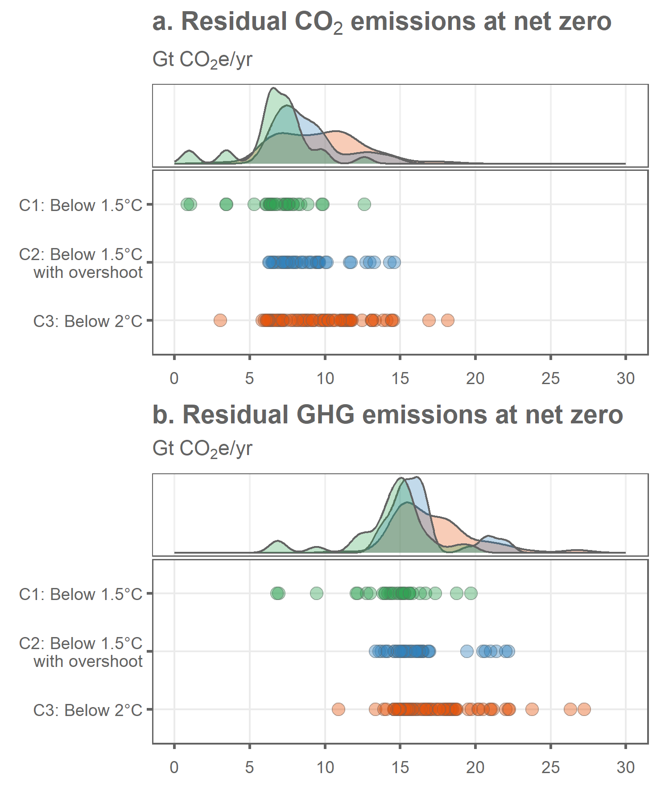

**Figure 1: Total residual emissions across scenarios.** Gross emissions are estimated as the sum of emissions by sector and carbon dioxide removals.

|  |  |  |  |  |  |  |
| --- | --- | --- | --- | --- | --- | --- |
| Scenario category | No. scenarios | Year of net zero CO2 | Residual CO2 emissions (GtCO2/yr) | CO2 reduction from 2020 (%) | Residual GHG emissions (GtCO2e/yr) | GHG reduction from 2020 (%) |
| C1-C3 | 156 | 2066  [2047-2083] | 8.4  [6.1-14] | 81  [67-85] | 16  [13-22] | 71  [62-77] |
| C1: Below 1.5°C | 31 | 2054  [2044-2068] | 6.8  [2.3-9.8] | 83  [76-95] | 15  [8.2-18] | 72  [68-85] |
| C2: Below 1.5°C with overshoot | 43 | 2060  [2047-2066] | 8.1  [6.5-13] | 81  [68-84] | 16  [14-21] | 71  [62-76] |
| C3: Below 2°C | 82 | 2072  [2061-2090] | 9.7  [6.1-14] | 77  [66-84] | 17  [15-22] | 70  [61-74] |

**Table 2: Median net zero years and total residual emissions across scenarios.** Ranges in the square brackets indicate the 5th-95th percentiles.

* 1. *The composition of residual emissions at net zero CO2*

Levels of residual CH4 and N2O emissions are relatively consistent in scenarios, regardless of model and temperature category (Figure 2a). Across the ensemble, CH4 emissions at net zero total 4.4 [3.7-5.5] GtCO2e/yr and N2O emissions total 2 [1.9-3.3] GtCO2e/yr. Scenarios also sustain residual F-gases of 0.24 [0.17-1.1] GtCO2e/yr, however unabated F-gases are more prevalent in the MESSAGE model at around 1 GtCO2e/yr (Figure 2a). As shown previously, there is significantly more variation in residual CO2 emissions at net zero compared to CH4 and N2O (Table 2; Figure 2a).

Total residual GHG emissions are primarily situated in the Energy and AFOLU sectors (Figure 2b). Across the ensemble, these account for emissions of 7 [4.9-11] GtCO2e/yr and 5.7 [4.8-8.6] GtCO2e/yr, respectively. Emissions from Industrial processes, F-gases and other activities account for the remaining 3.4 [2-4.1] GtCO2e/yr. However, there are some differences across scenarios, mainly driven by the model type: IMAGE reports relatively higher Energy and Other emissions compared to the median, while IMAGE and REMIND report relatively higher AFOLU emissions (Figure 2b).

Although all scenarios represent a deep transition of the global energy system away from fossil fuels, none complete this transition by the point of net zero (Figure 2c). Unabated fossil fuel use in primary energy supply stands at 110 [74-190] EJ across the ensemble: approximately 1/6th of the total (630 [480-780] EJ), with the remainder serviced by renewables, biomass and nuclear power (Figure 2c). However, models significantly differ in their outcomes. IMAGE deploys oil, gas or coal with CCS at levels far above the ensemble median: at 130 [76-170] EJ/yr compared to 39 [14-150] EJ/yr. Conversely, MESSAGE tends towards a relatively deep phase down of unabated oil use at 32 [25-37] EJ/yr (ensemble median: 42 [26-89] EJ/yr); while REMIND tends to a deep phase down of gas use at 33 [17-60] EJ/yr (ensemble median: 58 [26-120] EJ/yr). Unabated coal (i.e. without CCS) is almost entirely absent across the scenario ensemble.

Although Figure 2c depicts varying total levels of primary energy supply, it shows scenario outcomes at different points in time for an indicator which continuously grows throughout the 21st century. When compared in the same year (e.g. 2050), scenarios are relatively consistent at 540 [480-590] EJ/yr. None achieve the very low levels of primary energy supply (290EJ/yr in 2050) depicted in the Low Energy Demand scenario by Grubler et al. (2018).

Of all subsectors, the energy supply sector has the deepest reductions and lowest relative residual emissions compared to 2020 at -91 [-79 to -96] % across all scenarios (Figure 3b). However, these emissions do tend to be higher and have a wider spread of outcomes in the IMAGE model. Similarly, there are deep – but not complete – reductions in fugitive methane emissions (“Energy|CH4”) across all models (Figure 3b). Among the energy demand sectors, transport tends to have the lowest relative reductions and highest residual emissions at net zero, followed by industry and buildings (“Energy|CO2|Residential and Commercial”).

Scenarios are far more diverse in their residual AFOLU emissions. Whereas CO2 from land use is consistently almost eliminated in REMIND – and severely curtailed in MESSAGE – IMAGE depicts a wide range of outcomes and median of -46% reductions. Consequently, CH4 emissions from livestock (specifically enteric fermentation) are typically the largest remaining component of residual AFOLU emissions, followed by N2O emissions (Figure 3a). These categories are reduced by -37 [-6 to -42] % and -23 [+17 to -24] %, respectively.

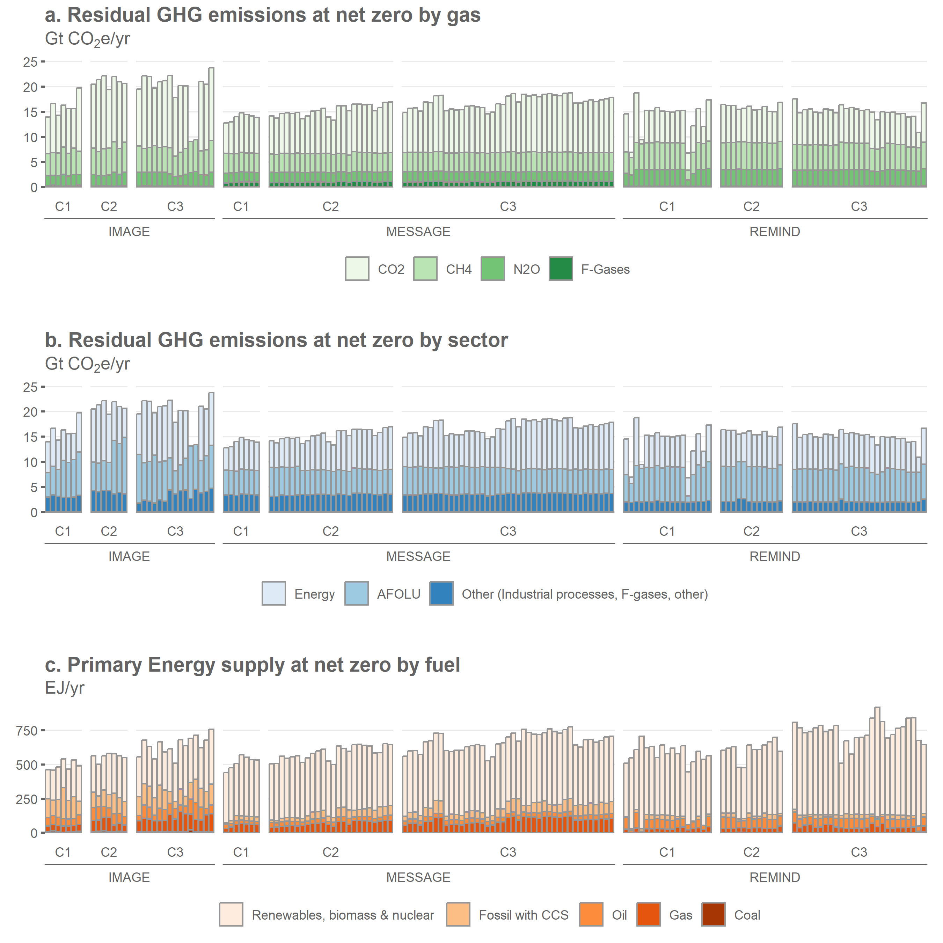

**Figure 2: Residual GHG emissions by gas, sector and fuel.** Note that the year corresponding to net zero CO2 varies for each scenario, as summarised in Table 2. Total primary energy supply levels should therefore not be compared between scenarios, as this indicator continuously grows throughout the 21st century.

In the remaining ‘Other’ sector, CH4 emissions (i.e. from waste) are typically the largest residual sector, with an average of -54 [-46 to -48] % reductions. Industrial process emissions are very low in REMIND, but relatively higher in the MESSAGE and IMAGE models. Note that the large gross emissions in the “CO2|Other” category for IMAGE are due to the allocation of removals from direct air capture to this sector.

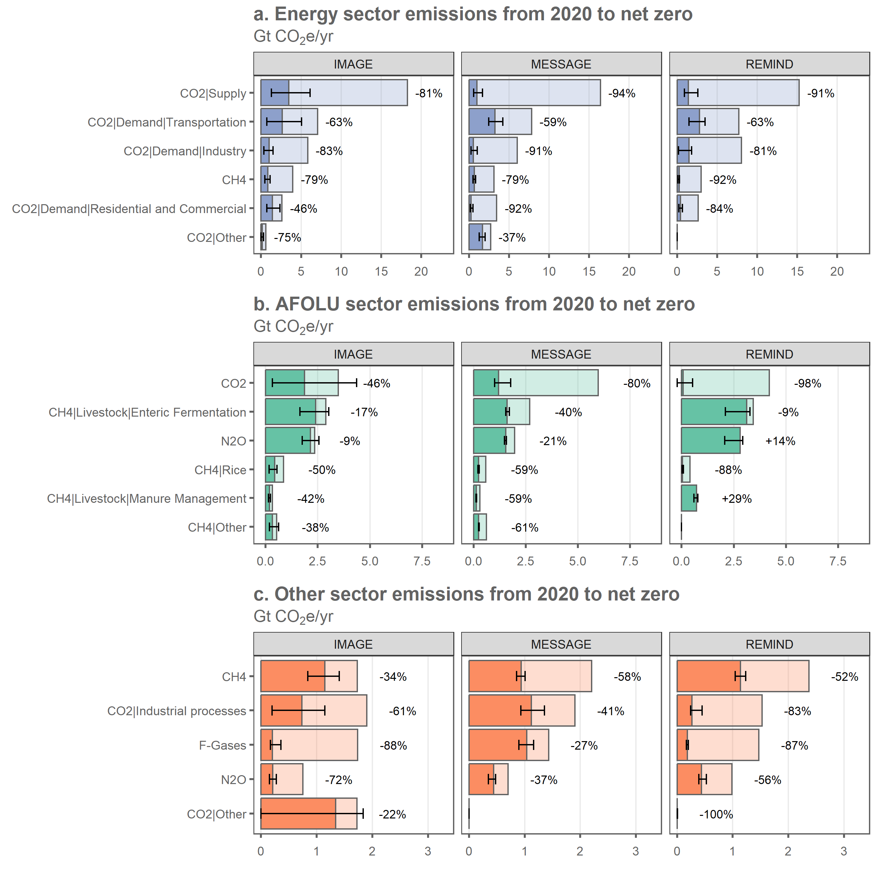

**Figure 3: Energy, AFOLU and Other sector emissions from 2020 to net zero.** Each column represents the multi-scenario median from the models IMAGE, MESSAGE and REMIND. Error bars represent the 5th-95th percentile of scenarios in each model category. Note that negative gross emissions are not possible, but can be found in some cases, suggest accounting inconsistencies around carbon sequestration (Prütz et al 2023). These are found here in the lower percentile of REMIND model results for the “AFOLU|CO2|Land use” sector.

* 1. *Explaining variations in residual emissions*

In the prior analysis of sector and subsector emissions, reporting was organised around model family. To test this assumption that models are critical to explaining variations in residual emissions, I performed a principal component and cluster analysis. The first two principal components explaining 76% of variance in residual emissions at the subsector level show a strong three-way grouping according to model type, with the IMAGE model having the largest spread of outcomes (SI Figure 1). In addition, a k-means analysis – again at the subsector level – resolves one cluster each for IMAGE, MESSAGE and REMIND at 3 clusters. Further numbers of clusters tend to depict additional variance within the models until 5 clusters are reached (SI Table 1). In other words, scenarios that have similar outcomes in terms of subsector residual emissions tend to belong to the same model family.

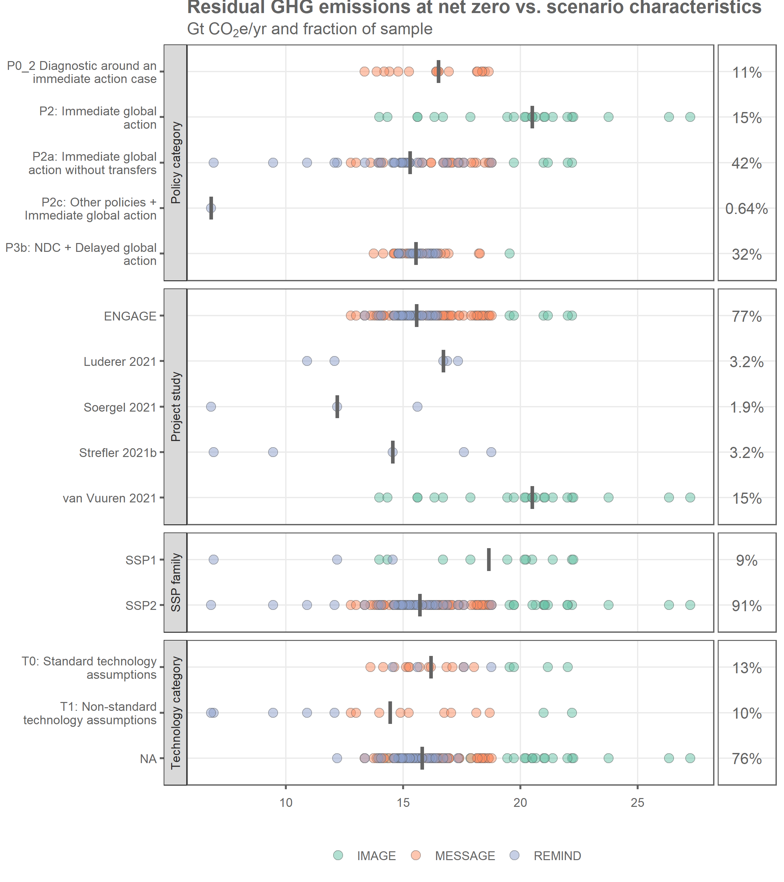

**Figure 4: Scenario characteristics and residual emissions at net zero.** Each row depicts the spread of residual GHG emissions at net zero for scenarios with the given characteristic, with vertical lines depicting the row-wise median. The fraction of the row-wise sample is given in the right column (out of a total of 156 scenarios).

The AR6 scenario database provides some high-level scenario characteristics to aid inter-comparison, namely the “policy category”, “project study”, “SSP family” and “technology category” variables. However, descriptively, these characteristics do not provide significant insight on why total residual emissions vary between scenarios (Figure 4). Further, several characteristics are highly weighted in the sample and correlate with the model family. For instance, when discarding the three policy categories that are entirely weighted by model family, median total residual GHG emissions are highly similar between immediate (P2c) and delayed action (P3b) scenarios (Figure 4). In addition, a significant majority of scenarios are sourced from the ENGAGE project (77% of total), the SSP2 “Middle of the Road” pathway (91%), and do not report any distinguishing technology characteristics (76%). However, a handful of studies are responsible for delivering a set of REMIND scenarios with the lowest residual emissions in the ensemble (Strefler *et al* 2021, Luderer *et al* 2022, Soergel *et al* 2021).

1. Discussion

In this article I assess the level and composition of residual GHG emissions in AR6 scenarios. An important motivation for this is simple transparency: as discussions of net zero move into practice, there are increasing calls to distinguish gross emissions and removals in pledges, plans and policies (Rogelj *et al* 2021, Buck *et al* 2023). It would be similarly desirable to achieve such transparency in the scenario literature, which is an influential source of climate policy advice. Countries are now starting to adopt scenarios in their long-term low emissions development strategies, making it even more important to elevate transparency standards and ensure these are open for critical appraisal (Smith *et al* 2022).

As it stands, a relatively complex set of procedures are required to calculate residual emissions in the current iteration of the IPCC scenario database. Such information could be put further within reach if gross emissions and removals were reported separately in each relevant sector. This becomes increasingly relevant as new CDR technologies that belong to neither the land use nor the energy supply sectors are integrated into scenarios. For instance, it is currently unclear which gross emissions are offset by direct air capture, which are here allocated to a residual “CO2|Other” category. Similar problems will arise when enhanced weathering or blue carbon technologies are implemented. Separate reporting would also help to diagnose inconsistencies, such as when gross land use emissions are resolved as negative (Prütz *et al* 2023).

A striking result of this analysis is the overall expected level of residual emissions at net zero CO2 in scenarios: 8.4 [6.1-14] GtCO2/yr across the ensemble, representing gross emissions reductions of 81 [67-85] % from 2020. This contrasts with expectations now being set in a string of corporate net zero standards that benchmark significantly deeper reductions of up to 95% in energy and industrial process CO2 emissions (ISO 2023, SBTi 2023). Indeed, scenarios depict lower reductions and higher residual emissions across all sectors that are comparable to the SBTi standards (Table 3). Of course, scenarios must reflect regional variations in transition speeds, whereas corporate-oriented targets can afford to set stringent benchmarks and anchor higher ambition. However, it does suggest an emerging divide in expert assessments on how low residual emissions might go. This has also been reflected in a recent assessment of Germany’s net zero plan, where the legal benchmark of 97% reductions from 1990 (leaving residual emissions of ~40MtCO2e) remained significantly below even the most ambitious modelled scenario (Merfort *et al* 2023).

The challenge of residual emissions is that a wide array of factors may lead to differences in assessments. In particular, the system boundaries concerning the scope of gases and emissions sources matters – scenarios that covers not just energy system CO2 emissions, but also industrial processes, land use fluxes, agricultural CH4 and N2O, and the waste sector will tend to show progressively higher residual emissions. This scope will likely continue to expand as peatland emissions are integrated into modelling frameworks (Loisel *et al* 2021).

As it stands, however, very few models report a wide scope of detail across these emissions categories. Only 52% of scenarios in the AR6 database report agricultural emissions, while 46% capture more detailed categories such as livestock or managed soils – a reflection of the still limited state of land use model integration in IAMs. Another widely cited example of a ‘hard-to-abate’ sector is aviation, yet just 2% of scenarios report emissions at this level. While it is important not to seek a false level of precision around expectations of residual emissions, a minimum degree of reporting will be required to facilitate inter-comparison and reflection on the various possible futures.

|  |  |  |  |  |
| --- | --- | --- | --- | --- |
|  | Science Based Targets initiative | Below 1.5°C scenarios | Below 1.5°C with overshoot scenarios | Below 2°C scenarios |
|  | Reductions by 2050 (%) | Reductions by net zero CO2 (%) | | |
| Forest, land and agriculture | 72 | 39 [27-65] | 53 [4.4-60] | 53 [27-61] |
| Power | 100 | 92 [88-97] | 92 [84-96] | 91 [75-96] |
| Cement | 95 | 84 [78-98] | 81 [72-86] | 78 [69-85] |
| Iron and steel | 93 | 84 [78-98] | 81 [72-86] | 78 [69-85] |
| Service buildings | 99,6 | 84 [50-98] | 91 [16-96] | 86 [36-95] |
| Residential buildings | 97,9 | 84 [50-98] | 91 [16-96] | 86 [36-95] |

**Table 3: Sector-based reduction targets in corporate net zero standards versus global reductions in scenarios by net zero CO2.** Note that insufficient data is present in the AR6 database to distinguish cement versus iron and steel emissions. These sectors are here mapped to the "CO2|Energy|Demand|Industry" and "CO2|Industrial processes" variables in the AR6 database. Similarly, service and residential buildings are mapped to the "CO2|Energy|Demand|Residential and Commercial" variable. Sources: SBTi (2023), Byers et al. (2022).

Inter-comparison of the AR6 database scenarios is further hindered by a lack of descriptive variables characterising each pathway. But sampling the set of scenarios at the lower end of residual GHG emissions (e.g. <12 GtCO2e/yr at net zero) suggests a number of strategies. The first is to resolve land-based impacts through a reduction of food waste and a transition to healthy and sustainable diets, namely via a significant increase in the dietary share of plant based proteins. Soergel et al. (2021) increase this share to ~80% and observe rapid reductions in agricultural N20 and CH4 emissions, which also facilitates a higher CO2 budget for meeting the 1.5°C target. The second is to focus on a particularly deep decarbonisation of the energy system, which is implemented in Luderer (2022) via the electrification of end-use technologies in the transport, industry and buildings sectors, supported by a rapid scale-up of solar power and wind generation. The third is to limit CDR availability, as in Strefler (2021), which constrains models to implementing deeper gross emissions reductions at higher costs. Finally, cross-cutting demand-side measures appear to have particular resonance for mitigating emissions in ‘hard-to-abate’ sectors. This is the case for not just sustainable diets, but also through de-incentivising aviation, reducing building floor areas, and limiting material demand – all of which cumulate to residual emissions of ~10 GtCO2e/yr in 2060 in one recent scenario that is not in the AR6 database (Edelenbosch *et al* 2022).

1. Conclusion

As countries begin to design their pathways to net zero, the topic of residual emissions will gain increasing resonance. The scenario literature suggests a wide range of possible outcomes, with relatively little reflection to date on the size and composition of these emissions.

A specific policy demand that is emerging is the question of “how much carbon dioxide removal will be needed” (Smith *et al* 2023). This question is consequential for understanding the degree of policy effort required to establish CDR technologies – and whether we are off track in this domain of climate mitigation, in addition to emissions reductions. Of course, different levels of residual emissions and consequent CDR deployments are possible, but arguably the frontier of minimal residual emissions in scenarios remains unknown. Given the cost-optimisation nature of IAMs, strategies that limit CDR or execute extremely high carbon prices may be needed to systematically explore this frontier.

The categories of residual emissions and ‘hard-to-abate’ sectors would seem to add to the complexity of climate policy. Further, they enable another level of subjectivity with regards to where efforts should take place and where difficulties will be met. However, it is also unambiguously clear that a wide range of short-term, effective and necessary intervention points exist to phase-out fossil fuels and eliminate deforestation. It is only through learning by doing that residual emissions will finally become known.

**Acknowledgement**

William F. Lamb was supported by the ERC-2020-SyG "GENIE" (grant ID 951542). I thank Jan Minx and Mathew Gidden for insights on the analysis and discussion in this manuscript.

Old text

Advocates of stronger climate policy might note that claims a sector is “hard-to-abate” can be challenged if alternative forms of provisioning and shifts in demand are considered. For instance, livestock or aviation may not be integral to satisfying human needs and could therefore be challenged from a normative perspective (Lund *et al* 2023). [FEASIBILITY??] Hence, any discussion of residual emissions cannot be decoupled from the political and normative, as well as technical, aspects of decarbonisation pathways.

The concept of net-zero CO2 raises the question of what “residual emissions” will remain once it is reached. These are the emissions that would still be released on an annual basis after a period of deep reductions in fossil fuel use and deforestation. They would need to be balanced with carbon dioxide removal (CDR) as a pre-requisite to stabilising temperatures and limiting dangerous climate change (Allen *et al* 2022, Fankhauser *et al* 2022). While residual emissions are now receiving increasing attention in the literature (Buck *et al* 2023, Lund *et al* 2023, Schenuit *et al* 2023, Edelenbosch *et al* 2022), consensus on what types of gases, economic sectors or activities they might be composed of remains elusive.

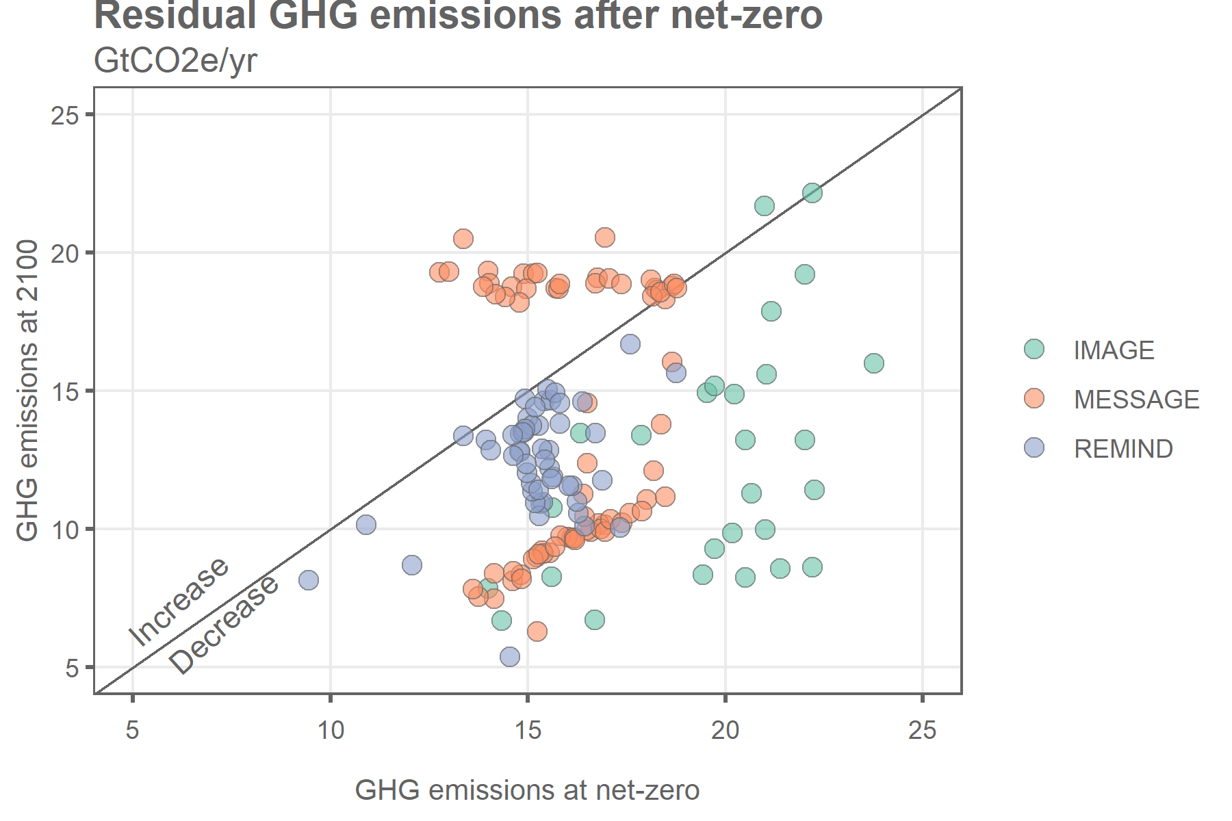

References

Allen M R, Friedlingstein P, Girardin C A J, Jenkins S, Malhi Y, Mitchell-Larson E, Peters G P and Rajamani L 2022 Net Zero: Science, Origins, and Implications *Annu. Rev. Environ. Resour.* **47** annurev-environ-112320-105050

Buck H J, Carton W, Lund J F and Markusson N 2023 Why residual emissions matter right now *Nat. Clim. Chang.* **13** 351–8

Byers, Edward, Krey V, Kriegler E, Riahi K, Schaeffer R, Kikstra J, Lamboll R, Nicholls Z, Sandstad M, Smith C, van der Wijst K, Al Khourdajie A, Lecocq F, Portugal-Pereira J, Saheb Y, Stromann A, Winkler H, Auer C, Brutschin E, Gidden M, Hackstock P, Harmsen M, Huppmann D, Kolp P, Lepault C, Lewis J, Marangoni G, Müller-Casseres E, Skeie R, Werning M, Calvin K, Forster P, Guivarch C, Hasegawa T, Meinshausen M, Peters G, Rogelj J, Samset B, Steinberger J, Tavoni M and van Vuuren D 2022 *AR6 Scenarios Database hosted by IIASA* (International Institute for Applied Systems Analysis) Online: https://doi.org/10.5281/zenodo.5886911

Edelenbosch O, van den Berg M, De Boer H S, Chen H, Daioglou V, Dekker M, Doelman J, den Elzen M, Frinking V, Harmsen M, Hof A F, Mikropoulos E, van Sluisveld M, Tagomori I and Van Vuuren D P 2022 *Mitigating greenhouse gas emissions in hard-to-abate sectors* (The Hague: PBL Netherlands Environmental Assessment Agency) Online: https://www.pbl.nl/sites/default/files/downloads/pbl-2022-mitigating-greenhouse-gas-emissions-in-hard-to-abate-sectors-4901.pdf

Fankhauser S, Smith S M, Allen M, Axelsson K, Hale T, Hepburn C, Kendall J M, Khosla R, Lezaun J, Mitchell-Larson E, Obersteiner M, Rajamani L, Rickaby R, Seddon N and Wetzer T 2022 The meaning of net zero and how to get it right *Nat. Clim. Chang.* **12** 15–21

Forster P, Storelvmo T, Armour K, Collins W, Dufresne J-L, Frame D, Lunt D J, Mauritsen T, Palmer M D, Watanabe M, Wild M and Zhang H 2021 Chapter 7: The Earth’s Energy Budget, Climate Feedbacks and Climate Sensitivity *Climate Change 2021: The Physical Science Basis. Contribution of Working Group I to the Sixth Assessment Report of the Intergovernmental Panel on Climate Change* (Cambridge, United Kingdom and New York, NY, USA: Cambridge University Press) pp 923–1054

Grubler A, Wilson C, Bento N, Boza-kiss B, Krey V, Mccollum D L, Rao N D, Riahi K, Rogelj J, Stercke S D, Cullen J, Frank S, Fricko O, Guo F, Gidden M, Havlík P, Huppmann D, Kiesewetter G, Rafaj P, Schoepp W and Valin H 2018 A low energy demand scenario for meeting the 1.5oC target and sustainable development goals without negative emissions technologies *Nature Energy* **3** 515–27

IPCC 2022 Summary for Policymakers *Climate Change 2022: Mitigation of Climate Change. Contribution of Working Group III to the Sixth Assessment Report of the Intergovernmental Panel on Climate Change* ed P R Shukla, J Skea, R Slade, A Al Khourdajie, R van Diemen, D McCollum, M Pathak, S Some, P Vyas, R Fradera, M Belkacemi, A Hasija, G Lisboa, S Luz and J Malley (Cambridge, UK and New York, NY, USA: Cambridge University Press) Online: https://www.ipcc.ch/report/ar6/wg3/downloads/report/IPCC_AR6_WGIII_SPM.pdf

ISO 2023 *IWA 42:2022(en) Net zero guidelines* (Geneva, Switzerland: International Standards Organisation (ISO)) Online: https://www.iso.org/obp/ui/en/#iso:std:iso:iwa:42:ed-1:v1:en

Loisel J, Gallego-Sala A V, Amesbury M J, Magnan G, Anshari G, Beilman D W, Benavides J C, Blewett J, Camill P, Charman D J, Chawchai S, Hedgpeth A, Kleinen T, Korhola A, Large D, Mansilla C A, Müller J, Van Bellen S, West J B, Yu Z, Bubier J L, Garneau M, Moore T, Sannel A B K, Page S, Väliranta M, Bechtold M, Brovkin V, Cole L E S, Chanton J P, Christensen T R, Davies M A, De Vleeschouwer F, Finkelstein S A, Frolking S, Gałka M, Gandois L, Girkin N, Harris L I, Heinemeyer A, Hoyt A M, Jones M C, Joos F, Juutinen S, Kaiser K, Lacourse T, Lamentowicz M, Larmola T, Leifeld J, Lohila A, Milner A M, Minkkinen K, Moss P, Naafs B D A, Nichols J, O’Donnell J, Payne R, Philben M, Piilo S, Quillet A, Ratnayake A S, Roland T P, Sjögersten S, Sonnentag O, Swindles G T, Swinnen W, Talbot J, Treat C, Valach A C and Wu J 2021 Expert assessment of future vulnerability of the global peatland carbon sink *Nat. Clim. Chang.* **11** 70–7

Luderer G, Madeddu S, Merfort L, Ueckerdt F, Pehl M, Pietzcker R, Rottoli M, Schreyer F, Bauer N, Baumstark L, Bertram C, Dirnaichner A, Humpenöder F, Levesque A, Popp A, Rodrigues R, Strefler J and Kriegler E 2022 Impact of declining renewable energy costs on electrification in low-emission scenarios *Nat Energy* **7** 32–42

Luderer G, Vrontisi Z, Bertram C, Edelenbosch O Y, Pietzcker R C, Rogelj J, De Boer H S, Drouet L, Emmerling J, Fricko O, Fujimori S, Havlík P, Iyer G, Keramidas K, Kitous A, Pehl M, Krey V, Riahi K, Saveyn B, Tavoni M, Van Vuuren D P and Kriegler E 2018 Residual fossil CO2 emissions in 1.5-2°C pathways *Nature Climate Change* **8** 626–33

Lund J F, Markusson N, Carton W and Buck H J 2023 Net zero and the unexplored politics of residual emissions *Energy Research & Social Science* **98** 103035

Merfort A, Stevanovic M and Strefler J 2023 *Energiewende auf Netto-Null - Passen Angebot und Nachfrage nach CO2-Entnahme aus der Atmosphäre zusammen?* (Potsdam: Kopernikus-Projekt Ariadne)

Prütz R, Strefler J, Rogelj J and Fuss S 2023 Understanding the carbon dioxide removal range in 1.5 °C compatible and high overshoot pathways *Environ. Res. Commun.* **5** 041005

Rogelj J, Geden O, Cowie A and Reisinger A 2021 Net-zero emissions targets are vague: three ways to fix *Nature* **591** 365–8

SBTi 2023 *SBTi Corporate Net-Zero Standard* (Science Based Targets Initiative) Online: https://sciencebasedtargets.org/resources/files/Net-Zero-Standard.pdf

Schenuit F, Böttcher M and Geden O 2023 “Carbon Management”: Opportunities and risks for ambitious climate policy

Smith H B, Vaughan N E and Forster J 2022 Long-term national climate strategies bet on forests and soils to reach net-zero *Commun Earth Environ* **3** 305

Smith S M, Geden O, Nemet G F, Gidden M J, Lamb W F, Powis C, Bellamy R, Callaghan M W, Cowie A, Cox E, Fuss S, Gasser T, Grassi G, Greene J, Lück S, Mohan A, Müller-Hansen F, Peters G P, Pratama Y, Repke T, Riahi K, Schenuit F, Steinhauser J, Strefler J, Valenzuela J M and Minx J C 2023 *The State of Carbon Dioxide Removal - 1st Edition* Online: Available at: https://www.stateofcdr.org

Soergel B, Kriegler E, Weindl I, Rauner S, Dirnaichner A, Ruhe C, Hofmann M, Bauer N, Bertram C, Bodirsky B L, Leimbach M, Leininger J, Levesque A, Luderer G, Pehl M, Wingens C, Baumstark L, Beier F, Dietrich J P, Humpenöder F, von Jeetze P, Klein D, Koch J, Pietzcker R, Strefler J, Lotze-Campen H and Popp A 2021 A sustainable development pathway for climate action within the UN 2030 Agenda *Nat. Clim. Chang.* **11** 656–64

Strefler J, Bauer N, Humpenöder F, Klein D, Popp A and Kriegler E 2021 Carbon dioxide removal technologies are not born equal *Environ. Res. Lett.* **16** 074021