Four ways to talk about residual emissions

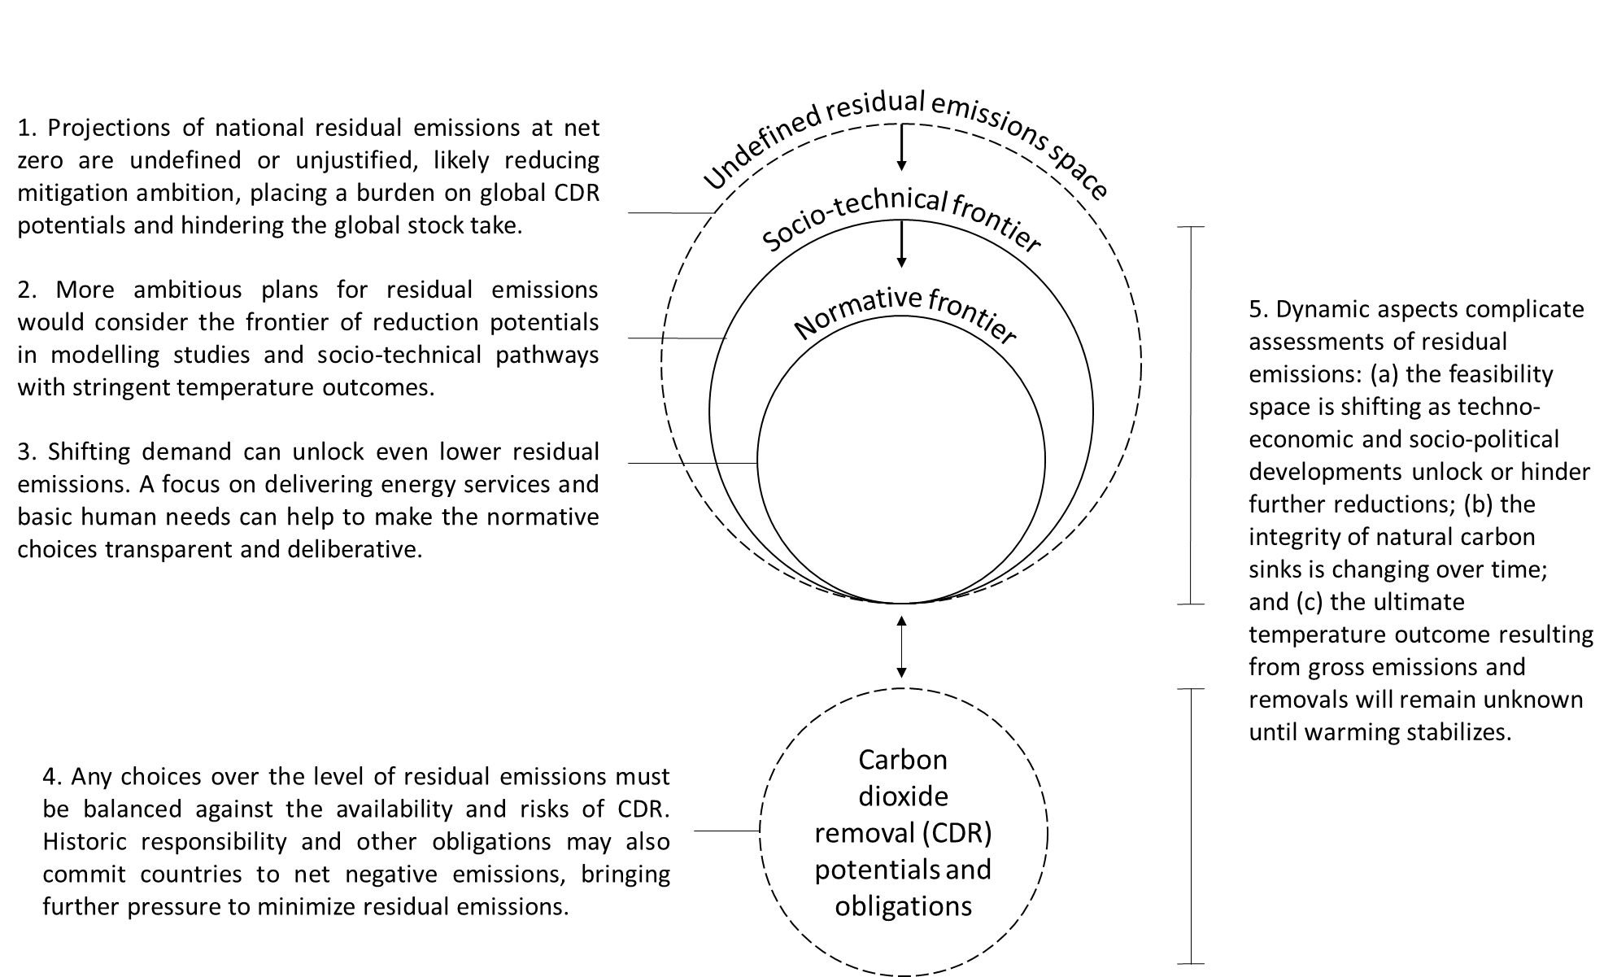

1. Introduction

* A common refrain in the literature and in net zero policy documents is that carbon dioxide removal (CDR) is necessary to offset “residual emissions” and reach net zero emissions. These residual emissions remain because some sectors are “hard to mitigate”.
* What are these residual emissions and why are they hard to mitigate?
* This question has received relatively little attention, despite recent efforts to develop rigorous definitions of “net zero” and a shared lexicon of relevant terms. [List UNFCCC lexicon, SBTi definitions, etc.]

1. Residual emissions as a technological frontier
2. Residual emissions as techno-economic choices
3. Residual emissions as normative choices
4. Residual emissions as a trade-off with carbon dioxide removals

|  |  |  |
| --- | --- | --- |
| Orientation | Overarching question | Evidence basis |
| Technological frontier | What residual emissions remain after exploiting the full breadth of technically feasible mitigation options, while delivering expected service demand? |  |
| Techno-economic choices | What residual emissions remain after exploiting economically feasible mitigation options, including shifts in demand to deliver expected services? |  |
| Normative choices | What residual emissions remain after |  |
| CDR trade-off |  |  |