residual_emissions_scenarios

William F. Lamb

5 12 2022

median_and_range <- function(data,grouping_vars) {  
   
 data <- data %>%   
 group_by_at(grouping_vars) %>%   
 summarise(median = signif(median(value),2),  
 percentile_5th = signif(quantile(value, probs = c(0.05)),2),  
 percentile_95th = signif(quantile(value, probs = c(0.95)),2)) %>%   
 mutate(value=paste0(median," [",percentile_5th,"-",percentile_95th,"]")) %>%   
 select(-median,-percentile_5th,-percentile_95th)  
   
}

## identify gases in the scenario data  
wd_scenarios_emissions <- data_r1 %>%   
 ungroup() %>%   
 mutate(gas=ifelse(grepl("CO2",var),"CO2",NA)) %>%   
 mutate(gas=ifelse(grepl("CH4",var),"CH4",gas)) %>%   
 mutate(gas=ifelse(grepl("N2O",var),"N2O",gas)) %>%   
 mutate(gas=ifelse(grepl("F-Gases",var),"F-Gases",gas)) %>%   
 mutate(gas=ifelse(grepl("Kyoto Gases",var),"Kyoto Gases",gas)) %>%   
 select(-region)  
  
  
## join GWPs and calculate CO2e by sector  
wd_scenarios_emissions <- left_join(wd_scenarios_emissions,cc_gwps %>%   
 select(gas,gwp100_ar6) %>%   
 mutate(gwp100_ar6=ifelse(gas=="CH4",27,gwp100_ar6)),by="gas")  
  
wd_scenarios_emissions <- wd_scenarios_emissions %>%   
 mutate(gwp100_ar6=ifelse(unit=="Mt CO2-equiv/yr",1,gwp100_ar6)) %>%   
 mutate(value=ifelse(unit=="kt N2O/yr",value/1000,value)) %>% # N2O is in kt, not Mt   
 mutate(value_gwp=value*gwp100_ar6) %>%   
 select(-value,-gwp100_ar6)  
  
  
## create unique scenario IDs  
wd_scenarios_emissions <- wd_scenarios_emissions %>%   
 mutate(id=paste0(model,"|",scenario)) %>%   
 select(id,everything()) %>%   
 arrange(id)  
  
  
## exclude scenarios based on whether they have semi-detailed sector data  
cc_sectors <- read.xlsx("../Data/scenario_sector_mapping.xlsx",sheet=2)  
cc_scenarios <- left_join(wd_scenarios_emissions,cc_sectors %>% select(var) %>% mutate(include=1),by="var")  
cc_scenarios <- cc_scenarios %>%   
 ungroup() %>%   
 select(-unit,-gas) %>%   
 filter(year==2050) %>%   
 filter(include==1)  
cc_scenarios <- spread(cc_scenarios,var,value_gwp)  
# Manually fill Emissions|CO2|Other as this is important for resolving totals in some scenarios, but isn't universally available  
cc_scenarios <- cc_scenarios %>%   
 mutate(`Emissions|CO2|Other`=ifelse(is.na(`Emissions|CO2|Other`),0,`Emissions|CO2|Other`))  
cc_scenarios <- cc_scenarios %>%   
 na.omit() %>%   
 select(id)  
  
wd_scenarios_emissions <- left_join(wd_scenarios_emissions,cc_scenarios %>% mutate(include=1),by="id") %>%   
 filter(include==1) %>%   
 select(-include)  
  
  
## rejoin the list of emissions sectors  
wd_scenarios_emissions <- left_join(wd_scenarios_emissions,cc_sectors,by=join_by(var,gas))  
  
  
# infill the Emissions|CO2|Other sector  
wd_co2_other_fix <- wd_scenarios_emissions %>%   
 ungroup() %>%   
 filter(var=="Emissions|CO2") %>%   
 select(id,model,scenario,category,unit,year)  
wd_co2_other_fix <- left_join(wd_co2_other_fix,wd_scenarios_emissions %>%   
 ungroup() %>%   
 filter(var=="Emissions|CO2|Other") %>%  
 select(id,model,scenario,category,unit,year,value_gwp),  
 by = join_by(id, model, scenario, category, unit, year))  
wd_co2_other_fix <- wd_co2_other_fix %>%   
 mutate(var="Emissions|CO2|Other") %>%   
 mutate(value_gwp=ifelse(is.na(value_gwp),0,value_gwp)) %>%   
 mutate(gas="CO2") %>%   
 mutate(sector="Other") %>%   
 mutate(subsector="Total")  
  
wd_scenarios_emissions <- wd_scenarios_emissions %>%   
 filter(var!="Emissions|CO2|Other")  
wd_scenarios_emissions <- rbind(wd_scenarios_emissions,wd_co2_other_fix)  
  
blarg <- wd_scenarios_emissions %>% filter(id=="IMAGE 3.0|EN_NPi2020_1000") %>% filter(year==2050)  
  
## resolve sector and gas inconsistencies  
wd_sector_totals <- wd_scenarios_emissions %>%   
 ungroup() %>%   
 filter(subsector=="Total") %>%   
 group_by(id,model,scenario,year,gas,sector) %>%   
 summarise(sector_total=sum(value_gwp))

## `summarise()` has grouped output by 'id', 'model', 'scenario', 'year', 'gas'.  
## You can override using the `.groups` argument.

wd_gas_totals <- wd_scenarios_emissions %>%   
 ungroup() %>%   
 filter(sector=="Total") %>%   
 group_by(id,model,scenario,year,gas) %>%   
 summarise(gas_total=sum(value_gwp))

## `summarise()` has grouped output by 'id', 'model', 'scenario', 'year'. You can  
## override using the `.groups` argument.

wd_scenarios_emissions <- wd_scenarios_emissions %>%   
 filter(!is.na(sector)) %>%   
 filter(!is.na(subsector)) %>%   
 filter(subsector!="Total") %>%   
 group_by(id,model,scenario,category,gas,sector,subsector,year) %>%  
 summarise(value_gwp=sum(value_gwp,na.rm=TRUE))

## `summarise()` has grouped output by 'id', 'model', 'scenario', 'category',  
## 'gas', 'sector', 'subsector'. You can override using the `.groups` argument.

# sector inconsistencies  
wd_scenarios_emissions <- full_join(wd_scenarios_emissions,wd_sector_totals,by = join_by(id, model, scenario, year, gas,sector))  
  
wd_scenarios_emissions <- wd_scenarios_emissions %>%   
 mutate(value_gwp=ifelse(is.na(subsector),sector_total,value_gwp)) %>%   
 mutate(subsector=ifelse(is.na(subsector),"Other",subsector))  
  
residuals <- wd_scenarios_emissions %>%   
 group_by(id,model,scenario,year,gas,sector) %>%  
 summarise(value_gwp=sum(value_gwp),sector_total=first(sector_total)) %>%   
 mutate(value_gwp=sector_total-value_gwp) %>%   
 mutate(subsector="Other") %>%   
 select(-sector_total) %>%   
 filter(value_gwp>0)

## `summarise()` has grouped output by 'id', 'model', 'scenario', 'year', 'gas'.  
## You can override using the `.groups` argument.

wd_scenarios_emissions <- rbind(wd_scenarios_emissions,residuals)  
  
  
## gas inconsistencies  
wd_scenarios_emissions <- left_join(wd_scenarios_emissions %>% select(-sector_total),wd_gas_totals,by = join_by(id, model, scenario, year, gas))  
  
residuals <- wd_scenarios_emissions %>%   
 group_by(id,model,scenario,year,gas) %>%  
 summarise(value_gwp=sum(value_gwp),gas_total=first(gas_total))%>%   
 mutate(value_gwp=gas_total-value_gwp) %>%   
 mutate(sector="Other") %>%   
 select(-gas_total) %>%   
 filter(value_gwp>0)

## `summarise()` has grouped output by 'id', 'model', 'scenario', 'year'. You can  
## override using the `.groups` argument.

wd_scenarios_emissions <- rbind(wd_scenarios_emissions,residuals)  
  
  
## tidy up naming conventions  
  
wd_scenarios_emissions <- wd_scenarios_emissions %>%   
 mutate(var=ifelse(sector=="Other",paste0(gas,"|",sector),paste0(gas,"|",sector,"|",subsector))) %>%   
 mutate(var=ifelse(var=="F-Gases|F-Gases|Other","F-Gases",var)) %>%   
 mutate(var=ifelse(var=="CO2|AFOLU|Other","CO2|AFOLU",var)) %>%   
 mutate(var=ifelse(var=="N2O|AFOLU|Other","N2O|AFOLU",var)) %>%   
 mutate(var=ifelse(var=="CH4|Energy|Other","CH4|Energy",var)) %>%   
 mutate(var=ifelse(var=="CO2|Industrial processes|Other","CO2|Industrial processes",var)) %>%   
 mutate(var=ifelse(gas=="Kyoto Gases","Kyoto Gases",var)) %>%   
 mutate(subsector=ifelse(is.na(subsector),"Other",subsector))  
  
## save the updated list of sectors  
cc_sectors <- wd_scenarios_emissions %>%   
 ungroup() %>%   
 select(gas,sector,subsector,var) %>%   
 distinct()  
  
wd_scenarios_emissions <- wd_scenarios_emissions %>%   
 group_by(id,model,scenario) %>%   
 mutate(category=first(category))  
  
wd_scenarios_emissions <- wd_scenarios_emissions %>%   
 group_by(id,model,scenario,category,gas,sector,subsector,var,year) %>%   
 summarise(value_gwp=sum(value_gwp,na.rm=TRUE))

## `summarise()` has grouped output by 'id', 'model', 'scenario', 'category',  
## 'gas', 'sector', 'subsector', 'var'. You can override using the `.groups`  
## argument.

## Check for major discrepancies between the reconstructed sectors and the Kyoto gas total  
  
# test_residual <- wd_scenarios_emissions %>%   
# filter(year==2050) %>%   
# filter(gas!="Kyoto Gases") %>%   
# group_by(id,year) %>%   
# summarise(value=sum(value,na.rm=TRUE))  
#   
# test_residual <- left_join(test_residual,wd_scenarios_emissions %>% ungroup %>% filter(year==2050) %>% filter(gas=="Kyoto Gases") %>% select(id,kyoto_gas_total=value))  
#   
# test_residual <- test_residual %>%   
# mutate(difference=value-kyoto_gas_total) %>%   
# mutate(difference_abs=abs(difference)) %>%   
# group_by(year) %>%   
# summarise(median=signif(median(difference_abs),2),  
# percentile_5th = signif(quantile(difference_abs, probs = c(0.05)),2),  
# percentile_95th = signif(quantile(difference_abs, probs = c(0.95)),2))  
#

## filter scenarios  
wd_scenarios_removals <- data_r1 %>%   
 ungroup() %>%   
 mutate(id=paste0(model,"|",scenario)) %>%   
 select(id,everything(),-region,-unit) %>%   
 rename(value_gwp=value) %>%   
 arrange(id)  
  
wd_scenarios_removals <- left_join(wd_scenarios_removals,cc_scenarios %>% mutate(include=1),by="id") %>%   
 filter(include==1) %>%   
 select(-include)  
  
  
## identify relevant sectors  
cc_removals <- read.xlsx("../Data/scenario_sector_mapping.xlsx",sheet=3)  
wd_scenarios_removals <- left_join(wd_scenarios_removals,cc_removals %>% mutate(include=1),by="var")  
wd_scenarios_removals <- wd_scenarios_removals %>%   
 filter(include==1) %>%   
 select(-include)  
  
  
## subtract CCS|Biomass|industrial processes from CCS|Biomass, so that the former aren't double counted when allocated to the process sector  
wd_scenarios_removals <- spread(wd_scenarios_removals,var,value_gwp)  
wd_scenarios_removals <- wd_scenarios_removals %>%  
 mutate(`Carbon Sequestration|CCS|Biomass|Industrial Processes`=ifelse(is.na(`Carbon Sequestration|CCS|Biomass|Industrial Processes`),0,`Carbon Sequestration|CCS|Biomass|Industrial Processes`)) %>%   
 mutate(`Carbon Sequestration|CCS|Biomass`=`Carbon Sequestration|CCS|Biomass`-`Carbon Sequestration|CCS|Biomass|Industrial Processes`)  
  
  
## merge the other removal categories  
wd_scenarios_removals <- wd_scenarios_removals %>%   
 rowwise() %>%   
 mutate(`Carbon Sequestration|Other`= sum(`Carbon Sequestration|Direct Air Capture`,  
 `Carbon Sequestration|Enhanced Weathering`,  
 `Carbon Sequestration|Feedstocks`,  
 `Carbon Sequestration|Other`,na.rm = TRUE))  
  
  
## update the scenario inclusion list to exclude scenarios without land use removals reporting   
cc_scenarios <- anti_join(cc_scenarios,wd_scenarios_removals %>% filter(is.na(`Carbon Sequestration|Land Use`)) %>% select(id))

## Joining with `by = join_by(id)`

## tidy up   
wd_scenarios_removals <- gather(wd_scenarios_removals,var,value_gwp,`Carbon Sequestration|CCS|Biomass`:`Carbon Sequestration|Other`) %>%   
 filter(var %in% c("Carbon Sequestration|CCS|Biomass",  
 "Carbon Sequestration|CCS|Biomass|Industrial Processes",  
 "Carbon Sequestration|Land Use",  
 "Carbon Sequestration|Other"))  
  
  
## join data to main dataset  
wd_scenarios_emissions <- rbind(wd_scenarios_emissions,wd_scenarios_removals) %>%   
 arrange(id,year)  
  
  
## calculate gross emissions by sector  
wd_scenarios_emissions <- spread(wd_scenarios_emissions %>%   
 ungroup() %>%   
 select(id,model,scenario,category,year,var,value_gwp),var,value_gwp)  
  
wd_scenarios_emissions <- wd_scenarios_emissions %>%   
 mutate(`CO2|Energy|Supply`=`CO2|Energy|Supply`+`Carbon Sequestration|CCS|Biomass`) %>%   
 mutate(`CO2|AFOLU`=`CO2|AFOLU`+`Carbon Sequestration|Land Use`) %>%   
 mutate(`CO2|Other`=`CO2|Other`+`Carbon Sequestration|Other`)  
  
wd_scenarios_emissions <- gather(wd_scenarios_emissions,var,value,-id,-model,-scenario,-category,-year)  
wd_scenarios_emissions <- left_join(wd_scenarios_emissions,cc_sectors,by="var")  
wd_scenarios_emissions <- wd_scenarios_emissions %>%   
 select(id,model,scenario,category,gas,sector,subsector,var,year,value)  
  
  
  
## source the net zero years from scenario metadata  
cc_netzero <- read.xlsx("../Data/AR6_Scenarios_Database_metadata_indicators_v1.1_1.xlsx",sheet=2) %>%   
 mutate(id=paste0(Model,"|",Scenario)) %>%   
 select(id,net_zero_CO2=`Year.of.netzero.CO2.emissions.(Harm-Infilled).Table.SPM2`,  
 net_zero_GHG=`Year.of.netzero.GHG.emissions.(Harm-Infilled).Table.SPM2`)  
cc_netzero <- left_join(cc_netzero,cc_scenarios %>% mutate(include=1),by="id") %>%   
 filter(include==1) %>%   
 select(-include)  
  
wd_scenarios_emissions <- left_join(wd_scenarios_emissions,cc_netzero,by="id")  
  
  
## exclude the scenarios that don't reach net zero by 2100 and tidy up  
wd_scenarios_emissions <- wd_scenarios_emissions %>%   
 filter(!is.na(net_zero_CO2)) %>%   
 arrange(id,year) %>%   
 mutate(value=value/1000)  
  
no_scenarios <- wd_scenarios_emissions %>%   
 select(id) %>%  
 distinct()  
  
  
## simplify the model names  
  
wd_scenarios_emissions <- wd_scenarios_emissions %>%   
 mutate(model=ifelse(grepl("IMAGE",model),"IMAGE",model)) %>%   
 mutate(model=ifelse(grepl("MESSAGE",model),"MESSAGE",model)) %>%   
 mutate(model=ifelse(grepl("REMIND",model),"REMIND",model))  
  
  
wd_scenarios_emissions$category <- as.factor(wd_scenarios_emissions$category)  
wd_scenarios_emissions$category <- fct_relevel(wd_scenarios_emissions$category,"C3","C2","C1")  
  
  
wd_scenarios_emissions$gas <- as.factor(wd_scenarios_emissions$gas)  
wd_scenarios_emissions$gas <- fct_relevel(wd_scenarios_emissions$gas,"CO2","CH4","N2O","F-Gases")  
  
  
wd_scenarios_emissions$sector <- as.factor(wd_scenarios_emissions$sector)  
wd_scenarios_emissions$sector <- fct_relevel(wd_scenarios_emissions$sector,"Energy","AFOLU","Industrial processes","F-Gases","Other")

## any scenarios where final gross emissions by sector are still negative?  
  
check <- wd_scenarios_emissions %>%  
 # mutate(include=ifelse(year==net_zero_CO2,1,0)) %>%   
 # filter(include==1) %>%   
 filter(year==2100) %>%   
 filter(var=="CO2|AFOLU") %>%   
 filter(value<0) %>%   
 select(id,model,var,value) %>%   
 mutate(group="blarg")  
  
check <- median_and_range(check,"group")

colors=c("#e6550d","#3182bd","#31a354")  
  
## gross CO2 emissions at net zero CO2  
wd_totals_co2 <- wd_scenarios_emissions %>%   
 filter(var!="Kyoto Gases") %>%   
 filter(!grepl("Carbon Sequestration",var)) %>%   
 filter(gas=="CO2") %>%   
 mutate(value=ifelse(is.na(value),0,value)) %>%   
 mutate(include=ifelse(net_zero_CO2==year,1,0)) %>%   
 filter(include==1) %>%   
 group_by(id,category,year) %>%   
 summarise(value=sum(value)) %>%   
 mutate(var="CO2")

## `summarise()` has grouped output by 'id', 'category'. You can override using  
## the `.groups` argument.

## gross GHG emissions at net zero CO2  
wd_totals_ghg <- wd_scenarios_emissions %>%   
 filter(var!="Kyoto Gases") %>%   
 filter(!grepl("Carbon Sequestration",var)) %>%   
 mutate(value=ifelse(is.na(value),0,value)) %>%   
 mutate(include=ifelse(net_zero_CO2==year,1,0)) %>%   
 filter(include==1) %>%   
 group_by(id,category,year) %>%   
 summarise(value=sum(value)) %>%   
 mutate(var="GHG")

## `summarise()` has grouped output by 'id', 'category'. You can override using  
## the `.groups` argument.

## join  
wd_totals <- rbind(wd_totals_co2,wd_totals_ghg) %>%   
 select(id,category,year,var,value) %>%   
 arrange(var,desc(category))  
  
  
# labels  
wd_totals <- wd_totals %>%   
 mutate(category=as.character(category)) %>%   
 mutate(category=ifelse(grepl("C1",category),"C1: Below 1.5°C",category)) %>%   
 mutate(category=ifelse(grepl("C2",category),"C2: Below 1.5°C with overshoot",category)) %>%   
 mutate(category=ifelse(grepl("C3",category),"C3: Below 2°C",category)) %>%   
 mutate(category=as.factor(category))  
  
wd_totals$category <- fct_relevel(wd_totals$category,  
 "C3: Below 2°C",  
 "C2: Below 1.5°C with overshoot",  
 "C1: Below 1.5°C")   
  
  
## plot CO2  
p1 <- wd_totals %>%   
 filter(var=="CO2") %>%   
 ggplot(.,aes(x=value,fill=category)) +  
 geom_density(alpha=0.3,color='#636363') +  
 scale_x_continuous(limits=c(0,30),breaks=c(0,5,10,15,20,25,30)) +  
 scale_fill_manual(values=colors) +  
 theme(axis.title = element_blank(),  
 axis.ticks = element_blank(),  
 axis.text = element_blank(),  
 panel.border = element_rect(color='#636363',fill=NA),  
 panel.background = element_blank(),  
 panel.grid.major.y = element_blank(),  
 panel.grid.major.x = element_line(color='#f0f0f0'),  
 legend.position = "none",  
 plot.background = element_blank(),  
 plot.margin = margin(0,0,0,0,"cm"),  
 plot.title = element_text(color='#636363',size = 14,face = 'bold'),  
 plot.subtitle = element_text(color='#636363')) +  
 labs(title=bquote(bold("a. Residual"~CO[2]*" emissions at net zero")),  
 subtitle=bquote("Gt"~CO[2]*"e/yr"))

## Scale for fill is already present.  
## Adding another scale for fill, which will replace the existing scale.

p2 <- wd_totals %>%   
 filter(var=="CO2") %>%   
 ggplot(.,aes(x=value,y=category,fill=category)) +  
 geom_point(shape=21,size=3,alpha=0.4,color="#636363") +  
 scale_y_discrete(labels = function(x) str_wrap(x, width = 17)) +  
 scale_fill_manual(values=colors) +  
 theme_wl() +  
 theme(legend.position="none",  
 axis.title = element_blank(),  
 plot.margin = margin(0,0,0,0,"cm")) +  
 scale_x_continuous(limits=c(0,30),breaks=c(0,5,10,15,20,25,30))

## Scale for fill is already present.  
## Adding another scale for fill, which will replace the existing scale.

## Warning: The `size` argument of `element_line()` is deprecated as of ggplot2 3.4.0.  
## ℹ Please use the `linewidth` argument instead.  
## This warning is displayed once every 8 hours.  
## Call `lifecycle::last_lifecycle_warnings()` to see where this warning was  
## generated.

## Warning: The `size` argument of `element_rect()` is deprecated as of ggplot2 3.4.0.  
## ℹ Please use the `linewidth` argument instead.  
## This warning is displayed once every 8 hours.  
## Call `lifecycle::last_lifecycle_warnings()` to see where this warning was  
## generated.

## plot GHG  
p3 <- wd_totals %>%   
 filter(var=="GHG") %>%   
 ggplot(.,aes(x=value,fill=category)) +  
 geom_density(alpha=0.3,color='#636363') +  
 scale_x_continuous(limits=c(0,30),breaks=c(0,5,10,15,20,25,30)) +  
 scale_fill_manual(values=colors) +  
 theme(axis.title = element_blank(),  
 axis.ticks = element_blank(),  
 axis.text = element_blank(),  
 panel.border = element_rect(color='#636363',fill=NA),  
 panel.background = element_blank(),  
 panel.grid.major.y = element_blank(),  
 panel.grid.major.x = element_line(color='#f0f0f0'),  
 legend.position = "none",  
 plot.background = element_blank(),  
 plot.margin = margin(0,0,0,0,"cm"),  
 plot.title = element_text(color='#636363',size = 14,face = 'bold'),  
 plot.subtitle = element_text(color='#636363')) +  
 labs(title=bquote(bold("b. Residual GHG emissions at net zero")),  
 subtitle=bquote("Gt"~CO[2]*"e/yr"))

## Scale for fill is already present.  
## Adding another scale for fill, which will replace the existing scale.

p4 <- wd_totals %>%   
 filter(var=="GHG") %>%   
 ggplot(.,aes(x=value,y=category,fill=category)) +  
 geom_point(shape=21,size=3,alpha=0.4,color="#636363") +  
 scale_y_discrete(labels = function(x) str_wrap(x, width = 17)) +  
 scale_fill_manual(values=colors) +  
 theme_wl() +  
 theme(legend.position="none",  
 axis.title = element_blank(),  
 plot.margin = margin(0,0,0,0,"cm")) +  
 scale_x_continuous(limits=c(0,30),breaks=c(0,5,10,15,20,25,30))

## Scale for fill is already present.  
## Adding another scale for fill, which will replace the existing scale.

p1/plot_spacer()/p2/p3/plot_spacer()/p4 + plot_layout(heights=c(1.8,-0.5,4,1.8,-0.5,4))

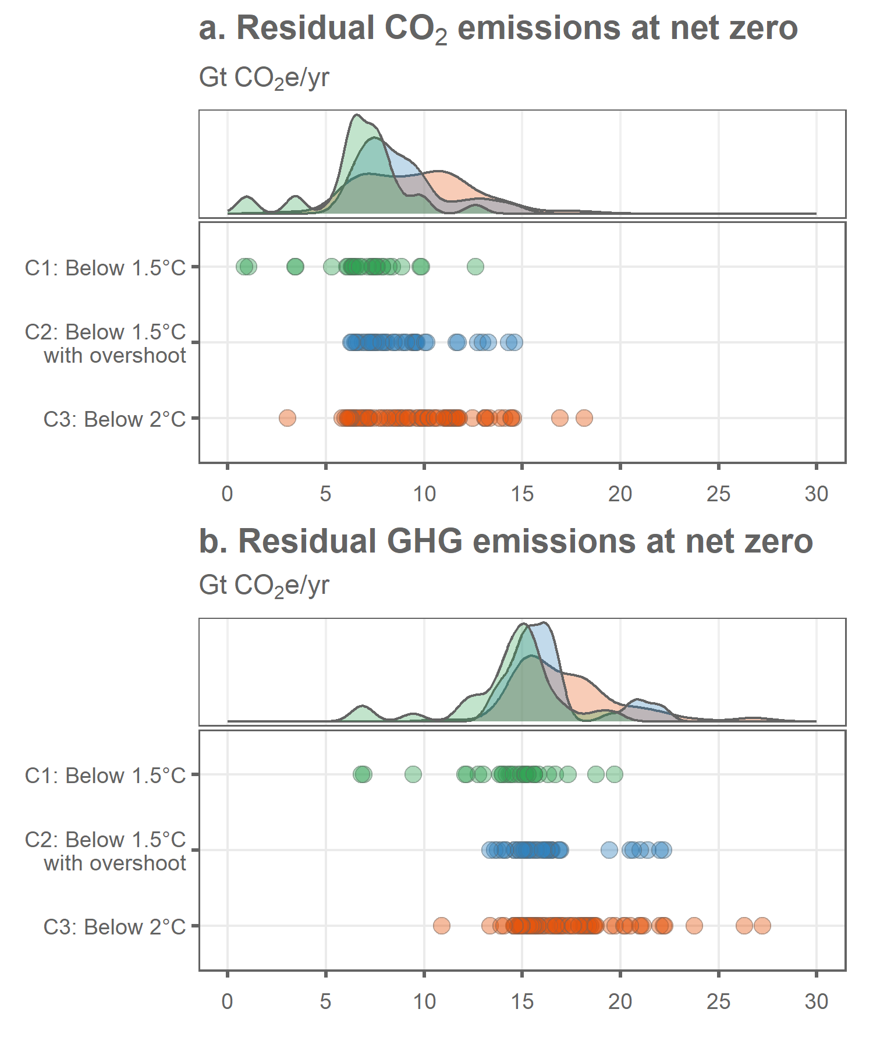

## save plot data  
addWorksheet(wb_figures,"fig_1_total_residual")  
writeData(wb_figures, sheet = "fig_1_total_residual",  
 wd_totals, colNames = T, rowNames = F)

## summary of scenario totals  
wd_totals_summary <- median_and_range(wd_totals,c("var","category"))

## `summarise()` has grouped output by 'var'. You can override using the `.groups`  
## argument.

wd_totals_summary <- left_join(wd_totals_summary,wd_totals %>%   
 group_by(var,category) %>%   
 summarise(n=n(),  
 year_median = signif(median(year),4),  
 year_5th = signif(quantile(year, probs = c(0.05)),4),  
 year_95th = signif(quantile(year, probs = c(0.95)),4)) %>%   
 mutate(year=paste0(year_median," [",year_5th,"-",year_95th,"]")) %>%   
 select(var,category,year,n),by = join_by(var, category))

## `summarise()` has grouped output by 'var'. You can override using the `.groups`  
## argument.

wd_totals_summary <- rbind(wd_totals_summary,  
 left_join(median_and_range(wd_totals,"var"),wd_totals %>%   
 group_by(var) %>%   
 summarise(n=n(),year_median = signif(median(year),4),  
 year_5th = signif(quantile(year, probs = c(0.05)),4),  
 year_95th = signif(quantile(year, probs = c(0.95)),4)) %>%   
 mutate(year=paste0(year_median," [",year_5th,"-",year_95th,"]")) %>%   
 select(var,year,n),by = join_by(var)) %>%   
 mutate(category="all"))  
  
  
## calculate reductions and join  
wd_total_reductions <- wd_scenarios_emissions %>%   
 mutate(include=ifelse(net_zero_CO2==year,1,0)) %>%   
 mutate(include=ifelse(year==2020,1,include)) %>%   
 filter(include==1) %>%   
 filter(gas=="CO2") %>%   
 group_by(id,gas,category,year) %>%   
 summarise(value=sum(value,na.rm=TRUE))

## `summarise()` has grouped output by 'id', 'gas', 'category'. You can override  
## using the `.groups` argument.

wd_total_reductions <- rbind(wd_total_reductions,wd_scenarios_emissions %>%   
 mutate(include=ifelse(net_zero_CO2==year,1,0)) %>%   
 mutate(include=ifelse(year==2020,1,include)) %>%   
 filter(include==1) %>%   
 filter(var!="Kyoto Gases") %>%   
 filter(!grepl("Carbon Sequestration",var)) %>%   
 group_by(id,category,year) %>%   
 summarise(value=sum(value,na.rm=TRUE)) %>%   
 mutate(gas="GHG"))

## `summarise()` has grouped output by 'id', 'category'. You can override using  
## the `.groups` argument.

wd_total_reductions <- wd_total_reductions %>%   
 group_by(id,gas,category) %>%   
 summarise(rel_change=(first(value)-last(value))/first(value)) %>%   
 mutate(rel_change=rel_change*100)

## `summarise()` has grouped output by 'id', 'gas'. You can override using the  
## `.groups` argument.

wd_total_reductions_summary <- median_and_range(wd_total_reductions %>% mutate(value=rel_change),c("gas","category"))

## `summarise()` has grouped output by 'gas'. You can override using the `.groups`  
## argument.

wd_total_reductions_summary <- rbind(wd_total_reductions_summary,  
 median_and_range(wd_total_reductions %>% mutate(value=rel_change),c("gas")) %>%   
 mutate(category="all"))  
  
wd_total_reductions_summary <- wd_total_reductions_summary %>%   
 mutate(category=as.character(category)) %>%   
 mutate(category=ifelse(grepl("C1",category),"C1: Below 1.5°C",category)) %>%   
 mutate(category=ifelse(grepl("C2",category),"C2: Below 1.5°C with overshoot",category)) %>%   
 mutate(category=ifelse(grepl("C3",category),"C3: Below 2°C",category)) %>%   
 mutate(category=as.factor(category))  
  
wd_totals_summary <- left_join(wd_totals_summary %>% rename(residual=value,gas=var),  
 wd_total_reductions_summary %>% rename(reductions=value),  
 by = join_by(gas,category))  
  
  
wd_totals_summary <- gather(wd_totals_summary,var,value,residual,reductions)  
wd_totals_summary <- wd_totals_summary %>%   
 ungroup() %>%   
 mutate(var=paste0(gas,"_",var)) %>%   
 select(-gas)  
wd_totals_summary <- spread(wd_totals_summary,var,value)  
wd_totals_summary <- wd_totals_summary %>%   
 select(category,n,year,CO2_residual,CO2_reductions,GHG_residual,GHG_reductions)  
  
addWorksheet(wb_analysis,"total_residual_at_nz")  
writeData(wb_analysis, sheet = "total_residual_at_nz",  
 wd_totals_summary, colNames = T, rowNames = F)  
  
  
  
## how many scenarios were excluded??  
total_scenarios <- data_r1 %>%   
 ungroup() %>%   
 select(model,scenario,category) %>%   
 distinct() %>%   
 group_by(category) %>%   
 summarise(n=n())

blarg <- wd_scenarios_emissions %>%   
 filter(year %in% c(2020,2100)) %>%   
 filter(var!="Kyoto Gases") %>%   
 filter(!grepl("Carbon Sequestration",var)) %>%   
 group_by(id,category,year) %>%   
 summarise(value=sum(value,na.rm=TRUE)) %>%   
 mutate(gas="GHG")

## `summarise()` has grouped output by 'id', 'category'. You can override using  
## the `.groups` argument.

blarg <- blarg %>%   
 group_by(id,gas,category) %>%   
 summarise(level=last(value),  
 rel_change=(first(value)-last(value))/first(value)) %>%   
 mutate(rel_change=rel_change*100)

## `summarise()` has grouped output by 'id', 'gas'. You can override using the  
## `.groups` argument.

blarg <- median_and_range(blarg %>% mutate(value=rel_change),c("gas","category"))

## `summarise()` has grouped output by 'gas'. You can override using the `.groups`  
## argument.

## emissions by gas at NZ  
wd_gases <- wd_scenarios_emissions %>%   
 filter(var!="Kyoto Gases") %>%   
 filter(!grepl("Carbon Sequestration",var)) %>%   
 mutate(value=ifelse(is.na(value),0,value)) %>%   
 mutate(include=ifelse(net_zero_CO2==year,1,0)) %>%   
 filter(include==1) %>%   
 group_by(id,model,scenario,category,year,gas) %>%   
 summarise(value=sum(value,na.rm=TRUE))

## `summarise()` has grouped output by 'id', 'model', 'scenario', 'category',  
## 'year'. You can override using the `.groups` argument.

## emissions by sector at NZ  
wd_sectors <- wd_scenarios_emissions %>%   
 filter(var!="Kyoto Gases") %>%   
 filter(!grepl("Carbon Sequestration",var)) %>%   
 mutate(value=ifelse(is.na(value),0,value)) %>%   
 mutate(include=ifelse(net_zero_CO2==year,1,0)) %>%   
 filter(include==1) %>%   
 mutate(sector=as.character(sector)) %>%   
 mutate(sector=ifelse(sector %in% c("Industrial processes","F-Gases","Other"),"Other (Industrial processes, F-gases, other)",sector)) %>%   
 group_by(id,model,scenario,category,year,sector) %>%   
 summarise(value=sum(value,na.rm=TRUE))

## `summarise()` has grouped output by 'id', 'model', 'scenario', 'category',  
## 'year'. You can override using the `.groups` argument.

## energy by fuel type at NZ  
wd_fuels <- data_r1 %>%   
 ungroup() %>%   
 mutate(id=paste0(model,"|",scenario)) %>%   
 select(-region,-unit) %>%   
 filter(var %in% c("Primary Energy",  
 "Primary Energy|Fossil|w/ CCS",  
 "Primary Energy|Coal|w/o CCS",  
 "Primary Energy|Gas|w/o CCS",  
 "Primary Energy|Oil|w/o CCS"))  
  
wd_fuels <- left_join(wd_fuels,cc_netzero,by="id") %>%   
 mutate(include=ifelse(net_zero_CO2==year,1,0)) %>%   
 filter(include==1) %>%   
 select(-include)  
  
wd_fuels <- spread(wd_fuels,var,value)  
wd_fuels <- wd_fuels %>%   
 mutate(`Primary Energy|Renewable & nuclear`=`Primary Energy`-  
 `Primary Energy|Fossil|w/ CCS`-  
 `Primary Energy|Coal|w/o CCS` -  
 `Primary Energy|Gas|w/o CCS` -  
 `Primary Energy|Oil|w/o CCS`)  
  
wd_fuels <- gather(wd_fuels,var,value,`Primary Energy`:`Primary Energy|Renewable & nuclear`) %>%   
 filter(var!="Primary Energy")  
  
wd_fuels <- left_join(wd_fuels,data.frame(var=c("Primary Energy|Renewable & nuclear",  
 "Primary Energy|Fossil|w/ CCS",  
 "Primary Energy|Coal|w/o CCS",  
 "Primary Energy|Gas|w/o CCS",  
 "Primary Energy|Oil|w/o CCS"),  
 fuel=c("Renewables, biomass & nuclear",  
 "Fossil with CCS",  
 "Coal",  
 "Gas",  
 "Oil")),by="var")  
  
wd_fuels$fuel <- as.factor(wd_fuels$fuel)  
wd_fuels$fuel <- fct_relevel(wd_fuels$fuel,"Renewables, biomass & nuclear","Fossil with CCS","Oil","Gas","Coal")  
  
wd_fuels$category <- as.factor(wd_fuels$category)  
wd_fuels$category <- fct_relevel(wd_fuels$category,"C3","C2","C1")  
  
wd_fuels <- wd_fuels %>%   
 mutate(model=ifelse(grepl("IMAGE",model),"IMAGE",model)) %>%   
 mutate(model=ifelse(grepl("REMIND",model),"REMIND",model)) %>%   
 mutate(model=ifelse(grepl("MESSAGE",model),"MESSAGE",model))  
  
  
  
## data summaries  
## at this point we ignore C1-C3 really  
wd_gases_summary <- median_and_range(wd_gases,c("model","gas"))

## `summarise()` has grouped output by 'model'. You can override using the  
## `.groups` argument.

wd_gases_summary <- rbind(wd_gases_summary,  
 median_and_range(wd_gases,"gas") %>% mutate(model="all"))  
wd_gases_summary <- spread(wd_gases_summary,gas,value) %>%   
 arrange(model)  
  
wd_sectors_summary <- median_and_range(wd_sectors,c("model","sector"))

## `summarise()` has grouped output by 'model'. You can override using the  
## `.groups` argument.

wd_sectors_summary <- rbind(wd_sectors_summary,  
 median_and_range(wd_sectors,"sector") %>% mutate(model="all"))  
wd_sectors_summary <- spread(wd_sectors_summary,sector,value) %>%   
 arrange(model)  
  
wd_fuels_extra_vars <- spread(wd_fuels %>% select(-var),fuel,value) %>%   
 mutate(`Fossil total`=Oil+Coal+Gas) %>%   
 mutate(Total=`Fossil total`+`Renewables, biomass & nuclear`+`Fossil with CCS`)  
wd_fuels_extra_vars <- gather(wd_fuels_extra_vars,fuel,value,`Renewables, biomass & nuclear`:Total)  
  
wd_fuels_summary <- median_and_range(wd_fuels_extra_vars,c("model","fuel"))

## `summarise()` has grouped output by 'model'. You can override using the  
## `.groups` argument.

wd_fuels_summary <- rbind(wd_fuels_summary,  
 median_and_range(wd_fuels_extra_vars,"fuel") %>% mutate(model="all"))  
wd_fuels_summary$fuel <- as.factor(wd_fuels_summary$fuel)  
wd_fuels_summary$fuel <- fct_relevel(wd_fuels_summary$fuel,"Coal","Oil","Gas","Fossil total","Fossil with CCS","Renewables, biomass & nuclear","Total")  
wd_fuels_summary <- spread(wd_fuels_summary,fuel,value) %>%   
 arrange(model)  
  
addWorksheet(wb_analysis,"gas_residual_at_nz")  
addWorksheet(wb_analysis,"sector_residual_at_nz")  
addWorksheet(wb_analysis,"fuel_at_nz")  
writeData(wb_analysis, sheet = "gas_residual_at_nz",  
 wd_gases_summary, colNames = T, rowNames = F)  
writeData(wb_analysis, sheet = "sector_residual_at_nz",  
 wd_sectors_summary, colNames = T, rowNames = F)  
writeData(wb_analysis, sheet = "fuel_at_nz",  
 wd_fuels_summary, colNames = T, rowNames = F)

## what about primary energy supply if we compare across the same year??  
  
wd_fuels_check <- data_r1 %>%   
 ungroup() %>%   
 mutate(id=paste0(model,"|",scenario)) %>%   
 select(-region,-unit) %>%   
 filter(var %in% c("Primary Energy",  
 "Primary Energy|Fossil|w/ CCS",  
 "Primary Energy|Coal|w/o CCS",  
 "Primary Energy|Gas|w/o CCS",  
 "Primary Energy|Oil|w/o CCS"))  
  
wd_fuels_check <- left_join(wd_fuels_check,cc_scenarios %>% mutate(include=1)) %>%   
 filter(year %in% c(2050,2075,2100)) %>%   
 filter(include==1) %>%   
 select(-include)

## Joining with `by = join_by(id)`

wd_fuels_check <- spread(wd_fuels_check,var,value)  
wd_fuels_check <- wd_fuels_check %>%   
 mutate(`Primary Energy|Renewable & nuclear`=`Primary Energy`-  
 `Primary Energy|Fossil|w/ CCS`-  
 `Primary Energy|Coal|w/o CCS` -  
 `Primary Energy|Gas|w/o CCS` -  
 `Primary Energy|Oil|w/o CCS`)  
  
wd_fuels_check <- gather(wd_fuels_check,var,value,`Primary Energy`:`Primary Energy|Renewable & nuclear`) %>%   
 filter(var!="Primary Energy")  
  
wd_fuels_check <- left_join(wd_fuels_check,data.frame(var=c("Primary Energy|Renewable & nuclear",  
 "Primary Energy|Fossil|w/ CCS",  
 "Primary Energy|Coal|w/o CCS",  
 "Primary Energy|Gas|w/o CCS",  
 "Primary Energy|Oil|w/o CCS"),  
 fuel=c("Renewables, biomass & nuclear",  
 "Fossil with CCS",  
 "Coal",  
 "Gas",  
 "Oil")),by="var")  
  
wd_fuels_check <- wd_fuels_check %>%   
 group_by(id,year) %>%   
 summarise(value=sum(value))

## `summarise()` has grouped output by 'id'. You can override using the `.groups`  
## argument.

wd_fuels_check <- median_and_range(wd_fuels_check,c("year"))

p1 <- wd_gases %>% ggplot(.,aes(x=id,y=value,fill=gas)) +  
 geom_bar(stat="identity",color="#969696") +  
 facet_nested(.~model + fct_rev(category),scales="free_x",space="free",switch = "x",  
 nest_line = element_line(linetype = 1,color='#636363')) +  
 theme_wl() +  
 scale_y_continuous(limits=c(0,25),breaks=c(0,5,10,15,20,25)) +  
 #scale_fill_manual(values=colors[1:4]) +  
 scale_fill_brewer(palette="Greens") +  
 theme(axis.title = element_blank(),  
 axis.text.x = element_blank(),  
 axis.ticks.x = element_blank(),  
 panel.grid.major.x = element_blank(),  
 legend.position="bottom",  
 legend.title=element_blank(),  
 legend.background = element_blank(),  
 legend.margin = margin(t=-5),  
 strip.background = element_blank(),  
 panel.spacing.x=unit(0.4, "lines"),  
 panel.border = element_blank(),  
 strip.text = element_text(color='#636363'),) +  
 labs(title="a. Residual GHG emissions at net zero by gas",  
 subtitle=bquote("Gt"~CO[2]*"e/yr"))

## Scale for fill is already present.  
## Adding another scale for fill, which will replace the existing scale.

wd_sectors$sector <- as.factor(wd_sectors$sector)  
wd_sectors$sector <- fct_relevel(wd_sectors$sector,"Energy","AFOLU","Other (Industrial processes, F-gases, other)")  
  
p2 <- wd_sectors %>% ggplot(.,aes(x=id,y=value,fill=sector)) +  
 geom_bar(stat="identity",color="#969696") +  
 facet_nested(.~model + fct_rev(category),scales="free_x",space="free",switch = "x",  
 nest_line = element_line(linetype = 1,color='#636363')) +  
 theme_wl() +  
 scale_y_continuous(limits=c(0,25),breaks=c(0,5,10,15,20,25)) +  
 scale_fill_brewer(palette="Blues") +  
 theme(axis.title = element_blank(),  
 axis.text.x = element_blank(),  
 axis.ticks.x = element_blank(),  
 panel.grid.major.x = element_blank(),  
 legend.position="bottom",  
 legend.title=element_blank(),  
 legend.background = element_blank(),  
 legend.margin = margin(t=-5),  
 strip.background = element_blank(),  
 panel.spacing.x=unit(0.4, "lines"),  
 panel.border = element_blank(),  
 strip.text = element_text(color='#636363'),  
 strip.clip = element_blank()  
 ) +  
 labs(title="b. Residual GHG emissions at net zero by sector",  
 subtitle=bquote("Gt"~CO[2]*"e/yr"))

## Scale for fill is already present.  
## Adding another scale for fill, which will replace the existing scale.

p3 <- wd_fuels %>% ggplot(.,aes(x=id,y=value,fill=fuel)) +  
 geom_bar(stat="identity",color="#969696") +  
 facet_nested(.~model + fct_rev(category),scales="free_x",space="free",switch = "x",  
 nest_line = element_line(linetype = 1,color='#636363')) +  
 theme_wl() +  
 scale_fill_brewer(palette="Oranges") +  
 theme(axis.title = element_blank(),  
 axis.text.x = element_blank(),  
 axis.ticks.x = element_blank(),  
 panel.grid.major.x = element_blank(),  
 legend.position="bottom",  
 legend.title=element_blank(),  
 legend.background = element_blank(),  
 legend.margin = margin(t=-5),  
 strip.background = element_blank(),  
 panel.spacing.x=unit(0.4, "lines"),  
 panel.border = element_blank(),  
 strip.text = element_text(color='#636363'),  
 strip.clip = element_blank()  
 ) +  
 labs(title="c. Primary Energy supply at net zero by fuel",  
 subtitle=bquote("EJ/yr"))

## Scale for fill is already present.  
## Adding another scale for fill, which will replace the existing scale.

p1/plot_spacer()/p2/plot_spacer()/p3 + plot_layout(heights=c(5,1,5,1,5))

## Warning: Removed 2 rows containing missing values (`geom_bar()`).  
## Removed 2 rows containing missing values (`geom_bar()`).

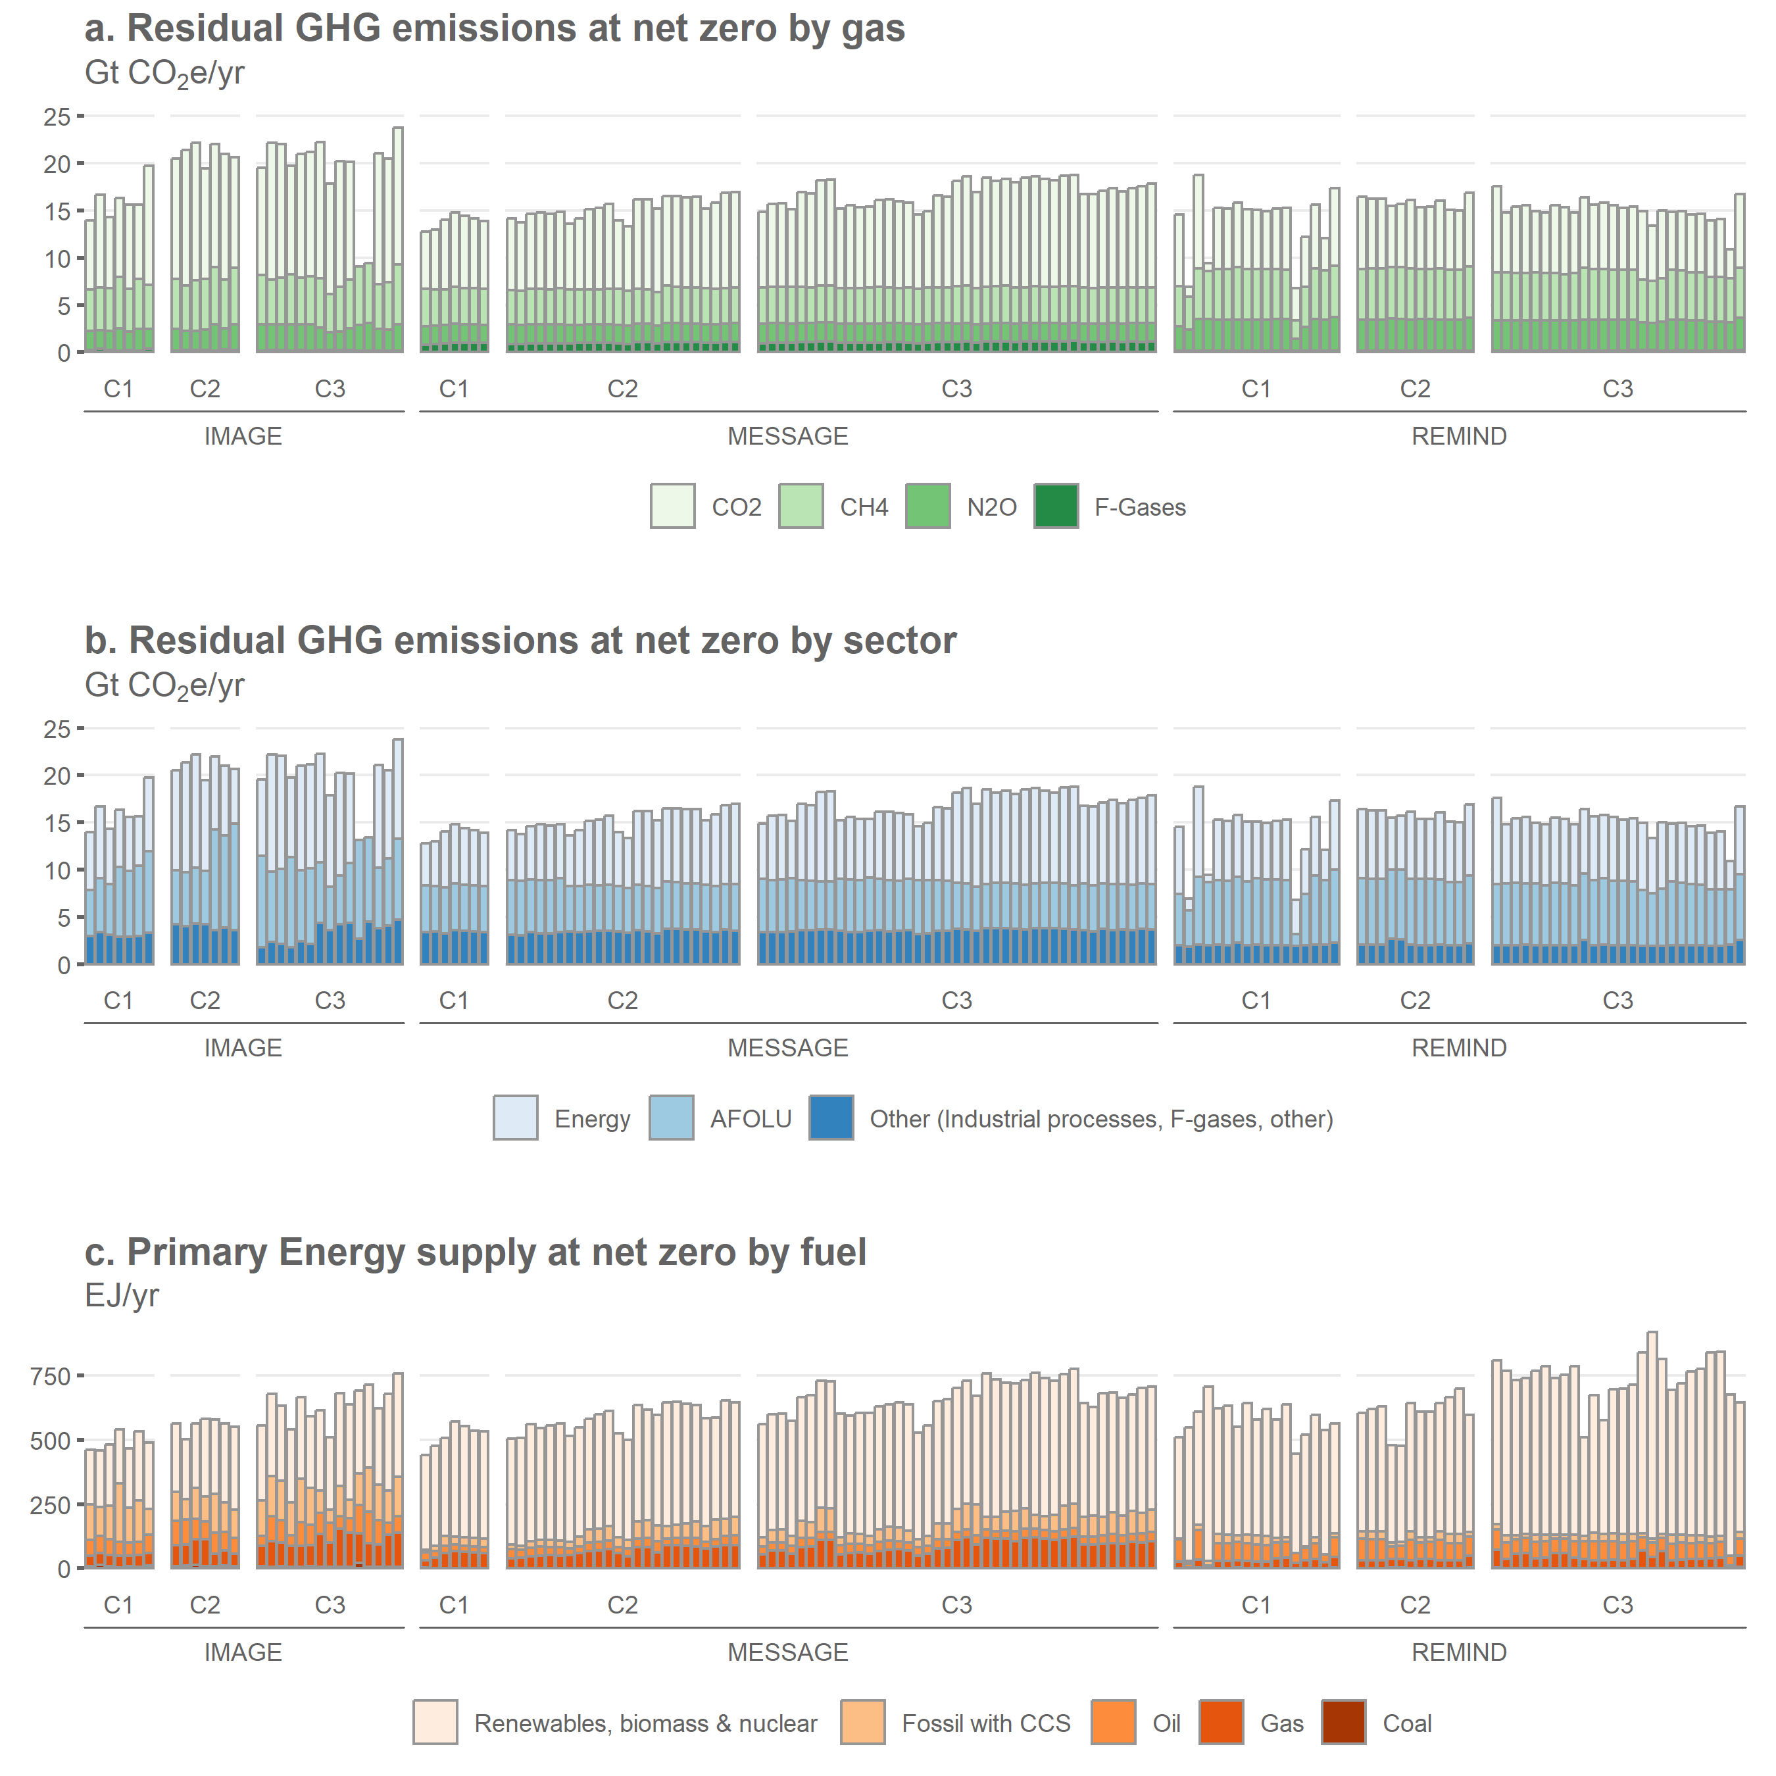

wd_pca <- wd_scenarios_emissions %>%  
 filter(var!="Kyoto Gases") %>%  
 filter(!grepl("Carbon Sequestration",var)) %>%  
 mutate(value=ifelse(is.na(value),0,value)) %>%  
 mutate(include=ifelse(net_zero_CO2==year,1,0)) %>%   
 filter(include==1) %>%  
 group_by(id,model,var) %>%  
 summarise(value=sum(value,na.rm=TRUE))

## `summarise()` has grouped output by 'id', 'model'. You can override using the  
## `.groups` argument.

wd_pca <- spread(wd_pca,var,value)  
pca <- prcomp(wd_pca %>% ungroup() %>% select(-id,-model),scale=TRUE)  
wd_pca <- cbind(wd_pca %>% select(id,model),pca$x)  
pca_variance <-get_eigenvalue(pca)$variance.percent  
sum(pca_variance[1:2])

## [1] 75.74677

colors=c("#e6550d","#3182bd","#31a354")  
wd_pca %>% ggplot(.,aes(x=PC1,y=PC2,fill=model)) +  
 geom_point(shape=21,size=3,alpha=0.6) +  
 theme_wl() +  
 scale_fill_manual(values=colors) +  
 theme(legend.title=element_blank()) +  
 labs(title=paste0("Principal components explaining ",signif(sum(pca_variance[1:2]),2), "% of residual\nsubsector emissions variance"))

## Scale for fill is already present.  
## Adding another scale for fill, which will replace the existing scale.

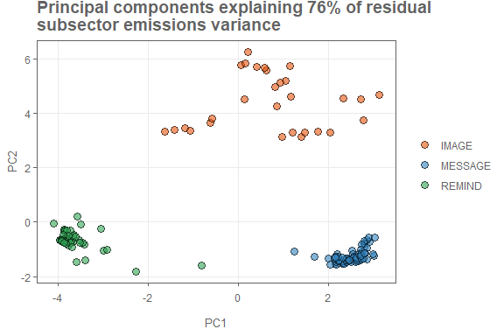

wd_clusters <- wd_scenarios_emissions %>%  
 filter(var!="Kyoto Gases") %>%  
 filter(!grepl("Carbon Sequestration",var)) %>%  
 mutate(value=ifelse(is.na(value),0,value)) %>%  
 mutate(include=ifelse(net_zero_CO2==year,1,0)) %>%  
 filter(include==1) %>%  
 group_by(id,category,var) %>%  
 summarise(value=sum(value,na.rm=TRUE))

## `summarise()` has grouped output by 'id', 'category'. You can override using  
## the `.groups` argument.

wd_clusters <- spread(wd_clusters,var,value) %>%  
 ungroup()  
  
cc_clusters = wd_clusters %>%  
 select(id) %>%   
 mutate(no_clusters=NA) %>%   
 mutate(value=NA)  
  
for(x in 3:6) {  
   
 wd_cluster_summary <- kmeans(scale(wd_clusters %>% select(-id,-category)),x,nstart=25)  
   
 blarg <- cbind(cc_clusters %>% select(id),value=wd_cluster_summary$cluster) %>%   
 mutate(no_clusters=x)  
 cc_clusters <- rbind(cc_clusters,blarg)  
   
}  
  
cc_clusters <- left_join(cc_clusters %>% filter(!is.na(no_clusters)),wd_pca %>% select(id,model,PC1,PC2))

## Joining with `by = join_by(id)`

cc_clusters <- cc_clusters %>%   
 mutate(label=paste0(no_clusters," Clusters"))  
  
cc_clusters$value <- as.factor(cc_clusters$value)  
  
  
cc_clusters %>% ggplot(.,aes(x=PC1,y=PC2,fill=value)) +  
 geom_point(shape=21,size=3,alpha=0.6) +  
 theme_wl() +  
 facet_wrap(.~label) +  
 theme(legend.position="none") +  
 labs(title=paste0("Principal components explaining ",signif(sum(pca_variance[1:2]),2), "% of residual subsector emissions variance"))

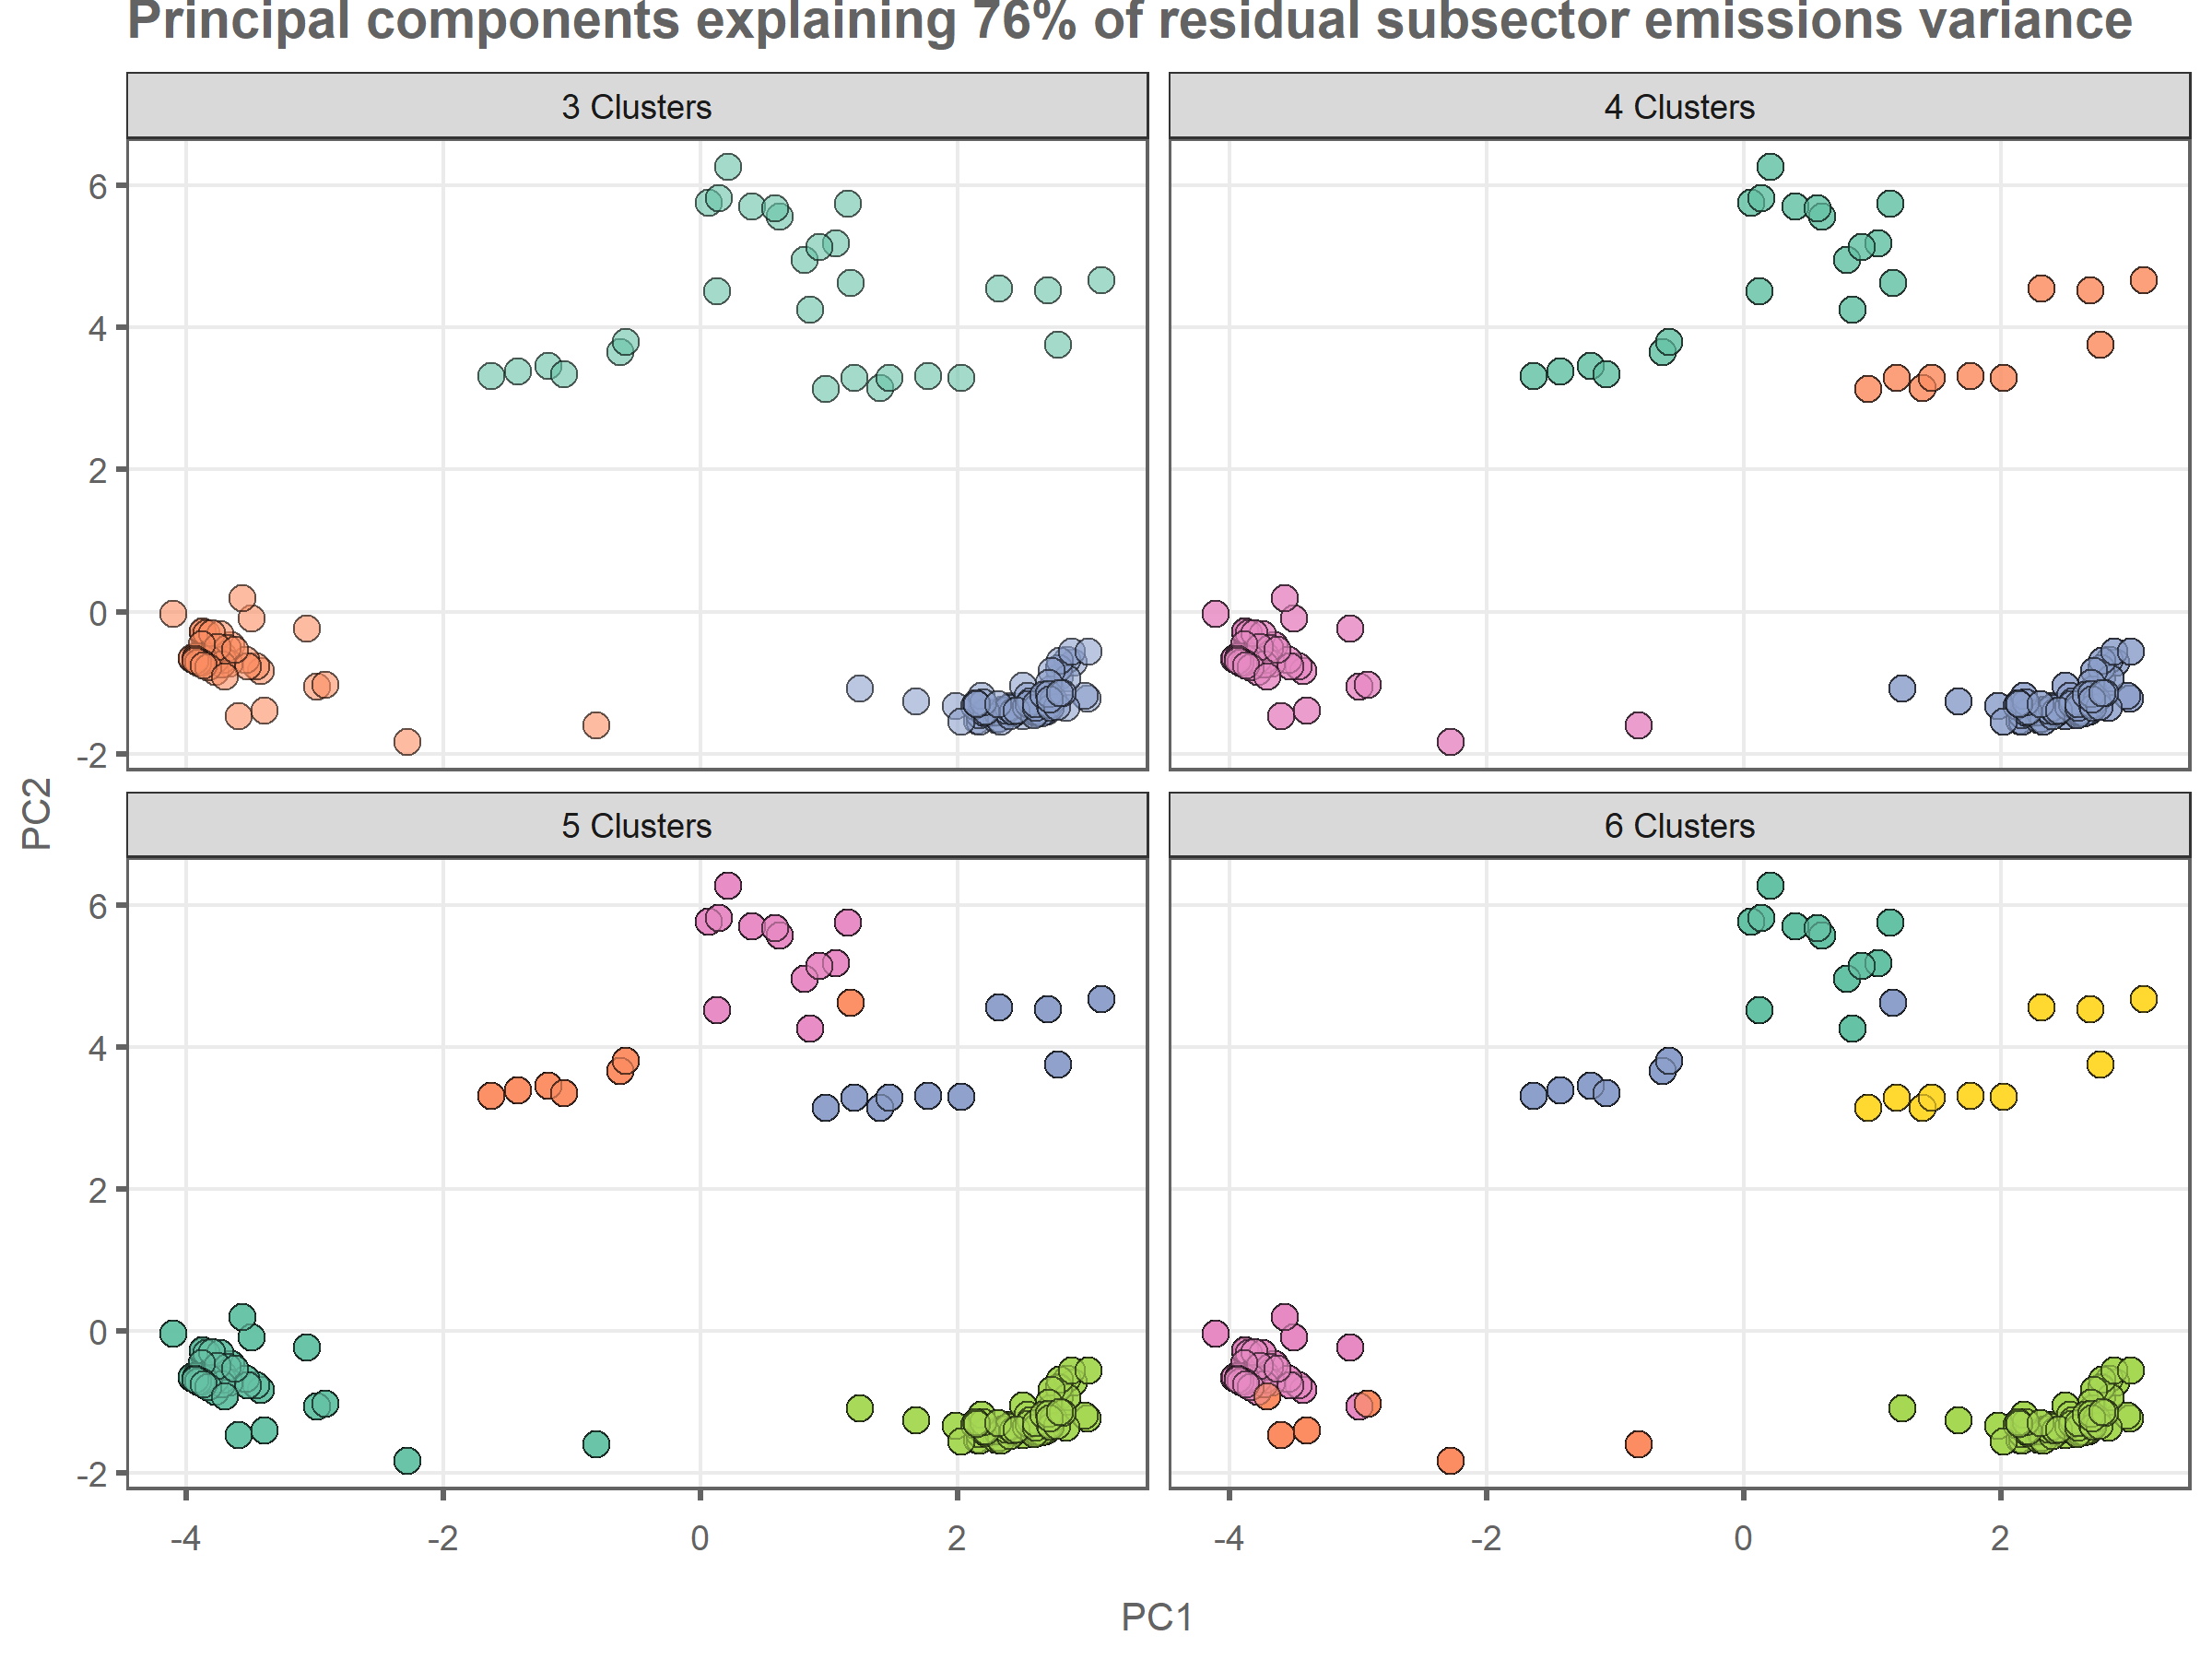

## get the scenario data  
wd_subsectors <- wd_scenarios_emissions %>%  
 filter(var!="Kyoto Gases") %>%  
 filter(!grepl("Carbon Sequestration",var)) %>%  
 mutate(value=ifelse(is.na(value),0,value)) %>%  
 mutate(include=ifelse(net_zero_CO2==year,1,0)) %>%  
 mutate(include=ifelse(year==2020,1,include)) %>%   
 filter(include==1) %>%  
 group_by(id,model,category,year,sector,var) %>%  
 summarise(value=sum(value,na.rm=TRUE))

## `summarise()` has grouped output by 'id', 'model', 'category', 'year',  
## 'sector'. You can override using the `.groups` argument.

## generate median scenarios for each  
  
wd_subsectors_total <- wd_subsectors %>%   
 mutate(model="All") %>%   
 mutate(year=ifelse(year!=2020,2050,year)) %>%  
 group_by(model,year,sector,var) %>%  
 summarise(percentile_5th = quantile(value, probs = c(0.05)),  
 percentile_95th = quantile(value, probs = c(0.95)),  
 value=median(value,na.rm=TRUE)) %>%   
 mutate(model="All")

## `summarise()` has grouped output by 'model', 'year', 'sector'. You can override  
## using the `.groups` argument.

wd_subsectors <- wd_subsectors %>%   
 mutate(year=ifelse(year!=2020,2050,year)) %>%  
 group_by(model,year,sector,var) %>%  
 summarise(percentile_5th = quantile(value, probs = c(0.05)),  
 percentile_95th = quantile(value, probs = c(0.95)),  
 value=median(value,na.rm=TRUE))

## `summarise()` has grouped output by 'model', 'year', 'sector'. You can override  
## using the `.groups` argument.

## calculate relative and absolute changes for each model and variable  
wd_subsectors <- rbind(wd_subsectors,wd_subsectors_total)  
wd_subsectors <- wd_subsectors %>%   
 group_by(model,sector,var) %>%   
 mutate(change_rel = (first(value)-last(value))/first(value)) %>%   
 mutate(change_rel_5th = (first(percentile_5th)-last(percentile_5th))/first(percentile_5th)) %>%   
 mutate(change_rel_95th = (first(percentile_95th)-last(percentile_95th))/first(percentile_95th)) %>%   
 mutate(change_rel=-round(change_rel*100,0)) %>%   
 mutate(change_rel_5th=-round(change_rel_5th*100,0)) %>%   
 mutate(change_rel_95th=-round(change_rel_95th*100,0))  
  
  
## rebase the data so that totals in 2020 vs 2050 are shown  
wd_subsectors <- wd_subsectors %>%   
 group_by(model,sector,var) %>%   
 mutate(value_rebased=first(value)-last(value)) %>%   
 mutate(value_rebased=ifelse(year==2050,value,value_rebased))  
  
wd_subsectors <- wd_subsectors %>%  
 mutate(value_rebased=ifelse(value_rebased<0,0,value_rebased))  
  
wd_subsectors$year = as.factor(wd_subsectors$year)  
wd_subsectors$year <- fct_relevel(wd_subsectors$year,"2020","2050")  
  
p1 <- wd_subsectors %>%   
 filter(model!="All") %>%   
 filter(sector=="Energy") %>%   
 mutate(var=gsub("\\|Energy","",var)) %>%   
 ggplot(.,aes(x=value_rebased,y=reorder(var,value_rebased),alpha=year)) +  
 geom_col(color='#636363',fill="#8da0cb") +  
 geom_errorbar(data=wd_subsectors %>%  
 filter(model!="All") %>%   
 filter(year==2050) %>%  
 filter(sector=="Energy") %>%  
 mutate(var=gsub("\\|Energy","",var)),inherit.aes = FALSE,  
 aes(xmin=percentile_5th,xmax=percentile_95th,y=reorder(var,value_rebased)),  
 width=0.3) +  
 geom_text(data=wd_subsectors %>%  
 filter(model!="All") %>%   
 filter(sector=="Energy") %>%  
 mutate(var=gsub("\\|Energy","",var)) %>%   
 group_by(model,var,change_rel) %>%  
 summarise(value=sum(value_rebased)),  
 inherit.aes = FALSE,aes(x=value+1,y=var,  
 label=ifelse(change_rel<0,  
 paste0(change_rel,"%"),  
 paste0("+",change_rel,"%"))),  
 hjust=0,size=3) +  
 scale_x_continuous(expand = expansion(mult = c(0.05, 0.25))) +  
 scale_alpha_discrete(range=c(0.3,1)) +  
 scale_fill_brewer(palette="Blues") +  
 facet_grid(.~model) +  
 theme_wl() +  
 theme(legend.position="none",  
 axis.title=element_blank(),  
 panel.grid.major.y = element_blank()) +  
 labs(title="a. Energy sector emissions from 2020 to net zero",  
 subtitle=bquote("Gt"~CO[2]*"e/yr"))

## `summarise()` has grouped output by 'model', 'var'. You can override using the  
## `.groups` argument.

## Warning: Using alpha for a discrete variable is not advised.

## Scale for fill is already present.  
## Adding another scale for fill, which will replace the existing scale.

p2 <- wd_subsectors %>%  
 filter(model!="All") %>%   
 filter(sector=="AFOLU") %>%   
 mutate(var=gsub("\\|AFOLU","",var)) %>%   
 ggplot(.,aes(x=value_rebased,y=reorder(var,value_rebased),alpha=year)) +  
 geom_col(color='#636363',fill="#66c2a5") +  
 geom_errorbar(data=wd_subsectors %>%  
 filter(model!="All") %>%   
 filter(year==2050) %>%  
 filter(sector=="AFOLU") %>%   
 mutate(var=gsub("\\|AFOLU","",var)),inherit.aes = FALSE,  
 aes(xmin=percentile_5th,xmax=percentile_95th,y=reorder(var,value_rebased)),  
 width=0.3) +  
 geom_text(data=wd_subsectors %>%  
 filter(model!="All") %>%   
 filter(sector=="AFOLU") %>%  
 mutate(var=gsub("\\|AFOLU","",var)) %>%   
 group_by(model,var,change_rel) %>%  
 summarise(value=sum(value_rebased)),  
 inherit.aes = FALSE,aes(x=value+1.2,y=var,  
 label=ifelse(change_rel<0,  
 paste0(change_rel,"%"),  
 paste0("+",change_rel,"%"))),  
 hjust=0,size=3) +  
 scale_x_continuous(expand = expansion(mult = c(0.05, 0.25))) +  
 scale_alpha_discrete(range=c(0.3,1)) +  
 #scale_fill_brewer(palette="Greens") +  
 facet_grid(.~model) +  
 theme_wl() +  
 theme(legend.position="none",  
 axis.title=element_blank(),  
 panel.grid.major.y = element_blank()) +  
 labs(title="b. AFOLU sector emissions from 2020 to net zero",  
 subtitle=bquote("Gt"~CO[2]*"e/yr"))

## `summarise()` has grouped output by 'model', 'var'. You can override using the  
## `.groups` argument.

## Warning: Using alpha for a discrete variable is not advised.

p3 <- wd_subsectors %>%   
 filter(model!="All") %>%   
 filter(sector!="Energy") %>%   
 filter(sector!="AFOLU") %>%   
 mutate(var=gsub("\\|Other","",var)) %>%   
 mutate(var=ifelse(var=="CO2","CO2|Other",var)) %>%   
 ggplot(.,aes(x=value_rebased,y=reorder(var,value_rebased),alpha=year)) +  
 geom_col(color='#636363',fill="#fc8d62") +  
 geom_errorbar(data=wd_subsectors %>%  
 filter(model!="All") %>%   
 filter(year==2050) %>%   
 filter(sector!="Energy") %>%   
 filter(sector!="AFOLU") %>%   
 mutate(var=gsub("\\|Other","",var)) %>%   
 mutate(var=ifelse(var=="CO2","CO2|Other",var)),inherit.aes = FALSE,  
 aes(xmin=percentile_5th,xmax=percentile_95th,y=reorder(var,value_rebased)),  
 width=0.3) +  
 geom_text(data=wd_subsectors %>%  
 filter(model!="All") %>%   
 filter(sector!="Energy") %>%  
 filter(sector!="AFOLU") %>%  
 mutate(var=gsub("\\|Other","",var)) %>%  
 mutate(var=ifelse(var=="CO2","CO2|Other",var)) %>%  
 group_by(model,var,change_rel) %>%  
 summarise(value=sum(value_rebased)),  
 inherit.aes = FALSE,aes(x=value+0.4,y=var,  
 label=ifelse(change_rel<0,  
 paste0(change_rel,"%"),  
 paste0("+",change_rel,"%"))),  
 hjust=0,size=3) +  
 scale_x_continuous(expand = expansion(mult = c(0.05, 0.25))) +  
 scale_alpha_discrete(range=c(0.3,1)) +  
 scale_fill_brewer(palette="Oranges") +  
 facet_grid(.~model) +  
 theme_wl() +  
 theme(legend.position="none",  
 axis.title=element_blank(),  
 panel.grid.major.y = element_blank()) +  
 labs(title="c. Other sector emissions from 2020 to net zero",  
 subtitle=bquote("Gt"~CO[2]*"e/yr"))

## `summarise()` has grouped output by 'model', 'var'. You can override using the  
## `.groups` argument.

## Warning: Using alpha for a discrete variable is not advised.

## Scale for fill is already present.  
## Adding another scale for fill, which will replace the existing scale.

p1 / p2 / p3

## Warning: Removed 1 rows containing missing values (`geom_text()`).

## Warning: Removed 1 rows containing missing values (`geom_text()`).  
## Removed 1 rows containing missing values (`geom_text()`).

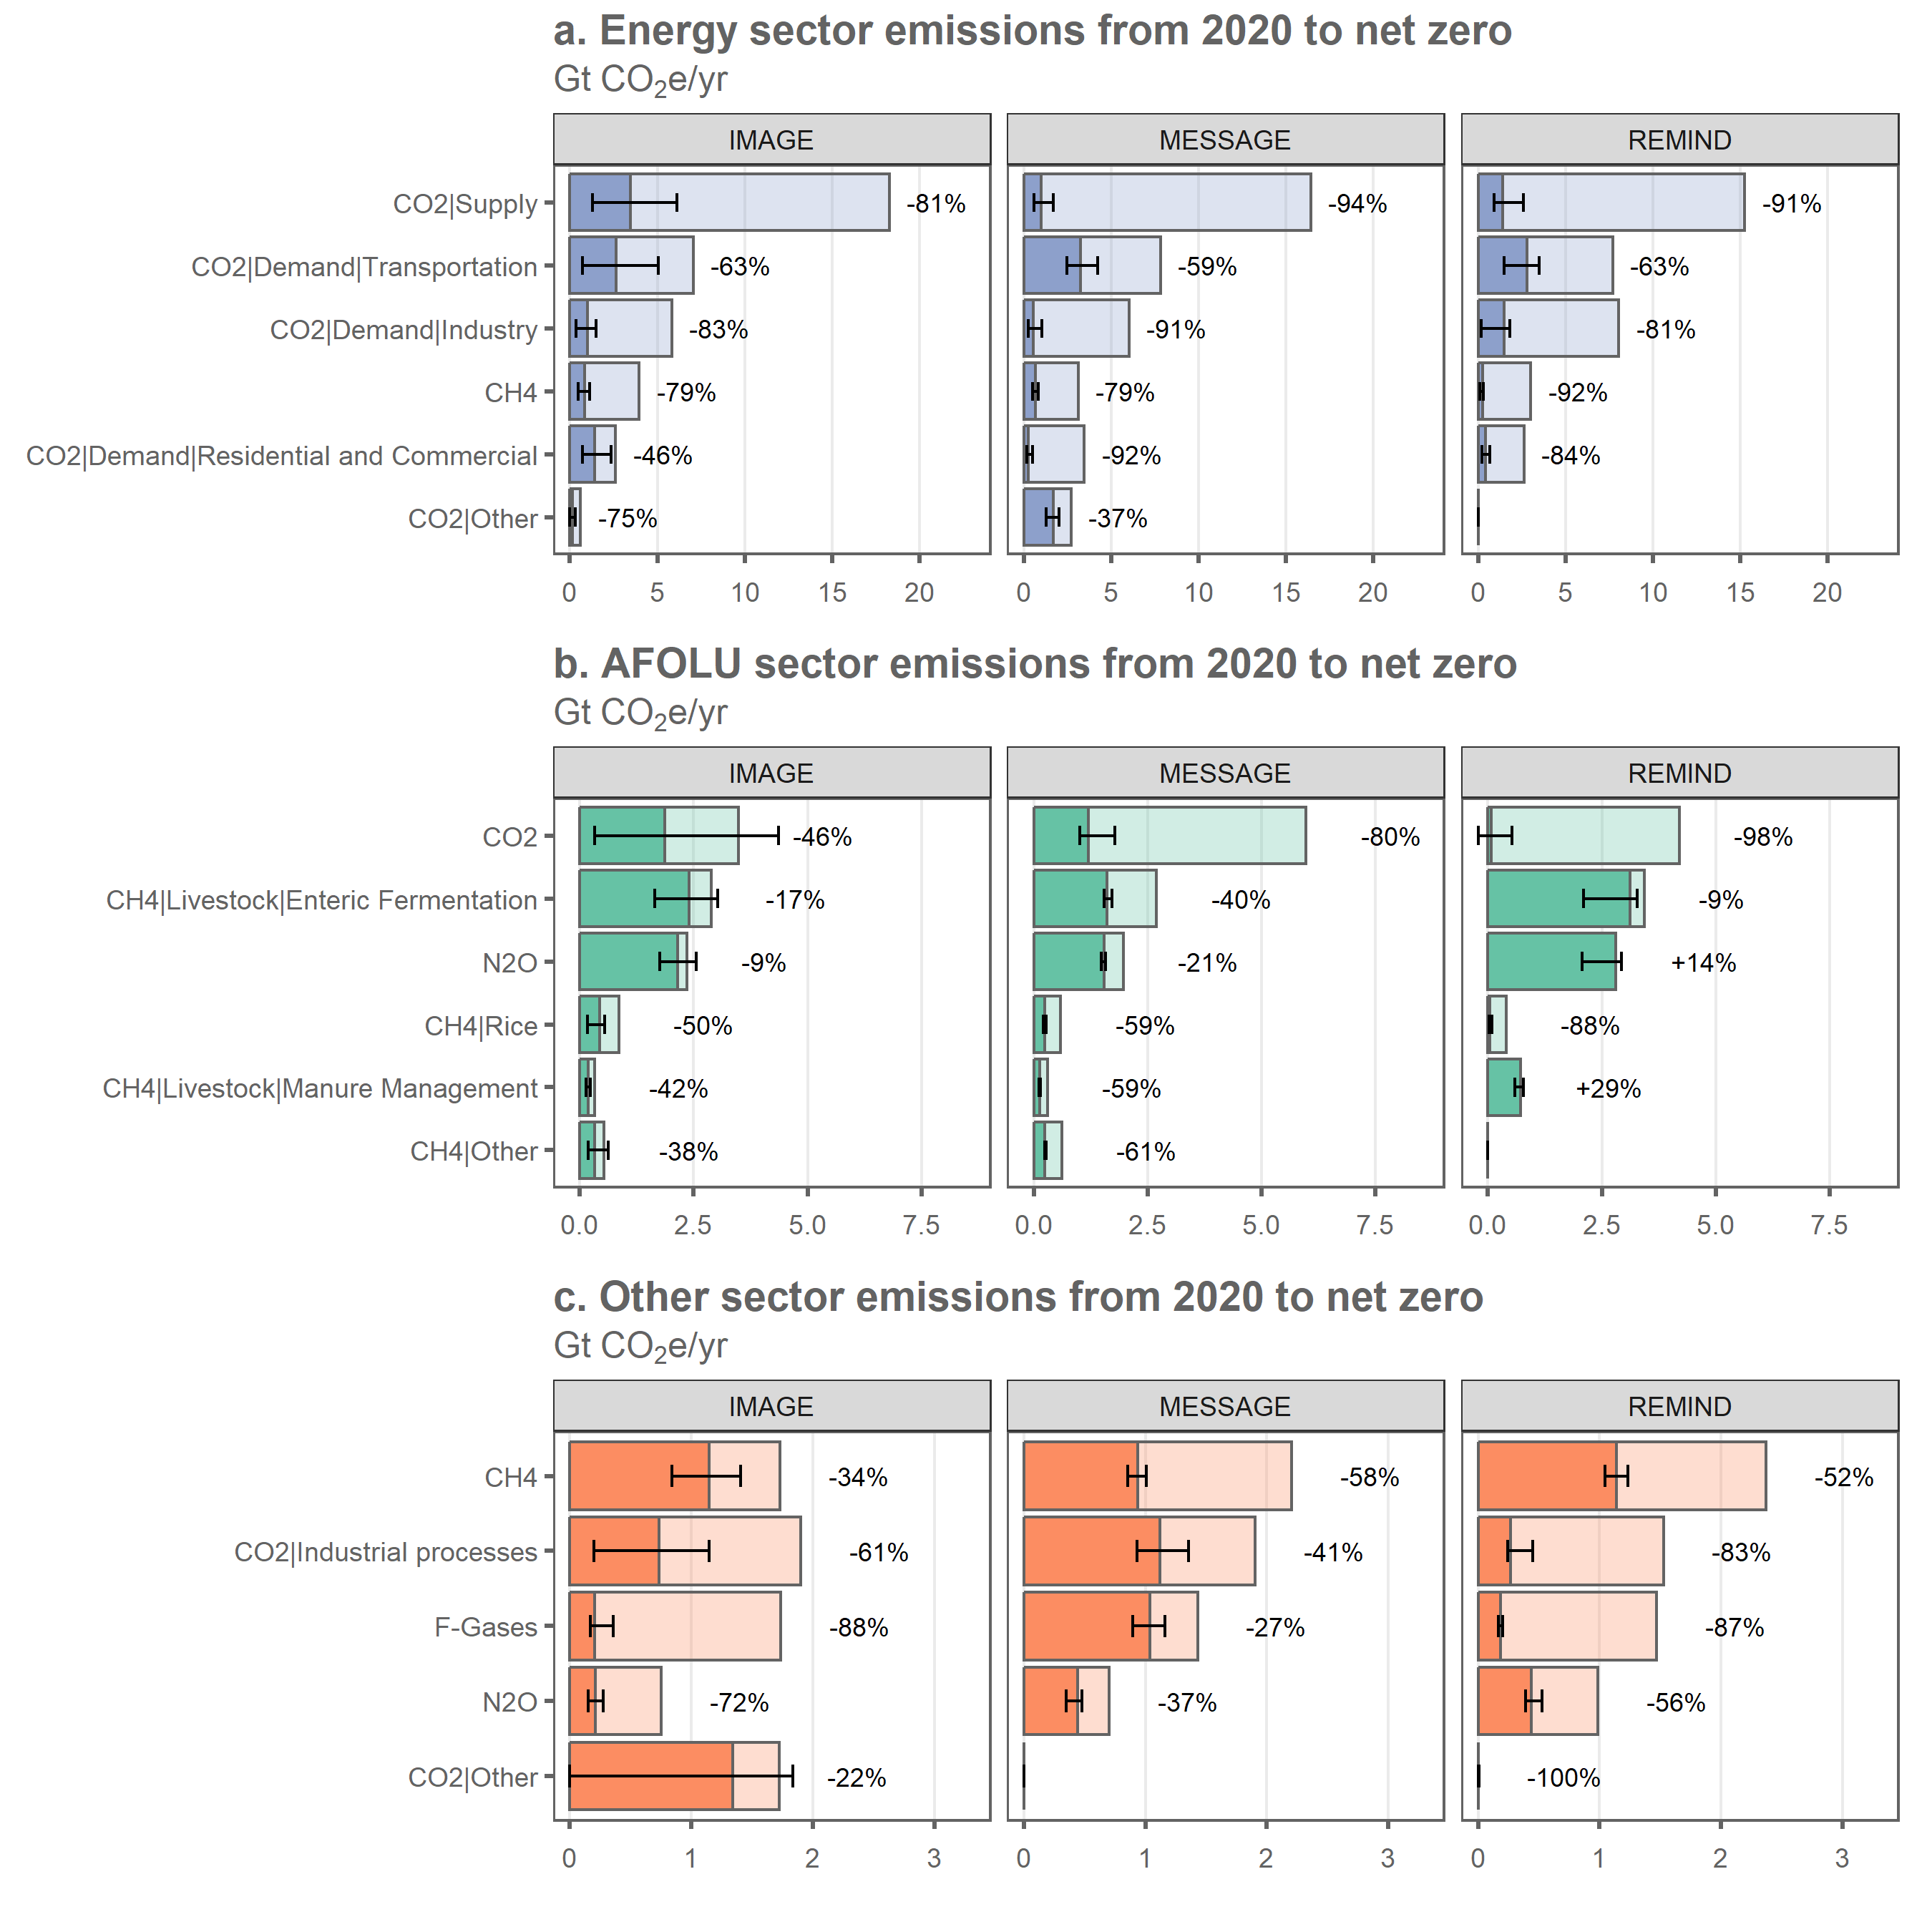

wd_subsectors_summary <- wd_subsectors %>%   
 ungroup() %>%   
 filter(year==2050) %>%   
 mutate(sector=as.character(sector)) %>%   
 mutate(sector=ifelse(sector=="F-Gases","Other",sector)) %>%   
 mutate(sector=ifelse(sector=="Industrial processes","Other",sector)) %>%   
 mutate(change_rel_5th=ifelse(percentile_5th==0,-100,change_rel_5th)) %>%   
 mutate(value=paste0(signif(value,2)," [",signif(percentile_5th,2),"-",signif(percentile_95th,2),"]")) %>%   
 mutate(change_rel=paste0(change_rel," [",change_rel_5th," to ",change_rel_95th,"]")) %>%   
 select(model,sector,var,value,change_rel)  
  
wd_subsectors_summary$sector <- as.factor(wd_subsectors_summary$sector)  
wd_subsectors_summary$sector <- fct_relevel(wd_subsectors_summary$sector,  
 "AFOLU","Energy","Other")  
  
wd_subsectors_summary <- cbind(spread(wd_subsectors_summary %>%   
 mutate(model=paste0(model,"_level")) %>%   
 select(-change_rel),model,value),  
 spread(wd_subsectors_summary %>%   
 mutate(model=paste0(model,"_reduction")) %>%   
 select(-value),model,change_rel) %>%   
 select(-sector,-var)) %>%   
 arrange(sector,var)  
  
  
addWorksheet(wb_analysis,"subsector_residual_at_nz")  
writeData(wb_analysis, sheet = "subsector_residual_at_nz",  
 wd_subsectors_summary, colNames = T, rowNames = F)

cc_expl <- read.xlsx('../Data/AR6_Scenarios_Database_metadata_indicators_v1.1_1.xlsx',sheet=2)  
cc_expl <- cc_expl %>%  
 mutate(id=paste0(Model,"|",Scenario)) %>%   
 select(id,Policy_category,Policy_category_name,Project_study,reference=`Literature.Reference.(if.applicable)`,  
 Ssp_family,Technology_category_name)  
  
## explanatory factors vs. total residual?  
wd_expl <- left_join(wd_scenarios_emissions,cc_expl,by="id") %>%   
 mutate(include=ifelse(year==net_zero_CO2,1,0)) %>%   
 filter(include==1) %>%   
 select(-include) %>%   
 filter(var!="Kyoto Gases") %>%   
 filter(!is.na(subsector))  
  
wd_expl <- wd_expl %>%   
 group_by(id,model,category,Policy_category,Policy_category_name,Project_study,reference,  
 Ssp_family,Technology_category_name) %>%   
 summarise(value=sum(value,na.rm=TRUE)) %>%  
 mutate(Ssp_family=as.character(Ssp_family)) %>%   
 mutate(Ssp_family=ifelse(Ssp_family=="1","SSP1",Ssp_family)) %>%  
 mutate(Ssp_family=ifelse(Ssp_family=="2","SSP2",Ssp_family)) %>%   
 mutate(Ssp_family=as.factor(Ssp_family))

## `summarise()` has grouped output by 'id', 'model', 'category',  
## 'Policy_category', 'Policy_category_name', 'Project_study', 'reference',  
## 'Ssp_family'. You can override using the `.groups` argument.

wd_expl <- wd_expl %>%   
 ungroup() %>%   
 select(-category,-Policy_category,-reference)  
wd_expl <- gather(wd_expl,key,var,-id,-value,-model)

## Warning: attributes are not identical across measure variables; they will be  
## dropped

p1 <- wd_expl %>%   
 ggplot(.,aes(x=value,y=var)) +  
 geom_point(shape=21,size=3,alpha=0.5,color="#636363",aes(fill=model)) +  
 stat_summary(fun=median,geom="crossbar", color="#636363",width=0.5,show.legend = FALSE) +  
 facet_grid(key~.,scales="free_y",space="free",switch="y",  
 labeller=as_labeller(c(Policy_category_name="Policy category",  
 Project_study="Project study",  
 Ssp_family="SSP family",  
 Technology_category_name="Technology category"))) +  
 scale_y_discrete(limits=rev,labels = function(x) str_wrap(x, width = 25)) +  
 theme_wl() +  
 theme(legend.position="bottom",  
 legend.title=element_blank(),  
 axis.title = element_blank(),  
 strip.text = element_text(color="#252525"),  
 plot.margin = margin(0,0,0,0,"cm"),) +  
 labs(title="Residual GHG emissions at net zero vs. scenario characteristics",  
 subtitle=bquote("Gt"~CO[2]*"e/yr and fraction of sample"))  
  
  
## how many scenarios are from the ENGAGE project?  
wd_expl_totals <- wd_expl %>%   
 group_by(key,var) %>%   
 summarise(n=n(),  
 fraction=n/length(no_scenarios$id)) %>%   
 mutate(fraction=signif(fraction*100,2))

## `summarise()` has grouped output by 'key'. You can override using the `.groups`  
## argument.

p2 <- wd_expl_totals %>% ggplot(.,aes(x="% of sample",y=var,label=paste0(fraction,"%"))) +  
 geom_text(size=4,color="#636363") +  
 facet_grid(key~.,scales="free_y",space="free") +  
 scale_y_discrete(limits=rev) +  
 theme_wl() +  
 theme(legend.position="none",  
 axis.title = element_blank(),  
 axis.text = element_blank(),  
 plot.background = element_blank(),  
 strip.background = element_blank(),  
 strip.text = element_blank(),  
 axis.ticks = element_blank(),  
 panel.grid.major.x = element_blank(),  
 plot.margin = margin(0,0,0,0,"cm"),  
 axis.text.x = element_blank())  
  
  
p1 + p2 + plot_layout(widths=c(9,1))

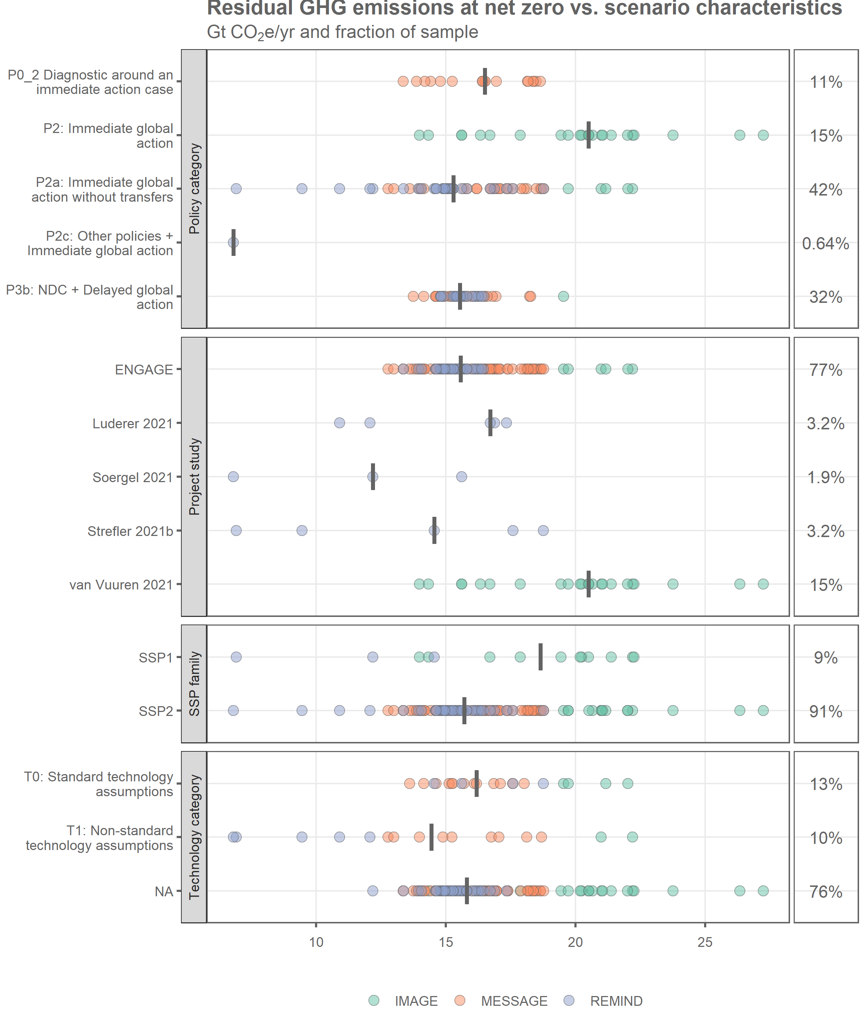

# pd <- pd %>%   
# mutate(include=ifelse(year==2020,1,0)) %>%   
# mutate(include=ifelse(year==net_zero_CO2,1,include)) %>%   
# mutate(include=ifelse(year==2100,1,include)) %>%   
# filter(include==1)  
  
  
  
# pd <- wd_scenarios_emissions %>%   
# filter(var!="Kyoto Gases") %>%   
# filter(!grepl("Carbon Sequestration",var)) %>%   
# mutate(include=ifelse(year>=net_zero_CO2,1,0)) %>%   
# filter(include==1) %>%   
# group_by(id,model,scenario,category,year,net_zero_CO2) %>%   
# summarise(value=sum(value,na.rm=TRUE)) #%>%   
# group_by(id,model,scenario,category) %>%   
# summarise(emissions_nz=first(value),  
# emissions_2100=last(value))  
  
  
  
# pd <- gather(pd,var,value,-id,-category)  
#   
# pd %>% filter(var=="change_rel") %>% ggplot(.,aes(x=value,y=category,fill=category)) +  
# geom_point(shape=21,size=3,alpha=0.6,color="#636363") +  
# theme_wl() +  
# theme(legend.position="none",  
# axis.title = element_blank(),  
# plot.margin = margin(0,0,0,0,"cm"))  
  
#   
#   
# pd %>% ggplot(.,aes(x=emissions_2100,y=emissions_nz))+  
# geom_abline(intercept=0,color="#636363") +  
# geom_point(shape=21,size=3,alpha=0.6,color="#636363",aes(fill=category)) +  
# geom_text(data=data.frame(emissions_nz=c(6,5),  
# emissions_2100=c(5,6),  
# label=c("Decrease","Increase")),  
# aes(label=label),  
# color="#636363",  
# angle=35,  
# hjust=0) +  
# facet_wrap(.~category) +  
# theme_wl() +  
# theme(legend.title=element_blank()) +  
# xlim(5,25) +  
# ylim(5,25) +  
# ylab("GHG emissions at net-zero") +  
# xlab("GHG emissions at 2100") +  
# labs(title="Residual GHG emissions after net-zero",  
# subtitle="GtCO2e/yr")  
#   
#   
# pd <- wd_scenarios_emissions %>%   
# filter(var!="Kyoto Gases") %>%   
# filter(!grepl("Carbon Sequestration",var)) %>%   
# group_by(id,model,scenario,category,year,net_zero_CO2) %>%   
# summarise(value=sum(value,na.rm=TRUE))  
#   
# pd %>% ggplot(.,aes(x=year,y=value,group=id,color=model)) +  
# geom_line() +  
# facet_grid(category~model) +  
# theme_wl() +  
# theme(legend.position="none") +  
# scale_y_continuous(limits=c(0,60),breaks=c(0,10,20,30,40,50,60))

wd_standards <- wd_scenarios_emissions %>%   
 filter(var!="Kyoto Gases") %>%   
 filter(!grepl("Carbon Sequestration",var)) %>%   
 mutate(include=ifelse(year==net_zero_CO2,1,0)) %>%  
 mutate(include=ifelse(year==2020,1,include)) %>%   
 filter(include==1) %>%   
 select(-include)  
  
wd_standards <- wd_standards %>%   
 mutate(mapping=ifelse(sector=="AFOLU","AFOLU",NA)) %>%   
 mutate(mapping=ifelse(var=="CO2|Energy|Supply","Power",mapping)) %>%   
 mutate(mapping=ifelse(var=="CO2|Energy|Demand|Industry","Cement/Iron and Steel",mapping)) %>%   
 mutate(mapping=ifelse(var=="CO2|Industrial processes","Cement/Iron and Steel",mapping)) %>%   
 mutate(mapping=ifelse(var=="CO2|Energy|Demand|Residential and Commercial","Buildings",mapping))  
  
wd_standards <- wd_standards %>%   
 filter(!is.na(mapping)) %>%   
 group_by(id,category,year,mapping) %>%   
 summarise(value=sum(value,na.rm=TRUE))

## `summarise()` has grouped output by 'id', 'category', 'year'. You can override  
## using the `.groups` argument.

wd_standards <- wd_standards %>%   
 group_by(id,category,mapping) %>%   
 mutate(rel_change=(first(value)-last(value))/first(value)) %>%   
 mutate(rel_change=rel_change*100)  
  
wd_standards <- median_and_range(wd_standards %>% select(id,category,sector=mapping,value=rel_change),c("sector","category"))

## `summarise()` has grouped output by 'sector'. You can override using the  
## `.groups` argument.

wd_standards$category <- fct_relevel(wd_standards$category,"C1","C2","C3")  
wd_standards <- spread(wd_standards,category,value)  
  
  
addWorksheet(wb_analysis,"scenarios_vs_standards")  
writeData(wb_analysis, sheet = "scenarios_vs_standards",  
 wd_standards, colNames = T, rowNames = F)

saveWorkbook(wb_figures,"../Results/figure_data.xlsx",overwrite=T)

## Warning in file.create(to[okay]): kann Datei '../Results/figure_data.xlsx'  
## nicht erzeugen. Grund 'Permission denied'

saveWorkbook(wb_analysis,"../Results/analysis.xlsx",overwrite=T)

## Warning in file.create(to[okay]): kann Datei '../Results/analysis.xlsx' nicht  
## erzeugen. Grund 'Permission denied'

#saveWorkbook(wb_data,"../Results/processed_data.xlsx",overwrite=T)