residual_emissions_scenarios

William F. Lamb

5 12 2022

median_and_range <- function(data,grouping_vars) {  
   
 data <- data %>%   
 group_by_at(grouping_vars) %>%   
 summarise(median = signif(median(value),2),  
 percentile_5th = signif(quantile(value, probs = c(0.05)),2),  
 percentile_95th = signif(quantile(value, probs = c(0.95)),2)) %>%   
 mutate(value=paste0(median," [",percentile_5th,"-",percentile_95th,"]")) %>%   
 select(-median,-percentile_5th,-percentile_95th)  
   
}

## identify gases in the scenario data  
wd_scenarios_emissions <- data_r1 %>%   
 ungroup() %>%   
 mutate(gas=ifelse(grepl("CO2",var),"CO2",NA)) %>%   
 mutate(gas=ifelse(grepl("CH4",var),"CH4",gas)) %>%   
 mutate(gas=ifelse(grepl("N2O",var),"N2O",gas)) %>%   
 mutate(gas=ifelse(grepl("F-Gases",var),"F-Gases",gas)) %>%   
 mutate(gas=ifelse(grepl("Kyoto Gases",var),"Kyoto Gases",gas)) %>%   
 select(-region)  
  
  
## join GWPs and calculate CO2e by sector  
wd_scenarios_emissions <- left_join(wd_scenarios_emissions,cc_gwps %>%   
 select(gas,gwp100_ar6) %>%   
 mutate(gwp100_ar6=ifelse(gas=="CH4",27,gwp100_ar6)),by="gas")  
  
wd_scenarios_emissions <- wd_scenarios_emissions %>%   
 mutate(gwp100_ar6=ifelse(unit=="Mt CO2-equiv/yr",1,gwp100_ar6)) %>%   
 mutate(value=ifelse(unit=="kt N2O/yr",value/1000,value)) %>% # N2O is in kt, not Mt   
 mutate(value_gwp=value*gwp100_ar6) %>%   
 select(-value,-gwp100_ar6)  
  
  
## create unique scenario IDs  
wd_scenarios_emissions <- wd_scenarios_emissions %>%   
 mutate(id=paste0(model,"|",scenario)) %>%   
 select(id,everything()) %>%   
 arrange(id)  
  
  
## exclude scenarios based on whether they have semi-detailed sector data  
cc_sectors <- read.xlsx("Data/scenario_sector_mapping.xlsx",sheet=2)  
cc_scenarios <- left_join(wd_scenarios_emissions,cc_sectors %>% select(var) %>% mutate(include=1),by="var")  
cc_scenarios <- cc_scenarios %>%   
 ungroup() %>%   
 select(-unit,-gas) %>%   
 filter(year==2050) %>%   
 filter(include==1)  
cc_scenarios <- spread(cc_scenarios,var,value_gwp)  
# Manually fill Emissions|CO2|Other as this is important for resolving totals in some scenarios, but isn't universally available  
cc_scenarios <- cc_scenarios %>%   
 mutate(`Emissions|CO2|Other`=ifelse(is.na(`Emissions|CO2|Other`),0,`Emissions|CO2|Other`))  
cc_scenarios <- cc_scenarios %>%   
 na.omit() %>%   
 select(id)  
  
wd_scenarios_emissions <- left_join(wd_scenarios_emissions,cc_scenarios %>% mutate(include=1),by="id") %>%   
 filter(include==1) %>%   
 select(-include)  
  
  
## rejoin the list of emissions sectors  
wd_scenarios_emissions <- left_join(wd_scenarios_emissions,cc_sectors,by=join_by(var,gas))  
  
  
# infill the Emissions|CO2|Other sector  
wd_co2_other_fix <- wd_scenarios_emissions %>%   
 ungroup() %>%   
 filter(var=="Emissions|CO2") %>%   
 select(id,model,scenario,category,unit,year)  
wd_co2_other_fix <- left_join(wd_co2_other_fix,wd_scenarios_emissions %>%   
 ungroup() %>%   
 filter(var=="Emissions|CO2|Other") %>%  
 select(id,model,scenario,category,unit,year,value_gwp),  
 by = join_by(id, model, scenario, category, unit, year))  
wd_co2_other_fix <- wd_co2_other_fix %>%   
 mutate(var="Emissions|CO2|Other") %>%   
 mutate(value_gwp=ifelse(is.na(value_gwp),0,value_gwp)) %>%   
 mutate(gas="CO2") %>%   
 mutate(sector="Other") %>%   
 mutate(subsector="Total")  
  
wd_scenarios_emissions <- wd_scenarios_emissions %>%   
 filter(var!="Emissions|CO2|Other")  
wd_scenarios_emissions <- rbind(wd_scenarios_emissions,wd_co2_other_fix)  
  
blarg <- wd_scenarios_emissions %>% filter(id=="IMAGE 3.0|EN_NPi2020_1000") %>% filter(year==2050)  
  
## resolve sector and gas inconsistencies  
wd_sector_totals <- wd_scenarios_emissions %>%   
 ungroup() %>%   
 filter(subsector=="Total") %>%   
 group_by(id,model,scenario,year,gas,sector) %>%   
 summarise(sector_total=sum(value_gwp))

## `summarise()` has grouped output by 'id', 'model', 'scenario', 'year', 'gas'.  
## You can override using the `.groups` argument.

wd_gas_totals <- wd_scenarios_emissions %>%   
 ungroup() %>%   
 filter(sector=="Total") %>%   
 group_by(id,model,scenario,year,gas) %>%   
 summarise(gas_total=sum(value_gwp))

## `summarise()` has grouped output by 'id', 'model', 'scenario', 'year'. You can  
## override using the `.groups` argument.

###  
blarg <- wd_scenarios_emissions %>%   
 filter(!is.na(gas)) %>%   
 arrange(year,var)  
   
wd <- wd_scenarios_emissions %>%   
 filter(!is.na(sector)) %>%  
 filter(!is.na(subsector)) %>%  
 filter(subsector!="Total") %>%  
 group_by(id,model,scenario,category,var,gas,sector,subsector,year) %>%  
 summarise(value_gwp=sum(value_gwp,na.rm=TRUE)) %>%   
 arrange(year,var)

## `summarise()` has grouped output by 'id', 'model', 'scenario', 'category',  
## 'var', 'gas', 'sector', 'subsector'. You can override using the `.groups`  
## argument.

# sector inconsistencies  
wd <- full_join(wd,wd_sector_totals,  
 by = join_by(id, model, scenario,year,gas,sector)) %>%   
 arrange(id,year,var)  
  
wd <- wd %>%  
 mutate(value_gwp=ifelse(is.na(subsector),sector_total,value_gwp)) %>%  
 mutate(subsector=ifelse(is.na(subsector),"Other",subsector))  
  
residuals <- wd %>%  
 group_by(id,model,scenario,year,gas,sector) %>%  
 summarise(value_gwp=sum(value_gwp),sector_total=first(sector_total)) %>%  
 mutate(value_gwp=sector_total-value_gwp) %>%  
 mutate(subsector="Other") %>%  
 select(-sector_total)# %>%

## `summarise()` has grouped output by 'id', 'model', 'scenario', 'year', 'gas'.  
## You can override using the `.groups` argument.

#filter(value_gwp>0)  
  
wd <- rbind(wd,residuals)  
#   
# wd <- wd %>%   
# group_by(id,model,scenario,category,year,gas,sector,subsector) %>%   
# summarise(value_gwp=sum(value_gwp))  
  
## gas inconsistencies  
wd <- left_join(wd,wd_gas_totals,  
 by = join_by(id, model, scenario, year, gas))  
  
  
residuals <- wd %>%  
 group_by(id,model,scenario,year,gas) %>%  
 summarise(value_gwp=sum(value_gwp),gas_total=first(gas_total))%>%  
 mutate(value_gwp=gas_total-value_gwp) %>%  
 mutate(sector="Other") %>%  
 select(-gas_total) #%>%

## `summarise()` has grouped output by 'id', 'model', 'scenario', 'year'. You can  
## override using the `.groups` argument.

#filter(value_gwp>0)  
  
wd <- rbind(wd,residuals)  
wd <- wd %>%   
 arrange(id,year,gas,sector)  
  
## tidy up naming conventions  
  
wd_scenarios_emissions <- wd %>%   
 mutate(var=ifelse(sector=="Other",paste0(gas,"|",sector),paste0(gas,"|",sector,"|",subsector))) %>%   
 mutate(var=ifelse(var=="F-Gases|F-Gases|Other","F-Gases",var)) %>%   
 mutate(var=ifelse(var=="CO2|AFOLU|Other","CO2|AFOLU",var)) %>%   
 mutate(var=ifelse(var=="N2O|AFOLU|Other","N2O|AFOLU",var)) %>%   
 mutate(var=ifelse(var=="CH4|Energy|Other","CH4|Energy",var)) %>%   
 mutate(var=ifelse(var=="CO2|Industrial processes|Other","CO2|Industrial processes",var)) %>%   
 mutate(var=ifelse(gas=="F-Gases","F-Gases",var)) %>%  
 mutate(var=ifelse(gas=="Kyoto Gases","Kyoto Gases",var)) %>%   
 mutate(subsector=ifelse(is.na(subsector),"Other",subsector)) %>%   
 mutate(sector=ifelse(gas=="F-Gases","F-Gases",sector)) %>%   
 mutate(sector=ifelse(gas=="Kyoto Gases","Total",sector))  
  
wd_scenarios_emissions <- wd_scenarios_emissions %>%   
 group_by(id,model,scenario) %>%   
 mutate(category=first(category))  
  
wd_scenarios_emissions <- wd_scenarios_emissions %>%   
 group_by(id,model,scenario,category,year,var,gas,sector,subsector) %>%   
 summarise(value_gwp=sum(value_gwp,na.rm=TRUE))

## `summarise()` has grouped output by 'id', 'model', 'scenario', 'category',  
## 'year', 'var', 'gas', 'sector'. You can override using the `.groups` argument.

## save the updated list of sectors  
cc_sectors <- wd_scenarios_emissions %>%   
 ungroup() %>%   
 select(gas,sector,subsector,var) %>%   
 distinct()

## check if the bottom-up estimated totals equal the original reporting  
  
check_co2 <- wd_scenarios_emissions %>%   
 group_by(id,year,gas) %>%   
 summarise(value=sum(value_gwp,na.rm=TRUE))

## `summarise()` has grouped output by 'id', 'year'. You can override using the  
## `.groups` argument.

check_co2_native <- data_r1 %>%   
 filter(var %in% c("Emissions|CO2",  
 "Emissions|CH4",  
 "Emissions|N2O",  
 "Emissions|F-Gases")) %>%  
 mutate(id=paste0(model,"|",scenario)) %>%  
 ungroup() %>%  
 select(id,year,var,value_native=value)  
  
check_co2_native <- check_co2_native %>%   
 mutate(gas=ifelse(grepl("CO2",var),"CO2",NA)) %>%   
 mutate(gas=ifelse(grepl("CH4",var),"CH4",gas)) %>%   
 mutate(gas=ifelse(grepl("N2O",var),"N2O",gas)) %>%   
 mutate(gas=ifelse(grepl("F-Gases",var),"F-Gases",gas))  
  
check_co2_native <- check_co2_native %>%   
 mutate(value_native=ifelse(gas=="CH4",value_native*27,value_native)) %>%   
 mutate(value_native=ifelse(gas=="N2O",(value_native*273.0)/1000,value_native))  
   
  
check_co2 <- left_join(check_co2,check_co2_native %>% select(-var))

## Joining with `by = join_by(id, year, gas)`

check_co2 <- check_co2 %>%   
 mutate(difference=value-value_native) %>%   
 filter(abs(difference)>1)  
  
  
  
## Check for major discrepancies between the reconstructed sectors and the Kyoto gas total  
check_kyoto <- wd_scenarios_emissions %>%  
 filter(gas!="Kyoto Gases") %>%  
 group_by(id,year) %>%  
 summarise(recalculated_net_emissions=sum(value_gwp,na.rm=TRUE))

## `summarise()` has grouped output by 'id'. You can override using the `.groups`  
## argument.

check_kyoto <- left_join(check_kyoto,wd_scenarios_emissions %>%   
 ungroup %>%   
 filter(gas=="Kyoto Gases") %>%   
 filter(sector=="Total") %>%   
 select(id,year,native_net_emissions=value_gwp),  
 by = join_by(id,year))  
  
check_kyoto <- check_kyoto %>%  
 mutate(difference=recalculated_net_emissions-native_net_emissions) %>%  
 mutate(difference_abs=abs(difference))  
  
check_kyoto <- left_join(check_kyoto,cc_scenarios %>% select(id) %>% mutate(include=1)) %>%   
 filter(include==1) %>%   
 select(-include)

## Joining with `by = join_by(id)`

check_kyoto <- check_kyoto %>%  
 group_by(year) %>%  
 summarise(median=signif(median(difference_abs),2),  
 percentile_5th = signif(quantile(difference_abs, probs = c(0.05)),2),  
 percentile_95th = signif(quantile(difference_abs, probs = c(0.95)),2))

## filter scenarios  
wd_scenarios_removals <- data_r1 %>%   
 ungroup() %>%   
 mutate(id=paste0(model,"|",scenario)) %>%   
 select(id,everything(),-region,-unit) %>%   
 rename(value_gwp=value) %>%   
 arrange(id)  
  
wd_scenarios_removals <- left_join(wd_scenarios_removals,cc_scenarios %>% mutate(include=1),by="id") %>%   
 filter(include==1) %>%   
 select(-include)  
  
  
## identify relevant sectors  
cc_removals <- read.xlsx("Data/scenario_sector_mapping.xlsx",sheet=3)  
wd_scenarios_removals <- left_join(wd_scenarios_removals,cc_removals %>% mutate(include=1),by="var")  
wd_scenarios_removals <- wd_scenarios_removals %>%   
 filter(include==1) %>%   
 select(-include)  
  
  
## subtract CCS|Biomass|industrial processes from CCS|Biomass, so that the former aren't double counted when allocated to the process sector  
wd_scenarios_removals <- spread(wd_scenarios_removals,var,value_gwp)  
wd_scenarios_removals <- wd_scenarios_removals %>%  
 mutate(`Carbon Sequestration|CCS|Biomass|Industrial Processes`=ifelse(is.na(`Carbon Sequestration|CCS|Biomass|Industrial Processes`),0,`Carbon Sequestration|CCS|Biomass|Industrial Processes`)) %>%   
 mutate(`Carbon Sequestration|CCS|Biomass`=`Carbon Sequestration|CCS|Biomass`-`Carbon Sequestration|CCS|Biomass|Industrial Processes`)  
  
  
## merge the other removal categories  
wd_scenarios_removals <- wd_scenarios_removals %>%   
 rowwise() %>%   
 mutate(`Carbon Sequestration|Other`= sum(`Carbon Sequestration|Direct Air Capture`,  
 `Carbon Sequestration|Enhanced Weathering`,  
 `Carbon Sequestration|Feedstocks`,  
 `Carbon Sequestration|Other`,na.rm = TRUE))  
  
  
## update the scenario inclusion list to exclude scenarios without land use removals reporting   
cc_scenarios <- anti_join(cc_scenarios,wd_scenarios_removals %>% filter(is.na(`Carbon Sequestration|Land Use`)) %>% select(id))

## Joining with `by = join_by(id)`

## tidy up   
wd_scenarios_removals <- gather(wd_scenarios_removals,var,value_gwp,`Carbon Sequestration|CCS|Biomass`:`Carbon Sequestration|Other`) %>%   
 filter(var %in% c("Carbon Sequestration|CCS|Biomass",  
 "Carbon Sequestration|CCS|Biomass|Industrial Processes",  
 "Carbon Sequestration|Land Use",  
 "Carbon Sequestration|Other"))  
  
  
## join data to main dataset  
wd_scenarios_emissions <- rbind(wd_scenarios_emissions,wd_scenarios_removals) %>%   
 arrange(id,year,var)  
  
  
## check whats going on with IMAGE / Industrial process CCS  
# check_ind <- wd_scenarios_emissions %>%  
# filter(id=="IMAGE 3.2|SSP1_SPA1_19I_D_LB") %>%  
# filter(var %in% c("CO2|Industrial processes",  
# "Carbon Sequestration|CCS|Biomass|Industrial Processes",  
# "CO2|Other"))  
#   
# ggplot(check_ind,aes(x=year,y=value,color=var)) +  
# geom_path()  
  
  
## calculate gross emissions by sector   
wd <- spread(wd_scenarios_emissions %>%   
 ungroup() %>%   
 select(id,model,scenario,category,year,var,value_gwp),var,value_gwp)  
  
wd <- wd %>%   
 mutate(`CO2|Energy|Supply`=`CO2|Energy|Supply`+`Carbon Sequestration|CCS|Biomass`) %>%   
 mutate(`CO2|AFOLU`=`CO2|AFOLU`+`Carbon Sequestration|Land Use`) %>%   
 mutate(`CO2|Other`=`CO2|Other`+`Carbon Sequestration|Other`) %>%   
 mutate(`CO2|Other`=`CO2|Other`+`Carbon Sequestration|CCS|Biomass|Industrial Processes`)  
  
wd <- gather(wd,var,value,-id,-model,-scenario,-category,-year)  
wd <- left_join(wd,cc_sectors,by="var")  
wd <- wd %>%   
 select(id,model,scenario,category,var,gas,sector,subsector,year,value) %>%   
 arrange(id,year,var)  
  
  
## source the net zero years from scenario metadata  
cc_netzero <- read.xlsx("Data/AR6_Scenarios_Database_metadata_indicators_v1.1_1.xlsx",sheet=2) %>%   
 mutate(id=paste0(Model,"|",Scenario)) %>%   
 select(id,net_zero_CO2=`Year.of.netzero.CO2.emissions.(Harm-Infilled).Table.SPM2`,  
 net_zero_GHG=`Year.of.netzero.GHG.emissions.(Harm-Infilled).Table.SPM2`)  
cc_netzero <- left_join(cc_netzero,cc_scenarios %>% mutate(include=1),by="id") %>%   
 filter(include==1) %>%   
 select(-include)  
  
wd <- left_join(wd,cc_netzero,by="id")  
  
  
## exclude the scenarios that don't reach net zero by 2100 and tidy up  
wd <- wd %>%   
 filter(!is.na(net_zero_CO2)) %>%   
 arrange(id,year) %>%   
 mutate(value=value/1000)  
  
no_scenarios <- wd %>%   
 select(id) %>%  
 distinct()  
  
  
## simplify the model names  
  
wd_scenarios_emissions <- wd %>%   
 mutate(model=ifelse(grepl("IMAGE",model),"IMAGE",model)) %>%   
 mutate(model=ifelse(grepl("MESSAGE",model),"MESSAGE",model)) %>%   
 mutate(model=ifelse(grepl("REMIND",model),"REMIND",model))  
  
  
wd_scenarios_emissions$category <- as.factor(wd_scenarios_emissions$category)  
wd_scenarios_emissions$category <- fct_relevel(wd_scenarios_emissions$category,"C3","C2","C1")  
  
  
wd_scenarios_emissions$gas <- as.factor(wd_scenarios_emissions$gas)  
wd_scenarios_emissions$gas <- fct_relevel(wd_scenarios_emissions$gas,"CO2","CH4","N2O","F-Gases")  
  
  
wd_scenarios_emissions$sector <- as.factor(wd_scenarios_emissions$sector)  
wd_scenarios_emissions$sector <- fct_relevel(wd_scenarios_emissions$sector,"Energy","AFOLU","Industrial processes","F-Gases","Other")

wd_check <- wd_scenarios_emissions %>%   
 filter(gas=="CO2") %>%   
 group_by(id,year,net_zero_CO2) %>%   
 summarise(value=sum(value,na.rm=TRUE))

## `summarise()` has grouped output by 'id', 'year'. You can override using the  
## `.groups` argument.

wd_check <- left_join(wd_check,wd_scenarios_emissions %>%   
 filter(grepl("Carbon Sequestration",var)) %>%   
 group_by(id,year) %>%   
 summarise(removals=sum(value,na.rm=TRUE)))

## `summarise()` has grouped output by 'id'. You can override using the `.groups`  
## argument.  
## Joining with `by = join_by(id, year)`

wd_check <- wd_check %>%   
 mutate(totals=value-removals)  
  
####  
wd_check <- left_join(wd_check,data_r1 %>%   
 ungroup() %>%   
 mutate(id=paste0(model,"|",scenario)) %>%  
 filter(var=="Emissions|CO2") %>%  
 mutate(value=value/1000) %>%   
 select(id,year,native_co2=value),  
 by = join_by(id, year))  
  
wd_check <- wd_check %>%   
 mutate(difference=totals-native_co2)  
  
wd_check <- left_join(wd_check,data_r1 %>%   
 ungroup() %>%   
 mutate(id=paste0(model,"|",scenario)) %>%  
 filter(var=="AR6 climate diagnostics|Infilled|Emissions|CO2") %>%  
 mutate(value=value/1000) %>%   
 select(id,year,infilled_co2=value),  
 by = join_by(id, year))  
  
wd_check_years <- wd_check %>%   
 filter(totals<0) %>%   
 group_by(id) %>%   
 summarise(native_net_zero_CO2=first(year))  
  
wd_check <- left_join(wd_check,wd_check_years)

## Joining with `by = join_by(id)`

wd_scenarios_emissions <- left_join(wd_scenarios_emissions,wd_check_years,by="id")  
wd_scenarios_emissions <- wd_scenarios_emissions %>%   
 mutate(native_net_zero_CO2=ifelse(is.na(native_net_zero_CO2),2100,native_net_zero_CO2))  
  
wd_check <- wd_scenarios_emissions %>%   
 select(id,native_net_zero_CO2,net_zero_CO2) %>%   
 distinct() %>%   
 mutate(difference=native_net_zero_CO2-net_zero_CO2) %>%   
 mutate(group="group") %>%   
 group_by(group) %>%   
 summarise(median=signif(median(difference),2),  
 percentile_5th = signif(quantile(difference, probs = c(0.05)),2),  
 percentile_95th = signif(quantile(difference, probs = c(0.95)),2))

## any scenarios where final gross emissions by sector are still negative?  
  
check <- wd_scenarios_emissions %>%  
 # mutate(include=ifelse(year==net_zero_CO2,1,0)) %>%   
 # filter(include==1) %>%   
 filter(year==2100) %>%   
 filter(var=="CO2|AFOLU") %>%   
 filter(value<0) %>%   
 select(id,model,var,value) %>%   
 mutate(group="blarg")  
  
check <- median_and_range(check,"group")

colors=c("#e6550d","#3182bd","#31a354")  
  
## gross CO2 emissions at net zero CO2  
wd_totals_co2 <- wd_scenarios_emissions %>%   
 filter(var!="Kyoto Gases") %>%   
 filter(!grepl("Carbon Sequestration",var)) %>%   
 filter(gas=="CO2") %>%   
 mutate(value=ifelse(is.na(value),0,value)) %>%   
 mutate(include=ifelse(native_net_zero_CO2==year,1,0)) %>%   
 filter(include==1) %>%   
 group_by(id,category,year) %>%   
 summarise(value=sum(value)) %>%   
 mutate(var="CO2")

## `summarise()` has grouped output by 'id', 'category'. You can override using  
## the `.groups` argument.

## gross GHG emissions at net zero CO2  
wd_totals_ghg <- wd_scenarios_emissions %>%   
 filter(var!="Kyoto Gases") %>%   
 filter(!grepl("Carbon Sequestration",var)) %>%   
 mutate(value=ifelse(is.na(value),0,value)) %>%   
 mutate(include=ifelse(native_net_zero_CO2==year,1,0)) %>%   
 filter(include==1) %>%   
 group_by(id,category,year) %>%   
 summarise(value=sum(value)) %>%   
 mutate(var="GHG")

## `summarise()` has grouped output by 'id', 'category'. You can override using  
## the `.groups` argument.

## join  
wd_totals <- rbind(wd_totals_co2,wd_totals_ghg) %>%   
 select(id,category,year,var,value) %>%   
 arrange(var,desc(category))  
  
  
# labels  
wd_totals <- wd_totals %>%   
 mutate(category=as.character(category)) %>%   
 mutate(category=ifelse(grepl("C1",category),"C1: Below 1.5°C",category)) %>%   
 mutate(category=ifelse(grepl("C2",category),"C2: Below 1.5°C with overshoot",category)) %>%   
 mutate(category=ifelse(grepl("C3",category),"C3: Below 2°C",category)) %>%   
 mutate(category=as.factor(category))  
  
wd_totals$category <- fct_relevel(wd_totals$category,  
 "C3: Below 2°C",  
 "C2: Below 1.5°C with overshoot",  
 "C1: Below 1.5°C")   
  
  
## plot CO2  
p1 <- wd_totals %>%   
 filter(var=="CO2") %>%   
 ggplot(.,aes(x=value,fill=category)) +  
 geom_density(alpha=0.3,color='#636363') +  
 scale_x_continuous(limits=c(0,30),breaks=c(0,5,10,15,20,25,30)) +  
 scale_fill_manual(values=colors) +  
 theme(axis.title = element_blank(),  
 axis.ticks = element_blank(),  
 axis.text = element_blank(),  
 panel.border = element_rect(color='#636363',fill=NA),  
 panel.background = element_blank(),  
 panel.grid.major.y = element_blank(),  
 panel.grid.major.x = element_line(color='#f0f0f0'),  
 legend.position = "none",  
 plot.background = element_blank(),  
 plot.margin = margin(0,0,0,0,"cm"),  
 plot.title = element_text(color='#636363',size = 14,face = 'bold'),  
 plot.subtitle = element_text(color='#636363')) +  
 labs(title=bquote(bold("a. Residual"~CO[2]*" emissions at net zero")),  
 subtitle=bquote("Gt"~CO[2]*"e/yr"))

## Scale for fill is already present.  
## Adding another scale for fill, which will replace the existing scale.

p2 <- wd_totals %>%   
 filter(var=="CO2") %>%   
 ggplot(.,aes(x=value,y=category,fill=category)) +  
 geom_point(shape=21,size=3,alpha=0.4,color="#636363") +  
 scale_y_discrete(labels = function(x) str_wrap(x, width = 17)) +  
 scale_fill_manual(values=colors) +  
 theme_wl() +  
 theme(legend.position="none",  
 axis.title = element_blank(),  
 plot.margin = margin(0,0,0,0,"cm")) +  
 scale_x_continuous(limits=c(0,30),breaks=c(0,5,10,15,20,25,30))

## Scale for fill is already present.  
## Adding another scale for fill, which will replace the existing scale.

## Warning: The `size` argument of `element_line()` is deprecated as of ggplot2 3.4.0.  
## ℹ Please use the `linewidth` argument instead.  
## This warning is displayed once every 8 hours.  
## Call `lifecycle::last_lifecycle_warnings()` to see where this warning was  
## generated.

## Warning: The `size` argument of `element_rect()` is deprecated as of ggplot2 3.4.0.  
## ℹ Please use the `linewidth` argument instead.  
## This warning is displayed once every 8 hours.  
## Call `lifecycle::last_lifecycle_warnings()` to see where this warning was  
## generated.

## plot GHG  
p3 <- wd_totals %>%   
 filter(var=="GHG") %>%   
 ggplot(.,aes(x=value,fill=category)) +  
 geom_density(alpha=0.3,color='#636363') +  
 scale_x_continuous(limits=c(0,30),breaks=c(0,5,10,15,20,25,30)) +  
 scale_fill_manual(values=colors) +  
 theme(axis.title = element_blank(),  
 axis.ticks = element_blank(),  
 axis.text = element_blank(),  
 panel.border = element_rect(color='#636363',fill=NA),  
 panel.background = element_blank(),  
 panel.grid.major.y = element_blank(),  
 panel.grid.major.x = element_line(color='#f0f0f0'),  
 legend.position = "none",  
 plot.background = element_blank(),  
 plot.margin = margin(0,0,0,0,"cm"),  
 plot.title = element_text(color='#636363',size = 14,face = 'bold'),  
 plot.subtitle = element_text(color='#636363')) +  
 labs(title=bquote(bold("b. Residual GHG emissions at net zero")),  
 subtitle=bquote("Gt"~CO[2]*"e/yr"))

## Scale for fill is already present.  
## Adding another scale for fill, which will replace the existing scale.

p4 <- wd_totals %>%   
 filter(var=="GHG") %>%   
 ggplot(.,aes(x=value,y=category,fill=category)) +  
 geom_point(shape=21,size=3,alpha=0.4,color="#636363") +  
 scale_y_discrete(labels = function(x) str_wrap(x, width = 17)) +  
 scale_fill_manual(values=colors) +  
 theme_wl() +  
 theme(legend.position="none",  
 axis.title = element_blank(),  
 plot.margin = margin(0,0,0,0,"cm")) +  
 scale_x_continuous(limits=c(0,30),breaks=c(0,5,10,15,20,25,30))

## Scale for fill is already present.  
## Adding another scale for fill, which will replace the existing scale.

p1/plot_spacer()/p2/p3/plot_spacer()/p4 + plot_layout(heights=c(1.8,-0.5,4,1.8,-0.5,4))

## Warning: Removed 2 rows containing non-finite values (`stat_density()`).

## Warning: Removed 2 rows containing missing values (`geom_point()`).

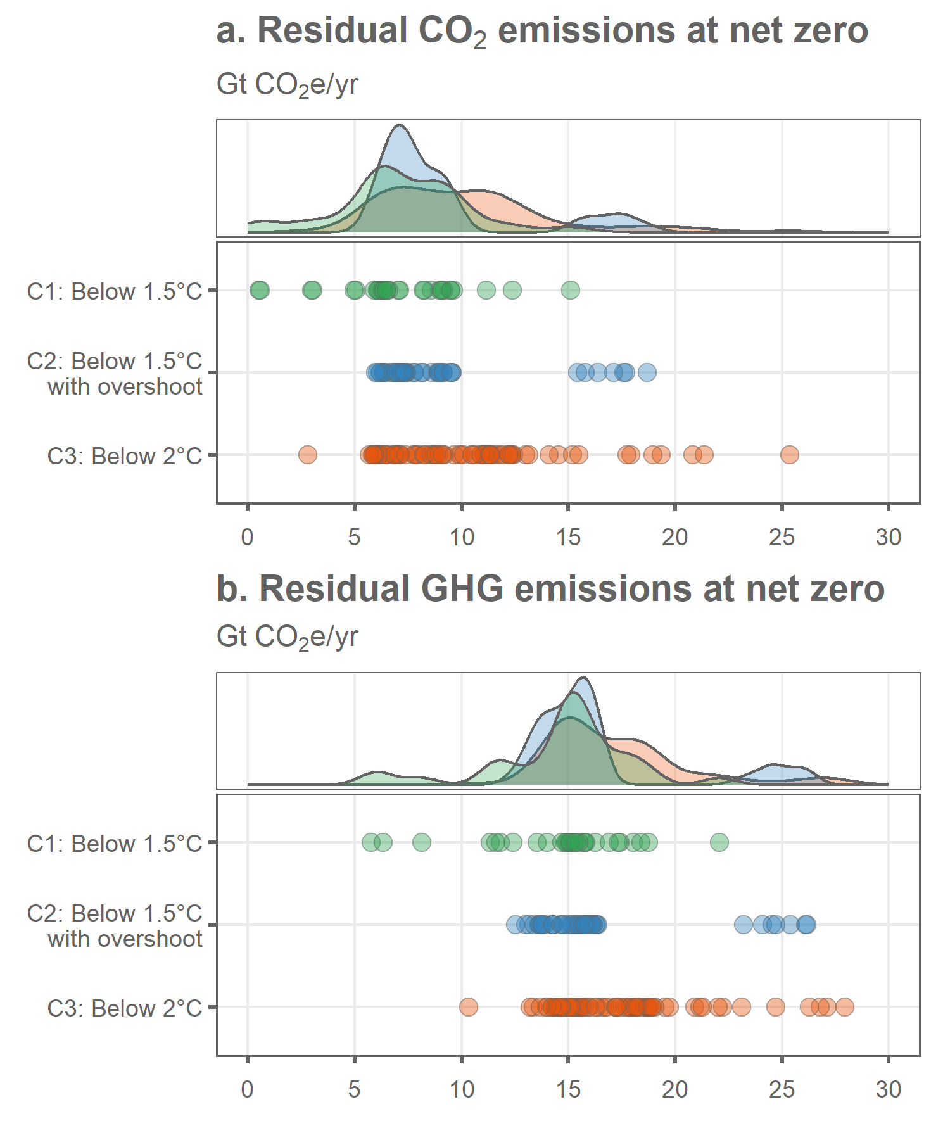

## save plot data  
addWorksheet(wb_figures,"fig_1_total_residual")  
writeData(wb_figures, sheet = "fig_1_total_residual",  
 wd_totals, colNames = T, rowNames = F)

## summary of scenario totals  
wd_totals_summary <- median_and_range(wd_totals,c("var","category"))

## `summarise()` has grouped output by 'var'. You can override using the `.groups`  
## argument.

wd_totals_summary <- left_join(wd_totals_summary,wd_totals %>%   
 group_by(var,category) %>%   
 summarise(n=n(),  
 year_median = signif(median(year),4),  
 year_5th = signif(quantile(year, probs = c(0.05)),4),  
 year_95th = signif(quantile(year, probs = c(0.95)),4)) %>%   
 mutate(year=paste0(year_median," [",year_5th,"-",year_95th,"]")) %>%   
 select(var,category,year,n),by = join_by(var, category))

## `summarise()` has grouped output by 'var'. You can override using the `.groups`  
## argument.

wd_totals_summary <- rbind(wd_totals_summary,  
 left_join(median_and_range(wd_totals,"var"),wd_totals %>%   
 group_by(var) %>%   
 summarise(n=n(),year_median = signif(median(year),4),  
 year_5th = signif(quantile(year, probs = c(0.05)),4),  
 year_95th = signif(quantile(year, probs = c(0.95)),4)) %>%   
 mutate(year=paste0(year_median," [",year_5th,"-",year_95th,"]")) %>%   
 select(var,year,n),by = join_by(var)) %>%   
 mutate(category="all"))  
  
  
## calculate reductions and join  
wd_total_reductions <- wd_scenarios_emissions %>%   
 mutate(include=ifelse(native_net_zero_CO2==year,1,0)) %>%   
 mutate(include=ifelse(year==2020,1,include)) %>%   
 filter(include==1) %>%   
 filter(gas=="CO2") %>%   
 group_by(id,gas,category,year) %>%   
 summarise(value=sum(value,na.rm=TRUE))

## `summarise()` has grouped output by 'id', 'gas', 'category'. You can override  
## using the `.groups` argument.

wd_total_reductions <- rbind(wd_total_reductions,wd_scenarios_emissions %>%   
 mutate(include=ifelse(native_net_zero_CO2==year,1,0)) %>%   
 mutate(include=ifelse(year==2020,1,include)) %>%   
 filter(include==1) %>%   
 filter(var!="Kyoto Gases") %>%   
 filter(!grepl("Carbon Sequestration",var)) %>%   
 group_by(id,category,year) %>%   
 summarise(value=sum(value,na.rm=TRUE)) %>%   
 mutate(gas="GHG"))

## `summarise()` has grouped output by 'id', 'category'. You can override using  
## the `.groups` argument.

wd_total_reductions <- wd_total_reductions %>%   
 group_by(id,gas,category) %>%   
 summarise(rel_change=(first(value)-last(value))/first(value)) %>%   
 mutate(rel_change=rel_change*100)

## `summarise()` has grouped output by 'id', 'gas'. You can override using the  
## `.groups` argument.

wd_total_reductions_summary <- median_and_range(wd_total_reductions %>% mutate(value=rel_change),c("gas","category"))

## `summarise()` has grouped output by 'gas'. You can override using the `.groups`  
## argument.

wd_total_reductions_summary <- rbind(wd_total_reductions_summary,  
 median_and_range(wd_total_reductions %>% mutate(value=rel_change),c("gas")) %>%   
 mutate(category="all"))  
  
wd_total_reductions_summary <- wd_total_reductions_summary %>%   
 mutate(category=as.character(category)) %>%   
 mutate(category=ifelse(grepl("C1",category),"C1: Below 1.5°C",category)) %>%   
 mutate(category=ifelse(grepl("C2",category),"C2: Below 1.5°C with overshoot",category)) %>%   
 mutate(category=ifelse(grepl("C3",category),"C3: Below 2°C",category)) %>%   
 mutate(category=as.factor(category))  
  
wd_totals_summary <- left_join(wd_totals_summary %>% rename(residual=value,gas=var),  
 wd_total_reductions_summary %>% rename(reductions=value),  
 by = join_by(gas,category))  
  
  
wd_totals_summary <- gather(wd_totals_summary,var,value,residual,reductions)  
wd_totals_summary <- wd_totals_summary %>%   
 ungroup() %>%   
 mutate(var=paste0(gas,"_",var)) %>%   
 select(-gas)  
wd_totals_summary <- spread(wd_totals_summary,var,value)  
wd_totals_summary <- wd_totals_summary %>%   
 select(category,n,year,CO2_residual,CO2_reductions,GHG_residual,GHG_reductions)  
  
addWorksheet(wb_analysis,"total_residual_at_nz")  
writeData(wb_analysis, sheet = "total_residual_at_nz",  
 wd_totals_summary, colNames = T, rowNames = F)  
  
  
## standard deviations  
  
wd_sd_summary <- wd_totals %>%   
 group_by(category,var) %>%   
 summarise(year_median = signif(median(year),4),  
 year_5th = signif(quantile(year, probs = c(0.05)),4),  
 year_95th = signif(quantile(year, probs = c(0.95)),4),  
 year_sd = signif(sd(year),2),  
 value_median = signif(median(value),2),  
 value_5th = signif(quantile(value, probs = c(0.05)),2),  
 value_95th = signif(quantile(value, probs = c(0.95)),2),  
 value_sd = signif(sd(value),2)) %>%   
 mutate(year=paste0(year_median," [",year_5th,"-",year_95th,"]")) %>%   
 mutate(value=paste0(value_median," [",value_5th,"-",value_95th,"]")) %>%   
 select(category,var,year,year_sd,value,value_sd)

## `summarise()` has grouped output by 'category'. You can override using the  
## `.groups` argument.

wd_sd_table <- spread(wd_sd_summary %>% select(-value_sd),var,value)  
wd_sd_table <- left_join(wd_sd_table,spread(wd_sd_summary %>% select(-value),var,value_sd) %>% select(category,CO2_sd=CO2,GHG_sd=GHG))

## Joining with `by = join_by(category)`

wd_sd_table <- wd_sd_table %>%   
 arrange(desc(category)) %>%   
 select(category,year,year_sd,CO2_residual=CO2,CO2_sd,GHG_residual=GHG,GHG_sd)

## how many scenarios were excluded?  
total_scenarios <- data_r1 %>%   
 ungroup() %>%   
 select(model,scenario,category) %>%   
 distinct() %>%   
 group_by(category) %>%   
 summarise(n=n())  
  
  
## what is the range of non-CO2 GHG emissions at net zero in C1-C3 scenarios ?  
non_CO2 <- wd_scenarios_emissions %>%   
 filter(var!="Kyoto Gases") %>%   
 filter(!grepl("Carbon Sequestration",var)) %>%   
 mutate(value=ifelse(is.na(value),0,value)) %>%   
 mutate(include=ifelse(native_net_zero_CO2==year,1,0)) %>%   
 filter(include==1) %>%  
 filter(gas!="CO2") %>%   
 group_by(id,category,year) %>%   
 summarise(value=sum(value)) %>%   
 mutate(var="GHG")

## `summarise()` has grouped output by 'id', 'category'. You can override using  
## the `.groups` argument.

non_CO2 <- median_and_range(non_CO2,"var")  
  
  
## how many scenarios adjust 2020 emissions for COVID?  
covid <- wd_scenarios_emissions %>%   
 filter(year==2020) %>%   
 select(id,category) %>%   
 distinct()  
cc_expl <- read.xlsx('Data/AR6_Scenarios_Database_metadata_indicators_v1.1_1.xlsx',sheet=2)  
covid <- left_join(covid,cc_expl %>% mutate(id=paste0(Model,"|",Scenario)) %>% select(id,COVID),by = join_by(id)) %>%   
 group_by(COVID) %>%   
 summarise(n=n())  
  
  
##

blarg <- wd_scenarios_emissions %>%   
 filter(year %in% c(2020,2100)) %>%   
 filter(var!="Kyoto Gases") %>%   
 filter(!grepl("Carbon Sequestration",var)) %>%   
 group_by(id,category,year) %>%   
 summarise(value=sum(value,na.rm=TRUE)) %>%   
 mutate(gas="GHG")

## `summarise()` has grouped output by 'id', 'category'. You can override using  
## the `.groups` argument.

blarg <- blarg %>%   
 group_by(id,gas,category) %>%   
 summarise(level=last(value),  
 rel_change=(first(value)-last(value))/first(value)) %>%   
 mutate(rel_change=rel_change*100)

## `summarise()` has grouped output by 'id', 'gas'. You can override using the  
## `.groups` argument.

blarg <- median_and_range(blarg %>% mutate(value=rel_change),c("gas","category"))

## `summarise()` has grouped output by 'gas'. You can override using the `.groups`  
## argument.

## emissions by gas at NZ  
wd_gases <- wd_scenarios_emissions %>%   
 filter(var!="Kyoto Gases") %>%   
 filter(!grepl("Carbon Sequestration",var)) %>%   
 mutate(value=ifelse(is.na(value),0,value)) %>%   
 mutate(include=ifelse(native_net_zero_CO2==year,1,0)) %>%   
 filter(include==1) %>%   
 group_by(id,model,scenario,category,year,gas) %>%   
 summarise(value=sum(value,na.rm=TRUE))

## `summarise()` has grouped output by 'id', 'model', 'scenario', 'category',  
## 'year'. You can override using the `.groups` argument.

## emissions by sector at NZ  
wd_sectors <- wd_scenarios_emissions %>%   
 filter(var!="Kyoto Gases") %>%   
 filter(!grepl("Carbon Sequestration",var)) %>%   
 mutate(value=ifelse(is.na(value),0,value)) %>%   
 mutate(include=ifelse(native_net_zero_CO2==year,1,0)) %>%   
 filter(include==1) %>%   
 mutate(sector=as.character(sector)) %>%   
 mutate(sector=ifelse(sector %in% c("Industrial processes","F-Gases","Other"),"Other (Industrial processes, F-gases, other)",sector)) %>%   
 group_by(id,model,scenario,category,year,sector) %>%   
 summarise(value=sum(value,na.rm=TRUE))

## `summarise()` has grouped output by 'id', 'model', 'scenario', 'category',  
## 'year'. You can override using the `.groups` argument.

## energy by fuel type at NZ  
wd_fuels <- data_r1 %>%   
 ungroup() %>%   
 mutate(id=paste0(model,"|",scenario)) %>%   
 select(-region,-unit) %>%   
 filter(var %in% c("Primary Energy",  
 "Primary Energy|Fossil|w/ CCS",  
 "Primary Energy|Coal|w/o CCS",  
 "Primary Energy|Gas|w/o CCS",  
 "Primary Energy|Oil|w/o CCS"))  
  
wd_fuels <- left_join(wd_fuels,wd_check_years,by="id") %>%   
 filter(!is.na(native_net_zero_CO2)) %>%   
 mutate(include=ifelse(native_net_zero_CO2==year,1,0)) %>%   
 #mutate(include=ifelse(year==2050,1,0)) %>%   
 filter(include==1) %>%   
 select(-include)  
  
wd_fuels <- spread(wd_fuels,var,value)  
wd_fuels <- wd_fuels %>%   
 mutate(`Primary Energy|Renewable & nuclear`=`Primary Energy`-  
 `Primary Energy|Fossil|w/ CCS`-  
 `Primary Energy|Coal|w/o CCS` -  
 `Primary Energy|Gas|w/o CCS` -  
 `Primary Energy|Oil|w/o CCS`)  
  
wd_fuels <- gather(wd_fuels,var,value,`Primary Energy`:`Primary Energy|Renewable & nuclear`) %>%   
 filter(var!="Primary Energy")  
  
wd_fuels <- left_join(wd_fuels,data.frame(var=c("Primary Energy|Renewable & nuclear",  
 "Primary Energy|Fossil|w/ CCS",  
 "Primary Energy|Coal|w/o CCS",  
 "Primary Energy|Gas|w/o CCS",  
 "Primary Energy|Oil|w/o CCS"),  
 fuel=c("Renewables, biomass & nuclear",  
 "Fossil with CCS",  
 "Coal",  
 "Gas",  
 "Oil")),by="var")  
  
wd_fuels$fuel <- as.factor(wd_fuels$fuel)  
wd_fuels$fuel <- fct_relevel(wd_fuels$fuel,"Renewables, biomass & nuclear","Fossil with CCS","Oil","Gas","Coal")  
  
wd_fuels$category <- as.factor(wd_fuels$category)  
wd_fuels$category <- fct_relevel(wd_fuels$category,"C3","C2","C1")  
  
wd_fuels <- wd_fuels %>%   
 mutate(model=ifelse(grepl("IMAGE",model),"IMAGE",model)) %>%   
 mutate(model=ifelse(grepl("REMIND",model),"REMIND",model)) %>%   
 mutate(model=ifelse(grepl("MESSAGE",model),"MESSAGE",model))  
  
  
  
## data summaries  
## at this point we ignore C1-C3 really  
wd_gases_summary <- median_and_range(wd_gases,c("model","gas"))

## `summarise()` has grouped output by 'model'. You can override using the  
## `.groups` argument.

wd_gases_summary <- rbind(wd_gases_summary,  
 median_and_range(wd_gases,"gas") %>% mutate(model="all"))  
wd_gases_summary <- spread(wd_gases_summary,gas,value) %>%   
 arrange(model)  
  
wd_sectors_summary <- median_and_range(wd_sectors,c("model","sector"))

## `summarise()` has grouped output by 'model'. You can override using the  
## `.groups` argument.

wd_sectors_summary <- rbind(wd_sectors_summary,  
 median_and_range(wd_sectors,"sector") %>% mutate(model="all"))  
wd_sectors_summary <- spread(wd_sectors_summary,sector,value) %>%   
 arrange(model)  
  
wd_fuels_extra_vars <- spread(wd_fuels %>% select(-var),fuel,value) %>%   
 mutate(`Fossil total`=Oil+Coal+Gas) %>%   
 mutate(Total=`Fossil total`+`Renewables, biomass & nuclear`+`Fossil with CCS`)  
wd_fuels_extra_vars <- gather(wd_fuels_extra_vars,fuel,value,`Renewables, biomass & nuclear`:Total)  
  
wd_fuels_summary <- median_and_range(wd_fuels_extra_vars,c("model","fuel"))

## `summarise()` has grouped output by 'model'. You can override using the  
## `.groups` argument.

wd_fuels_summary <- rbind(wd_fuels_summary,  
 median_and_range(wd_fuels_extra_vars,"fuel") %>% mutate(model="all"))  
wd_fuels_summary$fuel <- as.factor(wd_fuels_summary$fuel)  
wd_fuels_summary$fuel <- fct_relevel(wd_fuels_summary$fuel,"Coal","Oil","Gas","Fossil total","Fossil with CCS","Renewables, biomass & nuclear","Total")  
wd_fuels_summary <- spread(wd_fuels_summary,fuel,value) %>%   
 arrange(model)  
  
addWorksheet(wb_analysis,"gas_residual_at_nz")  
addWorksheet(wb_analysis,"sector_residual_at_nz")  
addWorksheet(wb_analysis,"fuel_at_nz")  
writeData(wb_analysis, sheet = "gas_residual_at_nz",  
 wd_gases_summary, colNames = T, rowNames = F)  
writeData(wb_analysis, sheet = "sector_residual_at_nz",  
 wd_sectors_summary, colNames = T, rowNames = F)  
writeData(wb_analysis, sheet = "fuel_at_nz",  
 wd_fuels_summary, colNames = T, rowNames = F)

## what about primary energy supply if we compare across the same year??  
  
wd_fuels_check <- data_r1 %>%   
 ungroup() %>%   
 mutate(id=paste0(model,"|",scenario)) %>%   
 select(-region,-unit) %>%   
 filter(var %in% c("Primary Energy",  
 "Primary Energy|Fossil|w/ CCS",  
 "Primary Energy|Coal|w/o CCS",  
 "Primary Energy|Gas|w/o CCS",  
 "Primary Energy|Oil|w/o CCS"))  
  
wd_fuels_check <- left_join(wd_fuels_check,cc_scenarios %>% mutate(include=1)) %>%   
 filter(year %in% c(2050,2075,2100)) %>%   
 filter(include==1) %>%   
 select(-include)

## Joining with `by = join_by(id)`

wd_fuels_check <- spread(wd_fuels_check,var,value)  
wd_fuels_check <- wd_fuels_check %>%   
 mutate(`Primary Energy|Renewable & nuclear`=`Primary Energy`-  
 `Primary Energy|Fossil|w/ CCS`-  
 `Primary Energy|Coal|w/o CCS` -  
 `Primary Energy|Gas|w/o CCS` -  
 `Primary Energy|Oil|w/o CCS`)  
  
wd_fuels_check <- gather(wd_fuels_check,var,value,`Primary Energy`:`Primary Energy|Renewable & nuclear`) %>%   
 filter(var!="Primary Energy")  
  
wd_fuels_check <- left_join(wd_fuels_check,data.frame(var=c("Primary Energy|Renewable & nuclear",  
 "Primary Energy|Fossil|w/ CCS",  
 "Primary Energy|Coal|w/o CCS",  
 "Primary Energy|Gas|w/o CCS",  
 "Primary Energy|Oil|w/o CCS"),  
 fuel=c("Renewables, biomass & nuclear",  
 "Fossil with CCS",  
 "Coal",  
 "Gas",  
 "Oil")),by="var")  
  
wd_fuels_check <- wd_fuels_check %>%   
 mutate(model=ifelse(grepl("IMAGE",model),"IMAGE",model)) %>%   
 mutate(model=ifelse(grepl("REMIND",model),"REMIND",model)) %>%   
 mutate(model=ifelse(grepl("MESSAGE",model),"MESSAGE",model)) %>%   
 filter(year==2050)  
  
wd_fuels_check_totals <- wd_fuels_check   
  
wd_fuels_check <- median_and_range(wd_fuels_check,c("model","var"))

## `summarise()` has grouped output by 'model'. You can override using the  
## `.groups` argument.

wd_fuels_check_totals <- median_and_range(wd_fuels_check_totals,c("var"))  
wd_fuels_check <- rbind(wd_fuels_check,wd_fuels_check_totals %>% mutate(model="all"))  
  
wd_fuels_check <- spread(wd_fuels_check,var,value)  
  
addWorksheet(wb_analysis,"fuel_at_2050")  
writeData(wb_analysis, sheet = "fuel_at_2050",  
 wd_fuels_check, colNames = T, rowNames = F)

p1 <- wd_gases %>% ggplot(.,aes(x=id,y=value,fill=gas)) +  
 geom_bar(stat="identity",color="#969696") +  
 facet_nested(.~model + fct_rev(category),scales="free_x",space="free",switch = "x",  
 nest_line = element_line(linetype = 1,color='#636363')) +  
 theme_wl() +  
 scale_y_continuous(limits=c(0,28),breaks=c(0,5,10,15,20,25)) +  
 #scale_fill_manual(values=colors[1:4]) +  
 scale_fill_brewer(palette="Greens") +  
 theme(axis.title = element_blank(),  
 axis.text.x = element_blank(),  
 axis.ticks.x = element_blank(),  
 panel.grid.major.x = element_blank(),  
 legend.position="bottom",  
 legend.title=element_blank(),  
 legend.background = element_blank(),  
 legend.margin = margin(t=-5),  
 strip.background = element_blank(),  
 panel.spacing.x=unit(0.4, "lines"),  
 panel.border = element_blank(),  
 strip.text = element_text(color='#636363'),) +  
 labs(title="a. Residual GHG emissions at net zero by gas",  
 subtitle=bquote("Gt"~CO[2]*"e/yr"))

## Scale for fill is already present.  
## Adding another scale for fill, which will replace the existing scale.

wd_sectors$sector <- as.factor(wd_sectors$sector)  
wd_sectors$sector <- fct_relevel(wd_sectors$sector,"Energy","AFOLU","Other (Industrial processes, F-gases, other)")  
  
p2 <- wd_sectors %>% ggplot(.,aes(x=id,y=value,fill=sector)) +  
 geom_bar(stat="identity",color="#969696") +  
 facet_nested(.~model + fct_rev(category),scales="free_x",space="free",switch = "x",  
 nest_line = element_line(linetype = 1,color='#636363')) +  
 theme_wl() +  
 scale_y_continuous(limits=c(0,28),breaks=c(0,5,10,15,20,25)) +  
 scale_fill_brewer(palette="Blues") +  
 theme(axis.title = element_blank(),  
 axis.text.x = element_blank(),  
 axis.ticks.x = element_blank(),  
 panel.grid.major.x = element_blank(),  
 legend.position="bottom",  
 legend.title=element_blank(),  
 legend.background = element_blank(),  
 legend.margin = margin(t=-5),  
 strip.background = element_blank(),  
 panel.spacing.x=unit(0.4, "lines"),  
 panel.border = element_blank(),  
 strip.text = element_text(color='#636363'),  
 strip.clip = element_blank()  
 ) +  
 labs(title="b. Residual GHG emissions at net zero by sector",  
 subtitle=bquote("Gt"~CO[2]*"e/yr"))

## Scale for fill is already present.  
## Adding another scale for fill, which will replace the existing scale.

p3 <- wd_fuels %>% ggplot(.,aes(x=id,y=value,fill=fuel)) +  
 geom_bar(stat="identity",color="#969696") +  
 facet_nested(.~model + fct_rev(category),scales="free_x",space="free",switch = "x",  
 nest_line = element_line(linetype = 1,color='#636363')) +  
 theme_wl() +  
 scale_fill_brewer(palette="Oranges") +  
 theme(axis.title = element_blank(),  
 axis.text.x = element_blank(),  
 axis.ticks.x = element_blank(),  
 panel.grid.major.x = element_blank(),  
 legend.position="bottom",  
 legend.title=element_blank(),  
 legend.background = element_blank(),  
 legend.margin = margin(t=-5),  
 strip.background = element_blank(),  
 panel.spacing.x=unit(0.4, "lines"),  
 panel.border = element_blank(),  
 strip.text = element_text(color='#636363'),  
 strip.clip = element_blank()  
 ) +  
 labs(title="c. Primary Energy supply at net zero by fuel",  
 subtitle=bquote("EJ/yr"))

## Scale for fill is already present.  
## Adding another scale for fill, which will replace the existing scale.

p1/plot_spacer()/p2/plot_spacer()/p3 + plot_layout(heights=c(5,1,5,1,5))

## Warning: Removed 2 rows containing missing values (`geom_bar()`).  
## Removed 2 rows containing missing values (`geom_bar()`).

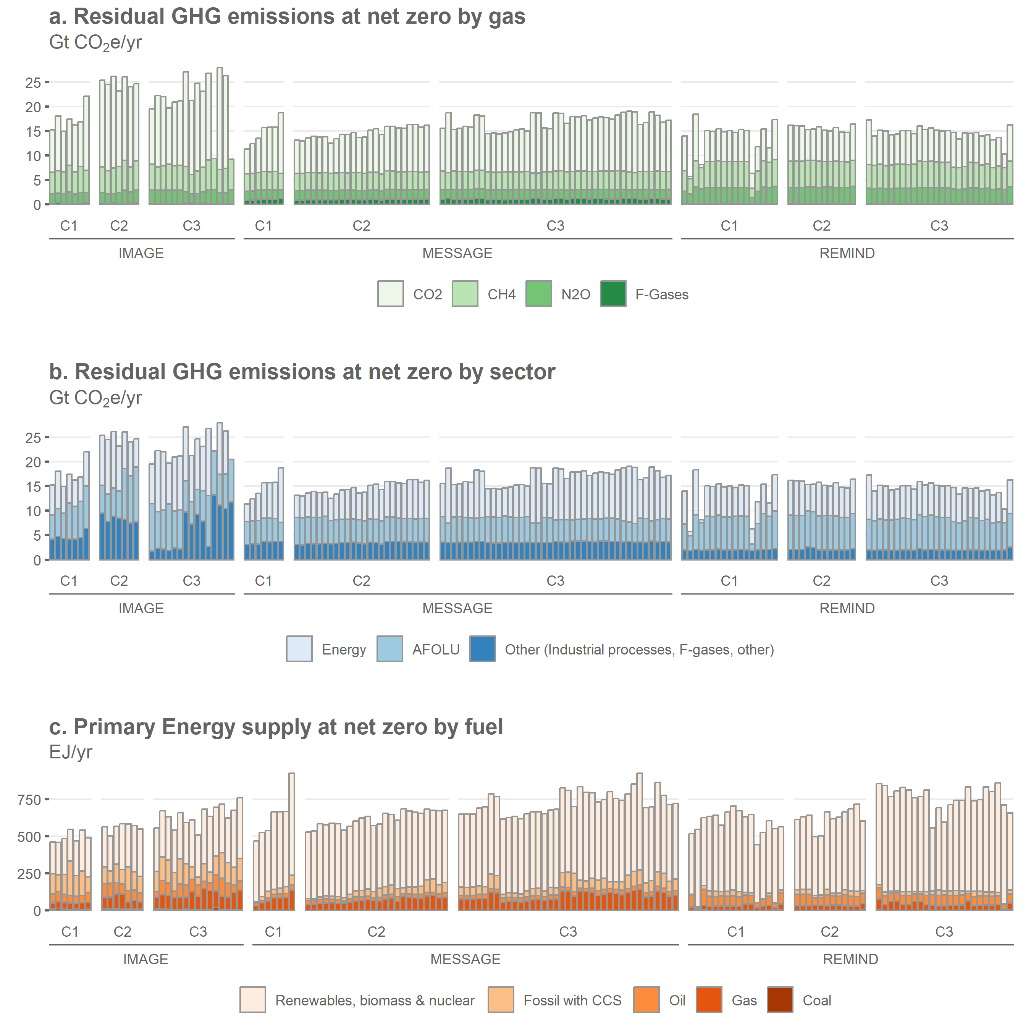

## save plot data  
addWorksheet(wb_figures,"fig_2a_gases")  
addWorksheet(wb_figures,"fig_2b_sectors")  
addWorksheet(wb_figures,"fig_2c_fuels")  
  
writeData(wb_figures, sheet = "fig_2a_gases",spread(wd_gases,gas,value)   
 %>% arrange(model,desc(category),scenario), colNames = T, rowNames = F)  
writeData(wb_figures, sheet = "fig_2b_sectors",spread(wd_sectors,sector,value)  
 %>% arrange(model,desc(category),scenario), colNames = T, rowNames = F)  
writeData(wb_figures, sheet = "fig_2c_fuels",spread(wd_fuels %>% select(-fuel),var,value) %>%   
 select(-native_net_zero_CO2,-native_net_zero_CO2) %>%   
 select(id,model,scenario,category,year,everything()) %>%   
 arrange(model,desc(category),scenario), colNames = T, rowNames = F)

## get the scenario data  
wd_subsectors <- wd_scenarios_emissions %>%  
 filter(var!="Kyoto Gases") %>%  
 filter(!grepl("Carbon Sequestration",var)) %>%  
 mutate(value=ifelse(is.na(value),0,value)) %>%  
 mutate(include=ifelse(native_net_zero_CO2==year,1,0)) %>%  
 mutate(include=ifelse(year==2020,1,include)) %>%   
 filter(include==1) %>%  
 group_by(id,model,category,year,sector,var) %>%  
 summarise(value=sum(value,na.rm=TRUE))

## `summarise()` has grouped output by 'id', 'model', 'category', 'year',  
## 'sector'. You can override using the `.groups` argument.

## generate median scenarios for each  
  
wd_subsectors_total <- wd_subsectors %>%   
 mutate(model="All") %>%   
 mutate(year=ifelse(year!=2020,2050,year)) %>% #2050 here is just a fake year to merge all the nz years  
 group_by(model,year,sector,var) %>%  
 summarise(percentile_5th = quantile(value, probs = c(0.05)),  
 percentile_95th = quantile(value, probs = c(0.95)),  
 std=sd(value),  
 value=median(value,na.rm=TRUE)) %>%   
 mutate(model="All")

## `summarise()` has grouped output by 'model', 'year', 'sector'. You can override  
## using the `.groups` argument.

wd_subsectors <- wd_subsectors %>%   
 mutate(year=ifelse(year!=2020,2050,year)) %>% #2050 here is just a fake year to merge all the nz years  
 group_by(model,year,sector,var) %>%  
 summarise(percentile_5th = quantile(value, probs = c(0.05)),  
 percentile_95th = quantile(value, probs = c(0.95)),  
 std=sd(value),  
 value=median(value,na.rm=TRUE))

## `summarise()` has grouped output by 'model', 'year', 'sector'. You can override  
## using the `.groups` argument.

## calculate relative and absolute changes for each model and variable  
wd_subsectors <- rbind(wd_subsectors,wd_subsectors_total)  
wd_subsectors <- wd_subsectors %>%   
 group_by(model,sector,var) %>%   
 mutate(change_rel = (first(value)-last(value))/first(value)) %>%   
 mutate(change_rel_5th = (first(percentile_5th)-last(percentile_5th))/first(percentile_5th)) %>%   
 mutate(change_rel_95th = (first(percentile_95th)-last(percentile_95th))/first(percentile_95th)) %>%   
 mutate(change_rel=-round(change_rel*100,0)) %>%   
 mutate(change_rel_5th=-round(change_rel_5th*100,0)) %>%   
 mutate(change_rel_95th=-round(change_rel_95th*100,0))  
  
  
## rebase the data so that totals in 2020 vs "2050" are shown  
wd_subsectors <- wd_subsectors %>%   
 group_by(model,sector,var) %>%   
 mutate(value_rebased=first(value)-last(value)) %>%   
 mutate(value_rebased=ifelse(year==2050,value,value_rebased))  
  
wd_subsectors <- wd_subsectors %>%  
 mutate(value_rebased=ifelse(value_rebased<0,0,value_rebased))  
  
wd_subsectors$year = as.factor(wd_subsectors$year)  
wd_subsectors$year <- fct_relevel(wd_subsectors$year,"2020","2050")  
  
p1 <- wd_subsectors %>%   
 filter(model!="All") %>%   
 filter(sector=="Energy") %>%   
 mutate(var=gsub("\\|Energy","",var)) %>%   
 ggplot(.,aes(x=value_rebased,y=reorder(var,value_rebased),alpha=year)) +  
 geom_col(color='#636363',fill="#8da0cb") +  
 geom_errorbar(data=wd_subsectors %>%  
 filter(model!="All") %>%   
 filter(year==2050) %>%  
 filter(sector=="Energy") %>%  
 mutate(var=gsub("\\|Energy","",var)),inherit.aes = FALSE,  
 aes(xmin=percentile_5th,xmax=percentile_95th,y=reorder(var,value_rebased)),  
 width=0.3) +  
 geom_text(data=wd_subsectors %>%  
 filter(model!="All") %>%   
 filter(sector=="Energy") %>%  
 mutate(var=gsub("\\|Energy","",var)) %>%   
 group_by(model,var,change_rel) %>%  
 summarise(value=sum(value_rebased)),  
 inherit.aes = FALSE,aes(x=value+1,y=var,  
 label=ifelse(change_rel<0,  
 paste0(change_rel,"%"),  
 paste0("+",change_rel,"%"))),  
 hjust=0,size=3) +  
 scale_x_continuous(expand = expansion(mult = c(0.05, 0.25))) +  
 scale_alpha_discrete(range=c(0.3,1)) +  
 scale_fill_brewer(palette="Blues") +  
 facet_grid(.~model) +  
 theme_wl() +  
 theme(legend.position="none",  
 axis.title=element_blank(),  
 panel.grid.major.y = element_blank()) +  
 labs(title="a. Energy sector emissions from 2020 to net zero",  
 subtitle=bquote("Gt"~CO[2]*"e/yr"))

## `summarise()` has grouped output by 'model', 'var'. You can override using the  
## `.groups` argument.

## Warning: Using alpha for a discrete variable is not advised.

## Scale for fill is already present.  
## Adding another scale for fill, which will replace the existing scale.

p2 <- wd_subsectors %>%  
 filter(model!="All") %>%   
 filter(sector=="AFOLU") %>%   
 mutate(var=gsub("\\|AFOLU","",var)) %>%   
 ggplot(.,aes(x=value_rebased,y=reorder(var,value_rebased),alpha=year)) +  
 geom_col(color='#636363',fill="#66c2a5") +  
 geom_errorbar(data=wd_subsectors %>%  
 filter(model!="All") %>%   
 filter(year==2050) %>%  
 filter(sector=="AFOLU") %>%   
 mutate(var=gsub("\\|AFOLU","",var)),inherit.aes = FALSE,  
 aes(xmin=percentile_5th,xmax=percentile_95th,y=reorder(var,value_rebased)),  
 width=0.3) +  
 geom_text(data=wd_subsectors %>%  
 filter(model!="All") %>%   
 filter(sector=="AFOLU") %>%  
 mutate(var=gsub("\\|AFOLU","",var)) %>%   
 group_by(model,var,change_rel) %>%  
 summarise(value=sum(value_rebased)),  
 inherit.aes = FALSE,aes(x=value+1.2,y=var,  
 label=ifelse(change_rel<0,  
 paste0(change_rel,"%"),  
 paste0("+",change_rel,"%"))),  
 hjust=0,size=3) +  
 scale_x_continuous(expand = expansion(mult = c(0.05, 0.25))) +  
 scale_alpha_discrete(range=c(0.3,1)) +  
 #scale_fill_brewer(palette="Greens") +  
 facet_grid(.~model) +  
 theme_wl() +  
 theme(legend.position="none",  
 axis.title=element_blank(),  
 panel.grid.major.y = element_blank()) +  
 labs(title="b. AFOLU sector emissions from 2020 to net zero",  
 subtitle=bquote("Gt"~CO[2]*"e/yr"))

## `summarise()` has grouped output by 'model', 'var'. You can override using the  
## `.groups` argument.

## Warning: Using alpha for a discrete variable is not advised.

p3 <- wd_subsectors %>%   
 filter(model!="All") %>%   
 filter(sector!="Energy") %>%   
 filter(sector!="AFOLU") %>%   
 mutate(var=gsub("\\|Other","",var)) %>%   
 mutate(var=ifelse(var=="CO2","CO2|Other",var)) %>%   
 ggplot(.,aes(x=value_rebased,y=reorder(var,value_rebased),alpha=year)) +  
 geom_col(color='#636363',fill="#fc8d62") +  
 geom_errorbar(data=wd_subsectors %>%  
 filter(model!="All") %>%   
 filter(year==2050) %>%   
 filter(sector!="Energy") %>%   
 filter(sector!="AFOLU") %>%   
 mutate(var=gsub("\\|Other","",var)) %>%   
 mutate(var=ifelse(var=="CO2","CO2|Other",var)),inherit.aes = FALSE,  
 aes(xmin=percentile_5th,xmax=percentile_95th,y=reorder(var,value_rebased)),  
 width=0.3) +  
 geom_text(data=wd_subsectors %>%  
 filter(model!="All") %>%   
 filter(sector!="Energy") %>%  
 filter(sector!="AFOLU") %>%  
 mutate(var=gsub("\\|Other","",var)) %>%  
 mutate(var=ifelse(var=="CO2","CO2|Other",var)) %>%  
 group_by(model,var,change_rel) %>%  
 summarise(value=sum(value_rebased)),  
 inherit.aes = FALSE,aes(x=value+0.4,y=var,  
 label=ifelse(change_rel<0,  
 paste0(change_rel,"%"),  
 paste0("+",change_rel,"%"))),  
 hjust=0,size=3) +  
 scale_x_continuous(expand = expansion(mult = c(0.05, 0.25))) +  
 scale_alpha_discrete(range=c(0.3,1)) +  
 scale_fill_brewer(palette="Oranges") +  
 facet_grid(.~model) +  
 theme_wl() +  
 theme(legend.position="none",  
 axis.title=element_blank(),  
 panel.grid.major.y = element_blank()) +  
 labs(title="c. Other sector emissions from 2020 to net zero",  
 subtitle=bquote("Gt"~CO[2]*"e/yr"))

## `summarise()` has grouped output by 'model', 'var'. You can override using the  
## `.groups` argument.

## Warning: Using alpha for a discrete variable is not advised.

## Scale for fill is already present.  
## Adding another scale for fill, which will replace the existing scale.

p1 / p2 / p3

## Warning: Removed 1 rows containing missing values (`geom_text()`).

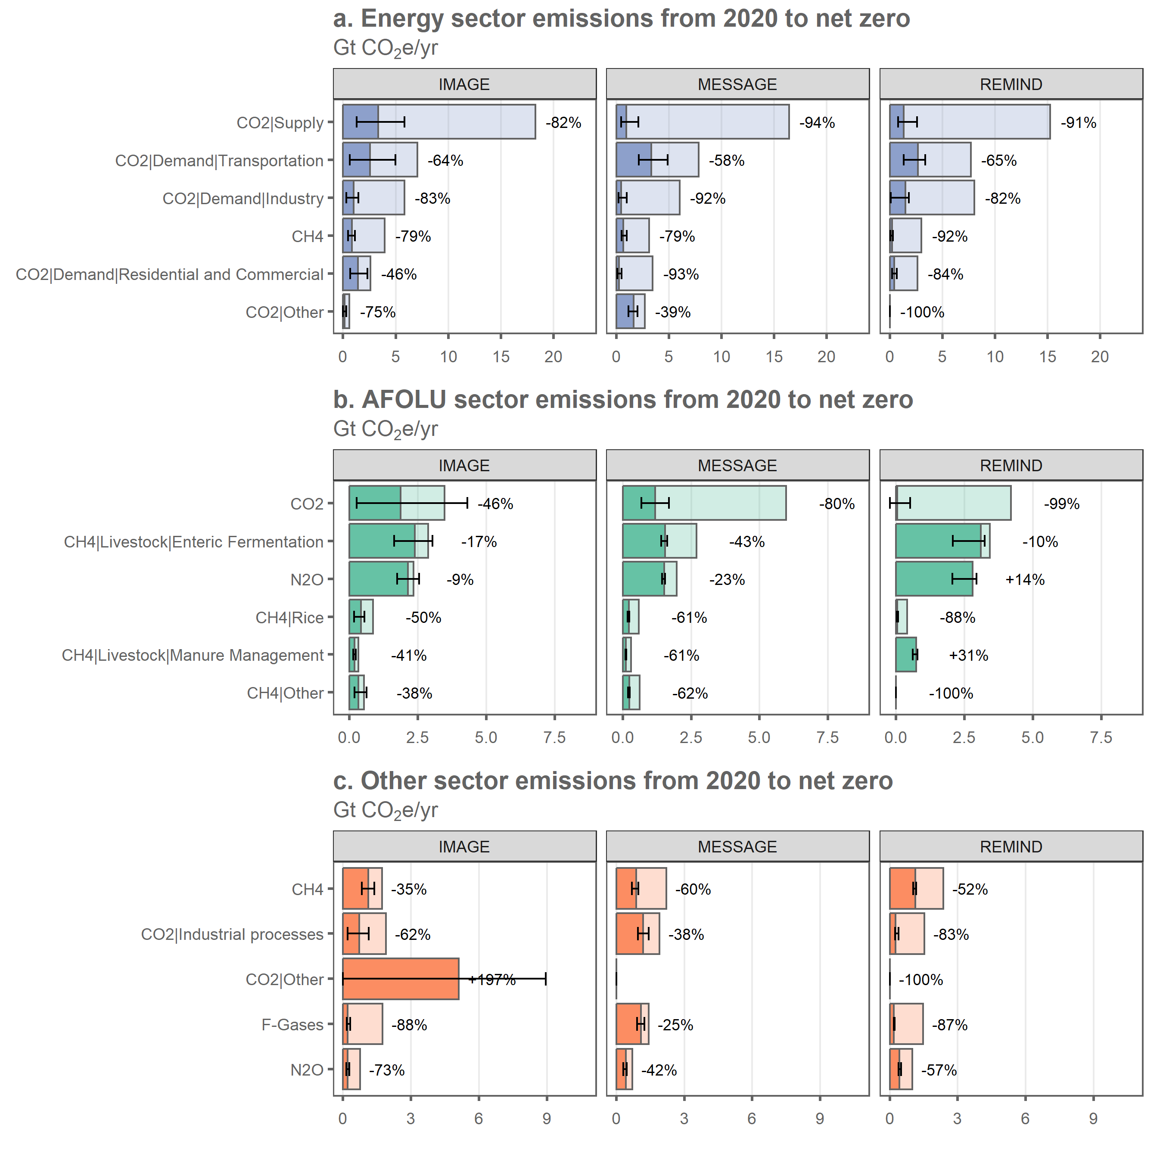

## save plot data  
addWorksheet(wb_figures,"fig_3_subsectors")  
  
  
writeData(wb_figures, sheet = "fig_3_subsectors",  
 wd_subsectors %>%   
 select(sector,model,var,year,value_rebased,percentile_5th,percentile_95th) %>%  
 arrange(sector,model,var,year) %>%   
 mutate(year=ifelse(year==2050,"Net Zero","2020")),  
 colNames = T, rowNames = F)

wd_subsectors_summary <- wd_subsectors %>%   
 ungroup() %>%   
 filter(year==2050) %>%   
 mutate(sector=as.character(sector)) %>%   
 mutate(sector=ifelse(sector=="F-Gases","Other",sector)) %>%   
 mutate(sector=ifelse(sector=="Industrial processes","Other",sector)) %>%   
 mutate(change_rel_5th=ifelse(percentile_5th==0,-100,change_rel_5th)) %>%   
 mutate(value=paste0(signif(value,2)," [",signif(percentile_5th,2),"-",signif(percentile_95th,2),"]")) %>%   
 mutate(change_rel=paste0(change_rel," [",change_rel_5th," to ",change_rel_95th,"]")) %>%   
 select(model,sector,var,value,change_rel)  
  
wd_subsectors_summary$sector <- as.factor(wd_subsectors_summary$sector)  
wd_subsectors_summary$sector <- fct_relevel(wd_subsectors_summary$sector,  
 "AFOLU","Energy","Other")  
  
wd_subsectors_summary <- cbind(spread(wd_subsectors_summary %>%   
 mutate(model=paste0(model,"_level")) %>%   
 select(-change_rel),model,value),  
 spread(wd_subsectors_summary %>%   
 mutate(model=paste0(model,"_reduction")) %>%   
 select(-value),model,change_rel) %>%   
 select(-sector,-var)) %>%   
 arrange(sector,var)  
  
  
addWorksheet(wb_analysis,"subsector_residual_at_nz")  
writeData(wb_analysis, sheet = "subsector_residual_at_nz",  
 wd_subsectors_summary, colNames = T, rowNames = F)

wd_pca <- wd_scenarios_emissions %>%  
 filter(var!="Kyoto Gases") %>%  
 filter(!grepl("Carbon Sequestration",var)) %>%  
 mutate(value=ifelse(is.na(value),0,value)) %>%  
 mutate(include=ifelse(native_net_zero_CO2==year,1,0)) %>%   
 filter(include==1) %>%  
 group_by(id,model,var) %>%  
 summarise(value=sum(value,na.rm=TRUE))

## `summarise()` has grouped output by 'id', 'model'. You can override using the  
## `.groups` argument.

wd_pca <- spread(wd_pca,var,value)  
pca <- prcomp(wd_pca %>% ungroup() %>% select(-id,-model),scale=TRUE)  
wd_pca <- cbind(wd_pca %>% select(id,model),pca$x)  
pca_variance <-get_eigenvalue(pca)$variance.percent  
sum(pca_variance[1:2])

## [1] 75.01983

# colors=c("#e6550d","#3182bd","#31a354")  
# wd_pca %>% ggplot(.,aes(x=PC1,y=PC2,fill=model)) +  
# geom_point(shape=21,size=3,alpha=0.6) +  
# theme_wl() +  
# scale_fill_manual(values=colors) +  
# theme(legend.title=element_blank()) +  
# labs(title=paste0("Principal components explaining ",signif(sum(pca_variance[1:2]),2), "% of residual\nsubsector emissions variance"))  
  
  
fviz_pca_biplot(pca,   
 geom.ind = "point",  
 pointshape = 21,  
 pointsize = 3,  
 fill.ind = wd_pca$model,  
 col.ind = "black",  
 select.var = list(contrib= 12),  
 col.var = "black",  
 repel = TRUE # Avoid label overplotting  
 ) +   
 theme_wl() +  
 xlim(-4,4) +  
 ylim(-3,6) +  
 theme(legend.title=element_blank()) +  
 labs(title=paste0("Principal components and variables explaining\nvariance in residual subsector emissions"))

## Warning: Removed 1 rows containing non-finite values (`stat_mean()`).

## Warning: Removed 1 rows containing missing values (`geom_point()`).

## Warning: Removed 1 rows containing missing values (`geom_text_repel()`).

## Warning: Removed 1 rows containing missing values (`geom_segment()`).

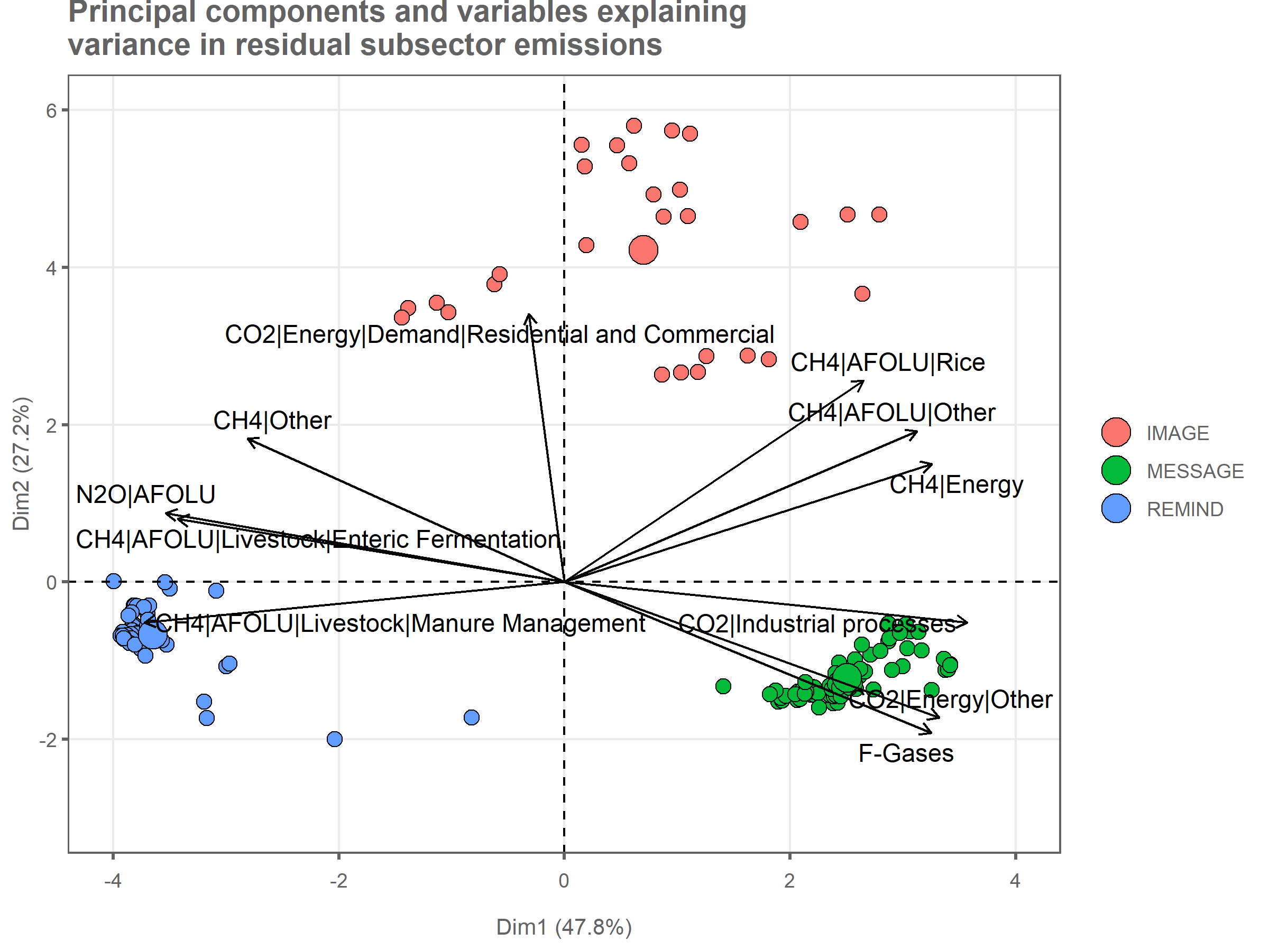

# fviz_contrib(pca,  
# choice = "var",  
# axes = 1:2,  
# fill="#3182bd") +  
# coord_flip() +  
# theme(axis.text.x = element_text(angle = 0,hjust=0.5),  
# axis.title.y = element_blank())

# wd_clusters <- wd_scenarios_emissions %>%  
# filter(var!="Kyoto Gases") %>%  
# filter(!grepl("Carbon Sequestration",var)) %>%  
# mutate(value=ifelse(is.na(value),0,value)) %>%  
# mutate(include=ifelse(native_net_zero_CO2==year,1,0)) %>%  
# filter(include==1) %>%  
# group_by(id,category,var) %>%  
# summarise(value=sum(value,na.rm=TRUE))  
#   
# wd_clusters <- spread(wd_clusters,var,value) %>%  
# ungroup()  
#   
# cc_clusters = wd_clusters %>%  
# select(id) %>%   
# mutate(no_clusters=NA) %>%   
# mutate(value=NA)  
#   
# for(x in 3:6) {  
#   
# wd_cluster_summary <- kmeans(scale(wd_clusters %>% select(-id,-category)),x,nstart=25)  
#   
# blarg <- cbind(cc_clusters %>% select(id),value=wd_cluster_summary$cluster) %>%   
# mutate(no_clusters=x)  
# cc_clusters <- rbind(cc_clusters,blarg)  
#   
# }  
#   
# cc_clusters <- left_join(cc_clusters %>% filter(!is.na(no_clusters)),wd_pca %>% select(id,model,PC1,PC2))  
# cc_clusters <- cc_clusters %>%   
# mutate(label=paste0(no_clusters," Clusters"))  
#   
# cc_clusters$value <- as.factor(cc_clusters$value)  
#   
#   
# cc_clusters %>% ggplot(.,aes(x=PC1,y=PC2,fill=model)) +  
# geom_point(shape=21,size=3,alpha=0.6) +  
# theme_wl() +  
# facet_wrap(.~label) +  
# #theme(legend.position="none") +  
# labs(title=paste0("Principal components explaining ",signif(sum(pca_variance[1:2]),2), "% of residual subsector emissions variance"))

cc_expl <- read.xlsx('Data/AR6_Scenarios_Database_metadata_indicators_v1.1_1.xlsx',sheet=2)  
cc_expl <- cc_expl %>%  
 mutate(id=paste0(Model,"|",Scenario)) %>%   
 select(id,Policy_category,Policy_category_name,Project_study,reference=`Literature.Reference.(if.applicable)`,  
 Ssp_family,Technology_category_name)  
  
## explanatory factors vs. total residual?  
wd_expl <- left_join(wd_scenarios_emissions,cc_expl,by="id") %>%   
 mutate(include=ifelse(year==native_net_zero_CO2,1,0)) %>%   
 filter(include==1) %>%   
 select(-include) %>%   
 filter(var!="Kyoto Gases") %>%   
 filter(!is.na(subsector))  
  
wd_expl <- wd_expl %>%   
 group_by(id,model,category,Policy_category,Policy_category_name,Project_study,reference,  
 Ssp_family,Technology_category_name) %>%   
 summarise(value=sum(value,na.rm=TRUE)) %>%  
 mutate(Ssp_family=as.character(Ssp_family)) %>%   
 mutate(Ssp_family=ifelse(Ssp_family=="1","SSP1",Ssp_family)) %>%  
 mutate(Ssp_family=ifelse(Ssp_family=="2","SSP2",Ssp_family)) %>%   
 mutate(Ssp_family=as.factor(Ssp_family))

## `summarise()` has grouped output by 'id', 'model', 'category',  
## 'Policy_category', 'Policy_category_name', 'Project_study', 'reference',  
## 'Ssp_family'. You can override using the `.groups` argument.

wd_expl <- wd_expl %>%   
 ungroup() %>%   
 select(-category,-Policy_category,-reference)  
wd_expl <- gather(wd_expl,key,var,-id,-value,-model)

## Warning: attributes are not identical across measure variables; they will be  
## dropped

p1 <- wd_expl %>%   
 ggplot(.,aes(x=value,y=var)) +  
 geom_point(shape=21,size=3,alpha=0.5,color="#636363",aes(fill=model)) +  
 stat_summary(fun=median,geom="crossbar", color="#636363",width=0.5,show.legend = FALSE) +  
 facet_grid(key~.,scales="free_y",space="free",switch="y",  
 labeller=as_labeller(c(Policy_category_name="Policy category",  
 Project_study="Project study",  
 Ssp_family="SSP family",  
 Technology_category_name="Technology category"))) +  
 scale_y_discrete(limits=rev,labels = function(x) str_wrap(x, width = 25)) +  
 theme_wl() +  
 theme(legend.position="bottom",  
 legend.title=element_blank(),  
 axis.title = element_blank(),  
 strip.text = element_text(color="#252525"),  
 plot.margin = margin(0,0,0,0,"cm"),) +  
 labs(title="Residual GHG emissions at net zero vs. scenario characteristics",  
 subtitle=bquote("Gt"~CO[2]*"e/yr and fraction of sample"))  
  
  
## how many scenarios are from the ENGAGE project?  
wd_expl_totals <- wd_expl %>%   
 group_by(key,var) %>%   
 summarise(n=n(),  
 fraction=n/length(no_scenarios$id)) %>%   
 mutate(fraction=signif(fraction*100,2))

## `summarise()` has grouped output by 'key'. You can override using the `.groups`  
## argument.

p2 <- wd_expl_totals %>% ggplot(.,aes(x="% of sample",y=var,label=paste0(fraction,"%"))) +  
 geom_text(size=4,color="#636363") +  
 facet_grid(key~.,scales="free_y",space="free") +  
 scale_y_discrete(limits=rev) +  
 theme_wl() +  
 theme(legend.position="none",  
 axis.title = element_blank(),  
 axis.text = element_blank(),  
 plot.background = element_blank(),  
 strip.background = element_blank(),  
 strip.text = element_blank(),  
 axis.ticks = element_blank(),  
 panel.grid.major.x = element_blank(),  
 plot.margin = margin(0,0,0,0,"cm"),  
 axis.text.x = element_blank())  
  
  
p1 + p2 + plot_layout(widths=c(9,1))

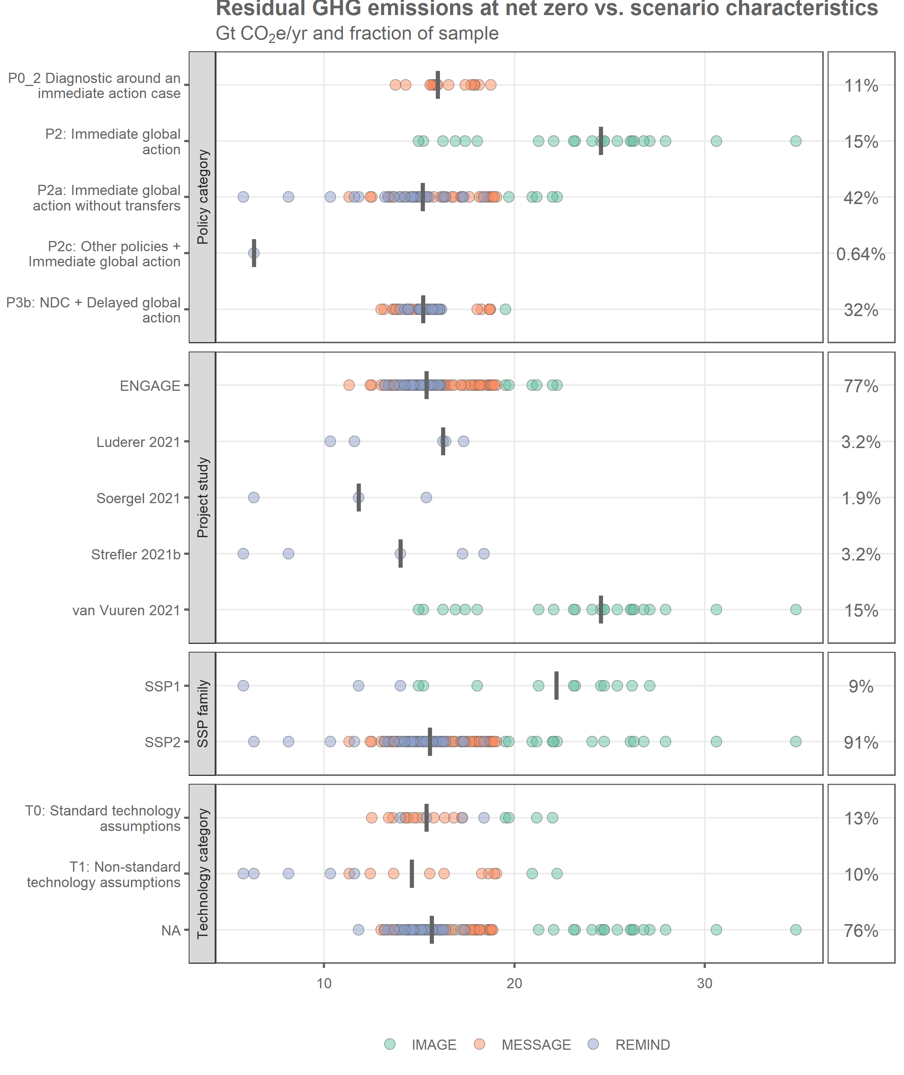

wd_expl <- median_and_range(wd_expl,c("key","var"))

## `summarise()` has grouped output by 'key'. You can override using the `.groups`  
## argument.

wd_expl <- left_join(wd_expl,wd_expl_totals)

## Joining with `by = join_by(key, var)`

addWorksheet(wb_analysis,"explanatory_vars")  
writeData(wb_analysis, sheet = "explanatory_vars",  
 wd_expl, colNames = T, rowNames = F)

# pd <- pd %>%   
# mutate(include=ifelse(year==2020,1,0)) %>%   
# mutate(include=ifelse(year==net_zero_CO2,1,include)) %>%   
# mutate(include=ifelse(year==2100,1,include)) %>%   
# filter(include==1)  
  
  
  
# pd <- wd_scenarios_emissions %>%   
# filter(var!="Kyoto Gases") %>%   
# filter(!grepl("Carbon Sequestration",var)) %>%   
# mutate(include=ifelse(year>=net_zero_CO2,1,0)) %>%   
# filter(include==1) %>%   
# group_by(id,model,scenario,category,year,net_zero_CO2) %>%   
# summarise(value=sum(value,na.rm=TRUE)) #%>%   
# group_by(id,model,scenario,category) %>%   
# summarise(emissions_nz=first(value),  
# emissions_2100=last(value))  
  
  
  
# pd <- gather(pd,var,value,-id,-category)  
#   
# pd %>% filter(var=="change_rel") %>% ggplot(.,aes(x=value,y=category,fill=category)) +  
# geom_point(shape=21,size=3,alpha=0.6,color="#636363") +  
# theme_wl() +  
# theme(legend.position="none",  
# axis.title = element_blank(),  
# plot.margin = margin(0,0,0,0,"cm"))  
  
#   
#   
# pd %>% ggplot(.,aes(x=emissions_2100,y=emissions_nz))+  
# geom_abline(intercept=0,color="#636363") +  
# geom_point(shape=21,size=3,alpha=0.6,color="#636363",aes(fill=category)) +  
# geom_text(data=data.frame(emissions_nz=c(6,5),  
# emissions_2100=c(5,6),  
# label=c("Decrease","Increase")),  
# aes(label=label),  
# color="#636363",  
# angle=35,  
# hjust=0) +  
# facet_wrap(.~category) +  
# theme_wl() +  
# theme(legend.title=element_blank()) +  
# xlim(5,25) +  
# ylim(5,25) +  
# ylab("GHG emissions at net-zero") +  
# xlab("GHG emissions at 2100") +  
# labs(title="Residual GHG emissions after net-zero",  
# subtitle="GtCO2e/yr")  
#   
#   
# pd <- wd_scenarios_emissions %>%   
# filter(var!="Kyoto Gases") %>%   
# filter(!grepl("Carbon Sequestration",var)) %>%   
# group_by(id,model,scenario,category,year,net_zero_CO2) %>%   
# summarise(value=sum(value,na.rm=TRUE))  
#   
# pd %>% ggplot(.,aes(x=year,y=value,group=id,color=model)) +  
# geom_line() +  
# facet_grid(category~model) +  
# theme_wl() +  
# theme(legend.position="none") +  
# scale_y_continuous(limits=c(0,60),breaks=c(0,10,20,30,40,50,60))

wd_standards <- wd_scenarios_emissions %>%   
 filter(var!="Kyoto Gases")%>%   
 filter(!grepl("Carbon Sequestration",var)) %>%   
 mutate(include=ifelse(year==native_net_zero_CO2,1,0)) %>%  
 mutate(include=ifelse(year==2020,1,include)) %>%   
 filter(include==1) %>%   
 select(-include)  
  
wd_standards <- wd_standards %>%   
 mutate(mapping=ifelse(sector=="AFOLU","AFOLU",NA)) %>%   
 mutate(mapping=ifelse(var=="CO2|Energy|Supply","Power",mapping)) %>%   
 mutate(mapping=ifelse(var=="CO2|Energy|Demand|Industry","Cement/Iron and Steel",mapping)) %>%   
 mutate(mapping=ifelse(var=="CO2|Industrial processes","Cement/Iron and Steel",mapping)) %>%   
 mutate(mapping=ifelse(var=="CO2|Energy|Demand|Residential and Commercial","Buildings",mapping))  
  
## cross-sector total (everything excl. AFOLU)  
wd_standards_total <- wd_scenarios_emissions %>%   
 filter(var!="Kyoto Gases")%>%   
 filter(!grepl("Carbon Sequestration",var)) %>%   
 mutate(include=ifelse(year==native_net_zero_CO2,1,0)) %>%  
 mutate(include=ifelse(year==2020,1,include)) %>%   
 filter(include==1) %>%   
 select(-include)  
  
wd_standards_total <- wd_standards_total %>%   
 mutate(mapping=ifelse(sector!="AFOLU","Total",NA))  
  
wd_standards <- rbind(wd_standards,wd_standards_total) %>%   
 filter(!is.na(mapping)) %>%   
 group_by(id,category,year,mapping) %>%   
 summarise(value=sum(value,na.rm=TRUE))

## `summarise()` has grouped output by 'id', 'category', 'year'. You can override  
## using the `.groups` argument.

wd_standards <- wd_standards %>%   
 group_by(id,category,mapping) %>%   
 mutate(rel_change=(first(value)-last(value))/first(value)) %>%   
 mutate(rel_change=rel_change*100)  
  
wd_standards <- median_and_range(wd_standards %>% select(id,category,sector=mapping,value=rel_change),c("sector","category"))

## `summarise()` has grouped output by 'sector'. You can override using the  
## `.groups` argument.

wd_standards$category <- fct_relevel(wd_standards$category,"C1","C2","C3")  
wd_standards <- spread(wd_standards,category,value)  
  
addWorksheet(wb_analysis,"scenarios_vs_standards")  
writeData(wb_analysis, sheet = "scenarios_vs_standards",  
 wd_standards, colNames = T, rowNames = F)

## get the scenario data  
wd_subsectors <- wd_scenarios_emissions %>%  
 filter(var!="Kyoto Gases") %>%  
 filter(!grepl("Carbon Sequestration",var)) %>%  
 mutate(value=ifelse(is.na(value),0,value)) %>%  
 mutate(include=ifelse(native_net_zero_CO2==year,1,0)) %>%  
 mutate(include=ifelse(year==2020,1,include)) %>%   
 filter(include==1) %>%  
 group_by(id,model,category,year,sector,var) %>%  
 summarise(value=sum(value,na.rm=TRUE))

## `summarise()` has grouped output by 'id', 'model', 'category', 'year',  
## 'sector'. You can override using the `.groups` argument.

## new sector aggregation  
aggregation <- read.xlsx("Data/cc_aggregation_socdr.xlsx")  
wd_subsectors <- left_join(wd_subsectors,aggregation)

## Joining with `by = join_by(sector, var)`

wd_subsectors <- wd_subsectors %>%   
 group_by(id,model,year,colour,aggregation) %>%   
 summarise(value=sum(value,na.rm=TRUE))

## `summarise()` has grouped output by 'id', 'model', 'year', 'colour'. You can  
## override using the `.groups` argument.

## generate median scenarios for each  
  
wd_subsectors <- wd_subsectors %>%   
 mutate(year=ifelse(year!=2020,2050,year)) %>% #2050 here is just a fake year to merge all the nz years  
 group_by(year,colour,aggregation) %>%  
 summarise(percentile_5th = quantile(value, probs = c(0.05)),  
 percentile_95th = quantile(value, probs = c(0.95)),  
 std=sd(value),  
 value=median(value,na.rm=TRUE))

## `summarise()` has grouped output by 'year', 'colour'. You can override using  
## the `.groups` argument.

## calculate relative and absolute changes for each model and variable  
wd_subsectors <- wd_subsectors %>%   
 group_by(colour,aggregation) %>%   
 mutate(change_rel = (first(value)-last(value))/first(value)) %>%   
 mutate(change_rel_5th = (first(percentile_5th)-last(percentile_5th))/first(percentile_5th)) %>%   
 mutate(change_rel_95th = (first(percentile_95th)-last(percentile_95th))/first(percentile_95th)) %>%   
 mutate(change_rel=-round(change_rel*100,0)) %>%   
 mutate(change_rel_5th=-round(change_rel_5th*100,0)) %>%   
 mutate(change_rel_95th=-round(change_rel_95th*100,0))  
  
  
## rebase the data so that totals in 2020 vs "2050" are shown  
wd_subsectors <- wd_subsectors %>%   
 group_by(colour,aggregation) %>%   
 mutate(value_rebased=first(value)-last(value)) %>%   
 mutate(value_rebased=ifelse(year==2050,value,value_rebased))  
  
wd_subsectors <- wd_subsectors %>%  
 mutate(value_rebased=ifelse(value_rebased<0,0,value_rebased))  
  
wd_subsectors$year = as.factor(wd_subsectors$year)  
wd_subsectors$year <- fct_relevel(wd_subsectors$year,"2020","2050")  
  
wd_subsectors$colour = as.factor(wd_subsectors$colour)  
wd_subsectors$colour <- fct_relevel(wd_subsectors$colour,"Energy","AFOLU","Other")  
  
blarg <- wd_subsectors %>%  
 filter(year==2020) %>%   
 arrange(desc(colour),value)  
blarg$levels = 1  
blarg$levels = cumsum(blarg$levels)  
wd_subsectors <- left_join(wd_subsectors,blarg)

## Joining with `by = join_by(year, colour, aggregation, percentile_5th,  
## percentile_95th, std, value, change_rel, change_rel_5th, change_rel_95th,  
## value_rebased)`

wd_subsectors$aggregation <- fct_reorder(wd_subsectors$aggregation,wd_subsectors$levels)

## Warning: `fct_reorder()` removing 11 missing values.  
## ℹ Use `.na_rm = TRUE` to silence this message.  
## ℹ Use `.na_rm = FALSE` to preserve NAs.

p1 <- wd_subsectors %>%   
 filter(aggregation!="Other") %>%   
 ggplot(.,aes(x=value_rebased,y=aggregation,alpha=year,fill=colour)) +  
 geom_col(color='#636363') +  
 geom_errorbar(data=wd_subsectors %>%  
 filter(aggregation!="Other") %>%   
 filter(year==2050),inherit.aes = FALSE,  
 aes(xmin=percentile_5th,xmax=percentile_95th,y=aggregation),  
 width=0.3) +  
 geom_text(data=wd_subsectors %>%  
 filter(aggregation!="Other") %>%   
 group_by(aggregation,change_rel) %>%  
 summarise(value=sum(value_rebased)),  
 inherit.aes = FALSE,aes(x=value+1,y=aggregation,  
 label=ifelse(change_rel<0,  
 paste0(change_rel,"%"),  
 paste0("+",change_rel,"%"))),  
 hjust=0,size=3) +  
 scale_x_continuous(expand = expansion(mult = c(0.05, 0.25))) +  
 scale_alpha_discrete(range=c(0.3,1)) +  
 theme_wl() +  
 theme(legend.position="none",  
 axis.title=element_blank(),  
 panel.grid.major.y = element_blank()) +  
 labs(title="Emissions by sector from 2020 to net zero CO2",  
 subtitle=bquote("Gt"~CO[2]*"e/yr"))

## `summarise()` has grouped output by 'aggregation'. You can override using the  
## `.groups` argument.

## Warning: Using alpha for a discrete variable is not advised.

## get the scenario data  
wd_gases <- wd_scenarios_emissions %>%  
 filter(var!="Kyoto Gases") %>%  
 filter(gas!="F-Gases") %>%   
 filter(!grepl("Carbon Sequestration",var)) %>%  
 mutate(value=ifelse(is.na(value),0,value)) %>%  
 mutate(include=ifelse(native_net_zero_CO2==year,1,0)) %>%  
 mutate(include=ifelse(year==2020,1,include)) %>%   
 filter(include==1) %>%  
 group_by(id,model,category,year,gas) %>%  
 summarise(value=sum(value,na.rm=TRUE))

## `summarise()` has grouped output by 'id', 'model', 'category', 'year'. You can  
## override using the `.groups` argument.

## generate median scenarios  
  
wd_gases <- wd_gases %>%   
 mutate(year=ifelse(year!=2020,2050,year)) %>% #2050 here is just a fake year to merge all the nz years  
 group_by(year,gas) %>%  
 summarise(percentile_5th = quantile(value, probs = c(0.05)),  
 percentile_95th = quantile(value, probs = c(0.95)),  
 std=sd(value),  
 value=median(value,na.rm=TRUE))

## `summarise()` has grouped output by 'year'. You can override using the  
## `.groups` argument.

## calculate relative and absolute changes for each model and variable  
wd_gases <- wd_gases %>%   
 group_by(gas) %>%   
 mutate(change_rel = (first(value)-last(value))/first(value)) %>%   
 mutate(change_rel_5th = (first(percentile_5th)-last(percentile_5th))/first(percentile_5th)) %>%   
 mutate(change_rel_95th = (first(percentile_95th)-last(percentile_95th))/first(percentile_95th)) %>%   
 mutate(change_rel=-round(change_rel*100,0)) %>%   
 mutate(change_rel_5th=-round(change_rel_5th*100,0)) %>%   
 mutate(change_rel_95th=-round(change_rel_95th*100,0))  
  
  
## rebase the data so that totals in 2020 vs "2050" are shown  
wd_gases <- wd_gases %>%   
 group_by(gas) %>%   
 mutate(value_rebased=first(value)-last(value)) %>%   
 mutate(value_rebased=ifelse(year==2050,value,value_rebased))  
  
wd_gases <- wd_gases %>%  
 mutate(value_rebased=ifelse(value_rebased<0,0,value_rebased))  
  
wd_gases$year = as.factor(wd_gases$year)  
wd_gases$year <- fct_relevel(wd_gases$year,"2020","2050")  
  
wd_gases$gas <- fct_relevel(wd_gases$gas,"F-Gases","N2O","CH4","CO2")  
  
  
p2 <- wd_gases %>%   
 ggplot(.,aes(x=value_rebased,y=gas,alpha=year,fill=gas)) +  
 geom_col(color='#636363',fill='#969696') +  
 geom_errorbar(data=wd_gases %>%  
 filter(year==2050),inherit.aes = FALSE,  
 aes(xmin=percentile_5th,xmax=percentile_95th,y=gas),  
 width=0.3) +  
 geom_text(data=wd_gases %>%  
 group_by(gas,change_rel) %>%  
 summarise(value=sum(value_rebased)),  
 inherit.aes = FALSE,aes(x=value+1,y=gas,  
 label=ifelse(change_rel<0,  
 paste0(change_rel,"%"),  
 paste0("+",change_rel,"%"))),  
 hjust=0,size=3) +  
 scale_x_continuous(expand = expansion(mult = c(0.05, 0.25))) +  
 scale_alpha_discrete(range=c(0.3,1)) +  
 theme_wl() +  
 theme(legend.position="none",  
 axis.title=element_blank(),  
 panel.grid.major.y = element_blank()) +  
 labs(title="Emissions by gas from 2020 to net zero CO2",  
 subtitle=bquote("Gt"~CO[2]*"e/yr"))

## `summarise()` has grouped output by 'gas'. You can override using the `.groups`  
## argument.

## Warning: Using alpha for a discrete variable is not advised.

p2 / p1 + plot_layout(heights=c(2,6))

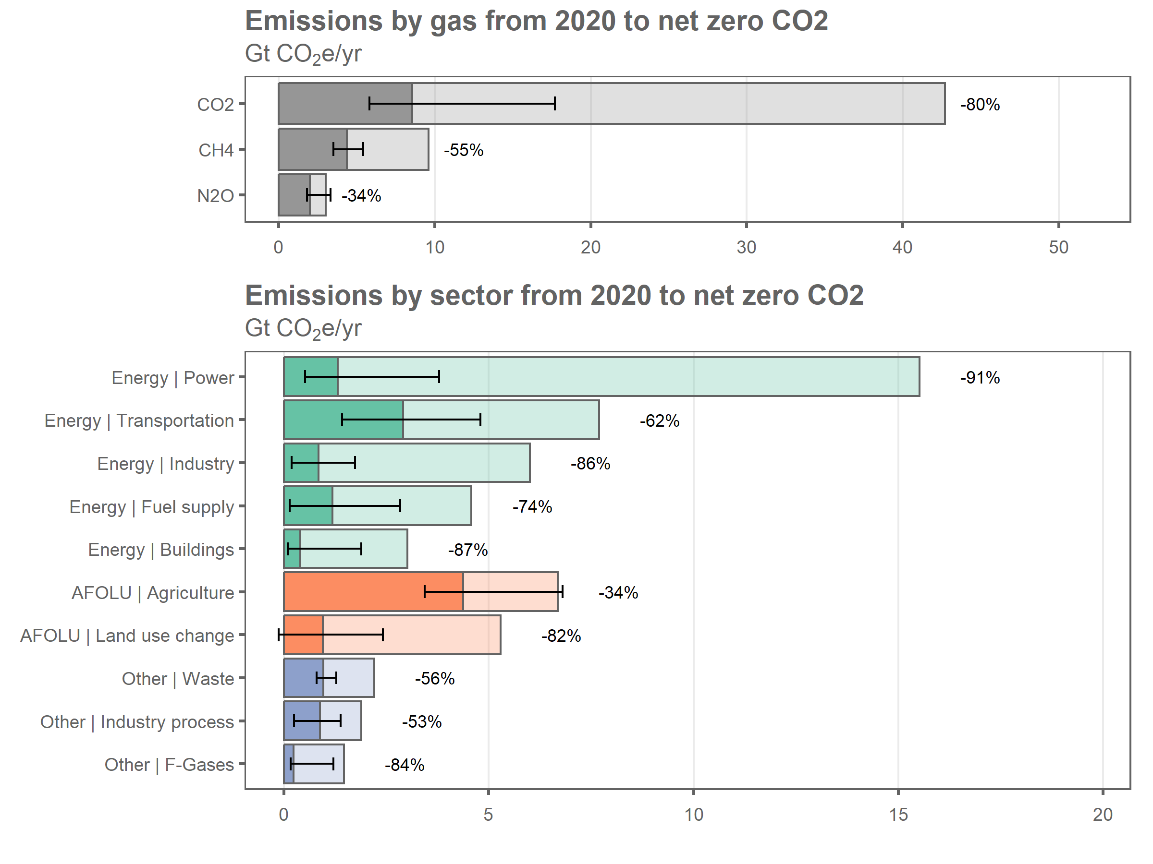

#   
# addWorksheet(wb_analysis,"recalcd_vs_native_net_emissions")  
# writeData(wb_analysis, sheet = "recalcd_vs_native_net_emissions",  
# test_residual %>% select(-difference_abs), colNames = T, rowNames = F)  
  
  
saveWorkbook(wb_figures,"Results/residual-emissions-ERL-figure-data.xlsx",overwrite=T)  
saveWorkbook(wb_analysis,"Results/residual-emissions-ERL-analysis.xlsx",overwrite=T)  
  
  
write.csv(wd_scenarios_emissions %>%  
 filter(var!="Kyoto Gases") %>%  
 filter(!grepl("Carbon Sequestration",var)),  
 file="Results/residual-emissions-ERL-processed-data.csv",sep=";")

## Warning in write.csv(wd_scenarios_emissions %>% filter(var != "Kyoto Gases")  
## %>% : Versuch ignoriert 'sep' zu setzen