The literature landscape on 1.5°C Climate Change and Cities

*William Lamb1, Max Callaghan1, Felix Creutzig1,2, Radhika Khosla3, Jan Minx1,4*

*Affiliations*

*1 Mercator Research Institute on Global Commons and Climate Change, Berlin*

*2 Technical University Berlin*

*3 Centre for Policy Research, New Delhi*

*4 Hertie School of Government, Berlin*

*Abstract. To achieve ambitious climate goals, such as 1.5°C target, all available options must be drawn. Cities as hotspots for people and infrastructure are key for a rapid transition towards a net zero emissions world economy. But systematic assessments on cities and climate change mitigation remain in their infancy. Yet, in times of big literature – defined as a large and exponentially growing literature base - the nature and size of the relevant literature for assessments is no longer obvious. Here, we use scientometric and big-data methods from computational linguistics for a systematic understanding of the research landscape on urban mitigation options and its evolutions over time. Such a systematic understanding is helpful for evaluating past and designing/performing future assessments on cities and climate change. We find that more than 80% of all relevant literature is not captured by a direct climate mitigation query. Most literature addresses social concerns of urban transport, buildings and metabolism, and climate action emerges as a co-benefit. We conclude by identifying epistemic communities that provide relevant input to this literature.*

# Introduction

For the global stock-take of the Paris Agreement, the Intergovernmental Panel on Climate Change (IPCC) has been tasked to inform climate diplomats comprehensively on the state of scientific knowledge around the 1.5°C goal in a Special Report. While the discussion of 1.5°C policy pathways has highlighted the role of negative emissions for staying within the tight and fast dwindling emission budget [1–4](REFs.), it has been largely neglected that the 1.5°C policy pathways also come with a distinctively different (gross) CO2 emissions profile compared to 2°C policy pathways: they require even more rapid in the medium-run and even deeper emissions reductions in the long-run as shown in Figure 1.

This paper starts from the assertion that the establishment of the 1.5°C goal has further reinforced the role and contribution of cities and urban infrastructures in climate change mitigation.[1] Arguably, achieving global (gross) emission levels close to zero in the long-run is unthinkable without low and zero-carbon infrastructures in place globally. Cities as infrastructure hotspots play a key role in shaping the long-run emission trajectories with opportunities for leapfrogging and risks for emissions lock-in. Even managing the rapid and steep emission reductions in the short- and medium-term will necessitate taking all available measures across governance levels. Particularly, with the slow progress in delivering national climate action, cities and local communities have emerged as one of the more ambitious policy communities in global climate change governance despite real problems in assessing their actual performance to date [5].

Despite being highlighted as a mitigation response topic to be treated in SR1.5 (Ref), cities have been staggeringly absent from the discussions on the 1.5°C so far. On the one hand, this is related to the fact that cities and urban infrastructures are not represented in global climate change mitigation models trying to explore the various economic, technological and institutional requirements of alternative climate stabilization pathways (REF). On the other hand, the literature on cities is largely place-based and does not relate directly to any global temperature target even though attempts have been made to establish such a link (REFs).

But the assessment of the role of cities and urban infrastructures for keeping warming below 1.5°C faces two further fundamental challenges: first, like in other fields of climate change research the body of relevant literature on urban climate change mitigation is large and fast-growing. Minx et al. (Ref) estimate that the number of new peer-reviewed research (as recorded in the ISI Web of Science) published during the sixth assessment cycle is roughly equal to the size of the entire climate change literature before AR6. As it increasingly becomes impossible for individuals to track progress even in highly specialized fields, bias in the selection of literature becomes an increasing problem in IPCC and other global environmental assessments.

Second, despite recent progress urban climate change assessments are still relatively in their infancy and the available literature has not yet been aggregated into discrete bodies of knowledge that can be easily drawn upon. This reinforces the problems caused by “big literature” described above. More importantly, it is particular the climate policy aspects that are less developed in a field where it remains a challenge to quantify the urban contribution to global emissions and to obtain comparable sets of emission data for larger samples of cities.

In order to allow for more transparent assessments of the role of cities in climate change mitigation and to enable more general discussions about the progress in urban climate change research in general, it is important to initiate some very basic but profound discussions about the relevant literature base. A fundamental question is what part of the urban literature should actually be considered in the upcoming special report, and how can it be organized around a coherent set of objectives and policies in the short, medium and long-term?

This paper aims to identify the relevant literature on cities and climate change transparently, and to analyze the state and evolution of the research field in terms of its thematic structure as a corner stone for the upcoming special report on the 1.5°C goal. We build a transparent and reproducible search query based on our own understanding of the urban literature, focusing on urban mitigation measures related to urban transport, buildings, waste, and urban form, but also including generic climate policies. We apply topic modelling [7] to endogenously identify the thematic structure of the literature corpus identified. A variety of other scientometric methods are used to characterize the research field, identify important contributions and key contributors to the various discussions.

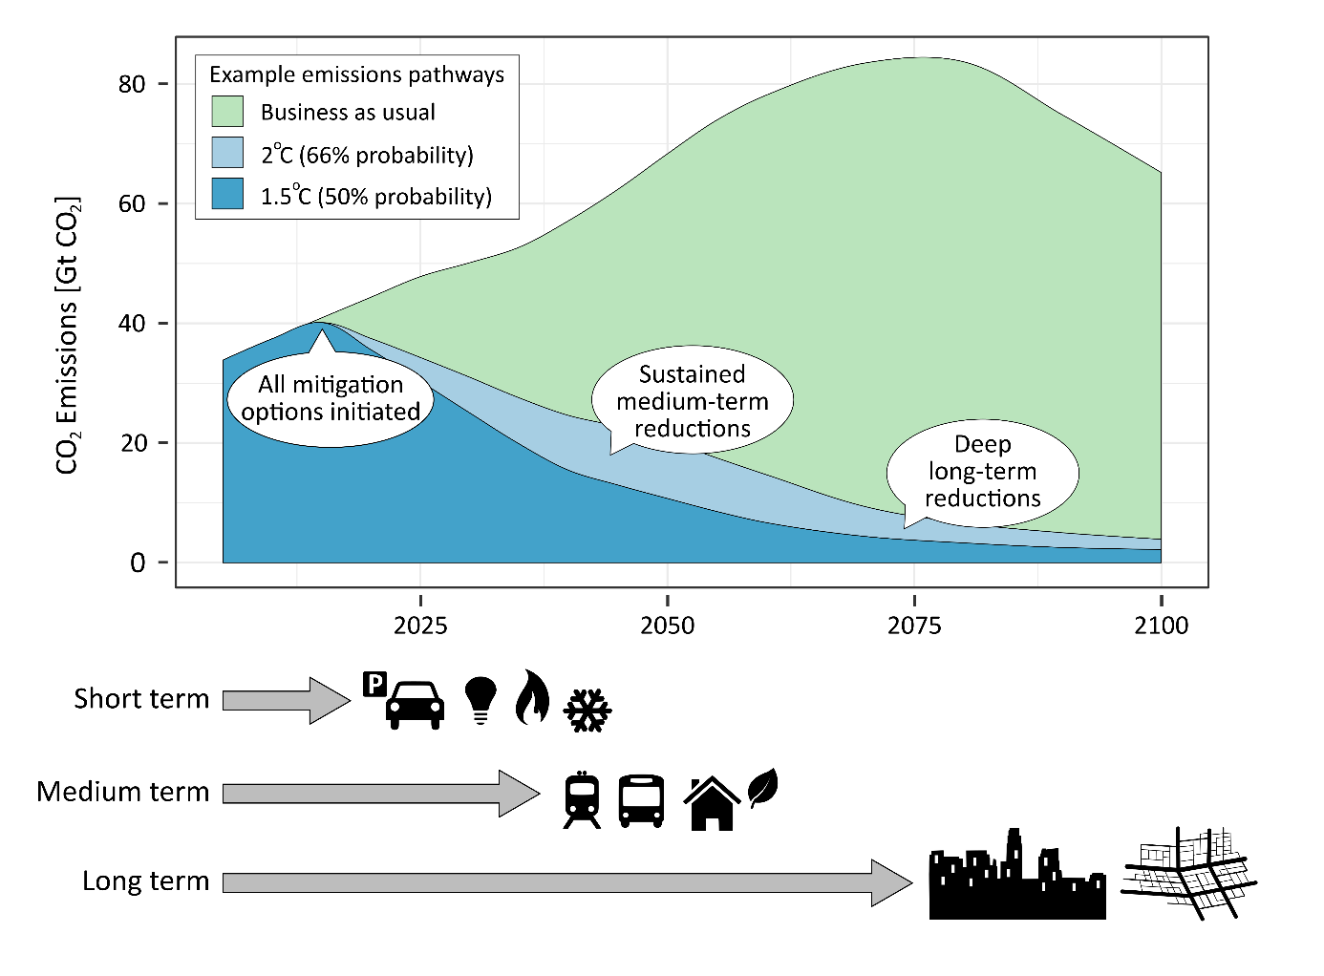

Figure 1: Initiating a structural shift towards low-carbon urban infrastructure is key for achieving 1.5°C, as compatible pathways are characterized by more rapid CO2 emission reductions and an even lower residual CO2 emissions than 2°C. Make clear that this graph does not show the negative emissions component of the 1.5°C and 2°C pathway. Define 1.5°C and 2°C precisely.

# Delineating the urban mitigation literature

In this review we focus on the demand-side of energy consumption and its associated climate impact. Although supply-side activities such as power generation also take place within cities, they are well captured by other research communities (e.g. IAMs). By contrast, the demand-side of climate change mitigation has received less attention in the literature and is a natural point of focus for an assessment of urban systems: not only are the everyday practices and uses of energy highly influenced by the shape, structure and organization of cities (REF), but the majority of energy consumption in the 21st century is projected to take place within them (REF).

Four key domains of literature can shed light on the urban drivers of greenhouse gas emissions, and opportunities for their mitigation: transportation, buildings, waste management, and urban form. In the context of the 1.5°C target, the four urban domains play varied roles (Fig 2). In the short-term, lifestyle and behavioral options can contribute most to climate change mitigation. This involves changes in preferences, habits, and decision-making, such as telecommuting, adapting to different room temperatures, food waste reduction, and so forth. These have been reviewed in literatures on the urban transport sector [8,9], the building sector [10,11], food waste [12], and the overall demand-side [13].

Understanding these time scales is crucial for advancing urban contributions towards net zero emission trajectories. Pointedly, the provision of low-carbon or energy-efficient appliances must be fostered now to achieve notable results in 5-10 years. Similarly, the transition towards sustainable transport systems needs to be implemented now to enable deep decarbonization in 20-40 years. These transport systems, together with price instruments, such as fuel taxes, in turn enable the realization of low-carbon compact urban form towards the end of this century. The middle and long-term is dominated by capital and infrastructure stocks [14]. This includes road and rail-based transport system with important network externalities and lifetimes of 40 to 75+ years or land use and urban form that often persist for more tan centuries. []

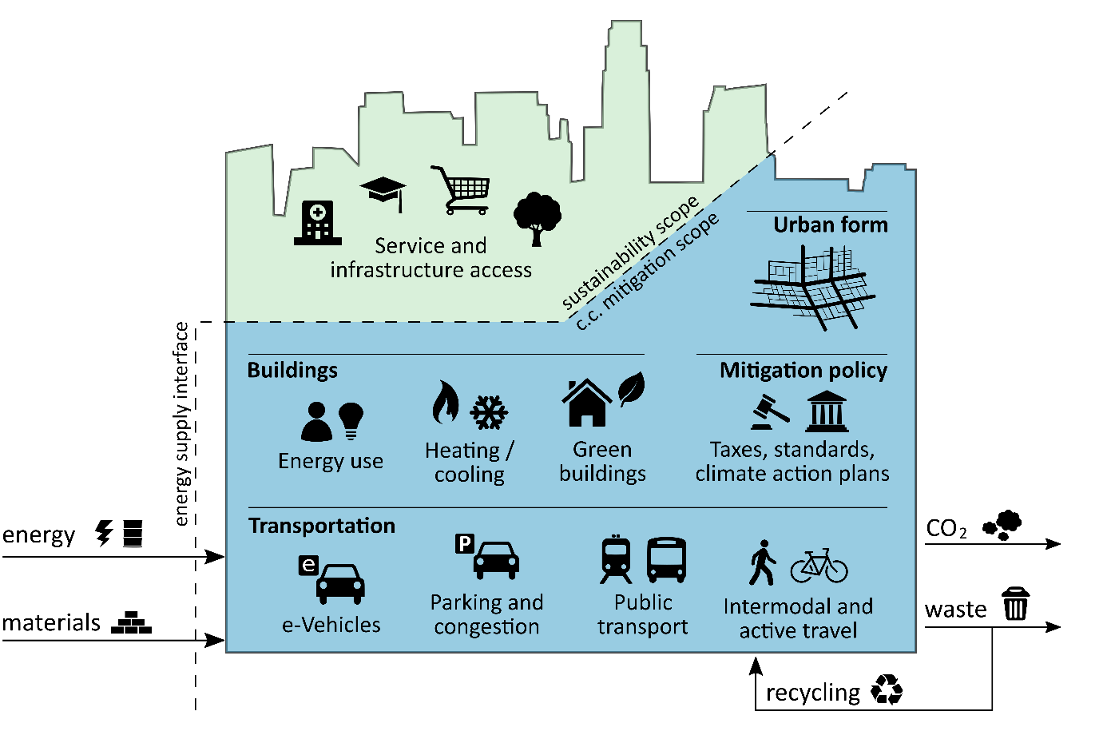

Figure 2: Scope of the urban mitigation literature, including measures that address urban transport, buildings, waste, and urban form.

# The structure and content of urban mitigation research

The results of our search query indicate that the urban mitigation literature is already quite large (8,120 publications), fast growing (X% per year), and is predominantly made up of contributions from engineering and technology, and the social sciences (SI text Fig 1). Over two thirds of the identified documents have been published since the beginning of the 5th IPCC Assessment (AR5) period (2008-2017). The keywords associated with transportation account for the largest portion of publications (4,127), followed by buildings (1,554), urban form and city-wide mitigation (1,531), and waste management (1,165). As compared to a simpler identification of urban mitigation literature (e.g. combining synonyms for “urban”, “mitigation” and “policies”), our targeted search identifies substantially more literature (8,120 compared to 610).

[We need to talk about the growth in the literature – with reference to SI figure]

25 latent topics in this document set are identified by the topic model. Table 1 lists these topics along with their names (manually assigned by the authors), stemmed keywords, and order of prevalence in the corpus.

The largest topic – planning and governance (#1) – well represents the policy and planning aspects of urban mitigation that were an explicit condition in our search (to be clear, each document is a combination of topics, hence the prevalence of this particular topic across the whole corpus). Building energy consumption (#2) is also a large topic, but this may reflect the fact that building topics are more aggregated (fewer) in this model, in contrast to transport, which has considerably more granularity due to its relatively larger set of documents.

[again – we need topic growth: suggest to include this in table & figure]

|  |  |  |  |
| --- | --- | --- | --- |
| **ID** | **Topic Name** | **Stemmed Keywords** | **Marginal Topic Distribution (%)** |
| 1 | Planning and governance | develop, sustain, plan, govern, project | 11.4 |
| 2 | Building energy performance | energi, build, consumpt, effici, perform | 7.1 |
| 3 | System optimisation | model, network, optim, system, propos | 6.6 |
| 4 | Travel behaviour | travel, mode, choic, time, car | 5.0 |
| 5 | Waste management | wast, manag, solid, landfil, municip | 4.9 |
| 6 | Urban form | urban, land, citi, area, spatial | 4.9 |
| 7 | Thermal comfort | heat, thermal, comfort, temperatur, build | 4.7 |
| 8 | Active travel | activ, school, health, physic, walk | 4.6 |
| 9 | Public transport | transport, public, access, car, system | 4.6 |
| 10 | GHG emissions | emiss, carbon, ghg, reduct, gas | 4.6 |
| 11 | Congestion charging | price, congest, road, charg, traffic | 4.2 |
| 12 | e-Vehicles | vehicl, electr, charg, batteri, power | 3.4 |
| 13 | Bus services | bus, servic, oper, passeng, buse | 3.4 |
| 14 | Local air pollution | air, pollut, qualiti, concentr, exposur | 3.3 |
| 15 | Waste water | treatment, wastewat, plant, remov, biolog | 3.2 |
| 16 | Rail transit | transit, rail, station, ridership, system | 3.2 |
| 17 | Policy instruments | polici, instrument, effect, local, implement | 3.1 |
| 18 | Climate change mitigation | climat, chang, mitig, local, govern | 2.9 |
| 19 | Car parking | park, space, price, car, lot | 2.7 |
| 20 | Household recycling | recycl, household, collect, program, materi | 2.7 |
| 21 | Green buildings and infrastructure | green, build, roof, infrastructur, ecosystem | 2.2 |
| 22 | Road tolls | toll, lane, link, revenu, optim | 2.1 |
| 23 | Building water use | water, heat, suppli, pump, system | 2.0 |
| 24 | Cycling | bicycl, cycl, cyclist, pedestrian, lane | 1.9 |
| 25 | Bus rapid transit | brt, bus, system, rapid, corridor | 1.1 |

Table 1: List of topics and their keywords

Figure 3 presents the correlations between topics, based on their co-occurrence within documents. Clusters of topics are clearly identifiable: around urban form, climate change mitigation, planning and governance; around energy and water use in buildings; between the three waste management topics; and in the highly interconnected group of transportation topics. These correlations allow us to identify the role of latent topics that were not explicit in our search query. For instance, “system optimization” (#3) comprises a set of keywords on mathematical optimization and is well connected to the topics on congestion charging and public transportation. This suggests a strong discourse of pricing and network optimization within transportation research. “Travel behavior” (#4) is also central within the transportation cluster and presents a complementary discourse on individual choice and behavior with respect to different modes of travel.

A surprising feature of the correlation network is the relative lack of policy and behavior oriented discourses in the buildings literature, as compared to transportation and waste research. A closer look at the documents and keywords highly correlated with building energy performance (#2) shows a consistent theme of energy performance assessment in relation to national building standards and codes. Thermal comfort (#7) is similarly technical in scope, focusing predominantly on the assessment of heating demand and supply systems. Neither topics include a strong behavioral aspect, nor are they directly connected to topics such as planning and governance (#1) or policy instruments (#17).

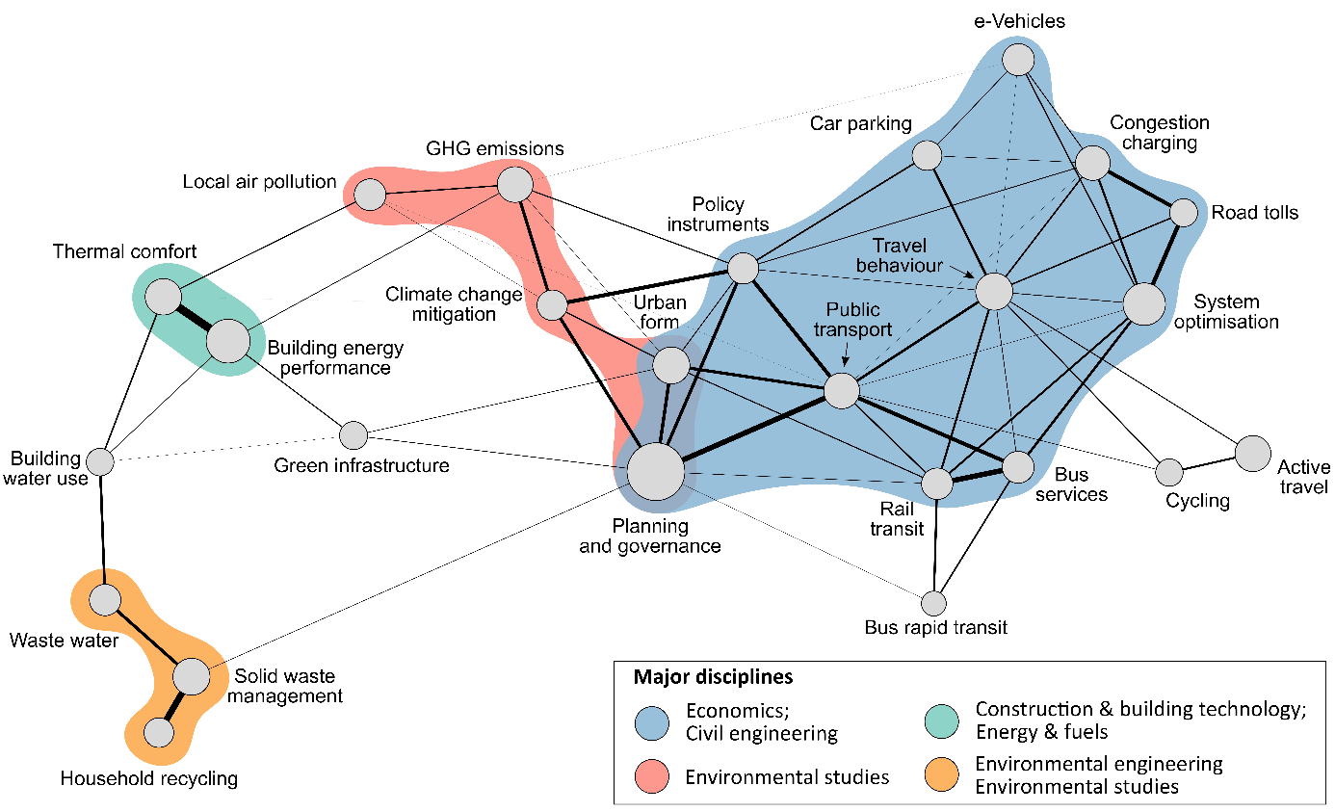

Figure 3: Topic correlations

It is further interesting to note the position and predominance of the topics that directly reference climate issues: climate change mitigation (#18) and GHG emissions (#10). The former is strongly connected to urban form (#6), planning and governance (#1), and policy instruments (#17), but remains relatively abstracted from specific transportation options, waste management, and the buildings literature (although the latter is indeed correlated with building energy performance). This likely reflects a range of competing discourses and priorities in these research areas: for instance, traffic congestion and cost-efficiency in the case of transportation, public health concerns in the case of active travel (#8), or thermal comfort in the case of buildings.

Using a compiled set of references from the IPCC AR5 Working Group III Report, we are able to assess its coverage of the urban mitigation literature identified here. This coverage extends to a total of 111 direct citations, out of 9,328 references in the report. While this might be considered a surprisingly low number, it is important to understand that the scope of the relevant chapter with its XXX references was much borader and included many issues that were not queried here. This analysis does suggest a predominant focus of the AR5 chapters on documents that are clearly designated as mitigation focused, related to urban form, building energy consumption, public transportation, or active travel (SI text Fig 2). Waste management and congestion charges are relatively minor topics in the IPCC reference set, while car parking is entirely absent.

Finally, and related to the timescale discussion raised early in this article (Figure 1), we perform a simple search on the document abstracts to identify years that are associated with projections or scenarios (within the range 2020-2100). Where sufficient data is available, the average timescales ranged between 2020 and 2040, increasing to the upper end of this range for the topic cluster on urban form and planning and governance, and decreasing towards 2020 for waste management, building energy performance, and e-Vehicles. The sparse timescales beyond 2050 suggest little in the way of medium and long-term planning relevant for 1.5°C mitigation pathways.

[1 Paragraph on the boundaries to sustainability via the infrastructure nexus, in particular water]

**Discussion and conclusion**

* In this paper we move beyond the ‘traditional’ focus of climate change mitigation to identify additional relevant policy options that would be needed for 1.5°C. These options are particularly evident in transportation management: congestion charges, parking prices and provisioning, public transportation provisioning, and support for active travel. Yet while these topics have formed flourishing literatures in their own right, they remain only marginally connected to climate change and mitigation discourses, even in recent years. (Check document list…)
* The lack of a behavioral aspect to the buildings literature is unexpected, as a wide variety of individual options are available to reduce energy demand in buildings [15,16], although these are likely assessed independently of the building context and may not be captured by our query.
* The lack of a strong policy theme in the buildings literature, as compared to transportation may be explained by inconsistencies of scale in the actual mitigation options that would be deployed: building and appliance codes are typically regulated at the national level, and experienced at an individual level; by contrast, transportation is planned and regulated at a municipal level, and experienced at a community level. The former is likely to comprise of a different set of nationally articulated measures (standards, codes, certificates), whereas the latter is more firmly situated in the urban context of planning, zoning and targeted investment.
* On the other hand, the embeddedness of building design and use within urban form and transportation systems has been largely overlooked. There are obvious links between these areas of literature that should be made, such as the trade-offs between urban density (which improves transportation and infrastructure efficiency) and building size (increasing height becomes more costly in terms of materials and energy flows).
* Limitations: obviously isn’t a comprehensive list of urban publications, due to the restrictive search criteria. Also doesn’t include grey literature, non-WOS databases.
* How many reviews do we find?
* Co-citation network
* Grapple with challenge of knowledge accumulation on climate change solution in a field that is still relatively in its infancy
* Conclusion: is the city-mitigation literature ready to inform deep decarbonisation for 1.5 degrees?
* could have been… discuss!

1. Rogelj J, Luderer G, Pietzcker RC, Kriegler E, Schaeffer M, Krey V, Riahi K: **Energy system transformations for limiting end-of-century warming to below 1.5 °C [Internet]**. *Nat. Clim. Chang.* 2015, **5**:519–527.

2. Luderer G, Pietzcker RC, Bertram C, Kriegler E, Meinshausen M, Edenhofer O: **Economic mitigation challenges: how further delay closes the door for achieving climate targets [Internet]**. *Environ. Res. Lett.* 2013, **8**:34033.

3. Clarke L, Jiang K, Akimoto K, Babiker M, Blanford G, Fisher-Vanden K, Hourcade JC, Krey V, Kriegler E, Loschel A, et al.: **Assessing transformation pathways [Internet]**. In *Climate Change 2014: Mitigation of Climate Change. Contribution of Working Group III to the Fifth Assessment Report of the Intergovernmental Panel on Climate Change*. Edited by Edenhofer O, Pichs-Madruga R, Sokona Y, Farahani E, Kadner S, Seyboth A, Adler A, Baum I, Brunner S, Eickemeier P, et al. Cambridge University Press; 2014.

4. IPCC: **Summary for Policymakers**. In *Climate Change 2014: Mitigation of Climate Change. Contribution of Working Group III to the Fifth Assessment Report of the Intergovernmental Panel on Climate Change*. Edited by Edenhofer O, Pichs-Madruga R, Sokona Y, Farahani E, Kadner S, Seyboth K, Adler A, Baum I, Brunner S, Eickemeier P, et al. Cambridge University Press; 2014:1–33.

5. Karen C. S, Dhakal S, Bigio A, Blanco H, Delgado GC, Dewar D, Huang L, Inaba A, Kansal A, Lwasa S, et al.: **Human Settlements, Infrastructure, and Spatial Planning**. In *Climate Change 2014: Mitigation of Climate Change. Contribution of Working Group III to the Fifth Assessment Report of the Intergovernmental Panel on Climate Change*. . Cambridge University Press; 2014:923–1000.

6. Minx JC, Callaghan MW, Lamb WF, Garard J, Edenhofer O: **Learning about climate change solutions in the IPCC and beyond**. *Environ. Sci. Policy* 2017, [no volume].

7. Blei DM: **Probabilistic Topic Models**. *Commun. ACM* 2012, **55**:77–84.

8. Salon D, Boarnet MG, Handy S, Spears S, Tal G: **How do local actions affect VMT? A critical review of the empirical evidence**. *Transp. Res. Part D Transp. Environ.* 2012, **17**:495–508.

9. Creutzig F: **Evolving Narratives of Low-Carbon Futures in Transportation**. *Transp. Rev.* 2016, **36**:341–360.

10. Ürge-Vorsatz D, Novikova A: **Potentials and costs of carbon dioxide mitigation in the world’s buildings**. *Energy Policy* 2008, **36**:642–661.

11. Lucon O, Ürge-Vorsatz D, Zain Ahmed A, Akbari H, Bertoldi P, Cabeza LF, Eyre N, Gadgil A, Harvey LDD, Jiang Y, et al.: **Buildings**. In *Climate Change 2014: Mitigation of Climate Change. Contribution of Working Group III to the Fifth Assessment Report of the Intergovernmental Panel on Climate Change [Edenhofer, O., R. Pichs-Madruga, Y. Sokona, E. Farahani, S. Kadner, K. Seyboth, A. Adler, I. Baum, S. Brunner, P. Eickemeier, B. Kriemann, J. Savolainen, S. Schlömer, C. von Stechow, T. Zwickel and J.C. Minx (eds.)]. Cambridge University Press, Cambridge, United Kingdom and New York, NY, USA.* . 2014.

12. Bajželj B, Richards KS, Allwood JM, Smith P, Dennis JS, Curmi E, Gilligan CA: **Importance of food-demand management for climate mitigation**. *Nat. Clim. Chang.* 2014, **4**:924–929.

13. Creutzig F, Fernandez B, Haberl H, Khosla R, Mulugetta Y, Seto KC: **Beyond Technology: Demand-Side Solutions to Climate Change Mitigation**. *Annu. Rev. Environ. Resour.* 2016, **41**:null.

14. Lecocq F, Shalizi Z: **The economics of targeted mitigation in infrastructure**. *Clim. Policy* 2014, **14**:187–208.

15. Creutzig F, Fernandez B, Haberl H, Khosla R, Mulugetta Y, Seto KC: **Beyond Technology: Demand-Side Solutions for Climate Change Mitigation. [Internet]**. *Annu. Rev. Environ. Resour.* 2016, **41**:173–198.

16. Sorrell S: **Reducing energy demand: A review of issues, challenges and approaches [Internet]**. *Renew. Sustain. Energy Rev.* 2015, **47**:74–82.

17. Fuss S, Canadell JG, Peters GP, Tavoni M, Andrew RM, Ciais P, Jackson RB, Jones CD, Kraxner F, Nakicenovic N, et al.: **Betting on negative emissions [Internet]**. *Nat. Clim. Chang.* 2014, doi:10.1038/nclimate2392.

1. In fact, we would further argue that it is almost equally important for less ambitious 2°C or 2.5°C scenarios as the public appetite and technological feasibility of large-scale negative emissions options is limited [17] (REFs).