Domain 1: Preliminary Work & Taxpayer Data 14 Questions

1.1. Preliminary work to prepare tax returns

- Why are Prior years' returns needed?
  - To compare Accuracy, Carryovers,
  - Net Operating Loss(NOL),
  - Depreciation,
  - Asset basis,
  - Prior yr minimum tax for current year's return

- What Taxpayer information is Needed?
  - Names,
  - Date of birth,
  - Marital status,
  - Dependents(names, dob, ssn, status)
  - Citizenship, Residency: SSN, ITIN, ATIN
  - Identity protection(IP-PIN)
  - photo ID, Look at SS card for FAKE/FALSE Returns
  - See: P4491, Vita/TCE training guide
  - NOTE: Deceased child w/o SSN (See: p17) write “DIED” in SSN, FILE By Paper
- Citizenship, Residency:
  - SSN, ITIN, ATIN (Individual / Adoption), visas, green cards, resident or non-resident alien
  - CANNOT USE: Employer Id number (EIN)
  - Lawfully admitted Non-citizens can work in certain circumstances
  - NOTE: NR-Alien can work in US, for example, foreign scholar, Post-doc, or Prof.
  - If you do not have ITIN, you must apply with W7 via
    - Certifying Acceptance Agents(CAA) (via mail in TX) or
    - Taxpayer Advocate(in person).

You may have a SSN & NOT be able to work, SEE: SS cards, below.
- Filing requirements & Due dates:
  - April 15th or next business day, October 15 for extension,
  - Common Tax Forms: 1040, -NR(non-resident), -SR(senior), -X (amendment), -ES (estimated)
[Uncommon: -PR(Puerto Rico), -GUAM, etc.]
  - Mailbox Rule: The USPS post mark determines if a filing (or payment) is on time or not. Can use DHL, UPS, FEDEX in some cases.
  - USE CERTIFIED MAIL, For crucial work/timing, bc you need proof you sent it!
NOTE: If you think it will be close just file Extensions to be safe, Ext = f4868
  - Extension f4868 is for individuals
  - Fisherman/ Farmers: two-thirds of income must be from the two, to have March 1st or Jan 15th deadline, Required Annual Payment, F&F do not pay have to pay estimated tax
  - See: Failure to File vs Failure to Pay, failure to file is more serious, has more penalties
  - Pay taxes using PAY.GOV with E-filing confirmation number
  - See “Purple Book” for IRC §7502
  - Tax payers outside the country can extend taxes until Dec.15 (6 + 2 months)
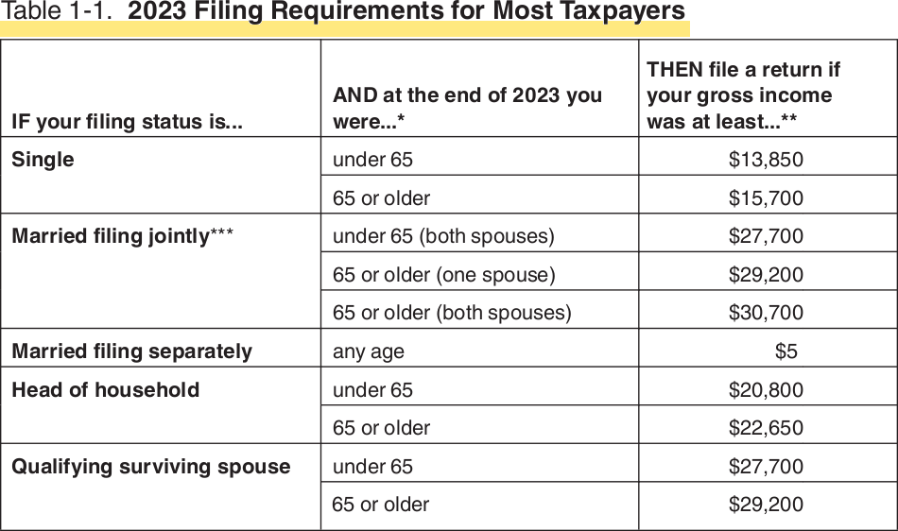

Table 1-2: 2023 Filing Requirements for Dependents

If parents (or someone else) can claim 'you' as a dependent, use table 1-2,
o/w see Table 1-3 for other situations.

See Next page
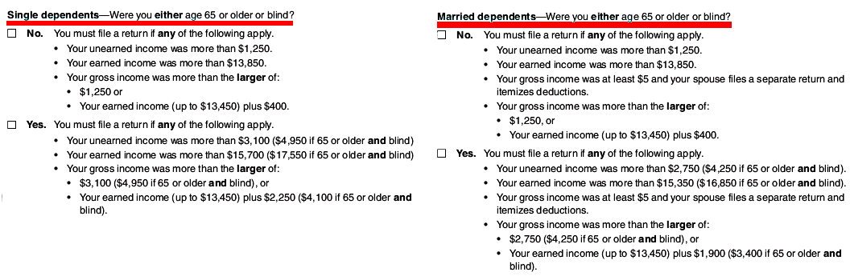
In this table, unearned income includes taxable interest, ordinary dividends, and capital gain distributions. It also includes unemployment compensation, taxable social security benefits, pensions, annuities, and distributions of unearned income from a trust. Earned income includes salaries, wages, tips, professional fees, and taxable scholarship and fellowship grants. Gross income is the total of your earned and unearned income.
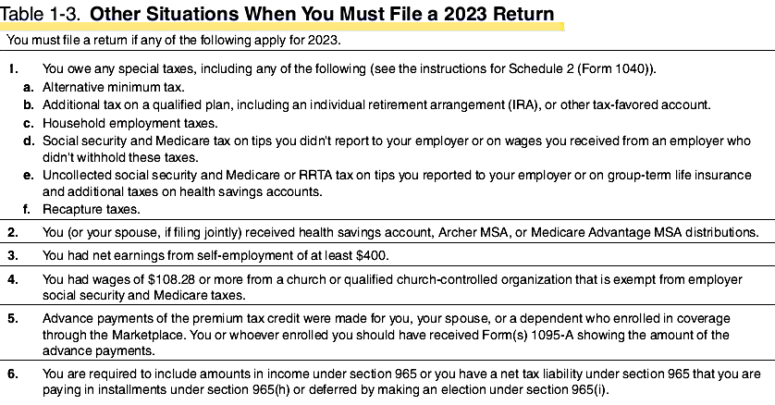
  - June 15 Deadlines (Automatic 2-Month Extension)
  - Three groups of taxpayers have automatic 2-month extensions:
  - Non-resident aliens(NRA) who do not have wage income subject to US withholding,
  - US citizens & residents living outside the US or Puerto Rico, and their main place of business is outside the US or PR,
  - Active military service duty outside the US

- Taxpayer filing status
  - People in combat have 6 months AFTER they leave combat zone to file.
  - US citizens living outside US have 2 month ext, BUT it is BETTER to file f4868.
  - SEE: www.TaxpayerAdvocate.irs.gov/2023PurpleBook
- Estimated Taxes & Penalties
  - taxes operates on a “pay-as-you-go” basis
  - Individuals, sole proprietors, partners & S-corp shareholders make estimated tax payments if:
    - they expect to owe at least $1,000
    - they owed tax in the prior year.
  - Taxpayers need to make estimated tax payments IF
    - receives income from interest, dividends, alimony, capital gains, prizes & awards,
    - salary, pension or it’s not enough,
    - has more than one job but doesn’t have each employer withhold taxes,
    - is self-employed,
    - is a representative of a direct-sales or in-home-sales company.
  - Form 2210, Underestimate of estimated tax requests a waiver of penalty
  - When to pay: April 15, June 15, Sept. 15, Jan. 15

  - Penalties – 4 Types:
    - Failure to file,
    - … to pay,
    - … to pay estimated,
    - … to pay interest

  - Failure to file: most severe, 5% of balance monthly(NOT pro-rated) up to max. 25%, more than 60d is lesser of $485 or 100% of tax.
  - Penalty for Failure to Pay: 0.5% of balance, up to 25%
- IFF Fail to File & Pay: instead of a 5% failure to file penalty for the month, we apply a 4.5% failure to file penalty & a 0.5% failure to pay penalty.
  - Fail to pay Estimated tax: To avoid a penalty pay,
    - you owe less than $1,000 or you owed zero last year,
    - pay 90% of tax on current year or
    - 100% of prior year.
  - Fail to pay Interest: the federal short-term rate plus 3%. See Form 843, Claim for Refund & Request for Abatement
  - Form W4V for W/H of SS tax
  - SAFE HARBOR – $0 tax liability for prior year, taxpayer will not face an underpayment penalty if tax liability is under $1,000.
  - BACKUP W/H – used when name or SSN is wrong for US citizen of legal resident. This ensures Feds get 24% of any form of income, for example dividends, investment income, etc.

NOTE: IRS Form 8801, Use Form 8801 for: If you had an AMT, calculate the minimum tax credit, To calculate carry over to future years.

- Innocent or Injured Spouse provisions:
  - BOTH are difficult to win & take long time,
If one spouse does not want to pay for other FILE SEPARATELY, for example gambling addiction, student loans
  - Form 8857, Innocent Spouse relief, One party is innocent of a mistake made by the other.
  - Form 8379, Injured Spouse relief, One party is hurt/injured by the others past debts.

- Special Filing Requirements:
  - Refunds & amendments generally go back 3 years.
  - An extension can extend liability window for refund or amendment
  - In some cases, late-filed returns will be honored, The IRS will consider reasons: Fire, casualty, FEMA natural disaster, Inability to obtain records, death, serious illness, incapacitation or unavoidable absence of the taxpayer or family member.
  - Certain situations allow taxpayers to request a refund past the usual deadline:
    - bad debt from worthless securities (7 years),
    - foreign tax payments (10 years), net operating loss or tax credit carrybacks, military personnel exceptions, federally declared disaster areas, & terrorism/military actions.
  - The IRS has 3 years to assess taxes from the filing date or the return's due date, whichever is later. If filed late or with an extension, the 3 years start from the actual filing date.
  - If no return is filed or it's fraudulent, there's no time limit for the IRS to assess taxes.
  - If income is under-reported by more than 25%, the IRS has 6 years to assess the tax.
  - The IRS has 10 years from the tax assessment date to collect unpaid taxes. This period starts when the tax is assessed, not when the return is filed. The Collection Statute Expiration Date (CSED) marks the end of this period.
  - efile will not take filing > 3 years, filing > 3 years has to be paper filing with ink-signature, ALSO > 3 years will not receive refunds!!!
  - ALWAYS file returns, this can prevent id theft, or past filings on years you thought you had not tax liability & the statute of time limits starting running.

- Determining Filing Status and Residency
  - Five filing statuses – usually taxpayers may choose the filing status that will result in the lowest overall tax.
  - In general, a taxpayer’s marital status on December 31 determines their marital status for entire year.
  - ALTHOUGH, special rules apply to annulled marriages, widowed taxpayers, and surviving spouses who have dependent children

- Filing Statuses – 5 Types:
    - Single
    - Married Filing Jointly(MFJ)
    - Married Filing Separately(MFS) “Default”
    - Head of Household(HOH)
    - Qualifying Surviving Spouse(QSS) – ex. widower with child dependent
  - Taxpayer can choose the status that nets the best result, lowest overall tax.
  - Publication 17, Your Federal Income Tax
  - Publication 54, Tax Guide for US Citizens and Resident Aliens Abroad
  - Publication 519, US Tax Guide for Aliens
  - In general, a taxpayer’s marital status on December 31 determines their marital status for entire year.
  - ALTHOUGH, special rules apply to annulled marriages, widowed taxpayers, and surviving spouses who have dependent children
  - Note: Federal law does not allow Registered Domestic Partners (RDPs) to file a joint.
  - IRS does recognize common-law marriages. Currently, only states with common-law marriage are: the District of Columbia, Colorado, Iowa, Kansas, Montana, Oklahoma, Rhode Island, and Texas.
  - The EA exam will not test on the matrimonial laws of any particular state, but you must know that only a legal marriage is recognized for IRS purposes, and not any other type of civil union nor registered domestic partnership.
  - Marriage licenses (IRM 25-018-001)

- Single Status
1. Taxpayer is considered single for the entire tax year if, on 12/31, he or she was: Unmarried, Legally separated, Legally divorced by 12/31.

- Married Filing Jointly (MFJ)
  - Filing status is an election, not the default. MFS IS default!
  - MFJ Req. BOTH signatures! both spouses must agree to sign a MFJ, both are responsible for any tax, even if the income was earned by only one spouse. If one spouse does not wish to MFJ, then both spouses must default to MFS.
  - End of the year rule: If the they are married by 12/31 then they may file MFJ.
  - Can file jointly if they live apart but are not legally separated or divorced,
  - A widowed taxpayer may use MFJ, if the taxpayer’s spouse died during the year and the taxpayer has not remarried as of 12/31.
  - Nonresident Alien Spouses: Special rules apply to NRA spouses. A US citizen who is married to a NRA can elect MFJ as long as both spouses agree to be taxed on their worldwide income. An election statement must be attached to the joint return.
  - Ammending MFJ or MFS: “you can make up but you can’t break up.” In other words, you can easily go from MFS to file Jointly but it is harder to go from MFJ to MFS.
  - Moving/Switching from MFJ to MFS can be done when a death occurs.
  - As long as one spouse is a US citizen or resident, they can file either joint or separate returns for later years.

- Married Filing Separately (MFS)
  - If one spouse chooses MFS return, the other is forced to.
  - Specific features of the MFS (Rules)
    - The tax rates are higher at the same levels of taxable income than MFJ
    - The AMT exemption is half of a joint return.
    - Various credits are either not allowed or more limited
    - Capital loss deduction is $1,500, half of a joint return.
    - Standard deduction is half of a joint return and cannot be claimed if the taxpayer’s itemizes deductions.
    - Neither spouse can deduct student loan interest on an MFS return.

- Example 1: Harrison and Regina are married and live together. They kept their assets and finances separate. Harrison plans to itemize his deductions this year, so Regina must either itemize her deductions or claim a standard zero deduction. The couple’s overall tax liability may be lower on a separate return when one spouse has significant medical expenses or large miscellaneous itemized deductions (such as a casualty loss).

- Example 2: Daniel and Inara are married and live together. Daniel earns $120,000, while Inara earns $40,000. This year, Inara had high medical expenses due to a hip replacement. If they file jointly, the medical costs cannot be deducted because expenses do not exceed 7.5% of their joint AGI; however, if Daniel and Inara file separate returns, Inara’s medical expenses are deductible on her separate tax return, eliminating her tax liability entirely and resulting in a large tax refund. They calculate their taxes both ways and find their tax liability will be less by filing separately.

- Example 3: Phillip and Dinah were married Dinah owes $80,000 in student loans. Phillip chooses to file separately, so her overdue tax debts will not offset his refund. He retains his entire refund.

- Example 4: Hillard and Ingrid were married. Ingrid owes $15,000 in child support. Georgia does not have a provision for relief for injured spouses. Hillard decides to file a separate return to retain his federal and state tax refunds.

- Amending Filing Status
  - There are strict rules when married taxpayers change their filing status:
  - Taxpayers generally cannot change from MFJ to MFS after the due date of the return.
  - For example, if a married couple files a joint (2023) return on February 1, 2024, then decide they to change to MFS, they would have only until April 15, 2024 (their original return due date) to file amended returns to MFS filing status to amend file Form 1040-X.

  - A notable exception to this strict deadline allows a representative of a deceased taxpayer to change from a joint return, to the surviving spouse, to a separate return for the decedent for up to a year after the filing deadline.

- Example: Landon and Bianca filed jointly. Bianca dies on November 16, 2023, and her will names Laura (her daughter from a previous marriage) as executor. Landon originally files a joint return with Bianca for 2023. Laura, as the executor, decides it would be better for the mother’s estate if Bianca's files as MFS. Laura files an amended return claiming MFS status for Bianca and signs the return as the executor. Laura has a full year after the filing deadline to submit the amended return.

  - To change from separate returns to a joint return (MFS to MFJ]), taxpayers must file a return using Form 1040-X. They may do so any time within three years from the due date of the original return (not including extensions).

- Example: Jackie and Kaleb file separately for 2023. They choose to amend their prior-year separate tax returns to “married filing joint” by filing a Form 1040-X. They have up to three years to amend their returns.

HEAD OF HOUSEHOLD

- Head of household will usually have a lower tax rate than (single or MFS) taxpayer and receive a higher standard deduction.

NOTE: HOH status is for taxpayers who meet all of the following requirements:

1. The taxpayer must be single, divorced, legally separated, or “considered unmarried” on the last day of the year.
2. The taxpayer must have paid more than half the cost of keeping up a home for the year.
3. The taxpayer must have had a qualifying person living in his home for more than half the year. There are exceptions for temporary absences, as well as for a qualifying parent, who does not have to live with the taxpayer. This would include hospitalization and stays in a nursing home.
4. For IRS purposes, “temporary absences” include time away from home going to college, vacation, business, medical care, hospitalization, military service, summer camp, and detention in a juvenile facility. It must be reasonable to assume that the absent person will return to the home after the temporary absence.

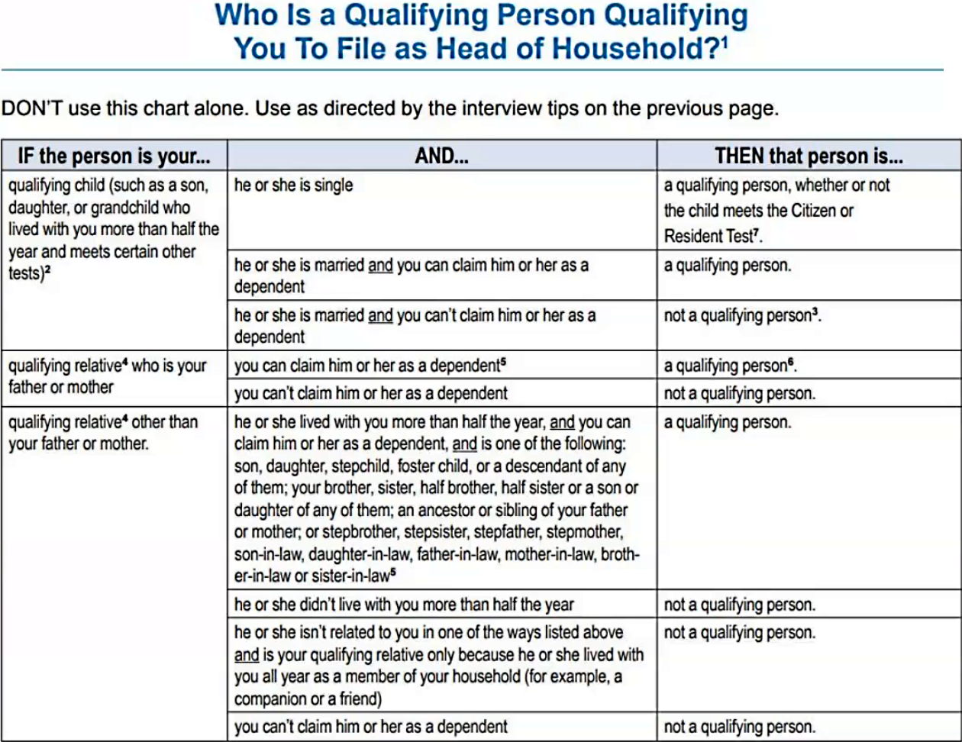
- HOH Status - When determining head of household filing status, valid household expenses used to calculate whether a taxpayer is paying more than half the cost of maintaining a home include:
- 1. Rent, mortgage interest, property taxes
- 2. Home insurance, repairs, and utilities
- 3. Food eaten in the home
- 4. Valid expenses do not include clothing, education, medical treatment, vacations, life insurance, or transportation. Welfare payments are not considered amounts that the taxpayer provides to maintain a home.

- Example: Rhonda is unmarried. Her son, Nathaniel, was eighteen years old at the end of the year. Nathaniel lived away from his mother all year because he was going to college. He lived on campus, in the dorms, returning home only on holidays. Nathaniel does not work and does not provide any of his own support. Since his time away from home to attend school is considered a “temporary absence,” Rhonda may claim head of household filing status, and claim Nathaniel as her dependent.

- A “Qualifying Person” for the HOH filing status must generally be related to the taxpayer either by blood, adoption, or marriage. However, a foster child qualifies if the child was legally placed in the home by a government agency. For purposes of the head of household filing status, a “qualifying person” is defined as:

1. A qualifying child,
2. A married child who can be claimed as a dependent, or A dependent parent,
3. A qualifying relative that meets certain relationship tests
4. A taxpayer’s qualifying person may include: a child or stepchild, sibling or step-sibling, or a descendant of any of these. For example, a niece or nephew, stepbrother or stepsister, or grandchild may all be eligible as qualifying persons for the HOH filing status.

- Example HOH w/ Qualifying Child: Kevin is unmarried and age 64. He earns $49,000 in wages during the year. His disabled sister, Francesca, has lived with him since their parents passed away six years ago. Francesca is 42 and has severe autism. She cannot engage in any substantial gainful activity, but she does receive a small amount of State Disability Assistance every month. These amounts are not taxable and Francesca does not have a filing requirement. Kevin can file as head of household and claim Francesca as his qualifying child, because she meets the relationship test (she is his sibling), and she meets the age test for a qualifying child, because she is permanently disabled.

- Example HOH w/ Qualifying Relative: Lamonte is 71 years old and unmarried. His daughter, Brooke, lived with him the entire year. Brooke turned 29 at the end of the year. She does not have a job, did not provide any of her own support, and cannot be claimed as a dependent by anyone else. She is not disabled. Although she cannot be Lamonte’s qualifying child, because of her age, she is a qualifying relative. As a result, Lamonte may use the HOH filing status.

- Divorced and Noncustodial Parents: A taxpayer can qualify as HOH, even though they may not claim a qualifying child as their dependent. This happens most often with divorced parents. This is because the head of household filing status applies to the taxpayer who maintains the main home of a qualifying child.

However, a custodial parent may choose to release the dependency exemption to a non-custodial parent. In this scenario, the custodial parent would claim head of household filing status, while the noncustodial parent would claim the dependency exemption.

- Example HOH w/ Custodial Parent: Nicolas and Vivian have been divorced for two years and they live apart. They have a twelve-year-old daughter named Cristina, who lives with her mother during the week and only sees her father on weekends. Therefore, Vivian is considered Cristina’s custodial parent. The parents agree, however, to allow Nicolas to claim the dependency exemption for Cristina on his tax return. Nicolas correctly files as “Single” and claims Cristina as his dependent. This entitles him to the Child Tax Credit. Vivian may still file as HOH if she otherwise qualifies, but she will not claim the dependency exemption for Cristina.

Examples HOH w/ Qualifying Relative: William earns $60,000 as a self-employed contractor. William's cousin, Jimmy has lived with William all year. Jimmy earned $3,100 in wages. William cannot file as head of household, but he can claim jimmy as his Qualifying Relative And Dependent, because Jimmy earned less than $4700.

- Qualifications for dependency
  - A dependent child must file if their earned income is > standard deduction filing status.
  - In determining who is a qualifying relative, the “deemed exemption” amount is $4,700 for 2023.
  - unearned income = first $1,250, next $1,250 is taxed at the child’s rate.
  - Anything above $2,500 is taxed at the parents’ rate
  - For 2023, a dependent child receiving > $13,850 of earned income (like wages or tips) needs to file. (i.e., the total is the standard deduction for their filing, which is $13,850 for most dependents in 2023).
  - The Kiddie Tax applies to certain dependent children who have unearned income (like interest, dividends, or capital gains) that exceeds a specific threshold.
  - Kiddie Tax applies to > $2,600 of a child's unearned income. Any portion above $2600 is taxed at the parent's rate, not the child's. SEE: https://www.irs.gov/taxtopics/tc553
  - Do not confuse the filing threshold amount for self-employed taxpayers with the filing requirement
  - for information returns (notably, Form 1099-NEC and 1099-MISC).
    - Form 1099-NEC is for payments to independent contractors earning $600 or more annually. This amount is for reporting purposes only and doesn't affect when you need to file taxes as a self-employed person. You still need to file your self-employment taxes by the due date. Social Security Tax=12.4%, Medicare=2.9%
    - Form 1099-MISC is still used to report other types of payments, such as rents, royalties, prizes, and awards.

Sources of worldwide taxable & non-taxable income
interest, wages, business, sales of property, dividends, rental income, flow-through entities, alimony received
- Sources of applicable exclusions & adjustments to gross income (e.g., foreign earned income exclusion, retirement plans, HSAs, alimony paid, health insurance, self-employment tax)
- Sources of applicable deductions (e.g., itemized, standard)
Standard Deductions for 2023:
Single,  Married filing separately (MFS) | Married filing jointly (MFJ)  Or Qualifying surviving spouse | Head of Household
13,850 | 27,700 | 20,800

- Requirements for the Self-Employed
  - Required to file if 1099-K (net earnings) > $400.

- Sources of applicable credits (e.g., education, foreign tax, child & dependent care, credit for other dependents, child tax credit)
- Sources of tax payments & refundable credits
- Previous IRS correspondence with taxpayer
- Additional required returns to be filed, & taxes paid (e.g., employment, gifts, international information returns, & other information returns)
- Special filing requirements (e.g. foreign income, presidentially declared disaster areas, injured spouse)
Foreign account & asset reporting (e.g., FBAR, Form 8938)
- Minor children's unearned income (“Kiddie” tax)
  - For 2023, a dependent child receiving > $13,850 of earned income (like wages or tips) needs to file. (i.e., the total is the standard deduction for their filing, which is $13,850 for most dependents in 2023).
  - The Kiddie Tax applies to certain dependent children who have unearned income (like interest, dividends, or capital gains) that exceeds a specific threshold.
  - Kiddie Tax applies to > $2,600 of a child's unearned income. Any portion above $2600 is taxed at the parent's rate, not the child's. SEE: https://www.irs.gov/taxtopics/tc553
- ACA requirements (e.g., , total household income, premium tax credit, household size)

Domain 2: Income & Assets 17 Questions

2.1. Income

Taxability of wages, salaries & other earnings:
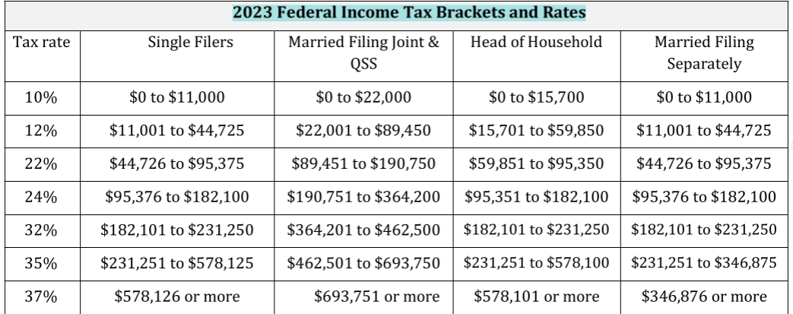
  - Interest Income (e.g., taxable & non-taxable)
  - Dividends & other distributions from mutual funds, corporations, & other entities
  - Personal property rental
  - Gambling income & allowable deductions (e.g., Form W-2G, documentation)
  - Tax treatment of cancellation of debt (e.g., Form 1099C, foreclosures, insolvency)
  - Tax treatment of a US. citizen/resident with foreign income, e.g., tax treaties,
    - Form 1116,
    - Form 2555,
    - Form 3520,
    - Form 5471
  - Other income (e.g., scholarships, barter income, hobby income, alimony, non-taxable combat pay, unearned income, taxable recoveries, NOL, illegal income)
  - Constructive receipt of income
  - Constructive dividends (e.g., payments of personal expenses from a business entity)
  - Passive income & loss
  - Pass-through income (e.g., Schedule K-1, income, deductions, basis, qualified business income (QBI) items)
  - Royalties & related expenses
  - State/local income tax refund & other itemized deduction recoveries
  - 1099 MISC, 1099 NEC, 1099 K reporting, irregularities, & corrections

2.2. Retirement income

- Basis in a traditional IRA (Form 8606)
- Comparison of & distributions from traditional & Roth IRAs
- Distributions from qualified & non-qualified plans (e.g., pre-tax, after-tax, rollovers, Form 1099R, qualified charitable distribution)
- Excess contributions & tax treatment (e.g., penalties)
- Penalties & exceptions on premature distributions from qualified retirement plans & IRAs
- Prohibited transactions & tax consequences
- IRA conversions & recharacterization (Form 8606)
- Required minimum distributions
- Loans from qualified plans
- Taxability of Social Security & Railroad Retirement benefits
- Inherited retirement accounts
- Foreign pensions & retirement income

2.3. Property, real & personal

- Sale or disposition of property including depreciation recapture rules & 1099A
- Capital gains & losses (e.g., netting effect, short-term, long-term, mark-to-market, virtual currency)
- Basis of assets (e.g., purchased, gifted or inherited)
- Basis of stock after stock splits &/or stock dividends (e.g., research, schedules, brokerage records)
- Publicly Traded Partnerships (PTP) (e.g., sales, dispositions, losses)
- Sale of a personal residence (e.g., IRC sec 121 exclusions)
- Installment sales (e.g., related parties, original cost, date of acquisition, possible recalculations & recharacterization)
- Options (e.g., stock, commodity, ISO, ESPP)
- Like-kind exchange
- Non-business bad debts
- Investor versus trader

2.4.Adjustments to Income

- Self-employment tax
- Retirement contribution limits & deductibility (e.g., earned compensation requirements)
- Health savings accounts
- Other adjustments to income (e.g., student loan interest, alimony, moving expenses for active military, write-in adjustments)
- Self-Employed Health Insurance

Domain 3: Deductions & Credits 17 Questions

3.1. Itemized deductions & QBI

- Medical, dental, vision, long-term care expenses
- Various taxes (e.g., state & local, personal property, real estate)
- Interest expense (e.g., mortgage interest, investment interest, tracing rules, points, indebtedness limitations)
- Charitable contributions (e.g., cash, non-cash, limitations, documentation required)
- Non-business casualty & theft losses-Other itemized deductions
- Itemized deductions for Form 1040-NR
- Qualified Business Income (QBI) deduction

3.2. Credits

- Child & dependent care credit
- Child tax credit & credit for other dependents
- Education credits
- Foreign tax credit
- Earned income tax credit (e.g., paid preparer's earned income credit checklist, eligibility & disallowance)
- Adoption credits (e.g., carryovers, limitations, special needs)
- ACA premium tax credit
- Other credits (refundable & non-refundable) (e.g., health coverage tax credit, energy credits, Retirement savings contribution credit)

Domain 4: Taxation, 15 Items

4.1. Taxation

- Alternative minimum tax & credit for prior year
- Household employees
- Underpayment penalties & interest
- Self-employment tax
- Excess Social Security withholding
- Tax provisions for members of the clergy
- Tax provisions for members of the military
- Income in respect of decedent
- Net investment income tax
- Additional Medicare tax
- Uncollected Social Security & Medicare tax
- Other taxes (e.g., first time homebuyer credit repayment)

Domain 5: Advising the individual taxpayer, 11 Questions

5.1. Advising the Individual Taxpayer

- Reporting obligations for individuals (e.g., 1099, bartering, cash)
- Property sales (e.g., homes, stock, businesses, antiques, collectibles)
- Education planning (e.g., lifetime learning credit, IRC section 529 plans)
- Estate planning (e.g., gift versus inheritance, trusts, family partnerships, charitable giving, long-term care, life insurance)
- Retirement planning (e.g., annuities, IRAs, employer plans, early retirement rules, required minimum distribution, beneficiary ownership, charitable distributions from an IRA)
- Marriage & divorce (e.g., divorce settlement, common-law, community property, alimony)
- Items that will affect future/past returns (e.g., carryovers, net operating loss, Schedule D, Form 8801, negative QBI carryover)
- Injured spouse
- Innocent spouse
- Estimated tax & penalty avoidance (e.g., mid-year estimated tax planning)
- Adjustments, deductions, & credits for tax planning (e.g., timing of income & expenses)
- Character of transaction (e.g., use of capital gain rates versus ordinary income rates)
- Advantages & disadvantages of MFJ/MFS/HOH filing statuses in various scenarios (e.g., joint & several liability)
- Conditions for filing a claim for refund (e.g., amended returns)
- Penalty of perjury

Domain 6: Specialized Returns for Individuals, 11 Questions

6.1. Estate Tax

- Gross estate, taxable estate (calculations & payments), unified credit
- Jointly held property
- Marital deduction & other marital issues (e.g., portability election)
- Life insurance, IRAs, & retirement plans
- Estate filing requirements & due dates (e.g., Form 706: Form 1041)

6.2. Gift Tax

- Gift-splitting-Annual exclusion
- Unified credit
- Effect on estate tax (e.g., Generation skipping transfer tax)
- Filing requirements (e.g., Form 709)

6.3.International Information Reporting

- Filing & reporting requirements & due dates (e.g., FBAR, Form 8938, Form 8865, Form 5471, Form 3520)
- Covered accounts (e.g., FBAR, Form 8938)
- Potential penalties (e.g., failure to file, under-reporting, substantially incomplete, statute of limitations, reduction of tax attributes)
- Distinctions between FBAR & Form 8938 requirements

