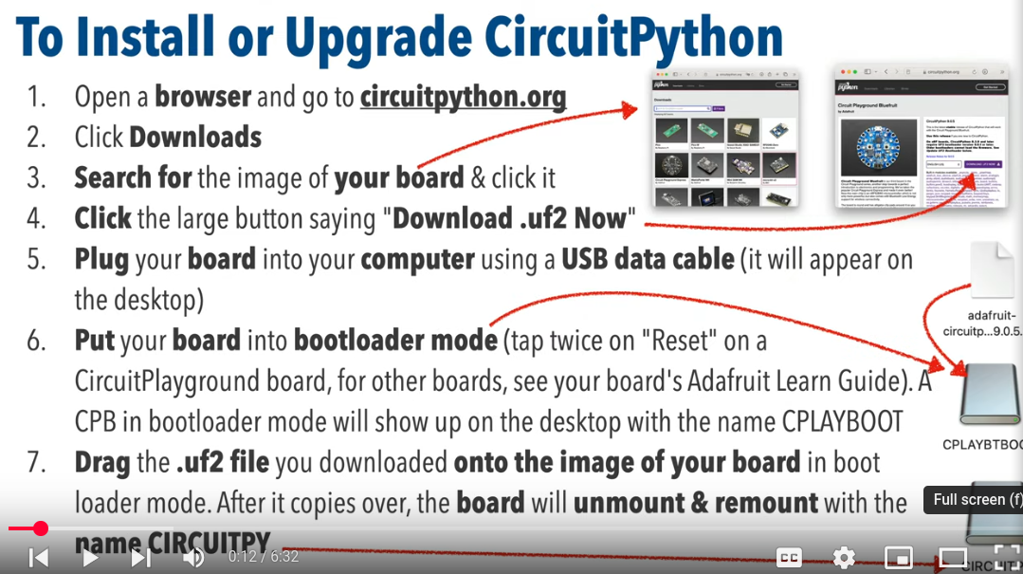

https://circuitpython.org/board/gemma_m0/

Gemma M0 features:
- Updating ATtiny85 8-bit AVR for ATSAMD21E18 32-bit Cortex M0+
- 256KB Flash - 8x as much as 8 KB on ATtiny85
- 32 KB RAM - 64x as much as 512 bytes on ATtiny85
- 48 MHz 32 bit processor - 6x as fast as ATtiny85 (not even taking into account 32-bit speedups)
- Native USB supported by every OS - can be used in CircuitPython as USB serial console, Keyboard/Mouse HID, even a little disk drive for storing Python scripts. (ATtiny85 does not have native USB)
- Built in RGB DotStar LED
- Three big-hole sew-pads can be used for conductive thread or alligator-clips for fast prototyping
  - Each I/O pad can be used for 12-bit analog input, or digital input/output with internally connected pullups or pulldowns
  - True analog output on one I/O pad - can be used to play 10-bit quality audio clips
  - Two high speed PWM outputs on other two I/O Pads - for servos, LEDs, etc
  - All three pads can also be used as hardware capacitive touch sensors with no additional components required
  - Can drive NeoPixels or DotStars on any pins, with enough memory to drive 8000+ pixels. DMA-NeoPixel support on one pin so you can drive pixels without having to spend any processor time on it.
  - Native hardware I2C or Serial available on two pads so you can connect to any I2C or Serial device with true hardware support (no annoying bit-banging)
- Same Reset switch for starting your project code over
- On/Off switch built in
- JST battery connector for plugging in AAA’s or LiPoly battery (no built-in LiPoly charging so it is safe to use with NiMH/Alkalines)

For INFO: search “adafruit learn guide gemma m0”

