**Chatham Marconi Summer Stem 2025**

* Two New Courses for 11 to 13 year olds (grades 6 and 7)
* August 5, 6, and 7, 2025
* Afternoons 12:30pm to 3:30pm

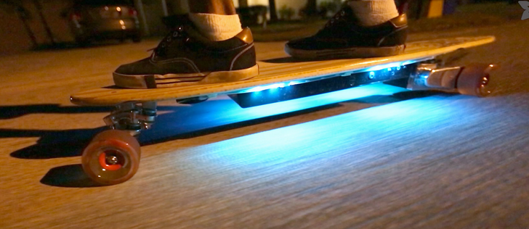

The **Fire Walker LED NEO-PIXEL project**! Here are a few options, designed to be catchy and appealing to kids aged 10-13:

**Option 1 (Focus on Visibility and Customization):**

"Light Up Your Ride With The LED NEO-PIXEL project 🚴✨

Want to make your bike helmet (or anything!) super bright and totally YOU? Join our workshop and create your own custom LED light string!

**Build It Fast**: Assemble your glowing light string in a flash.

**Motion Activated Fun**: Watch your lights spring to life with a simple movement.

**Rainbow Power**: Program your own awesome color sequences using the Adafruit Gemma M0 mini circuit board.

**Shine Bright**: Be seen and be cool with your personalized, multi-color light display.

**Personalize Anything**: Attach your glowing creation to your helmet, backpack, or anything you want!

We'll start with the basics and you'll be coding like a pro in no time. Get ready to turn heads with your custom light show!

**Imagine**: your helmet flashing your favorite colors, or your jacket glowing with a wild light pattern! We'll show you how to code your own light shows and turn your gear into a dazzling spectacle.

Get ready to glow! Sign up for our LED light string workshop!"

<https://learn.adafruit.com/firewalker-led-sneakers>