## Domain 1: Preliminary Work & Taxpayer Data 14 Questions

### 1.1. Preliminary work to prepare tax returns

- Prior years' returns:
  - Used for comparison, accuracy, & carryovers,
  - Net Operating Loss (NOL),
  - depreciation, asset basis, prior yr minimum tax for current year's return

- Taxpayer Bio-information NEEDED:
  - date of birth, marital status, dependents, identity protection IP-PIN,
  - photo ID, Look at SS card for Fake/False Returns
  - See: P4491, Vita/TCE training guide
  - NOTE: Deceased child w/o SSN (See: p17) write “DIED” in SSN, FILE By Paper
- Citizenship, Residency:
  - SSN, ITIN, ATIN (Individual / Adoption), visas, green cards, resident or non-resident alien
  - CANNOT USE: Employer Id number (EIN)
  - It is possible to have a SSN & not be able to work, SEE: SS card!!
  - Lawfully admitted Non-citizens can work in certain circumstances
  - NOTE: NR-Alien can work in US, for example, Foreign scholar, Post-doc, or Prof.
  - If you do not have ITIN, you must apply with W7 via CAA(in TX) or Taxpayer Advocate(in person).
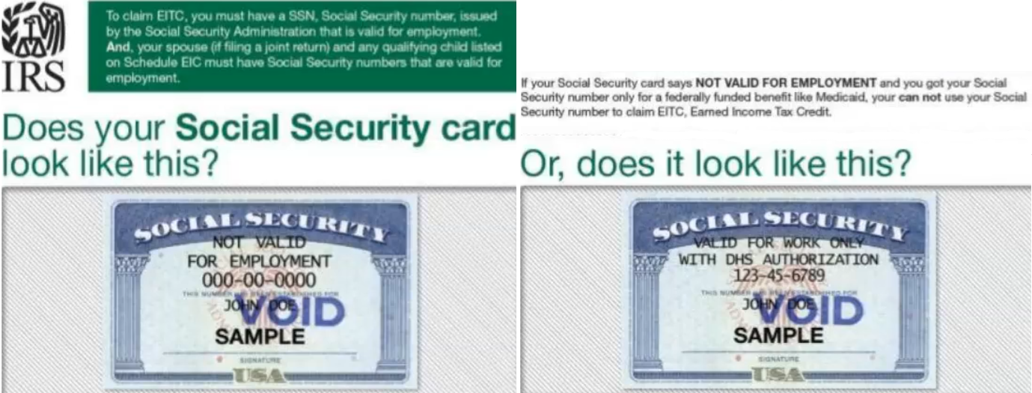
- Filing requirements & due dates:
  - April 15th OR Next Business Day
  - IRS has 1040, -NR(non-resident), -SR(senior), -X(amendment), -ES(estimated)
[Uncommon: -PR(Puerto Rico), -GUAM, etc.]
  - MAILBOX RULE – The USPS post mark determines if a filing (or payment) is on time or not. Can use DHL, UPS, FEDEX in some cases.
  - USE: Certified mail is BEST, (for crucial work) bc you need proof you sent it!
  - If you think it will be close just file Extension(s), f4868, to be safe
  - Extension f4868 is only for individuals
  - Fisherman/ Farmers: two-thirds of income must be from the two, to have March 1st, Jan 15th deadline, Required Annual Payment, F&F do not pay have to pay estimated tax
  - See: Failure to File vs Failure to Pay, 6.7 Estimate Taxes & Penalties
  - To pay use PAY.GOV with Electronic filing confirmation number
  - See “Purple Book” for IRC section 7502
  - Tax payers outside the country can extend taxes until Dec.15 (6 + 2 months)

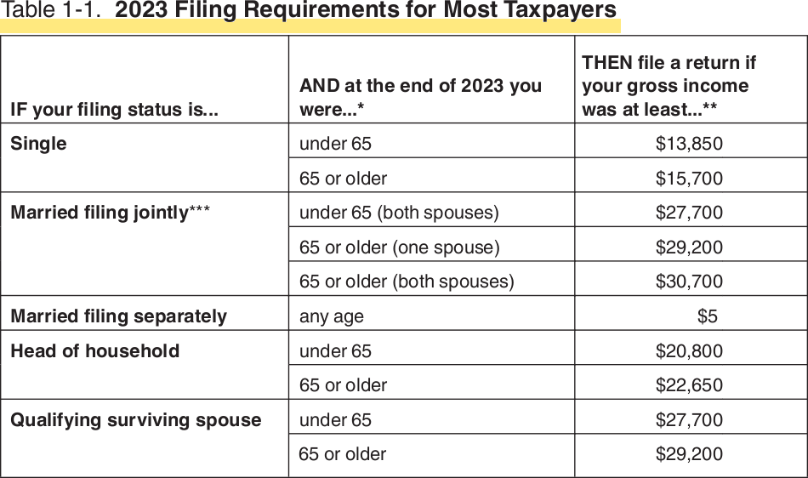

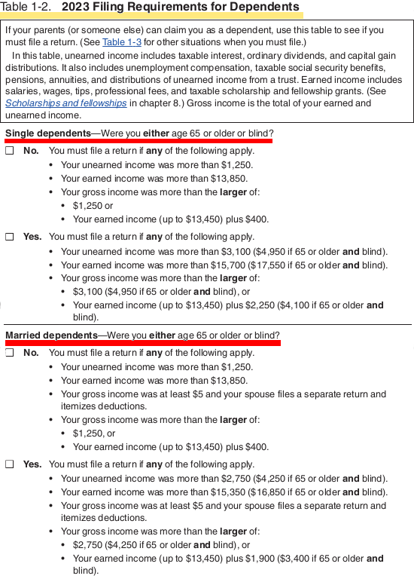

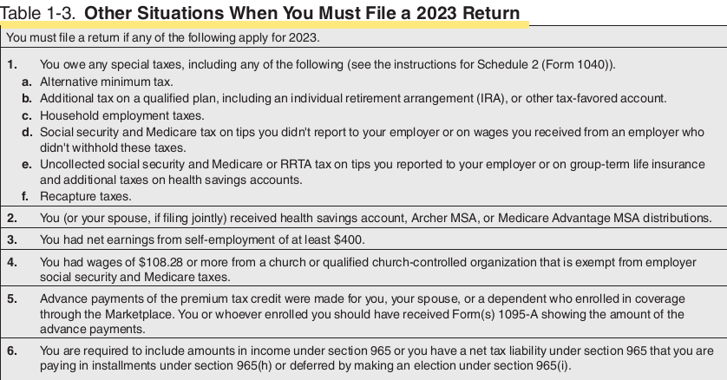
June 15 Deadlines (Automatic Two-Month Extension)
Three groups of taxpayers are granted an automatic two-month extensions:
• Nonresident aliens who do not have wage income subject to US withholding,
• US citizens or legal US residents who are living outside the US or Puerto Rico, and
their main place of business is outside the US or PR,
• Taxpayers on active military service duty outside the US

- Taxpayer filing status
  - People in combat have 6 months AFTER they leave combat zone to file.
  - US citizens living outside US have 2 month ext, BUT it is BETTER to file f4868.
  - www.TaxpayerAdvocate.irs.gov/2023PurpleBook
- Estimate taxes & Penalties
  - taxes operates on a “pay-as-you-go” basis
  - Individuals, including sole proprietors, partners & S corporation shareholders, need to make estimated tax payments if: 1. they expect to owe at least $1,000 2. they owed tax in the prior year.
  - Taxpayers need to make estimated tax payments IF 1. receives income from interest, dividends, alimony, capital gains, prizes & awards, 2. salary, pension or it’s not enough, 3. has more than one job but doesn’t have each employer withhold taxes, 4. is self-employed, 5. is a representative of a direct-sales or in-home-sales company.
  - Form 2210, Underestimate of estimated tax requests a waiver of penalty
  - When to pay: April 15, June 15, Sept. 15, Jan. 15
  - Penalties – 4 Types, Failure to file, to pay, to pay estimated, to pay interest
  - Failure to file: most severe, 5% of balance monthly(NOT pro-rated) up to max. 25%, more than 60d is lesser of $485 or 100% of tax.
  - Fail to Pay: 0.5% of balance, up to 25%
  - IFF Fail to File & Pay: instead of a 5% failure to file penalty for the month, we apply a 4.5% failure to file penalty & a 0.5% failure to pay penalty.
  - Fail to pay Estimated tax: To avoid a penalty pay, 1. you owe less than $1,000 or 2. pay 90% of tax on current year or 3. 100% of prior year.
  - Fail to pay Interest: the federal short-term rate plus 3%. See Form 843, Claim for Refund & Request for Abatement
  - Form W4V for W/H of SS tax
  - SAFE HARBOR – $0 tax liability for prior year, taxpayer will not face an underpayment penalty if tax liability is under $1,000.
  - BACKUP W/H – used when name or SSN is wrong for US citizen of legal resident. This ensures Feds get 24% of any form of income, for example dividends, investment income, etc.

NOTE: IRS Form 8801, Use Form 8801 for:
- If you had an AMT, calculate the minimum tax credit, To calculate carry over to future years

- Innocent or Injured Spouse provisions:
  - BOTH are difficult to win & take long time,
If one spouse does not want to pay for other FILE SEPARATELY, for example gambling addiction, student loans
  - Form 8857: Innocent Spouse relief
  - Form 8379 Injured Spouse relief

- Special Filing Requirements:
  - Refunds & amendments generally go back 3 years.
  - An extension can extend liability window for refund or amendment
  - In some cases, late-filed returns will be honored, The IRS will consider reasons: Fire, casualty, FEMA natural disaster, Inability to obtain records, death, serious illness, incapacitation or unavoidable absence of the taxpayer or family member.
  - Certain situations allow taxpayers to request a refund past the usual deadline: bad debt from worthless securities (7 years), foreign tax payments (10 years), net operating loss or tax credit carrybacks, military personnel exceptions, federally declared disaster areas, & terrorism/military actions.
  - The IRS has 3 years to assess taxes from the filing date or the return's due date, whichever is later. If filed late or with an extension, the 3 years start from the actual filing date.
  - If no return is filed or it's fraudulent, there's no time limit for the IRS to assess taxes.
  - If income is under-reported by more than 25%, the IRS has 6 years to assess the tax.
  - The IRS has 10 years from the tax assessment date to collect unpaid taxes. This period starts when the tax is assessed, not when the return is filed. The Collection Statute Expiration Date (CSED) marks the end of this period.
  - efile will not take filing > 3 years, filing > 3 years has to be paper filing with ink-signature, ALSO > 3 years will not receive refunds!!!
  - ALWAYS file returns, this can prevent id theft, or past filings on years you thought you had not tax liability & the statute of time limits starting running.

- Sources of worldwide taxable & non-taxable income
  - interest, wages, business, sales of property, dividends, rental income, flow-through entities, alimony received
- Sources of applicable exclusions & adjustments to gross income (e.g., foreign earned income exclusion, retirement plans, HSAs, alimony paid, health insurance, self-employment tax)
- Sources of applicable deductions (e.g., itemized, standard)
Standard Deductions for 2023:
Single,  Married filing separately (MFS) | Married filing jointly (MFJ)  Qualifying surviving spouse | Head of household
13,850 | 27,700 | 20,800

- Qualifications for dependency
  - A dependent child must file if their earned income is > standard deduction filing status.
  - unearned income = first $1,250, next $1,250 is taxed at the child’s rate.
  - Anything above $2,500 is taxed at the parents’ rate
  - For 2023, a dependent child receiving > $13,850 of earned income (like wages or tips) needs to file. (i.e., the total is the standard deduction for their filing, which is $13,850 for most dependents in 2023).
  - The Kiddie Tax applies to certain dependent children who have unearned income (like interest, dividends, or capital gains) that exceeds a specific threshold.
  - Kiddie Tax applies to > $2,600 of a child's unearned income. Any portion above $2600 is taxed at the parent's rate, not the child's. SEE: https://www.irs.gov/taxtopics/tc553
  - Do not confuse the filing threshold amount for self-employed taxpayers with the filing requirement
for information returns (notably, Form 1099-NEC and 1099-MISC).
    - Form 1099-NEC is for payments to independent contractors earning $600 or more annually. This amount is for reporting purposes only and doesn't affect when you need to file taxes as a self-employed person. You still need to file your self-employment taxes by the due date. Social Security Tax=12.4%, Medicare=2.9%
    - Form 1099-MISC is still used to report other types of payments, such as rents, royalties, prizes, and awards.
- Requirements for the Self-Employed
  - Required to file if 1099-K (net earnings) > $400.

- Sources of applicable credits (e.g., education, foreign tax, child & dependent care, credit for other dependents, child tax credit)
- Sources of tax payments & refundable credits
- Previous IRS correspondence with taxpayer
- Additional required returns to be filed, & taxes paid (e.g., employment, gifts, international information returns, & other information returns)
- Special filing requirements (e.g. foreign income, presidentially declared disaster areas, injured spouse)
- Foreign account & asset reporting (e.g., FBAR, Form 8938)
- Minor children's unearned income (“Kiddie” tax)
- ACA requirements (e.g., , total household income, premium tax credit, household size)

## Domain 2: Income & Assets 17 Questions

### 2.1. Income

- Taxability of wages, salaries & other earnings
- Interest Income (e.g., taxable & non-taxable)
- Dividends & other distributions from mutual funds, corporations, & other entities
- Personal property rental
- Gambling income & allowable deductions (e.g., Form W-2G, documentation)
- Tax treatment of cancellation of debt (e.g., Form 1099C, foreclosures, insolvency)
- Tax treatment of a US. citizen/resident with foreign income (e.g., tax treaties, Form 1116, Form 2555, Form 3520, Form 5471)
- Other income (e.g., scholarships, barter income, hobby income, alimony, non-taxable combat pay, unearned income, taxable recoveries, NOL, illegal income)
- Constructive receipt of income
- Constructive dividends (e.g., payments of personal expenses from a business entity)
- Passive income & loss
- Pass-through income (e.g., Schedule K-1, income, deductions, basis, qualified business income
(QBI) items)
- Royalties & related expenses
- State/local income tax refund & other itemized deduction recoveries
- 1099 MISC, 1099 NEC, 1099 K reporting, irregularities, & corrections

### 2.2. Retirement income

- Basis in a traditional IRA (Form 8606)
- Comparison of & distributions from traditional & Roth IRAs
- Distributions from qualified & non-qualified plans (e.g., pre-tax, after-tax, rollovers, Form 1099R, qualified charitable distribution)
- Excess contributions & tax treatment (e.g., penalties)
- Penalties & exceptions on premature distributions from qualified retirement plans & IRAs
- Prohibited transactions & tax consequences
- IRA conversions & recharacterization (Form 8606)
- Required minimum distributions
- Loans from qualified plans
- Taxability of Social Security & Railroad Retirement benefits
- Inherited retirement accounts
- Foreign pensions & retirement income

2.3. Property, real & personal

- Sale or disposition of property including depreciation recapture rules & 1099A
- Capital gains & losses (e.g., netting effect, short-term, long-term, mark-to-market, virtual currency)
- Basis of assets (e.g., purchased, gifted or inherited)
- Basis of stock after stock splits &/or stock dividends (e.g., research, schedules, brokerage records)
- Publicly traded partnerships (PTP) (e.g., sales, dispositions, losses)
- Sale of a personal residence (e.g., IRC sec 121 exclusions)
- Installment sales (e.g., related parties, original cost, date of acquisition, possible recalculations & recharacterization)
- Options (e.g., stock, commodity, ISO, ESPP)
- Like-kind exchange
- Non-business bad debts
- Investor versus trader

### 2.4.Adjustments to Income

- Self-employment tax
- Retirement contribution limits & deductibility (e.g., earned compensation requirements)
- Health savings accounts
- Other adjustments to income (e.g., student loan interest, alimony, moving expenses for active military, write-in adjustments)
- Self-Employed Health Insurance

Domain 3: Deductions & Credits 17 Questions

### 3.1. Itemized deductions & QBI

- Medical, dental, vision, long-term care expenses
- Various taxes (e.g., state & local, personal property, real estate)
- Interest expense (e.g., mortgage interest, investment interest, tracing rules, points, indebtedness limitations)
- Charitable contributions (e.g., cash, non-cash, limitations, documentation required)
- Non-business casualty & theft losses-Other itemized deductions
- Itemized deductions for Form 1040-NR
- Qualified Business Income (QBI) deduction

### 3.2. Credits

- Child & dependent care credit
- Child tax credit & credit for other dependents
- Education credits
- Foreign tax credit
- Earned income tax credit (e.g., paid preparer's earned income credit checklist, eligibility & disallowance)
- Adoption credits (e.g., carryovers, limitations, special needs)
- ACA premium tax credit
- Other credits (refundable & non-refundable) (e.g., health coverage tax credit, energy credits, Retirement savings contribution credit)

Domain 4: Taxation 15 Items

4.1. Taxation

- Alternative minimum tax & credit for prior year
- Household employees
- Underpayment penalties & interest
- Self-employment tax
- Excess Social Security withholding
- Tax provisions for members of the clergy
- Tax provisions for members of the military
- Income in respect of decedent
- Net investment income tax
- Additional Medicare tax
- Uncollected Social Security & Medicare tax
- Other taxes (e.g., first time homebuyer credit repayment)

Domain 5: Advising the individual taxpayer 11 Questions

5.1. Advising the Individual Taxpayer

- Reporting obligations for individuals (e.g., 1099, bartering, cash)
- Property sales (e.g., homes, stock, businesses, antiques, collectibles)
- Education planning (e.g., lifetime learning credit, IRC section 529 plans)
- Estate planning (e.g., gift versus inheritance, trusts, family partnerships, charitable giving, long-term care, life insurance)
- Retirement planning (e.g., annuities, IRAs, employer plans, early retirement rules, required minimum distribution, beneficiary ownership, charitable distributions from an IRA)
- Marriage & divorce (e.g., divorce settlement, common-law, community property, alimony)
- Items that will affect future/past returns (e.g., carryovers, net operating loss, Schedule D, Form 8801, negative QBI carryover)
- Injured spouse
- Innocent spouse
- Estimated tax & penalty avoidance (e.g., mid-year estimated tax planning)
- Adjustments, deductions, & credits for tax planning (e.g., timing of income & expenses)
- Character of transaction (e.g., use of capital gain rates versus ordinary income rates)
- Advantages & disadvantages of MFJ/MFS/HOH filing statuses in various scenarios (e.g., joint & several liability)
- Conditions for filing a claim for refund (e.g., amended returns)
- Penalty of perjury

Domain 6: Specialized Returns for Individuals 11 Questions

6.1. Estate Tax

- Gross estate, taxable estate (calculations & payments), unified credit
- Jointly held property
- Marital deduction & other marital issues (e.g., portability election)
- Life insurance, IRAs, & retirement plans
- Estate filing requirements & due dates (e.g., Form 706: Form 1041)

6.2. Gift Tax

- Gift-splitting-Annual exclusion
- Unified credit
- Effect on estate tax (e.g., Generation skipping transfer tax)
- Filing requirements (e.g., Form 709)

6.3.International Information Reporting

- Filing & reporting requirements & due dates (e.g., FBAR, Form 8938, Form 8865, Form 5471, Form 3520)
- Covered accounts (e.g., FBAR, Form 8938)
- Potential penalties (e.g., failure to file, under-reporting, substantially incomplete, statute of limitations, reduction of tax attributes)
- Distinctions between FBAR & Form 8938 requirements

