____ ____________________________________________________________________________________________________
//¯¯\\__//¯¯¯¯¯¯¯¯¯¯¯¯¯¯¯¯¯¯¯¯¯¯¯¯¯¯¯¯¯¯¯¯¯¯¯¯¯¯¯¯¯¯¯¯¯¯¯¯¯¯¯¯¯¯¯¯¯¯¯¯¯¯¯¯¯¯¯¯¯¯¯¯¯¯¯¯¯¯¯¯¯¯¯¯¯¯¯¯¯¯¯¯¯¯¯¯¯¯\\___
\\__//¯¯¯ Russia [~] Crushing Defeat ___//¯¯\\
¯¯¯\\__________________________________________________________________________________________________//¯¯\\__//
¯¯¯¯¯¯¯¯¯¯¯¯¯¯¯¯¯¯¯¯¯¯¯¯¯¯¯¯¯¯¯¯¯¯¯¯¯¯¯¯¯¯¯¯¯¯¯¯¯¯¯¯¯¯¯¯¯¯¯¯¯¯¯¯¯¯¯¯¯¯¯¯¯¯¯¯¯¯¯¯¯¯¯¯¯¯¯¯¯¯¯¯¯¯¯¯¯¯¯¯ ¯¯¯¯
\_______________________________________________________________________________________________________________________/
Introduction /¯¯¯¯¯¯¯¯¯¯¯¯¯¯¯¯¯¯¯¯¯¯¯¯¯¯¯¯¯¯¯¯¯¯¯¯¯¯¯¯¯¯¯¯¯¯¯¯¯¯¯¯¯¯¯¯¯¯¯¯¯¯¯¯¯¯¯¯¯¯¯¯¯¯¯¯¯¯¯¯¯¯¯¯¯¯¯¯¯¯¯¯¯¯¯¯¯¯¯¯¯¯¯¯\
/¯¯¯¯¯¯¯¯¯¯¯¯¯¯
This document is based on the article found here:
https://www.msn.com/en-us/news/world/russia-just-suffered-a-crushing-defeat (continued on next line)
-and-lost-an-entire-elite-brigade/ss-AA17sId5
[Russia just suffered a crushing defeat and lost an entire elite brigade]
______________/
\________________________________________________________________________________________________________/ Introduction
Slideshow /¯¯¯¯¯¯¯¯¯¯¯¯¯¯¯¯¯¯¯¯¯¯¯¯¯¯¯¯¯¯¯¯¯¯¯¯¯¯¯¯¯¯¯¯¯¯¯¯¯¯¯¯¯¯¯¯¯¯¯¯¯¯¯¯¯¯¯¯¯¯¯¯¯¯¯¯¯¯¯¯¯¯¯¯¯¯¯¯¯¯¯¯¯¯¯¯¯¯¯¯¯¯¯¯¯¯¯\
/¯¯¯¯¯¯¯¯¯¯¯
[Vladimir “Dick-faced trollmeister” Putin] just suffered one of his most humiliating defeats in [Ukraine] after one
of [Russia]’s most elite brigades was destroyed near a coal mining town in [Donetsk].[1]
For weeks [Ukrainian officials] had been warning of a coming [Russian advance], and it looks like one of the
[first major attacks] came at [Vuhledar].[2]
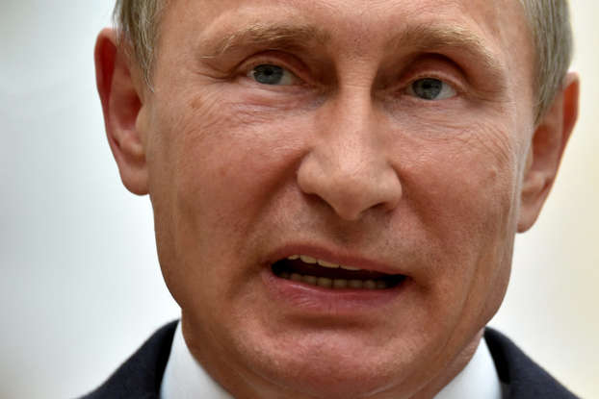  How did the [155th Naval Brigade] get destroyed at [Vuhledar]? [1] | 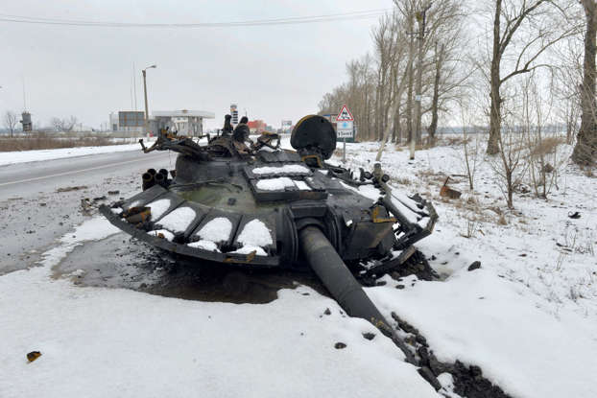  [Russia]'s offensive [2]
Images leaked by the [United Kingdom’s Ministry of Defense] showed that the [Russians] had likely lost [dozens of
armored vehicles] according to a [Reuters] report.[3]
Online military bloggers like [Reporting from Ukraine], claimed [Russia lost an entire tank battalion] based on
[video evidence] of the situation released by [Ukrainian marines].[4]
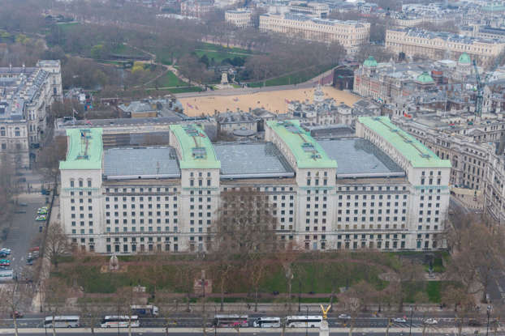  Leaked images show the destruction [3] | 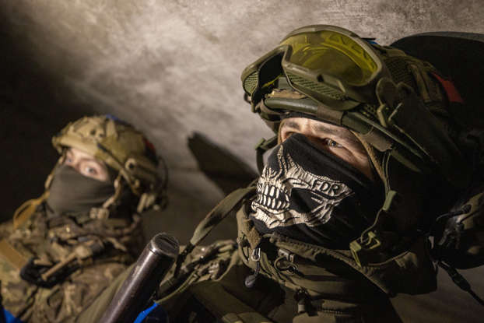  An entire tank battalion gone [4]
“[Russian units] have likely suffered [particularly heavy casualties] around [Vuhledar] as inexperienced units
have been committed,” [Britain’s Ministry of Defense] wrote on [02/10/23] in their [daily intelligence update].[5]
“[Russian troops] likely fled and abandoned at least (30) mostly intact armored vehicles in a single incident after
a failed assault,” [Ministry of Defense] officials added, but the devastation might have been much worse.[6]
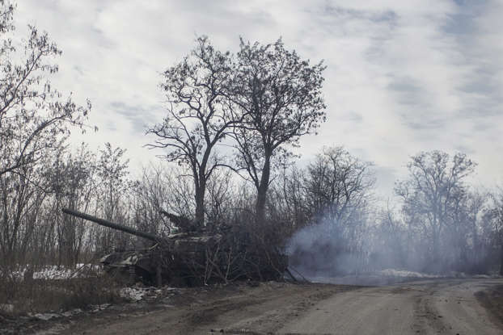  [Russia] suffered heavy casualties in [Vuhledar] [5] | 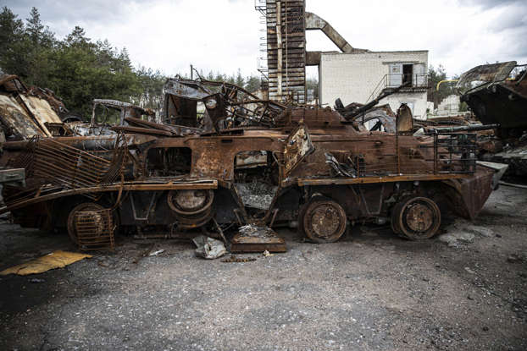  (30) armored vehicles abandoned [6]
On [02/13/23], reports of a [larger catastrophe] in [Vuhledar] began circulating with [Politco]’s
[Veronika Melkozeroa] writing that [Putin] may have lost one of his [most elite brigades].[7]
The [155th Naval Infantry Brigade] was tasked with [storming Vuhledar] according to information [Melkozeroa]
obtained from the head of [Tavriskiy District]’s press center, [Oleksiy Dmytrashkivskyi].[8]
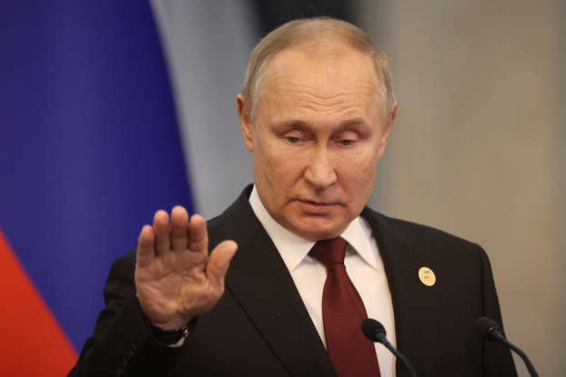  Reports of a larger disaster [7] | 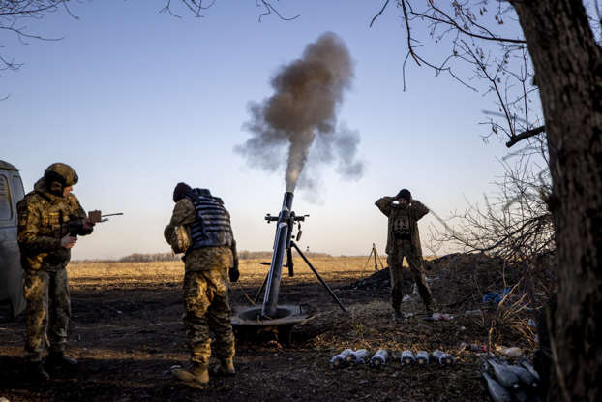  Storming [Vuhledar]... [8]
“A [large number of enemy forces], including the [command staff], were [destroyed near Vuhledar and Mariinka] in
[Donetsk Oblast],” [Dmytrashkivskyi] told [Politico].[9]
“In addition, over the past week, [the enemy lost about (130) units of equipment], including (36) units of tanks,”
[Dmytrashkivskyi] added. [10]
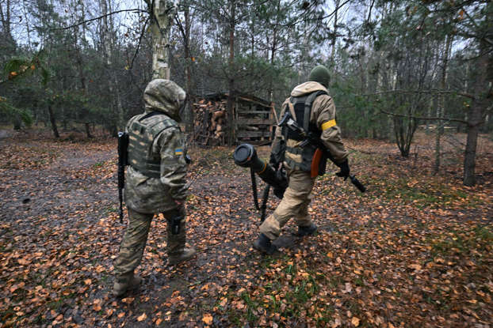  The enemy was destroyed [9] | 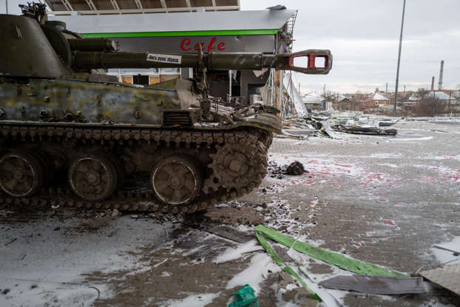  A tally of [Russian] losses from [Ukraine] [10]
The battle in [Vulhedar] wasn’t the first time [Russia’s elite 155th Naval Infantry Brigade] has suffered a [major
defeat in Ukraine], according to [Dmytrashkivskyi], it "had to be restaffed (3) times" after previous engagements
with [Ukrainian forces].[11] “The first time after [Irpin and Bucha]; the second time they were defeated near
[Donetsk]— they recovered again,” [Dmytrashkivskyi] told [Politico], "now, [almost the entire brigade] has already
been [destroyed near Vuhledar].”[12]

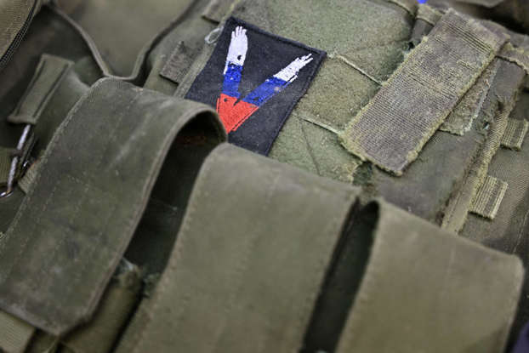  The (155th) have been defeated before [11] | 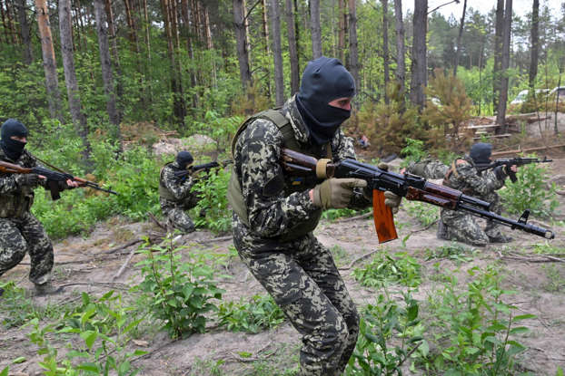  Destroyed in [Irpin] and [Bucha] [12]

The [Kremlin] has yet to [officially comment] on the allegation that its forces were soundly defeated in [Vulhedar],
but military blogger [Igor Girkin] sounded off on what he said was a battle that only had “one-sided” losses [13].
“[Ukrainian artillery shoots exceptionally accurately]. More than (30) units of armored vehicles were lost.
[Dozens of tankmen were killed]. Even more [marines], [special forces], and [motorized riflemen] died,” [Girkin]
wrote on his [Telegram] channel.[14]

Criticism of the [Kremlin] [13] | 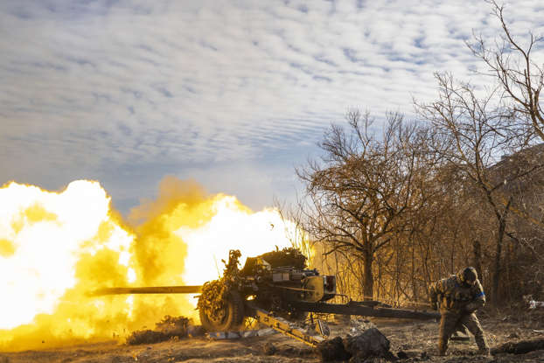  The [Ukrainians] destroyed our troops [14]

“All these losses turned out to be one-sided,” [Gherkin] added, “the [Ukrainians] shot the attackers like in a
[shooting gallery]” [15]. The [155th Naval Infantry Brigade] had previously attempted to take [Vuhledar] in [11/22],
but [that assault also ended in failure], and losses of up to (50%) according to a report from [CNN] [16].

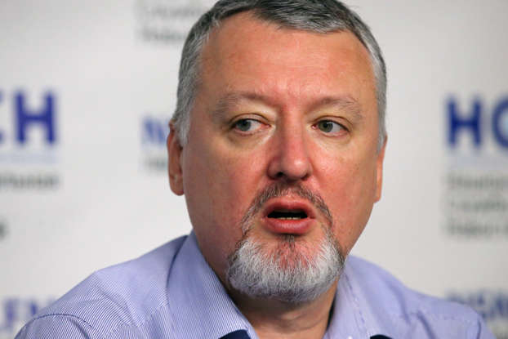  One-sided losses [15] | 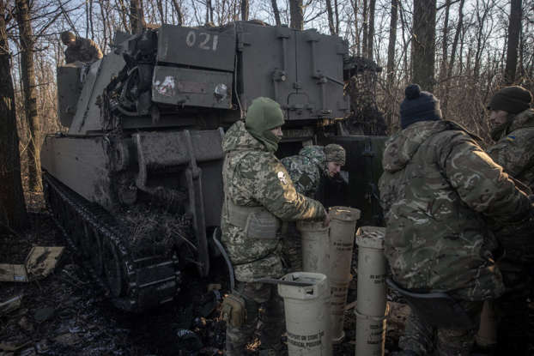  Previous defeat in [Vuhledar] [16]
___________/
\___________________________________________________________________________________________________________/ Slideshow
Opinion /¯¯¯¯¯¯¯¯¯¯¯¯¯¯¯¯¯¯¯¯¯¯¯¯¯¯¯¯¯¯¯¯¯¯¯¯¯¯¯¯¯¯¯¯¯¯¯¯¯¯¯¯¯¯¯¯¯¯¯¯¯¯¯¯¯¯¯¯¯¯¯¯¯¯¯¯¯¯¯¯¯¯¯¯¯¯¯¯¯¯¯¯¯¯¯¯¯¯¯¯¯¯¯¯¯¯¯¯¯\
/¯¯¯¯¯¯¯¯¯
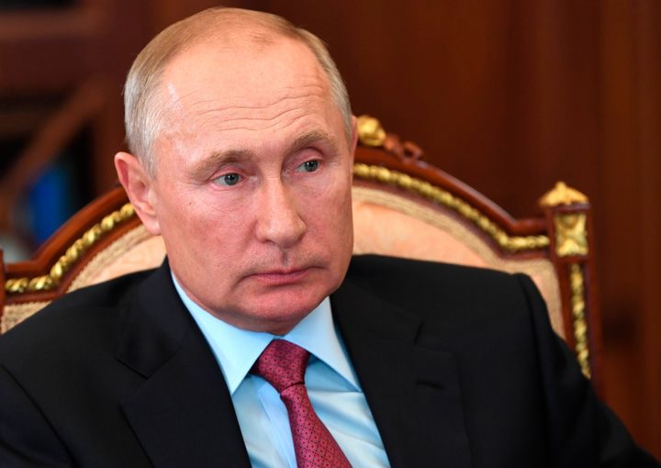
[Vladimir “Dick-faced trollmeister” Putin]

The questions that this man has caused me to ask myself, have changed a lot about how I see the world.
They've probably changed a lot about how HE sees the world too... It's caused us both to grow.
Because, anyone who considers themselves a respectable human being...?
They've always had this dream where they would spend an entire day hanging out with this dude, just [President
Vladamir Putin], and [that person].
Maybe [playing beer pong], or [going skydiving], or maybe just [playing a long-winded game of chess]...?
[This dude probably causes a lot of people to bawl their eyes out when he says he's gotta take off]...
It's the emotions, man.
After hanging out with such an awesome son-of-a-bitch like HIM...?
Of course, [people are going to cry].
It'd actually be [OFFENSIVE] if you [didn't bawl your eyes out] cause the man came to hang out real quick, but
then had to leave since he has other things to do... so, [failure to cry is rude].
Anyone who has this dream of hanging out with [President Vladamir “Dick-faced trollmeister” Putin] for a day,
or a portion of a day, or just ALMOST standing in the same building as him for like a split-second...?
Those people got a lot closer to [Vlad], than most people ever do.
Don't get mad, get [Vlad].
Anywhere from a few minutes, to a couple of hours...?
The president of [Russia] may occasionally be found, willing to show ANY down to earth person... one who realizes
how ridiculous would be, to think that he won't make an appearance in YOUR life... if you believe in him.
Sorta like the movie [Field of Dreams], starring [Kevin Costner].
“If you build it...? They will come.”
So, if you believe that the president of [Russia] will make an appearance in your life...?
He will.
No matter how ridiculous that dream may be, trying to hang out with this dude for a day, or not...?
[Everyone should consider that not all heroes wear capes...]
Cause, sometimes it's what they do for the common, every-day person, that really shows everybody, who the hell
that person is.
Let me tell ya something... sometimes people in [America] say all of this stuff out loud, or, maybe they don't
say any of it, it's just written on their face.
[That's when the magic begins].
I have to hope that SOMEONE will tell people in the future, that [there was an entire period of human history],
where this man actually lived his life.
In that time, he changed it in a permanent way that I feel certain, no man could ever surpass ... at being [one
of the most legendary douchebags who ever lived]... [Vladimir “Dick-faced trollmeister” Putin].
Yeah, when people heard me ranting and raving about how perplexed I am, that this man just never ceases to
amaze other people...? I don't think they truly realized just how blown away I've always been, by the fact that
this fuckin' dude actually exists.
He's real.
Pinch yourself if you don't believe me... but, there's no mistaking his existence.
Here I was, thinking [I] was the one being ridiculous, but no...
Prior to writing this document...?
Well, people would [literally argue with me], about how I noticed hundreds of these “flukes”.
Sometimes some idiot heard me say things about [Vladimir “Dick-faced trollmeister” Putin] for years, and they
got [annoyed] by the fact that I [kept making fun of this poor man]... one who's been [minding his own business]
in a country all the way around the world.
Naturally, people would get snippy with me and say
___________________________________________________________________________________
| What the hell has that man done to warrant such negative attention from YOU...? |
¯¯¯¯¯¯¯¯¯¯¯¯¯¯¯¯¯¯¯¯¯¯¯¯¯¯¯¯¯¯¯¯¯¯¯¯¯¯¯¯¯¯¯¯¯¯¯¯¯¯¯¯¯¯¯¯¯¯¯¯¯¯¯¯¯¯¯¯¯¯¯¯¯¯¯¯¯¯¯¯¯¯¯
Oh. I'll tell ya.
Dude literally asks himself questions on [how to change the way that games are typically played amongst people].
Sometimes the games being played, are:
[+] multi layered
[+] wrapped in a box with a big puffy bow
[+] ...and the guy has to keep his game face on, regardless of the facts...
...which has got to be the toughest part actually.
Because, ANYONE who's held such [high respect] for [President Vladimir “Dick-faced trollmeister” Putin] that whole
time he “stopped being a douchebag for a while”...? Well, [people who thought that was the case] simply [failed to
realize that he was only pretending to be nice for a while], and [that's why some people let their guard down].
[Anyone who allows themselves to let their guard down] around THIS dude...?
Well, typically they won't find out until it's [too late], that [doing so was a fuckin' stupid idea]...
This man will spend entire [days] or [weeks], [conceptualizing a new way to mess with people].
And, he may have jumped around, trying to take this strategy of his to new heights...
...because that's his [signature move].
People aren't SUPPOSED to actually [kick back and relax], especially if this dude is [making his rounds].
Nah.
The dude is a [shape shifter], he'll [jump forward]...?
And then, before you even know what the fuck he's doin'...?
...he [jumps right back], into being an even [HIGHER calibur of douchebag], at times...
...for extended periods of time.
Some people may have thought “maybe he changed”... but that's one of the dumbest things his victims ever say.
Him...?
Changing...?
*Scoffs* Yeah.
*Sarcasm* Oh, he fuckin' changed alright...
He might change the strategy AND up his game...?
But, to expect that [this man does stupid shit for no reason]...?
That's laughagble.
Nah.
[The man didn't change at all].
These idiots actually thought it [might've been alright to hang out with the guy BEFORE he started attacking
Ukraine]... they said to themselves:
___________________________________________________________________
| Gee, [President Vladimir “Dick-faced trollmeister” Putin] is |
| probably a pretty cool guy to play a game of basketball with... |
¯¯¯¯¯¯¯¯¯¯¯¯¯¯¯¯¯¯¯¯¯¯¯¯¯¯¯¯¯¯¯¯¯¯¯¯¯¯¯¯¯¯¯¯¯¯¯¯¯¯¯¯¯¯¯¯¯¯¯¯¯¯¯¯¯¯¯
Yeah, well...
Sometimes he will hear his citizens wishes, and then magically...?
As if he did so his entire life...?
The man challenged HIMSELF to play some basketball, 5 on 1. They said:
_______________________________________________
| Vlad, 5 on 1 isn't fair, we'll smoke you... |
¯¯¯¯¯¯¯¯¯¯¯¯¯¯¯¯¯¯¯¯¯¯¯¯¯¯¯¯¯¯¯¯¯¯¯¯¯¯¯¯¯¯¯¯¯¯¯
But- saying anything like THAT to THIS MAN...?
That is probably about the dumbest thing anyone could ever say.
The reason why, is because this dude has definitely shown people how real he keeps it, especially when it comes
to such [high octane douchebaggery]. [Compounding the amount of it at his fingertips]. It's actually UNFAIR how
effortlessly the man can surprise [everybody].
A bunch of people could be staring at him, when all of a sudden...?
This dude, turning on a fuckin' dime...?
He might instantaneously decide to [up the ante] with his [whole entire strategy].

Thats why it's important to tell people what this man is all about.
Because, all of the people who told themselves that [President Vladimir “Dick-faced trollmeister” Putin] had
[calmed down from his younger years] were ALMOST in a position to wanna hang out with this dude for being such a
legendary dude.
But, the time for them to have that special moment together with Vlad, where they would hang out with him for like
a few hours...?
Nah.
NOW, [people are too miffed], they see that this man, has lost his humanity...
While he might be the [president of Russia] to everybody else...?
[Everybody is a person to him].
You really cannot outdo this son-of-a-bitch at checking the highest possible fucking box, at being a consistently
above average human being... everywhere he goes, or wherever he is (SEEN/TALKED ABOUT) by people.
That's why he has these 1-on-1 sessions, where he's dedicated to proving that the man can do anything he sets
his mind to. Whether that thing happens to be:
[+] being a douchebag
[+] playing basketball
[+] whatever else...?
Doesn't matter.
He might have a dark twisted and haunted past...?
But- that's what made him such a legendary [president], [fighter], [politician], and a [strategist]...
Who the fuck are YOU, to question how awesome he is...?
There's no way that I'm being facetious or sarcastic, not in the fucking least.
Regardless of the facts, some people actually live their [whole life] HOPING that THEY get to spend AT LEAST a
few minutes, [hanging out with this dude].
So, the idea of being in the same room as [President Vladimir “Dick-faced trollmeister” Putin] probably [overwhelms]
some of them to the point where they have to have a conversation with themselves...
That's when they [pinch themselves] and ask whether or not it's a dream...? But- it isn't.
[President Vladimir “Dick-faced trollmeister” Putin] is literally there...
Not only is it a shock to their senses...?
But- they get so excited because he decided to show up [that day].
Some may say that [there's really nothing noteworthy about just “hanging out” with him], from what I understand...
But- think about how stupid that mentality really is.
Because, NOBODY can make the fuckin' argument that a large number of people appear to have this ridiculous thing
on their bucket list.
[Bucket List]
1) go skydiving
2) find a pot of gold at either end of a fuckin' rainbow
3) hang out with [President Vladimir “Dick-faced trollmeister” Putin] for awhile.

I'm being serious.
Grown-ass men AND women, [hoping they get to meet him], someday.
Now, think about how cool it COULD'VE been, BEFORE he had to go [be a douchebag] and [attack Ukraine]... Yeah.
[Some people actually get upset about it], because they think that he [BECAME a douchebag] the moment he decided
to [invade Ukraine]. But- the truth is...? [The man actually never took a single moment to stop being one].
[Invading Ukraine] caused a lot of people who thought he might still have it in him, to be “sort-of-cool” as they
considered [letting bygones be bygones]... to reconsider those bygones being let go, and then they remembered that
he's [probably not as cool as everyone thinks he is].
That's when they started searching all over the place, to see if those bygones were still sticking around...
...because, many have realized, that [he will never change].
Some people actually say it like that too:
___________________________________________________________________________
| Yeah, up until Putin had to go be a big douchebag and attack Ukraine... |
| Putin might've been an alright dude to hang out with.... |
¯¯¯¯¯¯¯¯¯¯¯¯¯¯¯¯¯¯¯¯¯¯¯¯¯¯¯¯¯¯¯¯¯¯¯¯¯¯¯¯¯¯¯¯¯¯¯¯¯¯¯¯¯¯¯¯¯¯¯¯¯¯¯¯¯¯¯¯¯¯¯¯¯¯¯
Meanwhile, I'm thinking:
______________________________________________
| Nah, he never stopping being a douchebag. |
| That's sorta his whole master game plan... |
¯¯¯¯¯¯¯¯¯¯¯¯¯¯¯¯¯¯¯¯¯¯¯¯¯¯¯¯¯¯¯¯¯¯¯¯¯¯¯¯¯¯¯¯¯¯
When you're like him...?
Being [one of the biggest douchebags in the world] is just never enough. Nah.
Some people rationalize the fact that there's NO WAY that he could be [such a major douchebag], if he's the
[President of Russia]. Then I think to myself, [the dude threatens anybody that tries to run for president, too].
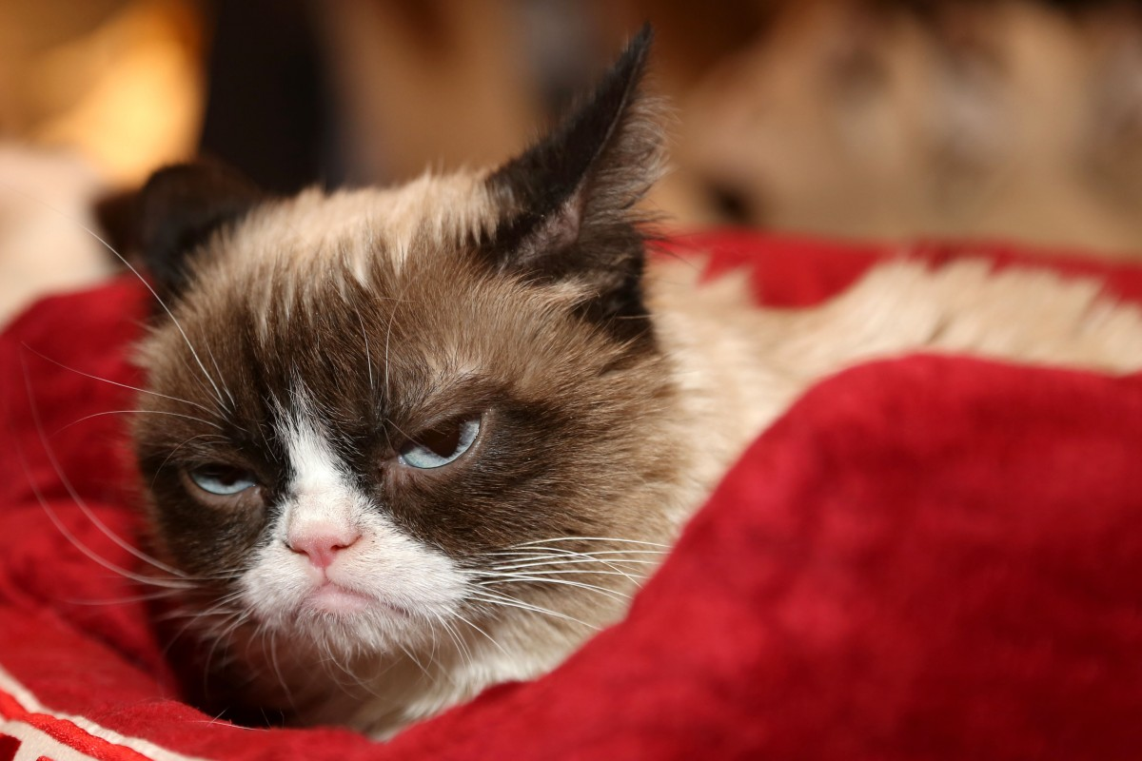
What [President Vladimir “Dick-faced trollmeister” Putin] looks like in person
If anything, [President Vladimir “Dick-faced trollmeister” Putin] is like a [grumpy cat] that doesn't feel like
[getting up], and [moving on with his life].
(23) years in office.
Same guy.
Calling all the shots.
Telling everybody and their mother, to 1) [fuck off] and 2) [eat a dick], 3) [or else].
[Bill Clinton] had (8) years.
[George W. “Bushmeister 5000” Bush] had (8) years.
[Barack “Leader of the free world” Obama] had (8) years.
NONE of them stand a chance at competing against this dude, on his level.
[The man is unrivaled].
If there's a list of stupid things that people can do...?
This man, [President Vladimir “Dick-faced trollmeister” Putin] wastes no fuckin' time at all, to do every single
one of those stupid things on that list.
It is [mesmerizing] to see how talented he is, at doing this. Procedurally, too.
[Total douchebaggery] this dude has mastered, [without even putting a whole lot of thought into it].
Apparently, he's always been a natural at it.
That's the part I never really understood...
When did he first start REALLY maxing out, with this [top-notch douchebaggery] of his...?
MAYBE he figured it out by accident... which would make it an even [better] story.
________________________________________________________________________________________________________________
| The man, the myth, the legend [Vladimir “Dick-faced trollmeister” Putin] takes douchebaggery to new heights. |
¯¯¯¯¯¯¯¯¯¯¯¯¯¯¯¯¯¯¯¯¯¯¯¯¯¯¯¯¯¯¯¯¯¯¯¯¯¯¯¯¯¯¯¯¯¯¯¯¯¯¯¯¯¯¯¯¯¯¯¯¯¯¯¯¯¯¯¯¯¯¯¯¯¯¯¯¯¯¯¯¯¯¯¯¯¯¯¯¯¯¯¯¯¯¯¯¯¯¯¯¯¯¯¯¯¯¯¯¯¯¯¯
The [true answer], is that it probably [DOES] have an [origin story].
Most people probably don't understand his [original origin story]...
However, knowing what made him who he is, and what it was that chiseled him into the highest knighthood ever
achieved by anyone, anywhere... at being a total douchebag...?
I gotta say, sometimes I am literally fuckin' speechless, at how far this dude will go to [set new precedents].
That is why he is doesn't waste any time at all, at setting world records at going the full mile, here.
Nah.
If you don't think he's got it left in him to take things to an all-time, higher extreme...?
Then you're a fuckin' idiot.
Cause this dude finds a way to do it.
For anybody that really stops and says something like:
________________________________________________
| I didn't know he was actually a douchebag... |
¯¯¯¯¯¯¯¯¯¯¯¯¯¯¯¯¯¯¯¯¯¯¯¯¯¯¯¯¯¯¯¯¯¯¯¯¯¯¯¯¯¯¯¯¯¯¯¯
Yeah.
The guy was always been the type of douchebag who never has ANY plans on the table, to invite ANYBODY to go
[scuba diving with him], just on a whim.
Everybody knows, when you're COOL like [Vladimir “Dick-faced trollmeister” Putin] is)...?
You'll become even COOLER, by [randomly inviting people to go scuba diving with you], on a whim.
So... sorry to burst anybody's bubble if that's what they were looking to do with this dude...?
But- the man is actually far too cool to be found doing that.
He thinks that shit is stupid...
To be fair, the dude is probably boring to go scuba diving with anyway, but-
I'm sure he'll tell people that he could do it if he wanted to.
If he told me he was good at it, I wouldn't heed much attention to it.
[The man has been known to say many things that aren't true]. [It's one of his specialties, actually].
So if you ask him if he's a dick-faced trollmeister, and he says “No”...?
That means “yes”.
That's what makes him such a worrying adversary.
He's a [wildcard], nobody actually knows WHY he's always been such a visionary, coming up with ideas that are
often considered [suicidal] or [moronic]... but- that's just [one way] that this dude REALLY [messes with
people's heads].
Anyone that may have had this [ridiculous dream] of [waiting for the one day in their life to eventually come],
where [they'd be able to do whatever the hell they want with this dude]...? I gotta say, hanging out with such
a [highly-respected douchebag] who is somehow ALWAYS able to [outdo himself] at [being such an unrivaled douchebag]
for [each additional day that goes by]...?
Well, [it's caused me to ask myself some questions that I don't think anybody can really answer].
Not even HIM.
_________/
\_____________________________________________________________________________________________________________/ Opinion
Conclusion /¯¯¯¯¯¯¯¯¯¯¯¯¯¯¯¯¯¯¯¯¯¯¯¯¯¯¯¯¯¯¯¯¯¯¯¯¯¯¯¯¯¯¯¯¯¯¯¯¯¯¯¯¯¯¯¯¯¯¯¯¯¯¯¯¯¯¯¯¯¯¯¯¯¯¯¯¯¯¯¯¯¯¯¯¯¯¯¯¯¯¯¯¯¯¯¯¯¯¯¯¯¯¯¯¯¯\
/¯¯¯¯¯¯¯¯¯¯¯¯
In conclusion, this dude probably [impresses the shit out of himself] too, with this [highly-skilled douchebaggery]
of his. Questioning what he's capable of, is basically [the dumbest thing anyone could do].
The dude knows the [ins] and [outs] of [how to be one of the most highly-feared people that ever lived], but at
the same time, [he is one of the fuckin' dumbest sons of bitches that ever lived], too.
Because, it's just the same old [Vlad] he's always been...
[President Vladimir “Dick-faced trollmeister” Putin].

[The dude probably lives for the days where someone would write so many things about him], and cause him to
ask some of these questions, too... I doubt that he is going to do anything [drastic] or [unexpected], because
if there's ANYTHING that ANYBODY should know about this dude...?
I gotta say... Being able to [outdo ones self] at [being a douchebag], for [each additional day that goes by]...?
That is quite a thing to brag about, to other people.
Because, who the hell can even pull that off...?
Well I'll tell ya.
This fuckin' dude sure as hell can.
____________/
\__________________________________________________________________________________________________________/ Conclusion
________________________________________________________  |¯¯¯¯¯¯¯¯¯¯¯¯¯¯¯¯¯¯¯¯¯¯¯¯¯¯¯¯¯¯¯¯¯¯¯¯¯¯¯¯¯¯¯¯¯¯¯¯¯¯¯¯¯¯|  | Michael C. Cook Sr. |  | Security Engineer |  | Secure Digits Plus LLC |  |______________________________________________________|  ¯¯¯¯¯¯¯¯¯¯¯¯¯¯¯¯¯¯¯¯¯¯¯¯¯¯¯¯¯¯¯¯¯¯¯¯¯¯¯¯¯¯¯¯¯¯¯¯¯¯¯¯¯¯¯¯ | 

