____ ____________________________________________________________________________________________________
//¯¯\\__//¯¯¯¯¯¯¯¯¯¯¯¯¯¯¯¯¯¯¯¯¯¯¯¯¯¯¯¯¯¯¯¯¯¯¯¯¯¯¯¯¯¯¯¯¯¯¯¯¯¯¯¯¯¯¯¯¯¯¯¯¯¯¯¯¯¯¯¯¯¯¯¯¯¯¯¯¯¯¯¯¯¯¯¯¯¯¯¯¯¯¯¯¯¯¯¯¯¯\\___
\\__//¯¯¯ Map Facts [~] 05/26/2023 ___//¯¯\\
¯¯¯\\__________________________________________________________________________________________________//¯¯\\__//
¯¯¯¯¯¯¯¯¯¯¯¯¯¯¯¯¯¯¯¯¯¯¯¯¯¯¯¯¯¯¯¯¯¯¯¯¯¯¯¯¯¯¯¯¯¯¯¯¯¯¯¯¯¯¯¯¯¯¯¯¯¯¯¯¯¯¯¯¯¯¯¯¯¯¯¯¯¯¯¯¯¯¯¯¯¯¯¯¯¯¯¯¯¯¯¯¯¯¯¯ ¯¯¯¯

\______________________________________________________________________________________________________________________/
Introduction /¯¯¯¯¯¯¯¯¯¯¯¯¯¯¯¯¯¯¯¯¯¯¯¯¯¯¯¯¯¯¯¯¯¯¯¯¯¯¯¯¯¯¯¯¯¯¯¯¯¯¯¯¯¯¯¯¯¯¯¯¯¯¯¯¯¯¯¯¯¯¯¯¯¯¯¯¯¯¯¯¯¯¯¯¯¯¯¯¯¯¯¯¯¯¯¯¯¯¯¯¯¯¯\
/¯¯¯¯¯¯¯¯¯¯¯¯¯¯
________________________________________________________________________________________________________
| Source (document/link): [https://www.exploredplanet.com/guides/maps-that-show-us-a-new-perspective/] |
¯¯¯¯¯¯¯¯¯¯¯¯¯¯¯¯¯¯¯¯¯¯¯¯¯¯¯¯¯¯¯¯¯¯¯¯¯¯¯¯¯¯¯¯¯¯¯¯¯¯¯¯¯¯¯¯¯¯¯¯¯¯¯¯¯¯¯¯¯¯¯¯¯¯¯¯¯¯¯¯¯¯¯¯¯¯¯¯¯¯¯¯¯¯¯¯¯¯¯¯¯¯¯¯
Like a side-view mirror, sometimes on maps, things look bigger to us than they actually appear.
Think about it; a world map shows [Greenland] as this giant landmass the size of [South America] when really
it's quite tiny, comparatively speaking.

Then there is the [Mongolian Empire], a massive region conquering of over (9M) square miles.
But what does that area look like on a map when compared to the rest of the world?
Don't worry; these maps will shed light on the true scope of things and may even help you obtain a more
worldly perspective.
______________/
\_______________________________________________________________________________________________________/ Introduction
Red Features A Total Population Greater Than The Gray /¯¯¯¯¯¯¯¯¯¯¯¯¯¯¯¯¯¯¯¯¯¯¯¯¯¯¯¯¯¯¯¯¯¯¯¯¯¯¯¯¯¯¯¯¯¯¯¯¯¯¯¯¯¯¯¯¯¯¯¯¯¯\
/¯¯¯¯¯¯¯¯¯¯¯¯¯¯¯¯¯¯¯¯¯¯¯¯¯¯¯¯¯¯¯¯¯¯¯¯¯¯¯¯¯¯¯¯¯¯¯¯¯¯¯¯¯¯¯

As you can clearly see by this map, [Americans] tend to favor the coastal states, considering the red
areas represent a greater population than that of the gray area. With a vast majority of 'red' being in
[southern California], it seems as though people flock to the west coast for the lifestyle:
the promise of year-round summer.

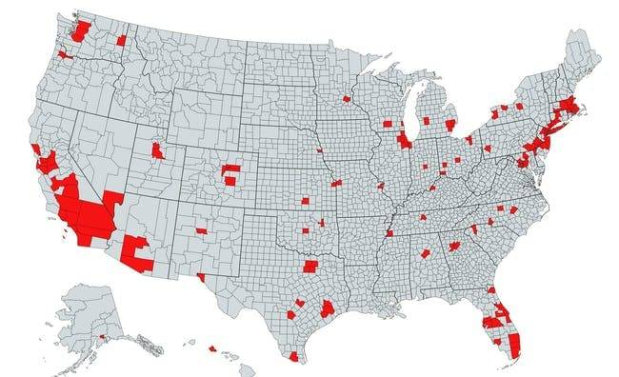
[https://www.exploredplanet.com/wp-content/uploads/2020/08/red-areas-feature-a-total-population-greater-than-grey-areas-photo-u1-60824.jpg]

Then, some favor the eastern seaboard, enjoying the lifestyles of [New Englanders] and the tri-state area.
What we can conclude from the map is that the colder and more rural states aren't on the 'move-to' list for
many of the (328.2M) [Americans].

Things aren't always bigger in [Texas] when the state is taken out of the country and placed next to [Africa].
Read on to see what that looks like....
_______________________________________________________/
\______________________________________________________________/ Red Features A Total Population Greater Than The Gray
New Zealand Is Very Small Compared To The United States /¯¯¯¯¯¯¯¯¯¯¯¯¯¯¯¯¯¯¯¯¯¯¯¯¯¯¯¯¯¯¯¯¯¯¯¯¯¯¯¯¯¯¯¯¯¯¯¯¯¯¯¯¯¯¯¯¯¯¯¯\
/¯¯¯¯¯¯¯¯¯¯¯¯¯¯¯¯¯¯¯¯¯¯¯¯¯¯¯¯¯¯¯¯¯¯¯¯¯¯¯¯¯¯¯¯¯¯¯¯¯¯¯¯¯¯¯¯¯

Since the [United States] is the (4th)-largest country in the entire world, it's no surprise that when
[New Zealand] is put on top of it, the island looks like a tiny blip in comparison.
To put it in mathematical language, the [US] is estimated to be around (9,833,517) km²,
while [New Zealand] is about (268,838) km².

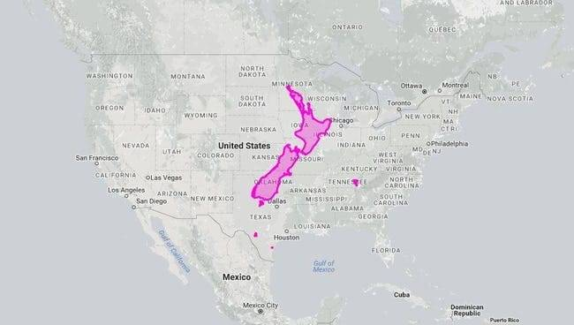
[https://www.exploredplanet.com/wp-content/uploads/2020/08/japan-in-the-midwest-photo-u1-97706.jpg]

This makes the [United States] around (3,558) percent larger than the [southwestern Pacific] country of [New
Zealand]! Thankfully, [New Zealand] isn't alone in its small area, being similar in size to the [United Kingdom].
_________________________________________________________/
\____________________________________________________________/ New Zealand Is Very Small Compared To The United States
Greenland Looks Tiny Next To South America /¯¯¯¯¯¯¯¯¯¯¯¯¯¯¯¯¯¯¯¯¯¯¯¯¯¯¯¯¯¯¯¯¯¯¯¯¯¯¯¯¯¯¯¯¯¯¯¯¯¯¯¯¯¯¯¯¯¯¯¯¯¯¯¯¯¯¯¯¯¯¯¯¯\
/¯¯¯¯¯¯¯¯¯¯¯¯¯¯¯¯¯¯¯¯¯¯¯¯¯¯¯¯¯¯¯¯¯¯¯¯¯¯¯¯¯¯¯¯

If you're like us, then when you look at a world map, the territory of [Greenland] seems like it could overtake
[South America] in terms of surface area. Well, we're here to tell you that is not the case, and this map should
put their respective sizes into perspective.

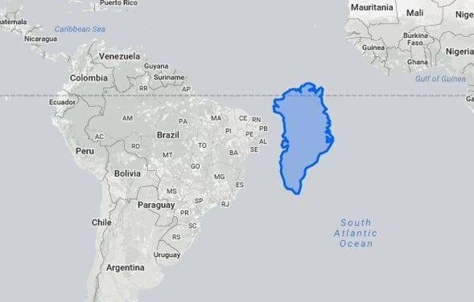
[https://www.exploredplanet.com/wp-content/uploads/2020/08/greenland-on-the-equator-photo-u1-20004.jpg]

Let's start with [Greenland]. The island has an area of (2,166,086) km², while the continent of [South America]
comes in at a whopping (17,840,000) km².
That, folks, tells us that [South America] is a solid (8.2x) larger than the northern territory.
____________________________________________/
\_________________________________________________________________________/ Greenland Looks Tiny Next To South America
Texas Doesn't Look All That Big Next Compared To Africa /¯¯¯¯¯¯¯¯¯¯¯¯¯¯¯¯¯¯¯¯¯¯¯¯¯¯¯¯¯¯¯¯¯¯¯¯¯¯¯¯¯¯¯¯¯¯¯¯¯¯¯¯¯¯¯¯¯¯¯¯\
/¯¯¯¯¯¯¯¯¯¯¯¯¯¯¯¯¯¯¯¯¯¯¯¯¯¯¯¯¯¯¯¯¯¯¯¯¯¯¯¯¯¯¯¯¯¯¯¯¯¯¯¯¯¯¯¯¯

While [Texas] is the (2nd)-largest state in the [United States] by area, right behind [Alaska], it is nothing in
comparison to the world's second-largest continent, [Africa]. Everything might be bigger in [Texas], but when
the state is dropped down on top of [Africa], it looks about as big as one of the countries-- which is still
impressive!

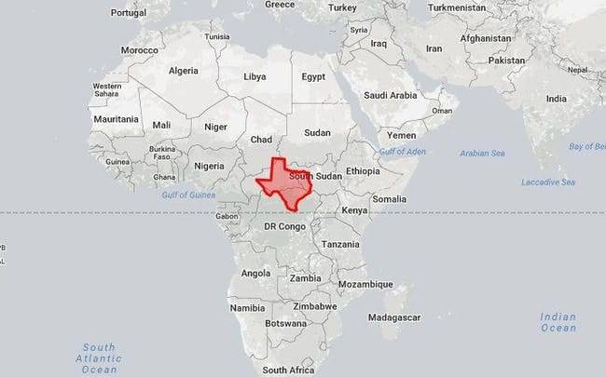
[https://www.exploredplanet.com/wp-content/uploads/2020/08/texas-in-africa-photo-u1-83635.jpg]

To put it in a bit of perspective for those who enjoy numbers, [Africa] has an area of (30,370,000) km², while
[Texas] doesn't even break (1M) km², coming in at (676,587) km². This means [Africa] is (45) times larger than
the state!
_________________________________________________________/
\____________________________________________________________/ Texas Doesn't Look All That Big Next Compared To Africa
Light Pollution Throughout The Continental United States /¯¯¯¯¯¯¯¯¯¯¯¯¯¯¯¯¯¯¯¯¯¯¯¯¯¯¯¯¯¯¯¯¯¯¯¯¯¯¯¯¯¯¯¯¯¯¯¯¯¯¯¯¯¯¯¯¯¯¯\
/¯¯¯¯¯¯¯¯¯¯¯¯¯¯¯¯¯¯¯¯¯¯¯¯¯¯¯¯¯¯¯¯¯¯¯¯¯¯¯¯¯¯¯¯¯¯¯¯¯¯¯¯¯¯¯¯¯¯

If you're an outdoor lover who enjoys star gazing at night, we recommend venturing to middle and northwest
[America], where the light pollution is substantially less than the coastal states east of the [Mississippi River].
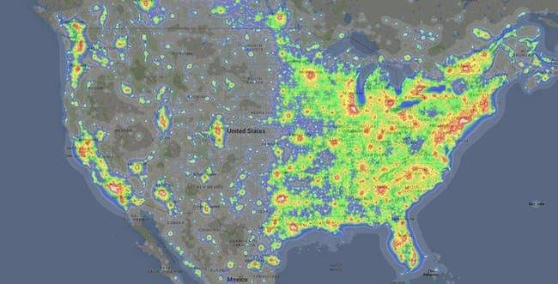
[https://www.exploredplanet.com/wp-content/uploads/2020/08/1002050914-photo-u1-76104.jpg]

Sadly, according to a (2016) study, scientists estimate that around (80%) of [North Americans] can't see the
[Milky Way].

But, as geographer [Tim Wallace] has mentioned, a majority of the states with random light output, such as
[North Dakota], are due to shale oil extractions and huge commercial buildings, such as airports and power stations.
__________________________________________________________/
\___________________________________________________________/ Light Pollution Throughout The Continental United States
Air Traffic Control Zones Look Nothing Like The Country /¯¯¯¯¯¯¯¯¯¯¯¯¯¯¯¯¯¯¯¯¯¯¯¯¯¯¯¯¯¯¯¯¯¯¯¯¯¯¯¯¯¯¯¯¯¯¯¯¯¯¯¯¯¯¯¯¯¯¯¯\
/¯¯¯¯¯¯¯¯¯¯¯¯¯¯¯¯¯¯¯¯¯¯¯¯¯¯¯¯¯¯¯¯¯¯¯¯¯¯¯¯¯¯¯¯¯¯¯¯¯¯¯¯¯¯¯¯¯

Interestingly, the air traffic control in the [United States] isn't broken up by state, but rather by zones and
sectors. Throughout the continental [US], there are (21) zones, as illustrated on the above map.
Each of these zones is centralized around a major city, such as [Houston], [New York], and [Washington D.C.]

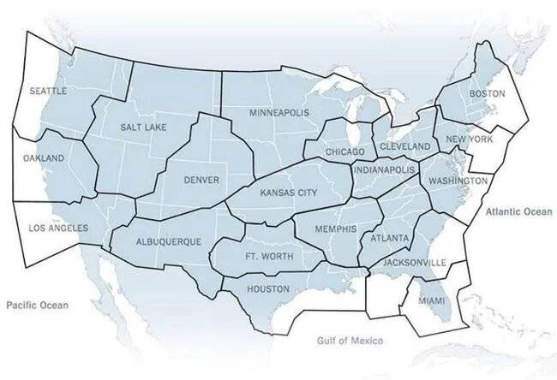
[https://www.exploredplanet.com/wp-content/uploads/2020/08/broken-up-by-air-traffic-control-zones-photo-u1-52596.jpg]

But that's not where air control ends. Within these (21) zones, there are sectors and (50 mi) in diameter of
airspace. Within each given portion of airspace is where all of the country's airports are located, each with
its own (5 mi) radius. Not only can maps show us excellent size comparisons, but they can also reveal a shocking
amount about what happens in regions all over the world. Keep viewing and you'll likely be very surprised...
_________________________________________________________/
\____________________________________________________________/ Air Traffic Control Zones Look Nothing Like The Country
Metric System Vs. Imperial System /¯¯¯¯¯¯¯¯¯¯¯¯¯¯¯¯¯¯¯¯¯¯¯¯¯¯¯¯¯¯¯¯¯¯¯¯¯¯¯¯¯¯¯¯¯¯¯¯¯¯¯¯¯¯¯¯¯¯¯¯¯¯¯¯¯¯¯¯¯¯¯¯¯¯¯¯¯¯¯¯¯¯\
/¯¯¯¯¯¯¯¯¯¯¯¯¯¯¯¯¯¯¯¯¯¯¯¯¯¯¯¯¯¯¯¯¯¯¯

One of the age-old arguments a majority of the world has with the [United States] is why the country insists on
staying with the imperial system of measurement. Aside from [Liberia] and [Myanmar], the rest of the world, as
you can see by the gray masses, use the metric system.

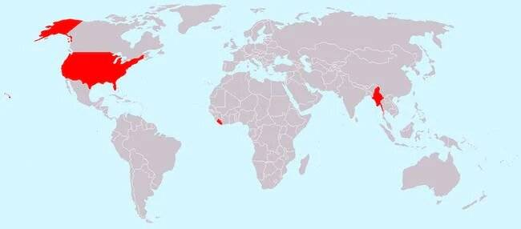
[https://www.exploredplanet.com/wp-content/uploads/2020/08/countries-that-don_t-use-the-metric-system-photo-u1-93063.jpg]

In [America]'s defense, they can actually blame the [British] on the unit of measurement. Hundreds of years ago,
when the [British] colonized [America], they brought with them the imperial system. Ever since, [Americans] have
used that system, deciding not to jump on the metric system-train, so to speak.
___________________________________/
\__________________________________________________________________________________/ Metric System Vs. Imperial System
Where Flamingos Flock In The Wild /¯¯¯¯¯¯¯¯¯¯¯¯¯¯¯¯¯¯¯¯¯¯¯¯¯¯¯¯¯¯¯¯¯¯¯¯¯¯¯¯¯¯¯¯¯¯¯¯¯¯¯¯¯¯¯¯¯¯¯¯¯¯¯¯¯¯¯¯¯¯¯¯¯¯¯¯¯¯¯¯¯¯\
/¯¯¯¯¯¯¯¯¯¯¯¯¯¯¯¯¯¯¯¯¯¯¯¯¯¯¯¯¯¯¯¯¯¯¯

While a majority of people will only ever see [flamingos] in zoos, there are some places around the world where
they live freely in the wild. As illustrated by the above map, these wading birds tend to favor [Africa],
[Europe], tiny parts of [Asia], the [Caribbean], and the southern tip of [America].

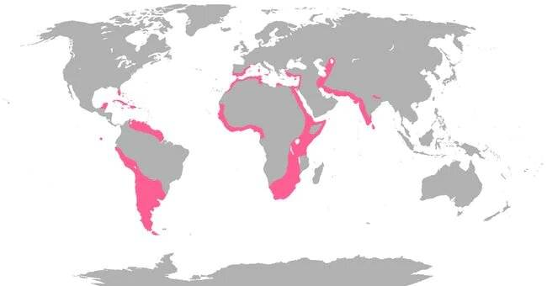
[https://www.exploredplanet.com/wp-content/uploads/2020/08/flamingo-distribution-photo-u1-1-32032.jpg]

Fun fact about [flamingos]: these birds tend to stand on one leg, but no one really knows why. It's thought that
they stand in such a way to retain body heat, as their long, skinny legs spend most of the day wading around in
cold water.
___________________________________/
\__________________________________________________________________________________/ Where Flamingos Flock In The Wild
Abandoned Railroads Throughout The United States /¯¯¯¯¯¯¯¯¯¯¯¯¯¯¯¯¯¯¯¯¯¯¯¯¯¯¯¯¯¯¯¯¯¯¯¯¯¯¯¯¯¯¯¯¯¯¯¯¯¯¯¯¯¯¯¯¯¯¯¯¯¯¯¯¯¯¯\
/¯¯¯¯¯¯¯¯¯¯¯¯¯¯¯¯¯¯¯¯¯¯¯¯¯¯¯¯¯¯¯¯¯¯¯¯¯¯¯¯¯¯¯¯¯¯¯¯¯¯

Railways played a huge role in the construction of [America], from the settlements in the west to the
[Industrial Revolution] in the east. It was (1827) when the first railroad was constructed.
The (B&O/Baltimore & Ohio Railroad) was the vision of [John Stevens] and catered to both freight and
passenger transport.

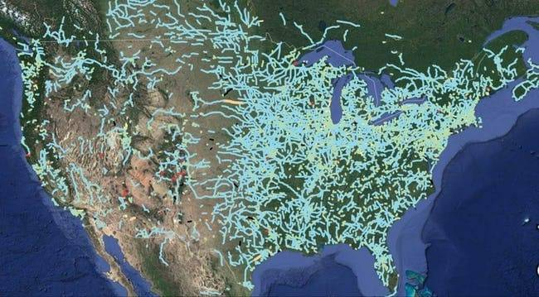
[https://www.exploredplanet.com/wp-content/uploads/2020/08/1002050874-photo-u1-35504.jpg]

As the map shows, a majority of the abandoned railways are located in the east, slowly expanding out west.
This pattern makes sense with the early settlements, slow construction, the (1893) economic panic that halted
many projects, and the eventual invention of the automobile and the airplane that would become the more popular
modes of transportation.
__________________________________________________/
\___________________________________________________________________/ Abandoned Railroads Throughout The United States
Further Proof That California Is Its Own Country /¯¯¯¯¯¯¯¯¯¯¯¯¯¯¯¯¯¯¯¯¯¯¯¯¯¯¯¯¯¯¯¯¯¯¯¯¯¯¯¯¯¯¯¯¯¯¯¯¯¯¯¯¯¯¯¯¯¯¯¯¯¯¯¯¯¯¯\
/¯¯¯¯¯¯¯¯¯¯¯¯¯¯¯¯¯¯¯¯¯¯¯¯¯¯¯¯¯¯¯¯¯¯¯¯¯¯¯¯¯¯¯¯¯¯¯¯¯¯

While [Italy] technically has a larger population than [California], having a population of (60.3M) compared to
the state's (39.5M), the latter is obviously bigger in terms of area. As you can see from the map, [California]
easily fits over the entirety of [Italy], even crossing over a few borders into [Swiss] territory.

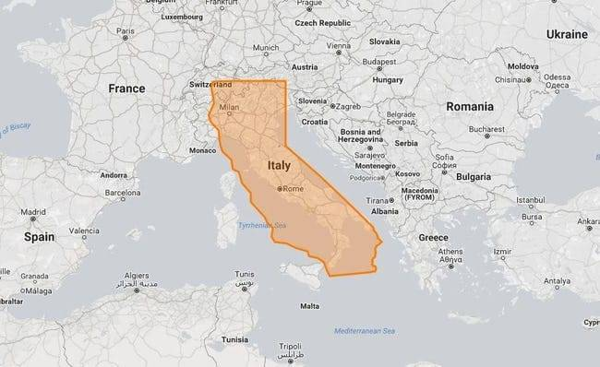
[https://www.exploredplanet.com/wp-content/uploads/2020/08/california-vs-italy-photo-u1-24998.jpg]

To give a bit of perspective on the size of the country versus the area of the state, let's look at some numbers.

[Italy] is (301,340) km², while [California]'s is a solid (403,882) km², making the country (74.61) percent the
size of the state.
__________________________________________________/
\___________________________________________________________________/ Further Proof That California Is Its Own Country
Eight Million Miles Of Highway In The United States /¯¯¯¯¯¯¯¯¯¯¯¯¯¯¯¯¯¯¯¯¯¯¯¯¯¯¯¯¯¯¯¯¯¯¯¯¯¯¯¯¯¯¯¯¯¯¯¯¯¯¯¯¯¯¯¯¯¯¯¯¯¯¯¯\
/¯¯¯¯¯¯¯¯¯¯¯¯¯¯¯¯¯¯¯¯¯¯¯¯¯¯¯¯¯¯¯¯¯¯¯¯¯¯¯¯¯¯¯¯¯¯¯¯¯¯¯¯¯

Formed back on [November 11, 1926], the [United States Federal Highways] has an expanded reach of (157,724 mi)
throughout the country. Each highway has a designated number, something that is coordinated among each of the
(50) states.

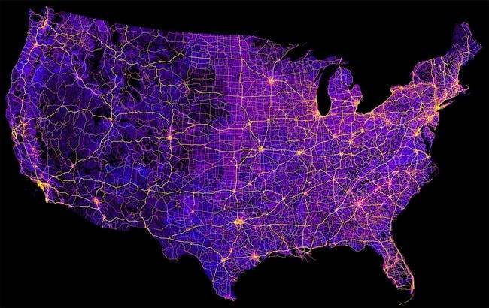
[https://www.exploredplanet.com/wp-content/uploads/2020/08/8-million-miles-of-highways-and-roads-photo-u1-83508.jpg]

And while the roadways stretch throughout the continental [U.S.], their maintenance is in the responsibility of
state and local governments. If you've ever been on a [New Jersey] highway, then you know tax money is going to
something other than fixing all of the highway potholes!
_____________________________________________________/
\________________________________________________________________/ Eight Million Miles Of Highway In The United States
The Population Density Of The U.S. /¯¯¯¯¯¯¯¯¯¯¯¯¯¯¯¯¯¯¯¯¯¯¯¯¯¯¯¯¯¯¯¯¯¯¯¯¯¯¯¯¯¯¯¯¯¯¯¯¯¯¯¯¯¯¯¯¯¯¯¯¯¯¯¯¯¯¯¯¯¯¯¯¯¯¯¯¯¯¯¯¯\
/¯¯¯¯¯¯¯¯¯¯¯¯¯¯¯¯¯¯¯¯¯¯¯¯¯¯¯¯¯¯¯¯¯¯¯¯

This map physically shows how dense the population is across the country, highlighting how most of the
population is located in the [Eastern] half of [America].

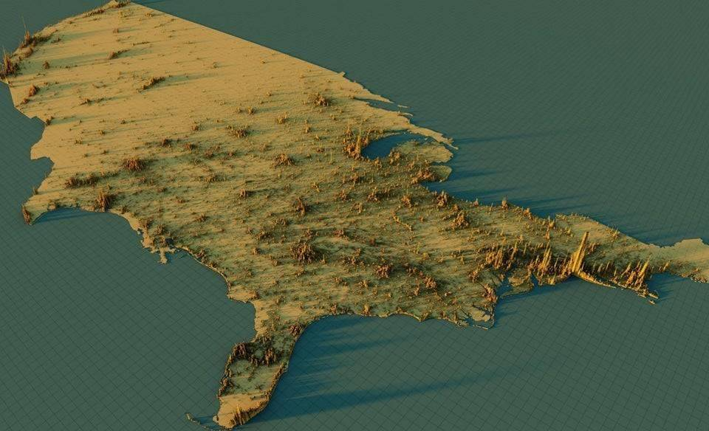
[https://www.exploredplanet.com/wp-content/uploads/2022/03/1zb2nb3o2ad51-18503-46782.jpg]

It seems the [West Coast] might not actually be the best coast.
____________________________________/
\_________________________________________________________________________________/ The Population Density Of The U.S.
Australia Vs. The United States /¯¯¯¯¯¯¯¯¯¯¯¯¯¯¯¯¯¯¯¯¯¯¯¯¯¯¯¯¯¯¯¯¯¯¯¯¯¯¯¯¯¯¯¯¯¯¯¯¯¯¯¯¯¯¯¯¯¯¯¯¯¯¯¯¯¯¯¯¯¯¯¯¯¯¯¯¯¯¯¯¯¯¯¯\
/¯¯¯¯¯¯¯¯¯¯¯¯¯¯¯¯¯¯¯¯¯¯¯¯¯¯¯¯¯¯¯¯¯

When looking at a world map, it's hard to determine which country is larger, [Australia] or the [United States].
So, we've layered them in order to gain a better perspective.

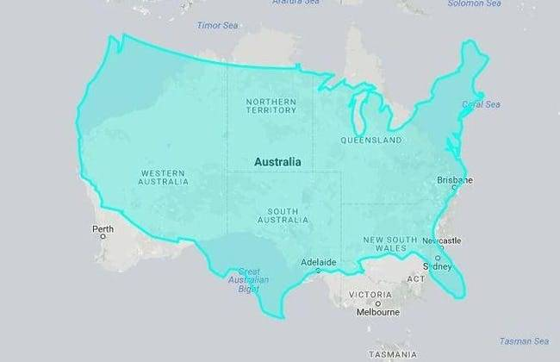
[https://www.exploredplanet.com/wp-content/uploads/2020/08/united-states-vs-australia-photo-u2-70611.jpg]

The [United States] is around (9,833,517) km², while the land down under is (7,741,220) km². In mathematical
terms, [America] is about (1.3x) as large as [Australia], or (27%). Considering the [United States] has a
population of (328.2M), it's a good thing there is so much space!

Between [Caribou], [Dunkin' Donuts], and [Starbucks], which coffee chain do you think is the most popular in
the [United States]? Keep reading to find out!
_________________________________/
\____________________________________________________________________________________/ Australia Vs. The United States
Majority Of The US Has A Smaller Population Than LA County /¯¯¯¯¯¯¯¯¯¯¯¯¯¯¯¯¯¯¯¯¯¯¯¯¯¯¯¯¯¯¯¯¯¯¯¯¯¯¯¯¯¯¯¯¯¯¯¯¯¯¯¯¯¯¯¯¯\
/¯¯¯¯¯¯¯¯¯¯¯¯¯¯¯¯¯¯¯¯¯¯¯¯¯¯¯¯¯¯¯¯¯¯¯¯¯¯¯¯¯¯¯¯¯¯¯¯¯¯¯¯¯¯¯¯¯¯¯¯

If there is one thing to say [Los Angeles County] in [southern California], it is packed tighter than a tin of
sardines. With a population of (10M), according to the (2019) census, the single county of LA out-populates a
vast majority of the [United States], as shown above.

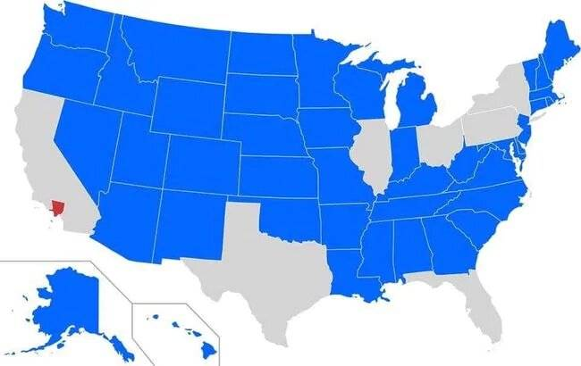
[https://www.exploredplanet.com/wp-content/uploads/2020/08/blue-states-have-a-smaller-population-than-los-angeles-county-photo-u1-93645.jpg]

Granted, [North Carolina] and [Georgia] should join [Ohio], [Illinois], [New York], [Florida], [Texas], and
[Pennsylvania] on this map. As of (2019), [North Carolina] just makes it past [LA County]'s population with
(10.49M) people, while [Georgia]'s population comes in at (10.62M).
____________________________________________________________/
\_________________________________________________________/ Majority Of The US Has A Smaller Population Than LA County
States With The Most Job Quitters /¯¯¯¯¯¯¯¯¯¯¯¯¯¯¯¯¯¯¯¯¯¯¯¯¯¯¯¯¯¯¯¯¯¯¯¯¯¯¯¯¯¯¯¯¯¯¯¯¯¯¯¯¯¯¯¯¯¯¯¯¯¯¯¯¯¯¯¯¯¯¯¯¯¯¯¯¯¯¯¯¯¯\
/¯¯¯¯¯¯¯¯¯¯¯¯¯¯¯¯¯¯¯¯¯¯¯¯¯¯¯¯¯¯¯¯¯¯¯

America saw the effects of 'the great resignation' beginning in (2020) and it's a trend that continues on.
The [US Bureau of Labor Statistics] released data on which [American] states are seeing the most people leaving
their jobs.

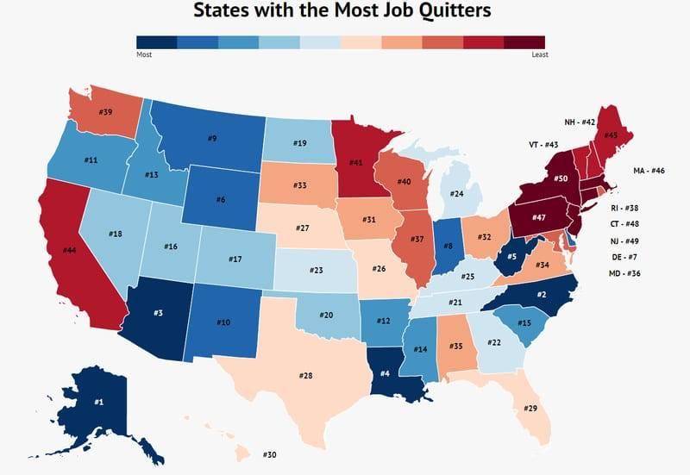
[https://www.exploredplanet.com/wp-content/uploads/2022/06/job-quitters-by-state-61603.jpg]

While the national average of people leaving their jobs is (2.8%), by [01/2022], (31) states were above that.
[Alaska] has the highest quit rate, (4.4%), followed by [Georgia] at (3.7%). [New York] had the lowest rate of
people leaving, just (1.9%), followed by [Massachusetts] at (2.1%) quit rate.
___________________________________/
\__________________________________________________________________________________/ States With The Most Job Quitters
A Minnesotian View Of The USA /¯¯¯¯¯¯¯¯¯¯¯¯¯¯¯¯¯¯¯¯¯¯¯¯¯¯¯¯¯¯¯¯¯¯¯¯¯¯¯¯¯¯¯¯¯¯¯¯¯¯¯¯¯¯¯¯¯¯¯¯¯¯¯¯¯¯¯¯¯¯¯¯¯¯¯¯¯¯¯¯¯¯¯¯¯¯\
/¯¯¯¯¯¯¯¯¯¯¯¯¯¯¯¯¯¯¯¯¯¯¯¯¯¯¯¯¯¯¯

This map shows the [United States] through the eyes of someone who lives in [Minnesota]. There is a whole lot
written on this map, including [California] apparently being nothing but a state that is on fire.

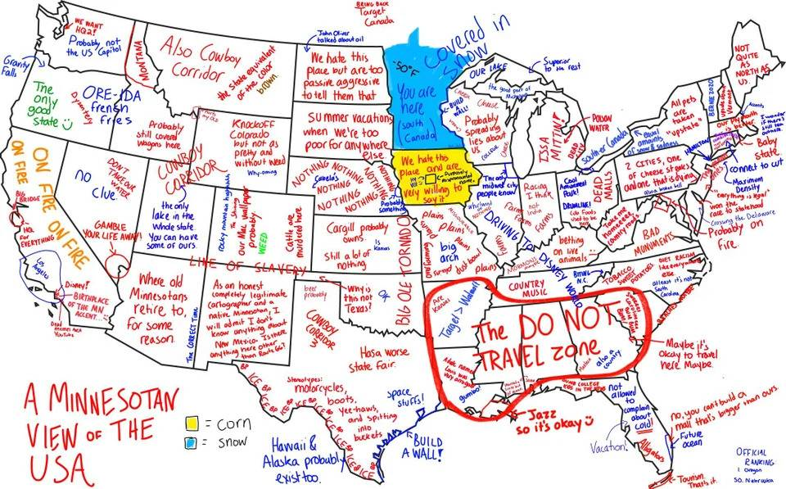
[https://www.exploredplanet.com/wp-content/uploads/2022/08/5dygwhm4ezc21-32079.jpg]

The south, on the other hand, looks like it has been marked as a Do Not Travel Zone, while the northern part
of the [Midwest] is just covered in snow! This map definitely shows the [United States] in a different way.
_______________________________/
\______________________________________________________________________________________/ A Minnesotian View Of The USA
The American Mediterranean Sea If It Was Ontop Of The USA /¯¯¯¯¯¯¯¯¯¯¯¯¯¯¯¯¯¯¯¯¯¯¯¯¯¯¯¯¯¯¯¯¯¯¯¯¯¯¯¯¯¯¯¯¯¯¯¯¯¯¯¯¯¯¯¯¯¯\
/¯¯¯¯¯¯¯¯¯¯¯¯¯¯¯¯¯¯¯¯¯¯¯¯¯¯¯¯¯¯¯¯¯¯¯¯¯¯¯¯¯¯¯¯¯¯¯¯¯¯¯¯¯¯¯¯¯¯¯

According to [Yahoo], this particular map of the [United States] is actually what the country would look like
due to climate change. Here, the [American Mediterranean], which includes both the [Gulf of Mexico] and the
[Caribbean Sea] has flooded [North America].

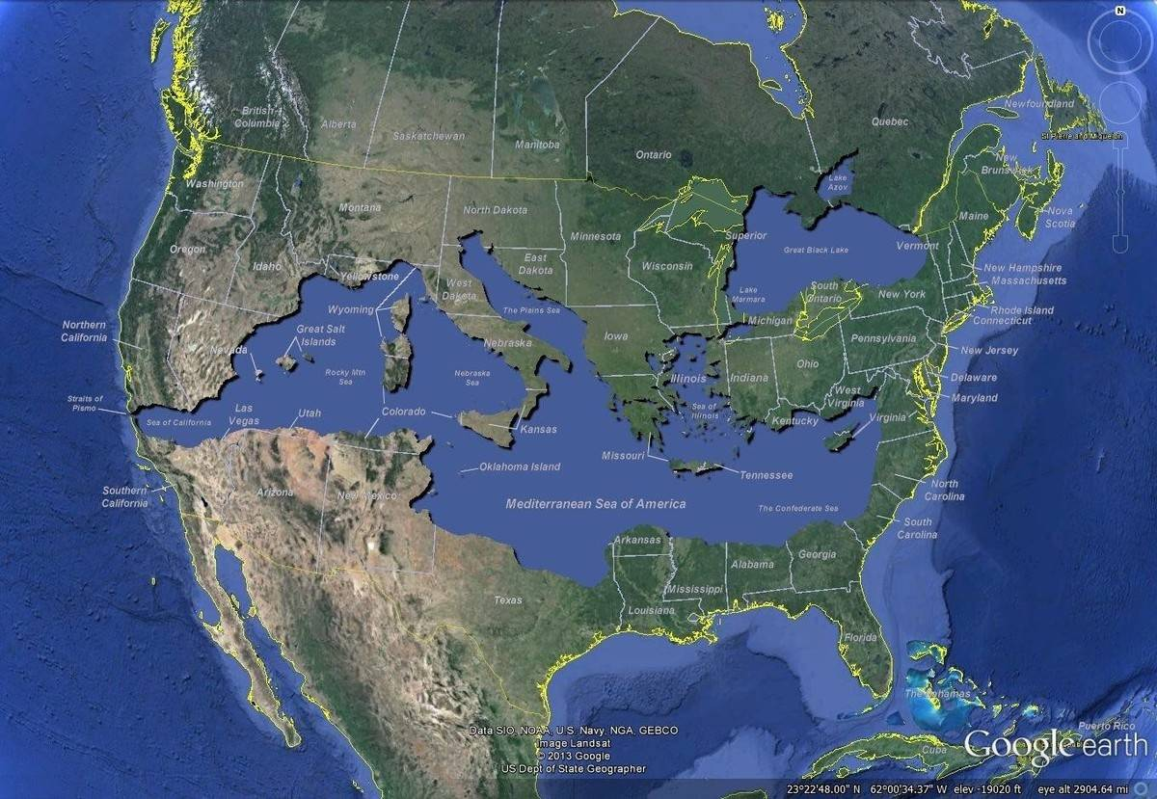
[https://www.exploredplanet.com/wp-content/uploads/2022/07/upv8x58p2rfz-62990.jpg]

It is a scary map to look at and might have people thinking twice abut the reality the world is facing when it
comes to climate change and climate control.
___________________________________________________________/
\__________________________________________________________/ The American Mediterranean Sea If It Was Ontop Of The USA
Land Use Throughout The United States /¯¯¯¯¯¯¯¯¯¯¯¯¯¯¯¯¯¯¯¯¯¯¯¯¯¯¯¯¯¯¯¯¯¯¯¯¯¯¯¯¯¯¯¯¯¯¯¯¯¯¯¯¯¯¯¯¯¯¯¯¯¯¯¯¯¯¯¯¯¯¯¯¯¯¯¯¯¯\
/¯¯¯¯¯¯¯¯¯¯¯¯¯¯¯¯¯¯¯¯¯¯¯¯¯¯¯¯¯¯¯¯¯¯¯¯¯¯¯

The [United States] has one of the largest landmasses at its disposal and a very diverse one at that.
With (3.8M) mi² to work with, it's only natural that the land making up the [United States] has various uses,
depending on where it's located.

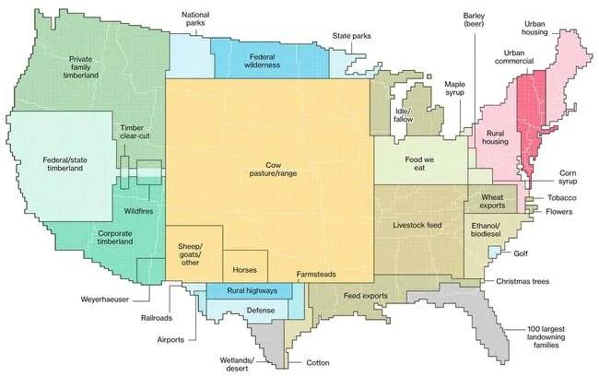
[https://www.exploredplanet.com/wp-content/uploads/2020/08/1002050910-photo-u1-65093.jpg]

While much of the western states use their land for forests and timber, [middle America] has great pastures for
farm animals, such as [cows], [sheep], and [horses]. But even tiny spaces go a long way, like the national parks
and the tiny northern splotch of land that produces maple syrup!
_______________________________________/
\______________________________________________________________________________/ Land Use Throughout The United States
The Population Of Middle America = Both Coasts /¯¯¯¯¯¯¯¯¯¯¯¯¯¯¯¯¯¯¯¯¯¯¯¯¯¯¯¯¯¯¯¯¯¯¯¯¯¯¯¯¯¯¯¯¯¯¯¯¯¯¯¯¯¯¯¯¯¯¯¯¯¯¯¯¯¯¯¯¯\
/¯¯¯¯¯¯¯¯¯¯¯¯¯¯¯¯¯¯¯¯¯¯¯¯¯¯¯¯¯¯¯¯¯¯¯¯¯¯¯¯¯¯¯¯¯¯¯¯

It's no secret that a majority of people flock away from [middle America] in favor of living on either the
eastern and western seaboard to live. But it might come to a surprise to see the population of both coasts
in comparison to a vast majority of the country's middle states.

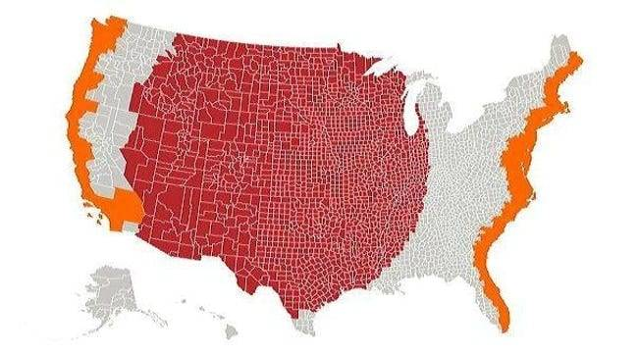
[https://www.exploredplanet.com/wp-content/uploads/2020/08/the-red-and-orange-sections-have-equal-populations-photo-u1-38942.jpg]

To break it down, the orange represents a population equivalent to that of the red portion in the middle of the
map. Pretty much, if you're not a people person, we recommend living somewhere in the red section of the map.
________________________________________________/
\_____________________________________________________________________/ The Population Of Middle America = Both Coasts
International Boarders Converging On The United States /¯¯¯¯¯¯¯¯¯¯¯¯¯¯¯¯¯¯¯¯¯¯¯¯¯¯¯¯¯¯¯¯¯¯¯¯¯¯¯¯¯¯¯¯¯¯¯¯¯¯¯¯¯¯¯¯¯¯¯¯¯\
/¯¯¯¯¯¯¯¯¯¯¯¯¯¯¯¯¯¯¯¯¯¯¯¯¯¯¯¯¯¯¯¯¯¯¯¯¯¯¯¯¯¯¯¯¯¯¯¯¯¯¯¯¯¯¯¯

The [United States] has int'l land borders with [Canada] and [Russia] to the [North] and [Mexico] to the [South].
On top of that, the country also has sea borders with [Cuba] and the [Bahamas] down in the [South].

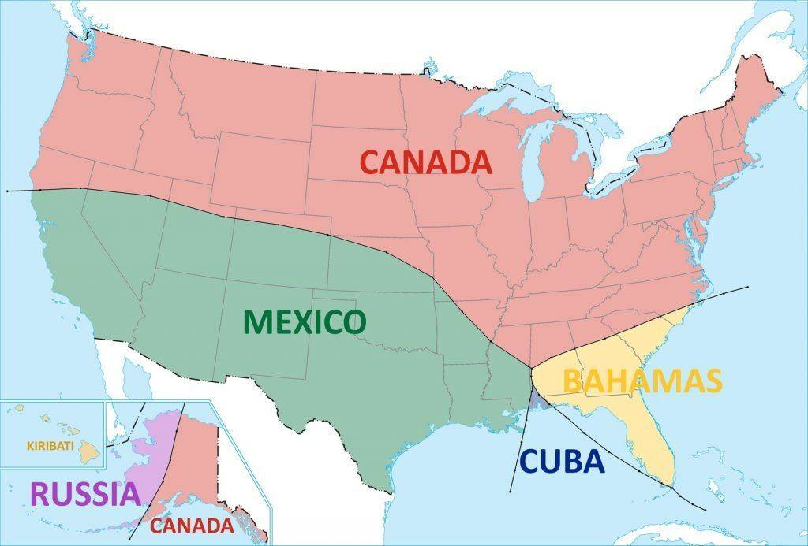
[https://www.exploredplanet.com/wp-content/uploads/2023/01/Borders-of-the-United-States-Vivid-Maps-96244.jpg]

This map is very interesting, as it shows all of those int'l borders converging onto [United States] soil.
One fun fact is [Canada]'s border with the [United States] is the longest in the entire world, stretching a
whopping (5,525) mi.
________________________________________________________/
\_____________________________________________________________/ International Boarders Converging On The United States
The US If States Were Sized By Population Density /¯¯¯¯¯¯¯¯¯¯¯¯¯¯¯¯¯¯¯¯¯¯¯¯¯¯¯¯¯¯¯¯¯¯¯¯¯¯¯¯¯¯¯¯¯¯¯¯¯¯¯¯¯¯¯¯¯¯¯¯¯¯¯¯¯¯\
/¯¯¯¯¯¯¯¯¯¯¯¯¯¯¯¯¯¯¯¯¯¯¯¯¯¯¯¯¯¯¯¯¯¯¯¯¯¯¯¯¯¯¯¯¯¯¯¯¯¯¯

Wouldn't it be interesting to open a textbook and see a map of the [United States] looking all split-up like this?
While normal images of the [US] have all of the borders connected, this interesting take is based on what the map
would look like, if it were designed based on the population density per state.

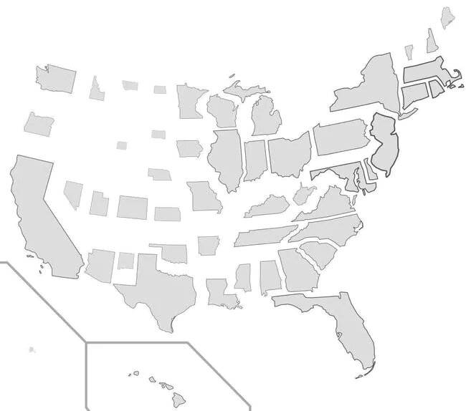
[https://www.exploredplanet.com/wp-content/uploads/2020/08/1002050868-photo-u1-39749.jpg]

As you can see, it doesn't look like the states of [California] or [Florida] changed much, if at all, while
[Alaska], the biggest state in the country, is shrunk down to almost nothing! And can we talk about how big
[New Jersey] is compared to its usual small self?
___________________________________________________/
\__________________________________________________________________/ The US If States Were Sized By Population Density
China Vs. The United States /¯¯¯¯¯¯¯¯¯¯¯¯¯¯¯¯¯¯¯¯¯¯¯¯¯¯¯¯¯¯¯¯¯¯¯¯¯¯¯¯¯¯¯¯¯¯¯¯¯¯¯¯¯¯¯¯¯¯¯¯¯¯¯¯¯¯¯¯¯¯¯¯¯¯¯¯¯¯¯¯¯¯¯¯¯¯¯¯\
/¯¯¯¯¯¯¯¯¯¯¯¯¯¯¯¯¯¯¯¯¯¯¯¯¯¯¯¯¯

It's no secret that [China] is the world's most populated country, being the home to over (1B) people.
But when it comes to the surface area of the land, it is just beaten out by the [United States].

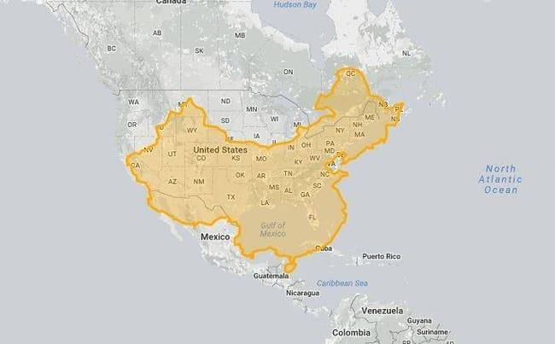
[https://www.exploredplanet.com/wp-content/uploads/2020/08/united-states-vs-china-photo-u1-83010.jpg]

By using a bit of imagination, you can see that if you reconfigure the shape of [China], it is almost the same
size as the [US]. But, at the end of the day, [China] is just a bit smaller, at (9,596,961) km², while the
[United States] comes in at (9,833,517) km².
_____________________________/
\________________________________________________________________________________________/ China Vs. The United States
The Reach Of The Mongolian Empire In 1279 /¯¯¯¯¯¯¯¯¯¯¯¯¯¯¯¯¯¯¯¯¯¯¯¯¯¯¯¯¯¯¯¯¯¯¯¯¯¯¯¯¯¯¯¯¯¯¯¯¯¯¯¯¯¯¯¯¯¯¯¯¯¯¯¯¯¯¯¯¯¯¯¯¯¯\
/¯¯¯¯¯¯¯¯¯¯¯¯¯¯¯¯¯¯¯¯¯¯¯¯¯¯¯¯¯¯¯¯¯¯¯¯¯¯¯¯¯¯¯

The [Mongolian Empire] was the largest bordering land empire in the history of the world. Through the (13th-14th)
centuries, the [Empire] stretched from [Central + Eastern Europe], down to the [Sea of Japan], northward into part
of the [Arctic], westward towards the [Carpathian] and [Levant Mountains], into the mainland of [Southeast Asia],
the [Indian subcontinent], and the [Iranian Plateau].

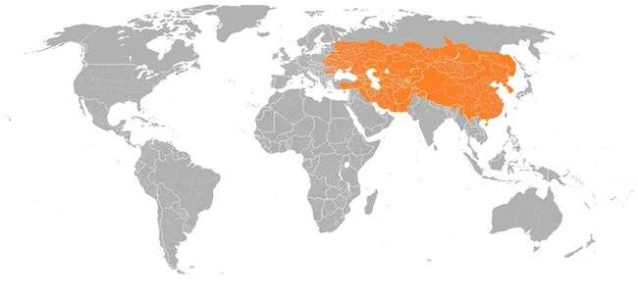
[https://www.exploredplanet.com/wp-content/uploads/2020/08/orange-roughly-the-reach-of-the-mongolian-empire-in-1279-photo-u1-68133.jpg]

Emerging from the alliance between several nomadic tribes, [Genghis Khan] took leadership and ruthlessly took over
a solid part of the world. Thankfully, after years of the [Empire], a war over succession eventually led to its
downfall. But before that, the [Empire] was an astounding (9M) mi².
___________________________________________/
\__________________________________________________________________________/ The Reach Of The Mongolian Empire In 1279
Middle America Has More Farmland Than Trees /¯¯¯¯¯¯¯¯¯¯¯¯¯¯¯¯¯¯¯¯¯¯¯¯¯¯¯¯¯¯¯¯¯¯¯¯¯¯¯¯¯¯¯¯¯¯¯¯¯¯¯¯¯¯¯¯¯¯¯¯¯¯¯¯¯¯¯¯¯¯¯¯\
/¯¯¯¯¯¯¯¯¯¯¯¯¯¯¯¯¯¯¯¯¯¯¯¯¯¯¯¯¯¯¯¯¯¯¯¯¯¯¯¯¯¯¯¯¯

America is home to eight percent of the world's forests, having around (228B) trees in the country. And, as
the map clearly illustrates, those forests are more densely populated in the northwest as well as east of the
[Mississippi River].

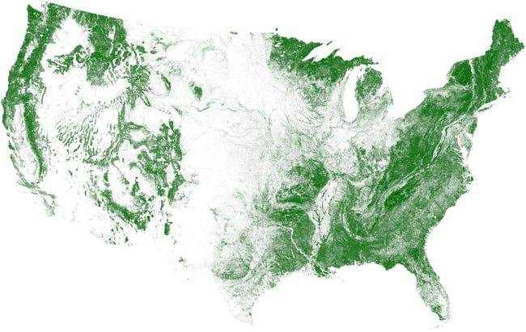
[https://www.exploredplanet.com/wp-content/uploads/2020/08/tree-cover-visualized-photo-u1-51528.jpg]

Contrary to popular belief, the wood-per-acre average has significantly grown since the (1950)'s, which is amazing
since the [European settlers] uprooted a lot of growth when they first arrived in [America]. Now more than ever,
people realize the importance of nature. In (2007), the then-mayor of [New York], [Michael Bloomberg], made plans
to plant (1M) trees in [New York] by (2017) -- the goal was met!
_____________________________________________/
\________________________________________________________________________/ Middle America Has More Farmland Than Trees
Cuba Fits In The Hudson Bay /¯¯¯¯¯¯¯¯¯¯¯¯¯¯¯¯¯¯¯¯¯¯¯¯¯¯¯¯¯¯¯¯¯¯¯¯¯¯¯¯¯¯¯¯¯¯¯¯¯¯¯¯¯¯¯¯¯¯¯¯¯¯¯¯¯¯¯¯¯¯¯¯¯¯¯¯¯¯¯¯¯¯¯¯¯¯¯¯\
/¯¯¯¯¯¯¯¯¯¯¯¯¯¯¯¯¯¯¯¯¯¯¯¯¯¯¯¯¯

It's amazing to see an entire country fit snugly inside a body of water, considering how bays tend to look
fairly small on the world map. Thankfully, we have this 'perspective map' to give us an idea of just how large
the [Hudson Bay] is compared to the island country of [Cuba].

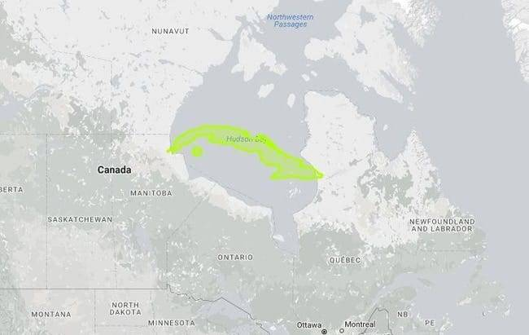
[https://www.exploredplanet.com/wp-content/uploads/2020/08/cuba-in-the-hudson-photo-u1-36290.jpg]

Let's start by saying, the bay is huge, comparatively speaking.
The [Hudson Bay]'s surface area is (1,230,000) km², while [Cuba] has an area of (110,860) km².
With that size difference, no wonder [Cuba] looks like nothing more than a sandbar on this map.
_____________________________/
\________________________________________________________________________________________/ Cuba Fits In The Hudson Bay
Popular Coffee Chains Across The United States /¯¯¯¯¯¯¯¯¯¯¯¯¯¯¯¯¯¯¯¯¯¯¯¯¯¯¯¯¯¯¯¯¯¯¯¯¯¯¯¯¯¯¯¯¯¯¯¯¯¯¯¯¯¯¯¯¯¯¯¯¯¯¯¯¯¯¯¯¯\
/¯¯¯¯¯¯¯¯¯¯¯¯¯¯¯¯¯¯¯¯¯¯¯¯¯¯¯¯¯¯¯¯¯¯¯¯¯¯¯¯¯¯¯¯¯¯¯¯

If there is one thing most people around the world can agree on, it's to never get in the way of them and their
coffee fix. In the [United States], that coffee fix comes in the form of (3) popular chains, well more like (2),
considering [Caribou] is only preferred in [Minnesota].

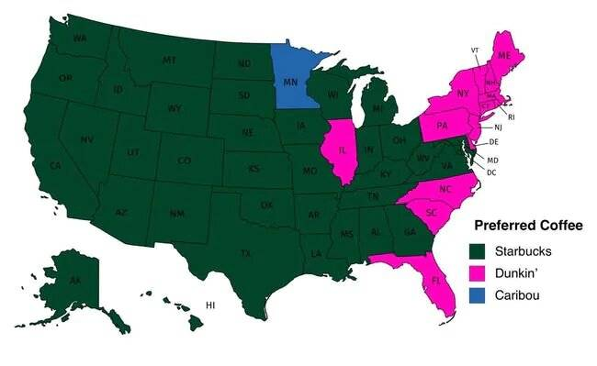
[https://www.exploredplanet.com/wp-content/uploads/2020/08/popular-coffee-shop-chains-by-number-of-locations-photo-u1-96212.jpg]

As [Dunkin' Donuts] stores are few and far between once you cross over the [Mississippi River], it comes as little
surprise that [Starbucks] is the preferred choice of a majority of states, excluding a few southern states, the
north, and randomly, [Illinois]. [Google Street View] has extending throughout the world, but there are still
some countries that don't have the technology. This next map will put it in perspective.
________________________________________________/
\_____________________________________________________________________/ Popular Coffee Chains Across The United States
Parts Of The World Covered By Google Street View /¯¯¯¯¯¯¯¯¯¯¯¯¯¯¯¯¯¯¯¯¯¯¯¯¯¯¯¯¯¯¯¯¯¯¯¯¯¯¯¯¯¯¯¯¯¯¯¯¯¯¯¯¯¯¯¯¯¯¯¯¯¯¯¯¯¯¯\
/¯¯¯¯¯¯¯¯¯¯¯¯¯¯¯¯¯¯¯¯¯¯¯¯¯¯¯¯¯¯¯¯¯¯¯¯¯¯¯¯¯¯¯¯¯¯¯¯¯¯

[Google Street View] was launched in several cities across the [United States] back in (2007). Since then,
the technology has expanded to places around the world, including both rural areas as well as cities.
The interesting thing about [Google Street View] is that the cameras are attached to various modes of transportation.

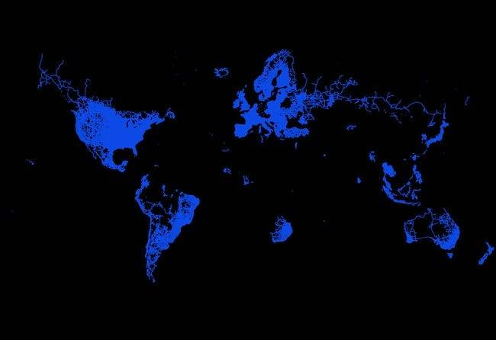
[https://www.exploredplanet.com/wp-content/uploads/2020/08/amount-of-the-world-covered-by-google-street-view-photo-u1-14899.jpg]

Most of the photography is done by a [Google] car. But depending on the landscape, some of the employees opt to
use a [snowmobile], [tricycle], or even photograph on [foot]~! Even [boats] are hooked up with the technology!
Still, places like [Russia], [China], and most of [Africa] do not have [Google Street View].
__________________________________________________/
\___________________________________________________________________/ Parts Of The World Covered By Google Street View
United States Vs. India /¯¯¯¯¯¯¯¯¯¯¯¯¯¯¯¯¯¯¯¯¯¯¯¯¯¯¯¯¯¯¯¯¯¯¯¯¯¯¯¯¯¯¯¯¯¯¯¯¯¯¯¯¯¯¯¯¯¯¯¯¯¯¯¯¯¯¯¯¯¯¯¯¯¯¯¯¯¯¯¯¯¯¯¯¯¯¯¯¯¯¯¯\
/¯¯¯¯¯¯¯¯¯¯¯¯¯¯¯¯¯¯¯¯¯¯¯¯¯

While [India] is the second most populated country in the world, housing over (1B) people, it is only the
(7th)-largest by surface area. As the map illustrates, while the [United States] doesn't look overly larger
than [South Asian] country, it is -- almost (3x) larger, if we're going to be specific.

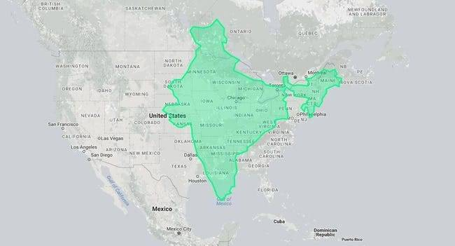
[https://www.exploredplanet.com/wp-content/uploads/2020/08/united-states-vs-india-photo-u1-33730.jpg]

[India]'s surface area is around (3,287,263) km² compared to the [United States]'s (9,833,517) km².
So, if you look at a world map sometime soon, don't make the mistake we did and think [India] would be able to
fit inside [America]'s borders. The country, although smaller, is larger than it appears on a world map!
_________________________/
\____________________________________________________________________________________________/ United States Vs. India
The Only Countries With A Population Under 100 Million /¯¯¯¯¯¯¯¯¯¯¯¯¯¯¯¯¯¯¯¯¯¯¯¯¯¯¯¯¯¯¯¯¯¯¯¯¯¯¯¯¯¯¯¯¯¯¯¯¯¯¯¯¯¯¯¯¯¯¯¯¯\
/¯¯¯¯¯¯¯¯¯¯¯¯¯¯¯¯¯¯¯¯¯¯¯¯¯¯¯¯¯¯¯¯¯¯¯¯¯¯¯¯¯¯¯¯¯¯¯¯¯¯¯¯¯¯¯¯

Considering the world has a population of (7.594B) as of (2018), it's incredible to think some countries don't
have a population of (100M+) people. Looking at this map, it's understandable why places such as [Australia],
[New Zealand], [Canada], [South America], [Africa], [Asia], and even parts of [Europe] have lower populations.

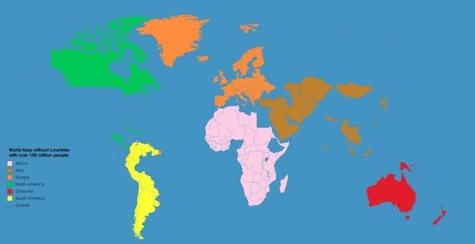
[https://www.exploredplanet.com/wp-content/uploads/2020/08/only-countries-with-populations-under-100-million-photo-u2-68890.jpg]

Let's start with the obvious: parts of [Australia] and [New Zealand] are uninhabitable. Then various countries
throughout [Africa] and [Asia] are very rural, whereas people tend to flock towards cities. Then there is the
freezing and horrible weather throughout locations in [Europe] and [Canada].
________________________________________________________/
\_____________________________________________________________/ The Only Countries With A Population Under 100 Million
China Vs. Russia /¯¯¯¯¯¯¯¯¯¯¯¯¯¯¯¯¯¯¯¯¯¯¯¯¯¯¯¯¯¯¯¯¯¯¯¯¯¯¯¯¯¯¯¯¯¯¯¯¯¯¯¯¯¯¯¯¯¯¯¯¯¯¯¯¯¯¯¯¯¯¯¯¯¯¯¯¯¯¯¯¯¯¯¯¯¯¯¯¯¯¯¯¯¯¯¯¯¯¯\
/¯¯¯¯¯¯¯¯¯¯¯¯¯¯¯¯¯¯

When looking at a world map, it is clear [Russia] is substantially larger than [China]. But, hopefully, this
illustration puts it into perspective just how much bigger. While the world map makes China look like a speck
of dust in comparison to the northern country, it overlaps fairly well.

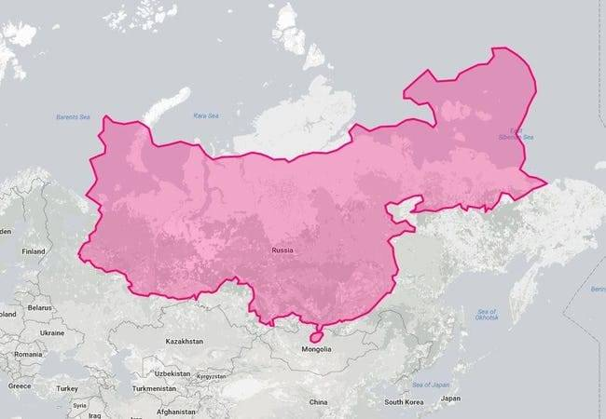
[https://www.exploredplanet.com/wp-content/uploads/2020/08/china-given-the-russia-treatment-photo-u1-31715.jpg]

While [Russia] is still clearly bigger, with a surface area of (17,098,242) km², [China] isn't the tiny country
a world map would have us believe. [China] is (44%) smaller than [Russia], with a surface area of (9,596,960) km².
Okay, yea, it's still small, comparatively. While [Antarctica] is big, it looks a whole lot bigger on a world map.
__________________/
\___________________________________________________________________________________________________/ China Vs. Russia
Antarctica Takes Over The United States And Parts Of Canada /¯¯¯¯¯¯¯¯¯¯¯¯¯¯¯¯¯¯¯¯¯¯¯¯¯¯¯¯¯¯¯¯¯¯¯¯¯¯¯¯¯¯¯¯¯¯¯¯¯¯¯¯¯¯¯¯\
/¯¯¯¯¯¯¯¯¯¯¯¯¯¯¯¯¯¯¯¯¯¯¯¯¯¯¯¯¯¯¯¯¯¯¯¯¯¯¯¯¯¯¯¯¯¯¯¯¯¯¯¯¯¯¯¯¯¯¯¯¯

Amazingly, [Antarctica] almost takes over the (24,490,000) km² surface area that makes up the [North American]
continent. Alas, it doesn't quite make it, which is strange, considering how large the frozen tundra looks lying
on the bottom of a world map. Well, at least this puts its size in perspective.

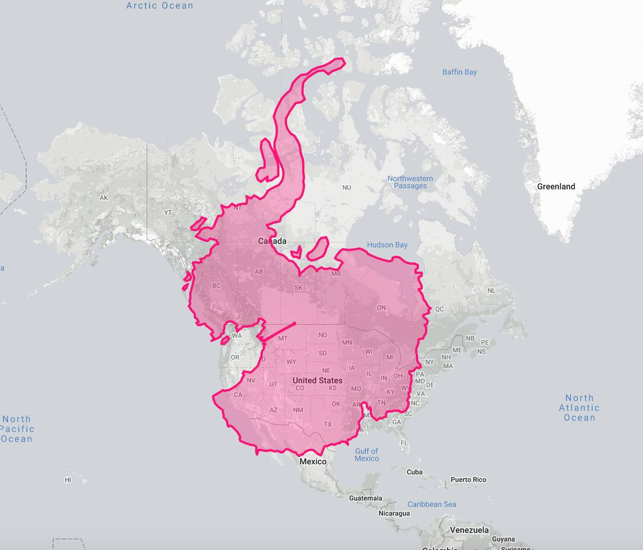
[https://www.exploredplanet.com/wp-content/uploads/2020/08/596ad0b64a21e30bee98485b143b3aca-95807.jpg]

[Antarctica], population (4,490), has a large surface area of (14,200,000) km². The size of the landmass is (75%)
larger than that of the [United States]' (9,833,517) km² and 40 percent larger than [Canada]'s surface area of
(9,984,670) km².
_____________________________________________________________/
\________________________________________________________/ Antarctica Takes Over The United States And Parts Of Canada
The Loud And Quiet Parts Of The United States /¯¯¯¯¯¯¯¯¯¯¯¯¯¯¯¯¯¯¯¯¯¯¯¯¯¯¯¯¯¯¯¯¯¯¯¯¯¯¯¯¯¯¯¯¯¯¯¯¯¯¯¯¯¯¯¯¯¯¯¯¯¯¯¯¯¯¯¯¯¯\
/¯¯¯¯¯¯¯¯¯¯¯¯¯¯¯¯¯¯¯¯¯¯¯¯¯¯¯¯¯¯¯¯¯¯¯¯¯¯¯¯¯¯¯¯¯¯¯

Aside from being a beautiful representation of noise pollution in various parts of the [United States], it also
shows where a majority of people flock to. If you're familiar with the states, then you'll notice that a majority
of noise spikes, the yellow color, occur near large cities, such as [Los Angeles], [New York], [Miami], [Dallas].

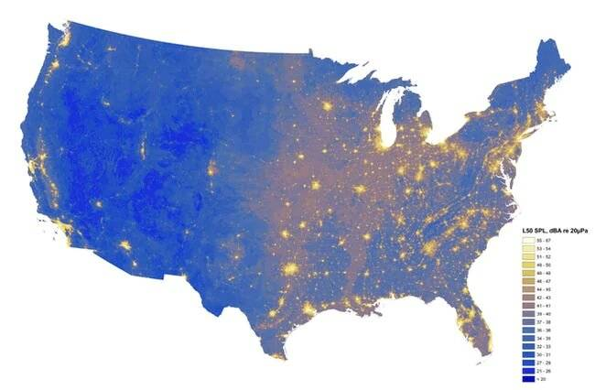
[https://www.exploredplanet.com/wp-content/uploads/2020/08/the-loudest-and-quietest-spots-in-the-continental-us-photo-u1-1-28093.jpg]

Then we have the dark blue, which shows the quieter regions of the country. Here we see a majority of the
[pacific northwest] as well as [Maine]. These towns are more rural, and wouldn't have as many people as, say,
[Manhattan, New York].
_______________________________________________/
\______________________________________________________________________/ The Loud And Quiet Parts Of The United States
Population Spikes Don't Really Happen Near The Canadian Border /¯¯¯¯¯¯¯¯¯¯¯¯¯¯¯¯¯¯¯¯¯¯¯¯¯¯¯¯¯¯¯¯¯¯¯¯¯¯¯¯¯¯¯¯¯¯¯¯¯¯¯¯¯\
/¯¯¯¯¯¯¯¯¯¯¯¯¯¯¯¯¯¯¯¯¯¯¯¯¯¯¯¯¯¯¯¯¯¯¯¯¯¯¯¯¯¯¯¯¯¯¯¯¯¯¯¯¯¯¯¯¯¯¯¯¯¯¯¯

As of (2019), the [United States] has a total population of (328.2M) people. Of those (100M+)'s of people,
(39.7M) live in [California], (29.1M) in [Texas], (19.4M) in [New York], and (21.6M) in [Florida].
Now, those numbers are just to put this population spike map in a bit of perspective.

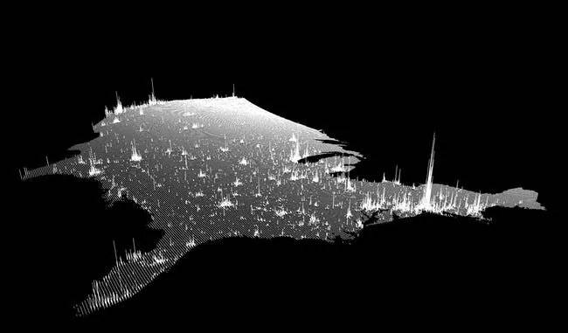
[https://www.exploredplanet.com/wp-content/uploads/2020/08/1002050892-photo-u1-58739.jpg]

As you can see, the spikes skyrocket in those specific states where the population is already one of the highest
in the nation, where there is little to no spike near the border of [Canada].
________________________________________________________________/
\_____________________________________________________/ Population Spikes Don't Really Happen Near The Canadian Border
Montana Fits Perfectly Inside Mongolia /¯¯¯¯¯¯¯¯¯¯¯¯¯¯¯¯¯¯¯¯¯¯¯¯¯¯¯¯¯¯¯¯¯¯¯¯¯¯¯¯¯¯¯¯¯¯¯¯¯¯¯¯¯¯¯¯¯¯¯¯¯¯¯¯¯¯¯¯¯¯¯¯¯¯¯¯¯\
/¯¯¯¯¯¯¯¯¯¯¯¯¯¯¯¯¯¯¯¯¯¯¯¯¯¯¯¯¯¯¯¯¯¯¯¯¯¯¯¯

[Montana] is a western state in the [United States] that is known for its wide-open lands, beautiful mountains,
and for being very peaceful. So, when it comes to how large it is, people often think it's bigger than it actually
is. But when looking on a world map, it is but a tiny dot amid a huge continent.

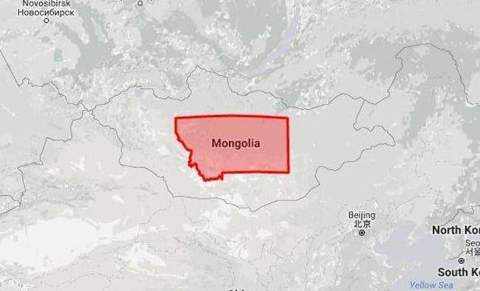
[https://www.exploredplanet.com/wp-content/uploads/2020/08/montana-in-mongolia-photo-u1-49901.jpg]

Then there is [Mongolia], a country that looks way bigger on a map than it actually is. We mean, just look at
this illustration for some perspective! While Mongolia is obviously bigger than Montana, with a surface area
(1,564,116) km², it's only (4.1x) times larger than [Montana]'s (376,962) km². Want to get a perspective on how
many [Springfield]'s there are in the [United States]? Keep reading to find out.
________________________________________/
\_____________________________________________________________________________/ Montana Fits Perfectly Inside Mongolia
The Best Route To Hit All Of The Springfield Towns In The US /¯¯¯¯¯¯¯¯¯¯¯¯¯¯¯¯¯¯¯¯¯¯¯¯¯¯¯¯¯¯¯¯¯¯¯¯¯¯¯¯¯¯¯¯¯¯¯¯¯¯¯¯¯¯¯\
/¯¯¯¯¯¯¯¯¯¯¯¯¯¯¯¯¯¯¯¯¯¯¯¯¯¯¯¯¯¯¯¯¯¯¯¯¯¯¯¯¯¯¯¯¯¯¯¯¯¯¯¯¯¯¯¯¯¯¯¯¯¯

If you've traveled through the [United States], then you know there are some towns in various locations that
have the same name. [Springfield] is one of those names. According to a geological survey, in the continental
[United States], there are (33) populated towns with the names throughout (25) different states, with five in
[Wisconsin] alone. And that's not including the [townships].

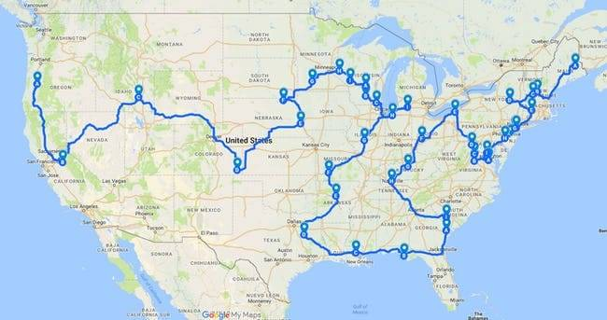
[https://www.exploredplanet.com/wp-content/uploads/2020/08/1002050902-photo-u1-84680.jpg]

If we're taking into consideration the [townships], then there are (36) throughout the country, (11) located in
[Ohio]. If you're planning a road trip anytime soon and want to visit the [Springfield of America], the above
map is the best route to travel.
______________________________________________________________/
\_______________________________________________________/ The Best Route To Hit All Of The Springfield Towns In The US
You Can Fit Poland Inside Texas /¯¯¯¯¯¯¯¯¯¯¯¯¯¯¯¯¯¯¯¯¯¯¯¯¯¯¯¯¯¯¯¯¯¯¯¯¯¯¯¯¯¯¯¯¯¯¯¯¯¯¯¯¯¯¯¯¯¯¯¯¯¯¯¯¯¯¯¯¯¯¯¯¯¯¯¯¯¯¯¯¯¯¯¯\
/¯¯¯¯¯¯¯¯¯¯¯¯¯¯¯¯¯¯¯¯¯¯¯¯¯¯¯¯¯¯¯¯¯

If you were to take [Poland] and set the country inside [Texas], you'd still have plenty of room to drive around
the state without ever needing to enter [Poland]. They say everything is bigger in [Texas], and they can add
bigger than [Poland] to that list.

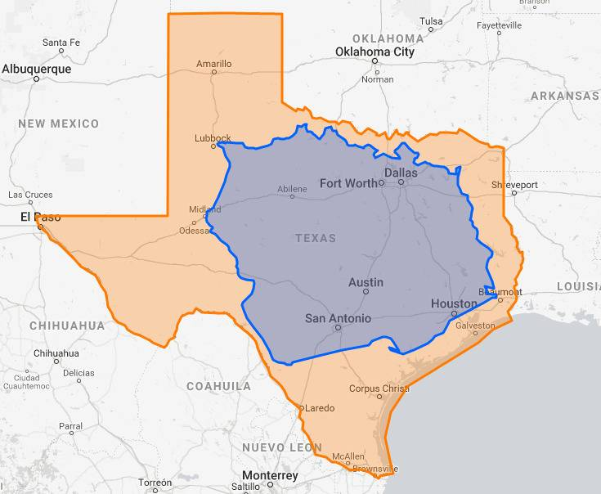
[https://www.exploredplanet.com/wp-content/uploads/2020/08/Poland-Inside-Of-Texas-21672.jpg]

The sheer size of the [United States] is impressive, especially when you consider that one state is larger than
so many countries around the world.
_________________________________/
\____________________________________________________________________________________/ You Can Fit Poland Inside Texas
A Lot Of Countries Can Fit Inside The US, All At Once /¯¯¯¯¯¯¯¯¯¯¯¯¯¯¯¯¯¯¯¯¯¯¯¯¯¯¯¯¯¯¯¯¯¯¯¯¯¯¯¯¯¯¯¯¯¯¯¯¯¯¯¯¯¯¯¯¯¯¯¯¯¯\
/¯¯¯¯¯¯¯¯¯¯¯¯¯¯¯¯¯¯¯¯¯¯¯¯¯¯¯¯¯¯¯¯¯¯¯¯¯¯¯¯¯¯¯¯¯¯¯¯¯¯¯¯¯¯¯

While the [United States] may not be the largest country by landmass, there are still a very large number of
countries around the world that could all fit inside the [United States] at the same time.

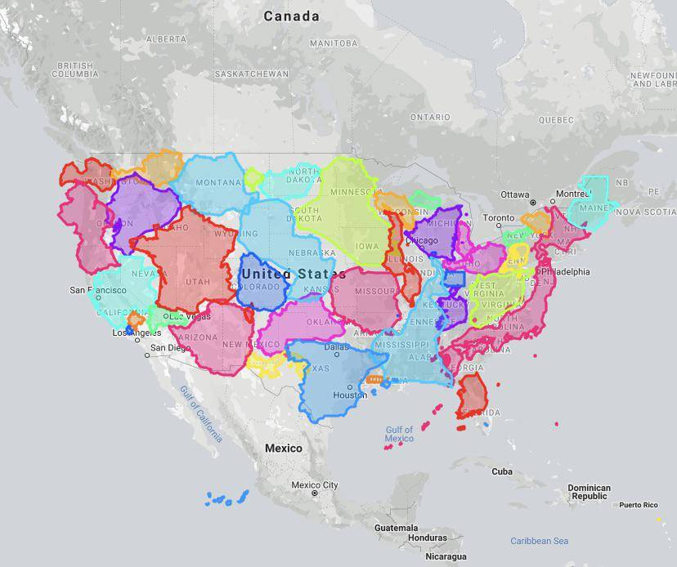
[https://www.exploredplanet.com/wp-content/uploads/2020/08/Countries-fitting-inside-the-United-States-88354.jpg]

A [Reddit] user posted this map that does a great job of utilizing almost all of the landmass in the [United States]
with very little room to spare. Even with all its land, much of the [United States] is left unpopulated.
_______________________________________________________/
\______________________________________________________________/ A Lot Of Countries Can Fit Inside The US, All At Once
Here's Canada, The US, And Mexico At Scale /¯¯¯¯¯¯¯¯¯¯¯¯¯¯¯¯¯¯¯¯¯¯¯¯¯¯¯¯¯¯¯¯¯¯¯¯¯¯¯¯¯¯¯¯¯¯¯¯¯¯¯¯¯¯¯¯¯¯¯¯¯¯¯¯¯¯¯¯¯¯¯¯¯\
/¯¯¯¯¯¯¯¯¯¯¯¯¯¯¯¯¯¯¯¯¯¯¯¯¯¯¯¯¯¯¯¯¯¯¯¯¯¯¯¯¯¯¯¯

Anyone who has studied geography can tell you that many maps are not drawn to scale. Look at a globe and the
[United States] appears to be a massive behemoth towering over its neighbors. In reality, the [United States]
is not as huge as we've been taught.

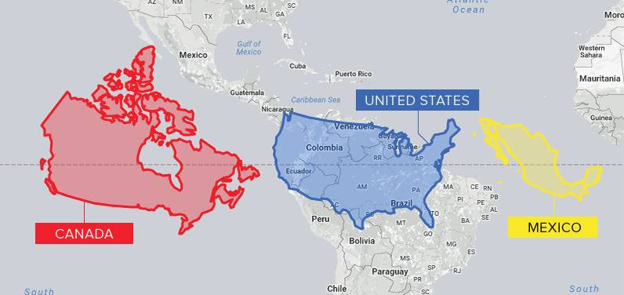
[https://www.exploredplanet.com/wp-content/uploads/2020/08/Canada-and-US-and-Mexico-at-Scale-59220.jpg]

Actually, [Canada] is the second-largest country in the world with a landmass that triumphs over its neighbor to
the south. [Canada] has a landmass of approximately (9,984,670) km², while the [United States] is approximately
(9,833,517) km². [Mexico] is also much larger than our current maps give it credit for.
____________________________________________/
\_________________________________________________________________________/ Here's Canada, The US, And Mexico At Scale
Every City In The World With A Population Of 100,000+ /¯¯¯¯¯¯¯¯¯¯¯¯¯¯¯¯¯¯¯¯¯¯¯¯¯¯¯¯¯¯¯¯¯¯¯¯¯¯¯¯¯¯¯¯¯¯¯¯¯¯¯¯¯¯¯¯¯¯¯¯¯¯\
/¯¯¯¯¯¯¯¯¯¯¯¯¯¯¯¯¯¯¯¯¯¯¯¯¯¯¯¯¯¯¯¯¯¯¯¯¯¯¯¯¯¯¯¯¯¯¯¯¯¯¯¯¯¯¯

If you plot out all of the cities around the world with (> 100K) people, it's shocking to realize how few cities
reach that threshold. This map, not surprisingly, shows a lot of coverage for that city size in places like [Asia],
where populations have exploded in recent years.

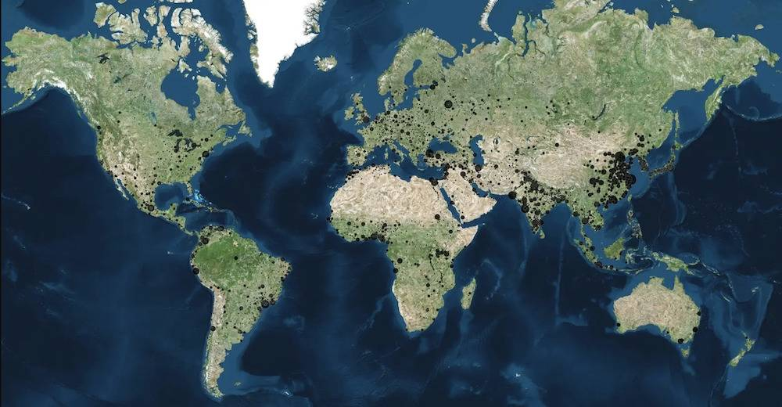
[https://www.exploredplanet.com/wp-content/uploads/2020/08/City-Population-Over-100000-63286.jpg]

Of course, this doesn't include many suburban areas where cities seem to pop up every few miles, many of which
feature (< 100K) people within their city limits but more than (1M) people living without close proximity to
each other.
_______________________________________________________/
\______________________________________________________________/ Every City In The World With A Population Of 100,000+
This Circle Represents A Majority Of The World's Population /¯¯¯¯¯¯¯¯¯¯¯¯¯¯¯¯¯¯¯¯¯¯¯¯¯¯¯¯¯¯¯¯¯¯¯¯¯¯¯¯¯¯¯¯¯¯¯¯¯¯¯¯¯¯¯¯\
/¯¯¯¯¯¯¯¯¯¯¯¯¯¯¯¯¯¯¯¯¯¯¯¯¯¯¯¯¯¯¯¯¯¯¯¯¯¯¯¯¯¯¯¯¯¯¯¯¯¯¯¯¯¯¯¯¯¯¯¯¯

It's amazing to think that with (7B+) people on our planet, more than (> 50%) of them live within this
highlighted area on the world map. It's a fairly large area but a lot of the population lives within major
cityscapes that have sprung up relatively quickly over recent years.

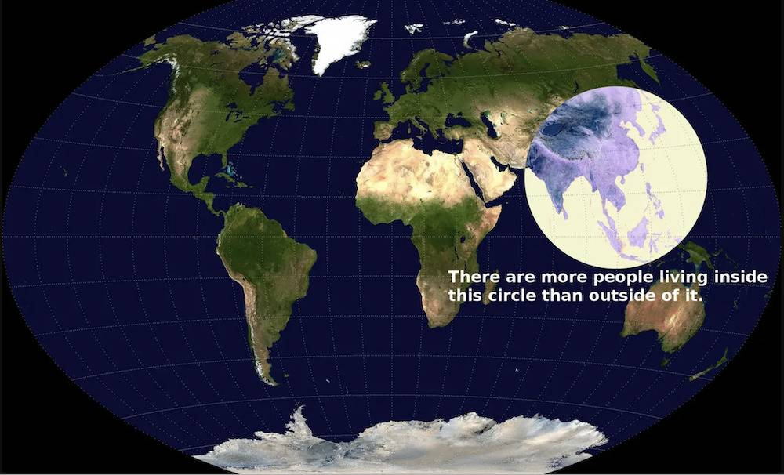
[https://www.exploredplanet.com/wp-content/uploads/2020/08/Most-of-the-worlds-population-in-one-circle-80775.jpg]

The [United States], in comparison, with a relatively large mass area, features only around (5%) of the world's
population.
_____________________________________________________________/
\________________________________________________________/ This Circle Represents A Majority Of The World's Population
One Sport To Nearly Rule Them All. We're Not Surprised /¯¯¯¯¯¯¯¯¯¯¯¯¯¯¯¯¯¯¯¯¯¯¯¯¯¯¯¯¯¯¯¯¯¯¯¯¯¯¯¯¯¯¯¯¯¯¯¯¯¯¯¯¯¯¯¯¯¯¯¯¯\
/¯¯¯¯¯¯¯¯¯¯¯¯¯¯¯¯¯¯¯¯¯¯¯¯¯¯¯¯¯¯¯¯¯¯¯¯¯¯¯¯¯¯¯¯¯¯¯¯¯¯¯¯¯¯¯¯

It's not really a surprise that soccer (futbol) is the (#1 sport) in many parts of the world. [Cricket] may
surprise many [Americans] but it's an internationally played sport filled by well-known athletes who are
celebrated by (100M)'s of fans.

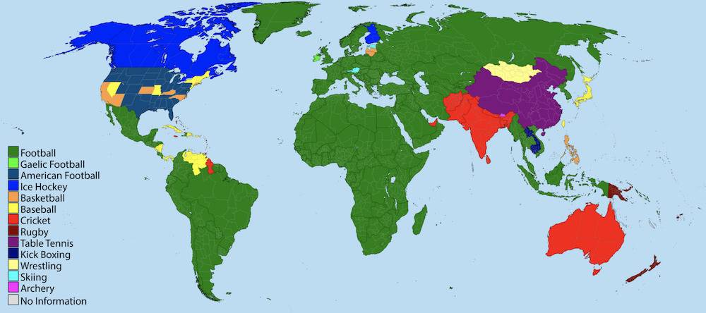
[https://www.exploredplanet.com/wp-content/uploads/2020/08/One-Sport-To-Rule-Them-All-30279.jpg]

In the [United States], there is a decently diverse choice in chosen sports with football the top choice in many
states, although basketball and baseball also take a fair share of the interest.
________________________________________________________/
\_____________________________________________________________/ One Sport To Nearly Rule Them All. We're Not Surprised
A NASA Snapshot Of Fires Around The World /¯¯¯¯¯¯¯¯¯¯¯¯¯¯¯¯¯¯¯¯¯¯¯¯¯¯¯¯¯¯¯¯¯¯¯¯¯¯¯¯¯¯¯¯¯¯¯¯¯¯¯¯¯¯¯¯¯¯¯¯¯¯¯¯¯¯¯¯¯¯¯¯¯¯\
/¯¯¯¯¯¯¯¯¯¯¯¯¯¯¯¯¯¯¯¯¯¯¯¯¯¯¯¯¯¯¯¯¯¯¯¯¯¯¯¯¯¯¯

In [July 2020], [NASA's Earth Observatory Team] captured a satellite shot of all the active fires happening around
the world at the time. Scientists have warned that active fires will continue to grow if climate change is not
reversed.

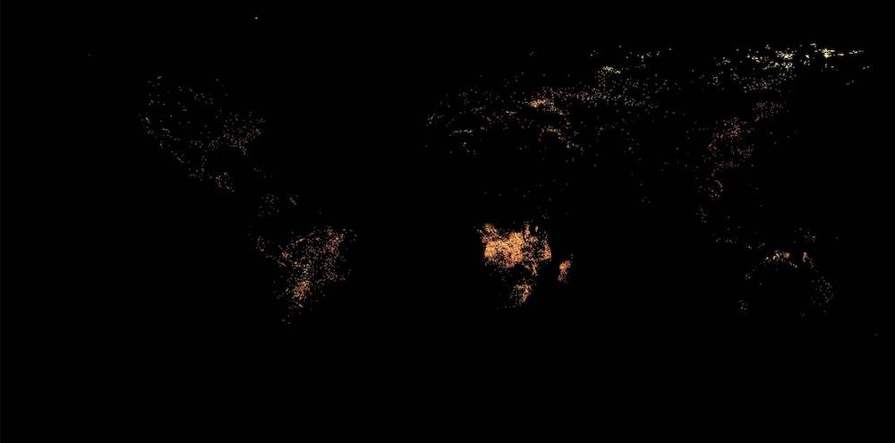
[https://www.exploredplanet.com/wp-content/uploads/2020/08/Active-Fires-Around-the-World-in-July-2020-57583.jpg]

As we can expect, areas with higher temperatures and dryer conditions are more likely to be highlighted by
[NASA]'s satellites. [NASA] captures this data every month and posts the results for historical analysis purposes.
___________________________________________/
\__________________________________________________________________________/ A NASA Snapshot Of Fires Around The World
Left-Side Versus Right-Side Driving /¯¯¯¯¯¯¯¯¯¯¯¯¯¯¯¯¯¯¯¯¯¯¯¯¯¯¯¯¯¯¯¯¯¯¯¯¯¯¯¯¯¯¯¯¯¯¯¯¯¯¯¯¯¯¯¯¯¯¯¯¯¯¯¯¯¯¯¯¯¯¯¯¯¯¯¯¯¯¯¯\
/¯¯¯¯¯¯¯¯¯¯¯¯¯¯¯¯¯¯¯¯¯¯¯¯¯¯¯¯¯¯¯¯¯¯¯¯¯

Why does it seem like every movie we watch outside the [United States] features left-side driving?
In reality, a majority of places in the world actually drive on the right side of the road.

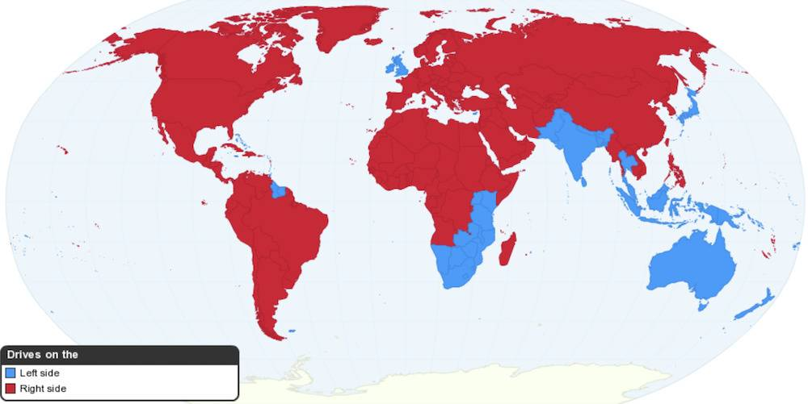
[https://www.exploredplanet.com/wp-content/uploads/2020/08/Left-Side-and-Right-Side-Driving-36881.jpg]

This appears to be one of the few areas where [Americans] got it right, most likely because the [United States]
was far ahead of other country's when it came to developing automobiles for mass use.
_____________________________________/
\________________________________________________________________________________/ Left-Side Versus Right-Side Driving
Population Density Around The World Shown In A Single Map /¯¯¯¯¯¯¯¯¯¯¯¯¯¯¯¯¯¯¯¯¯¯¯¯¯¯¯¯¯¯¯¯¯¯¯¯¯¯¯¯¯¯¯¯¯¯¯¯¯¯¯¯¯¯¯¯¯¯\
/¯¯¯¯¯¯¯¯¯¯¯¯¯¯¯¯¯¯¯¯¯¯¯¯¯¯¯¯¯¯¯¯¯¯¯¯¯¯¯¯¯¯¯¯¯¯¯¯¯¯¯¯¯¯¯¯¯¯¯

While there is a lot of landmass throughout our planet, a majority of the world's population lives within the
confines of less than half the planet's available space.

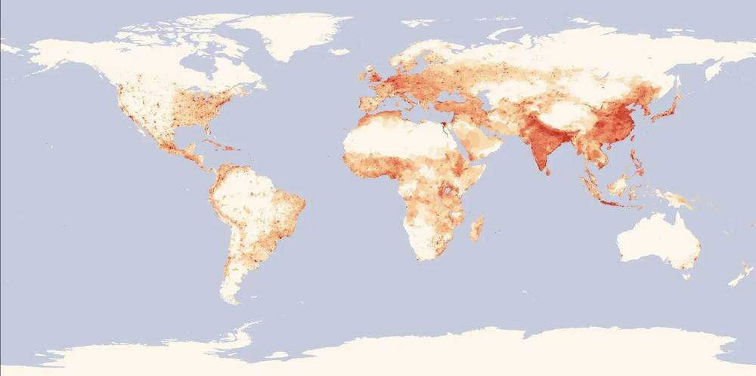
[https://www.exploredplanet.com/wp-content/uploads/2020/08/Population-Density-Around-The-World-56577.jpg]

This isn't really a shocking revelation. Populations of people have long congregated around areas of essential
commerce and locations abundant with available water and natural resources. Many areas around the world are also
simply not suited for supporting a lot of people, or any people at all. Up next, an actual look at a world map
with correct sizing.
___________________________________________________________/
\__________________________________________________________/ Population Density Around The World Shown In A Single Map
What A World Map Should Actually Look Like /¯¯¯¯¯¯¯¯¯¯¯¯¯¯¯¯¯¯¯¯¯¯¯¯¯¯¯¯¯¯¯¯¯¯¯¯¯¯¯¯¯¯¯¯¯¯¯¯¯¯¯¯¯¯¯¯¯¯¯¯¯¯¯¯¯¯¯¯¯¯¯¯¯\
/¯¯¯¯¯¯¯¯¯¯¯¯¯¯¯¯¯¯¯¯¯¯¯¯¯¯¯¯¯¯¯¯¯¯¯¯¯¯¯¯¯¯¯¯

The [Hobo-Dyer Equal Area Projection] map shows what the world actually looks like when correct landmass sizes
and dimensions are applied.

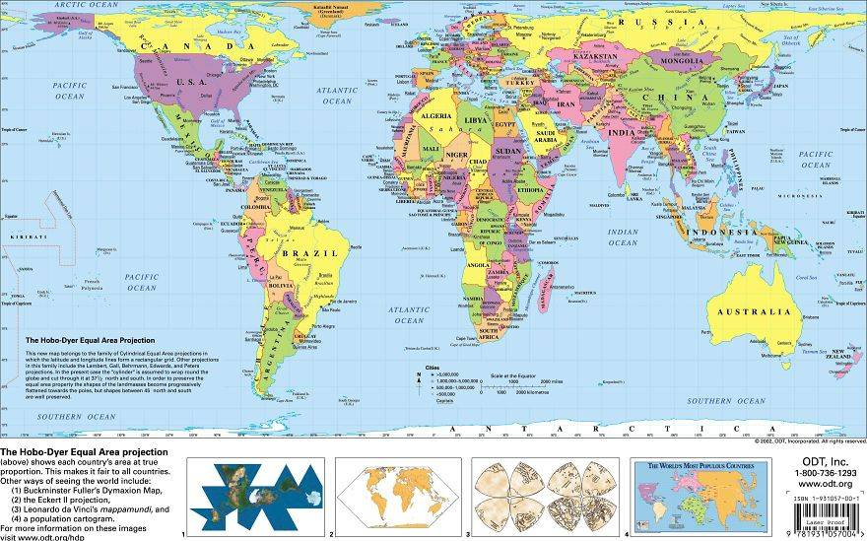
[https://www.exploredplanet.com/wp-content/uploads/2020/08/An-Actual-World-Map-with-correct-landmass-sizes-72037.jpg]

This is a vastly different look at our world and puts everything into proper perspective. We have to admit,
before seeing the [Hobo-Dyer] map we didn't know half of the countries on our planet were (bigger/smaller)
than we have been taught to believe all of our lives.
____________________________________________/
\_________________________________________________________________________/ What A World Map Should Actually Look Like
Australia Can Fit All Of These Countries Inside /¯¯¯¯¯¯¯¯¯¯¯¯¯¯¯¯¯¯¯¯¯¯¯¯¯¯¯¯¯¯¯¯¯¯¯¯¯¯¯¯¯¯¯¯¯¯¯¯¯¯¯¯¯¯¯¯¯¯¯¯¯¯¯¯¯¯¯¯\
/¯¯¯¯¯¯¯¯¯¯¯¯¯¯¯¯¯¯¯¯¯¯¯¯¯¯¯¯¯¯¯¯¯¯¯¯¯¯¯¯¯¯¯¯¯¯¯¯¯

On most maps of the world, [Australia] doesn't look that big. In reality, it's a massive country and continent that
covers (7.7M) km². A ton of countries can fit inside of the continent's landmass.

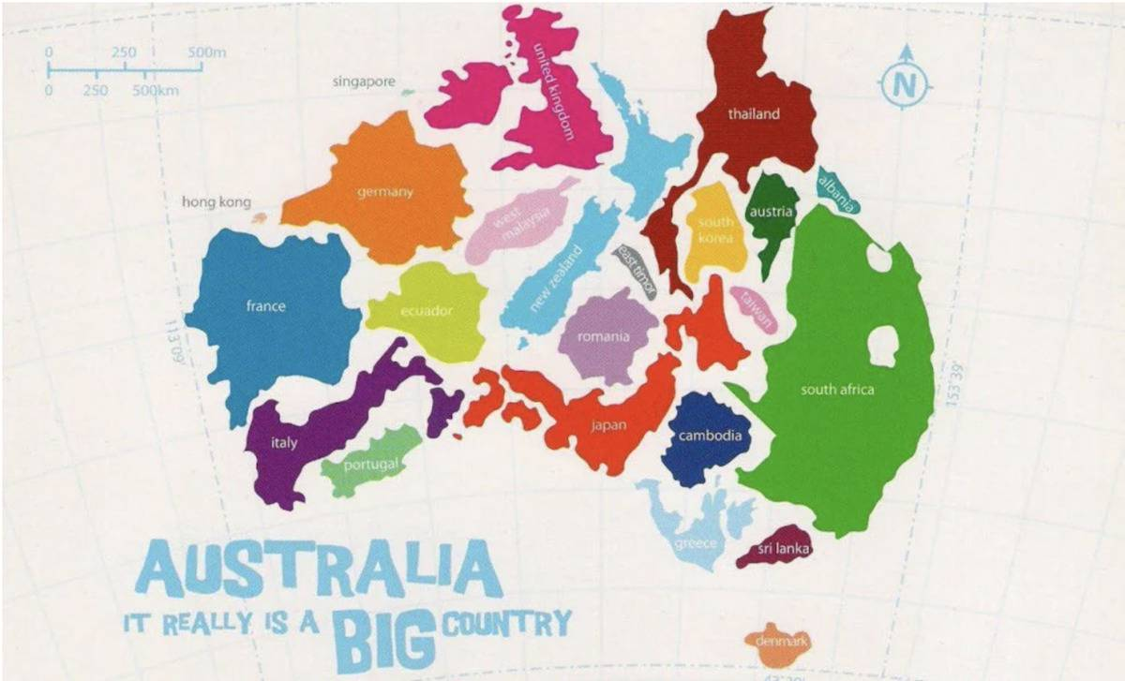
[https://www.exploredplanet.com/wp-content/uploads/2020/11/Australia-Countries-and-Maps-15502.jpg]

The countries that can fit inside include [Denmark], [Sri Lanka], [Greece], [Cambodia], [Taiwan], [South Africa],
[Albania], [South Korea], [Thailand], [East Timor], [Romania], [New Zealand], [Japan], [West Malaysia], [Ecuador],
[UK], [Germany], [Portugal], [Italy], and [France].
_________________________________________________/
\____________________________________________________________________/ Australia Can Fit All Of These Countries Inside
Mercator's Projection /¯¯¯¯¯¯¯¯¯¯¯¯¯¯¯¯¯¯¯¯¯¯¯¯¯¯¯¯¯¯¯¯¯¯¯¯¯¯¯¯¯¯¯¯¯¯¯¯¯¯¯¯¯¯¯¯¯¯¯¯¯¯¯¯¯¯¯¯¯¯¯¯¯¯¯¯¯¯¯¯¯¯¯¯¯¯¯¯¯¯¯¯¯¯\
/¯¯¯¯¯¯¯¯¯¯¯¯¯¯¯¯¯¯¯¯¯¯¯

When we look at modern maps of the world they are portrayed by an international standard known as the
[Mercator's Projection]. While there are other projections, this is one of the most commonly used options.

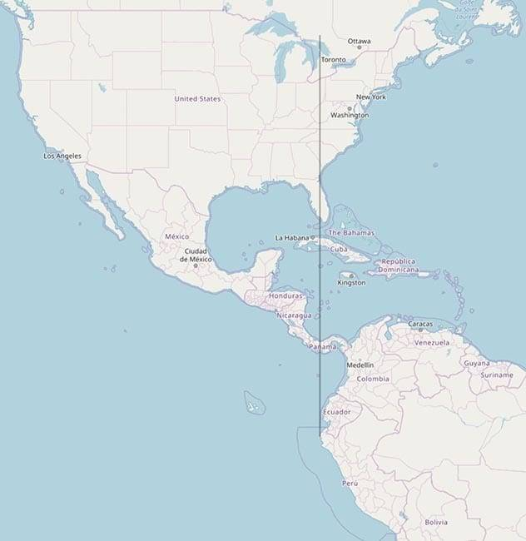
[https://www.exploredplanet.com/wp-content/uploads/2020/11/South-America-Location-on-Map-21033.jpg]

There's just one problem with [Mercator's Projection]: it's highly inaccurate. A proper map of the world would
clearly show that [South America] is almost completely to the east of the [United States] and most of [North America]
in general.
_______________________/
\______________________________________________________________________________________________/ Mercator's Projection
Japan Isn't As Tiny As You Might Think /¯¯¯¯¯¯¯¯¯¯¯¯¯¯¯¯¯¯¯¯¯¯¯¯¯¯¯¯¯¯¯¯¯¯¯¯¯¯¯¯¯¯¯¯¯¯¯¯¯¯¯¯¯¯¯¯¯¯¯¯¯¯¯¯¯¯¯¯¯¯¯¯¯¯¯¯¯\
/¯¯¯¯¯¯¯¯¯¯¯¯¯¯¯¯¯¯¯¯¯¯¯¯¯¯¯¯¯¯¯¯¯¯¯¯¯¯¯¯

Modern maps using the [Mercator's Projection] show Japan to be a tiny island country that looks capable of fitting
inside most other countries. In reality, the country is rather vast with (145,914) square miles of land. This map
puts the size of [Japan] in perspective by placing it next to the east coast of [America].

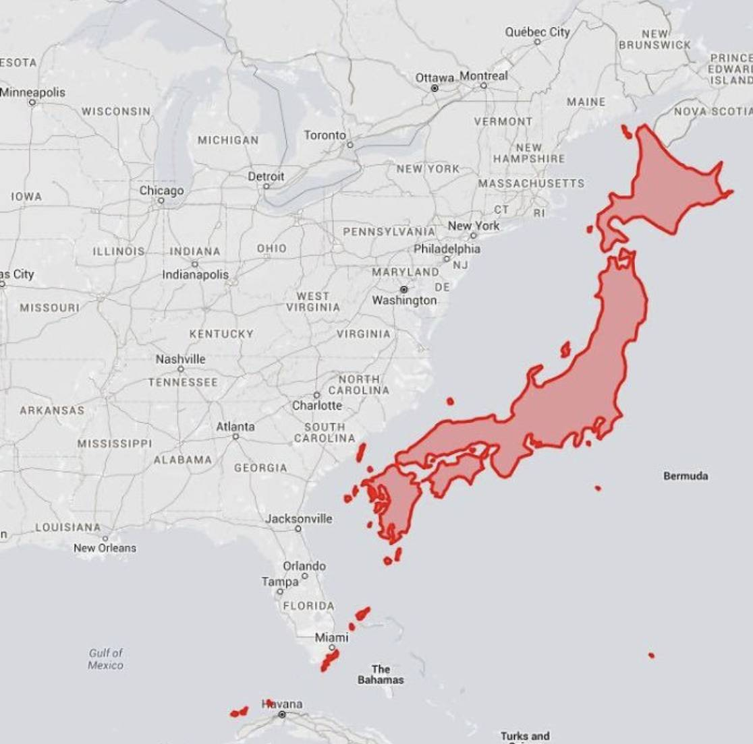
[https://www.exploredplanet.com/wp-content/uploads/2020/11/Japan-Size-Might-Surprise-You-77222.jpg]

A large percentage of the [U.S.] population could fit inside of [Japan]. This really isn't a surprise considering
the country's population of (126.5M) people which equals nearly one-third of [America]'s population.
________________________________________/
\_____________________________________________________________________________/ Japan Isn't As Tiny As You Might Think
Approximately 50% Of Canadians Live South Of This Red Line /¯¯¯¯¯¯¯¯¯¯¯¯¯¯¯¯¯¯¯¯¯¯¯¯¯¯¯¯¯¯¯¯¯¯¯¯¯¯¯¯¯¯¯¯¯¯¯¯¯¯¯¯¯¯¯¯¯\
/¯¯¯¯¯¯¯¯¯¯¯¯¯¯¯¯¯¯¯¯¯¯¯¯¯¯¯¯¯¯¯¯¯¯¯¯¯¯¯¯¯¯¯¯¯¯¯¯¯¯¯¯¯¯¯¯¯¯¯¯

(> 50%) of all [Canadians] live in just (2) provinces: [Ontario] and [Quebec]. What's even more amazing is that
(> 50%) of the population are located south of the red line featured in this map.

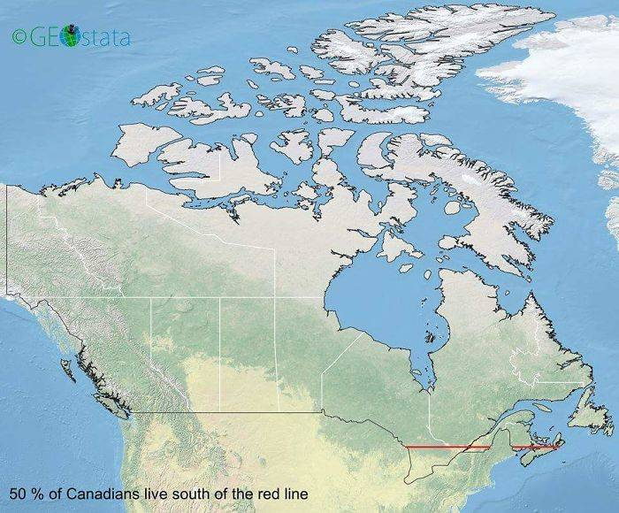
[https://www.exploredplanet.com/wp-content/uploads/2020/11/Where-most-Canadian-population-live-23083.jpg]

The [Canadian] population is (37.59M) and that means (~20M) [Canadians]...
...live in a very small portion of the country's available land.
Of course, that just means the country can preserve a greater amount of its natural beauty.
____________________________________________________________/
\_________________________________________________________/ Approximately 50% Of Canadians Live South Of This Red Line
These Are The Mass Migration Routes Of Animals Throughout North America /¯¯¯¯¯¯¯¯¯¯¯¯¯¯¯¯¯¯¯¯¯¯¯¯¯¯¯¯¯¯¯¯¯¯¯¯¯¯¯¯¯¯¯¯\
/¯¯¯¯¯¯¯¯¯¯¯¯¯¯¯¯¯¯¯¯¯¯¯¯¯¯¯¯¯¯¯¯¯¯¯¯¯¯¯¯¯¯¯¯¯¯¯¯¯¯¯¯¯¯¯¯¯¯¯¯¯¯¯¯¯¯¯¯¯¯¯¯¯

Animals in [North America] will go to great lengths to migrate between (cold/warm) temperatures.
The [caribou] is especially extraordinary, traveling up to (3,025) mi. every year.

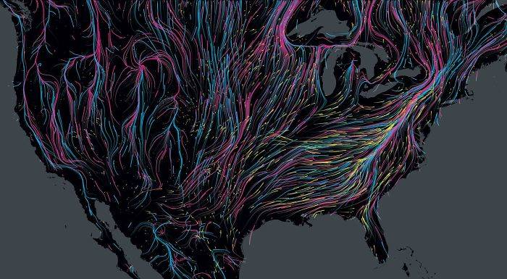
[https://www.exploredplanet.com/wp-content/uploads/2020/11/Mass-Migration-fo-Animals-throughout-North-America-32598.jpg]

This map shows the major mass migration route of mammals in [North America]. It's not just large mammals either.
The [Monarch butterfly] can travel up to (3,000) mi. to reach its winter home. While the map doesn't show which
animals use these routes, it paints a beautiful picture while showcasing the incredible lengths animals will go
to stay alive.
_________________________________________________________________________/
\____________________________________________/ These Are The Mass Migration Routes Of Animals Throughout North America
The Topologist's Map Of The World Shows Shared Borders /¯¯¯¯¯¯¯¯¯¯¯¯¯¯¯¯¯¯¯¯¯¯¯¯¯¯¯¯¯¯¯¯¯¯¯¯¯¯¯¯¯¯¯¯¯¯¯¯¯¯¯¯¯¯¯¯¯¯¯¯¯\
/¯¯¯¯¯¯¯¯¯¯¯¯¯¯¯¯¯¯¯¯¯¯¯¯¯¯¯¯¯¯¯¯¯¯¯¯¯¯¯¯¯¯¯¯¯¯¯¯¯¯¯¯¯¯¯¯

This map of the world looks a lot different, so let us explain. The topologist's map of the world removes the
traditional view of our world and replaces it with touchpoints for borders shared by various countries.

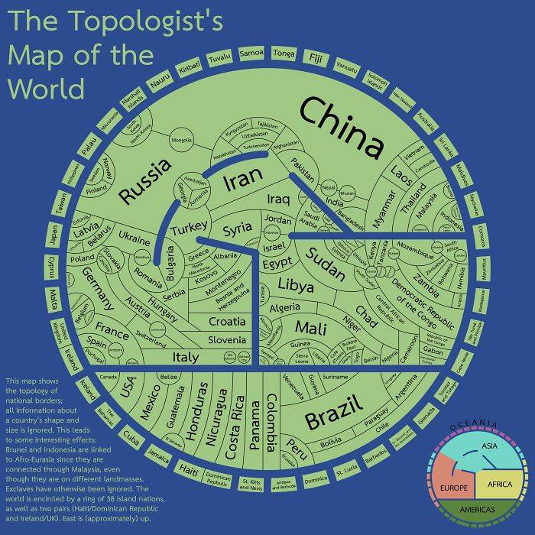
[https://www.exploredplanet.com/wp-content/uploads/2020/11/Topologist-Map-Of-The-World--30694.jpg]

For example, [North and South America] are featured at the bottom of the map with touching borders throughout all
shared landmass. This view demonstrates all of the major landmasses that are connected and the view is surrounded
by non-connected island masses. It's just another way to view how connected our world is, compared to a view from
traditional maps.
________________________________________________________/
\_____________________________________________________________/ The Topologist's Map Of The World Shows Shared Borders
A Map Of Rivers In The Contiguous United States /¯¯¯¯¯¯¯¯¯¯¯¯¯¯¯¯¯¯¯¯¯¯¯¯¯¯¯¯¯¯¯¯¯¯¯¯¯¯¯¯¯¯¯¯¯¯¯¯¯¯¯¯¯¯¯¯¯¯¯¯¯¯¯¯¯¯¯¯\
/¯¯¯¯¯¯¯¯¯¯¯¯¯¯¯¯¯¯¯¯¯¯¯¯¯¯¯¯¯¯¯¯¯¯¯¯¯¯¯¯¯¯¯¯¯¯¯¯¯

If you drive around the [United States] and pay close attention to the number of rivers you spot, you'll likely be
surprised by the sheer volume of rivers that weave throughout the [United States].

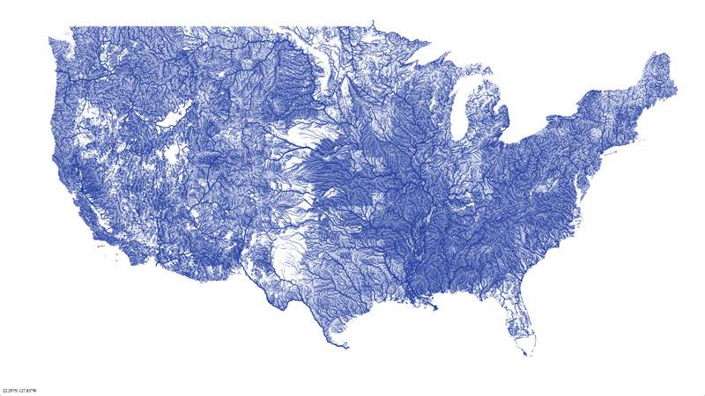
[https://www.exploredplanet.com/wp-content/uploads/2020/11/map-of-united-states-rivers-40030.jpg]

There are (> 250K) rivers in the [United States] with a total of nearly (3.5M) mi. among those rivers.
The [Missouri River] is the longest of those rivers, measuring in at (2,540) mi. long.
_________________________________________________/
\____________________________________________________________________/ A Map Of Rivers In The Contiguous United States
7,000 Rivers Feed Into The Mississippi River /¯¯¯¯¯¯¯¯¯¯¯¯¯¯¯¯¯¯¯¯¯¯¯¯¯¯¯¯¯¯¯¯¯¯¯¯¯¯¯¯¯¯¯¯¯¯¯¯¯¯¯¯¯¯¯¯¯¯¯¯¯¯¯¯¯¯¯¯¯¯¯\
/¯¯¯¯¯¯¯¯¯¯¯¯¯¯¯¯¯¯¯¯¯¯¯¯¯¯¯¯¯¯¯¯¯¯¯¯¯¯¯¯¯¯¯¯¯¯

While the [Missouri River] is the longest in [America], the river with the largest depth and volume is the
[Mississippi] river. The river is fed by (7,000) individual rivers that spread throughout a shocking amount of
the [United States].

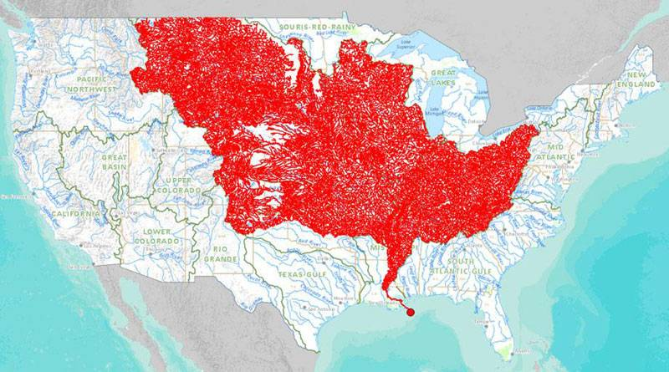
[https://www.exploredplanet.com/wp-content/uploads/2020/11/map-of-rivers-that-feed-into-the-mississippi-river-73653.jpg]

This map shows all of the rivers that feed into the mighty [Mississippi] and the eventual endpoint of that
journey. And now you know why the [Mississippi] is such a behemoth of a river.
______________________________________________/
\_______________________________________________________________________/ 7,000 Rivers Feed Into The Mississippi River
The World Divided Into 7 Regions With 1 Billion People /¯¯¯¯¯¯¯¯¯¯¯¯¯¯¯¯¯¯¯¯¯¯¯¯¯¯¯¯¯¯¯¯¯¯¯¯¯¯¯¯¯¯¯¯¯¯¯¯¯¯¯¯¯¯¯¯¯¯¯¯¯\
/¯¯¯¯¯¯¯¯¯¯¯¯¯¯¯¯¯¯¯¯¯¯¯¯¯¯¯¯¯¯¯¯¯¯¯¯¯¯¯¯¯¯¯¯¯¯¯¯¯¯¯¯¯¯¯¯

This color-coded map of the world shows how much of each area would need in order to reach a population of at
least (1B) people. While many continents such as [North America], [South America], and [Australia] consume much
of the landmass on our planet, it would take all (3) locations to reach a population that would still be
eclipsed by [China].

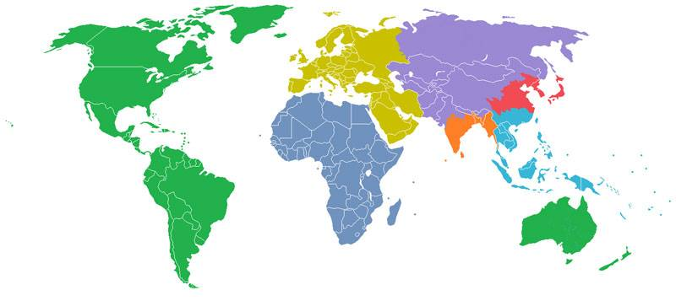
[https://www.exploredplanet.com/wp-content/uploads/2020/11/population-of-the-world-split-into-equal-sections-of-one-billion-66300.jpg]

As we previously showed, (~ 50%) of [Canada]'s population contribution is located on just a sliver of land
compared to the country's overall size.
________________________________________________________/
\_____________________________________________________________/ The World Divided Into 7 Regions With 1 Billion People
The Contiguous United States Overlaid On Top Of The Moon /¯¯¯¯¯¯¯¯¯¯¯¯¯¯¯¯¯¯¯¯¯¯¯¯¯¯¯¯¯¯¯¯¯¯¯¯¯¯¯¯¯¯¯¯¯¯¯¯¯¯¯¯¯¯¯¯¯¯¯\
/¯¯¯¯¯¯¯¯¯¯¯¯¯¯¯¯¯¯¯¯¯¯¯¯¯¯¯¯¯¯¯¯¯¯¯¯¯¯¯¯¯¯¯¯¯¯¯¯¯¯¯¯¯¯¯¯¯¯

The contiguous [United States] features a landmass size of (~2.95M) mi². If we were to lay the entire area across
the moon there would still be a decent amount of area left over for other countries.

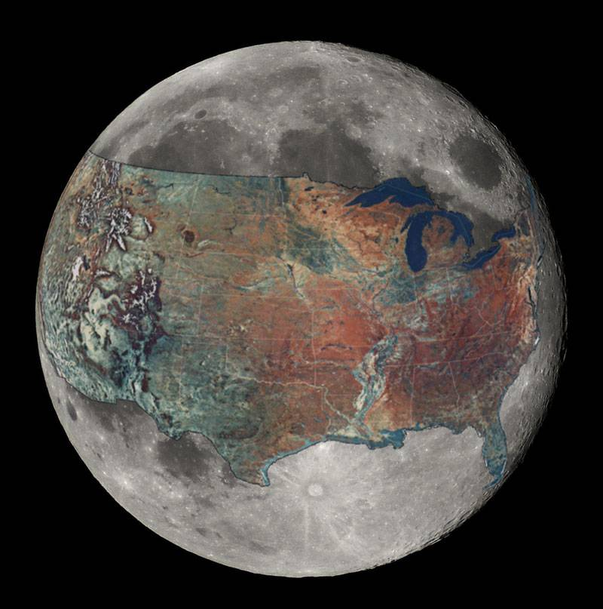
[https://www.exploredplanet.com/wp-content/uploads/2020/11/map-of-united-states-overlaid-on-the-moon-57840.jpg]

The moon's total surface area is (~ 14.6M) mi². If you wanted to take up all of the surface area on the moon,
your best bet would be [Asia], which features (17.21M) mi² of surface area.
__________________________________________________________/
\___________________________________________________________/ The Contiguous United States Overlaid On Top Of The Moon
Conclusion /¯¯¯¯¯¯¯¯¯¯¯¯¯¯¯¯¯¯¯¯¯¯¯¯¯¯¯¯¯¯¯¯¯¯¯¯¯¯¯¯¯¯¯¯¯¯¯¯¯¯¯¯¯¯¯¯¯¯¯¯¯¯¯¯¯¯¯¯¯¯¯¯¯¯¯¯¯¯¯¯¯¯¯¯¯¯¯¯¯¯¯¯¯¯¯¯¯¯¯¯¯¯¯¯¯\
/¯¯¯¯¯¯¯¯¯¯¯¯

Look, sometimes you just have to call it like you see it.
You just read up on a bunch of different map-types, as if you were born to do it.
Now what will you do with yourself...?

It's not every day that you get to check out all of these amazing fact-maps.
Or, a list of maps with their associated facts. [Map-facts].
____________/
\_________________________________________________________________________________________________________/ Conclusion
________________________________________________________  |¯¯¯¯¯¯¯¯¯¯¯¯¯¯¯¯¯¯¯¯¯¯¯¯¯¯¯¯¯¯¯¯¯¯¯¯¯¯¯¯¯¯¯¯¯¯¯¯¯¯¯¯¯¯|  | Michael C. Cook Sr. |  | Security Engineer |  | Secure Digits Plus LLC |  |______________________________________________________|  ¯¯¯¯¯¯¯¯¯¯¯¯¯¯¯¯¯¯¯¯¯¯¯¯¯¯¯¯¯¯¯¯¯¯¯¯¯¯¯¯¯¯¯¯¯¯¯¯¯¯¯¯¯¯¯¯ | 

