____ ____________________________________________________________________________________________________
//¯¯\\__//¯¯¯¯¯¯¯¯¯¯¯¯¯¯¯¯¯¯¯¯¯¯¯¯¯¯¯¯¯¯¯¯¯¯¯¯¯¯¯¯¯¯¯¯¯¯¯¯¯¯¯¯¯¯¯¯¯¯¯¯¯¯¯¯¯¯¯¯¯¯¯¯¯¯¯¯¯¯¯¯¯¯¯¯¯¯¯¯¯¯¯¯¯¯¯¯¯¯\\___
\\__//¯¯¯ Discussion [~] The Presidents of the United States of America ___//¯¯\\
¯¯¯\\__________________________________________________________________________________________________//¯¯\\__//
¯¯¯¯¯¯¯¯¯¯¯¯¯¯¯¯¯¯¯¯¯¯¯¯¯¯¯¯¯¯¯¯¯¯¯¯¯¯¯¯¯¯¯¯¯¯¯¯¯¯¯¯¯¯¯¯¯¯¯¯¯¯¯¯¯¯¯¯¯¯¯¯¯¯¯¯¯¯¯¯¯¯¯¯¯¯¯¯¯¯¯¯¯¯¯¯¯¯¯¯ ¯¯¯¯
This is the (1995) album [The Presidents of the United States of America]...
https://en.wikipedia.org/wiki/The_Presidents_of_the_United_States_of_America_(album)
...played by the band [The Presidents of the United States of America]...
https://en.wikipedia.org/wiki/The_Presidents_of_the_United_States_of_America_(band)
...not to be confused with the actual [Presidents of the United States of America]...
https://en.wikipedia.org/wiki/List_of_presidents_of_the_United_States
(2) really good popular hits on this album...
[Peaches], and [Dunebuggy].
[Peaches]
Peaches come from a can.
They were put there by a man,
In a factory down-town...
If I had my little way,
I'd eat peaches every day...
Sun-soaking bulges in the shade.
[Dunebuggy]
Little dune buggy
In the sand
Little blue dune buggy
In my hand
[Both] of these songs, are [extremely simple], and were [pretty popular] back in (1995).
[Hootie and the Blowfish] and [these guys] went [back] and [forth] with their [alternative rock band showdown],
fresh out of the war between [Pearl Jam/Eddie Vedder], [Nirvana/Kurt Kobain], + [Alice in Chains/Layne Staley].
I'm gonna tell ya right now.
The fact that this band was named [The Presidents of the United States of America] caused [a lot of confusion]
back when I was a kid...
My friend [Alex Philipsak] would say:
[Alex] : Hey, did you know that [The Presidents of the United States of America] just
came out with an album called [The Presidents of the United States of America]...?
[Me] : ...the [Presidents of the United States of America] came out with an album called...
...the [Presidents of the United States of America]...?
[Alex] : Yeh.
[Me] : ...so like [Bill Clinton] and [George H. W. Bush]...?
[Alex] : Nah.
Different [presidents of the United States of America].
[Me] : But I thought they WERE the [presidents of the United States of America]...?
[Alex] : The band [The Presidents of the United States of America], does not consist of the actual
[presidents of the United States of America].
[Me] : ...huh...?
[Alex] : It's just the bands' name...
[Me] : So, a band just went ahead and called themselves [The Presidents of the United States of America],
to [mess with people]...?
[Alex] : Yeh.
But, the album is ALSO named [The Presidents of the United States of America].
So, you're talkin'...
...naming the album the same thing, to [mess with people even more].
[Me] : So what you're sayin', is that, the actual [presidents of the United States of America] had NOTHING
to do with the band [The Presidents of the United States of America], releasing an album named
[The Presidents of the United States of America]...?
[Alex] : *snaps fingers, starts nodding* Exactly.
[Me] : I'm confused.
[Alex] : *whips out the dry erase marker, walks over to a white board* Alright, so... check it out.
*draws stick figures of the actual [presidents of the United States of America]*
You see these stick figure guys...?


[Me] : Yeh.
[Alex] : Alright, *draws a circle* these stick figure guys are supposed to represent the actual
[presidents of the United States of America], like [Bill Clinton], and [George H.W. Bush],
[Ronald Reagan], [Jimmy Carter], etc.



[Me] : ...alright...
[Alex] : Alright...?
Now, over here *starts drawing additional stick figure dudes*, these guys are supposed to represent
the band [The Presidents of the United States of America].
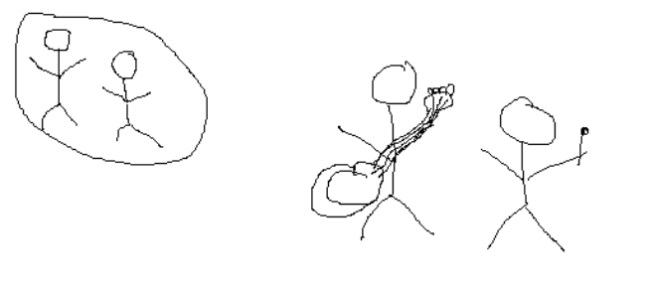
*draws a circle around the new stick figure guys, and writes [Band]*
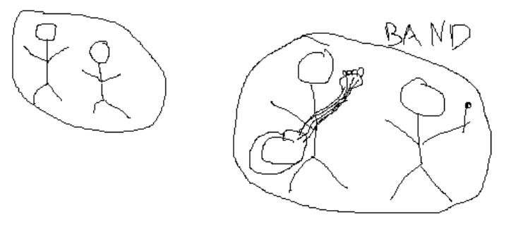

[Me] : ...alright...
[Alex] : You with me so far...?
[Me] : Yeh, standard-issue [presidents of the United States of America] in the circle over *points* there, and
a band that just so happens to be named [The Presidents of the United States of America] over there...
[Alex] : *snaps fingers, points* You got it, dude.
[Me] : So, which of them released the album, [The Presidents of the United States of America]...?
[Alex] : Alright, glad you asked.
So, right here... *draws a CD*

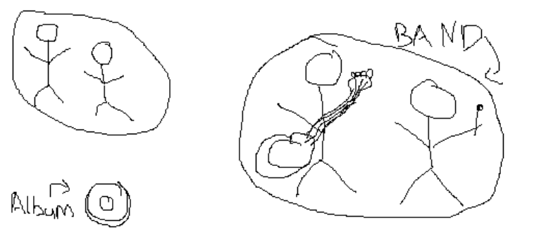
This is a CD, meant to represent the album [The Presidents of the United States of America].
[Me] : ...alright...?
[Alex] : You with me...?
[Me] : Yeh.
Album.
[The Presidents of the United States of America].
[Alex] : Alright, now check this out...
*draws a line from the album [The Presidents of the United States of America]...
...to the band [The Presidents of the United States of America]*...
You see this [line] right *points at the line he just drew* here...?

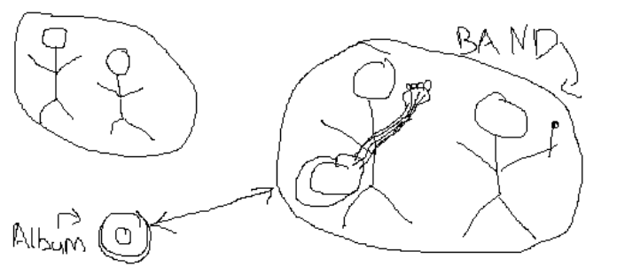

[Me] : Yeh.
[Alex] : Alright, now check this out.
*draws a checkmark next to that line*

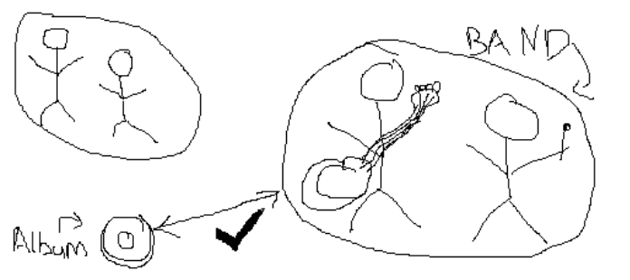
That's who made the [album].
[Me] : Alright, so why even bring up the actual [presidents of the United States of America], then...?
[Alex] : Glad you asked.
Check this out.
*draws a line from the actual [presidents of the United States of America]...
...to the album [The Presidents of the United States of America]*

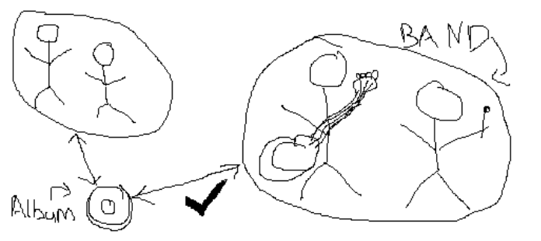
You see this line right here...?
[Me] : Yeh.
[Alex] : Alright.
*draws an X over the line between the actual [presidents of the United States of America]...
...and the album [The Presidents of the United States of America]*

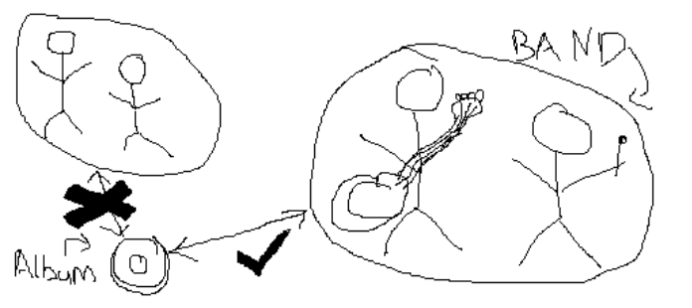

[Me] : Ah.
I get it now.
[Alex] : Yeh.
That's the band [The Presidents of the United States of America], who made the album
[The Presidents of the United States of America], for ya.
[Me] : But I mean, those [stick figures] aren't the actual [presidents of the United States of America]...
...how do you know they weren't involved in the album being made...?
[Alex] : I don't...
But, I'm pretty sure they had nothing to do with it.
[Me] : How do you know that though...?
[Alex] : Because, the actual [presidents of the United States of America] have really important shit to do,
they probably wouldn't have time to start playing music with the band
[The Presidents of the United States of America].
[Me] : What if they did, though...?
[Alex] : Well... if they did, then IDK.
Hadn't really put much thought into that...
[Me] : Yeh, answer man.
[Alex] : I'm just sayin', there's a couple of really cool songs on the album...
...[The Presidents of the United States of America]...
...by the band...
...[The Presidents of the United States of America]...?
[Me] : Oh yeah...?
There's a couple of really good songs on the album...
...[The Presidents of the United States of America]...
...by the band...
...[The Presidents of the United States of America]...?
[Alex] : Yeh.
There is.
[Me] : Like what...?
[Alex] : [Peaches], and [Dunebuggy].
[Me] : [Peaches] and [Dunebuggy]...?
[Alex] : *nodding* Yeh, [peaches come in a can], [they were put there by a man], [in a factory downtown]...
[Me] : Don't peaches come like, normally...?
[Alex] : They do.
No question, peaches come normally.
But- they ALSO come in a can.
[Me] : And when they do, [they're put there by a man], [in a factory downtown]...?
[Alex] : Yeah.
I mean, it's about as simple as it gets...
[Me] : My mind is blown.
[Alex] : Yeh.
Mine was too, when I first heard this song.
[Me] : Don't you think that the actual [presidents of the United States of America] would get pissed that
a band went ahead and started calling themselves [The Presidents of the United States of America]...?
[Alex] : I mean, maybe...?
[Me] : And then they had to go right ahead and name the album that too...
[Alex] : Yeh.
[Me] : Pretty inconsiderate of [The Presidents of the United States of America]...
[Alex] : Yeah well... it's just a band name.
[Me] : Yeah well, what if the band [The Presidents of the United States of America] comes out with an album
named [Declares War]
[Alex] : That wouldn't be good...
[Me] : Yeh.
Wtf.
________________________________________________________  |¯¯¯¯¯¯¯¯¯¯¯¯¯¯¯¯¯¯¯¯¯¯¯¯¯¯¯¯¯¯¯¯¯¯¯¯¯¯¯¯¯¯¯¯¯¯¯¯¯¯¯¯¯¯|  | Michael C. Cook Sr. |  | Security Engineer |  | Secure Digits Plus LLC |  |______________________________________________________|  ¯¯¯¯¯¯¯¯¯¯¯¯¯¯¯¯¯¯¯¯¯¯¯¯¯¯¯¯¯¯¯¯¯¯¯¯¯¯¯¯¯¯¯¯¯¯¯¯¯¯¯¯¯¯¯¯ | 

