Figure 1 Algorithm for kernel extraction

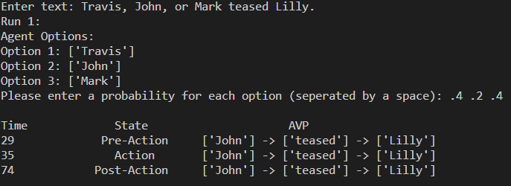

Figure 2 Example of generated SPN

Figure 3 Example of getting probability user input for different kernels

Figure 4 Example of getting probability user input for different agents

This work:

1. Before Travis teased Lilly, John teased Lilly.
2. Before Travis teased Lilly, John teased Lilly, and Mike teased Katie.
3. Before Travis teased Lilly, John teased Lilly, and afterward Mike teased Katie.

Previous work:

1. Output unknown due to comma without matching conjunction.
2. Before Travis teased Lilly, John teased Lilly, and Mike teased Katie.
3. Before Travis teased Lilly, John teased Lilly, and afterward Mike teased Katie.

Before Travis teased Lilly, John teased Lilly.

Kernel Order

* Travis teased Lilly 0
* John teased Lilly -1

Before Travis teased Lilly, John teased Lilly, and Mike teased Katie.

Kernel Order

* Travis teased Lilly 0
* John teased Lilly -1
* Mike teased Katie -1

Before Travis teased Lilly, John teased Lilly, and afterward Mike teased Katie.

Kernel Order

* Travis teased Lilly 0
* John teased Lilly -1
* Mike teased Katie 1

Travis teased Lilly. Afterward John teased Lilly.

Kernel Order

* Travis teased Lilly 0
* John teased Lilly 1

While Travis teased Lilly, John teased Lilly.

Kernel Order

* Travis teased Lilly 0
* John teased Lilly 0

Travis teased Lilly. At the same time, John teased Lilly.

Kernel Order

* Travis teased Lilly 0
* John teased Lilly 0

1. Before Travis teased Lilly, John teased Lilly.
2. Before Travis teased Lilly, John teased Lilly.
3. Before Travis teased Lilly, John teased Lilly.
4. Before Travis teased Lilly, John teased Lilly, and Mike teased Katie.
5. Before Travis teased Lilly, John teased Lilly, and Mike teased Katie.
6. Before Travis teased Lilly, John teased Lilly, and Mike teased Katie.
7. Before Travis teased Lilly, John teased Lilly
8. Before Travis teased Lilly, John teased Lilly, and afterward Mike teased Katie.
9. Before Travis teased Lilly, John teased Lilly, and afterward Mike teased Katie. *(Only consider the first timing word)*
10. Before Travis teased Lilly, John teased Lilly, and afterward Mike teased Katie.
11. Before Travis teased Lilly, John teased Lilly
12. Travis teased Lilly, John teased Lilly, and afterward Mike teased Katie.
13. Travis teased Lilly, John teased Lilly, and afterward Mike teased Katie.
14. Travis teased Lilly, John teased Lilly, and afterward Mike teased Katie.
15. Travis teased Lilly, John teased Lilly
16. Travis teased Lilly, while John teased Lilly.
17. Travis teased Lilly, while John teased Lilly.
18. Travis teased Lilly, while John teased Lilly.

Figure 5 Algorithm for ordering kernels

|  |  |  |
| --- | --- | --- |
| Sentence: Travis or Mark teased Lilly, or Jake teased Lilly.  Travis teased Lilly is randomly selected to be executed based on user input. | | |
| State | Busy Agents | Busy Patients |
| Pre-Action | Travis, Mark | Lilly |
| Action | Travis | Lilly |
| Post-Action | Travis | Lilly |

Sentence: Before Travis teased Lilly, John teased Lilly, or Jake teased Lilly.

Sentence Glossa: A0 V0 P0 #! (A1 V0 P0 ! A2 V0 P0)

Kernel Glossa:

* A0 V0 P0
* A1 V0 P0
* A2 V0 P0

Figure 6 Algorithm for initializing the state machine with tokens

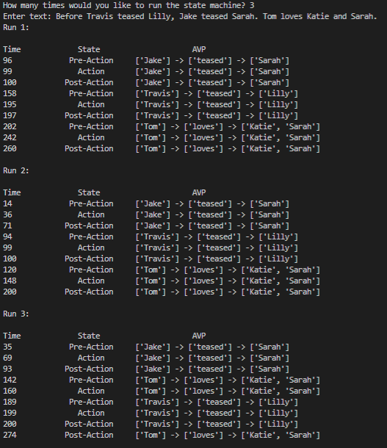

Figure 7 Shows 3 possible SPN combination outputs from the program for the sentences listed in the picture. Note the differing order and time of each run.

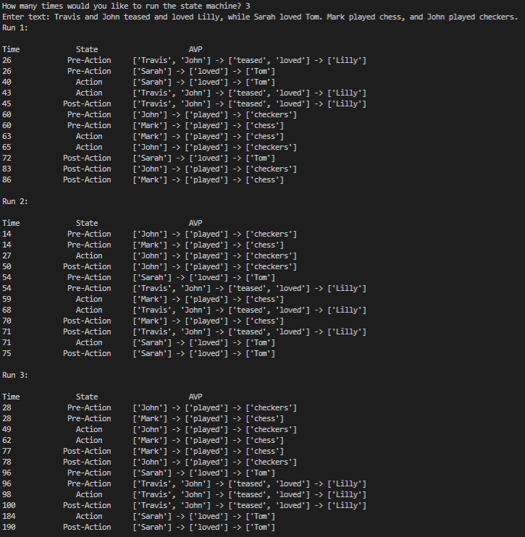

Figure 8 Shows 3 possible SPN combination outputs from the program for the sentences listed in the picture. Note the differing order and time of each run.

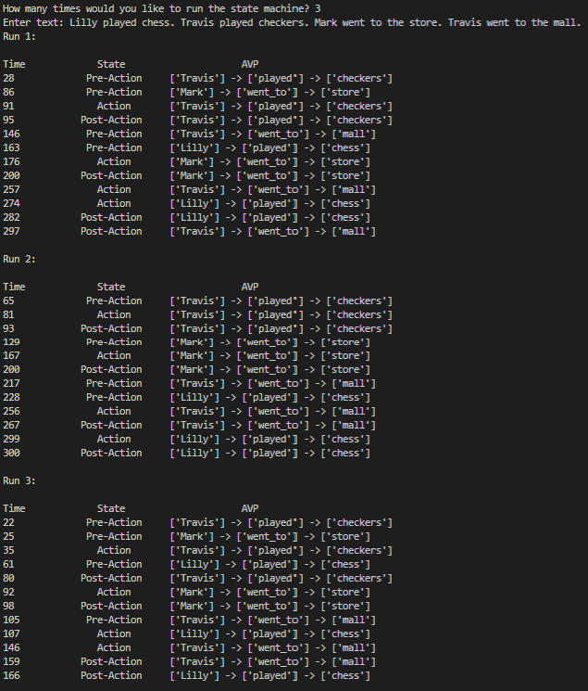

Figure 9 Shows 3 possible SPN combination outputs from the program for the sentences listed in the picture. Note the differing order and time of each run.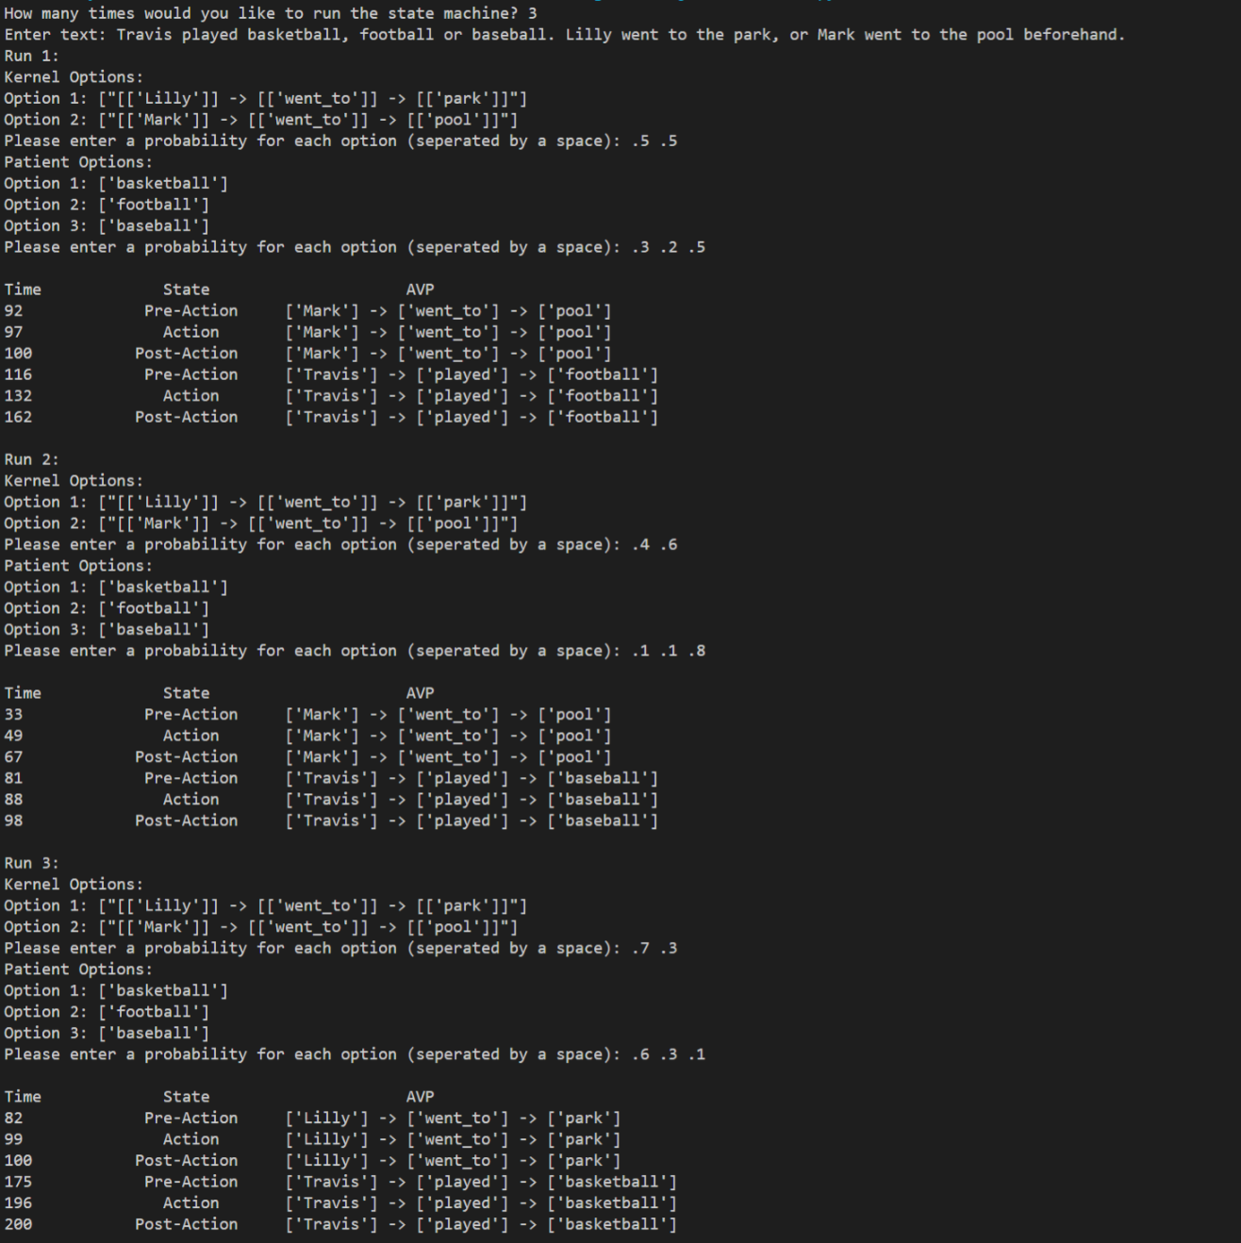

Figure 10 Shows 3 possible SPN combination outputs from the program for the sentences listed in the picture. Note the differing order and time of each run and how each run might be affected by the user input probabilities.

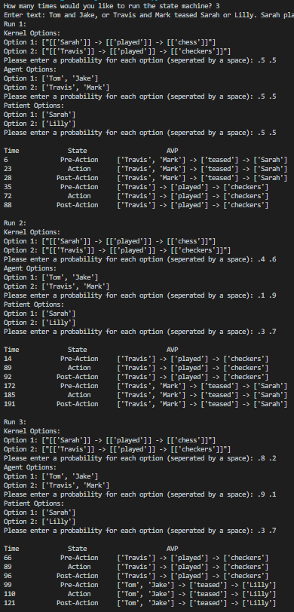

Figure 11 Shows 3 possible SPN combination outputs from the program for the sentences listed in the picture. Note the differing order and time of each run and how each run might be affected by the user input probabilities.

Figure Shows 3 possible SPN combination outputs from the program for the sentences listed in the picture. Note the differing order and time of each run and how each run might be affected by the user input probabilities.

–––––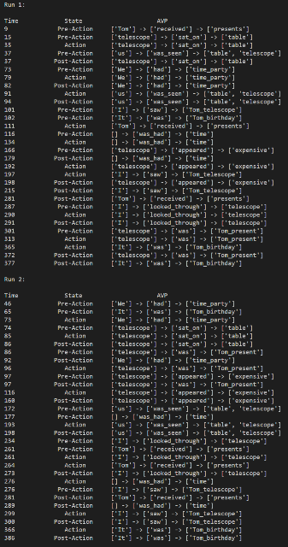

Figure 13 The program output from this work from the paragraph in section 4B. There are 2 possible SPN combination outputs listed.

Figure 14 The program output from the previous work from the paragraph in section 4B