CPE301 – SPRING 2019
Design Assignment DA-MIDTERM-2

Student Name: Tom McCarroll
Student #:5003331354
Student Email: mccart2@unlv.nevada.edu
Primary Github address: https://github.com/mccart2
Directory: https://github.com/mccart2/stuff13

Submit the following for all Labs:
- In the document, for each task submit the modified or included code (only) with highlights and justifications of the modifications. Also, include the comments.
- Use the previously create a Github repository with a random name (no CPE/301, Lastname, Firstname). Place all labs under the root folder ESD301/DA, sub-folder named LABXX, with one document and one video link file for each lab, place modified asm/c files named as LabXX-TYY.asm/c.
- If multiple asm/c files or other libraries are used, create a folder LabXX-TYY and place these files inside the folder.
- The folder should have a) Word document (see template), b) source code file(s) and other include files, c) text file with youtube video links (see template).

- COMPONENTS LIST AND CONNECTION BLOCK DIAGRAM w/ PINS

List of Components used :CPE 301 Development Board, Atmel Studio 7, Atmega 328P, Wires
Block diagram with pins used in the Atmega328P,RGB Sensor,UART,8266 WiFi Module
INITIAL/MODIFIED/DEVELOPED CODE OF TASK 1/A
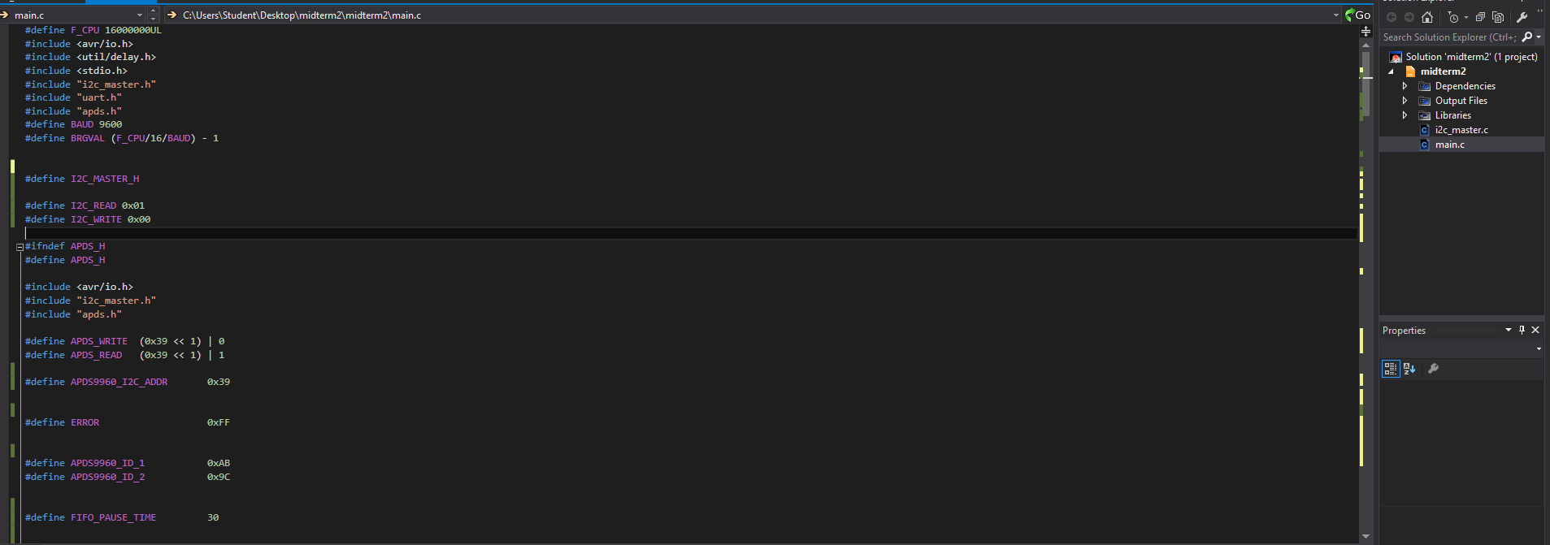
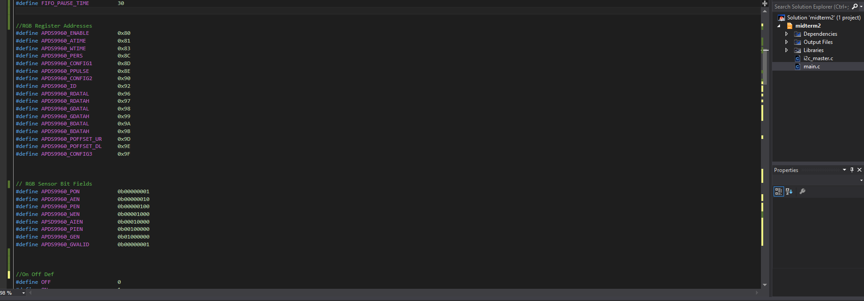
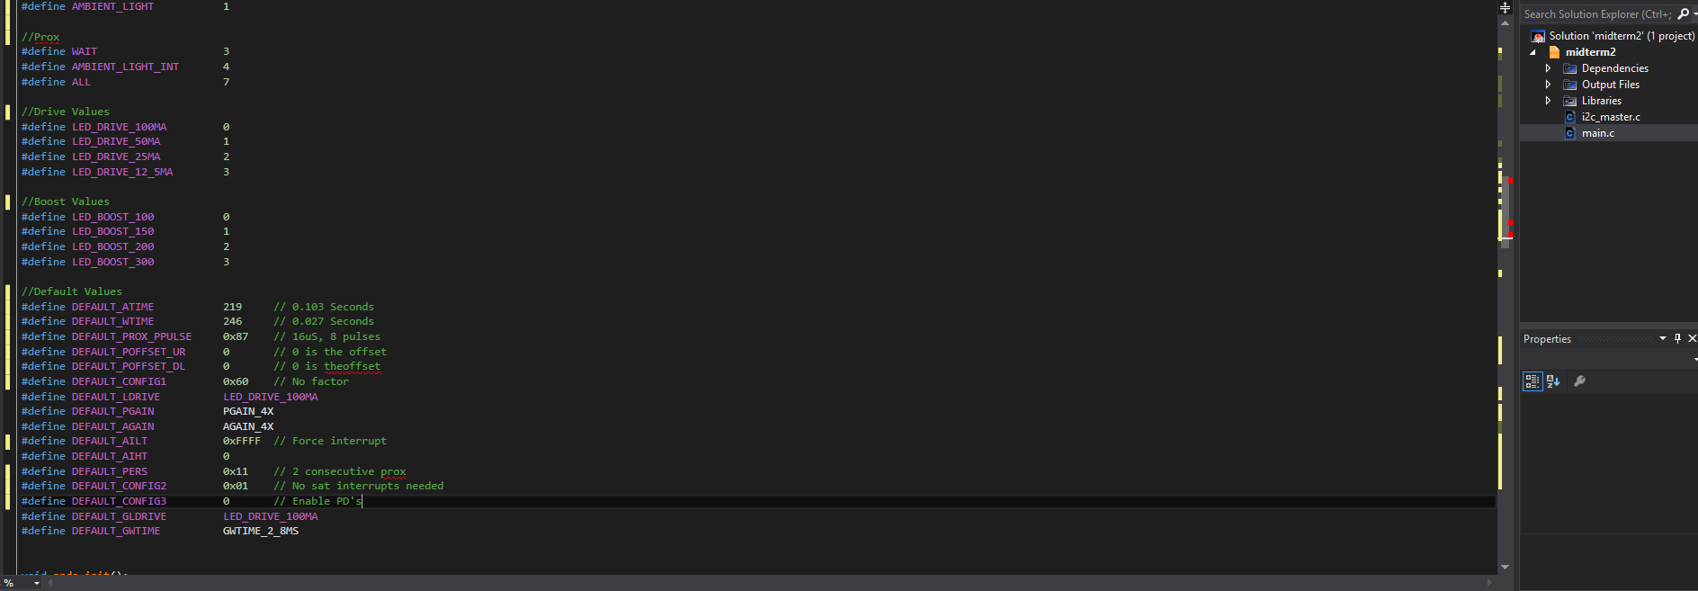

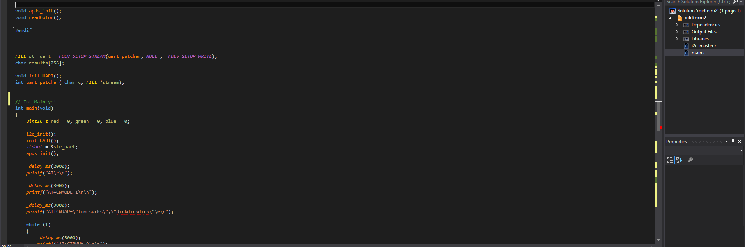
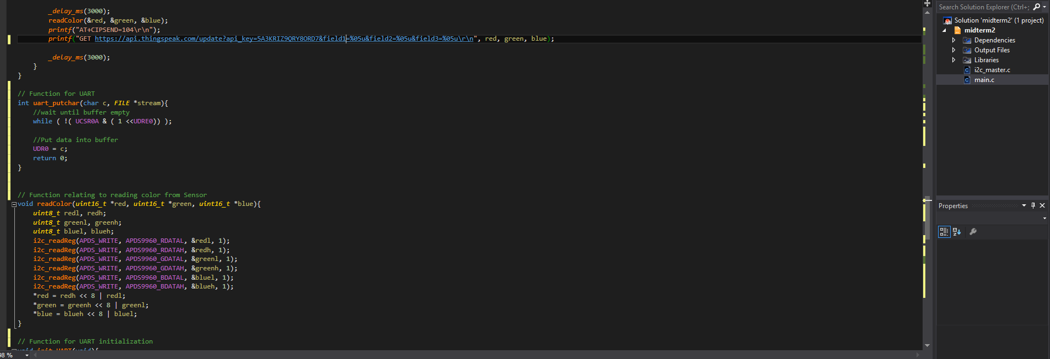
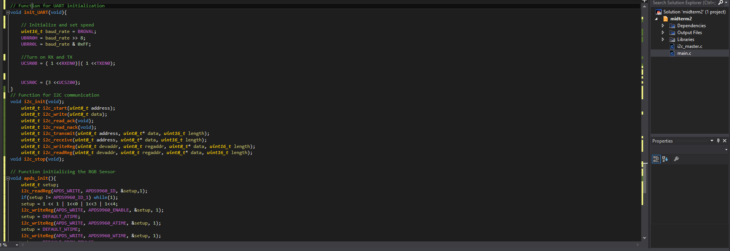
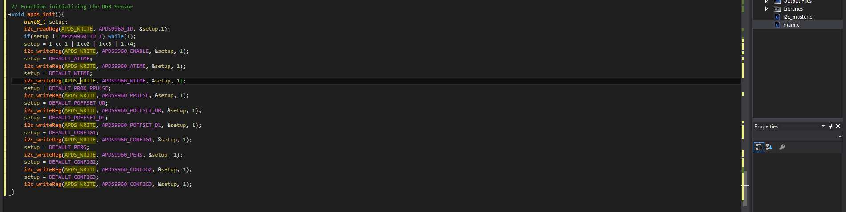

- DEVELOPED MODIFIED CODE OF TASK 2/A from TASK 1A

- SCHEMATICS

- SCREENSHOTS OF EACH TASK OUTPUT (ATMEL STUDIO OUTPUT)

- SCREENSHOT OF EACH DEMO (BOARD SETUP)

- VIDEO LINKS OF EACH DEMO

https://youtu.be/yPqchc0M-Uw

- GITHUB LINK OF THIS DA

https://github.com/mccart2/stuff13

Student Academic Misconduct Policy
http://studentconduct.unlv.edu/misconduct/policy.html

“This assignment submission is my own, original work”.
Tom McCarroll

