CPE301 – SPRING 2019

Design Assignment X

Student Name: Tom McCarroll

Student #:5003331354

Student Email: mccart2@unlv.nevada.edu

Primary Github address: https://github.com/mccart2/stuff

Directory: stuff

Submit the following for all Labs:

1. In the document, for each task submit the modified or included code (only) with highlights and justifications of the modifications. Also, include the comments.
2. Use the previously create a Github repository with a random name (no CPE/301, Lastname, Firstname). Place all labs under the root folder ESD301/DA, sub-folder named LABXX, with one document and one video link file for each lab, place modified asm/c files named as LabXX-TYY.asm/c.
3. If multiple asm/c files or other libraries are used, create a folder LabXX-TYY and place these files inside the folder.
4. The folder should have a) Word document (see template), b) source code file(s) and other include files, c) text file with youtube video links (see template).

1. **COMPONENTS LIST AND CONNECTION BLOCK DIAGRAM w/ PINS**

List of Components used

Block diagram with pins used in the Atmega328P

1. **INITIAL/MODIFIED/DEVELOPED CODE OF TASK 1/A**

This isn’t very clear so I am going to snip my code.

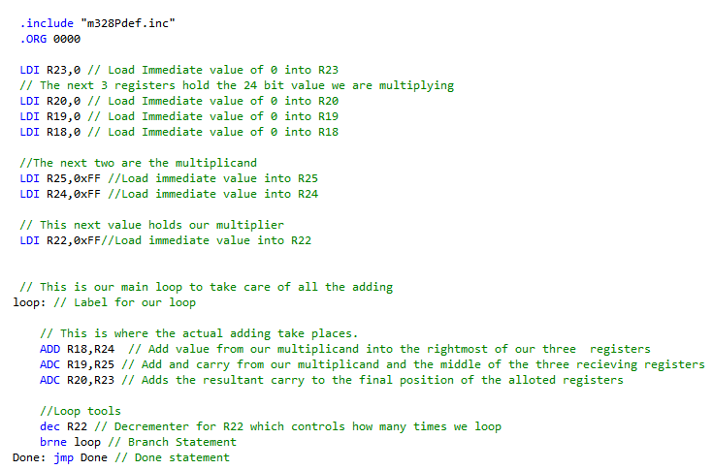

1. **DEVELOPED MODIFIED CODE OF TASK 2/A from TASK 1/A**

This also isn’t clear so I will snip my code that verifies my first code

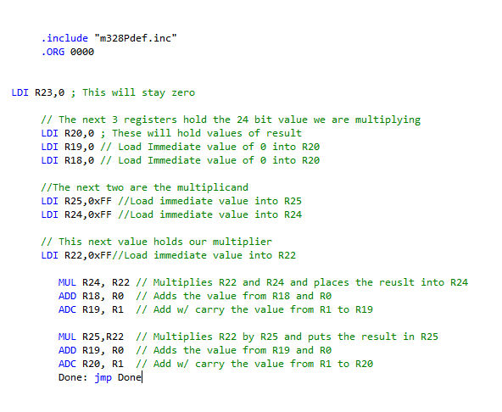

1. **SCHEMATICS**

There are no schematics

1. **SCREENSHOTS OF EACH TASK OUTPUT (ATMEL STUDIO OUTPUT)**

This is for addition

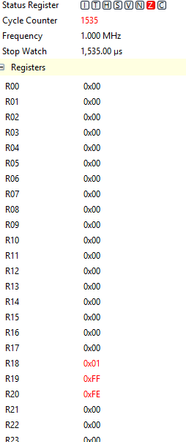

This is for the mutltiplication

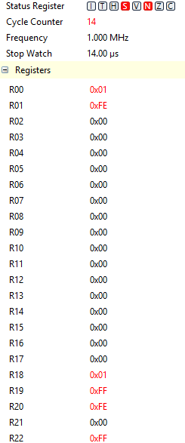

1. **SCREENSHOT OF EACH DEMO (BOARD SETUP)**



1. **VIDEO LINKS OF EACH DEMO**
2. **GITHUB LINK OF THIS DA**

**Student Academic Misconduct Policy**

<http://studentconduct.unlv.edu/misconduct/policy.html>

“This assignment submission is my own, original work”.

NAME OF THE STUDENT