CPE301 – SPRING 2019

Design Assignment DA4A

Student Name: Tom McCarroll

Student #:5003331354

Student Email: mccart2@unlv.nevada.edu

Primary Github address: https://github.com/mccart2

Directory: https://github.com/mccart2/stuff9

Submit the following for all Labs:

1. In the document, for each task submit the modified or included code (only) with highlights and justifications of the modifications. Also, include the comments.
2. Use the previously create a Github repository with a random name (no CPE/301, Lastname, Firstname). Place all labs under the root folder ESD301/DA, sub-folder named LABXX, with one document and one video link file for each lab, place modified asm/c files named as LabXX-TYY.asm/c.
3. If multiple asm/c files or other libraries are used, create a folder LabXX-TYY and place these files inside the folder.
4. The folder should have a) Word document (see template), b) source code file(s) and other include files, c) text file with youtube video links (see template).

1. **COMPONENTS LIST AND CONNECTION BLOCK DIAGRAM w/ PINS**

List of Components used :CPE 301 Development Board, Atmel Studio 7, Atmega 328P, Wires

Block diagram with pins used in the Atmega328P,DC Motor, L298 Driver

**INITIAL/MODIFIED/DEVELOPED CODE OF TASK 1/A**

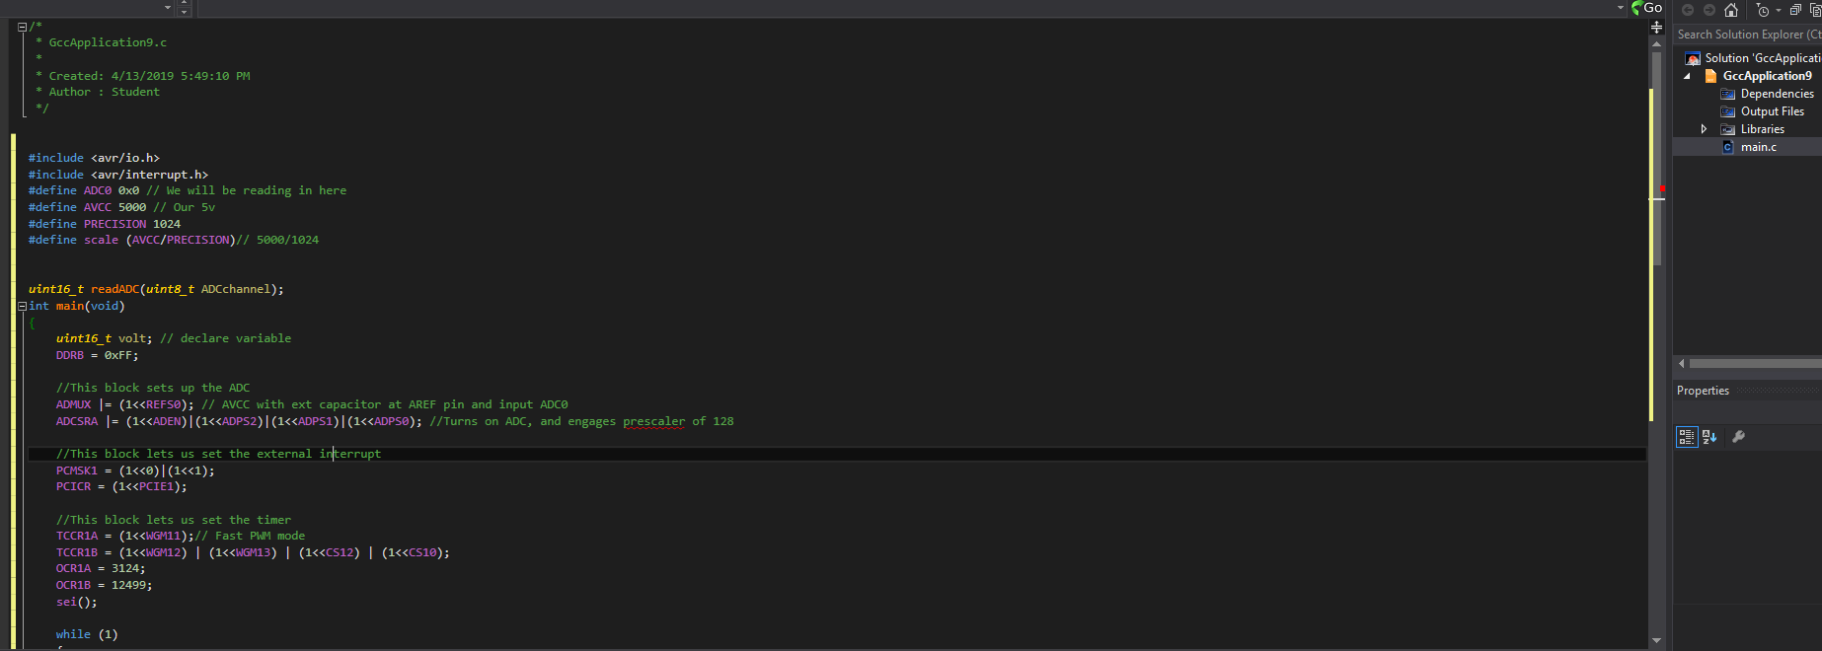

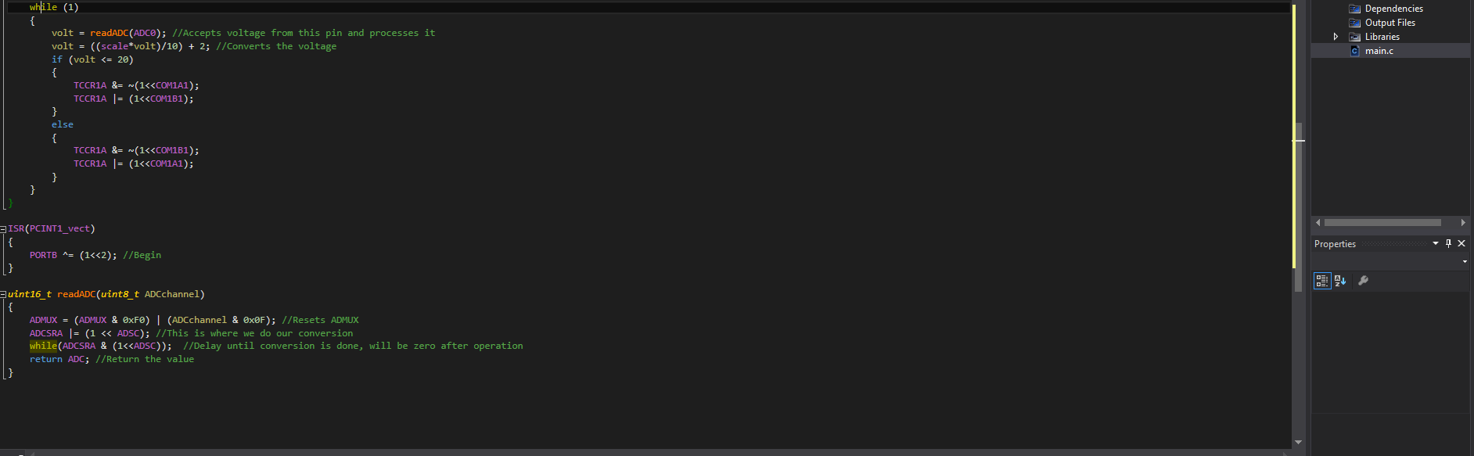

1. **DEVELOPED MODIFIED CODE OF TASK 2/A from TASK 1A**
2. **SCHEMATICS**

See youtube video

1. **SCREENSHOTS OF EACH TASK OUTPUT (ATMEL STUDIO OUTPUT)**

See youtube video

1. **SCREENSHOT OF EACH DEMO (BOARD SETUP)**
2. **VIDEO LINKS OF EACH DEMO**

<https://youtu.be/VM6pJgVTRtQ>

1. **GITHUB LINK OF THIS DA**

<https://github.com/mccart2/stuff9>

**Student Academic Misconduct Policy**

<http://studentconduct.unlv.edu/misconduct/policy.html>

“This assignment submission is my own, original work”.

Tom McCarroll