# EEG preprocessing diagnostics

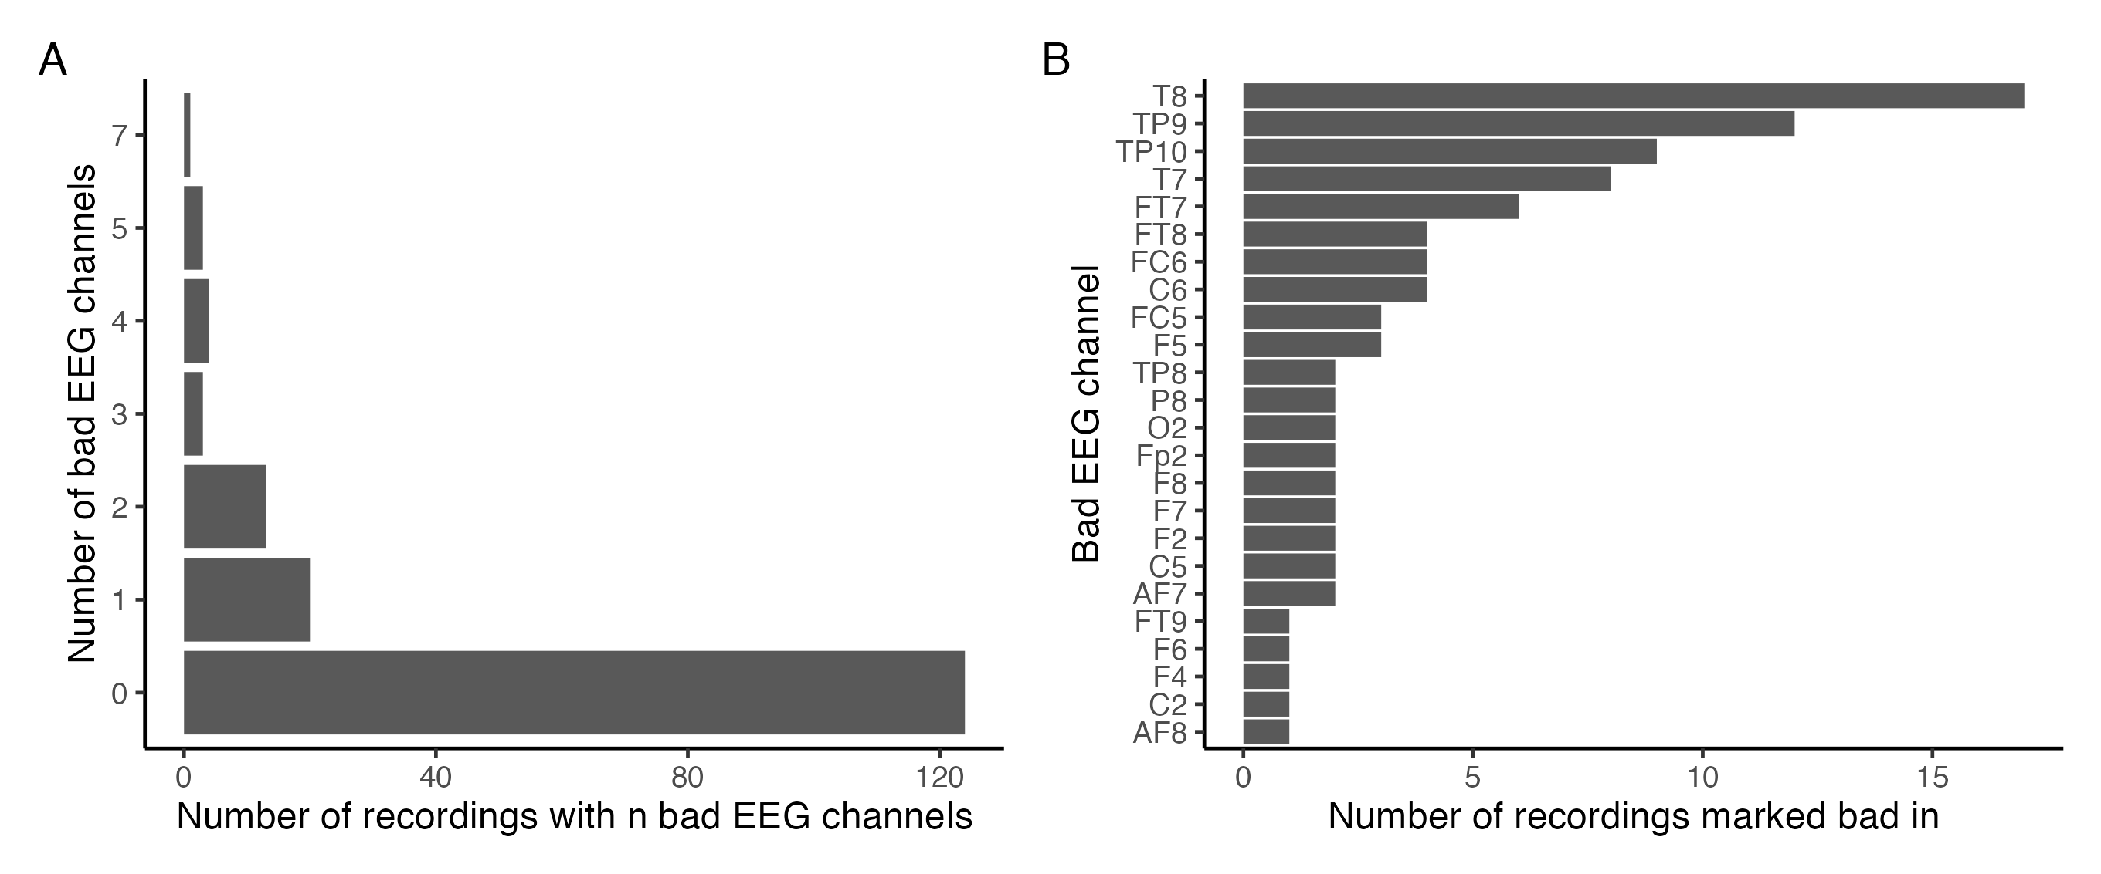

Figure 1: Bar plots showing the distribution of bad EEG channels by the total number of EEG channels marked bad per recording (A), and the total number of recordings a given EEG channels was marked bad in (B).

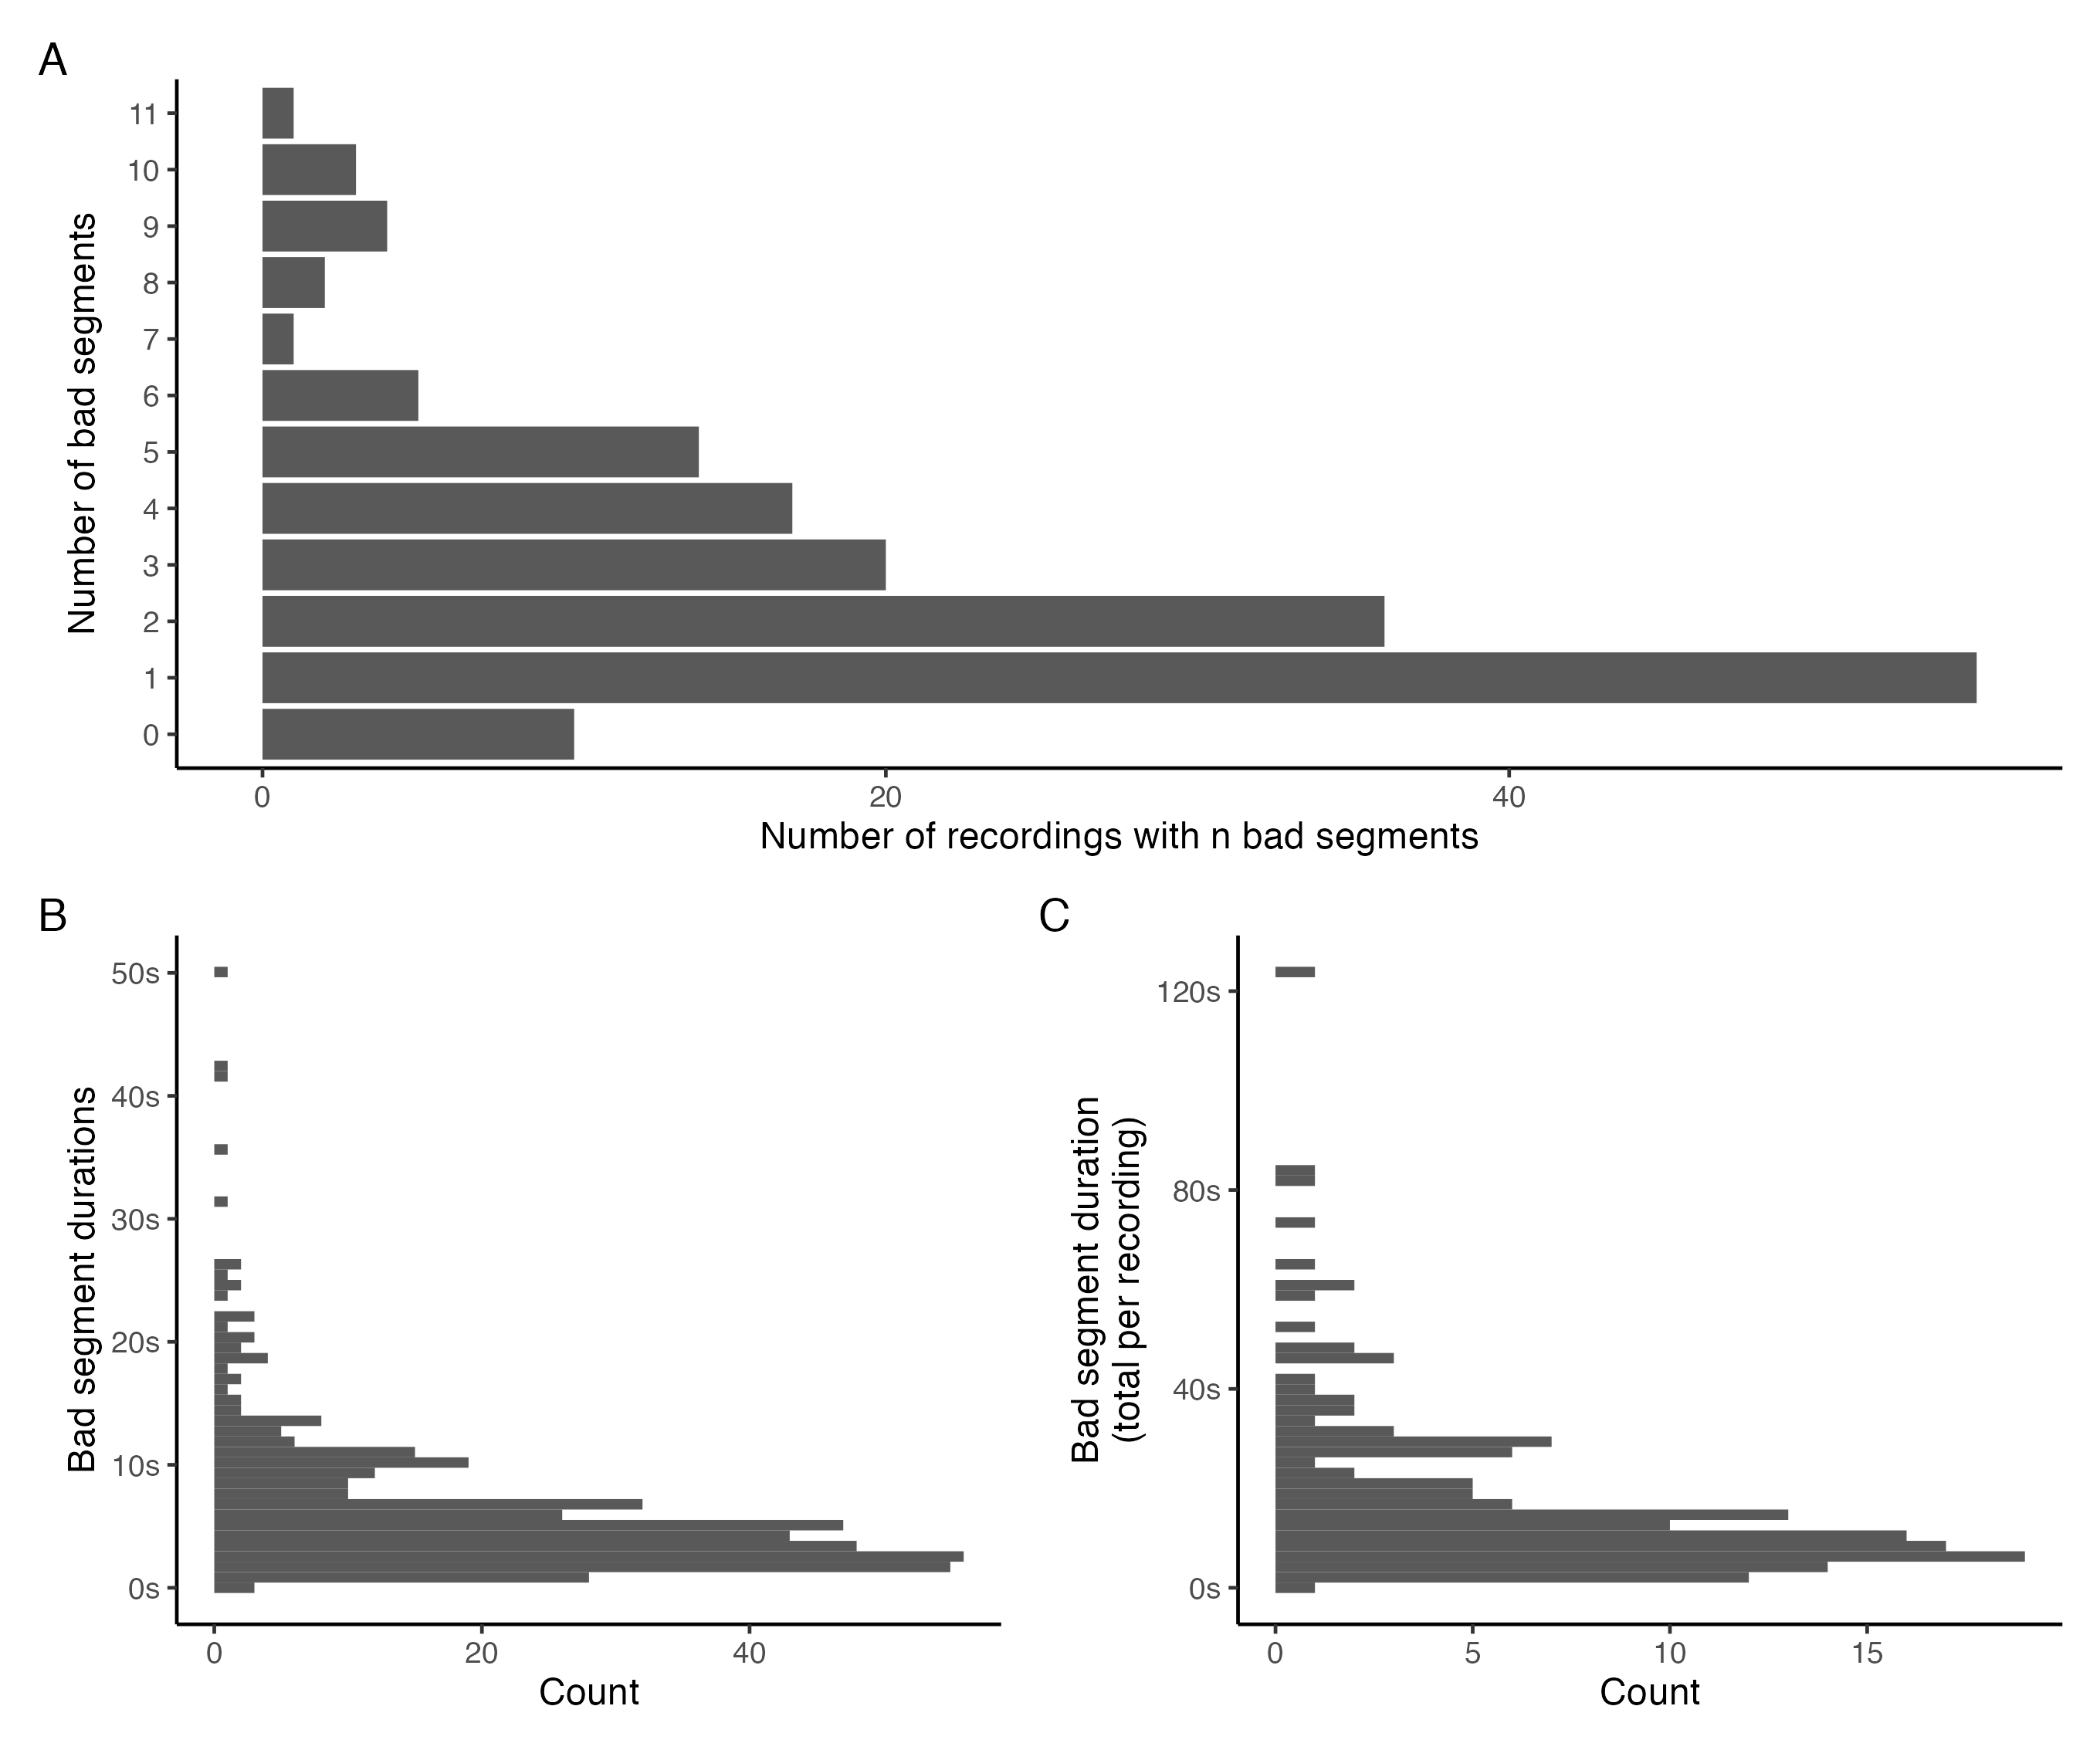

Figure 2: Bar plot showing the distribution of bad segments by the total number of segments marked bad per recording (A); histograms showing the distribution of bad segment durations across all recordings (B), and the total bad segment duration per recording (C).