# Similarity Matrices

## Phase coupling

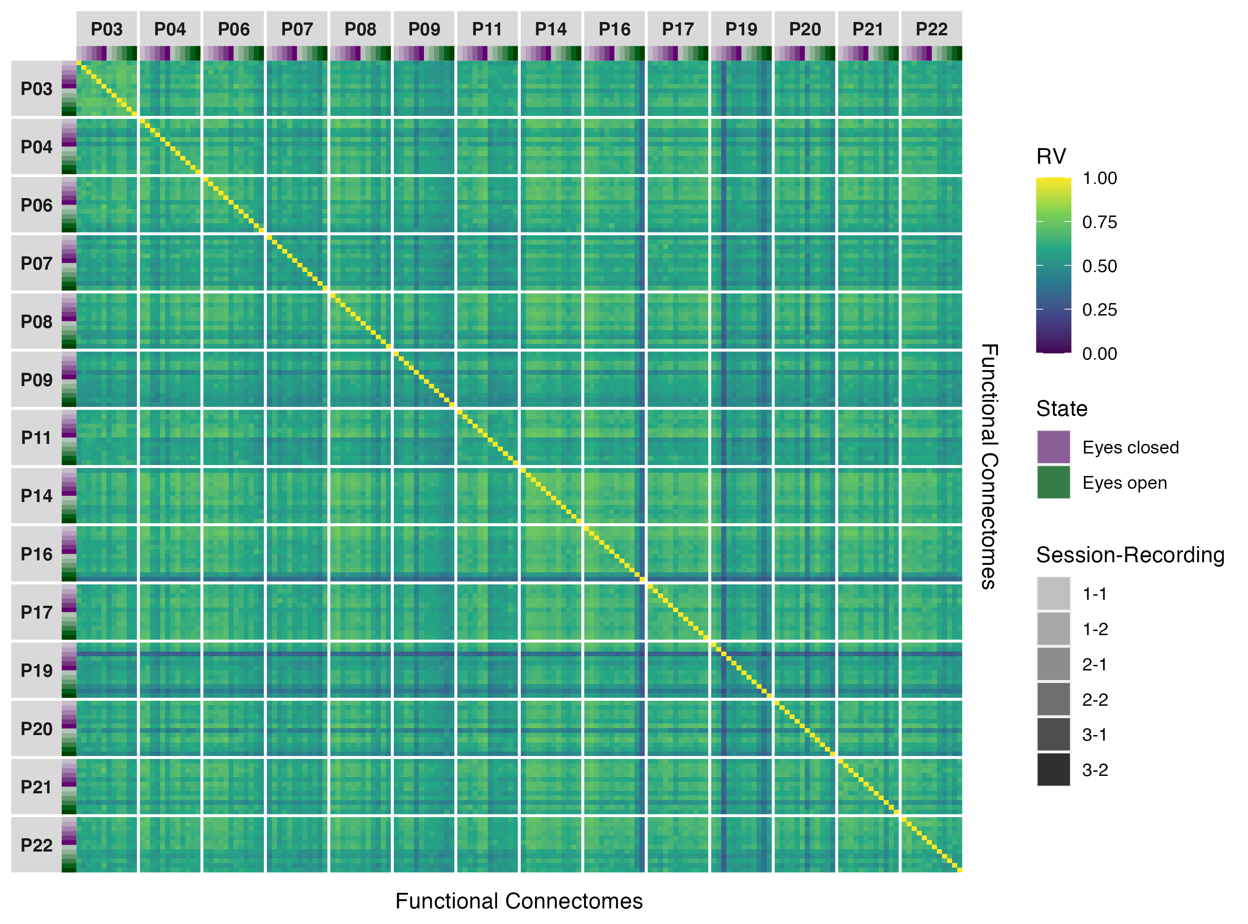

Figure 1: Similarity matrix showing functional connectome similarities within and between participants for phase coupling functional connectomes in the delta band.

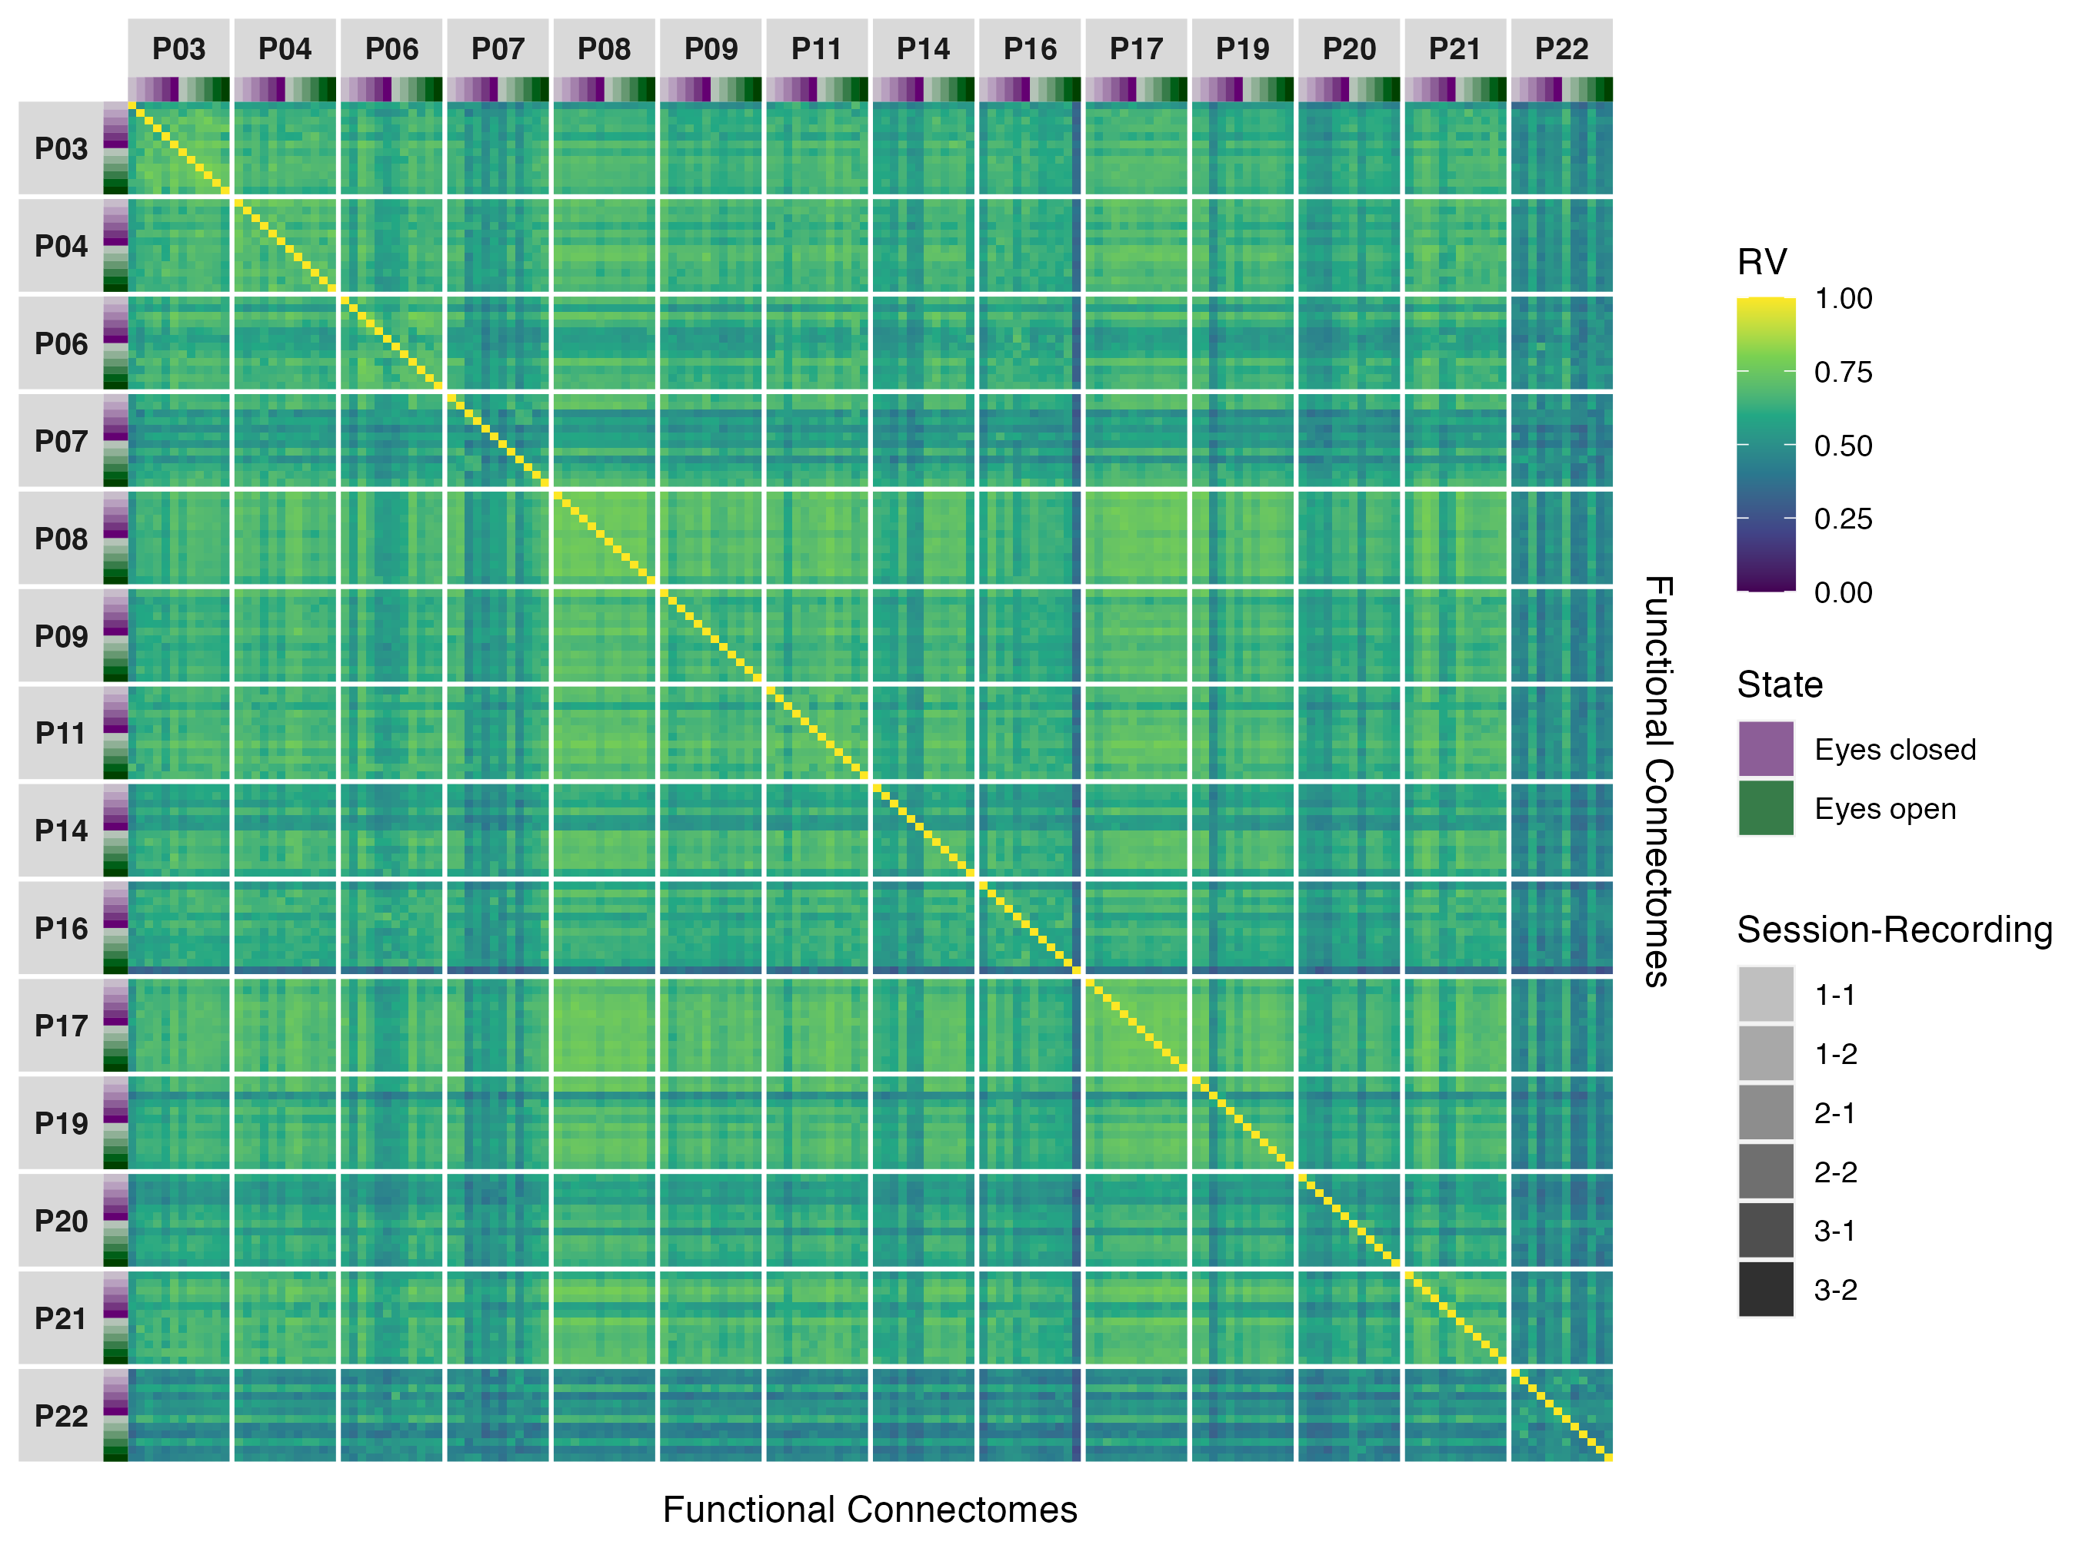

Figure 2: Similarity matrix showing functional connectome similarities within and between participants for phase coupling functional connectomes in the theta band.

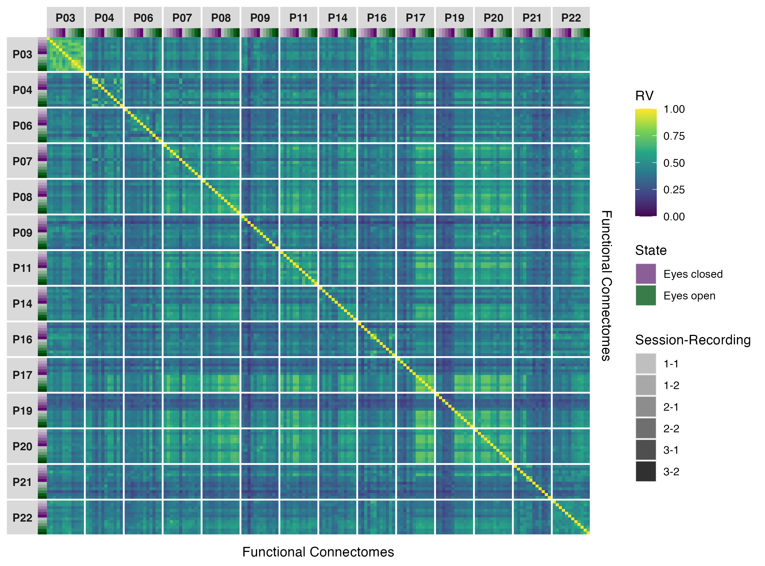

Figure 3: Similarity matrix showing functional connectome similarities within and between participants for phase coupling functional connectomes in the alpha band.

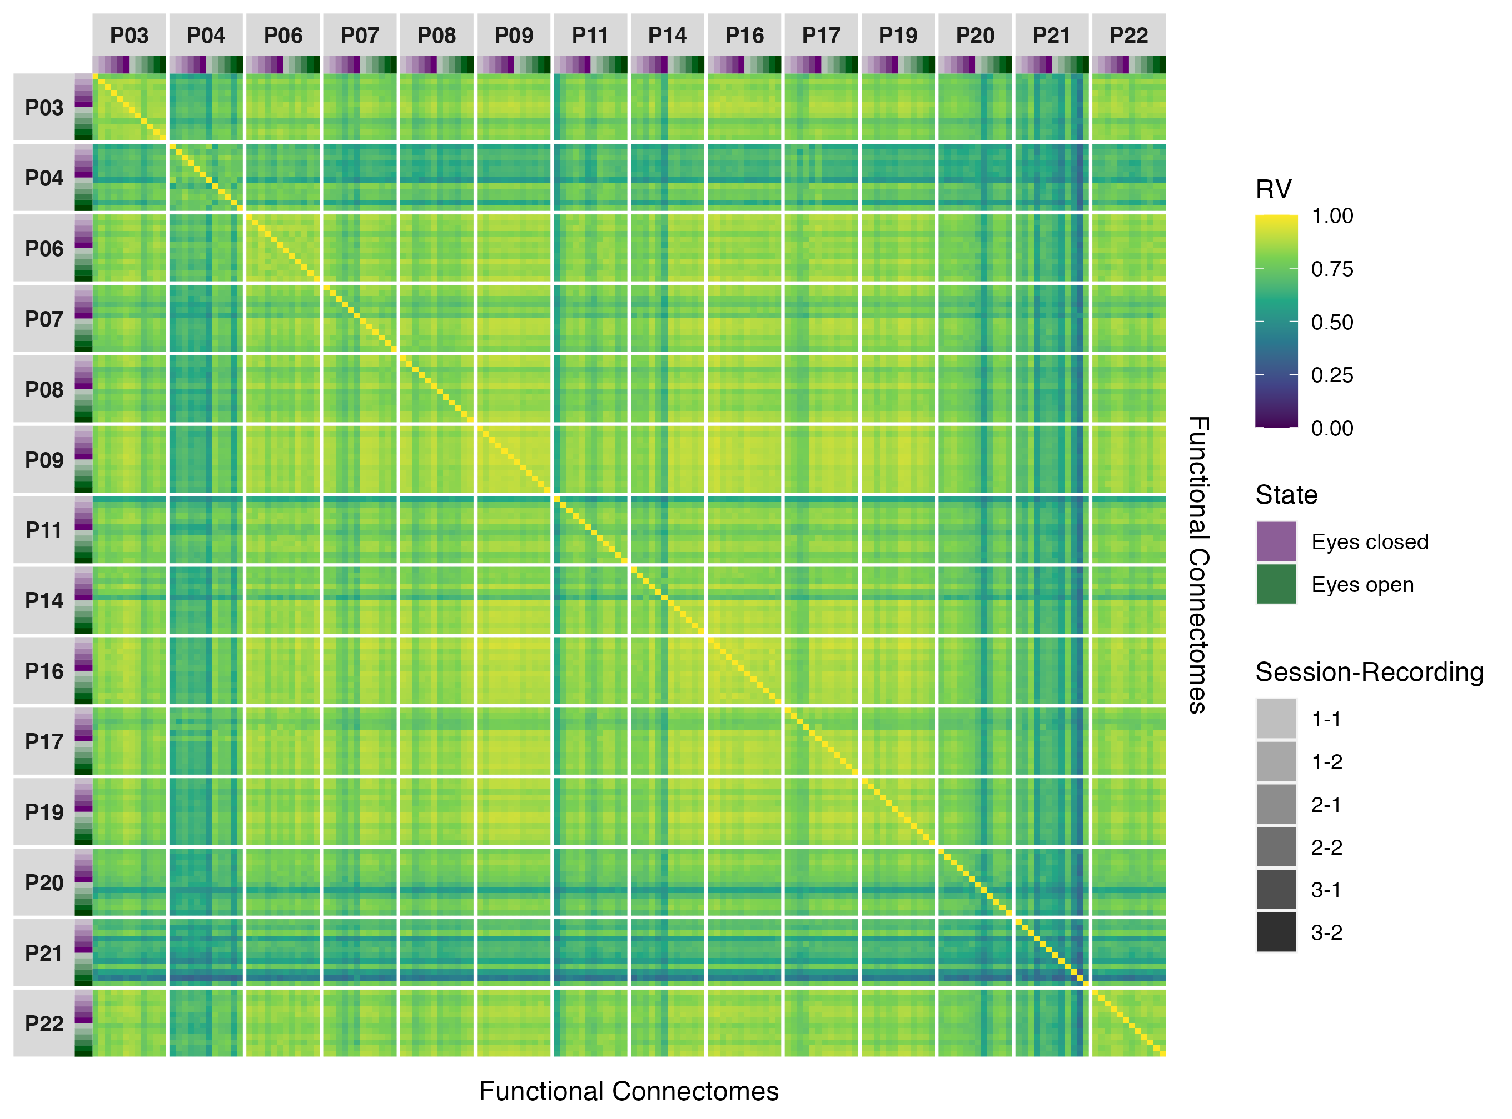

Figure 4: Similarity matrix showing functional connectome similarities within and between participants for phase coupling functional connectomes in the beta band.

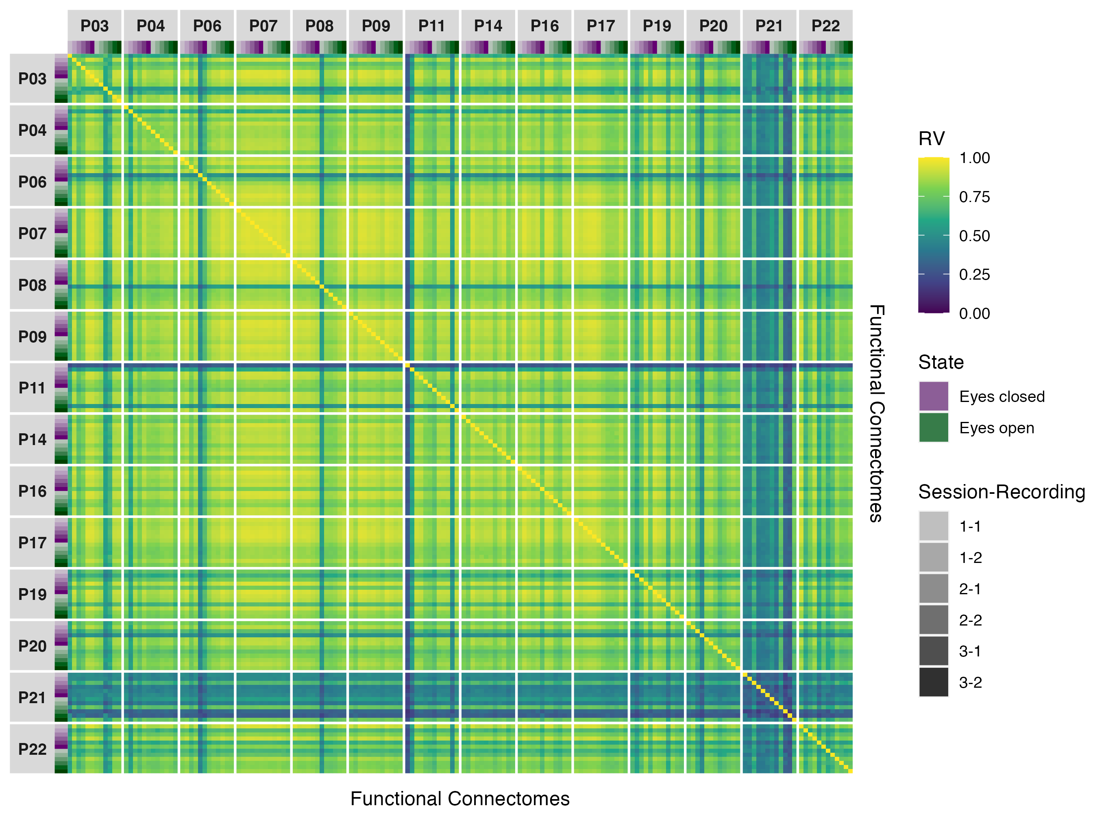

Figure 5: Similarity matrix showing functional connectome similarities within and between participants for phase coupling functional connectomes in the gamma band.

## Amplitude coupling

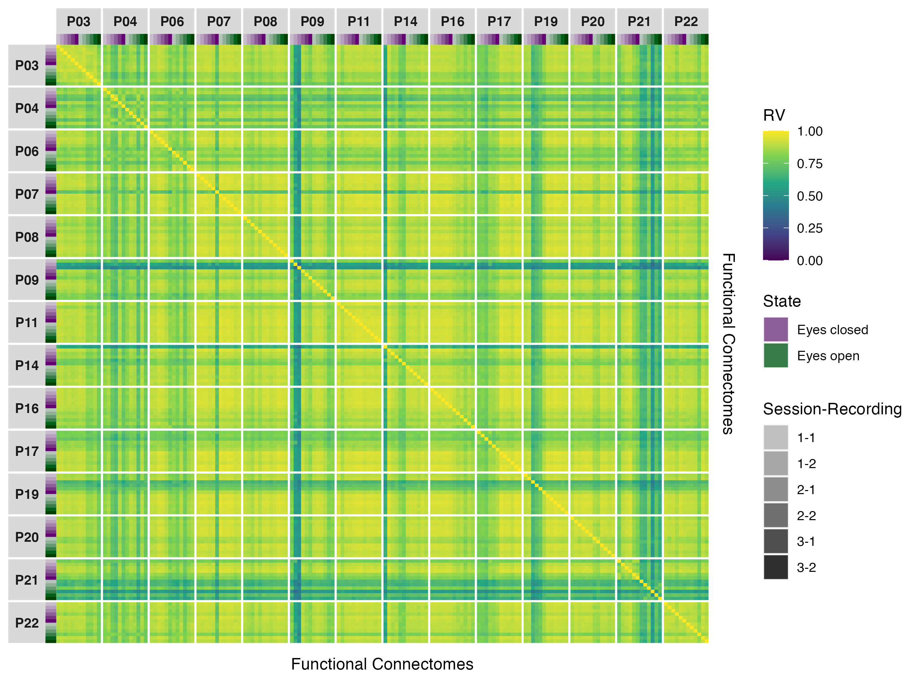

Figure 6: Similarity matrix showing functional connectome similarities within and between participants for amplitude coupling functional connectomes in the alpha band.

## Phase coupling (Hilbert transform)

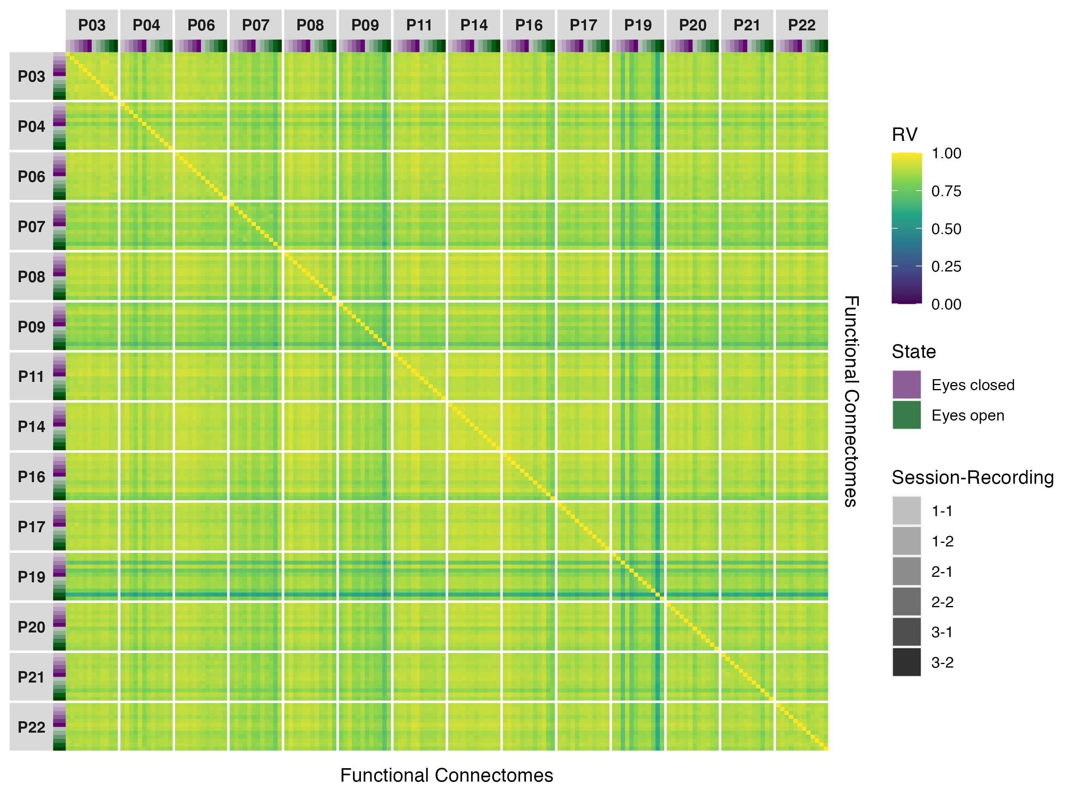

Figure 7: Similarity matrix showing functional connectome similarities within and between participants for phase coupling (Hilbert transform) functional connectomes in the delta band.

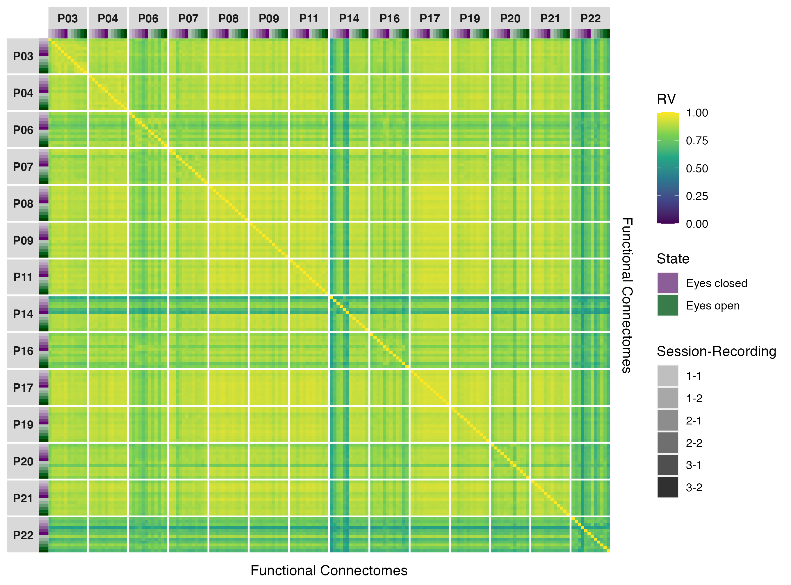

Figure 8: Similarity matrix showing functional connectome similarities within and between participants for phase coupling (Hilbert transform) functional connectomes in the theta band.

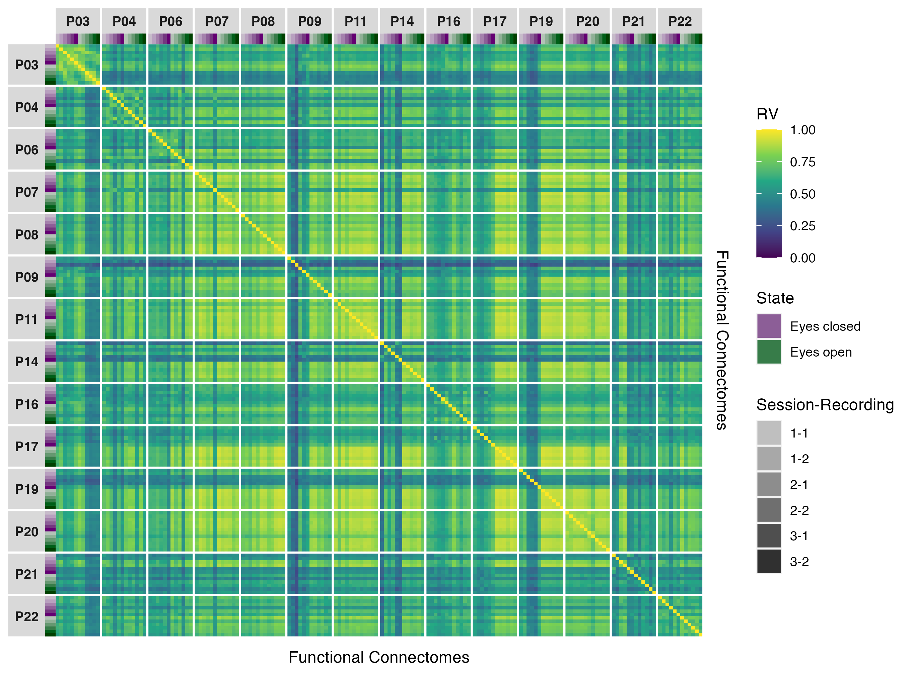

Figure 9: Similarity matrix showing functional connectome similarities within and between participants for phase coupling (Hilbert transform) functional connectomes in the alpha band.

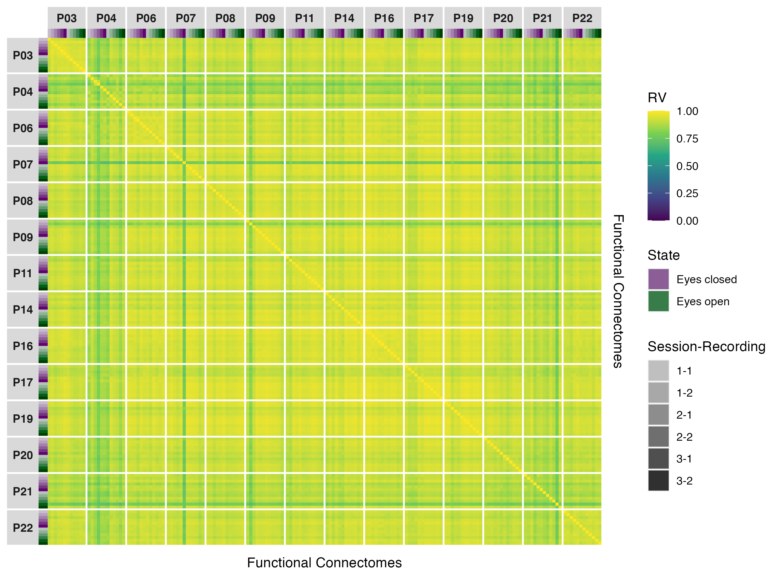

Figure 10: Similarity matrix showing functional connectome similarities within and between participants for phase coupling (Hilbert transform) functional connectomes in the beta band.

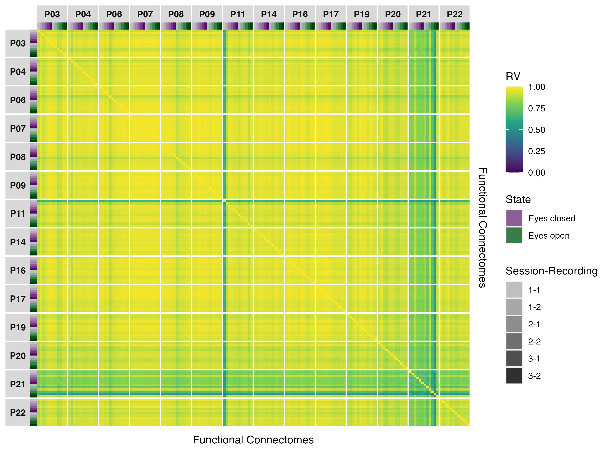

Figure 11: Similarity matrix showing functional connectome similarities within and between participants for phase coupling (Hilbert transform) functional connectomes in the gamma band.