Electrostatics Application:

Ion Thruster

**Group Members:**

Alexandre Tessier

John Buccilli

Scott McCartney

Wilson Guo

Dr. Dmitry Garmatyuk

ECE 325

12/1/2015

**Project Directory**: https://GitHub.com/McCarts3/IonThruster

**I. Problem Statement**

Field-emission electric propulsion (FEEP) is an advanced electrostatic propulsion concept that is currently being used as a form of ion thruster in space travel. FEEP is based on ionization of a liquid metal, in this case Cesium, Indium, and Mercury. This type of ion thruster can use a large variety of liquid metals or alloys for propulsion, but the thruster is most efficient using high weight alkali metals such as Cesium. This is because of low ionization potential, good wetting capabilities (ability to maintain propellant flow through the emitter), and low melting points.

Applying a high voltage difference between the accelerator and emitter creates a strong electric field. This, along with other properties, causes the liquid metal to create what are known as “Taylor Cones”. When the electric field is high enough the atoms at the tip of the cone ionize and the other atoms reject the electrons. The result is an ion jet that propels the rocket.

For this project we modeled a rocket in a vacuum and simulated the rocket’s movement based on the necessary controlled variables. A rocket could not get enough force to propel it into space from electric propulsion. The rocket uses FEEP as an ion thruster to accelerate it while in space. The thrust generally produced by electric propulsion ranges in the micro to milli-Newton range. Because of this FEEP systems have been proposed for attitude control and orbit maintenance on small space crafts.

**II. Your Goals**

    Right now, FEEP ion thrusters are in development and much of the work being done is only feasible in a vacuum environment.  The goal of this project is to continue this work and gather theoretical data based off of different system parameters for an ion thruster.  The data we are observing includes the thrust of the FEEP related to time, the thrust related to various voltages applied to the ring, the acceleration of the rocket due to thrust, and the velocity of the rocket during the impulse time.

Though gravity and air friction would be factors in thrust, they are omitted to simplify calculations. In the model we had two separate variables that made up the total mass, first is the rocket mass without fuel is 1999.8 kg and the mass of the fuel initially is 200 g. Each liquid metal had different associated fuel loss related to the atomic mass. The acceleration of the rocket is constant up to when the fuel is completely used. The potential difference between the emitter and accelerator electrode is set to 10 kV for our model.

From various papers and websites, thrust for a FEEP thruster is ideally in the micro to milli-Newton range.  This is because FEEP is meant for finely tuned corrections to a rocket’s flight pattern in space, and not their main source of propulsion.

**III. Solution Development**

To begin our project, we first began researching the latest information and papers on FEEP ion thrusters, since most of the work being done on FEEP is in progress.  Some diagrams were helpful in giving us an idea of how this project related to the course material in electromagnetics.

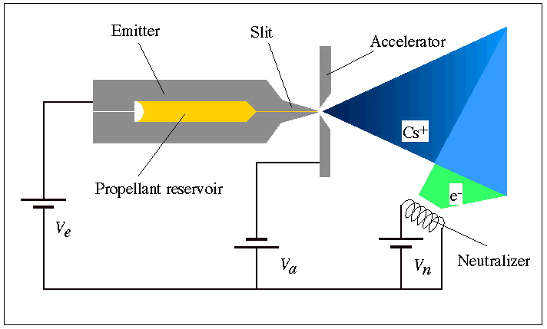

**Diagram 1:** FEEP Ion Thruster 3

From this diagram, we were able to see that the voltage Va could be changed to induce a different electric field in the ring. This is a very significant parameter that we determined we would change later in our experiment.

Next, we were able to find a research paper from the University of Michigan that included many equations related to thrust, voltage, mass of the rocket, and other variables we were interested in controlling in our simulation.

|  |  |
| --- | --- |
| **Parameters** | **Realistic Values** |
| Specific impulse (seconds) | 6,000-12,000 |
| Thrust (N) | 1 µN - 1 mN |
| Common propellant | Indium/Cesium |
| Thruster mass (g) | 3-200 |
| Impulse bits (nN-sec) | 1-1,000 |
| Prop. Electrical conductivity (S/m) | 100000 |

**Table 1:** FEEP Values 1

These parameters were helpful because they gave us a number of realistic values for different variables so as to find realistic results for the other variables we wish to observe. We were able to find several equations related to FEEP thrusters that used these parameters.

$$Thrust=Force=u\frac{dm}{dt}=ma (1)$$

$$a=∆v=u*ln\left(\frac{m_{i}}{m_{f}}\right) (2)$$

$$Ion Velocity \left(u\right)= \sqrt{\frac{2*q*V}{m}} (3)$$

The variables are defined as the following:

Equation (1)

u is the velocity of the ejected particles

m is mass of rocket

dm/dt is the change in mass over change in time

a is acceleration of rocket

Equation (2)

Delta v is the acceleration of rocket

u same as equation 1

mi initial mass of rocket

mf final mass of rocket

Equation (3)

q charge of ejected ion

V voltage applied

m mass of ion

By manipulating equations 1, 2, and 3 we came up with this equation:

$$Thrust=\left(m_{i}-r*t\right)*\sqrt{\frac{2*q*V}{m}} * ln\left(\frac{m_{i}-r*(t-1)}{m_{i}-r*t}\right)$$

$$r=I_{s}*m$$

Is is ion per second

m is mass of ion (eg. kg/ion)

r is mass of ion per second (mass lost due to fuel)

We modeled Thrust Vs. Time, Thrust/dt Vs. Time (Derivative of Thrust over Time), Thrust Vs. Voltage, Velocity vs. Time, and Thrust Vs. Time again for ion ejected at speed of light for three different liquid metals, Cesium, Indium, and Mercury. To do this we used different ion mass. This ion mass is found using the atomic mass of the element divided by Avogadro’s constant. For these equations, we made the assumption that the mass of an ion is equal to the mass of an atomic and the charge would just be the charge of one electron. The rocket mass was set to 1999.8 kg and fuel mass of 200 g. An equation for r could not be found, thus 15 sets of graphs were generated, each with varying r (IonFlowRate), r-value spans from 109 to 1023. The Thrust Vs. Time graphs were held at constant voltage (10kV). The Thrust Vs. Voltage graph was held at constant time. The time domain is from [1, 100] seconds and the voltage domain is from [10, 1000] kilovolts.

**Results and Discussion**

The graphs below show the various tests that had been made with changing Ion Flow Rates for all three different fuel types. As the graphs of down the Ion Flow Rate increases. The first graph shows the change of Thrust over Time for the three different fuel types. The second graph shows the change of Thrust acceleration over time. The middle graph shows the change of thrust over Voltage. The fourth graph shows the change of Thrust acceleration over Voltage at the speed of light. Finally, the last graph shows the change of Velocity over time. This organization is used for all the different gaphs of the tests preformed.

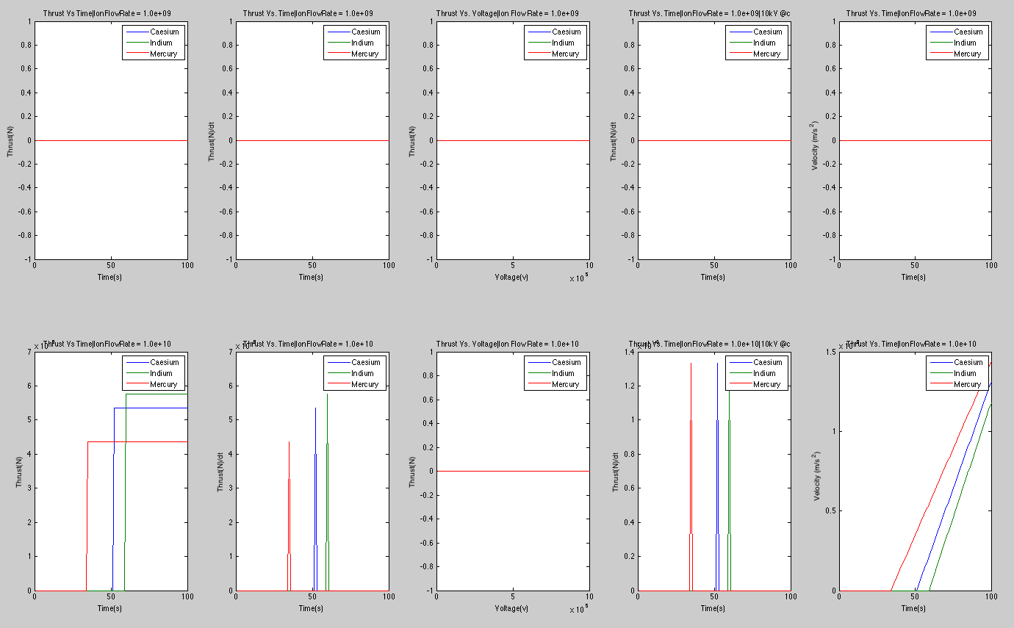

Figure 1

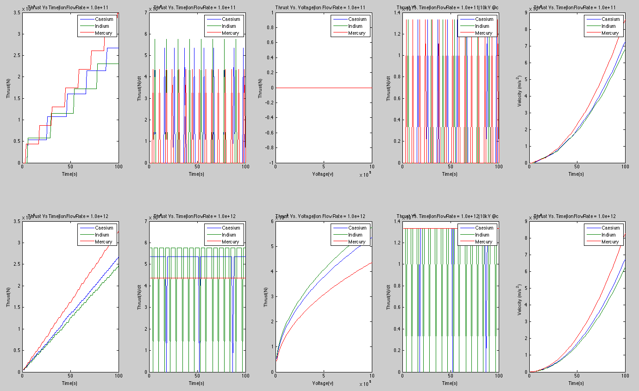

Figure 2

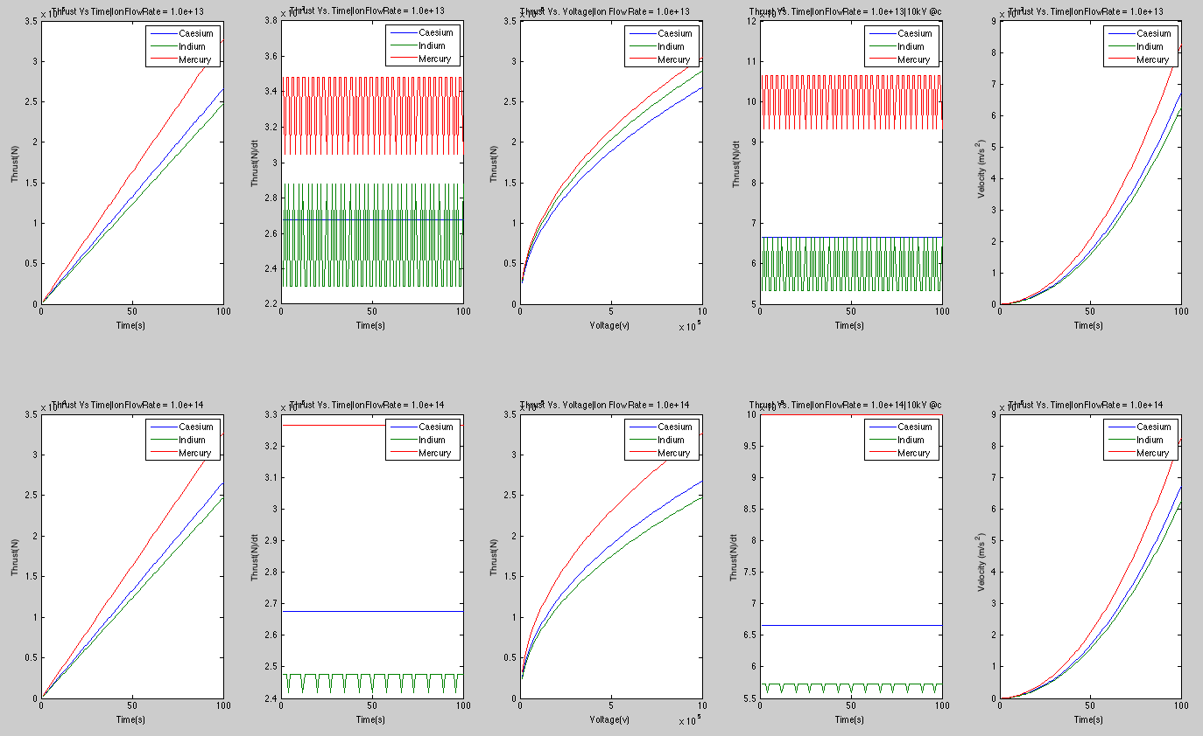

Figure 3

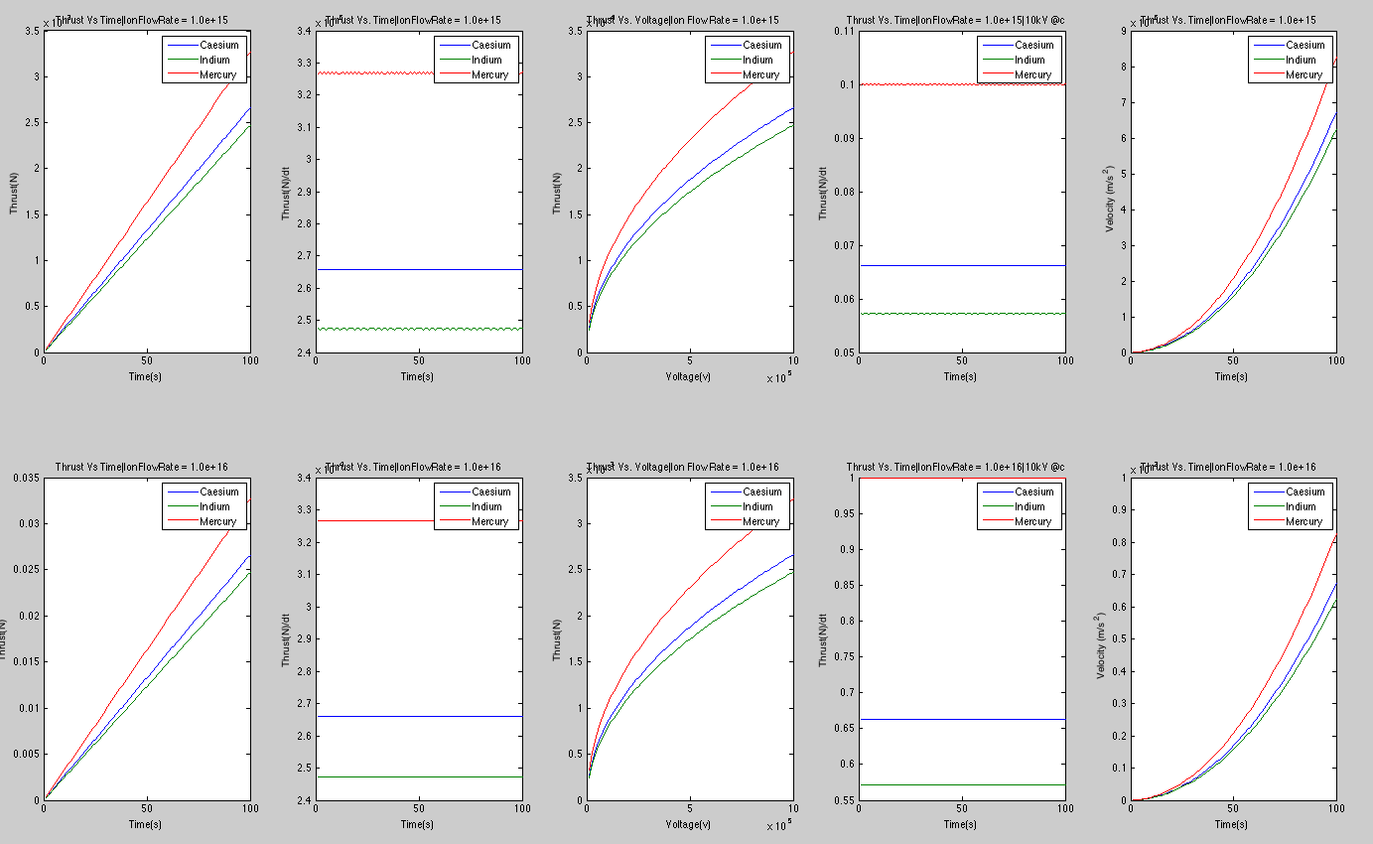

Figure 4

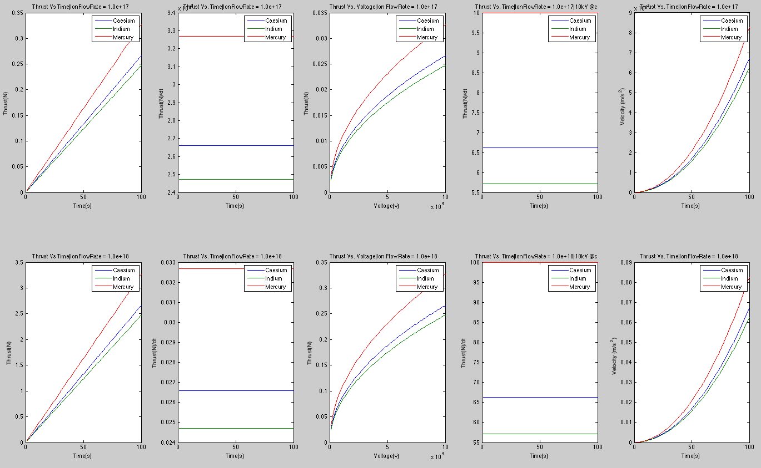

Figure 5

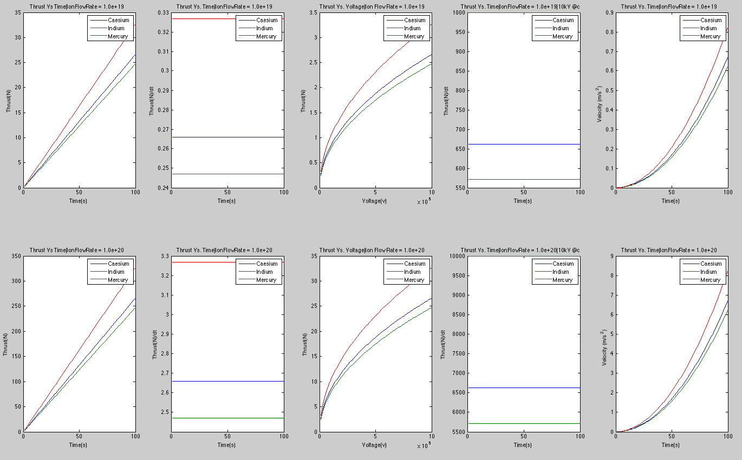

Figure 6

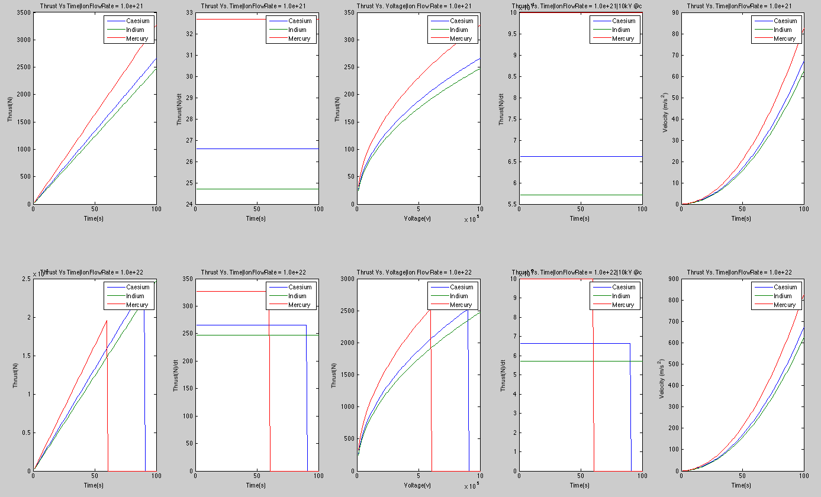

Figure 7

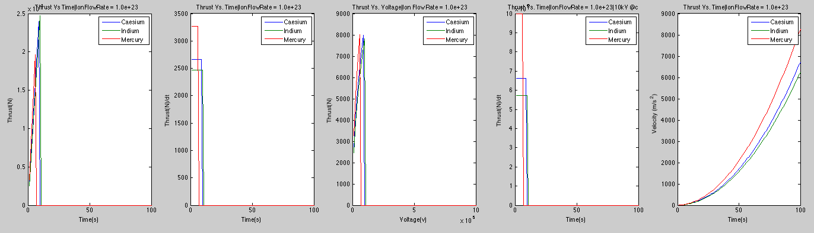

Figure 8

Looking at Figure 1, we see that the ion flow rate is less than 109 the thrust is just 0. This is because there not enough change in mass to produce a thrust. Once the ion flow rate reaches 1010 we see a spike in thrust. Each element spike at a different point in time and with varying thrust. Mercury, the element with the highest atomic mass happens to spike first. Follow by Indium and Caesium. Surprisingly, Indium has the lowest mass of three elements. This shows that the spike occurrence is not determined by the atomic mass. The Thrust Vs. Voltage graph is still 0 because the constant time I used was between 1 and 2 seconds, which is not where the thrust spikes.

In Figure 2, the ion flow rate reaches 1011 and 1012 we start to see some interesting behavior. On the Thrust/dt Vs. Time we see harmonic impulses. With Indium having the greatest peak thrust follow Caesium and Mercury. As the ion flow rate increases we see that the impulse increases. The extreme case in which particle is ejected at speed of light is similar to it normal case. On the Thrust Vs. Time graph we see staircase behavior from the thrust. As the ion flow rate the steps become smaller. On the Thrust vs Voltage graph we see a flat line at zero for ion flow rate at 1011 and a downward concave curve at 1012 . The Velocity Vs. Time shows a upward concave curve increasing over time.

In Figure 3, Thrust Vs. Time we see the absence of the stair case behavior. As ion flow rate increases the Thrust behavior becomes linear with constant slope. In Thrust/dt Vs. Time graph Caseium changes to a constant while Mercury and Indium are harmonic with time. As ion flow rate from 1013 to 1014 we see that Mercury has become constant. The behavior of the Thrust Vs. Voltage and Velocity Vs Time remain the same except with a increase in magnitude.

From figure 4 to figure 7, ion flow rate of 1015 to 1021 the general behavior of all the graphs remain the same. The only things that changed are the magnitude of thrust and velocity. In figure 7, once the ion flow rate reaches 1022 we see that the thrust goes to zero on the plot. This is because all the fuel is used up. The heavier elements hit zero faster than the lighter elements. This behavior is carried over in figure 8. The Velocity Vs. time graph is incorrect. Once fuel runs out Thrust is 0 and acceleration is 0, the velocity should not be increase. Instead it should flatten out at the point where fuel runs out.

**V. Conclusions**

Through our Matlab simulations, we were able to gather data about thrust, acceleration, and velocity in relation to voltage and time based off of realistic FEEP parameters. Using the equations in our report, our simulation resulted in thrust between tens of microNewtons to a few milliNewtons. Thrust increased with increasing voltage and decreasing mass, just as expected. Thrust of course changed slightly when comparing the different fuels of Cesium, Indium, or Mercury, due to differing atomic masses. Nonetheless, the shape of the graph remained the same.

Through our research, we found that FEEP ion thrusters were used for minor adjustments to velocity and propulsion in space. This explains the low thrust in the graphs above, which led to the acceleration and velocities in the millimeters per second. These small velocities mean quite a bit to the minor adjustments to a spacecraft’s movement through space. Because of this, the FEEP ion thrusters are incredibly useful in minor adjustments, but not the main propulsion of the rocket.

In our project, we were also concerned with some extreme cases related to FEEP. We were able to change the parameters to non-realistic values for voltage, ion flow rate, and the velocity of the ions to see how they affected the thrust and resulting velocity of the rocket.  From the graphs, we saw that an initial rise in voltage led to a significant increase in thrust.  For unrealistic values of voltage though, the thrust did not increase by much.  This supports a realistic, optimal voltage that is easy to achieve and still yields significant thrust.  An increased ion flow rate also led to an increased thrust.  Since thrust is a logarithmic equation, this makes sense.  As the ion flow rate reached extreme values, thrust did not increase by as much.  This increased ion flow rate correlated to an increase in the ion ejection velocity.  The graphs are similar shapes then, since if the ions move faster move through a given point, more ions will be able to be ejected.

In conclusion, with our simulation a field emission propulsion device is a feasible form of propulsion for space crafts.

**VI. Works Cited**

1 http://ngpdlab.engin.umich.edu/files/papers/VanderWyst.pdf

2 http://ngpdlab.engin.umich.edu/electric-propulsion/field-emission-electric-propulsion

3 http://eotvos.dm.unipi.it/ggweb/phaseA/chapter4/chapter4_2.html