# Service Name: eBay Data

## Purpose

* Isolate all applications from direct access to the eBay database. Provide all needed business functionality.

## eBay’s Star Ranking Explanation

On the eBay website, every seller has a star ranking. For every seller’s feedback, the buyer rates the seller through a star ranking system. The buyer has three options to rate the seller: positive, neutral, and negative experience. For each positive rating, the seller receives 1 star. A negative review decreases the sellers’ star by 1. Figure 1 shows eBay’s star ranking guide.

**Figure 1: Star Ranking Guide**

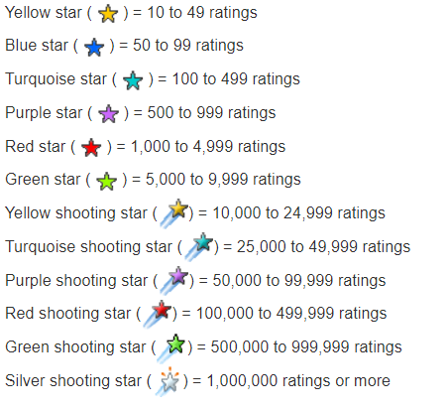

## Database Used

* EBAY (Read, update, insert, delete)
* In the database, we added a new attribute called StarRank in the Seller entity. StarRank counts the total number of the seller’s stars. See figure 1 and 2 for an updated schema and entity.

**Figure 2: Updated eBay Database Schema**

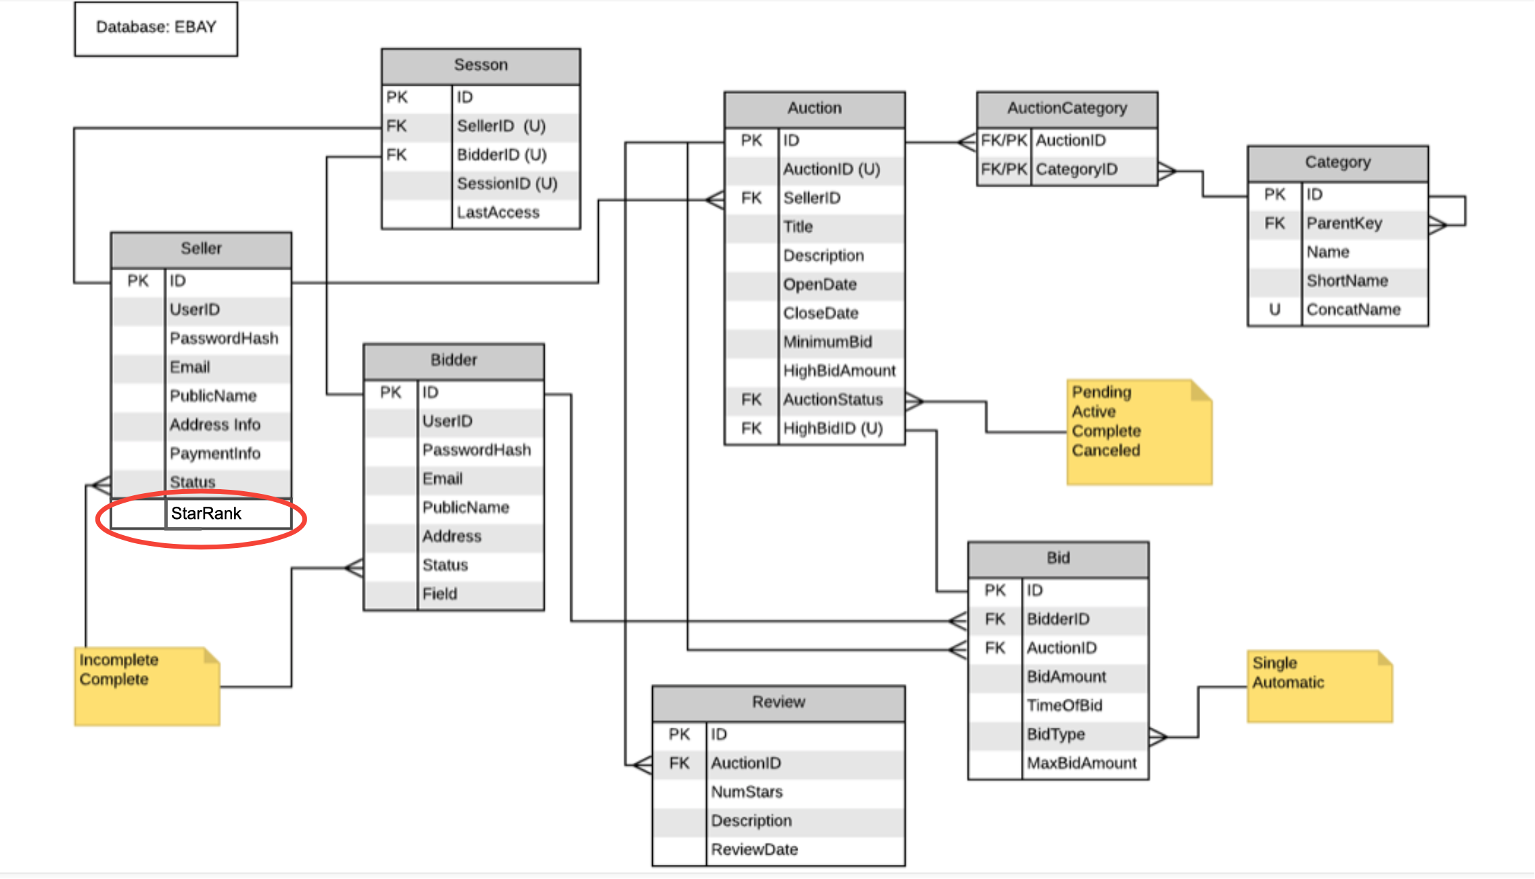

**Figure 3: Updated Seller Entity**

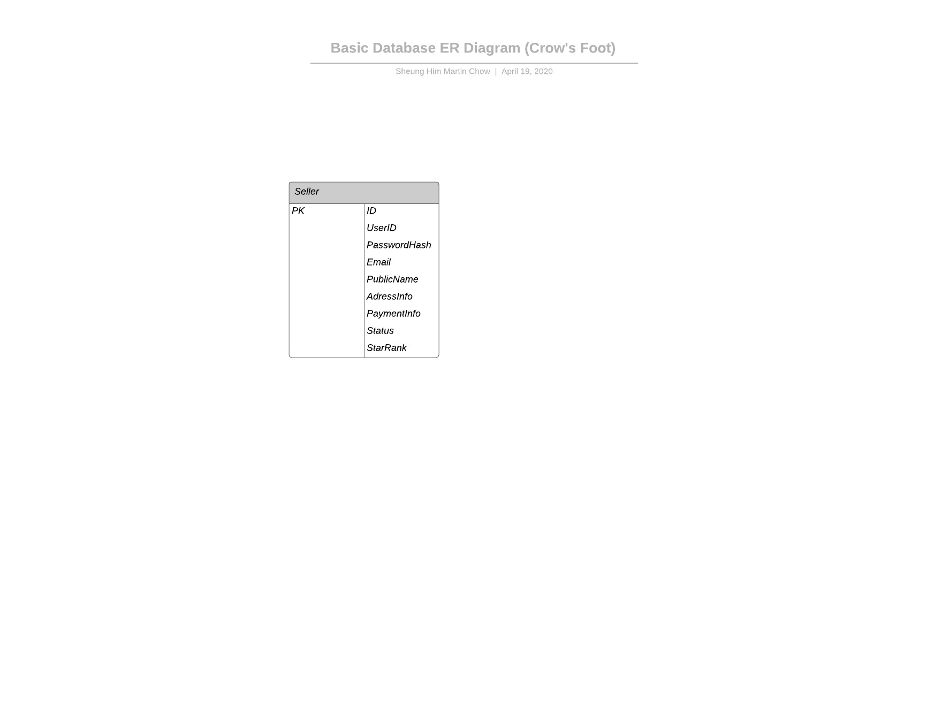

## New External Synchronous, Point to Point API Calls:

* InsertReview
  + When a review is inserted, StarRank takes the review and updates it according to the eBay’s protocols explained in StarRank.
* FindStarRanking
  + It finds the star ranking of the auction’s seller by entering the AuctionID and retrieving the ranking to the user.

## New Internal Synchronous Point to Point API Calls:

* StarRankUpdate
  + StarRank updates after a new review is inserted. It updates the seller’s starRank by adding 1, 0, or -1 to the current starRank.

## 

## Selected API Details:

### InsertReview

When a review is inserted, StarRank takes the review and updates it according to the eBay protocols explained in StarRank.This is intended to be used by the bidders.

In most cases, members receive:

* +1 point to your Feedback Score for each positive comment and rating left for you.
* No points for a neutral comment and rating left for you.
* -1 point to your Feedback Score for each negative comment and rating left for you.

InsertReview {AuctionID <string> , Numofstar <int> , description <string>}

{reply: “Success, Rank +1”}

{reply: “Success, Rank -1”}

{reply: “Success, Rank + 0”}

{reply: “Invalid Review”}

### FindStarRanking

It finds the star ranking of the auction’s seller by entering the AuctionID and retrieving the ranking to the user. It returns the seller’s public name, email address, and star rank. This is intended to be used by the bidders and buyers.

FindStarRanking {AuctionID: <string>}

{reply: “success”, starRank <integer>}

{reply: “InvalidAuctionID”}

## Trade-Offs

### Advantages

* The system does not need to calculate starRanking every time a buyer is looking for it
* The amount of the user’s review does not affect the search time

### Disadvantages

* Adding a review requires more steps for the database. When a buyer submits a new review, we need to update the star ranking
* We need to store more information about the seller