**Project 5 Group 5**

**Name: Chow Sheung Him Martin, Ahmed Elwalid, Yanling Zhu, Patrick Lam**

**Business Problem**

Amazon Database is getting overloaded and it needs to be fixed before it dies. Also, there is latency in different fulfillment centers that caused the system to be slow.

**Schema**

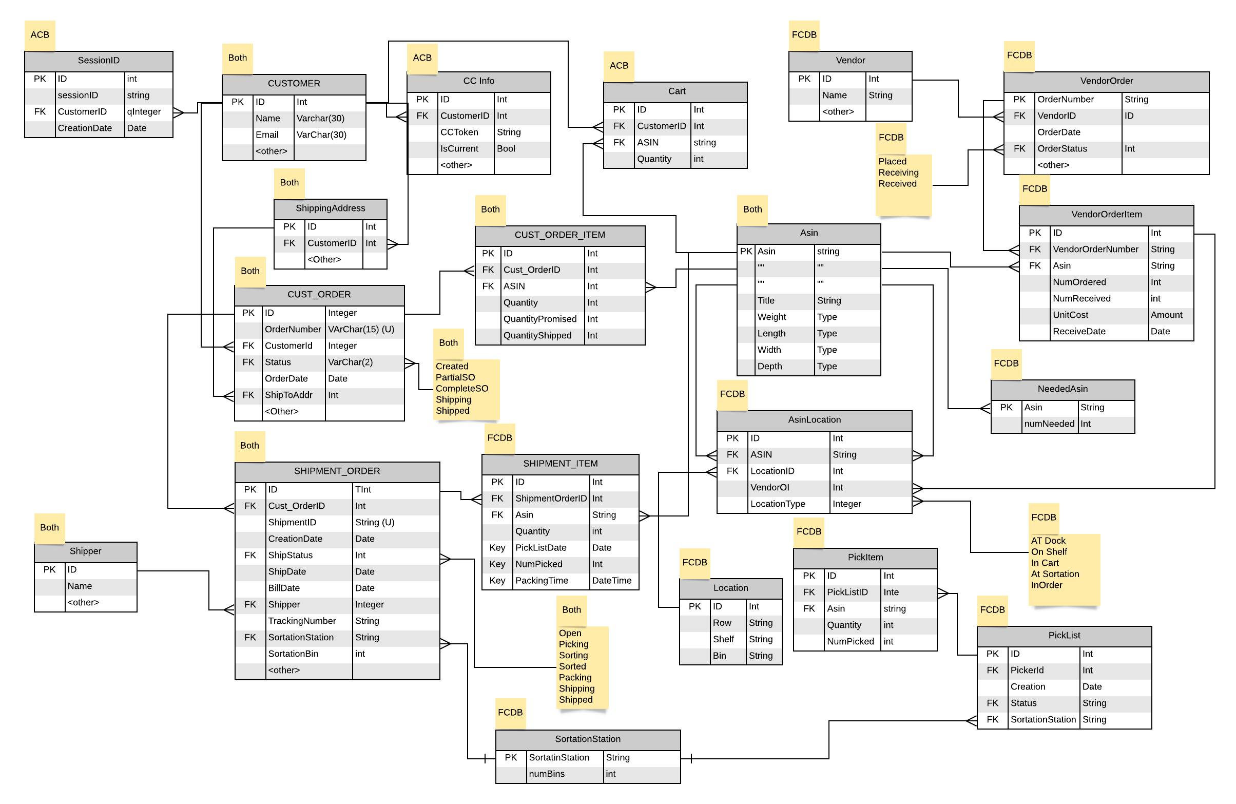

**Solution**

Making copies on some tables in ACB to create FCDB that only uses tables required for the fulfillment center functions. Reduce the workload and risk of crashing by dividing the difference update job to difference FCDB. We will use replication to update the tables that are shared between both databases.

Customer:

* Create ACB -> FCDB

Shipping Address:

* Create ACB ->FCDB

Cust_Order:

* Create ACB -> FCDB
* Status update FCDB -> ACB
* ACB may change Status from Created to Canceled.

Cust_Order_Item:

* Create ACB -> FCDB
* Quantity shipped update FCDB -> ACB

Asin:

* Create FCDB ->ACB

AsinLocation:

* Create FCDB ->ACB

Shipping_Order:

* Create ACB -> FCDB
* Status, shipper, sortstation, sortstationbin, shipDate updated FCDB ->ACB

Shipping_Item:

* Create FCDB->ACB
* Quantity update ACB ->FCDB

Shipping Address:

* Create ACB->FCDB

Shipper:

* Create FCDB

Use cases after changes(What database is use and what tables is include)

1. Customer logging on
   * Database: ACB
   * Table:SessionID Customer
2. searching and putting items in cart
   * Database: ACB
   * Table:SessionID Customer Cart
3. Creating the Customer Order<process on ACB>
   * Database: ACB
   * Table: Asin SessionID Customer Cart ShippingAddress CUST_ORDER CUST_ORDER_ITEM
4. Creating a Shipment Order<change the update by FCDB base on the status>
   * Database: FCDB
   * Table:Shipment_Order SHIPMENT_ITEM cust_order custoreritem asin asin_location, sortationstation
5. Shipment Overview
   * Database: FCDB
   * Table:Shipment_Order SHIPMENT_ITEM cust_order custoreritem asin asin_location
6. Pick List and Picking<change>
   * Database: FCDB
   * Table:Shimpent_order SHIPMENT_ITEM location asin_location location picklist PickItem SortationStation
7. Assembling the order
   * Database: FCDB
   * Table:Shimpent_order SHIPMENT_ITEM picklist pickitem sortationstation
8. Shipping
   * Database: FCDB
   * Table: Shimpent_order SHIPMENT_ITEM shipper
9. Deciding what to buy
   * Database:FCDB
   * Table: AsinLocation NeededAsin VenderOrderItem CustomerOrder_Item
10. Ordering
    * Database:FCDB
    * Table: Vendor VendorOrder VendorOrderItem NeededAsin
11. Receiving inventory into the FC and putting it on shelves
    * Database:FCDB
    * Table: VendorOrder VendorOrderItem asin asin_location location
12. Browse my orders
    * Database:ACB
    * Table: SessionID customer cust_order cus_order_item SHIPMENT_ITEM Shipper shipment_order