VALIDATION:

I have 5 different data nodes all of which are integers. The values from the micro bit are sent to the micro bit and the firebase. I had to validate all the data from the values of the dictionaries to see if they were integers. All the inputs originated from the micro bit. To validate the data I had to retrieve the data from Firebase using Python.

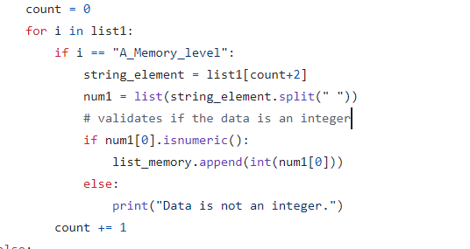

In this code, the loop goes through the database finds the key to memory_level and gets the right value. It then checks if the data is numeric if not it displays a message. There are no unexpected inputs because the micro-bit only allowed for the button to be pressed therefore there is no proper validation needed.

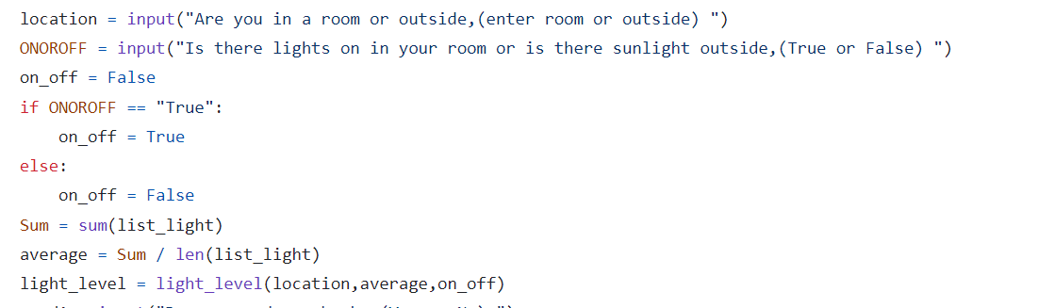

In this code, the three different data type parameters are inputted by the user.

This is done for age and memory as my 2 what if questions are related with age and light to memory.

TESTING:

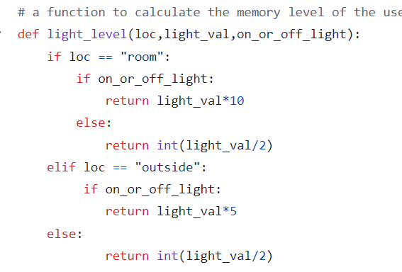

This code checks the parameters if they are true if it’s not then it defaults to a value.

As you can see the actual results are all valid it is because if they wrote the wrong input it will go to the condition as if the user made the false input for example the user has to write True or False but they write 456, the code will just return as if the user wrote False.

|  |  |  |  |
| --- | --- | --- | --- |
| Test Data | Expected Result | Actual Result | Pass |
| “room” | Valid | Valid | Y |
| 7 | Invalid | Valid | Y |
| “P” | Invalid | Valid | Y |
| 5.23 | Invalid | Valid | Y |