MCCI USB Switch 3141/3201 GUI User Guide

Engineering Report 950001552

Rev A950001552 Rev ARev A

Date: 2020-06-30

Copyright © 2020

All Rights Reserved

**PROPRIETARY NOTICE AND DISCLAIMER**

Unless noted otherwise, this document and the information herein disclosed are proprietary to MCCI Corporation, 3520 Krums Corners Road, Ithaca, New York 14850 (“MCCI”). Any person or entity to whom this document is furnished or having possession thereof, by acceptance, assumes custody thereof and agrees that the document is given in confidence and will not be copied or reproduced in whole or in part, nor used or revealed to any person in any manner except to meet the purposes for which it was delivered. Additional rights and obligations regarding this document and its contents may be defined by a separate written agreement with MCCI, and if so, such separate written agreement shall be controlling.

The information in this document is subject to change without notice, and should not be construed as a commitment by MCCI. Although MCCI will make every effort to inform users of substantive errors, MCCI disclaims all liability for any loss or damage resulting from the use of this manual or any software described herein, including without limitation contingent, special, or incidental liability.

MCCI, TrueCard, TrueTask, MCCI Catena, and MCCI USB Data Pump are registered trademarks of MCCI Corporation.

MCCI Instant RS-232, MCCI Wombat and InstallRight Pro are trademarks of MCCI Corporation.

All other trademarks and registered trademarks are owned by the respective holders of the trademarks or registered trademarks.

Copyright © 2020 by MCCI Corporation.

Document Release History

|  |  |  |
| --- | --- | --- |
| Rev A | 2020-06-30 | Initial Release |

**Table of Contents**

1 Introduction 5

2 Device Description 5

2.1 Model 3141 USB4™ Switch 5

2.2 Model 3201 Enhanced Type-C Connection Exerciser 6

3 Download and Installation 7

4 MCCI USB Switch 3141/3201 GUI Overview 7

5 GUI Features and Options 9

5.1 Device Selection 9

5.2 Model 3201 UI Control Window 10

5.3 Model 3141 UI Control Window 11

5.4 Modes of Operation 11

5.4.1 Manual Mode 12

5.4.2 Auto Mode 12

5.4.3 Loop Mode 13

5.5 USB Tree View Changes 15

5.6 Log Window 16

5.7 Disconnect & Close the Application 16

5.7.1 Disconnect 16

5.7.2 Close 16

5.8 Disconnect Pop-up Notification 17

6 Getting Help 17

**List of Tables**

Table 1 Select Model Options 10

Table 2 Model 3201/3141 Manual Mode Control Options 12

Table 3 Model 3201/3141 Auto Mode Control Options 13

Table 4 Model 3201/3141 Loop Mode Control Options 14

Table 5 Model 3201/3141 Loop Mode Configuration Default Values 14

**List of Figures**

Figure 1 Model 3141/3201 GUI Overview 5

Figure 2 Model 3141 USB4 Switch 6

Figure 3 Model 3201 Type-C Connection Exerciser 6

Figure 4 Status Bar 7

Figure 5 Menu Bar 8

Figure 6 Device Selection 9

Figure 7 Model 3201 UI Control Window 10

Figure 8 Model 3141 UI Control Window 11

Figure 9 Model 3201 Auto Mode Controls 12

Figure 10 Model 3141 Auto Mode Controls 13

Figure 11 Model 3201/3141 Loop Mode Controls 14

Figure 12 USB Device Tree View Change Control Options 15

Figure 13 Log Window 16

Figure 14 Disconnect Pop-up Notification 17

# Introduction

MCCI® develops a common UI “MCCI® USB Switch 3141/3201 GUI” to control the Model 3141 USB4™ Swtich and Model 3201 Enhanced Type-C Connection Exerciser. This document provides instructions on how to use features provided by the GUI application and other available control options. GUI overview is shown in the Figure 1

Figure 1 Model 3141/3201 GUI Overview

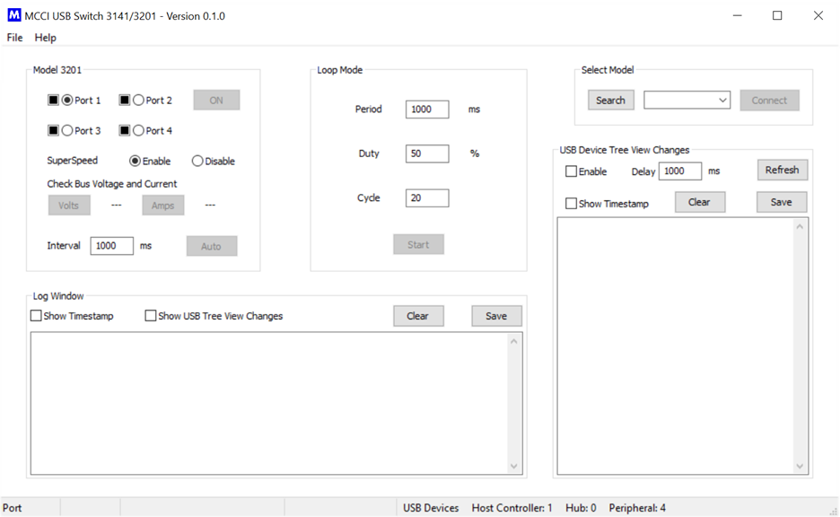

# Device Description

## Model 3141 USB4™ Switch

The MCCI® Model 3141 USB4™ Switch is a computer-controlled programmable 2:1 switch, connecting two USB Type-C™ receptacles to a single Type-C plug. It is compatible with USB4 hosts and devices, as well as older protocols such as Thunderbolt™ 3, USB 3.2 gen2 or gen1, USB 2.0, USB Type-C Alternate Modes, and of course Power Delivery.

The Model 3141 USB4 Switch automates connect/disconnect of one or two devices to a USB Type-C port. It can be used in stress testing, switching between peripherals (for example, a dock and a display), or any automated reconfiguration of a USB Type-C port. For more information, see the [product home page](https://mcci.com/usb/dev-tools/model-3141/) at [www.mcci.com](http://www.mcci.com).

Figure 2 Model 3141 USB4 Switch

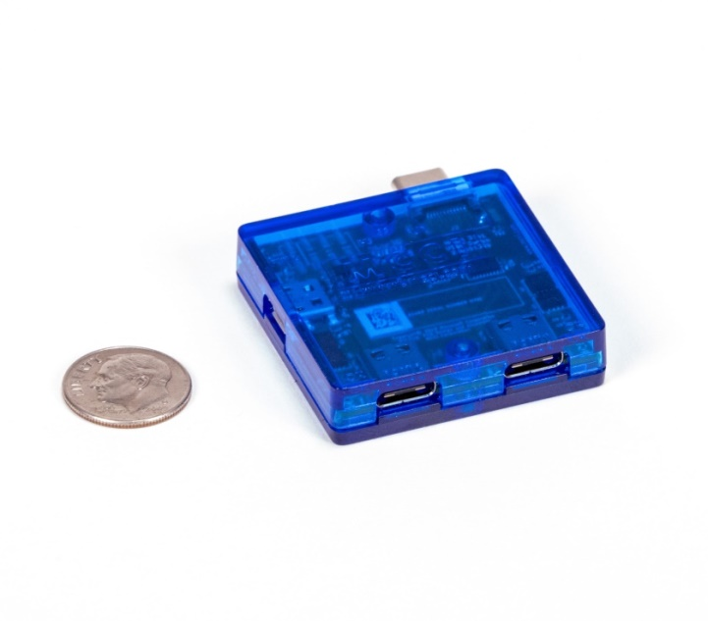

## Model 3201 Enhanced Type-C Connection Exerciser

The MCCI model 3201 Enhanced Type-C Connection Exerciser (MUTT ConnEX-C) plugs and unplugs up to 4 USB-C® devices for automated testing of USB Type-C® products. For more information, see the [product home page](https://mcci.com/usb/dev-tools/3201-enhanced-type-c-connection-exerciser/) at [www.mcci.com](http://www.mcci.com).

Figure 3 Model 3201 Type-C Connection Exerciser

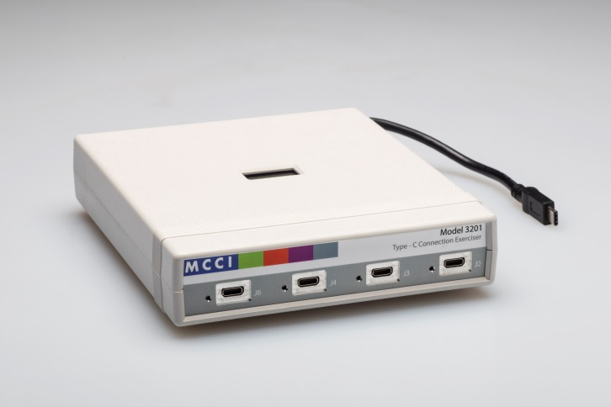

# Download and Installation

Download the installation setup for “MCCI USB Switch 3141/3201 GUI” software from [here](https://portal.mcci.com/portal/kb/articles/MCCI-GUI-3141-3201); Knowledge base section in MCCI portal (<https://portal.mcci.com/portal/kb> ).

# MCCI USB Switch 3141/3201 GUI Overview

When the installation successfully completes, execute “UI3141-3201” file, from Start → All Programs, or from the shortcut provided on the desktop. When the application starts, the following GUI screen displays as Figure 1. The GUI window contains these sections:

* Select Model: Listed the number of devices attached in it and the user can select the device to be controlled.
* Model 3201/3141 Ports Control: It has the option to control the ports of the device, this varies for Model 3141 and 3201.
* Loop Mode: Switch the selected port in cyclic mode.
* USB Tree View Changes: It displays the features of the attached Devices on to the port.
* Log Window: Print the device’s switching activity logs with timestamp.
* Status Bar: It displays the status of the connected switch devices and control system’s USB controller status. As shown in Figure 4
* Menu Bar: It has a File and Help menu. As shown below in Figure 5

Figure 4 Status Bar

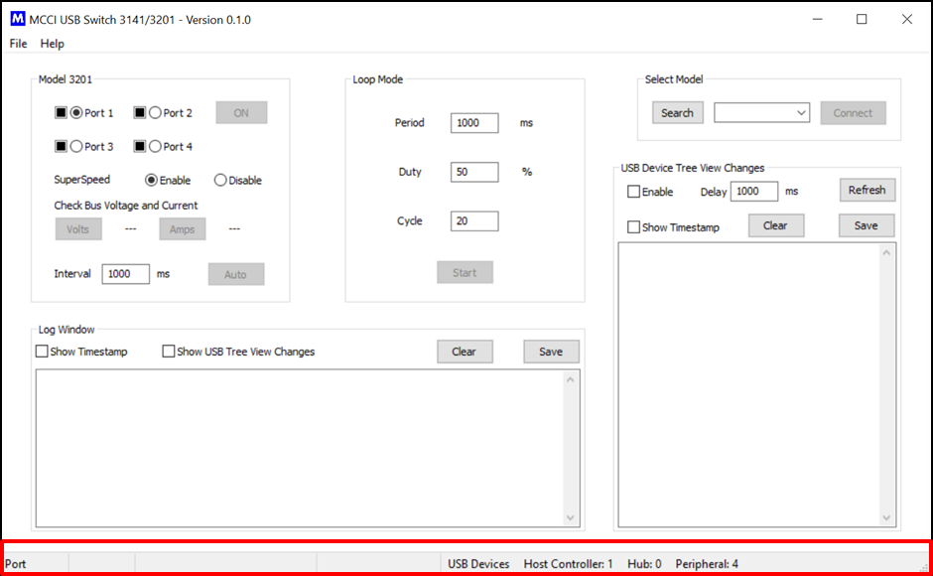

Figure 5 Menu Bar

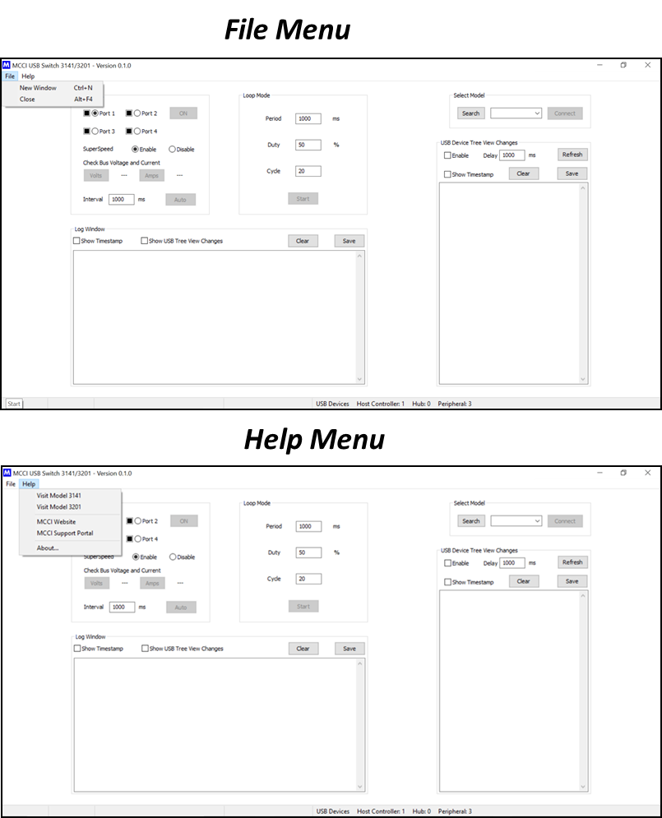

# GUI Features and Options

The GUI features and options are explained in this section.

## Device Selection

The GUI can automatically detect the 3141 and 3201 models. The devices 3201 or 3141 can be selected from the Select Model tab as shown in Figure 6.

Figure 6 Device Selection

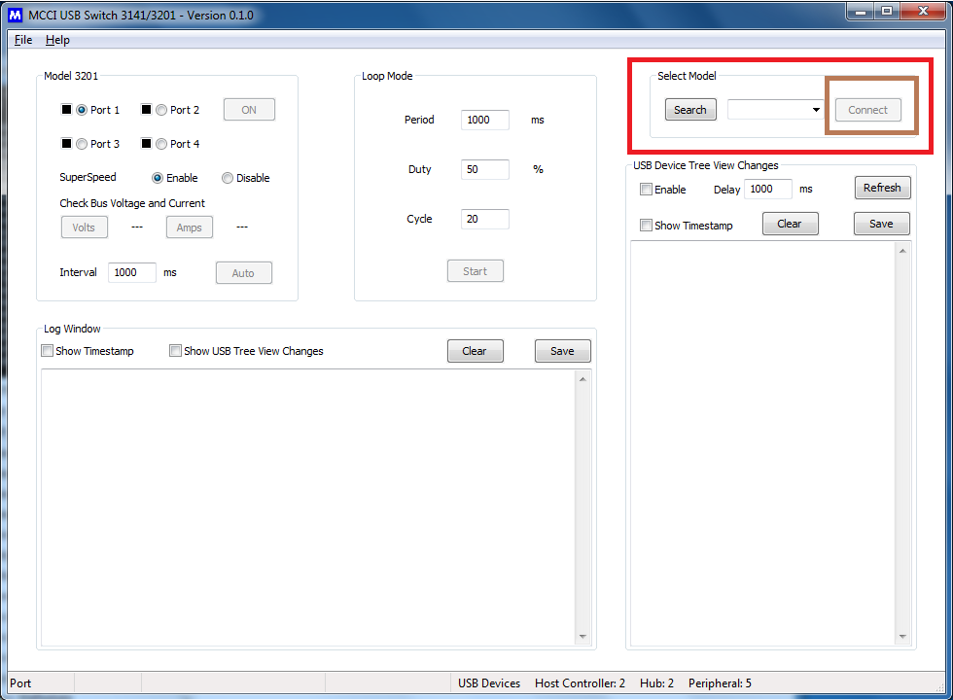

Once the device is selected, Click Connect*.* Search button in the Select Model will check the number of devices connected on to port(s) and also about the details of the attached device(s) (list of 3141 and 3201). From the drop down list user can select a device and control that using the GUI. Depends on the selected device model, UI structure changes dynamically to match the number of ports in the devices

The Select Model Icons and descriptions are mentioned in Table 1.

Table 1 Select Model Options

|  |  |
| --- | --- |
| **Control Option** | **Description** |
| **Search** | Clicking on that Search Button will show the attached devices in the USB bus/network |
| **Connect** | Clicking on that Connect Button, connect the selected device |
| **Disconnect** | Clicking on that Disconnect Button, Disconnect the selected device |

## Model 3201 UI Control Window

The control window of 3201 appears in the UI, when the 3201 device is selected from the Select Panel as shown in Figure 7.

The control options of Model 3201 are explained below:

* Four radio buttons to select the active port
* ON/OFF switch to control the port state.
* Radio button to Enable/Disable the SuperSpeed lines
* Volts and Amps button prints the VBUS voltage and current consumption with direction
* Auto switch (continuously switch between the ports in the defined interval)
* Window to provide an auto-mode switching interval

Figure 7 Model 3201 UI Control Window

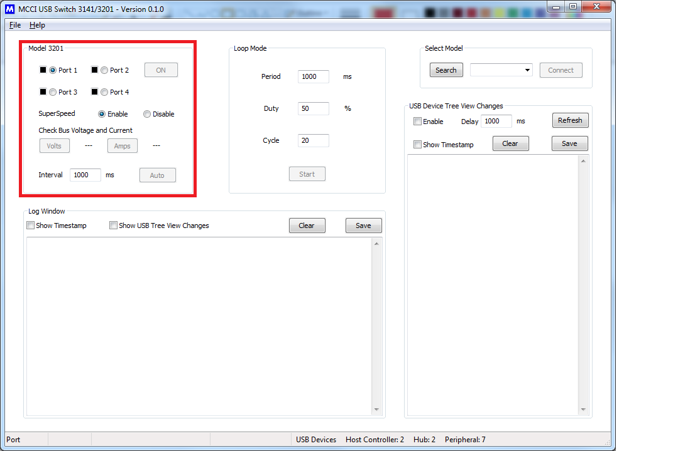

## Model 3141 UI Control Window

The control window of 3141 appears in the UI, when the 3141 device is selected from the *Select Panel* as shown in Figure 8.

The control options of Model 3141 are explained below:

* Two radio buttons to select the active port
* ON/OFF switch to control the port state.
* Check Orientation button to show the Type-C connector connection (Normal/Flip)
* Volts and Amps button prints the VBUS voltage and current consumption with direction
* Auto mode button and a window to provide switching interval.

Figure 8 Model 3141 UI Control Window

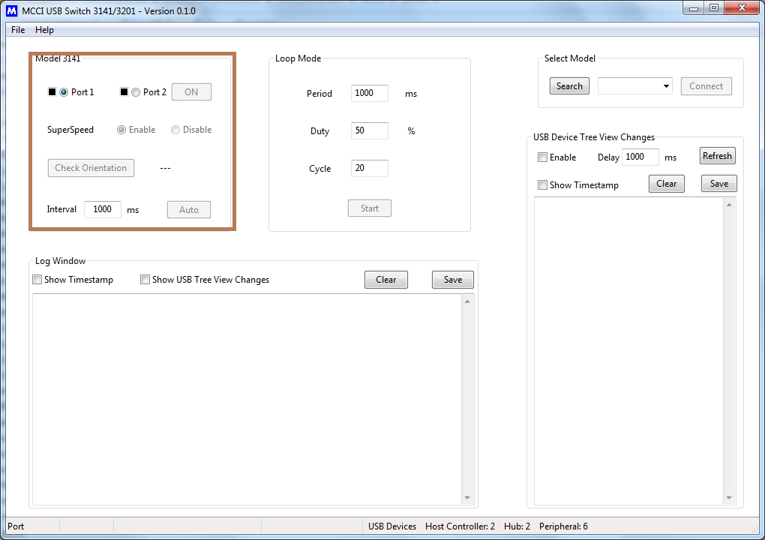

## Modes of Operation

In order to control the device, the GUI has supported 3 modes of operation

* Manual Mode
* Auto Mode
* Loop Mode

This section contains the detailed explanation about the modes.

### **Manual Mode**

* The active port needs to be selected via the radio button.
* The selected switch port can be controlled manually using ON/ OFF button in the UI as shown in the Figure 9
* Enable/Disable the SuperSpeed anytime using the radio button.
* The Model 3201 or 3141 Icon(s) and description are mentioned in Table 2.

Table 2 Model 3201/3141 Manual Mode Control Options

|  |  |
| --- | --- |
| **Icons** | **Description** |
| **PORT <n>** | Select the active port using the radio button |
| **ON/OFF** | The selected port should be ON /OFF |
| **Super speed Enable and Disable** | Enable/Disable super speed option |

### **Auto Mode**

* In GUI, the auto mode is used to switch between the available port(s) of the selected device’s continuously with configured delay (Default is 1000ms). This mode can start/stop using the Auto button show in Figure 10.

Figure 9 Model 3201 Auto Mode Controls

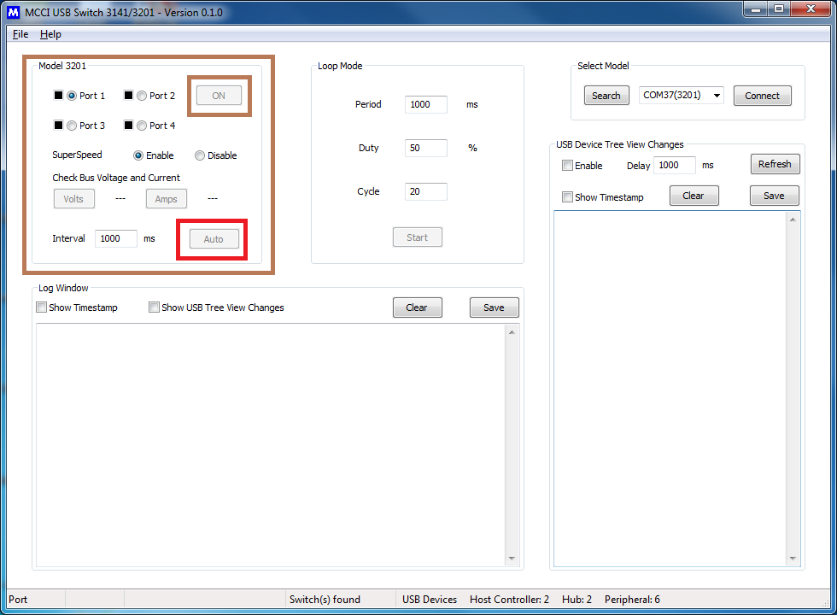

Figure 10 Model 3141 Auto Mode Controls

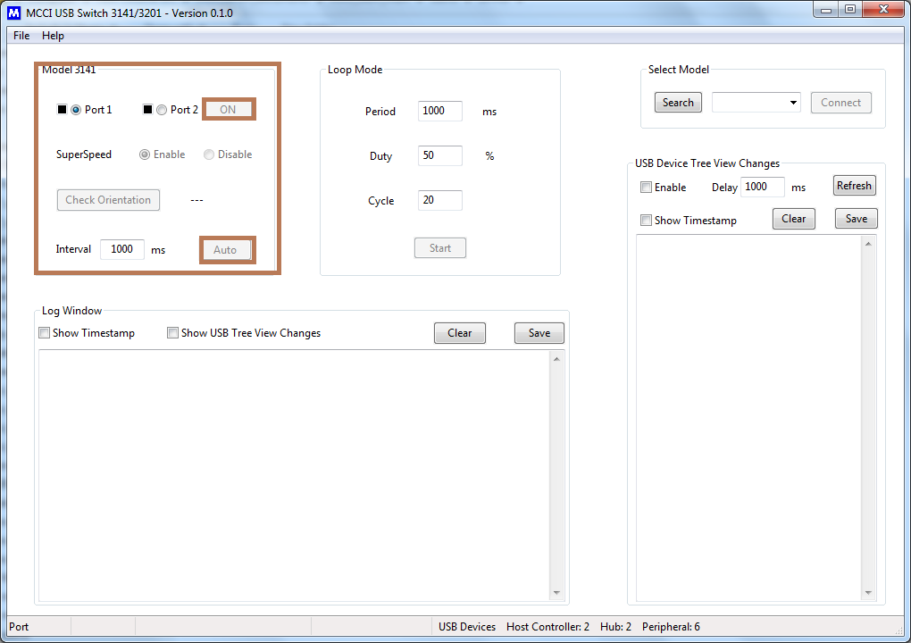

Note: If USB Device Tree Changes option is enabled, Then Delay specifies in that window is override the auto-mode interval.

The Model 3201 or 3141 auto mode control options and description are mentioned in Table 3.

Table 3 Model 3201/3141 Auto Mode Control Options

|  |  |
| --- | --- |
| **Control Option** | **Description** |
| **SuperSpeed Enable /Disable** | Enable/Disable SuperSpeed option |
| **Interval** | Auto-mode switching interval (ms); Default 1000 ms |
| **Auto/Stop** | Start/Stop the auto mode |

### Loop Mode

* In Loop Mode, active port is switch ON/OFF by given number of cycles, period, and duty.
* Before starting the loop mode, SuperSpeed enable/disable state needs to set.
* Click onthe **Start** button automatically starts the loop mode operation.
* Click on the **Stop** button to stop the loop mode operation.
* Loop mode control and its default values are shown in Figure 11.

Figure 11 Model 3201/3141 Loop Mode Controls

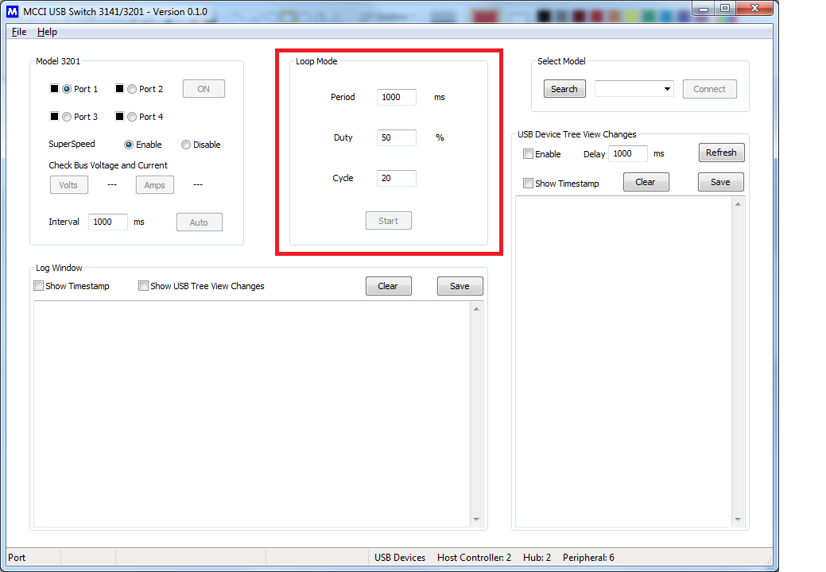

The Model 3201 or 3141 loop control options and description are mentioned in below Table 4.

Table 4 Model 3201/3141 Loop Mode Control Options

|  |  |
| --- | --- |
| **Control Option** | **Description** |
| **Period** | Time between two successive on cycle (ms) |
| **Duty** | Percentage of ON time in total time period (ON + OFF). |
| **Cycle** | Number of cycles |
| **Start/Stop** | Start the loop / Stop the loop. |

The Model 3201 or 3141 Loop mode configuration default values and Descriptions are mentioned in Table 5.

Table 5 Model 3201/3141 Loop Mode Configuration Default Values

|  |  |
| --- | --- |
| **Parameter** | **Default Values** |
| **Period** | 1000 ms |
| **Duty** | 50% |
| **Cycle** | 20 |

## USB Tree View Changes

This feature is convenient for the users to check the plug-in/plug-out list of the USB devices after every port state changes.

The options of the USB Tree View changes are explained in this section. The respective UI window is shown in the Figure 12.

* Enable: Tick the checkbox to enable USB device tree changes feature
* Delay: Min delay required for port connect/disconnect of the device (Depends on connected device enumeration time)
* Refresh: Collect the present USB device list of the system
* Show Timestamp: Option to log the device changes with timestamp
* Clear: Clears the log window
* Save: Save the log to a file in selected location

Figure 12 USB Device Tree View Change Control Options

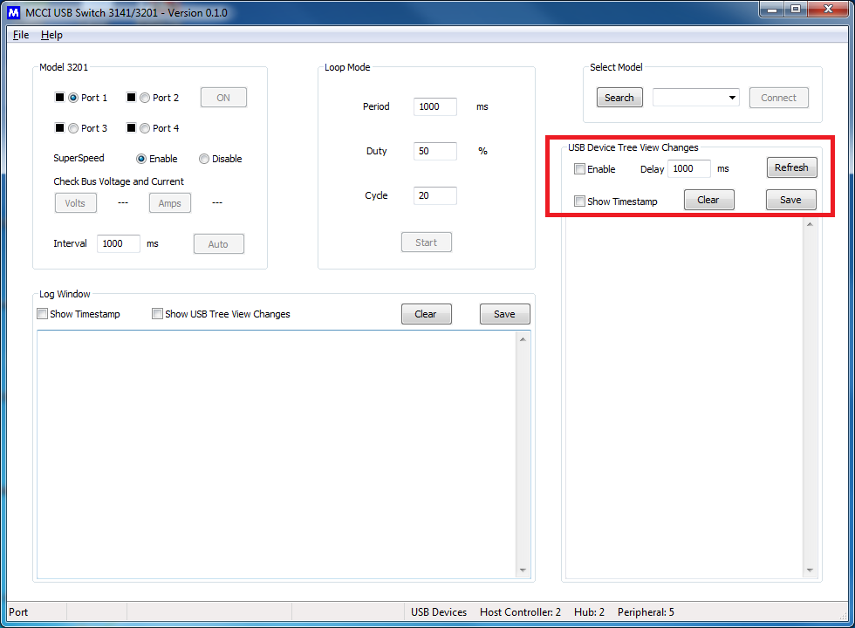

## Log Window

The log window helps to log the device activities, it has an option to enable and disable the timestamp. Log window UI show in Figure 13.

* Show Timestamp: Option to log the device changes with timestamp
* Show USB Tree View Changes: Option to merge the USB device tree view changes log in the log window
* Clear: Clears the log window
* Save: Save the log to a file in selected location.

Figure 13 Log Window

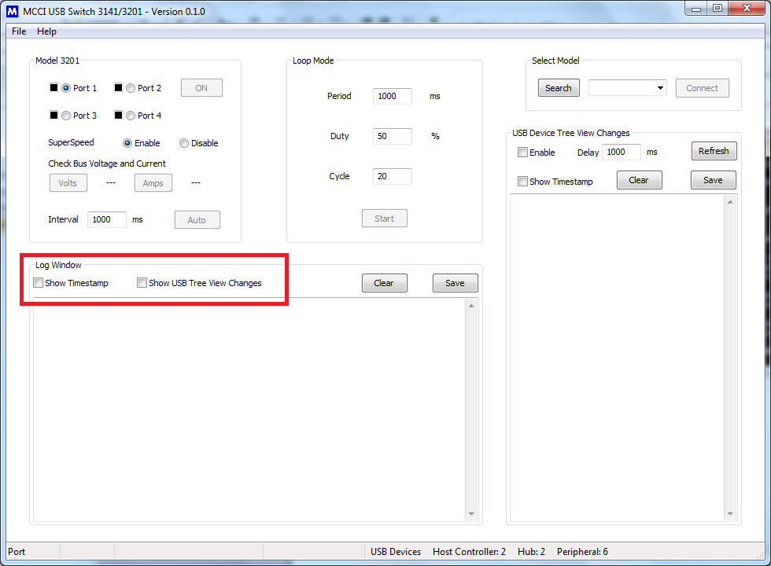

## Disconnect & Close the Application

### Disconnect

To DISCONNECT the device, click the Disconnect option from the Select Modelpanel and the selected device can be disconnected.

### Close

To Close the application. Click Close from the File Menu as displayed in Figure 5. The application is closed.

## Disconnect Pop-up Notification

The connected 3201 or 3141 device is plugged out while it’s being executed the notification message will pop up as **“Switch Disconnected!”** and the notification are shown in the Figure 14

Figure 14 Disconnect Pop-up Notification

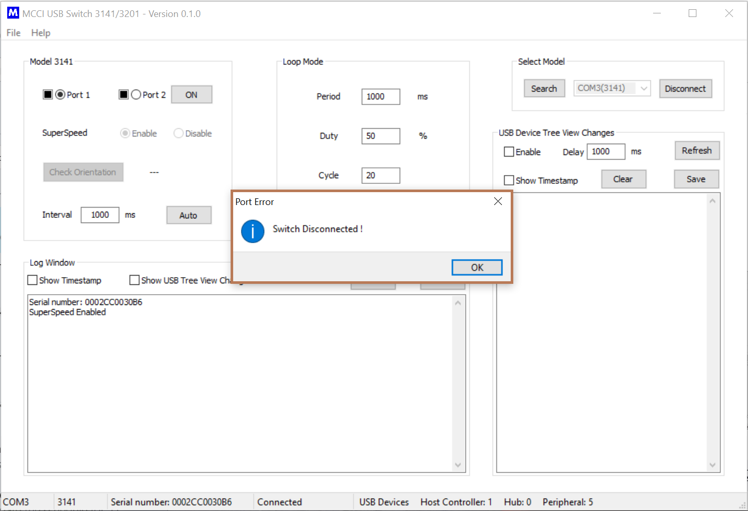

# Getting Help

If you have a question about using the GUI usage or operation, please visit MCCI’s support community. Feel free to post a question! We’ll do our best to assist, and you may benefit from the experience of others. You may also post private questions to MCCI by [opening a ticket](https://support.zoho.com/portal/mcciportal/newticket) or by sending email to [techsupport@mcci.com](mailto:techsupport@mcci.com).