MCCI Model 2450 UI User Guide

Engineering Report 950001668 950001668

Rev A950001668 Rev ARev A

Date: 2024-09-13

Copyright © 2024

All Rights Reserved

**PROPRIETARY NOTICE AND DISCLAIMER**

Unless noted otherwise, this document and the information herein disclosed are proprietary to MCCI Corporation, 3520 Krums Corners Road, Ithaca, New York 14850 (“MCCI”). Any person or entity to whom this document is furnished or having possession thereof, by acceptance, assumes custody thereof and agrees that the document is given in confidence and will not be copied or reproduced in whole or in part, nor used or revealed to any person in any manner except to meet the purposes for which it was delivered. Additional rights and obligations regarding this document and its contents may be defined by a separate written agreement with MCCI, and if so, such separate written agreement shall be controlling.

The information in this document is subject to change without notice, and should not be construed as a commitment by MCCI. Although MCCI will make every effort to inform users of substantive errors, MCCI disclaims all liability for any loss or damage resulting from the use of this manual or any software described herein, including without limitation contingent, special, or incidental liability.

MCCI, TrueCard, TrueTask, MCCI Catena, and MCCI USB DataPump are registered trademarks of MCCI Corporation.

MCCI Instant RS-232, MCCI Wombat, NerveCircuit, and InstallRight Pro are trademarks of MCCI Corporation.

All other trademarks and registered trademarks are owned by the respective holders of the trademarks or registered trademarks.

Copyright © 2021 by MCCI Corporation.

Document Release History

|  |  |  |
| --- | --- | --- |
| Rev A | 2024-09-13 | Initial Release |

**Table of Contents**

1 Introduction 5

2 MCCI Model 2450 6

3 Downloading and Installation 6

4 MCCI Model 2450 UI Overview 7

5 GUI Feature and Option 8

5.1 Select Model 8

6 Control Window 10

6.1 Manual control 10

6.2 Read with Time interval 10

7 Firmware Update 12

7.1 Firmware update Tab: 12

8 Configure 13

9 Disconnect and Close the Application 14

9.1 Disconnect 14

9.2 Close 14

10 Getting Help 14

**List of Tables**

Table 1 Connect the Mode 2450 BACK kit 8

**List of Figures**

Figure 1 MCCI Model 2450 UI Overview 5

Figure 2 MCCI Model 2450 Brightness and Color kit 6

Figure 3 Model 2450 UI v1.0.0 Overview 7

Figure 4 Model 2450 COMX selection 8

Figure 5 Connected Model 2450 to UI 9

Figure 6 Read the Light and Color values 11

Figure 7 Firmware Update Window 12

Figure 8 Blackframe Scan 13

**List of SeQUENCE Diagrams**

**No table of figures entries found.**

# Introduction

MCCI developed a common UI “**MCCI® Model2450 UI**” to control the “MCCI Model 2450 Brightness and Color Kit” this document provides in This document provides instructions on how to use features provided by the GUI application and other available control options shown in the Figure 1.

Figure 1 MCCI Model 2450 UI Overview

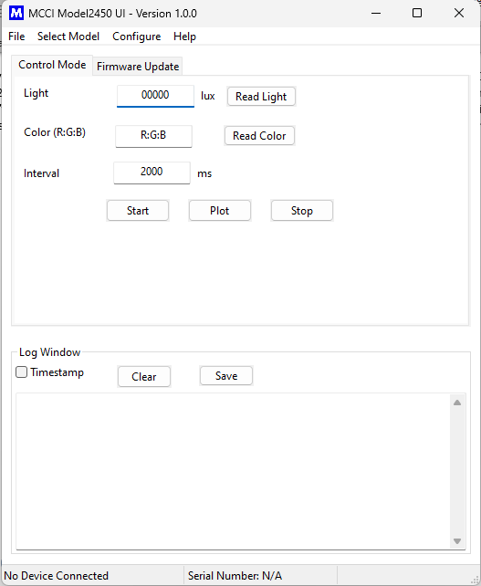

# MCCI Model 2450

The Model 2450 Brightness and Color kit is designed in partnership with Microsoft, to test the brightness and color of video displays on Windows-based devices such as PCs and tablets. It can be also used on other platforms as well. This product is assembled and tested to ensure high performance and ease of use, enabling developers and manufacturers to perform precise color and ambient light sensor testing in a controlled environment.

Figure 2 MCCI Model 2450 Brightness and Color kit

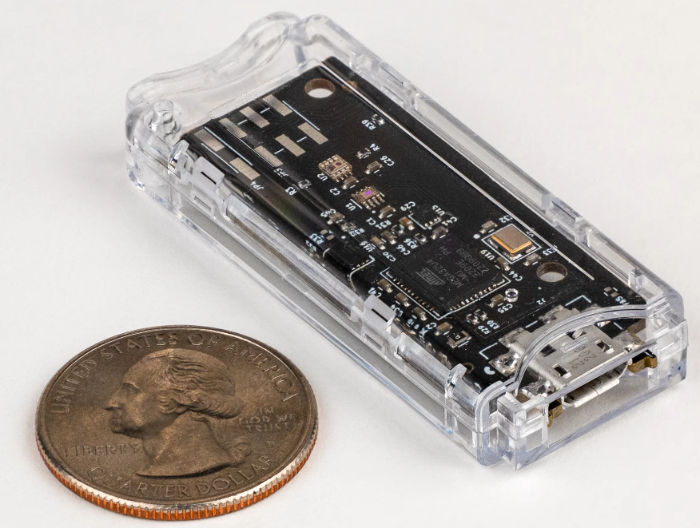

The system connects seamlessly to a control PC via a USB interface and generates controlled colors for testing Ambient-light sensors in various devices. It is compatible with Microsoft-supplied testing software for closed-loop testing.

The Model 2450 is available from stock from MCCI’s online store, <https://mcci-io/buy-2450>.

# Downloading and Installation

Download the installation setup for “MCCI Model 2450 UI” software [MCCI Model 2450 UI Installer](https://github.com/mcci-usb/COLLECTION-model2450-ui/releases) available in Github.

# MCCI Model 2450 UI Overview

When the installation successfully completes, execute the “Model 2450 UI” file, from Start → All Programs, or from the shortcut provided on the desktop. When the application starts, the following GUI screen displays, the GUI window contains these following sections.

* **Control Window:** Control Window provides the two controlling options, that is Light and color testing**.**
* **Firmware Window:** Provides the ability to update the device's firmware to the latest version.
* **Log Window**: Prints device switching activity logs along with timestamps for reference
* **Status Bar:** Status bar shows COM connection status and serial number of Model 2450 BACK kit.

Figure 3 Model 2450 UI v1.0.0 Overview

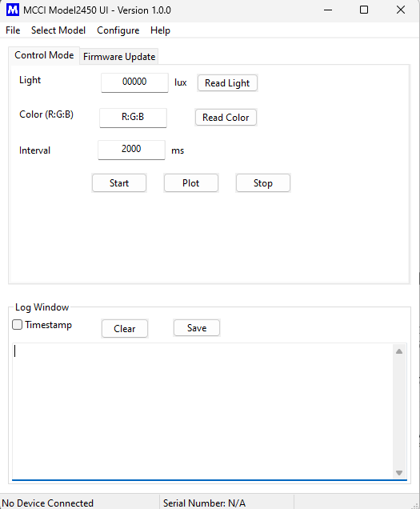

# GUI Feature and Option

## Select Model

"Upon clicking on 'Select Model,' two options are displayed: 'Connect' and 'Disconnect.'

Clicking the 'Connect' button opens a window labeled 'COM Port Selection.' By clicking the 'Search' button, the system searches for the Model 2450 Back Kit, allowing you to select and connect to the port."

Table 1 Connect the Mode 2450 BACK kit

|  |  |
| --- | --- |
| **Control Option** | **Description** |
| **Search** | Clicking on that Search Button will show the attached model 2450. |
| **Connect Menu** | Clicking on that Connect Button, connect the selected Model 2450. |
| **Disconnect Option** | Clicking on Disconnect Menu, Disconnect the Model 2450 |

Figure 4 Model 2450 COMX selection

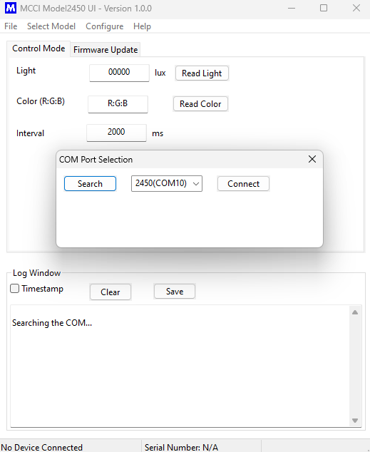

Figure 5 Connected Model 2450 to UI

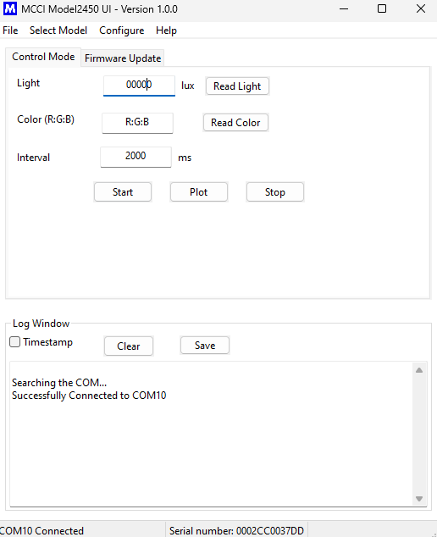

* Once connected, the Model 2450 COM port is actively displayed in the status bar, along with the serial number of the specific Model 2450 device.

# Control Window

## Manual control

**Click on 'Read Light' button:**

* **Ambient Light Testing**: Simulates varying lighting conditions and system scenarios to test the responsiveness and accuracy of ambient light sensors.

**Click on 'Read Color' button:**

* **Brightness and Color Testing:** Ensures that video displays meet brightness and color accuracy standards. It also tests and simulates auto brightness and manual brightness control.

## Read with Time interval

**Auto Testing:**

* Set the desired interval and click on the 'Start' button. The system will continuously read both light and color values until the 'Stop' button is clicked. Data is collected throughout the process.
* Once data is collected, click on the 'Plot' button to display the results graphically.

Figure 6 Read the Light and Color values

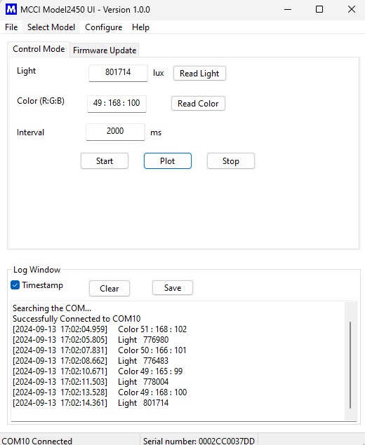

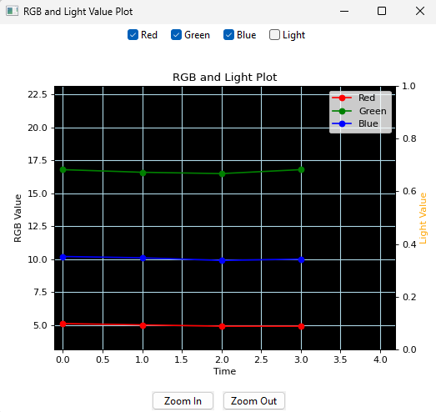

# Firmware Update

* Here, Model 2450 UI provides the feature of Firmware update to Model 2450 BACK kit.

Figure 7 Firmware Update Window

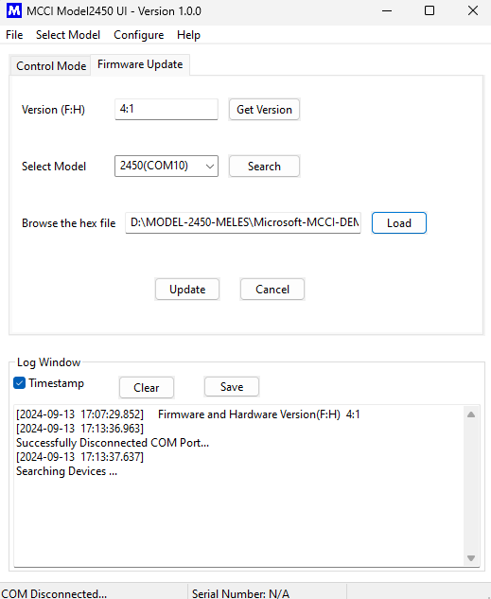

## Firmware update Tab:

* Goto the Firmware update Tab.
* disconnect the Model 2450 for Before connecting the Model 2450.
* Once searching the Model 2450 is found in Drop down box list and select it.
* Click on the Load button it goes to the Folder and there select updated version of Model 2450 hex file.
* Just click on the Update, start the Firmware update.

# Configure

Click on the **'Configure'** menu:

* The **Color Calibration** window appears, allowing you to set values for red, green, and blue color calibration.

Click on the **Black frame Scan** menu:

* This opens a window where you can set the "Light Value Threshold."
* Click the 'Update' button to apply the threshold.
* Clicking the 'Run' button starts counting the number of black frames.
* Once done, click the 'Stop' button to stop the counting process.

Figure 8 Blackframe Scan

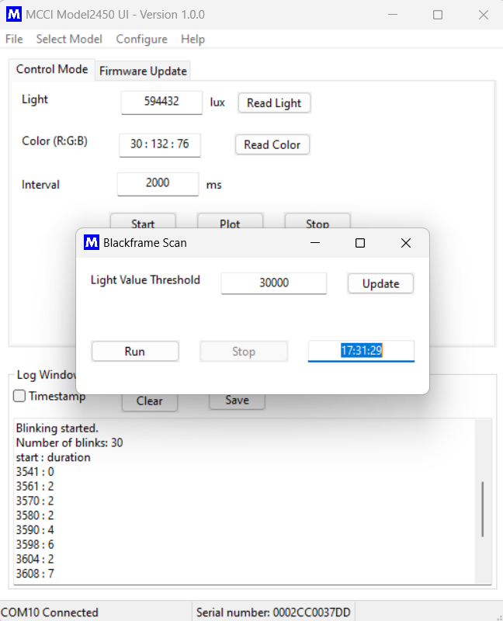

# Disconnect and Close the Application

## Disconnect

To disconnect a Model, click the Disconnect option from the Select Model.

## Close

To close the application, Click Close from the File Menu as displayed in. The application will be closed.

# Getting Help

If you have a question about using the GUI usage or operation, please visit MCCI’s support community. Feel free to post a question! We’ll do our best to assist, and you may benefit from the experience of others. You may also post private questions to MCCI by [opening a ticket](https://support.zoho.com/portal/mcciportal/newticket) or by sending email to [techsupport@mcci.com](mailto:techsupport@mcci.com).