Disorders_in_the_DSM5TR_Presentation companion document

Slide 1. Psychological Disorders in the DSM-5-TR
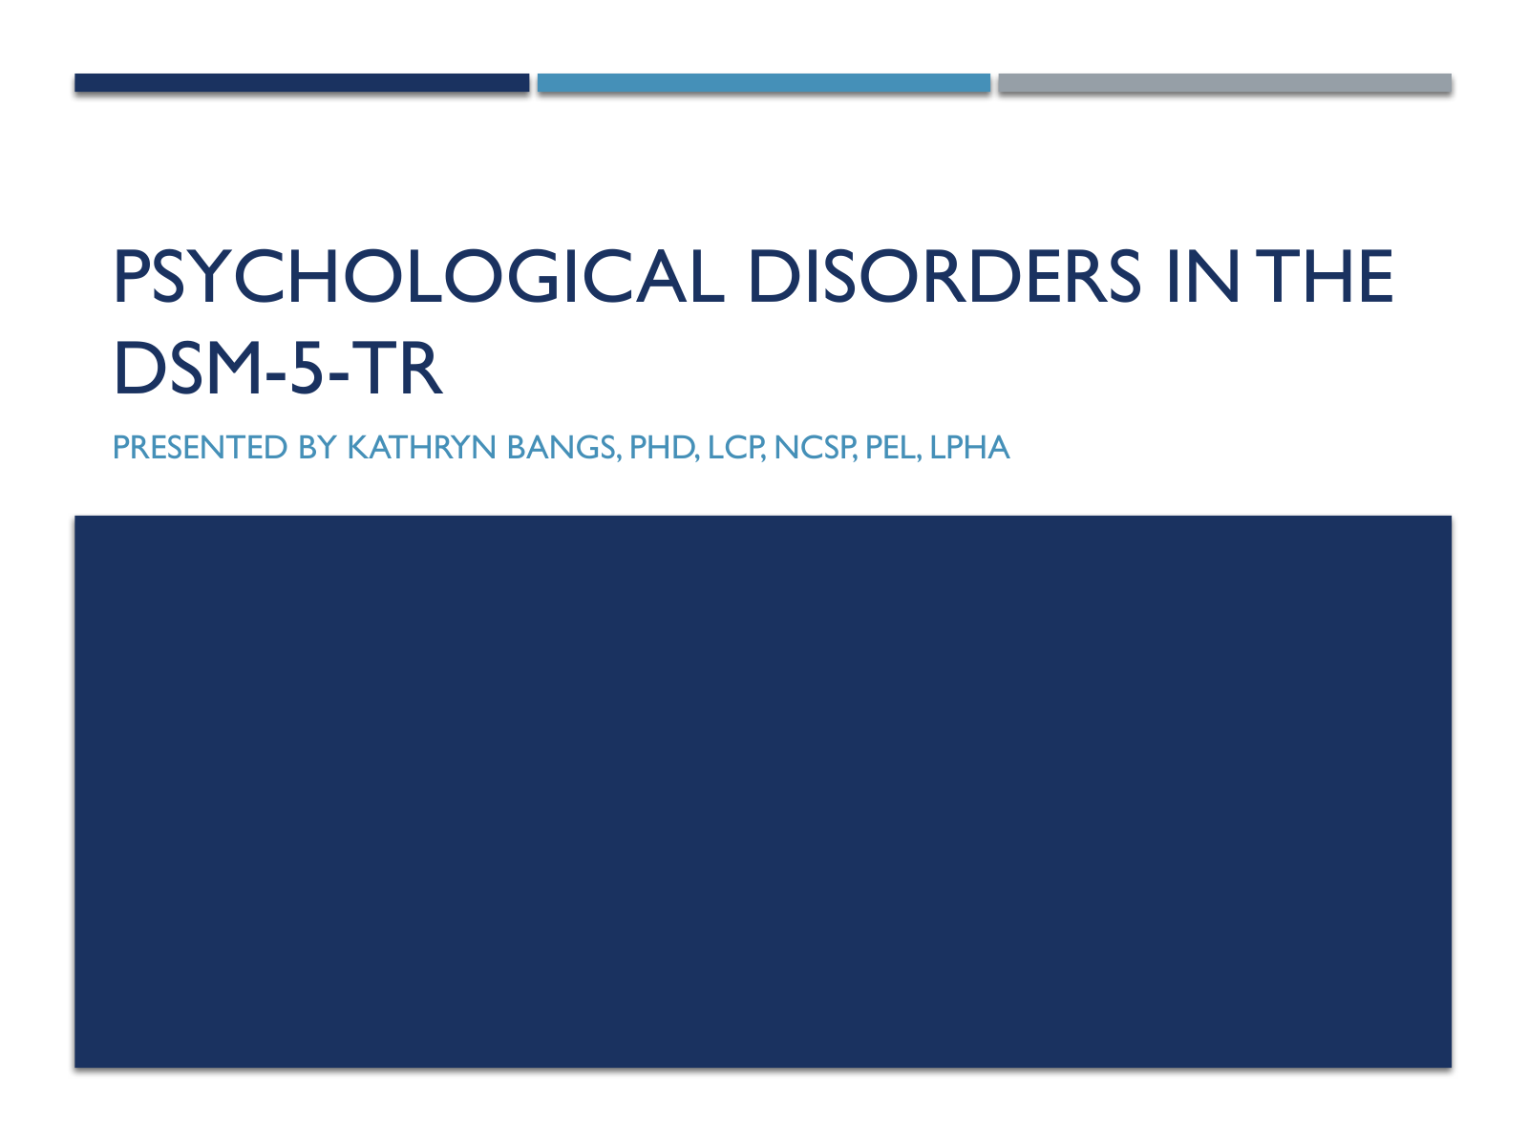

Slide text
Psychological Disorders in the DSM-5-TR
Presented By Kathryn Bangs, PhD, LCP, NCSP, PEL, LPHA

Slide 2. Defining Abnormal
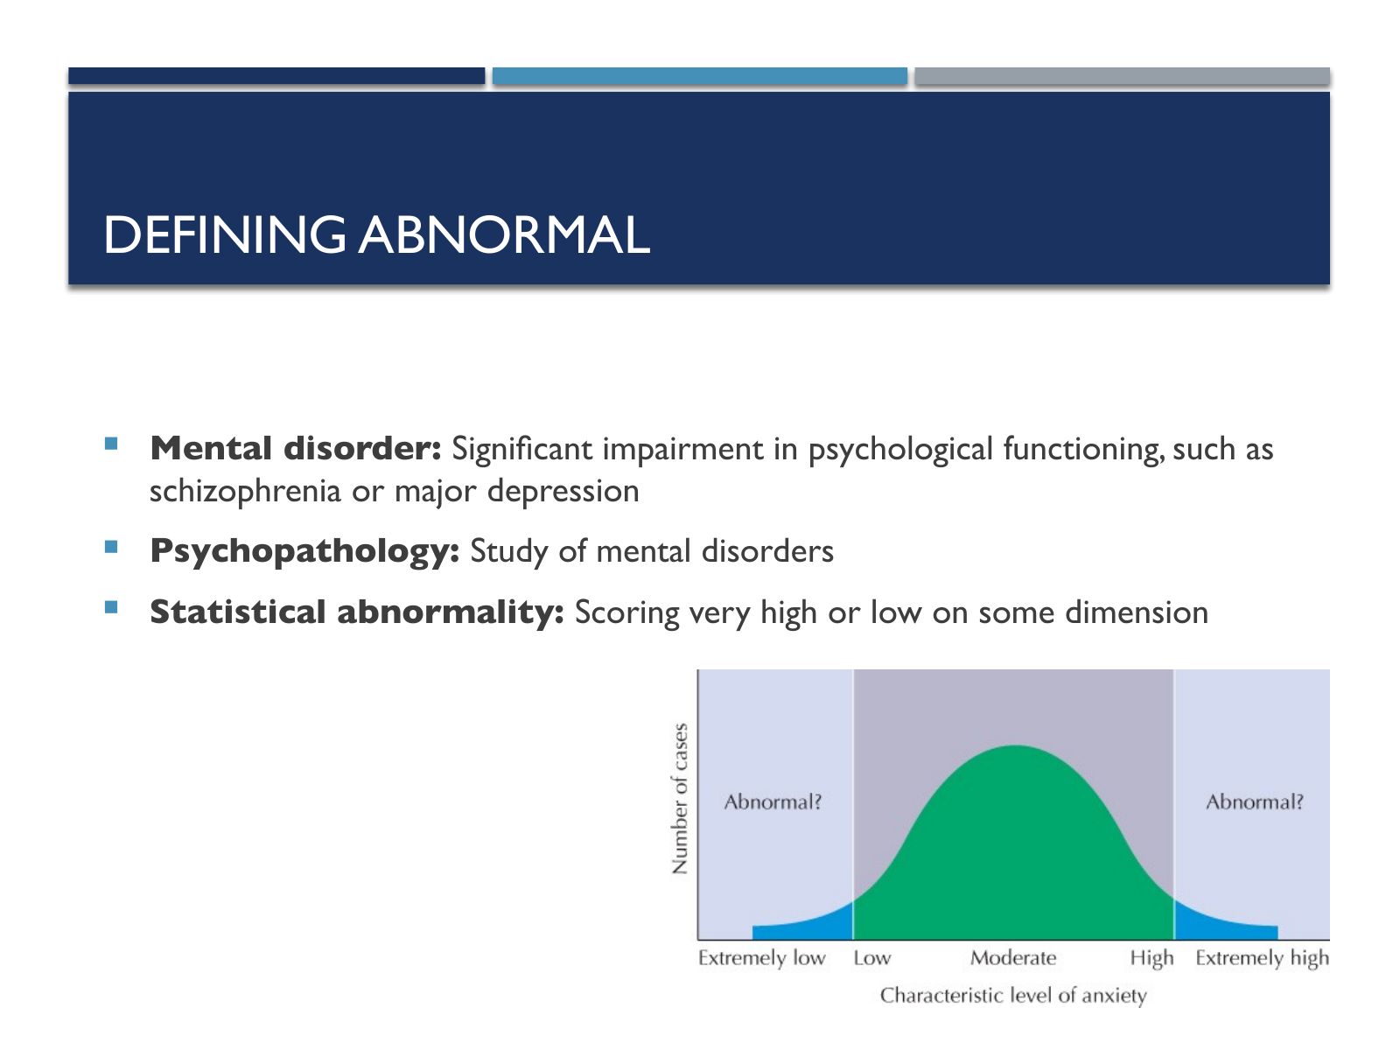

Slide text
Defining Abnormal
Mental disorder: Significant impairment in psychological functioning, such as schizophrenia or major depression
Psychopathology: Study of mental disorders
Statistical abnormality: Scoring very high or low on some dimension

Visual descriptions
Visual 1. Photo: The x-axis of a chart shows the characteristic level of anxiety. It is divided into 3 parts, Extremely low, Moderate, and Extremely high. The moderate part is shown to extend from low on the left to high on the right. The widths of extremely low and extremely high are the same while the width of moderate is significantly high. The y-axis shows the number of cases. The chart shows a bell curve over the x-axis. It starts from the middle of extremely low part of the x-axis, curves up, reaches its peak at the middle of the moderate part of the x-axis, curves down, and ends at the middle of the extreme high part of the x-axis. The chart shows the note abnormal with a question mark on the extremely low and extremely high parts of the chart.

Slide 3. Reminder about Stigma
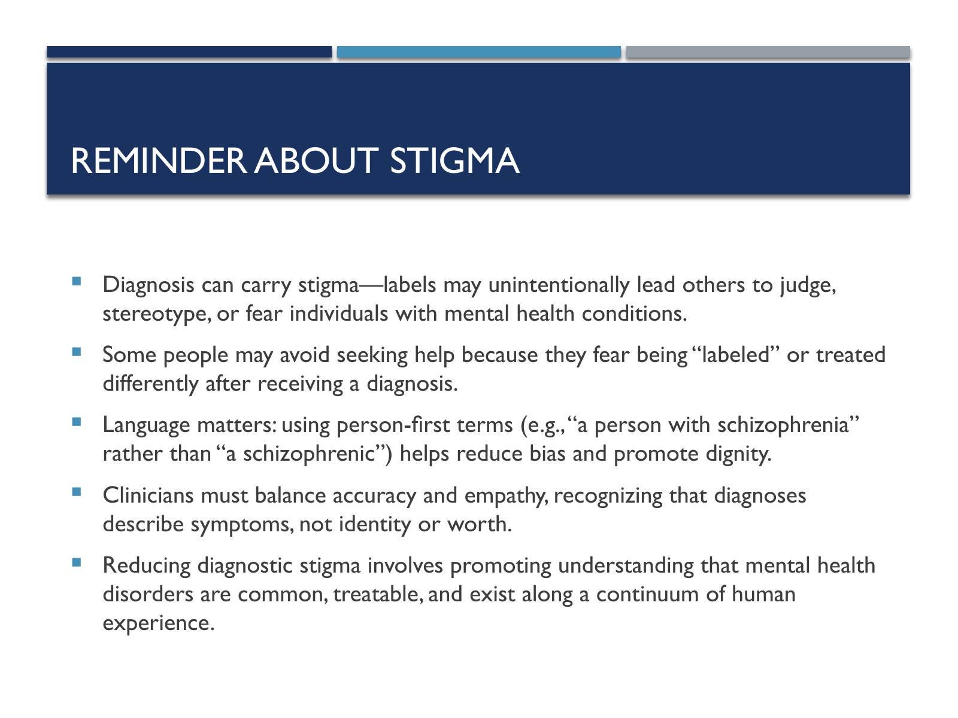

Slide text
Reminder about Stigma
Diagnosis can carry stigma—labels may unintentionally lead others to judge, stereotype, or fear individuals with mental health conditions.
Some people may avoid seeking help because they fear being “labeled” or treated differently after receiving a diagnosis.
Language matters: using person-first terms (e.g., “a person with schizophrenia” rather than “a schizophrenic”) helps reduce bias and promote dignity.
Clinicians must balance accuracy and empathy, recognizing that diagnoses describe symptoms, not identity or worth.
Reducing diagnostic stigma involves promoting understanding that mental health disorders are common, treatable, and exist along a continuum of human experience.

Slide 4. Causes of Mental Illness
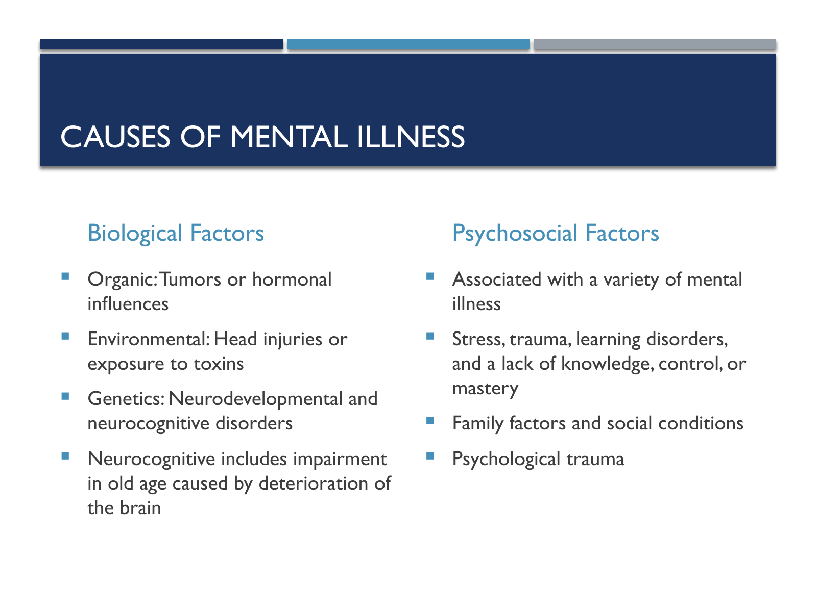

Slide text
Causes of Mental Illness
Biological Factors
Psychosocial Factors
Organic: Tumors or hormonal influences
Environmental: Head injuries or exposure to toxins
Genetics: Neurodevelopmental and neurocognitive disorders
Neurocognitive includes impairment in old age caused by deterioration of the brain
Associated with a variety of mental illness
Stress, trauma, learning disorders, and a lack of knowledge, control, or mastery
Family factors and social conditions
Psychological trauma

Slide 5. The Stress-Vulnerability Model
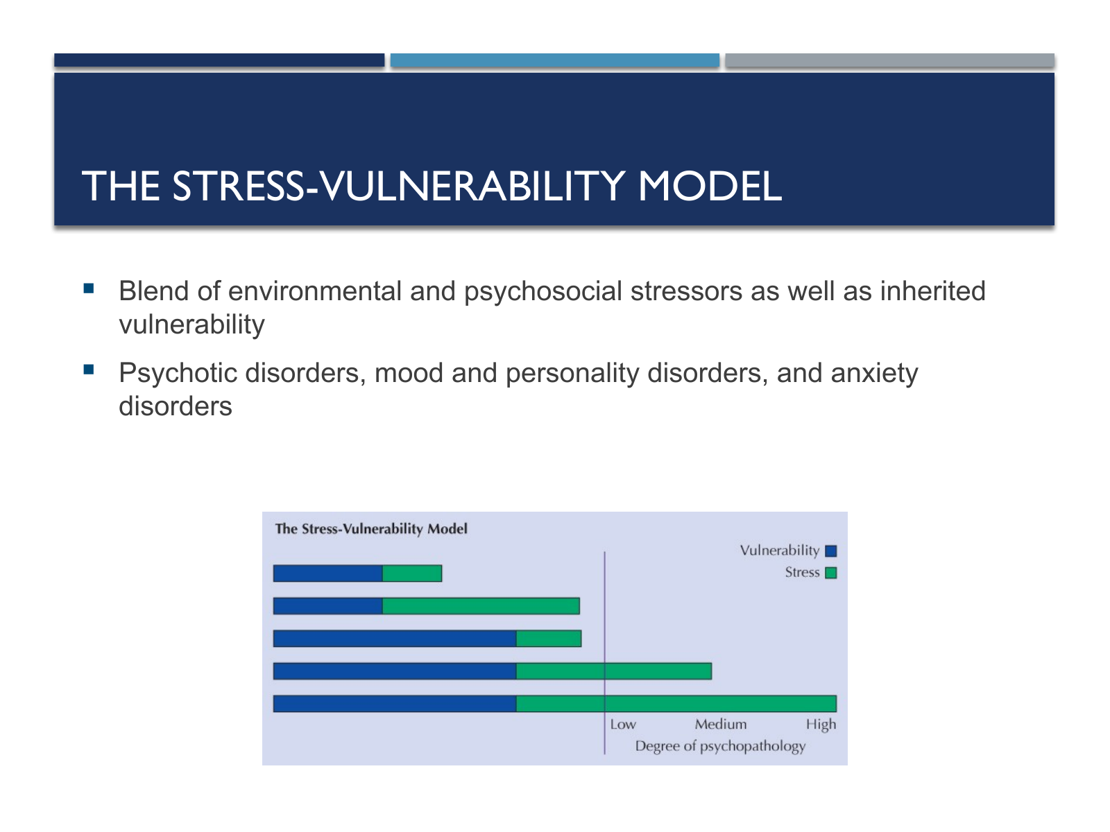

Slide text
The Stress-Vulnerability Model
Blend of environmental and psychosocial stressors as well as inherited vulnerability
Psychotic disorders, mood and personality disorders, and anxiety disorders

Visual descriptions
Visual 1. Photo: A chart shows 5 horizontal stacked bars. A vertical line runs to the right of the top 3 bars. The bottom 2 bars cross the vertical line. Each stacked bar shows two bars, vulnerability and stress. The vulnerability bars of the top 2 stacked bars are of the same length. However, the stress bar of the second stacked bar is longer than the first. The total length of the second and third stacked bars is the same. However, the vulnerability bar of the third is longer than that of the second. The total length of the fourth stacked bar is shorter than the total length of the fifth stacked bar. The two stacked bars cross the vertical line. The vulnerability bars of the 2 stacked bars are of the same length as that of the third stacked bar. The stress bar of the fourth stacked bar is shorter than that of the fifth stacked bar. The region of the chart to the right of the vertical line is labeled degree of psychopathology. It is divided vertically into low, medium, and high. The fourth stacked bar extends up to medium. The fifth stacked bar extends up to high.

Slide 6. Diagnostic Considerations
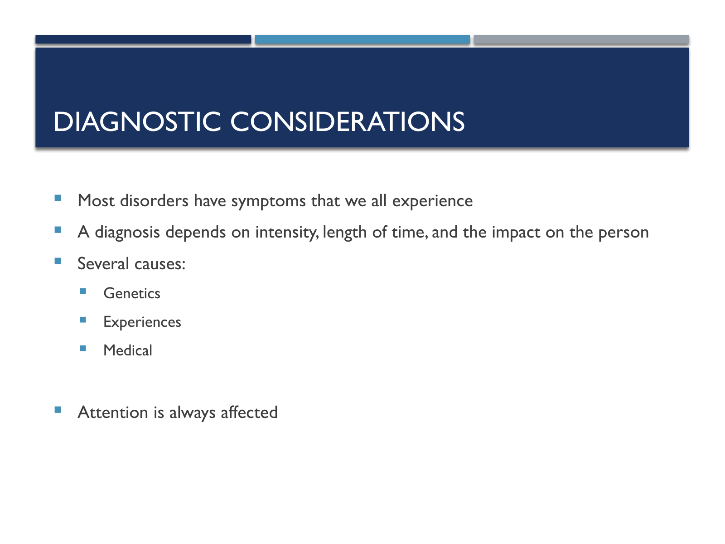

Slide text
Diagnostic Considerations
Most disorders have symptoms that we all experience
A diagnosis depends on intensity, length of time, and the impact on the person
Several causes:
Genetics
Experiences
Medical
Attention is always affected

Slide 7. Purpose and Organization of the DSM-5-TR
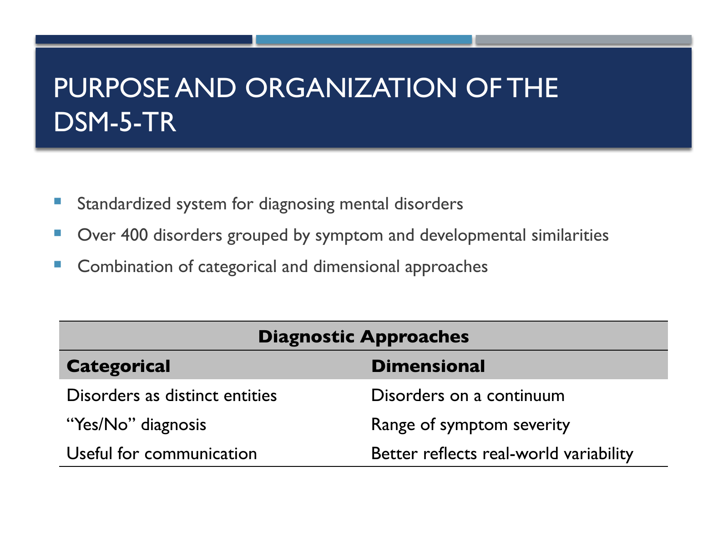

Slide text
Purpose and Organization of the DSM-5-TR
Standardized system for diagnosing mental disorders
Over 400 disorders grouped by symptom and developmental similarities
Combination of categorical and dimensional approaches
Diagnostic Approaches
Categorical
Dimensional
Disorders as distinct entities
Disorders on a continuum
“Yes/No” diagnosis
Range of symptom severity
Useful for communication
Better reflects real-world variability

Slide 8. Purpose of Classification
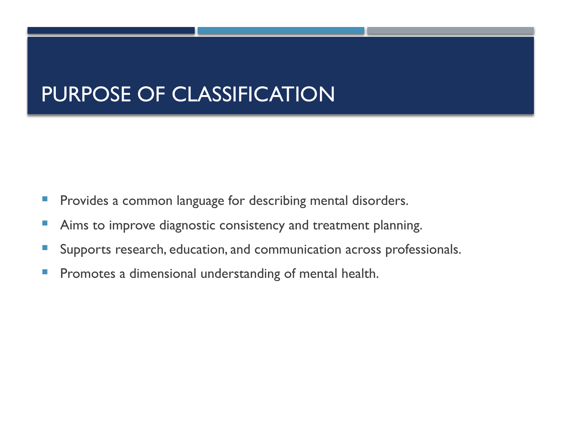

Slide text
Purpose of Classification
Provides a common language for describing mental disorders.
Aims to improve diagnostic consistency and treatment planning.
Supports research, education, and communication across professionals.
Promotes a dimensional understanding of mental health.

Slide 9. Hierarchical Structure of Classification
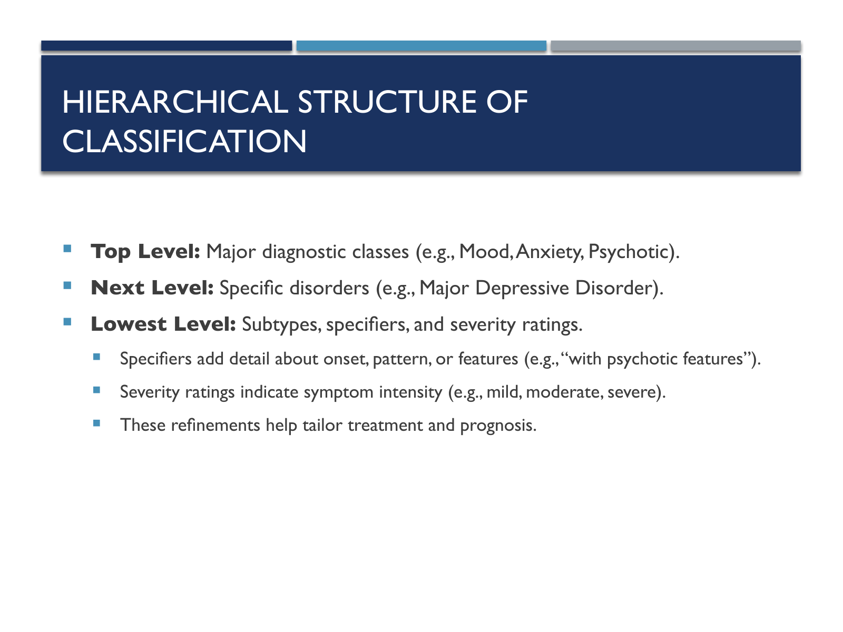

Slide text
Hierarchical Structure of Classification
Top Level: Major diagnostic classes (e.g., Mood, Anxiety, Psychotic).
Next Level: Specific disorders (e.g., Major Depressive Disorder).
Lowest Level: Subtypes, specifiers, and severity ratings.
Specifiers add detail about onset, pattern, or features (e.g., “with psychotic features”).
Severity ratings indicate symptom intensity (e.g., mild, moderate, severe).
These refinements help tailor treatment and prognosis.

Slide 10. Major Diagnostic Categories
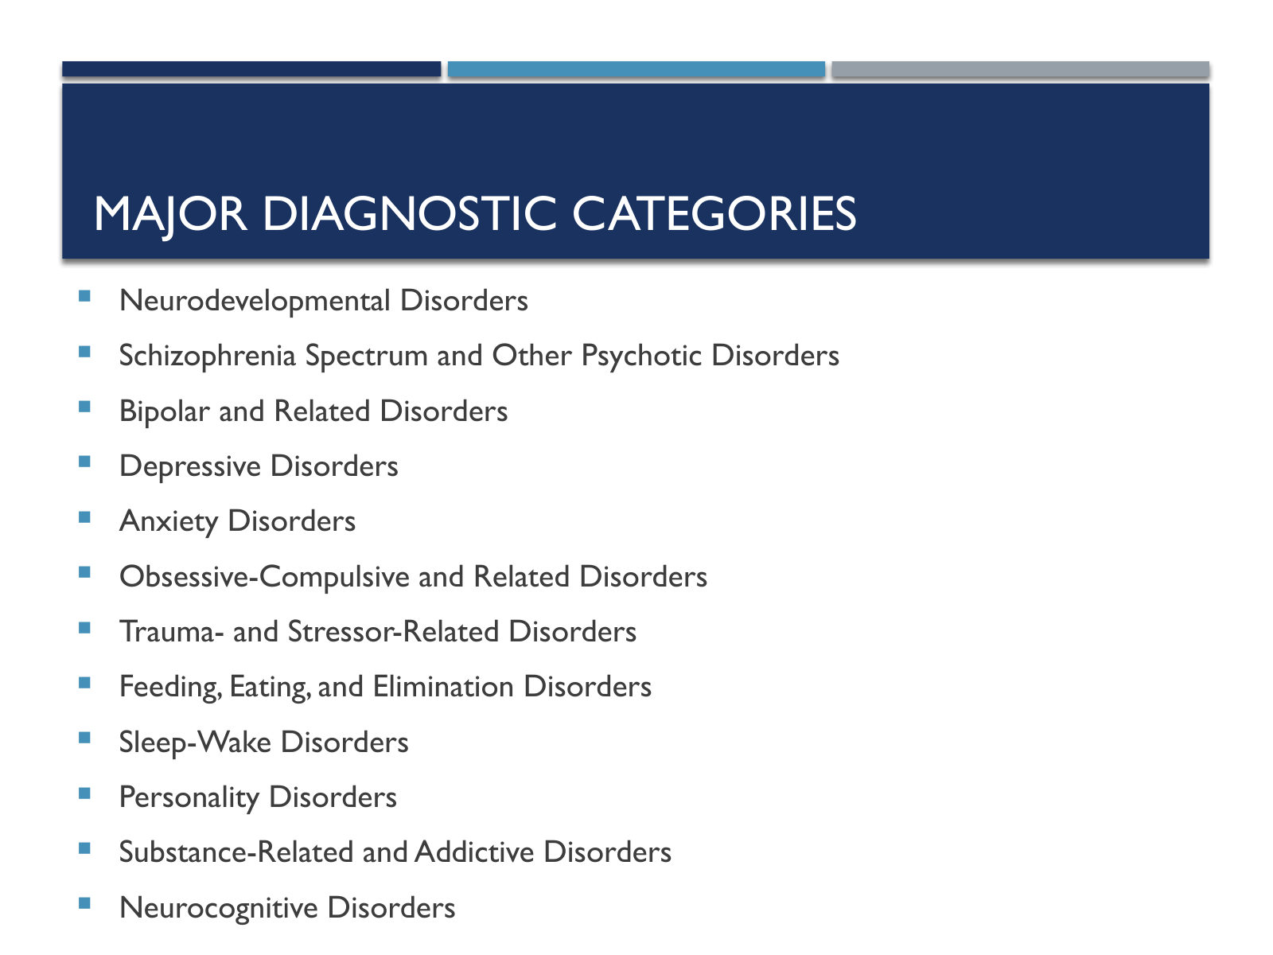

Slide text
Major Diagnostic Categories
Neurodevelopmental Disorders
Schizophrenia Spectrum and Other Psychotic Disorders
Bipolar and Related Disorders
Depressive Disorders
Anxiety Disorders
Obsessive-Compulsive and Related Disorders
Trauma- and Stressor-Related Disorders
Feeding, Eating, and Elimination Disorders
Sleep-Wake Disorders
Personality Disorders
Substance-Related and Addictive Disorders
Neurocognitive Disorders

Slide 11. Neurodevelopmental Disorders
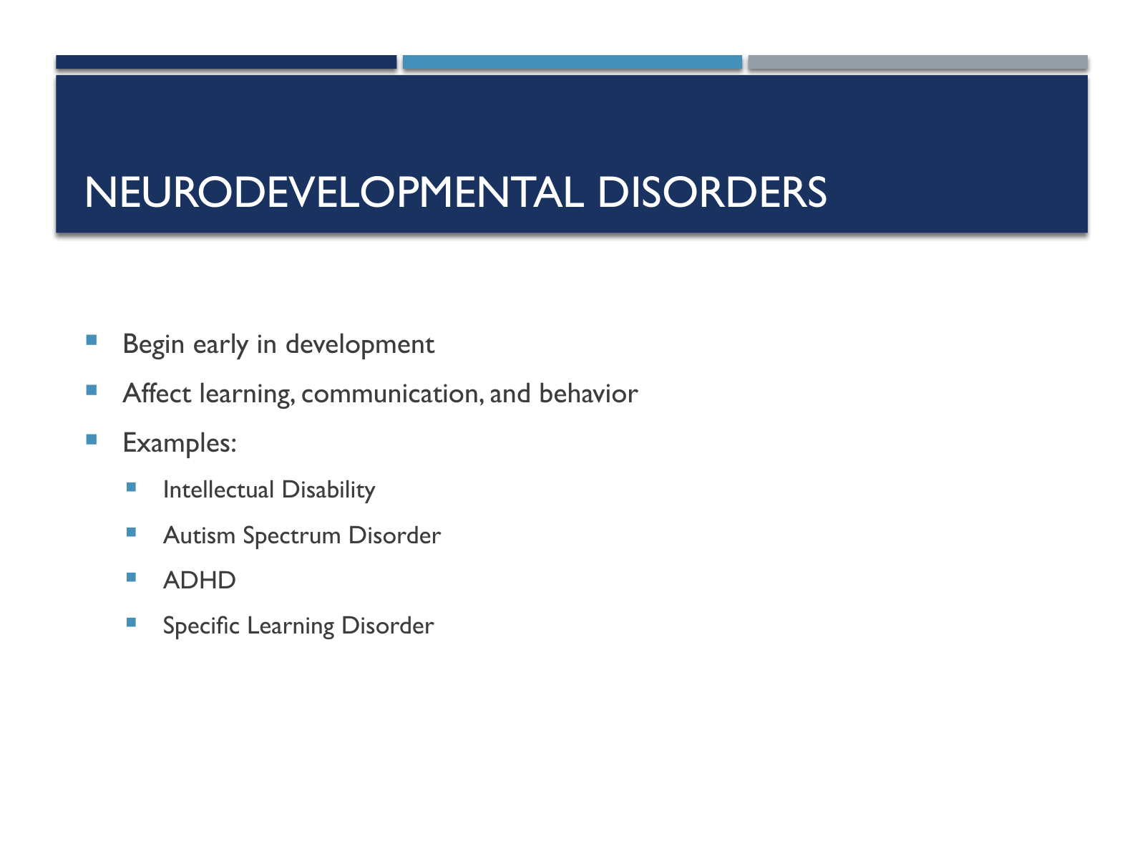

Slide text
Neurodevelopmental Disorders
Begin early in development
Affect learning, communication, and behavior
Examples:
Intellectual Disability
Autism Spectrum Disorder
ADHD
Specific Learning Disorder

Slide 12. Schizophrenia Spectrum and Other Psychotic Disorders
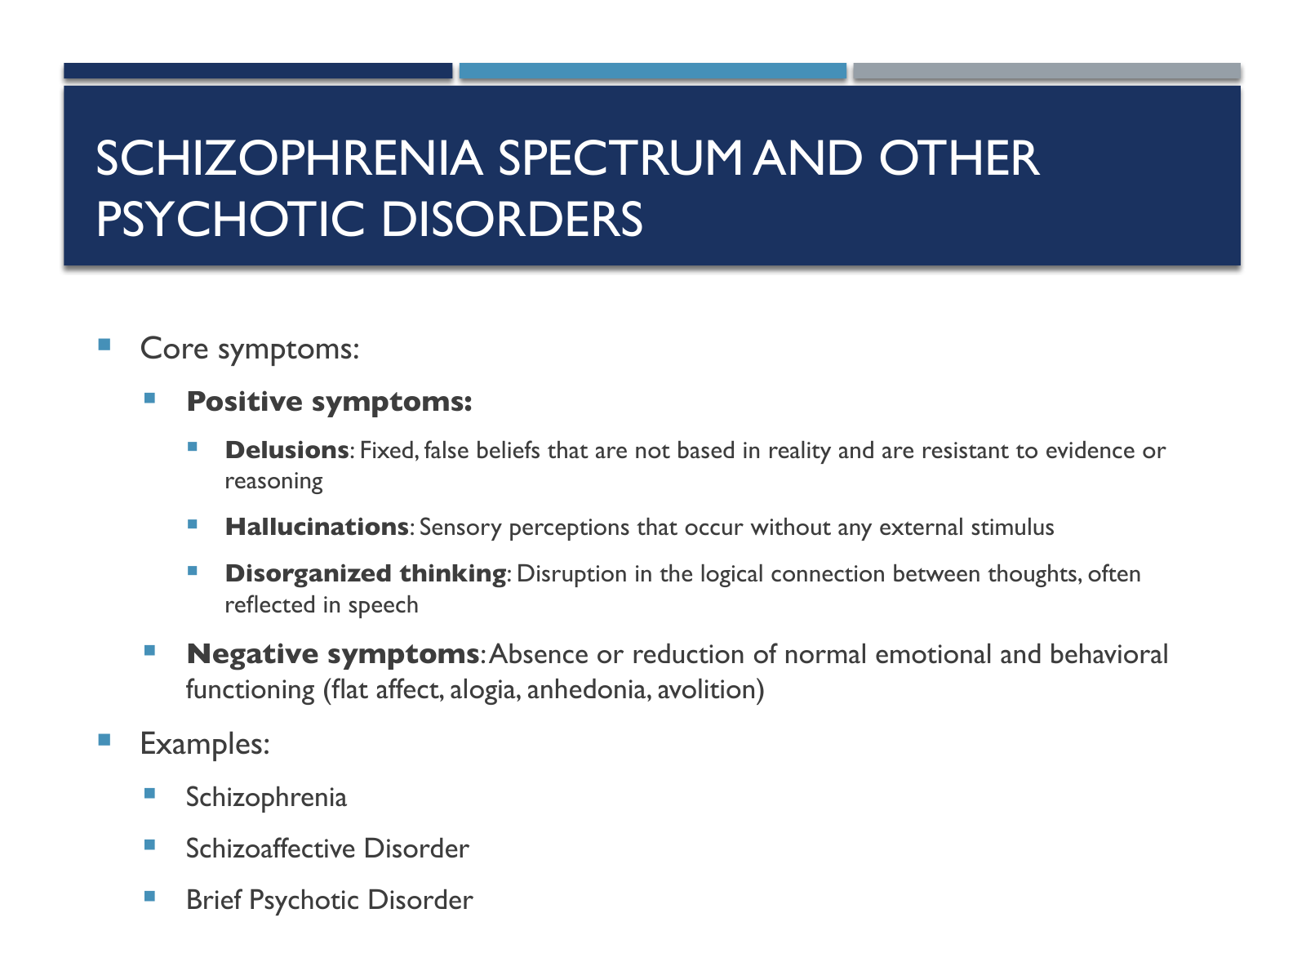

Slide text
Schizophrenia Spectrum and Other Psychotic Disorders
Core symptoms:
Positive symptoms:
Delusions: Fixed, false beliefs that are not based in reality and are resistant to evidence or reasoning
Hallucinations: Sensory perceptions that occur without any external stimulus
Disorganized thinking: Disruption in the logical connection between thoughts, often reflected in speech
Negative symptoms: Absence or reduction of normal emotional and behavioral functioning (flat affect, alogia, anhedonia, avolition)
Examples:
Schizophrenia
Schizoaffective Disorder
Brief Psychotic Disorder

Slide 13. Schizophrenia Simulation
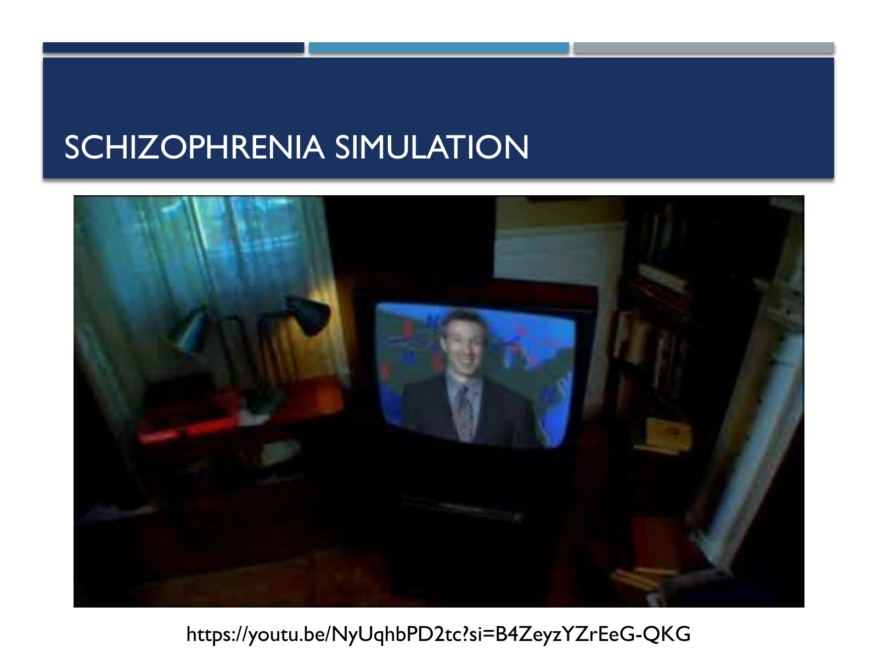

Slide text
Schizophrenia Simulation
https://youtu.be/NyUqhbPD2tc?si=B4ZeyzYZrEeG-QKG

Slide 14. Bipolar and Depressive Disorders
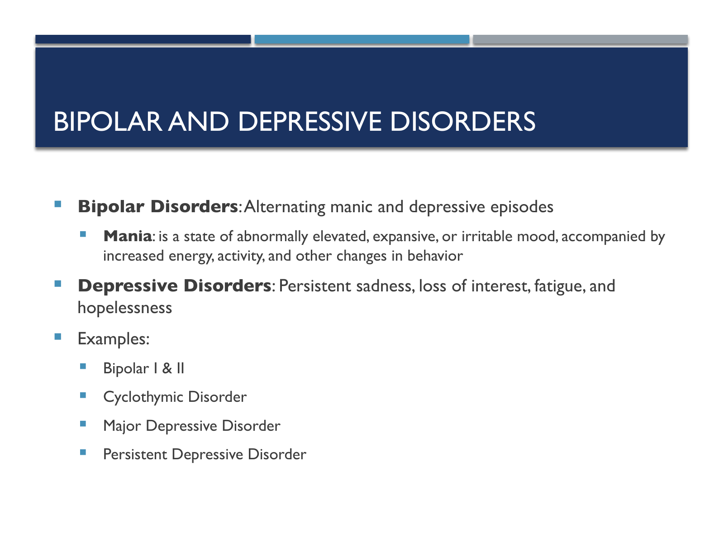

Slide text
Bipolar and Depressive Disorders
Bipolar Disorders: Alternating manic and depressive episodes
Mania: is a state of abnormally elevated, expansive, or irritable mood, accompanied by increased energy, activity, and other changes in behavior
Depressive Disorders: Persistent sadness, loss of interest, fatigue, and hopelessness
Examples:
Bipolar I & II
Cyclothymic Disorder
Major Depressive Disorder
Persistent Depressive Disorder

Slide 15. Anxiety and Obsessive-Compulsive Disorders
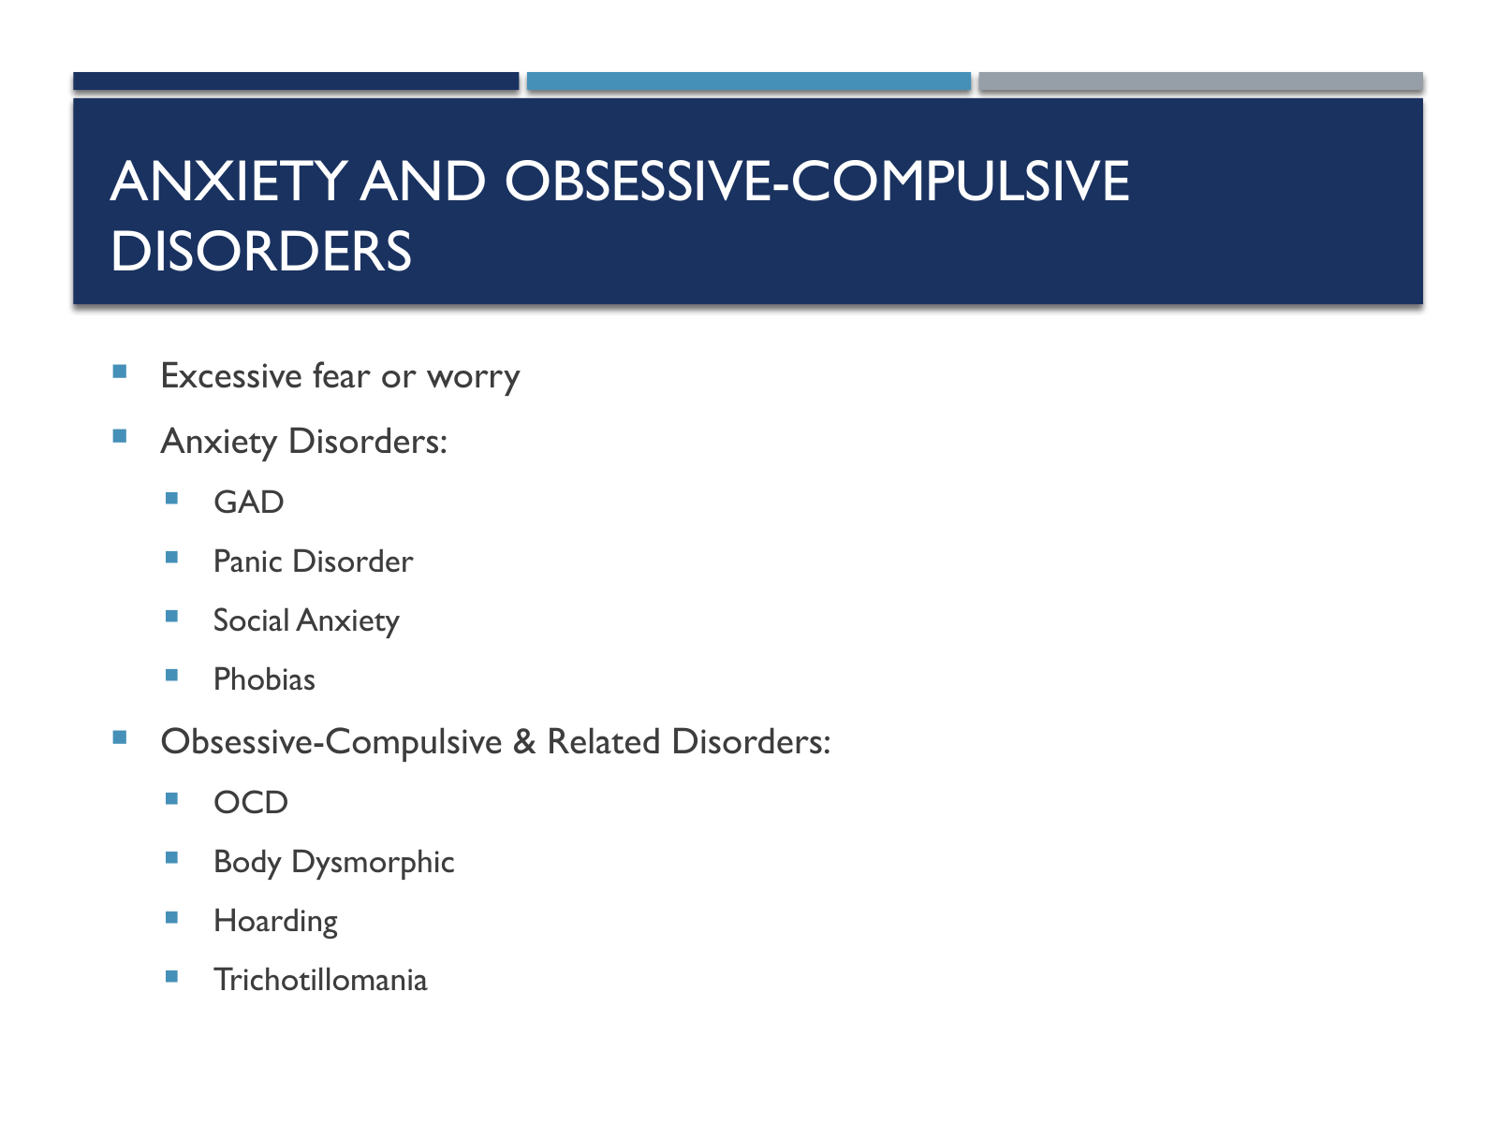

Slide text
Anxiety and Obsessive-Compulsive Disorders
Excessive fear or worry
Anxiety Disorders:
GAD
Panic Disorder
Social Anxiety
Phobias
Obsessive-Compulsive & Related Disorders:
OCD
Body Dysmorphic
Hoarding
Trichotillomania

Slide 16. Trauma- and Stressor-Related Disorders
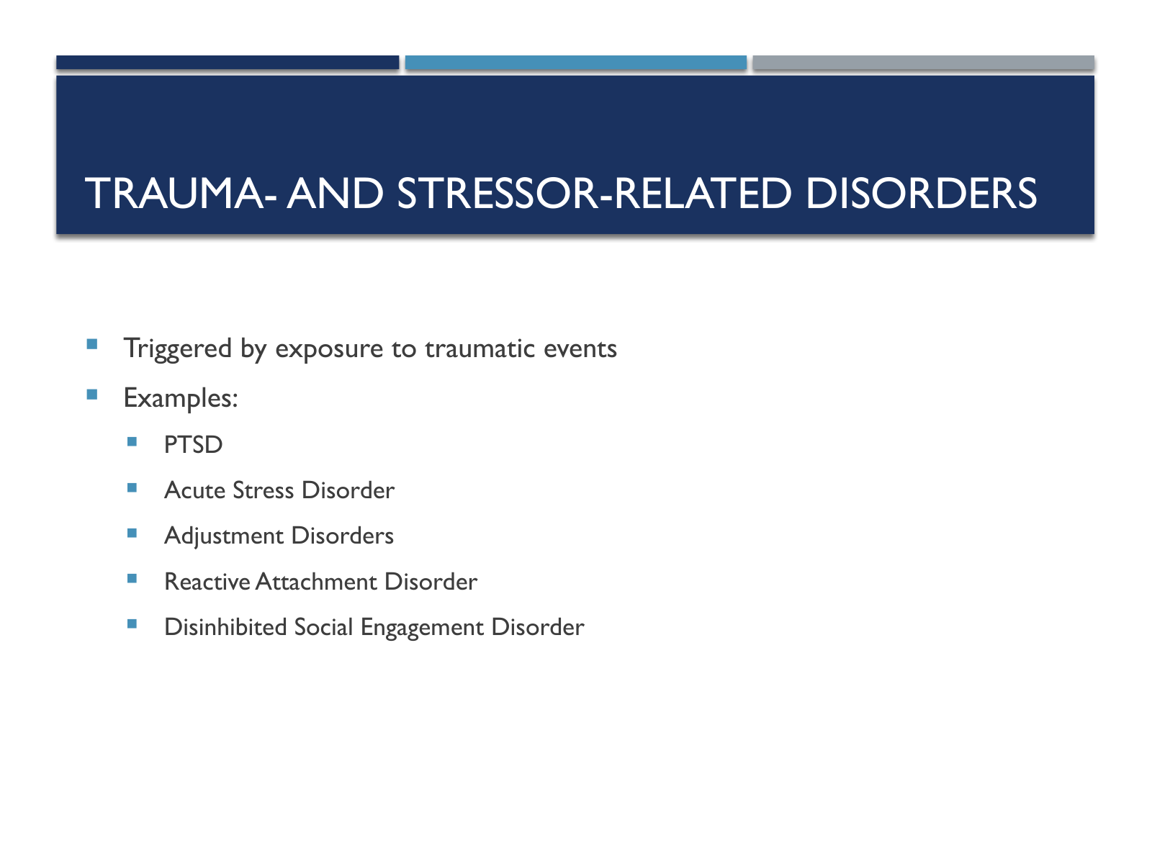

Slide text
Trauma- and Stressor-Related Disorders
Triggered by exposure to traumatic events
Examples:
PTSD
Acute Stress Disorder
Adjustment Disorders
Reactive Attachment Disorder
Disinhibited Social Engagement Disorder

Slide 17. Dissociative and Somatic Symptom Disorders
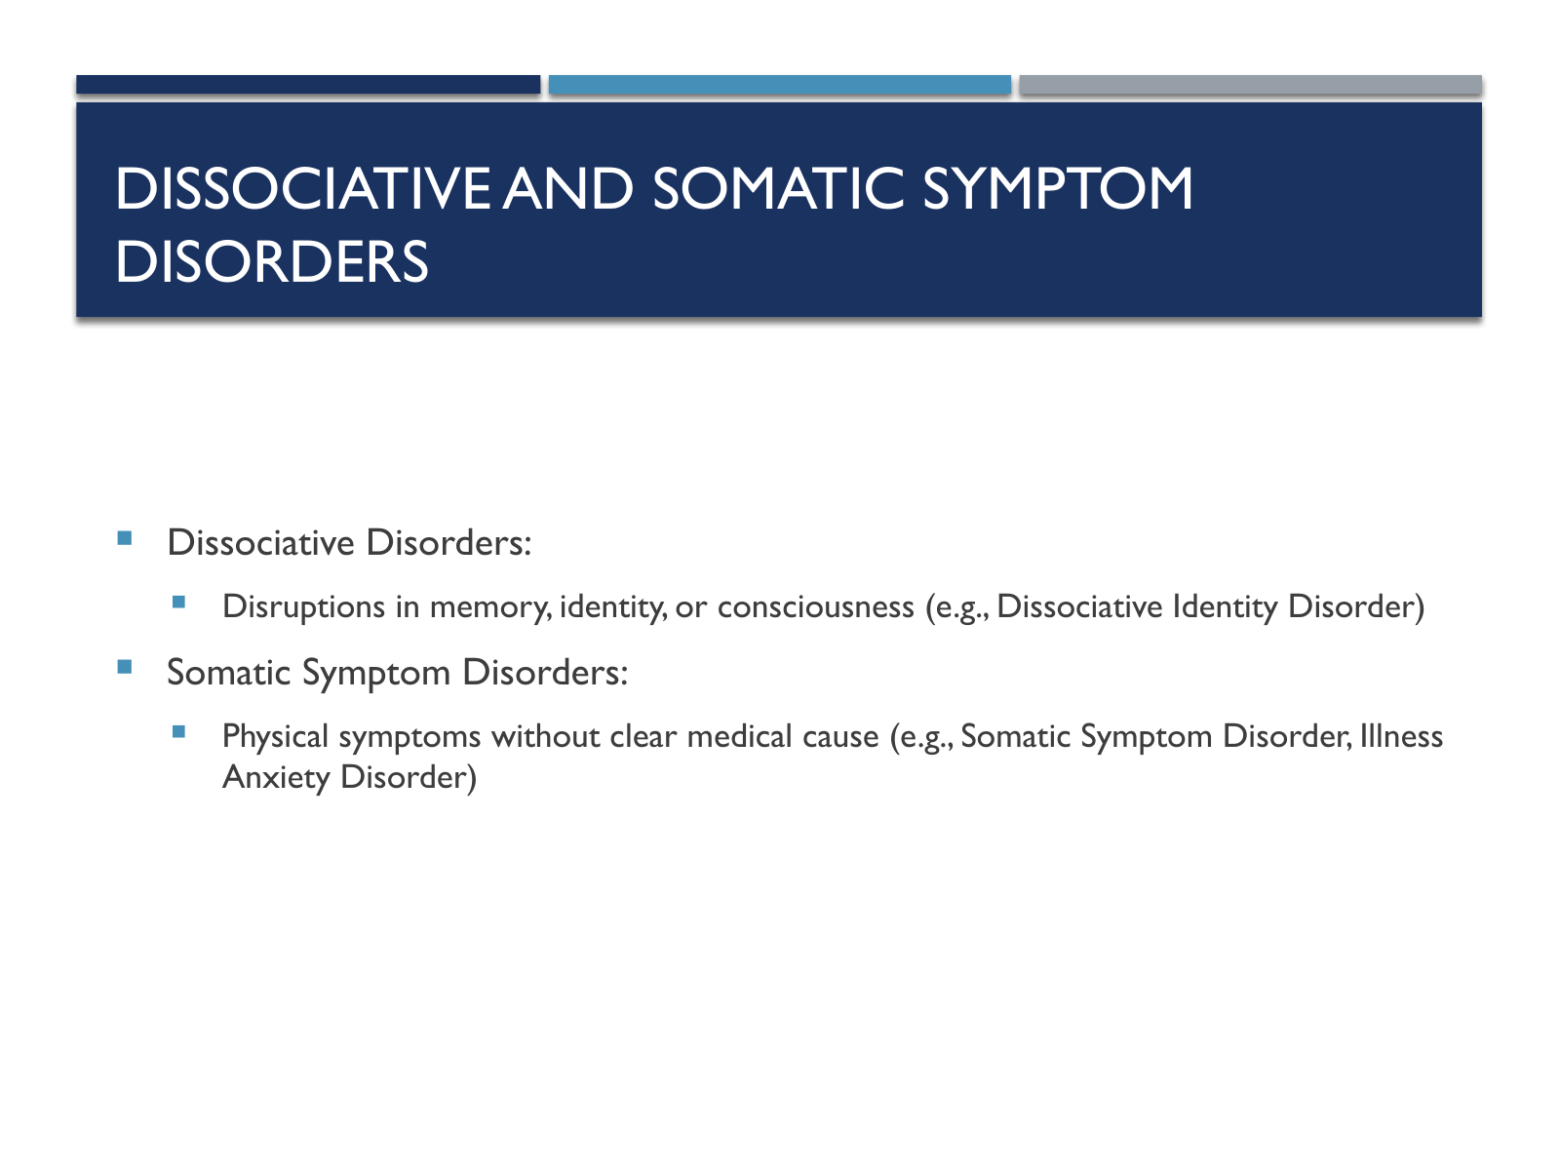

Slide text
Dissociative and Somatic Symptom Disorders
Dissociative Disorders:
Disruptions in memory, identity, or consciousness (e.g., Dissociative Identity Disorder)
Somatic Symptom Disorders:
Physical symptoms without clear medical cause (e.g., Somatic Symptom Disorder, Illness Anxiety Disorder)

Slide 18. Feeding, Eating, and Elimination Disorders
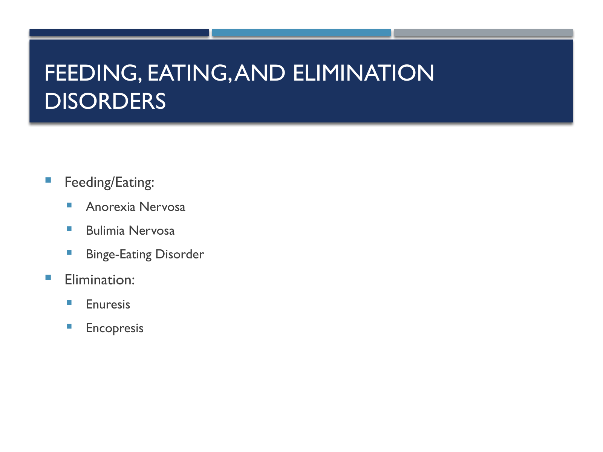

Slide text
Feeding, Eating, and Elimination Disorders
Feeding/Eating:
Anorexia Nervosa
Bulimia Nervosa
Binge-Eating Disorder
Elimination:
Enuresis
Encopresis

Slide 19. Sleep-Wake and Sexual Disorders
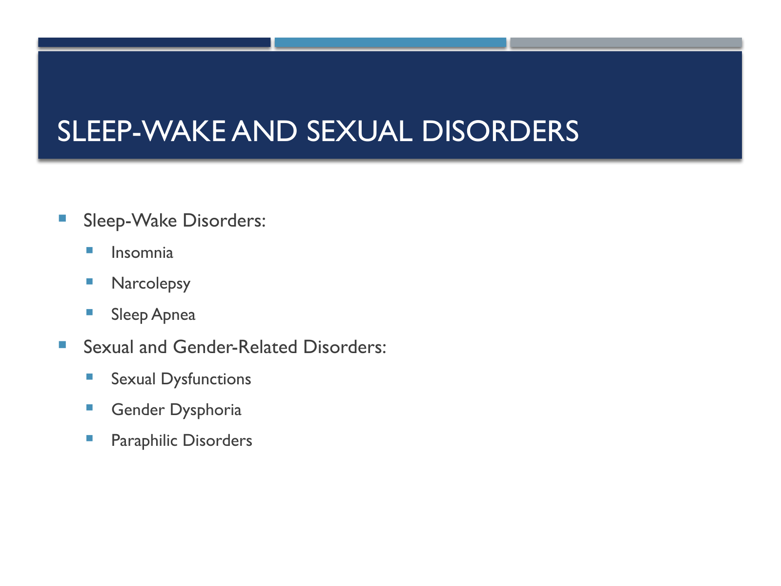

Slide text
Sleep-Wake and Sexual Disorders
Sleep-Wake Disorders:
Insomnia
Narcolepsy
Sleep Apnea
Sexual and Gender-Related Disorders:
Sexual Dysfunctions
Gender Dysphoria
Paraphilic Disorders

Slide 20. Disruptive, Impulse-Control, and Conduct Disorders
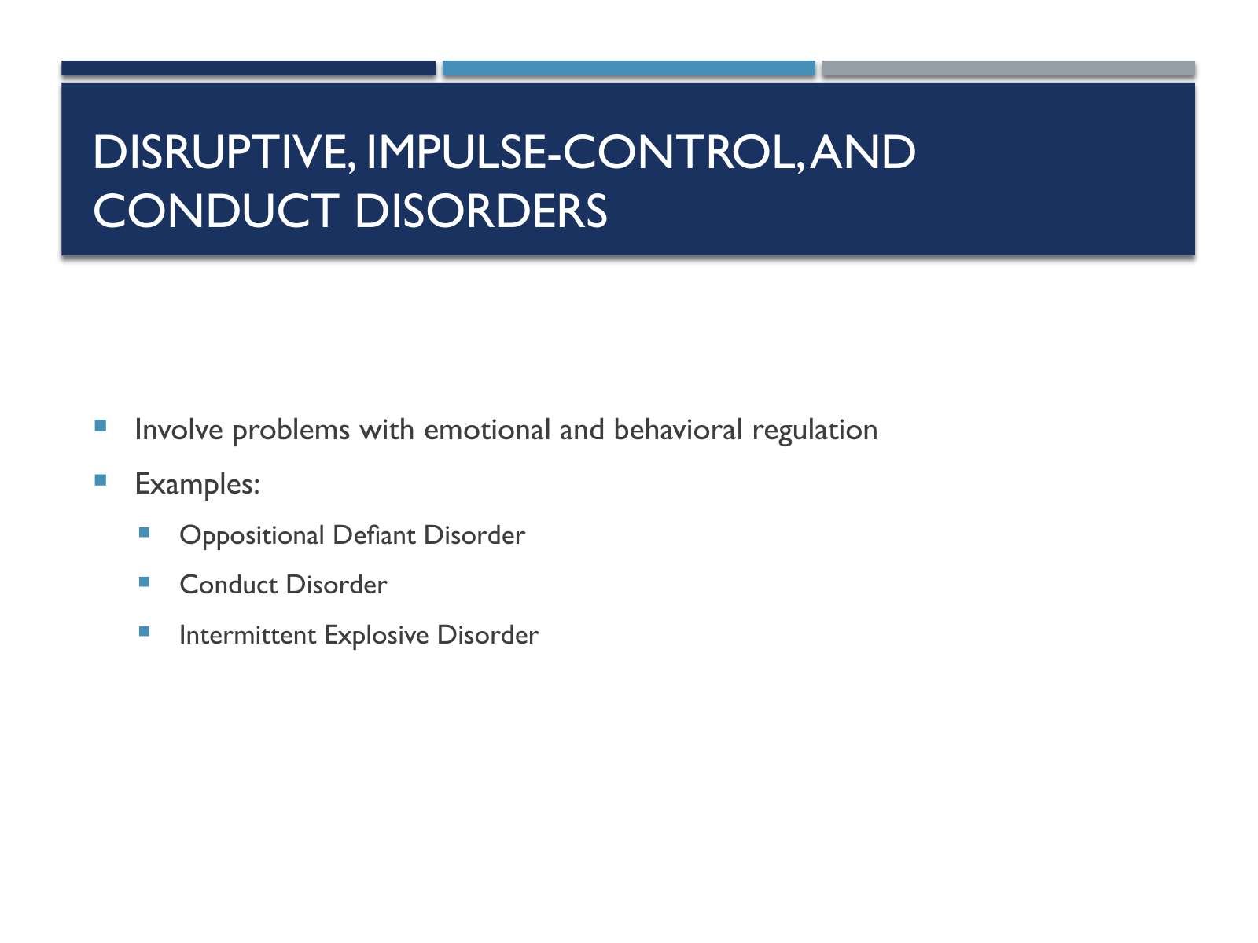

Slide text
Disruptive, Impulse-Control, and Conduct Disorders
Involve problems with emotional and behavioral regulation
Examples:
Oppositional Defiant Disorder
Conduct Disorder
Intermittent Explosive Disorder

Slide 21. Substance-Related and Neurocognitive Disorders
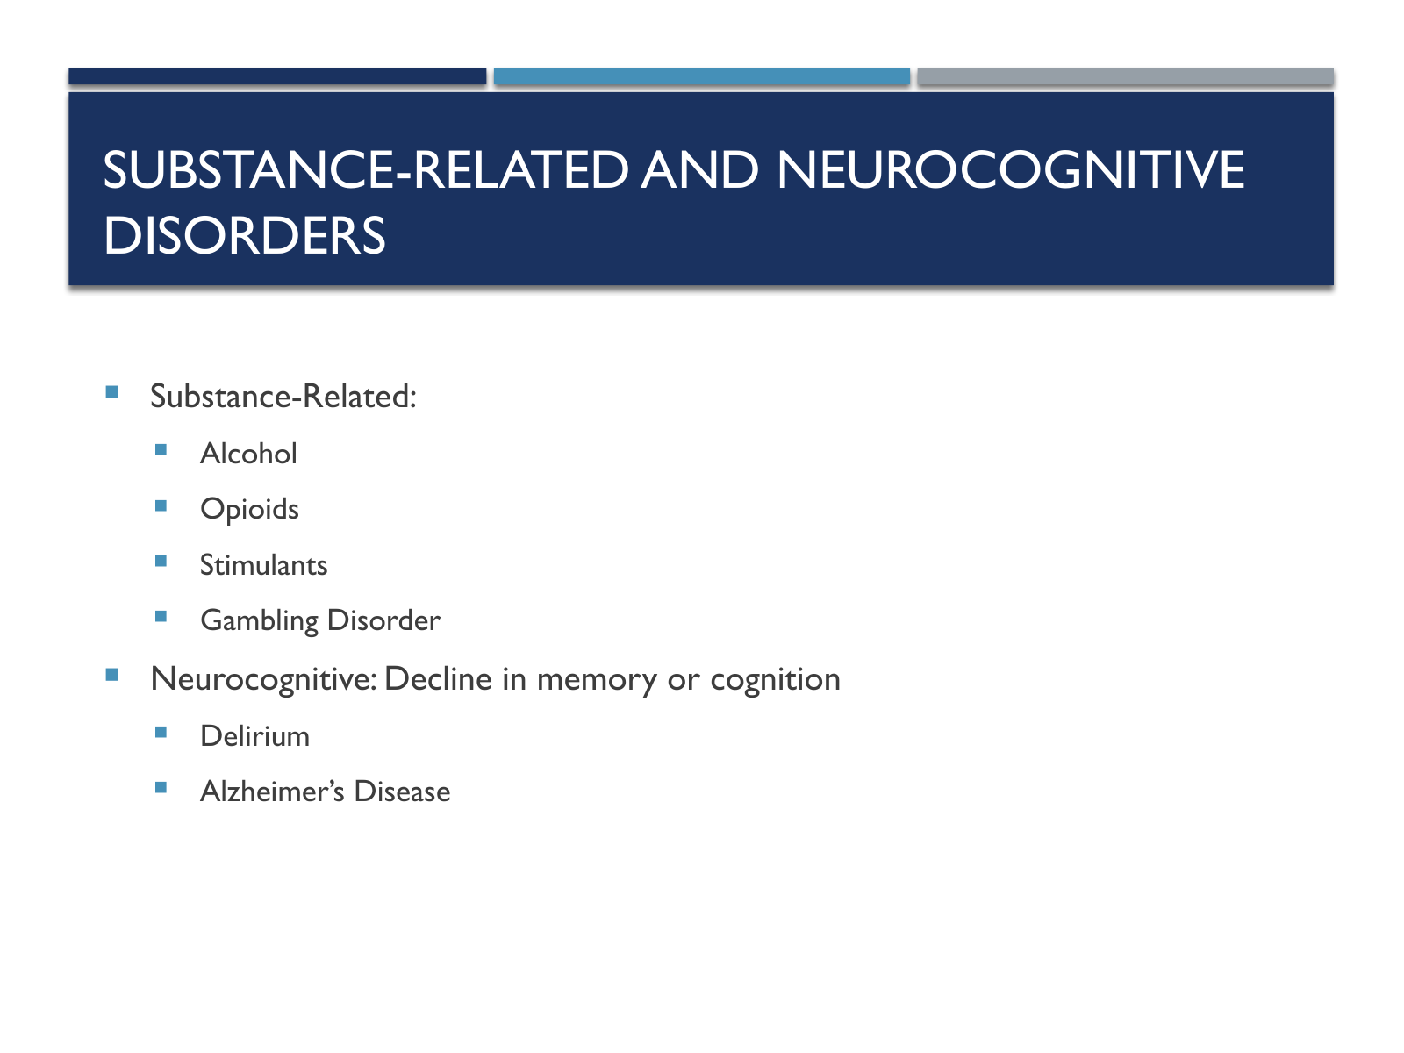

Slide text
Substance-Related and Neurocognitive Disorders
Substance-Related:
Alcohol
Opioids
Stimulants
Gambling Disorder
Neurocognitive: Decline in memory or cognition
Delirium
Alzheimer’s Disease

Slide 22. Personality Disorders
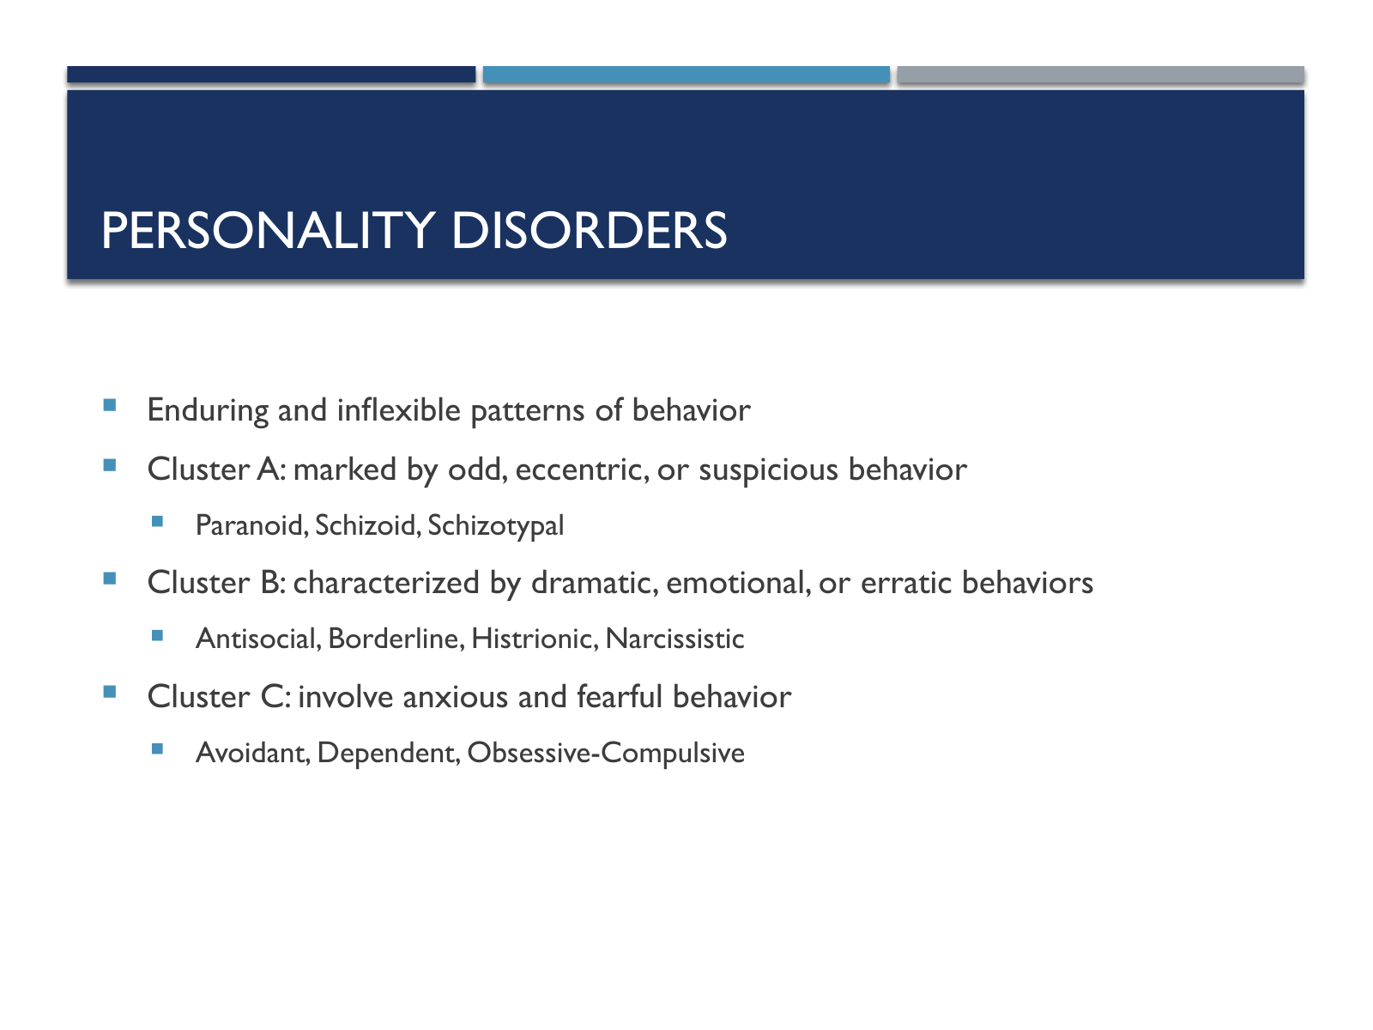

Slide text
Personality Disorders
Enduring and inflexible patterns of behavior
Cluster A: marked by odd, eccentric, or suspicious behavior
Paranoid, Schizoid, Schizotypal
Cluster B: characterized by dramatic, emotional, or erratic behaviors
Antisocial, Borderline, Histrionic, Narcissistic
Cluster C: involve anxious and fearful behavior
Avoidant, Dependent, Obsessive-Compulsive

Slide 23. Diagnostic Features
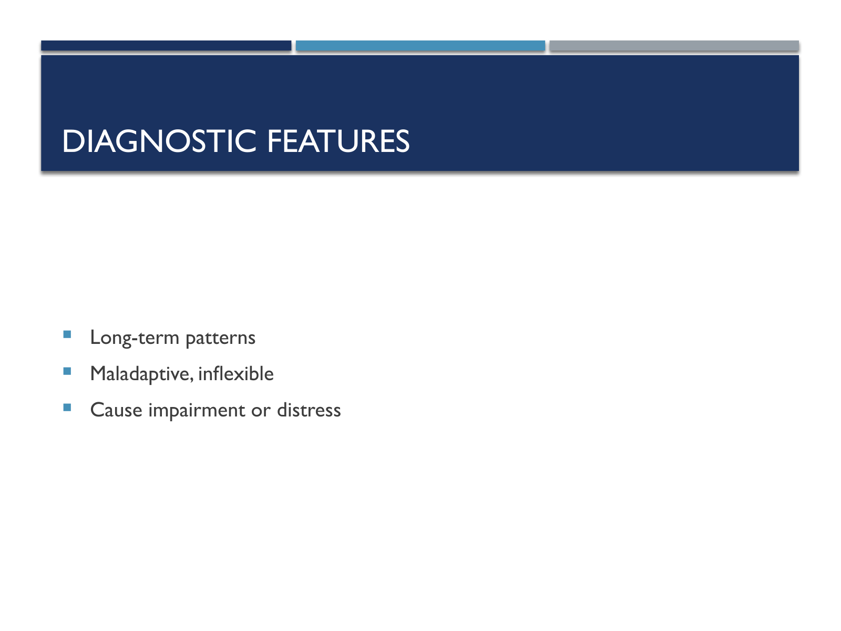

Slide text
Diagnostic Features
Long-term patterns
Maladaptive, inflexible
Cause impairment or distress

Slide 24. Personality Disorders vs. Other Disorders
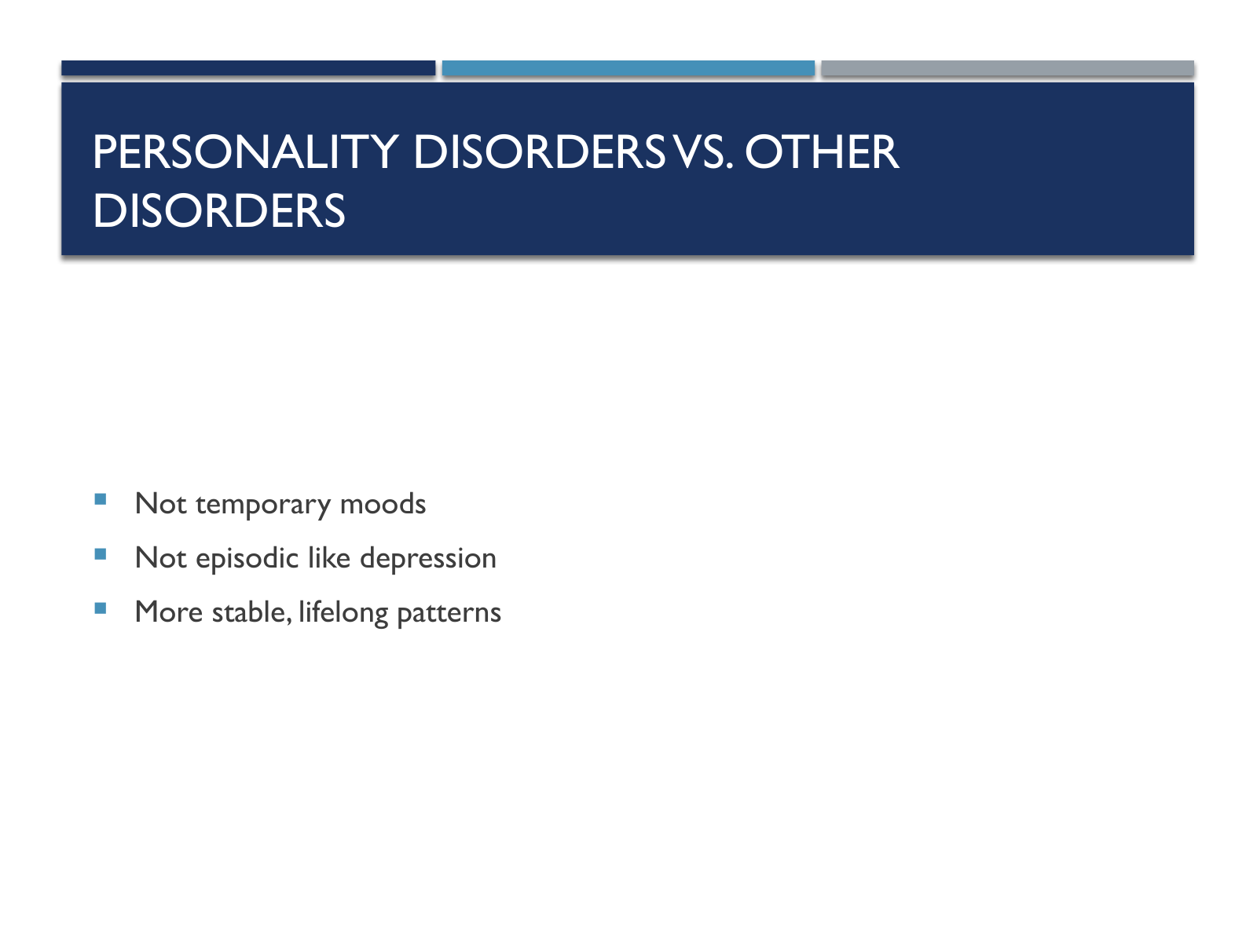

Slide text
Personality Disorders vs. Other Disorders
Not temporary moods
Not episodic like depression
More stable, lifelong patterns

Slide 25. Treatment Challenges
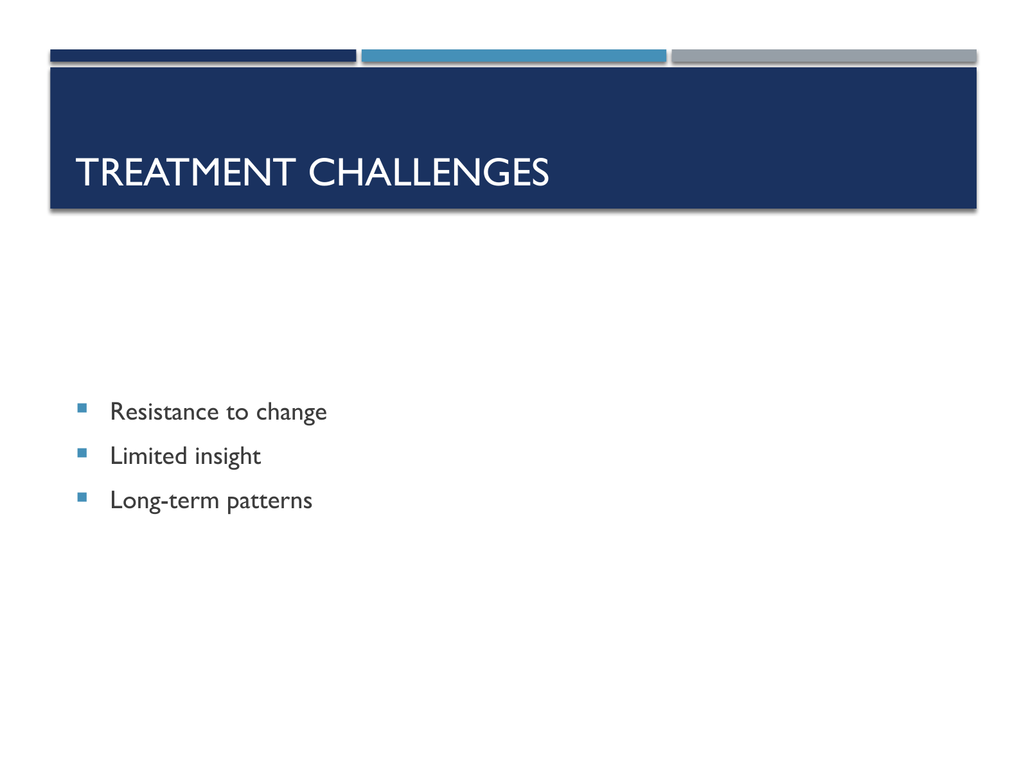

Slide text
Treatment Challenges
Resistance to change
Limited insight
Long-term patterns

Slide 26. Cluster A Disorders (Odd/Eccentric)
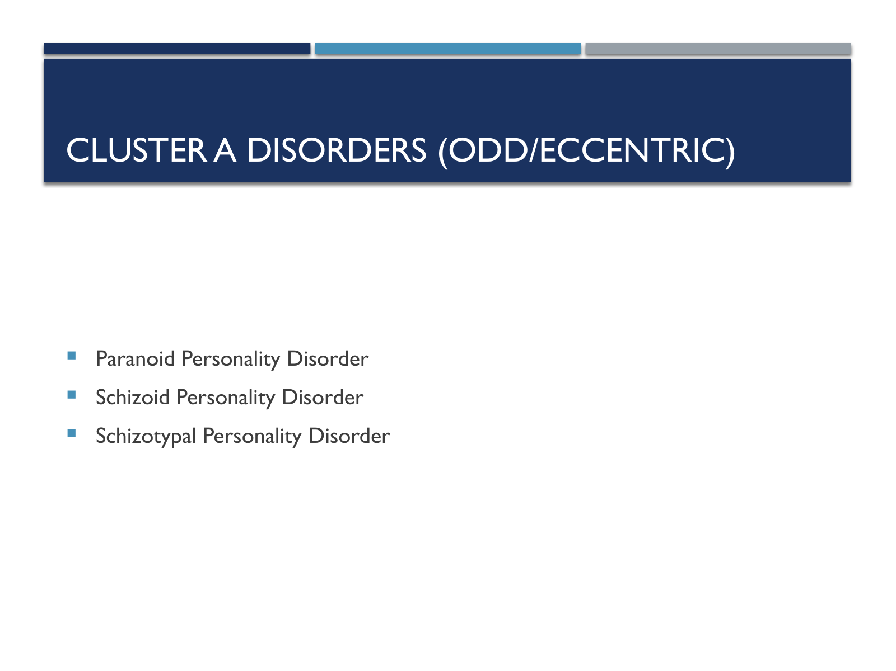

Slide text
Cluster A Disorders (Odd/Eccentric)
Paranoid Personality Disorder
Schizoid Personality Disorder
Schizotypal Personality Disorder

Slide 27. Cluster B Disorders (Dramatic, Emotional, Erratic)
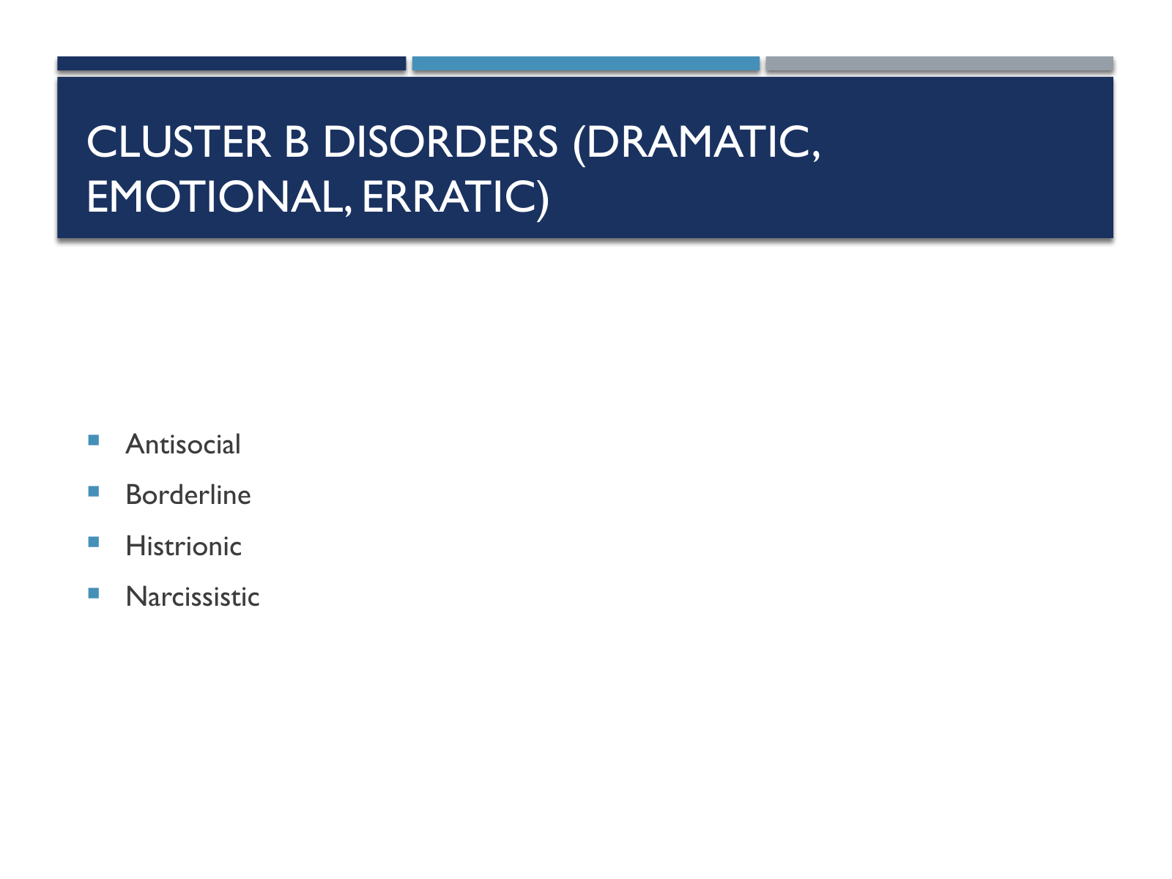

Slide text
Cluster B Disorders (Dramatic, Emotional, Erratic)
Antisocial
Borderline
Histrionic
Narcissistic

Slide 28. Cluster C Disorders (Anxious/Fearful)
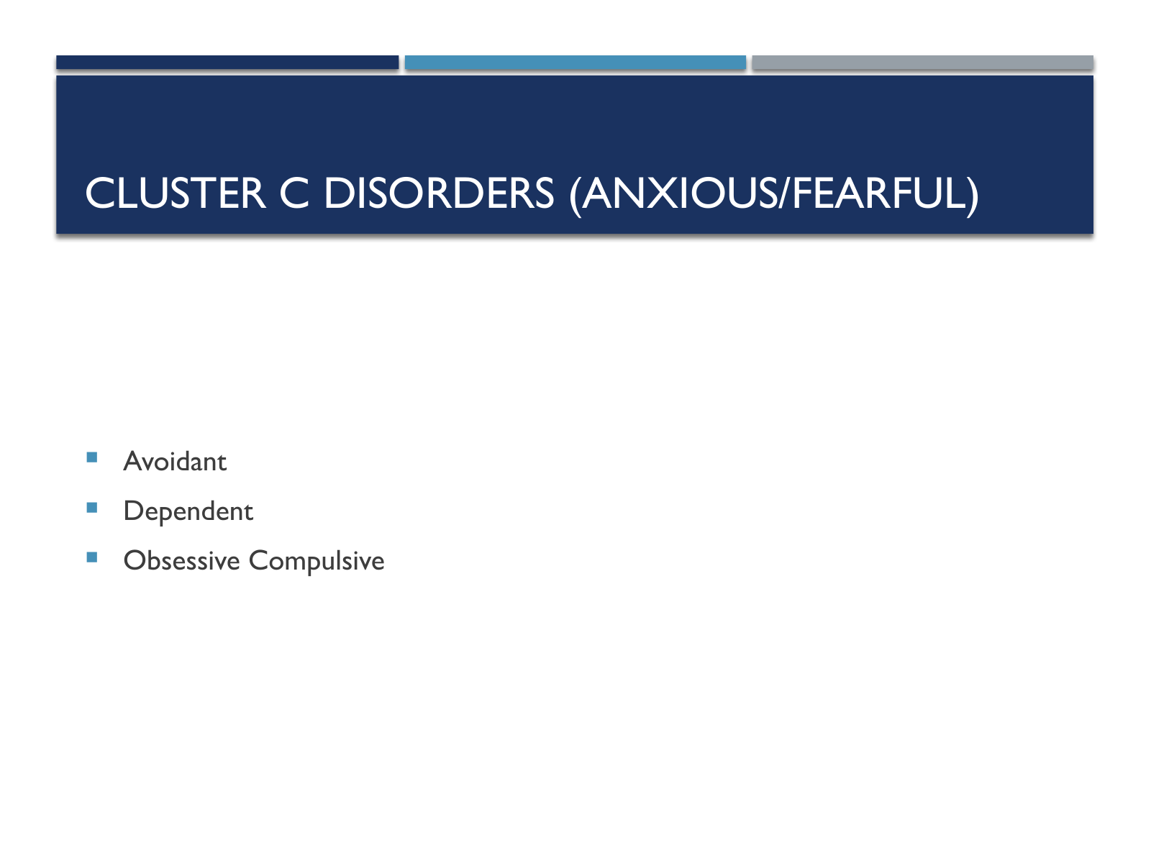

Slide text
Cluster C Disorders (Anxious/Fearful)
Avoidant
Dependent
Obsessive Compulsive

