MYSQL INSTALL

For the GUI to MYSQL go to http://dev.mysql.com/downloads/gui-tools/5.0.html
-Click MySQL Workbench
- Choose the platform of choice and follow the prompts. Take all the default settings
- Once installed for instance in Windows 7 go to All Programs, MySQL Workbench (note you can
Create a shortcut on desktop)

-Once MySQL Workbench is opened you should see the following screen:
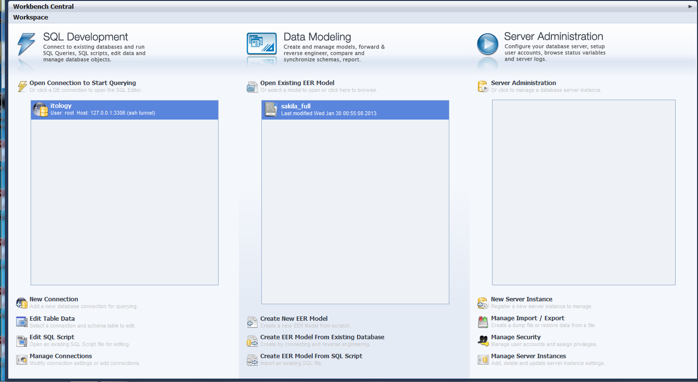
To access MySQL on the linux box do the following:
-Click new Connection on the Workbench
-You should see a setup New Connection screen.
-For the connection method choose Standard TCP/IP over SSH
-Enter the information as seen below. Note : the SSH username and password is the same you would use to log into the Linux box. The Username to connect to the database can be obtained from Karl Mccollek.
-Test you connection and then click ok. You should be connected to the MySQL database on the Linux box.
- You can click Open Connection to start querying to access the SQL Editor
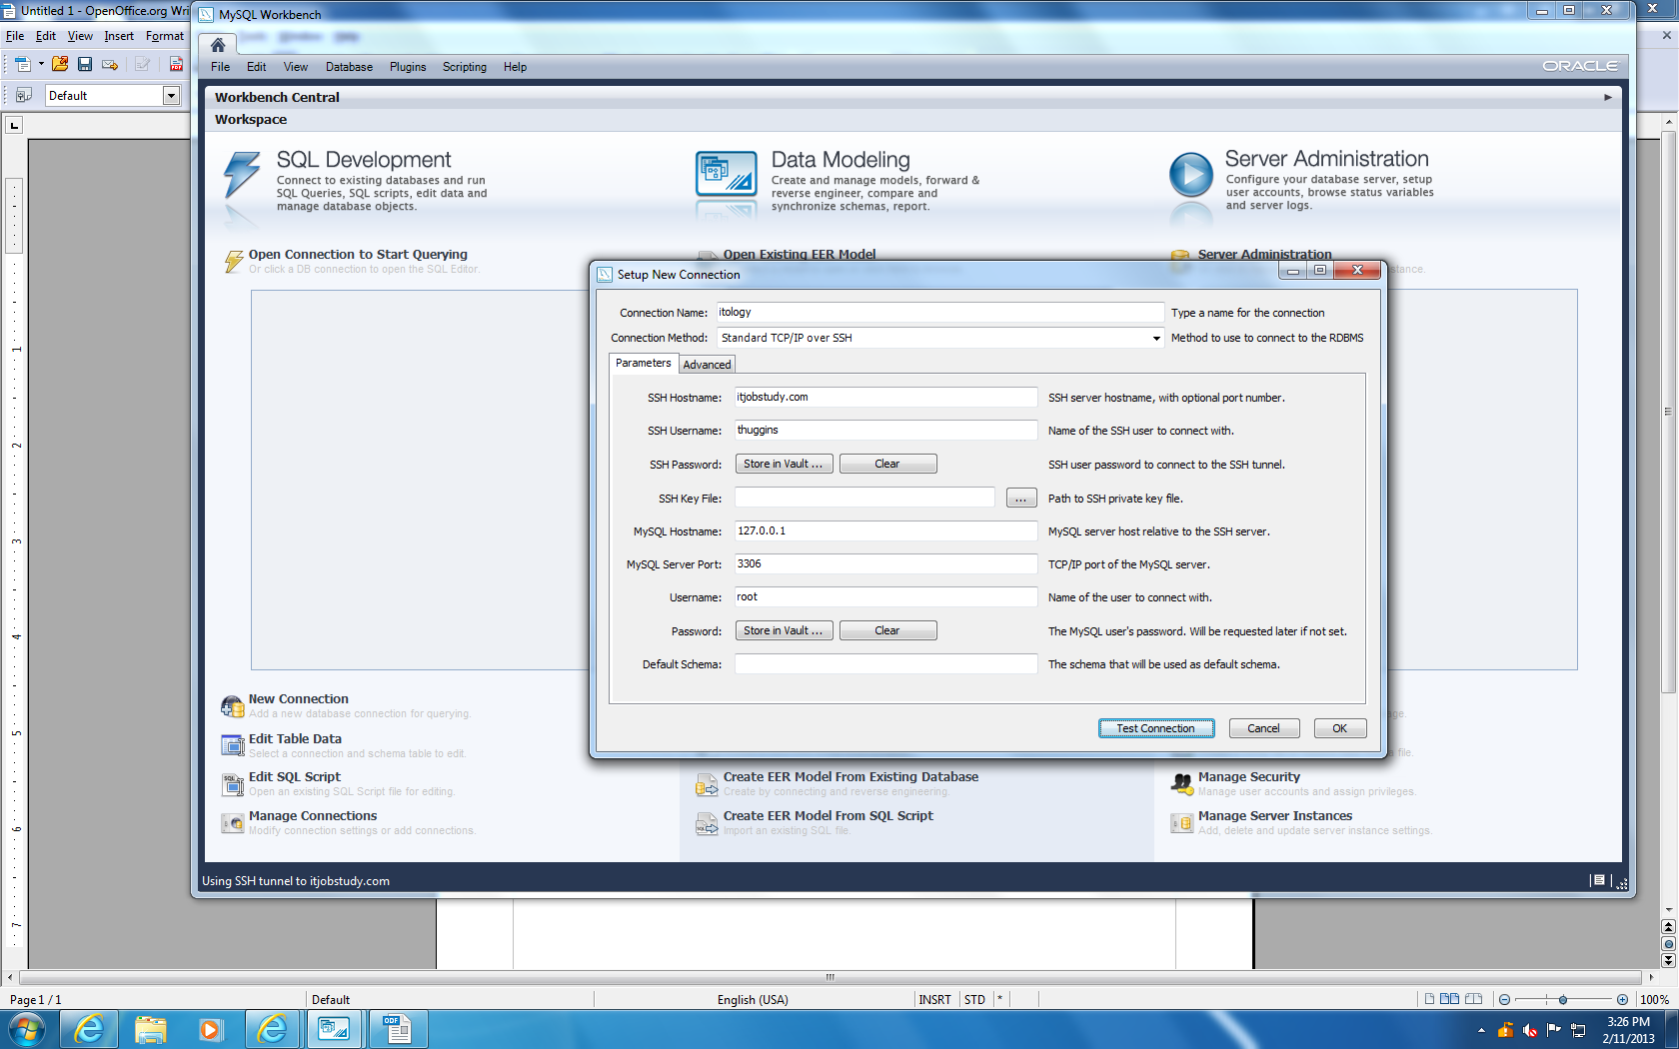

PUTTY.EXE

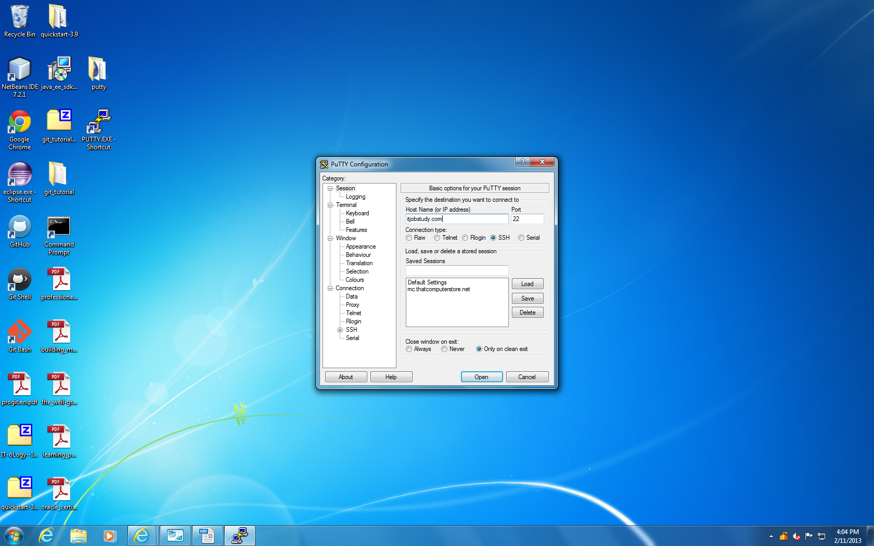
PuTTY is an SSH and telnet client used to access the Linux on the z-series. PuTTY is an open source software. To download go to www.putty.org . For windows click putty.zip file and save it to your desktop. Once on the desktop extract all the files. Create a shortcut to the putty.exe file. Double click the shortcut to open the PuTTY configuration screen. Enter the below information. Then click open to log into Linux on the z-series.
Once you have log into Linux, drill down into the mysql directory as shown:
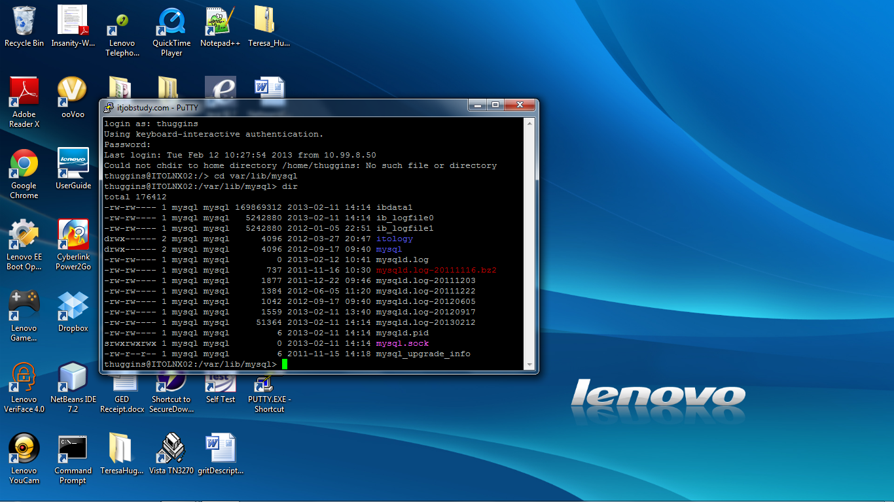

Once in the mysql folder to access the itjobstudy database, type: mysql itology –u root –h localhost -p
Then enter. You should be prompted to enter the database password. Enter the password.

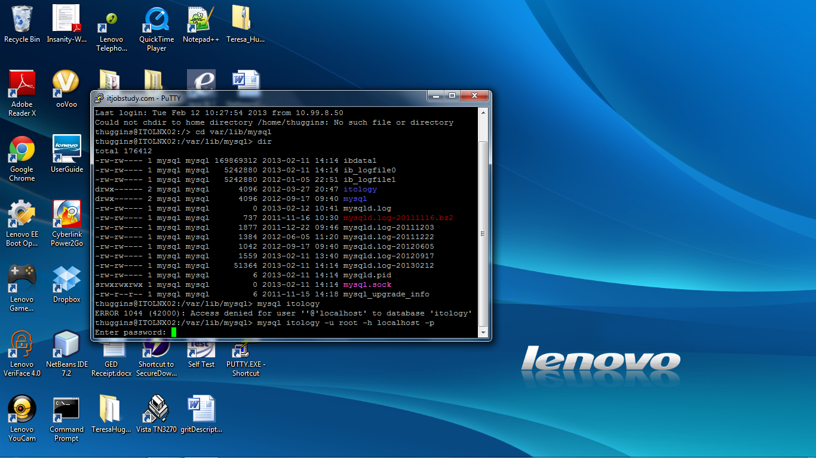

Once you press enter, you should be logged into the mysql database. To see the tables, you can type show tables; at the mysql prompt. Note in mysql all queries or commands must end with a semi-colon. For commands used in MySQL visit the following site: http://www.mysqltutorial.org/ .. To log off the database type \q at the prompt. To exit out of Linux type exit

The itjobstudy website source code is located at srv/www/htdocs. To download the files locally, do the following:

- Go to http://fileZilla-project.org/
- Click Download FileZilla Client all platforms
- Click the download now in the green box
- Run the setup. Accept all defaults. Note you can click the box to add desktop shortcut during setup.
- Open FileZilla client. The following information will be needed to log onto the z-series box:
Host: itjobstudy.com Port: 22
Use your assigned username and password
- After you have logged in, you can drag and drop files/folders from the remote site to your local drive.

How to download excel spreadsheets for itjobstudy site

- Go to http://www.bls.gov/oes/oes_datahtm
- Locate the year you want data.
- Click link “Download May year Occupational Emlployment and Wage Estimates in Zipped XLS files
- Download the following files locally:
- Metropolitan Area Cross-Industry estimates. (zip contains MSA_M201*_dl_1.xls, MSA_M201*_dl_2.xls, MSA_M201*_dl_3.xls, aMSA_M201*_dl.xls, Bos_M201*_dl_xls)
- State Cross_Industry estimates (zip contains state_M201*_dl.xls)

NOTE: * IS THE LAST DIGIT FOR THE YEAR OF INTEREST.

General python script information

Note: All the scripts needed to update itology database with occupational data is located on GitHub in IT-oLogy—IT-Jobs-Report-Application repository. There is also a copy on the Linux server at the following location: /usr/tmp/itologyLoadScripts also there is a copy at srv/www/itologyLoadScripts. Also note that all the code for the itjobstudy website is located at srv/www/htdocs. Within the itologyLoadScripts folder you will find the following files:
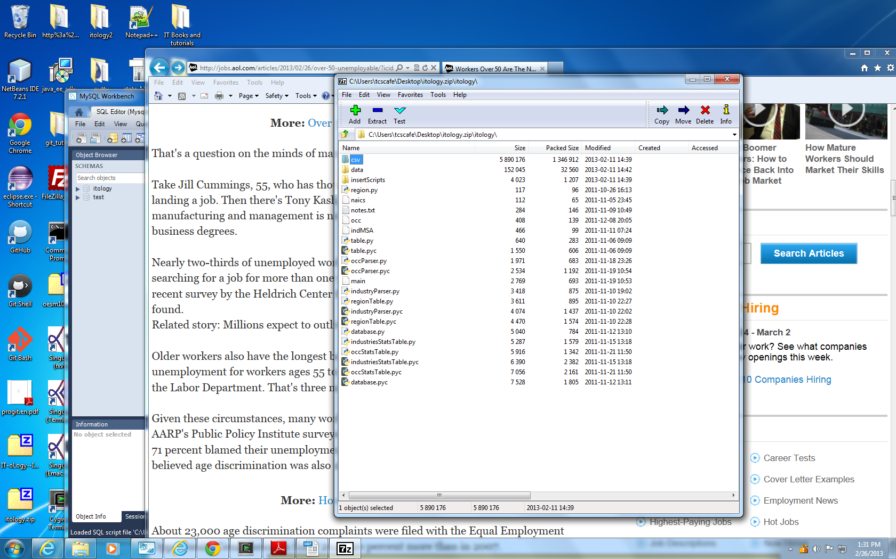

The data folder contains the excel downloads from the US Department of labor.

The insertScripts folder contains the scripts needed to update data in the itology database.

The occ file contains the occupational codes that are of interest. The main file is the entry point to run the python. The main file will call other python files as needed.

HOW TO CREATE/RUN AN UPDATE SCRIPT

1.Create a new script file by either opening the insertScripts folder and editing a previous script using notepad++ or vi on Linux server.
2.To run the script locally, please follow the instructions in the below section on Cygwin. To run on the Linux server, ftp the files over if they are on your local to /usr/tmp/itologyLoadScripts. Note I ran from this location instead of srv/www/itologyLoadScripts because I had a problem getting the excel spreadsheets to copy over to www folder. The insert_files** shoud be ran from the main root of the itologyLoadScripts folder not from inside of the insertScripts folder.
3.Log onto the Linux box using putty.exe (see section for installation above)
4. At the prompt: cd user/tmp/itologyLoadScripts
5. run the following command at the prompt: bash –x insert_files**
Note: ** is the year for the data being pulled. –x activates the script in debug mode so that you can see how your python code is being executed.

When you run the insert_file, you are calling main with four parameters: --year, --format,--file,--action. The action will determine which route the program will go. To load scripts to the itology database use --action none .
Python code can be viewed in notepad++ or in the python shell. To run the code successfully, you must hardcode the connection string or create a connection file and call it from within python code. I hard coded the connection string in the database.py using the following (db=self.dbName, user=self.usrName, passwd=”******”, host=”127.0.0.1, port=3306). Ask Karl Mccollester for the database password. Note since the code in the itologyLoadScripts folder may have been in the process of being updated in the past, some of the tables called to query in the code doesn’t match up. I code that does the inserts into the itology database does work. But if you try to run the scripts using –action query, there may be errors such as table does not exist. As of 3/5/2013 the 2011 jobs data is in the itology database. But, a script is missing to updated the tables needed for the itjobstudy website. For instance, the index.php code located in the htdocs forder (srv/www/htdocs on Linux server) calls the table indstateitstats. This table is not updated when running the insert_files script. I have contacted Jeremy to get the updated scripts on 3/5/2013.

How to set your computer to run Linux/MySQL/python/PHP locally
- Download Cygwin collections of tools which provide a look and feel of Linux in a Windows environment http://cygwin.com/install.htm. Note the computer closest to the door on the first floor of itology has Cygwin completely installed and configured. When install download, installed everything using all default settings. The install took a couple of hours.
- Once installed. The Cygwin environment by default looks at this location first to locate files in Cygwin: /home/tcscafe/
- Much of the python code used to run the script to load the data to itology database imports MySQLdb class and XLRD (methods to manipulate excel files and data).
- To set up Cygwin to have access to these classes, download the following into your Cygwin home directory (/home/tcscafe)
  - Setuptools-0.6c11.tar.gz (https://pypi.python.org/pypi/setuptools#files)
  - Mysql-5.6.10.tar.gz (dev.mysql.com/downloads/mysql/?current_OS=SRC)
- To run the setups. Open Cygwin Terminal
- At the prompt type: tar zxf setuptools-0.6c11.tar.gz (Note this will unzip the file)
- At the prompt type: ls
- Type: cd setuptools-0.6c11
- Type: python ez_setup.py
- Repeat steps 5 and 6 to unzip mysql-5.6.10.tar.gz
- Cd mysql-5.6.10
- Type make install
- To install the libraries at the Cygwin prompt type: easy_install xlrd
- Enter
- At the prompt type: easy_install mySQL-Python and then enter
- Now you should have access to the objects in your python code.
- To test to make sure the package is available at the Cygwin prompt type: python and enter
- >>> import xlrd and enter ( if available should return back to >>> otherwise will say module not found)
- >>> import MySQLdb and enter ( if available should return back to >>> otherwise will say module not found)
- >>>ctrl d ( to exit out of python).

Note: itology database located on Linux server : var/lib/mysql. To log in at the prompt type: mysql itology -u root -h localhost -p

