- Go to http://itjobstudy.com/ and click on the IT Job Study link on the right side.


- By default, Occupation will be selected, which means that the graph will show small business jobs as opposed to Industrial type jobs.

- If you select Industry, only IT sector jobs will be displayed on the graph. For example, jobs for companies like Google, Yahoo, IBM, etc.

- When Industry is chosen, select a state and choose up to 5 sub-industries by clicking on them and clicking Select for each one. Each sub-industry will be represented by a line on the graph. When Occupation is chosen, select a state and choose up to 5 occupations by clicking on them and clicking Select for each one.
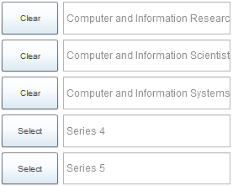
- You can mouse-over the lines and see the salaries or number of jobs, as well as a pie chart.
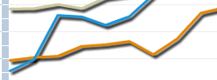
- If you click Download, you can see the graphs as an table document.


